UNITED  NATIONS | 

UNEP/MC/COP.6/29

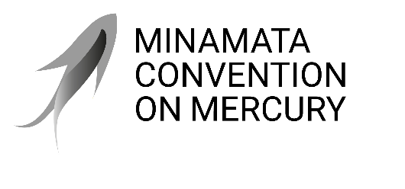 |  | Distr.: General  12 January 2026  English only

Conference of the Parties to the
Minamata Convention on Mercury
Sixth meeting
Geneva, 3–7 November 2025
Agenda item 4 (j) (ii)
Matters for consideration or action by the Conference of the Parties: cross-cutting matters: implementation of decision MC-5/15
Activities to address health concerns of women and children in the biennium 2026–2027
Note by the secretariat
At the sixth meeting, the Conference of the Parties to the Minamata Convention adopted in decision MC-6/16 on suggested activities to address health concerns of women and children in the biennium 2026–2027. The suggested activities, as adopted, are set out in the annex to the present note.

Annex
Activities that the secretariat and parties could carry out to address health concerns of women and children during the
biennium 2026–2027
- Activities that the secretariat could carry out to implement decision MC-5/15, subject to the availability of resources, include:
  - Supporting the integration and monitoring of strategies to prevent the exposure of vulnerable populations, particularly children and women of childbearing age, especially pregnant women, to mercury used in artisanal and small-scale gold mining, as appropriate, in the reviews of national action plans to be submitted by parties pursuant to paragraph 3 (c) of article 7, in collaboration with the Chemicals and Health Branch of the United Nations Environment Programme;
  - Supporting the coordination of the women’s caucus of the Minamata Convention on Mercury to advance the equality and empowerment of women in the implementation of the Convention;
  - Collecting information from parties and other stakeholders on capacity-building needs and interests with respect to mercury exposure of women and children.
- Activities that parties could, within the scope of their respective capabilities, carry out include:
  - Integrating and monitoring the implementation of strategies to prevent the exposure of vulnerable populations, particularly children and women of childbearing age, especially pregnant women, to mercury used in artisanal and small-scale gold mining, as appropriate, in the reviews of national action plans to be submitted pursuant to paragraph 3 (c) of article 7;
  - Providing financial resources to support the participation of representatives of the women’s caucus in the meetings of the Conference of the Parties to advance the equality and empowerment of women in the implementation of the Convention;
  - Developing, in consultation with youth, a Children and Youth Engagement Action Plan to mainstream youth engagement in the Convention;
  - Responding to requests for information to enable the secretariat to identify capacity -building needs and interests of parties with respect to the implementation of decision MC-5/15, including on the exposure of women and children to mercury.

