UNITED  NATIONS | 

UNEP/MC/COP.6/24

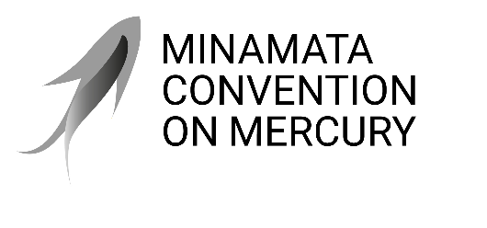 |  | Distr.: General  26 June 2025  Original: English

Conference of the Parties to the
Minamata Convention on Mercury
Sixth meeting
Geneva, 3–7 November 2025
Item 7 of the provisional agenda*
Venue and dates of the seventh meeting of the
Conference of the Parties
Venue and dates of the seventh meeting of the Conference of the Parties to the Minamata Convention on Mercury
Note by the secretariat
I. Introduction
- Meetings of the Conference of the Parties to the Minamata Convention on Mercury are to take place at the seat of the secretariat unless the Conference of the Parties decides otherwise or other appropriate arrangements are made by the secretariat in consultation with the parties.
- At the first meeting of the Bureau of the sixth meeting of the Conference of the Parties, which was held online on 28 January 2025, the secretariat invited parties to submit, if possible by 2 May 2025, offers to host the seventh meeting of the Conference of the Parties for consideration by the Conference of the Parties at its sixth meeting.
II. Implementation
- Information to be taken into account by any party wishing to offer to host a meeting of the Conference of the Parties at a location other than the seat of the secretariat is available on the Convention website.
- As at 1 September 2025, the secretariat had not received any offers to host the seventh meeting of the Conference of the Parties.
- In case no offers to host the seventh meeting are received, the secretariat has tentatively booked the Geneva International Conference Centre for the period from 14 to 18 June 2027, with preparatory meetings to be held on 13 June 2027.
- Pursuant to rule 11 of the rules of procedure for the Conference of the Parties, the provisional agenda for each ordinary meeting, together with supporting documents, will be issued in the official languages of the Conference of the Parties and distributed by the secretariat to the parties at least six weeks before the opening of the meeting. The time frames specified in the rules of procedure determine the date by which the United Nations Office at Nairobi, the provider of translation services for the processes it serves, issues pre-session documents for a given meeting. In the run-up to meetings of the Conference of the Parties, the secretariat has encountered challenges in organizing all regional preparatory meetings within the six-week period before the meeting. The Conference of the Parties may wish to request that the provisional agenda, together with supporting documents, be issued in the official working languages at least eight weeks prior to future meetings of the Conference of the Parties in order to ensure the availability of translated documents for all regional preparatory meetings.
III. Suggested action by the Conference of the Parties
- The Conference of the Parties may wish to adopt a decision along the following lines:
The Conference of the Parties
- Decides to convene the next meeting of the Conferences of the Parties to the Minamata Convention on Mercury from [--] to [--] 2027, in [--];
- Requests the Executive Secretary, in order to assist parties in their preparations for the meeting, to support, subject to the availability of resources, regional meetings, held in coordination with other regional meetings, to facilitate regional preparatory processes;
- Invites the Executive Secretary, in order to further assist parties and regions in their preparations, to distribute the provisional agenda, together with supporting documents, to the parties, in the official languages of the Conference of the Parties, at least eight weeks before the opening of future meetings of the Conference of the Parties;
- Invites parties to submit offers to host the eighth meeting of the Conference of the Parties at least three months before the opening of the seventh meeting, in 2027, for consideration by the Conference of the Parties at its seventh meeting.

* UNEP/MC/COP.6/1/Rev.1.
See rule 3 of the rules of procedure for the Conference of the Parties to the Minamata Convention on Mercury.
At www.minamataconvention.org/sites/default/files/documents/other/Information_on_hosting_COPs.pdf.

