UNITED  NATIONS | 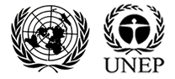

UNEP/MC/COP.6/20

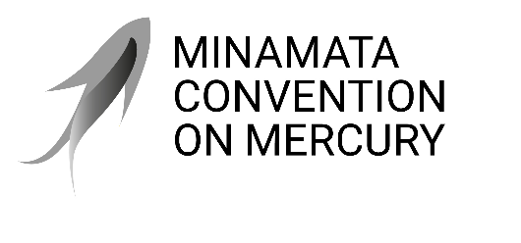 |  | Distr.: General  29 July 2025  Original: English

Conference of the Parties to the
Minamata Convention on Mercury
Sixth meeting
Geneva, 3–7 November 2025
Item 4 (l) of the provisional agenda*
Matters for consideration or action by the Conference of the Parties: mercury and the Kunming-Montreal Global Biodiversity Framework
Road map for enhancing co-benefits from implementation of the Minamata Convention and the Kunming-Montreal Global Biodiversity Framework
Note by the secretariat
I. Introduction
Background
- At its fifth meeting, the Conference of the Parties to the Minamata Convention on Mercury adopted decision MC-5/17 on mercury and the Kunming-Montreal Global Biodiversity Framework.
- The decision was informed by a report prepared by the secretariat on how the Convention and the Framework could be implemented in a mutually supportive manner, including the mapping of the interlinkages between the Convention and the Framework, as summarized in document UNEP/MC/COP.5/20 and described in full in document UNEP/MC/COP.5/INF/27. The report showed that work under the Minamata Convention contributes to nearly all the targets of the Framework.
- In decision MC-5/17, the secretariat was requested, subject to the availability of resources, to prepare a draft road map, including possible actions and indicators, to support parties in demonstrating and maximizing the co-benefits arising from the implementation of the Minamata Convention and the Kunming-Montreal Global Biodiversity Framework, for consideration by the Conference of the Parties at its sixth meeting.
- The present note summarizes the activities undertaken by the secretariat in response to decision MC-5/17 and presents a draft road map for enhancing co-benefits from implementation of the Minamata Convention and the Kunming-Montreal Global Biodiversity Framework by 2030. Annex I to the note sets out a proposed decision on the matter.
- In preparing the draft road map, the secretariat considered the outcomes of the sixteenth meeting of the Conference of the Parties to the Convention on Biological Diversity, which was held in two parts: in Cali, Colombia (21 October–1 November 2024) and in Rome (25–27 February 2025). Annex II to the present note provides an overview of the resulting decisions that are of direct relevance to the Minamata Convention. For ease of reference, document UNEP/MC/COP.6/INF/41 contains a list of key decisions from the fifteenth and sixteenth meetings of the Conference of the Parties to the Convention on Biological Diversity.
II. Activities undertaken in response to decision MC-5/17
- The secretariat undertook activities to inform the Conference of the Parties to the Convention on Biological Diversity, its subsidiary bodies and the secretariat of the Convention on Biological Diversity of the outcomes of the fifth meeting of the Conference of the Parties to the Minamata Convention relating to the Framework. In a letter sent on 31 January 2024, the Executive Secretary of the Minamata Convention communicated the relevant decisions to the Executive Secretary of the Convention on Biological Diversity, including the invitation to develop monitoring indicators related to highly hazardous chemicals and mercury under target 7 of the Framework. The secretariat also submitted a report to the Conference of the Parties to the Convention on Biological Diversity at its sixteenth meeting summarizing the relevant decisions from the fifth meeting of the Conference of the Parties to the Minamata Convention as well as recent work under the Convention to reduce the impacts of mercury pollution on biodiversity. Finally, the secretariat participated in the twenty-sixth meeting of the Subsidiary Body on Scientific, Technical and Technological Advice, held in Nairobi from 13 to 18 May 2024, and the sixteenth meeting of the Conference of the Parties to the Convention on Biological Diversity in Cali, including several side events and sessions that showcased work on how coherent implementation of the Minamata Convention and the Framework could generate multiple benefits for the environment and society at large.
- Furthermore, the secretariat developed new resources to support national-level work to improve coherence across the chemical and biodiversity agendas. With the financial support of the Kingdom of the Netherlands, the secretariat developed a technical document on incorporating mercury targets and actions into national biodiversity strategies and action plans (NBSAPs) as they are being revised or updated to align with the Kunming-Montreal Global Biodiversity Framework. The document was developed in partnership with The Nature Conservancy and is available in document UNEP/MC/COP.6/INF/27. Further, utilizing the report prepared for the fifth meeting of the Conference of the Parties, the secretariat prepared a publication entitled Mercury and Biodiversity – Opportunities for Generating Co-Benefits through Coherent Implementation of the Minamata Convention on Mercury and the Kunming-Montreal Global Biodiversity Framework and made it available on the Convention website.
- In addition, the secretariat, together with the secretariat of the Basel, Rotterdam and Stockholm conventions and the secretariat of the Convention on Biological Diversity, co-organized a series of information sessions, with two held on 18 April and 12 September 2024 and another planned prior to the sixth meeting of the Conference of the Parties, with a view to facilitating an exchange among national focal points to the biodiversity and chemicals and waste multilateral environmental agreement clusters. The secretariat of the Intergovernmental Platform on Biodiversity and Ecosystem Services (IPBES) also organized a webinar on the Minamata Convention for the IPBES Multidisciplinary Expert Panel, which was held on 4 October 2024.
- The secretariat represented the Minamata Convention at the Bern III Conference on cooperation among the biodiversity-related conventions for the implementation of the Kunming-Montreal Global Biodiversity Framework, which took place from 23 to 25 January 2024 in Bern. The conference was organized by the Government of Switzerland and the United Nations Environment Programme (UNEP), and representatives of several parties to the Minamata Convention were invited to attend. The secretariat also participated in the Bogis-Bossey expert workshop on the Bern process and the contribution of multilateral environmental agreements to the implementation of the Kunming-Montreal Global Biodiversity Framework, held in Bogis-Bossey, Switzerland, on 27 and 28 August 2025.
- The secretariat cooperated with focal points of the Global Environment Facility (GEF), the Minamata Convention and other multilateral environmental agreements to support project development across focal areas and integrated programmes and promoted integration at the GEF Technical Advisory Group meetings, GEF Council meetings and GEF trust fund replenishment meetings. More information on GEF-related matters can be found in document UNEP/MC/COP.6/10.
III. Draft road map for enhancing co-benefits from implementation of the Minamata Convention and the Kunming-Montreal Global Biodiversity Framework
A. Background information on the contribution of the Minamata Convention to the monitoring framework of the Kunming-Montreal Global Biodiversity Framework
- In its decision MC-5/17, the Conference of the Parties to the Minamata Convention noted the absence in the monitoring framework for the Kunming-Montreal Global Biodiversity Framework of indicators regarding the overall risk from highly hazardous chemicals, and it invited the Conference of the Parties to the Convention on Biological Diversity to consider additional indicators, under target 7, to cover highly hazardous chemicals and mercury.
- Furthermore, the Conference of the Parties, in its decision MC-5/14, adopted indicators to support the evaluation of the effectiveness of the Minamata Convention, including indicator 1, levels and trends of mercury and mercury compounds in the environment and in humans due to anthropogenic emissions and releases, and indicator 29, mercury levels in vulnerable human populations.
- The Open-ended Scientific Group established in decision MC-4/11 is responsible for analysing indicators 1 and 29 and developing a scientific report synthesizing the available data on mercury monitoring, emissions and releases, to address scientific questions regarding the levels of mercury in the environment and humans, its temporal trends and spatial patterns, its adverse impact and cause-effect relationships. The Conference of the Parties is to consider the scientific report when it evaluates the effectiveness of the Convention for the first time at its seventh meeting, and also when it evaluates the effectiveness of the Convention periodically thereafter, considering available monitoring data.
- Effectiveness evaluation indicators 1 and 29 could also serve as additional indicators under target 7 of the Kunming-Montreal Global Biodiversity Framework.
- At its sixteenth meeting, the Conference of the Parties to the Convention on Biological Diversity established a process for considering additional indicators by requesting the Executive Secretary to compile submissions from secretariats of multilateral environmental agreements, among others, for the inclusion of additional headline, component and complementary indicators that meet the criteria for inclusion in the monitoring framework, in order to help address the gaps in the monitoring framework.
- In response to the call for information issued by the Executive Secretary of the Convention on Biological Diversity on 3 April 2025, the secretariat submitted information identifying a gap in the current indicators on pollution by highly hazardous chemicals and proposing the inclusion of “levels and trends of mercury and mercury compounds in the environment and in humans due to anthropogenic emissions and releases” as an additional indicator.
- The secretariat also provided input in response to another call for information, related to biodiversity and health. On 7 February 2025, the Executive Secretary of the Convention on Biological Diversity issued an invitation to submit information for the development of indicators, metrics and progress measurement tools on biodiversity and health, including examples of indicators on biodiversity and health, data sources and efforts by other organizations and initiatives. The secretariat submitted information on the work of the Open-ended Scientific Group, including the comparison of the observed level of mercury in the environment and humans with established national and international benchmark levels on human health and the environment.
B. Timeline for the 2030 targets of the Kunming-Montreal Global Biodiversity Framework
- NBSAPs are national strategies, plans or programmes developed by parties to the Convention on Biological Diversity for the conservation and sustainable use of biodiversity. Each party to the Convention, in accordance with its particular conditions and capabilities, is expected have an NBSAP. They are the main tool for implementing the Convention at the national level.
- In decision 15/6, the Conference of the Parties to the Convention on Biological Diversity requested parties to revise and update their NBSAPs in accordance with article 6 of the Convention, following the guidance provided in annex I to the decision, to align them with the Kunming-Montreal Global Biodiversity Framework and its goals and targets, including those related to means of implementation, and to submit them through the clearing-house mechanism by the sixteenth meeting of the Conference of the Parties. It also requested parties not in a position to submit their revised NBSAPs by that time to communicate national targets reflecting, as applicable, all the goals and targets of the Framework, including those related to all means of implementation, in accordance with the reporting template provided in annex I to the decision, as a standalone submission, by the sixteenth meeting of the Conference of the Parties, in advance of the full submission of the NBSAP.
- By the sixteenth meeting of the Conference of the Parties, 44 parties had submitted their NBSAPs and 119 parties has communicated national targets. As of 25 July 2025, 55 parties had submitted 57 NBSAPs and 137 parties had communicated 3,231 national targets.
- In decision 15/6, parties were also requested to submit national reports in 2026 and 2029 and to use the headline indicators adopted in decision 15/5, supplemented by optional component and complementary indicators and other national indicators. At its sixteenth meeting, the Conference of the Parties, through decision 16/32, endorsed the national reporting template for the seventh and eighth national reports as contained in annex I to that decision.
- Figure 1 (on p. 5) presents the timeline for monitoring, reporting on and reviewing progress in the implementation of the Kunming-Montreal Global Biodiversity Framework up to 2030, when the final global review of progress in implementation of the Framework will be undertaken. Figure 2 (on p. 5) shows the timeline of meetings of the conferences of the parties to the Convention on Biological Diversity and the Minamata Convention, highlighting decisions on cooperative processes and other opportunities for cooperation.
Figure 1
Timeline for monitoring, reporting on and reviewing progress in the implementation of the Kunming-Montreal Global Biodiversity Framework
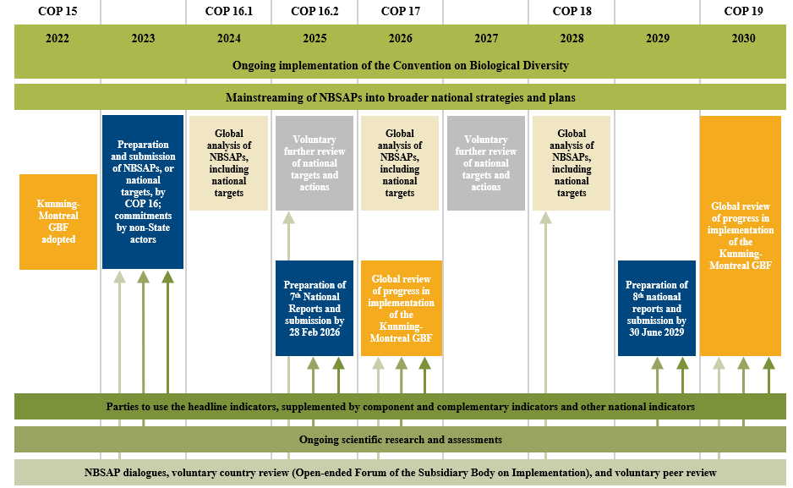
Abbreviations: COP 15 – fifteenth meeting of the Conference of the Parties; COP 16.1 – part I of the sixteenth meeting of the Conference of the Parties; COP 16.2 – part II of the sixteenth meeting of the Conference of the Parties; COP 17 – seventeenth meeting of the Conference of the Parties; COP 18 – eighteenth meeting of the Conference of the Parties; COP 19 – nineteenth meeting of the Conference of the Parties; GBF – Kunming-Montreal Global Biodiversity Framework.
Figure 2
Timeline of meetings of the conferences of the parties to the Convention on Biological Diversity and the Minamata Convention on Mercury and opportunities for cooperation
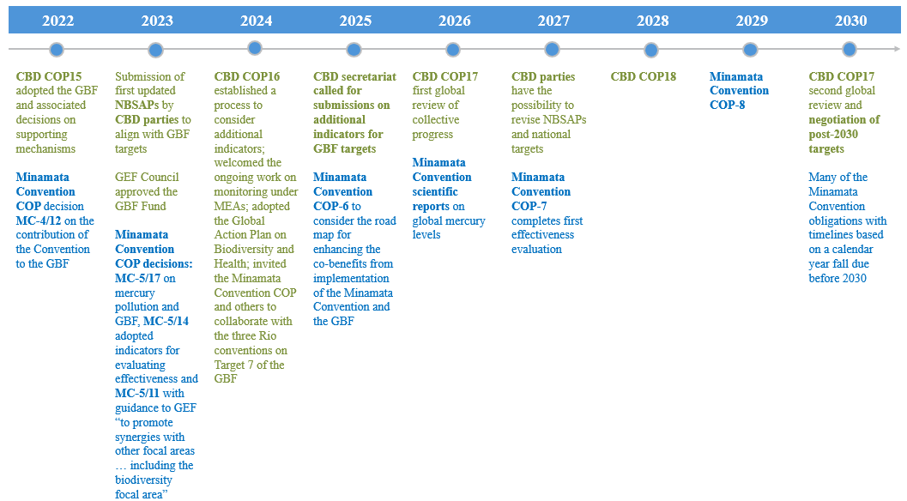

Abbreviations: COP – Conference of the Parties; CBD – Convention on Biological Diversity; COP-6 – sixth meeting of the Conference of the Parties; COP-7 – seventh meeting of the Conference of the Parties; COP-8 – eighth meeting of the Conference of the Parties; COP15 – fifteenth meeting of the Conference of the Parties; COP16 – sixteenth meeting of the Conference of the Parties; COP17 – seventeenth meeting of the Conference of the Parties; COP18 – eighteenth meeting of the Conference of the Parties; GBF – Kunming-Montreal Global Biodiversity Framework.
C. Key pillars of the road map
- The three key pillars of the road map for enhancing co-benefits from implementation of the Minamata Convention and the Kunming-Montreal Global Biodiversity Framework and advancing overall coherence across the mercury and biodiversity agendas are described below. While the focus of this document is on the links between the implementation of the Minamata Convention and the Framework, the pillars would also support coherence and synergies in the implementation of the Minamata Convention and the Convention on Biological Diversity more generally.
- The three pillars are: (i) contribution to the monitoring framework of the Kunming-Montreal Global Biodiversity Framework, (ii) inclusion of mercury reduction actions and targets in NBSAPs and national biodiversity targets; and (iii) creation of an enabling environment for enhanced co-benefits, including resource mobilization, capacity-building and cooperation.
1. Contribution to the monitoring framework of the Kunming-Montreal Global Biodiversity Framework
- The purpose of this pillar of the road map is to cooperate and continue sharing and exchanging information to fill in the gap under target 7 of the Framework to cover highly hazardous chemicals and mercury.
- The following are possible actions for this pillar of the road map:
  - Minamata Convention national focal points to establish contact with the national focal points of the Convention on Biological Diversity (including the Subsidiary Body on Scientific, Technical and Technological Advice ) to exchange information on mercury monitoring and target 7 of the Framework;
  - Minamata Convention national focal points and experts to engage, as appropriate, in the work of the Subsidiary Body on Scientific, Technical and Technological Advice on Framework indicators, making use of the knowledge and information from mercury-related research and development work and mercury monitoring;
  - The secretariat to share information on relevant monitoring initiatives under the Minamata Convention with the Executive Secretary of the Convention on Biological Diversity, as indicated in decision 16/31 of the Conference of the Parties to the Convention on Biological Diversity, on the monitoring framework for the Kunming Montreal Global Biodiversity Framework.
  - The secretariat to contribute to the further development and monitoring of Framework indicators, as well as indicators for the Global Action Plan on Biodiversity and Health, with information from the effectiveness evaluation of the Minamata Convention, including the scientific report of the Open-ended Scientific Group;
2. Inclusion of mercury reduction actions and targets in national biodiversity strategies and action plans and national biodiversity targets
- This pillar of the road map is to promote parties’ integration of mercury reduction targets into the revision or updating of their NBSAPs for alignment with the Kunming-Montreal Global Biodiversity Framework and beyond.
- The following are possible national-level actions that could be taken by parties and other Governments, Indigenous Peoples, local communities and other relevant stakeholders, including the private sector, academia, women, children and youth; they are interrelated and could be carried out sequentially or iteratively:
  - Establish contact with the national focal points of the Convention on Biological Diversity (including the Subsidiary Body on Scientific, Technical and Technological Advice) and the operational focal points of the Global Environment Facility, as appropriate, to agree on next steps;
  - Carry out consultations with experts and Indigenous Peoples, local communities and other relevant stakeholders, including women and youth, on various aspects of the implementation of the Minamata Convention to identify priorities for action and means of implementation at the national level;
  - Take stock of and summarize the current situation, at the national and subnational levels, as appropriate, concerning the identified priorities, utilizing Minamata Initial Assessments, existing national action plans for artisanal and small-scale gold mining, and other documents to identify sources of mercury and planned activities for mercury reduction;
  - Create a national planning process for the synergistic implementation of the Minamata Convention and the Convention on Biological Diversity, including the Kunming-Montreal Global Biodiversity Framework, to identify reduction priorities for mercury use, emissions and releases and decontamination and restoration, as appropriate, and mainstream them into the NBSAP process, and propose complementary indicators related to those priorities.
3. Creation of an enabling environment for enhanced co-benefits
- The third pillar of the road map involves creating an enabling environment for enhanced co-benefits from the implementation of the Minamata Convention and the Kunming-Montreal Global Biodiversity Framework.
- Actions under this pillar relate to resource mobilization, research, capacity-building and cooperation, and could be undertaken by parties, other Governments, local and subnational governments, the secretariat, academia and other stakeholders, as appropriate. Possible actions under this pillar include the following:
  - Pursue synergies between the GEF chemicals and waste and biodiversity focal areas through projects funded through the eighth and ninth replenishments of the GEF trust fund, as well as integration of mercury action into projects developed through the Global Biodiversity Framework Fund, in line with decision MC-5/11, paragraphs 3 and 4 (a), and MC-5/17, paragraph 4, as well as paragraph 8 of decision 16/33 of the Conference of the Parties to the Convention on Biological Diversity;
  - Collaborate with the three Rio conventions on target 7 of the Framework, reduction of pollution to levels that are not harmful to biodiversity, in consultation with parties to the Convention on Biological Diversity and other Governments, Indigenous Peoples, local communities and other relevant stakeholders in response to the invitation to the governing bodies of the Minamata Convention, the Basel Convention on the Control of Transboundary Movements of Hazardous Wastes and Their Disposal, the Rotterdam Convention on the Prior Informed Consent Procedure for Certain Hazardous Chemicals and Pesticides in International Trade, the Stockholm Convention on Persistent Organic Pollutants, the Food and Agriculture Organization of the United Nations and other relevant conventions and organizations, including the Global Framework on Chemicals – for a Planet Free of Harm from Chemicals and Waste, contained in paragraph 19 of decision 16/35 of the Conference of the Parties to the Convention on Biological Diversity, on cooperation with other conventions and international organizations;
  - Promote environmental and socioeconomic research and assessments – for example, through collaboration with the International Conference on Mercury as a Global Pollutant – concerning the impact of mercury on biodiversity and ecosystem functions and services and on the livelihoods, culture and health of Indigenous Peoples and of local communities;
  - Provide input to a global report on collective progress in the implementation of the Kunming-Montreal Global Biodiversity Framework in accordance with decision 16/32 of the Conference of the Parties to the Convention on Biological Diversity, on mechanisms for planning, monitoring, reporting and review, including the global review of collective progress in the implementation of the Kunming-Montreal Global Biodiversity Framework, to be conducted at the seventeenth and nineteenth meetings of the Conference of the Parties to the Convention on Biological Diversity;
  - Build capacity to monitor mercury levels in the environment and in vulnerable populations;
  - Improve the quality of existing public health and environmental monitoring programmes in relation to mercury and the extent to which mercury concerns are incorporated in such programmes, and promote appropriate prevention and care services for Indigenous Peoples and local communities affected by exposure to mercury from artisanal and small-scale gold mining;
  - Enhance information-sharing and promote understanding of the linkages between mercury and waste and human health impacts, thereby contributing to the Global Action Plan on Biodiversity and Health;
  - Continue organizing webinars and other events to inform parties to the Minamata Convention and the Convention on Biological Diversity of relevant outcomes of meetings of the conferences of the parties and related developments;
  - Incorporate mercury into the relevant biodiversity-related outreach, communication and awareness-raising activities, and biodiversity into mercury-related outreach, communication and awareness-raising activities;
  - Disseminate information on actions that can generate co-benefits for the Minamata Convention and the Kunming-Montreal Global Biodiversity Framework.
4. Indicators for measuring progress in implementing the road map
- The following are indicators through which progress in implementing the road map could be measured; importantly, they are based on existing mechanisms that could be used to support mercury reduction and the conservation and sustainable use of biodiversity:
  - Minamata Convention effectiveness evaluation indicator 1, levels and trends of mercury and mercury compounds in the environment and in humans due to anthropogenic emissions and releases, and 29, mercury levels in vulnerable human populations;
  - Number of revised or updated NBSAPs that contain actions related to reduction in mercury use, emissions and releases or decontamination or restoration of contaminated sites, linked to specific targets of the Kunming-Montreal Global Biodiversity Framework;
  - Number of countries that have considered mercury in their national biodiversity target submissions;
  - Number of new artisanal and small-scale gold mining national action plans, as well as Article 7 reviews conducted with the participation of Indigenous Peoples;
  - Number of countries that have proposed complementary indicators related to mercury.
IV. Suggested action by the Conference of the Parties
- The Conference of the Parties may wish to consider adopting a decision along the lines of the text set out in annex I to the present document.

Annex I
Draft decision MC-6/[--]: Road map for enhancing co-benefits from implementation of the Minamata Convention and the Kunming-Montreal Global Biodiversity Framework
The Conference of the Parties,
Acknowledging with appreciation the work by the secretariat in response to decision MC-5/17 on mercury and the Kunming-Montreal Global Biodiversity Framework, including the input prepared in response to the calls by the Executive Secretary of the Convention on Biological Diversity on indicators, as reported to the Conference of the Parties to the Minamata Convention at its sixth meeting,
Acknowledging the invitation by the Conference of the Parties to the Convention on Biological Diversity, in its decision 16/35, to the Conference of Parties to the Minamata Convention, along with the governing bodies of the other chemical and waste conventions, the Food and Agriculture Organization of the United Nations and other relevant conventions and organizations, including the Global Framework on Chemicals – for a Planet Free of Harm from Chemicals and Waste, to collaborate with the three Rio conventions on target 7 of the Framework, “reduce pollution to levels that are not harmful to biodiversity”,
Acknowledging with appreciation the work facilitated by the United Nations Environment Programme under the “Bern process”, including the outcomes of the third conference under that process,
- Welcomes the road map for enhancing co-benefits from implementation of the Minamata Convention and the Kunming-Montreal Global Biodiversity Framework by 2030, prepared by the secretariat pursuant to decision 5/17;
- Encourages parties, and invites other Governments and local and subnational governments, as well as Indigenous Peoples, local communities and other relevant stakeholders, including the private sector and academia, women, children and youth, as appropriate, to undertake the actions suggested in the road map;
- Encourages parties, and invites other Governments that have submitted notifications pursuant to paragraph 3 of article 7 on artisanal and small-scale gold mining, to make use of the technical support document prepared by the secretariat on integrating action to reduce mercury pollution from artisanal and small-scale gold mining into national biodiversity strategies and action plans aligned with the Kunming-Montreal Global Biodiversity Framework (UNEP/MC/COP.6/INF/27);
- Welcomes the decision of the Conference of the Parties to the Convention on Biological Diversity to invite the Intergovernmental Science-Policy Platform on Biodiversity and Ecosystem Services to consider adding an assessment of pollution and biodiversity to its rolling work programme, and requests the secretariat to initiate cooperation with the secretariat of the Platform with a view to exploring possible ways in which the work of the Platform might support the implementation of the Minamata Convention;
- Encourages parties to engage in the Bern process and actively promote cooperation and policy coherence among multilateral environmental agreements at the national level, taking into account national circumstances, needs and priorities through, as appropriate, a whole-of-government and whole-of-society approach;
- Requests the secretariat, subject to the availability of resources, to contribute to the implementation of the road map and to continue its engagement in the Bern process, in collaboration with the United Nations Environment Programme and other multilateral environmental agreements.

Annex II
An overview of decisions taken by the Conference of the Parties to the Convention on Biological Diversity at its sixteenth meeting that are of direct relevance to the Minamata Convention
- The sixteenth meeting of the Conference of the Parties to the Convention on Biological Diversity, held in two parts – in Cali, Colombia (21 October–1 November 2024) and in Rome
(25–27 February 2025) – reaffirmed government commitments to reverse the loss of biodiversity and the decline in ecosystem services. The following is an overview of the decisions taken at that meeting that are of direct relevance to the Minamata Convention. For ease of reference, document UNEP/MC/COP.6/INF/41 contains a list of key decisions from the fifteenth and sixteenth meetings of the Conference of the Parties to the Convention on Biological Diversity.
- In its decision 16/31, on the monitoring framework for the Kunming Montreal Global Biodiversity Framework, the Conference of the Parties to the Convention on Biological Diversity endorsed the technical updates to the headline and binary indicators in the monitoring framework for the Kunming-Montreal Global Biodiversity Framework, as contained in annex I to that decision. Annex II to the same decision included a list of voluntary component and complementary indicators. Furthermore, the Conference of the Parties established a process for considering additional indicators by requesting the Executive Secretary to compile submissions from the secretariats of multilateral environmental agreements, among others, for the inclusion of additional headline, component and complementary indicators that meet the criteria for inclusion in the monitoring framework, in order to help address the gaps in the monitoring framework. The compiled information is to be made available to the Subsidiary Body on Scientific, Technical and Technological Advice for its consideration at a meeting held before the seventeenth meeting of the Conference of the Parties to the Convention on Biological Diversity, scheduled to take place in Armenia in 2026.
- Furthermore, in decision 16/31, the Conference of the Parties to the Convention on Biological Diversity welcomed the ongoing work on monitoring conducted under multilateral environmental agreements and relevant initiatives and invited the secretariats of multilateral environmental agreements and relevant initiatives to share information on relevant monitoring initiatives with the Executive Secretary of that convention. Such information is to be made available to parties through the clearing-house mechanism of the Convention.
- In decision 16/11, on matters related to the work programme of the Intergovernmental Science-Policy Platform on Biodiversity and Ecosystem Services, the Conference of the Parties to the Convention on Biological Diversity invited the Platform to consider preparing potential additional assessments, including an assessment of pollution and biodiversity.
- In decision 16/35, on cooperation with other conventions and international organizations, the Conference of the Parties to the Convention on Biological Diversity invited the governing bodies of the chemicals and waste conventions (including the Minamata Convention and the Basel, Rotterdam and Stockholm conventions), the Food and Agriculture Organization of the United Nations and other relevant conventions and organizations, including the Global Framework on Chemicals – for a Planet Free of Harm from Chemicals and Waste, to collaborate with the three Rio conventions on target 7 of the Framework, “reduce pollution to levels that are not harmful to biodiversity”, in consultations with parties, other Governments, Indigenous Peoples and local communities and relevant stakeholders.
- In decision 16/19, on biodiversity and health, the Conference of the Parties to the Convention on Biological Diversity adopted the Global Action Plan on Biodiversity and Health, as contained in the annex to that decision, as a voluntary plan supporting the implementation of the Kunming-Montreal Global Biodiversity Framework. The aim of the action plan is to mainstream biodiversity and health linkages into the implementation of the Framework and its actions. Those actions include raising awareness of the negative impact of pollution from all sources, including heavy metals, highly hazardous chemicals and plastics, and developing monitoring and/or surveillance data, enhancing information-sharing and promoting understanding of the linkages between chemicals and waste and human health impacts to maximize the co-benefits for biodiversity and human health, including through the One Health approach.
- Also in decision 16/19, the Conference of the Parties noted the importance given to biodiversity and health linkages by other organizations and initiatives, including the Global Framework on Chemicals, and invited secretariats of relevant multilateral environmental and health agreements, among others, to raise awareness of the Global Action Plan on Biodiversity and Health, to contribute to mainstreaming biodiversity and health linkages across sectors, respecting self-determined national priorities, and to further support the development and implementation of measures, guidance and tools for promoting and supporting the mainstreaming of biodiversity and health linkages.
- In decision 16/32, the Conference of the Parties to the Convention on Biological Diversity reiterated decision 15/6 to conduct a global review of collective progress in the implementation of the Framework at its seventeenth and nineteenth meetings. The global review is to be focused on assessing collective progress and be primarily based on national reports and a global report on collective progress in the implementation of the Framework, also drawing on the global analysis of information in national biodiversity strategies and action plans. The decision lays out the structural elements of the global report, which include a concise compilation of examples of contributions of relevant multilateral environmental agreements towards the implementation of the Framework, in line with their respective mandates. It also sets out the main sources of information the global report should draw on, one of which is relevant information from the secretariats of biodiversity-related conventions and other relevant multilateral environmental agreements, international organizations and processes, including reports submitted under related conventions and on the Sustainable Development Goals.
- In decision 16/33, the Conference of the Parties to the Convention on Biological Diversity encouraged the Global Environment Facility and eligible parties to maintain the contribution of the international waters focal area to the implementation of the Kunming-Montreal Global Biodiversity Framework and to extend that practice to other focal areas, including climate change, land degradation and chemicals and waste, in line with national circumstances and priorities. In addition, annex I to the decision contains a four-year outcome-oriented framework of biodiversity programme priorities of the Convention on Biological Diversity and its protocols for the ninth replenishment of the Global Environment Facility trust fund (2026–2030), in which the importance of synergies in the context of the ninth replenishment is also mentioned.

* UNEP/MC/COP.6/1/Rev.1.
Available on the Minamata Convention website (https://minamataconvention.org/en/news/decision-mercury-and-kunming-montreal-global-biodiversity-framework-adopted-conference-parties).
Target 7: reduce pollution to levels that are not harmful to biodiversity (see https://www.cbd.int/gbf/targets/7).
Document CBD/COP/16/INF/21 is available at https://www.cbd.int/meetings/COP-16.
UNEP, Mercury and Biodiversity – Opportunities for Generating Co-Benefits through Coherent Implementation of the Minamata Convention on Mercury and the Kunming-Montreal Global Biodiversity Framework (Geneva, 2024), available at https://minamataconvention.org/en/resources/mercury-and-biodiversity.
The main task of the Multidisciplinary Expert Panel is to oversee the scientific quality of IPBES assessments as well as their adherence to IPBES procedures and their application of IPBES concepts.
Convention on Biological Diversity notification 2025-044. The deadline was extended by notification 2025-077. The secretariat’s submission is available on the Convention website, at https://minamataconvention.org/en/news/information-inclusion-additional-headline-component-and-complementary-indicators-monitoring.
Convention on Biological Diversity notification 2025-012. The input is available at https://minamataconvention.org/en/news/information-development-indicators-metrics-and-progress-measurement-tools-biodiversity-and.
The submitted NBSAPs and national targets are available at https://ort.cbd.int/.
Document UNEP/MC/COP.6/INF/27, on integrating action to reduce mercury pollution from artisanal and small-scale gold mining into the Kunming-Montréal Global Biodiversity Framework National Biodiversity Strategies and Action Plans, identifies mercury-related activities and targets for possible use in countries.
See https://www.unep.org/events/conference/bern-iii-conference-cooperation-among-biodiversity-related-conventions.
As presented in section III of document UNEP/MC/COP.6/20.
Convention on Biological Diversity decision 16/11, para. 3.

