UNITED  NATIONS | 

UNEP/MC/COP.6/16

 |  | Distr.: General  6 August 2025  Original: English

Conference of the Parties to the
Minamata Convention on Mercury
Sixth meeting
Geneva, 3–7 November 2025
Item 4 (i) of the provisional agenda*
Matters for consideration or action by the Conference of the Parties: effectiveness evaluation
Progress report on the development of the first effectiveness evaluation of the Minamata Convention on Mercury
Note by the secretariat
I. Introduction
- In accordance with article 22 of the Minamata Convention on Mercury, on effectiveness evaluation, the Conference of the Parties to the Convention is required to evaluate the effectiveness of the Convention, beginning no later than six years after the date of entry into force of the Convention and periodically thereafter at intervals to be decided on by the Conference.
- In decision MC-4/11, the Conference of the Parties agreed to begin the first effectiveness evaluation of the Minamata Convention on Mercury. By the same decision, the Conference established the Open-ended Scientific Group to work in accordance with its terms of reference as set out in annex II to that decision.
- In decision MC-5/14, the Conference of the Parties agreed to consider the outcome of the first effectiveness evaluation of the Convention at its seventh meeting and established the Effectiveness Evaluation Group to work in accordance with its terms of reference as set out in annex I to that decision. By the same decision, the Conference adopted 36 indicators to support the evaluation of the effectiveness of the Convention as set out in annex II to that decision.
- The present note provides an update on progress in the development of the first effectiveness evaluation of the Minamata Convention on Mercury. The note is to be read in conjunction with the preliminary draft annotated outline of the first effectiveness evaluation report (UNEP/MC/COP.6/INF/22) and the update on the work of the Open-ended Scientific Group (UNEP/MC/COP.6/INF/23).
II. Overview of work done since the fifth meeting of the Conference of the Parties
- The latest timeline for the first effectiveness evaluation is set out in annex II to the present note.
A. Effectiveness Evaluation Group
- According to the terms of reference set out in annex I to decision MC-5/14, the Effectiveness Evaluation Group is to be responsible for and oversee the development of the effectiveness evaluation report, which is to be presented for the consideration of the Conference of the Parties, along with recommendations for improvement, lessons learned and best practices.
- The Effectiveness Evaluation Group consists of 25 participants from parties, comprising five representatives of parties from each of the five United Nations regions, nominated by the region. The Effectiveness Evaluation Group also invites five participants from developed and developing countries to participate as observers, drawing from civil society, Indigenous organizations, local community organizations, intergovernmental organizations, industry and the Global Mercury Partnership. The full list of members and observers is available on the Convention website.
- At its first meeting, the Group elected Linroy Christian (Antigua and Barbuda) and Itsuki Kuroda (Japan) to serve as Co-Chairs.
- The Effectiveness Evaluation Group has met six times online since the fifth meeting of the Conference of the Parties, on 25 June, 4 September and 5 December 2024, and 24 March, 19 June and 23 July 2025.
- The Co-Chairs of the Open-ended Scientific Group and the Chair of the Implementation and Compliance Committee of the Minamata Convention on Mercury provide regular updates to the Effectiveness Evaluation Group on the work of their respective bodies.
- Members of the Effectiveness Evaluation Group and observers carried out an initial analysis of how effectively individual provisions of the Convention were being implemented. The analysis was based on available information. Members and observers were invited to share their views on the exercise, including on any challenges faced.
- Six sub-groups were formed to advance the work of the Effectiveness Evaluation Group, focusing on the following areas:
  - Sub-group A analyses the 10 indicators linked to articles 3, 4 and 5;
  - Sub-group B analyses the eight indicators linked to articles 7, 8, 9 and 12;
  - Sub-group C analyses the four indicators linked to articles 10 and 11;
  - Sub-group D analyses the seven indicators linked to articles 16, 17, 18 and 19;
  - Sub-group E analyses the six indicators linked to articles 13, 14 and 21;
  - Sub-group F is developing an annotated outline of the effectiveness evaluation report.
- Sub-group F, co-led by the Co-Chairs of the Effectiveness Evaluation Group, has developed a preliminary draft annotated outline of the first effectiveness evaluation report, which has been discussed with the Effectiveness Evaluation Group and is available in document UNEP/MC/COP.6/INF/22.
- In addition to the regular online quarterly meetings, the Effectiveness Evaluation Group intends to meet twice in person in 2026 to develop and finalize the effectiveness evaluation report for consideration by the Conference of the Parties at its seventh meeting, to be held in 2027. The first and second in-person meetings will be held in January and October 2026, respectively.
- The secretariat is providing administrative, logistical, programmatic and substantive support to the meetings and work of the Effectiveness Evaluation Group.
B. Open-ended Scientific Group
- The Open-ended Scientific Group is developing a scientific report, including a summary of available monitoring, emission and release data and an analysis of available data addressing the guiding questions outlined in the monitoring guidance, and an analysis of data gaps and lessons learned. The Group consists of 44 members nominated by parties and is supported by experts from a roster compiled on the basis of nominations from parties and other stakeholders. The Group has been co-chaired by Dominique Bally Kpokro (Côte d’Ivoire) and Terry Keating (United States of America) since its first online meeting in June 2022.
- During the intersessional period between the fifth and sixth meetings of the Conference of the Parties, the Group held its second face-to-face meeting, in Minamata, Japan, from 17 to 21 March 2025, hosted by Japan, and 10 online meetings, on 29 November 2023, 12 February, 20 March, 22 May, 2 July, 2 October and 4 December 2024, and 5 February, 14 May and 2 July 2025. Seven small groups, which conducted their work in online meetings, were formed on air monitoring, other abiotic media monitoring, biota monitoring, human biomonitoring, emissions and releases, integrated analysis, and future vision.
- With financial support from the European Union, a global workshop on the comparability of mercury emission and release data was held in Cape Town, South Africa, on 18 and 19 July 2024, back to back with the International Conference on Mercury as a Global Pollutant.
- In order to collect information on mercury monitoring, emissions and releases, the Open-ended Scientific Group invited parties and other stakeholders to submit data; developed data submission formats; established an online data repository with the support of the Biodiversity Research Institute; received data using the submission format; and converted data submitted in formats other than those developed by the Group. The Group also reviewed data available from scientific literature and existing databases.
- The Group developed a draft overview of monitoring, emission and release data, posted it on the Convention website on 25 June 2025, and invited parties and the Effectiveness Evaluation Group to provide comments by 24 July 2025. The Open-ended Scientific Group continued to work on the analysis of data and the identification of gaps and lessons learned, with a view to developing a draft scientific report before the sixth meeting of the Conference of the Parties. An update on the work of the Open-ended Scientific Group is set out in document UNEP/MC/COP.6/INF/23.
III. Suggested action by the Conference of the Parties
- In the light of the information contained in the present note, the Conference of the Parties, at its sixth meeting, may wish to adopt a decision along the lines of the draft decision set out in annex I to the note.

Annex I
Draft decision MC-6/[--]: Progress in the first effectiveness evaluation of the Minamata Convention on Mercury
The Conference of the Parties,
Recalling decision MC-5/14, in which it agreed to consider the outcome of the first effectiveness evaluation of the Minamata Convention on Mercury at its seventh meeting,
- Takes note of the progress made by the Effectiveness Evaluation Group and the Open-ended Scientific Group since the fifth meeting and requests both groups to continue working to support the Conference of the Parties in the first effectiveness evaluation in accordance with their respective terms of reference;
- Acknowledges with appreciation the input from parties and other stakeholders on the effectiveness evaluation, including the submission of monitoring, emission and release data and comments on draft reports, and invites parties to continue providing such input, including comments on the draft documents developed by the Effectiveness Evaluation Group and the Open-ended Scientific Group;
- Requests parties to submit their full national reports under article 21 of the Convention to the secretariat by 31 December 2025, in order to ensure that the most recent information is available for the first effectiveness evaluation.

Annex II
Timeline for the first effectiveness evaluation of the Minamata Convention on Mercury
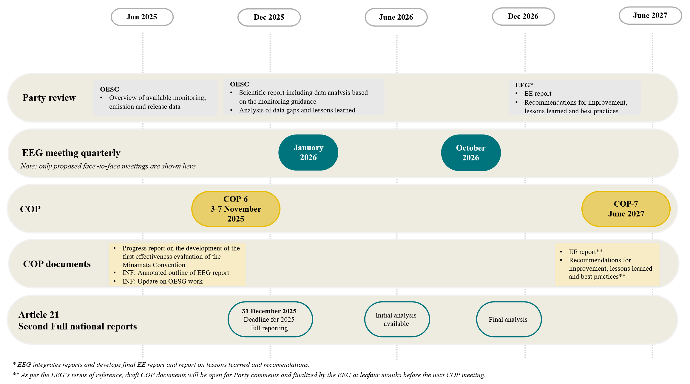
Abbreviations: COP – Conference of the Parties; EE – effectiveness evaluation; EEG – Effectiveness Evaluation Group; INF – information document; OESG – Open-ended Scientific Group.

* UNEP/MC/COP.6/1/Rev.1.
https://minamataconvention.org/en/intersessional-work-and-submissions-cop-6#sec2417.
Itsuki Kuroda resigned from the Effectiveness Evaluation Group in August 2025. The group is expected to elect a new co-chair at its online meeting in September 2025.
Terry Keating resigned from the Open-ended Scientific Group in July 2025. The group is expected to elect a new co-chair at its online meeting in September 2025.
The work of the Open-ended Scientific Group before the fifth meeting of the Conference of the Parties is described in documents UNEP/MC/COP.5/16/Add.2, UNEP/MC/COP.5/INF/24 and UNEP/MC/COP.5/INF/37.
https://minamataconvention.org/en/intersessional-work-and-submissions-cop-6#sec2417.

