UNITED  NATIONS | 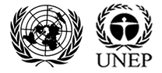

UNEP/MC/COP.6/10/Add.1

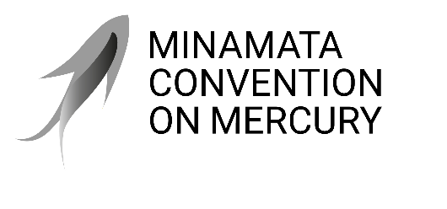 |  | Distr.: General  6 August 2025  Original: English

Conference of the Parties to the
Minamata Convention on Mercury
Sixth meeting
Geneva, 3–7 November 2025
Item 4 (e) (i) of the provisional agenda*
Matters for consideration or action by the Conference of the Parties: financial resources and mechanism: Global Environment Facility
Update on matters related to the Global Environment Facility
Addendum
Executive summary of the report of the Council of the Global Environment Facility to the Conference of the Parties to the Minamata Convention on Mercury at its sixth meeting
Note by the secretariat
The executive summary of the report of the Council of the Global Environment Facility to the Conference of the Parties to the Minamata Convention on Mercury at its sixth meeting is set out in the annex to the present note. The annex is reproduced as received, without formal editing. The full report is set out in the annex to document UNEP/MC/COP.6/INF/13.

Annex*
Executive summary of the report of the Council of the Global Environment Facility to the Conference of the Parties to the Minamata Convention on Mercury at its sixth meeting

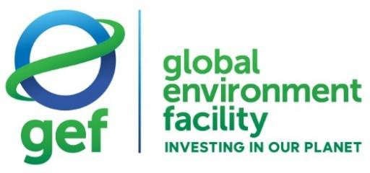

Report of the Global Environment Facility to the Sixth Meeting
of the Conference of the Parties
to the Minamata Convention on Mercury

August 31, 2025

Executive summary
- Article 13 of the Minamata Convention on Mercury includes the Global Environment Facility (GEF) in the Financial Mechanism to provide new, predictable, adequate, and timely financial resources to meet costs in support of implementation of this Convention as agreed by the Conference of the Parties (COP).
- This report presents the work of the GEF in fulfilling its mandate under the Minamata Convention in the reporting period (from July 1, 2022 to June 30, 2025) and its updated response to the guidance received from the COP.
- The eighth replenishment of the GEF commenced on July 1, 2022, to be completed on June 30, 2026. The replenishment allocated $800 million to the chemicals and waste focal area, including $269 million for the implementation of the Minamata Convention.
- In the reporting period, the GEF has approved four programmatic approaches covering twenty-one countries, twelve full-sized projects (FSPs) covering thirty countries, two medium- sized projects (MSPs) covering two countries, and three single-country enabling activities (EAs).
- Of the four programmatic approaches, two directly address priorities of the Convention including taking action on the emissions of mercury from the non-ferrous metals sector through the Global elimination of mercury in non-ferrous metals initiative (GEMINI) and monitoring of mercury for effectiveness evaluation through the Global Chemicals Monitoring Program. The other two programs address mercury in electronics and in infrastructure in the tourism sector.
- The projects in the reporting period address a broad range of key provisions of the Convention, including mercury in artisanal and small-scale gold mining (ASGM), emissions of mercury from the cement industry and non-ferrous metals sector, mercury use in the chlor-alkali sector and in cosmetics, managing trade in mercury, global monitoring, primary production of mercury and management of mercury waste and products waste.
- The GEF resources committed in the reporting period for the implementation of the Minamata Convention amounted to $155.5 million. Additionally project preparation grants (PPGs) amounted to $4.0 million and Agency fees amounted to $14.5 million, bringing the total GEF financing programmed in the reporting period to $174.0 million, which represents sixty-five percent of the $269.0 million allocated by the replenishment.
- In the reporting period, GEF resources supported one Minamata Initial Assessments (MIAs). Cumulatively, GEF resources have supported 120 countries to conduct MIAs, since GEF-5. To date, 82 MIAs have been submitted to the Minamata Convention Secretariat.
- Two National Action Plans (NAPs) for ASGM have also been supported in the reporting period, bringing the total to 50 countries receiving support. To date, 37 NAPs have been submitted to the Minamata Convention Secretariat.
- In the reporting period, a total of 45 countries has received support, including sixteen least developed countries (LDCs) and three small island developing States (SIDS).
- The portfolio leveraged $13 in co-financing for each $1 invested by the GEF in the reporting period.
- The GEF-8 results framework included a core indicator to measure the results in the chemicals and waste focal area. This core indicator had a target of addressing 300,000 metric tons of chemicals and waste, including mercury. While there was no stand-alone target for mercury in GEF-8, the amount of mercury targeted by projects was reported through sub-indicator 9.2 of the GEF results framework. With reference to this sub-indicator, the projects approved in the reporting period are expected to reduce 911 metric tons of mercury.
- In addition to mercury reductions, projects approved in the reporting period included the benefits of reducing 8,097 metric tons of persistent organic pollutants (POPs) and disposing of 1.6 million metric tons of POPs and mercury-containing material as well as addressing 1.1 million tons of plastics.
- The portfolio also addressed core indicators on terrestrial protected areas, landscapes under better management, carbon sequestered, and emissions avoided.

* UNEP/MC/COP.6/1/Rev.1.
* The annex has not been formally edited.
Excluding project preparation grants (PPGs) and Agency fees.
List of MIAs submitted to the Convention Secretariat can be found at: https://mercuryconvention.org/en/parties/minamata- initial-assessments.
List of NAPs submitted to the Convention Secretariat can be found at: https://mercuryconvention.org/en/parties/national- action-plans.
Co-financing amount is calculated based on GEF project financing of programs, FSPs and MSPs. EAs, PPGs and Agency fees are excluded.
GEF, 2023, Report of the Eighth Replenishment of the GEF Trust Fund, Assembly Document GEF/A.7/04.

