UNITED  NATIONS | 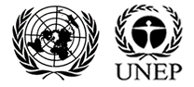

UNEP/MC/COP.6/6

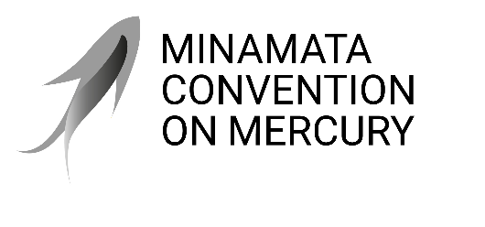 |  | Distr.: General  28 July 2025  Original: English

Conference of the Parties to the
Minamata Convention on Mercury
Sixth meeting
Geneva, 3–7 November 2025
Item 4 (b) (i) of the provisional agenda*
Matters for consideration or action by the Conference of the Parties: mercury-added products and manufacturing processes in which mercury or mercury compounds are used: amendments to annex A
Amendments to Annex A
Note by the secretariat
I. Introduction
- The present note sets out the proposals to amend annex A to the Minamata Convention on Mercury as contained in decision MC-5/4.
- Item 4 (b) of the provisional agenda for the sixth meeting of the Conference of the Parties to the Convention also includes sub-items on cosmetics listed in part I of annex A and on the consideration of the feasibility of mercury-free alternatives for manufacturing vinyl chloride monomer. Information on those matters is provided in documents UNEP/MC/COP.6/6/Add.1 and UNEP/MC/COP.6/6/Add.2, respectively.
- The secretariat has received a request for an extension of exemptions from the phase-out dates listed in annex A, for consideration by the Conference of Parties pursuant to paragraph 6 of article 6 of the Convention. Relevant information on the matter is set out in document UNEP/MC/COP.6/6/Add.3.
II. Proposals to amend annex A to the Convention
- The Conference of the Parties, at its fifth meeting, considered a proposal submitted by Botswana and Burkina Faso on behalf of the African region to amend annex A to the Convention with regard to the measures on dental amalgam. Pursuant to paragraph 7 of article 4, the proposal included information related to the availability, technical and economic feasibility, and environmental and health risks and benefits of the non-mercury alternatives.
- The Conference of the Parties, in decision MC-5/4, decided to amend part II of annex A by adding the following provision:
Mercury-added products | Provisions
Dental amalgam | In addition, Parties that have not yet phased out dental amalgam shall:  - Submit to the secretariat a national action plan or a report based on available information with respect to progress they have made or are making to phase down or phase out dental amalgam every four years as part of national reporting.
- The Conference of the Parties also decided to consider at its sixth meeting the proposal to amend part I of annex A by adding the following entry:
Mercury-added products | Date after which the manufacture, import or export of the product shall not be allowed (phase-out date)
[Dental amalgam] | [2030]
- In the same decision, the Conference decided to consider at its sixth meeting the proposal to further amend part II of annex A by adding the following provision:
Mercury-added products | Provisions
Dental amalgam | In addition, Parties shall:  (iv) [[Exclude or not allow] [phase down], by taking measures as appropriate, the use of dental amalgam in government insurance policies and programmes.]  (Alternative to (iv)) [Take measures, as appropriate, to exclude, not allow, [or phase down] dental amalgam in government policies or programmes.]
III. Proposed action
- The Conference of the Parties may wish to consider the proposed amendments to annex A with a view to adopting decisions thereon, as appropriate.

* UNEP/MC/COP.6/1/Rev.1.

