UNITED  NATIONS | 

UNEP/MC/COP.6/6/Add.3

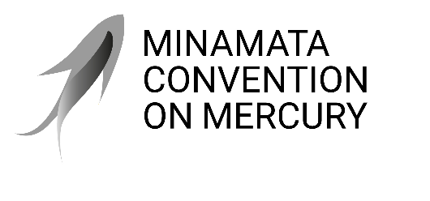 |  | Distr.: General  8 August 2025  Original: English

Conference of the Parties to the
Minamata Convention on Mercury
Sixth meeting
Geneva, 3–7 November 2025
Item 4 (b) (iv) of the provisional agenda*
Matters for consideration or action by the Conference of the Parties: mercury-added products and manufacturing processes in which mercury or mercury compounds are used: extensions for exemptions
Extension of exemptions pursuant to article 6 of the Convention
Note by the secretariat
I. Introduction
- Paragraph 1 of article 6 of the Minamata Convention on Mercury provides that any State or regional economic integration organization may register one or more exemptions from the phase-out dates listed in annex A and annex B for mercury-added products and for manufacturing processes in which mercury or mercury compounds are used, respectively. Paragraph 5 of article 6 provides that such exemptions expire five years after the phase-out date listed in annex A or B unless a shorter period is indicated by a party. Fourteen parties have registered exemptions, as listed on the Convention website.
- Paragraph 6 of article 6 provides that the Conference of the Parties may, at the request of a party, decide to extend an exemption for five years unless the party requests a shorter period. The same paragraph provides that an exemption may only be extended once per product and phase-out date, and that the Conference is to take due account of the following in making its decision:
  - A report from the party justifying the need to extend the exemption and outlining activities undertaken and planned to eliminate the need for the exemption as soon as feasible;
  - Available information, including in respect of the availability of alternative products and processes that are free of mercury or that involve the consumption of less mercury than the exempt use;
  - Activities planned or under way to provide environmentally sound storage of mercury and disposal of mercury wastes.
- Paragraph 7 of article 6 provides that a party may at any time withdraw an exemption. As at July 2025, no registered exemptions had been withdrawn.
II. Request for the extension of exemptions pursuant to article 6
- On 25 July 2025, pursuant to the provisions of paragraph 6 of article 6, Thailand sent a letter to the secretariat in which it requested the Conference of the Parties to decide to extend the exemptions for switches and relays, compact fluorescent lamps, linear fluorescent lamps, cold cathode fluorescent lamps and external electrode fluorescent lamps, high-pressure mercury vapour lamps and non-electronic measuring devices. The letter included an attachment explaining the need for the extension and the activities undertaken or planned to eliminate the need for the exemption. The letter and the attachment have been made available in document UNEP/MC/COP.6/INF/42.
- Should the secretariat receive requests for extension from any other parties, such requests will be made available as additional information documents.
III. Proposed action
- The Conference of the Parties may wish to consider the request by the party to extend the exemption pursuant to paragraph 6 of article 6, as set out in document UNEP/MC/COP.6/INF/42, as well as other requests that may be received by 8 September 2025 and be set out in additional information documents, with a view to adopting decisions on those requests, as appropriate.

* UNEP/MC/COP.6/1/Rev.1.
Argentina, Bangladesh, Botswana, Canada, China, Eswatini, Ghana, India, Iran (Islamic Republic of), Lesotho, Madagascar, Peru and Thailand registered exemptions for some mercury-added products listed in annex A. Argentina, Ghana, India, Iran (Islamic Republic of), Peru and the United States of America registered exemptions for some manufacturing processes in which mercury or mercury compounds are used, as listed in annex B. All the registered exemptions for annex A expire in 2025. With regard to annex B, the exemption for acetaldehyde production expired in 2023, and the exemption for chlor-alkali production expires in 2030. Information on registered exemptions is available at https://minamataconvention.org/en/parties/exemptions.
This deadline was communicated to parties in view of the requirement in the rules of procedure of the Conference of the Parties to have supporting documents available at least six weeks before the opening of the meeting, and in view of the two weeks needed for processing the documents.

