UNITED  NATIONS | 

UNEP/MC/COP.6/5/Add.1

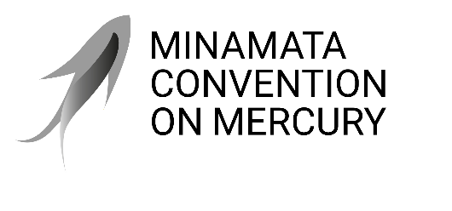 |  | Distr.: General  23 July 2025  Original: English

Conference of the Parties to the
Minamata Convention on Mercury
Sixth meeting
Geneva, 3–7 November 2025
Item 4 (a) of the provisional agenda*
Matters for consideration or action by the Conference of the Parties: mercury supply sources and trade
Study of the global supply, production, trade and use of mercury compounds
Note by the secretariat
I. Introduction
- Paragraph 13 of article 3 of the Minamata Convention on Mercury requires the Conference of the Parties to evaluate whether the trade in specific mercury compounds compromises the objective of the Convention and to consider whether specific mercury compounds should, by their listing in an additional annex adopted in accordance with article 27, be made subject to paragraphs 6 and 8 of article 3.
- Recalling that paragraph, the Conference of the Parties, in decision MC-5/3, requested the secretariat, subject to the availability of resources, to initiate a study of the global supply, production, trade and use of mercury compounds, and to present the report to the Conference of the Parties at its sixth meeting for consideration.
II. Study of the global supply, production, trade and use of mercury compounds
- The secretariat developed a draft study with support from a consultant hired thanks to voluntary contributions from Canada and Spain. The draft study was posted on the Convention website on 12 February 2025, with an invitation to parties and stakeholders to submit comments and input by 5 March 2025. Comments were received from 11 parties and three organizations.
- The secretariat has incorporated the comments received into the final version of the study, which is set out in document UNEP/MC/COP.6/INF/5.
- The study considered the potential of mercury compounds being traded to circumvent mercury trade restrictions on the basis of available information on the production of those compounds, cross-border trade, the ease of recovery of mercury from those compounds, and their use in skin-lightening products.
- The study concluded that the six mercury compounds listed in paragraph 1 (b) of article 3 (mercury(I) chloride, mercury(II) sulphide, cinnabar, mercury(II) oxide, mercury(II) sulphate and mercury(II) nitrate), as well as others (especially mercury(II) acetate, mercury(II) chloride and mercury(II) iodide), could be produced and traded for the purpose of circumventing restrictions on trade in elemental mercury. The production of those compounds, as well as the recovery of elemental mercury from any of them, is relatively straightforward. The study cites recent evidence of cinnabar trade being used, under certain circumstances, to circumvent mercury trade restrictions. For other mercury compounds, hard evidence of such circumvention was not identified.
- Furthermore, the study provided evidence of recent trade in mercury(II) amidochloride for the purpose of producing mercury-added skin-lightening products. The study also provided evidence that mercury(II) iodide, mercury(I) chloride and mercury(II) oxide have been intentionally added to such products.
III. Proposed action
- The Conference of the Parties may wish to review the study and consider adopting a decision related to the trade in mercury compounds, as appropriate.

* UNEP/MC/COP.6/1/Rev.1.
See https://minamataconvention.org/en/intersessional-work-and-submissions-cop-6#sec2412.
Argentina, Austria, Brazil, Burkina Faso, Canada, China, the European Union and its member States, Japan, Mauritius, Peru and the United States of America, as well as the Natural Resources Defense Council, the New York City Department of Health and Mental Hygiene and the Zero Mercury Working Group.

