UNITED  NATIONS | 

UNEP/MC/COP.6/1/Rev.1

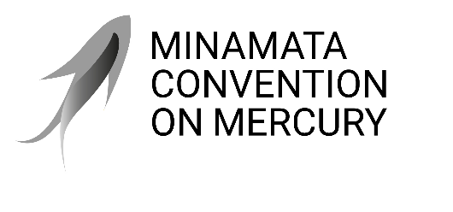 |  | Distr.: General  7 August 2025  Original: English

Conference of the Parties to the
Minamata Convention on Mercury
Sixth meeting
Geneva, 3–7 November 2025
Provisional agenda
- Opening of the meeting.
- Organizational matters:
- Adoption of the agenda;
- Organization of work;
- Election of officers;
- Report on the credentials of representatives.
- Rules of procedure and financial rules for the Conference of the Parties.
- Matters for consideration or action by the Conference of the Parties:
- Mercury supply sources and trade;
- Mercury-added products and manufacturing processes in which mercury or mercury compounds are used:
- Amendments to annex A;
- Cosmetics listed in part I of annex A;
- Consideration of the feasibility of mercury-free alternatives for manufacturing vinyl chloride monomer;
- Extensions for exemptions;
- Artisanal and small-scale gold mining;
- Mercury waste;
- Financial resources and mechanism:
- Global Environment Facility;
- Specific International Programme to Support Capacity-Building and Technical Assistance;
- Review of the financial mechanism;
- Capacity-building, technical assistance and technology transfer;
- Implementation and Compliance Committee;
- National reporting;
- Effectiveness evaluation;
- Cross-cutting matters:
  - Implementation of decision MC-5/1;
  - Implementation of decision MC-5/15;
- Knowledge management;
- Mercury and the Kunming-Montreal Global Biodiversity Framework.
- International cooperation and coordination.
- Programme of work and budget.
- Dates and venue of the seventh meeting of the Conference of the Parties.
- Other matters.
- Adoption of the report of the meeting.
- Closure of the meeting.

