UNITED  NATIONS |  |  |  | MC
 |  |  | UNEP/MC/EEG.8/L.5
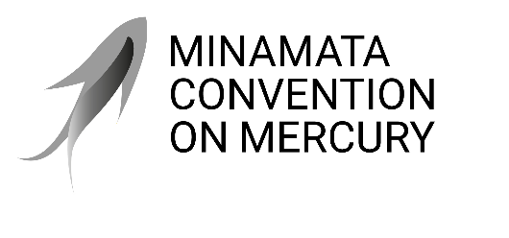 |  |  | Distr.: Limited  5 February 2025  English only
Effectiveness Evaluation Group
Minamata Convention on Mercury
Eighth meeting
Geneva, 9–11 February 2026
Item 3 (b) (ii) of the provisional agenda
Introduction: Updates from the secretariat: Initial feedback on the second full national reports
Status update of second full national reports
Note by the Secretariat
The annex to the present note sets out a preliminary summary information on the second full national reports submitted by Parties to the Minamata Convention on Mercury, which was due by 31 December 2025 for the reporting period from 1 January 2021 to 31 December 2024, based on submissions received as of 5 February 2026.

Annex
I. Overview of reporting performance rate 2021-2024 (as of 5 February 2026)
- The figure below shows the reporting rate of the second full national reports as of 5 February 2026 at 70 percent with the regional breakdown.
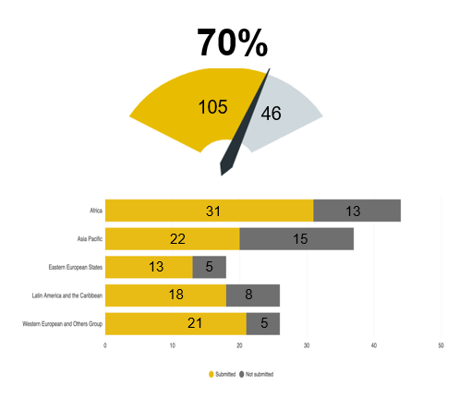
II. Some considerations when reviewing the national report
- Operationalized decision MC-5/13
- 19 reporting format (questions) were amended by decision MC-5/13 and is reflected in the second full national report Online Reporting Tool
- Baseline and Timing Issues:
- Some obligations have different timelines (e.g., ASGM, products with later phase-outs)
- “Varying” report submission cut-off dates
- Chronological cut-off dates reflecting report versions for ICC and COP
- Allowing time for inclusion in reports.
- Reporting Party cut-off date
- 151 Parties as of 31 December 2024 (end of reporting period)
- New Parties submission will be noted and indicated separately.
- Data review and validation process
- 56 reports under further review
- Responses to questions 4.3(b), 8.2, 11.1, 11.2 require further clarification or information.
III. General reflections: Trends and Progress
- Strong institutional implementation
- High reporting compliance; high rate of Party designation of National Focal Points
- 51 Parties notified ASGM as more than insignificant
- 37 submitted National Action Plans (NAP)
- 7 Review of the implementation of Article 7 (RIA) submissions
- Measurable source reductions
- Primary mining ↘ (China: 193t → 34t), Indonesia (0t)
- Chlor-alkali mercury use being phased out ↘
- Mercury-added products phase-outs (High compliance reported)
- Growing health & public engagement
- Health sector initiatives reported by many Parties
- Improved responses
- Stocks and sources distinction
- Trade formal vs. illegal
- Explanations
IV. Challenges and Gaps
- Data quality & consistency issues
- Outdated inventories in MIAs
- Inconsistent reporting – thresholds; across reporting cycles
- ASGM mercury use, waste tracking, emissions inventories
- Illegal/Illicit/Informal activities undermining progress
- Primary mercury mining and trade
- ASGM (largely informal/illegal) remains significant mercury source
- Implementation & technical constraints
- Regional disparities in implementation capacity
- Limited final disposal facilities
- Financial & technical barriers
- Many Parties cite resource limitations
- Technical capacity varies by region
V. Key areas for further review
- ASGM estimates:
- Illegal/Illicit/Informal nature of activities makes monitoring challenging
- Best practices on reporting on illegal/informal activities
- RIA guidance implementation and reported results
- Emissions & releases inventories:
- Parties only required to establish inventories 5 years after entry into force
- Many inventories still under development
- Waste management reporting:
- Reporting of specific mercury waste disposal quantities
- Distinction between commodity mercury and mercury waste often unclear
- Questions:
- 4(b) - entry into force for Parties; some responses need clarification
- 8.2 Progress description on emission measures missing or unclear
- 11.1 (measures) and 11.2 (final disposal) - need clarification
IV. Schedule for 2026–2027:
Critical milestones of national report analysis and report development

