UNITED  NATIONS |  |  |  | MC
 |  |  | UNEP/MC/EEG.8/L.4
 |  |  | Distr.: Limited  29 January 2026  English only
Effectiveness Evaluation Group
Minamata Convention on Mercury
Eighth meeting
Geneva, 9–11 February 2026

Item 6 of the provisional agenda
Schedule and workplan for the completion of the effectiveness evaluation report and lessons learned report
Draft schedule and workplan
Note by the secretariat
The annex to the present note sets out the timeline and draft workplan for the delivery of the first effectiveness evaluation. The timeline presented is based on the previous version contained in annex II to document UNEP/MC/COP.6/16, as presented to the Conference of the Parties at its sixth meeting.

Annex
Part I:
Timeline for the first effectiveness evaluation of the Minamata Convention on Mercury

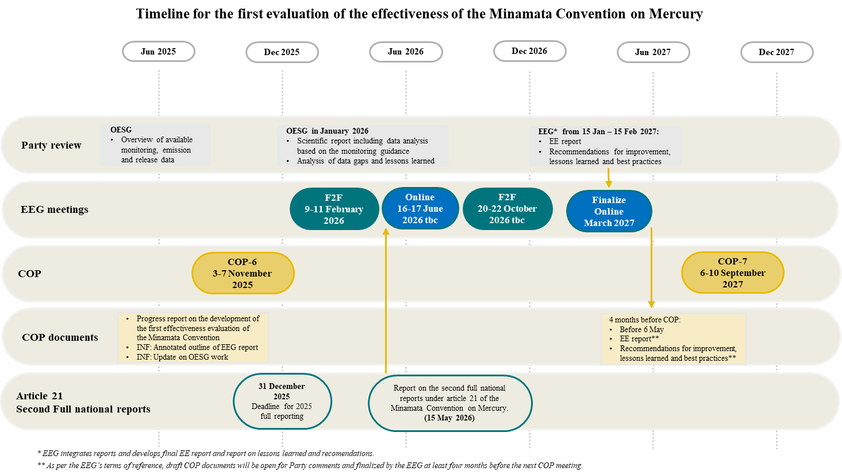

Part II: Initial proposed workplan for discussion at EEG-8
 | EEG-8 F2F:  9-11 February 2026 | EEG-9 online: 16-17 June 2026 (two slots of 3 hours) | EEG-10 F2F: 20-22 October 2026 (tbc) | Party review  15 Jan-15 Feb ‘27 | EEG-11 online:  March 2027
Executive Summary |  | 17 June: Discuss elements and agree on the approach to draft. | Draft to be finalized at this meeting.
- Introduction | Finalize |  | Re-visit as appropriate
- Methodology | Finalize |  | Re-visit as appropriate
- Evaluation of the effectiveness
- Overall protection of human health and the environment (article 1) |  | 16 June: OESG to provide a draft section A. | Finalize
Sections B - H | Sub-groups to update respective sections based on feedback at EEG-8 by 9 April and submit to the secretariat for the master document. | 16 June: Discuss any new information available from the national reporting data, OESG, etc.  Finalize.
- National Reporting (article 21) |  | 16 June: Secretariat to present its report on the second full National Report under Art. 21 | Finalize
- Overall summary assessment and conclusions | Initial list of elements for the report generated at EEG-8. Agree on approach to draft. | 17 June: Initial draft for input at this meeting. | Revised for finalization at this meeting.
Additional report on lessons learned and recommendations | Initial list of elements for the report generated at EEG-8. Agree on approach to draft. | 17 June: Initial draft for input at this meeting. | Revised for finalization at this meeting.
EEG finalizes the effectiveness evaluation, lessons learned and recommendations to be made available for Party Review.
Secretariat finalizes documentation for the Party review period under the guidance of the co-chairs.
Party review inputs. |  |  |  |  | Party review inputs considered. Report finalized before 6 May ‘27.
______________

