UNITED  NATIONS | 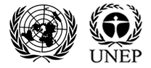

UNEP/MC/COP.6/INF/43

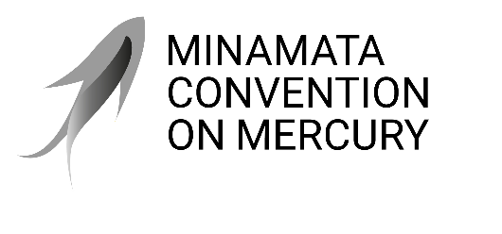 |  | Distr.: General  14 October 2025  English only

Conference of the Parties to the
Minamata Convention on Mercury
Sixth Meeting
Geneva, 3–7 November 2025
Item 2 (b) of the provisional agenda*
Organizational matters: organization of work
Admission of observers: organizations having requested admission to participate as observers in the sixth meeting of the Conference of the Parties to the Minamata Convention on Mercury**
Note by the secretariat
The annexes to the present note set out lists of intergovernmental organizations other than the United Nations, its specialized agencies and the International Atomic Energy Agency (annex I) and nongovernmental organizations (annex II) that have requested admission to participate as observers in the sixth meeting of the Conference of the Parties to the Minamata Convention on Mercury, in accordance with rule 7 of the rules of procedure of the Conference of the Parties. Lists of such entities that requested admission and were subsequently approved to participate as observers in previous meetings of the Conference of the Parties are set out in documents UNEP/MC/COP.1/INF/16, UNEP/MC/COP.2/INF/19, UNEP/MC/COP.3/INF/2, UNEP/MC/COP.4/INF/28/Rev.1 and UNEP/MC/COP.5/INF/39. The lists set out in the annexes to the present note do not include all organizations that have registered to attend the sixth meeting of the Conference of the Parties to the Minamata Convention on Mercury.

Annex I

Intergovernmental organizations other than the United Nations, its specialized agencies and the International Atomic Energy Agency
International Criminal Police Organization (INTERPOL)
Observatorio Andino Encargado de la Gestión de la Información Oficial en Materia de Mercurio

Annex II

Non-governmental organizations
Africa Sustainable Climate and Environment Foundation (ASCEF)
Ghana

AKO Foundation
Ghana

Alternative des Jeunes pour la préservation et la conservation des Ecosystèmes, de la Biodiversité et l’Environnement pour le Développement Durable (AJEBEDD-Congo)
Congo

Amazon Aid Foundation
United States of America

Ardha Jabesa Foundation
Kenya

Asia Indigenous Peoples Pact (AIPP)
Thailand

Jeunesse pour l’Environnement et le Développement Durable (AJEDD)
Burkina Faso

Association of Journalists for Human Rights (JHR)
North Macedonia

Bread of Peace (BOP)
Canada

Center for Climate Crime Analysis (CCCA)
Kingdom of the Netherlands

Centro de Estudios Multidisciplinarios Aymara (CEM-Aymara)
Plurinational State of Bolivia

Children and Youth International (CYI)
United States of America

Community Action Against Plastic Waste (CAPws)
Nigeria

Community Restoration Initiative Project
Uganda

Comparatively for Tanzania Elites Community Organizers (CTECO)
United Republic of Tanzania

Derecho, Ambiente y Recursos Naturales (DAR)
Peru

DMUN Foundation
Republic of Korea

Fédération des Coopératives des Pays de Mayoko (Congo)
Congo

Fédération des Coopératives des Pays de Mayoko (France)
France

Fondation Moise Tshibangu – The Arch of Hope Worldwide (MTFA ASBL)
Democratic Republic of the Congo

Frankfurt Zoological Society (FZS) Colombia
Colombia

Fundación Cristina Cortinas
Mexico

Fundación para la Conservación y el Desarrollo Sostenible (FCDS)
Peru

Global Alliance on Health and Pollution (GAHP)
Switzerland

Global Peace and Development Organization (GPDO)
Liberia

Green Botswana Trust
Botswana

Greenplanet
India

HATOF Foundation (HATOF)
Ghana

Johannes Gutenberg-Universität Mainz (JGU)
Germany

MSP Institute
Germany

Network For Climate Action
Gambia

Nyankonton Aid Foundation
Ghana

Regional Environmental Centre for the Caucasus (REC Caucuas)
Georgia

Réseau des Femmes Africaines pour la Gestion Communautaire des Forêts (REFACOF)
Cameroon

Rural Development Aid Ghana (RDAG)
Ghana

Santé & Nature
Congo

Swiss Better Gold Association (SBG Association)
Switzerland

Tusimbe Biodiversity and Adaptation Initiative
Uganda

Universidad Autónoma de Querétaro (UAQ)
Mexico

Women Environmental Programme (WEP)
Nigeria

Y30 Association
Switzerland

Young Liberian Women Organization For Improvement (WOFIM)
Liberia

* UNEP/MC/COP.6/1/Rev.1.
** The present document has not been formally edited.

