UNITED  NATIONS | 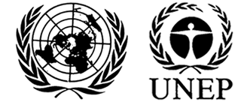 |  |  | MC
 |  |  | UNEP/MC/COP.6/INF/40
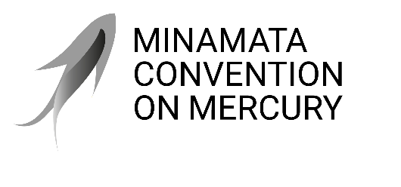 |  |  | Distr.: General  28 August 2025  English only
Conference of the Parties to the
Minamata Convention on Mercury
Sixth meeting
Geneva, 3–7 November 2025
Item 4 (e) (ii) of the provisional agenda*
Matters for consideration or action by the Conference of the Parties: financial resources and mechanism: Specific International Programme to Support Capacity-Building and Technical Assistance
Draft analysis of expected funding needs and related staffing needs for the Specific International Programme**
Note by the secretariat
I. Introduction
- The secretariat was requested in decision MC-5/11 to prepare an analysis of expected funding needs and related staffing needs through the second half of the initial term of the Specific International Programme, taking into consideration the midterm evaluation of the Programme set out in document UNEP/MC/COP.5/INF/16 and the second review of the financial mechanism outlined in document UNEP/MC/COP.5/INF/17.
- This draft analysis was prepared by the secretariat. The structure of this draft analysis was presented to and agreed upon by the Governing Board at its tenth meeting in January 2025.
II. Overview of the Specific International Programme
- The Specific International Programme is open to receive voluntary contributions and applications for support for an initial period of ten years from the establishment of its trust fund in January 2018 as set out in decision MC-1/6. The decision further specifies that the Conference of the Parties may decide to extend the Programme beyond 31 December 2027, not exceeding an additional seven years, taking into account the review process of the financial mechanism in accordance with paragraph 11 of article 13 of the Minamata Convention.
A. Total contributions to the Specific Trust Fund
- The total contributions and pledges received for the Specific Trust Fund since its establishment on 1 January 2018, as at 28 May 2025, amount to $8,449,992 from a total of 10 governments as set out in section V of document UNEP/MC/COP.6/11. In addition to these contributions and pledges, the Government of Italy has fully funded a Junior Professional Officer post in the secretariat for two years and co-funded it for a third year.
- Over the four rounds of funding, most of the Specific Trust Fund resources have been allocated to approved projects of eligible parties with a minor portion set aside for in-person meetings of the Governing Board, and operations of the Programme. The Specific Trust Fund contributions are subject to 13 per cent programme support costs (PSC).
B. Overview of SIP projects and allocated funding
- The midterm evaluation of the Specific International Programme, covering the time span from first through to third round of applications, confirmed the high strategic relevance of the SIP in relation to addressing the needs of the parties under the Minamata Convention by providing technical support and capacity needed for them to meet their obligations under the Convention. Furthermore, report on the second review of the financial mechanism of the Convention highlighted that recipient countries appreciated the Programme for its flexibility and ease of access and implementation.
- Throughout its four application rounds, the programme funded 34 projects out of 99 applications received from parties across Africa, Asia-Pacific, Eastern European States, and Latin America and the Caribbean. Overall interest of parties in the programme has grown substantially over time, from 19 project proposals received by the secretariat in the first round to 36 applications in the fourth round. The table below provides an overview of the status of all 34 projects funded by the Specific International Programme in 31 developing parties and country parties with economies in transition.
Table 1: Overview of projects funded by the Programme
Round of applications | Submitted applications | Approved projects | Status of project implementation
First round (2018) | 19 | 5 (2 developing countries, 1 country with economy in transition, 2 least developed countries) | All completed
Second round (2019) | 20 | 10 (7 developing countries, 1 country with economy in transition, 1 least developed country, 1 small island developing state) | All completed
Third round (2020-2021) | 24 | 9 (4 developing countries, 1 country with economy in transition, 3 least developed countries, 1 small island developing state) | All ongoing (6 to be completed in 2025, 2 in 2026, 1 in 2027)
Fourth round (2024-2025) | 36 | 10 (3 developing countries, 2 countries with economy in transition, 5 least developed countries) | Approved (legal agreements are being drafted)
- The total Specific International Programme funding allocated to the 34 projects approved in the four rounds of applications amounts to $7,237,699 ($8,178,598 inclusive of PSC).
C. Overview of SIP results of completed and ongoing projects
- The figure below, extracted from the dashboard of the Specific International Programme, provide an overview of the project topics and relevant Convention articles to which the 34 projects funded by the Specific International Programme have contributed.
Figure 1: Breakdown of projects based on the Convention articles to which they contributed
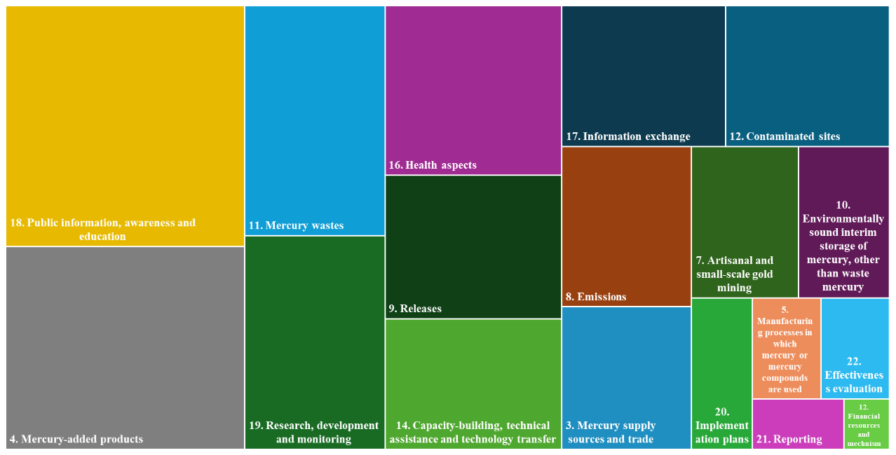
- Each project of the Specific International Programme is designed to fulfil the obligations of one or more control articles of the Minamata Convention, and in doing so, the project also contributes to the Party’s efforts to implement other relevant articles. A high number of approved projects to date have worked towards phasing down mercury-added products and ensuring the environmentally sound management of associated waste, thereby advancing the implementation of articles 4 and 11 of the Convention. These projects have implemented activities aimed at assessing the flows of mercury-added products, promoting their phase out, updating the countries’ regulatory frameworks, strengthening national capacities and raising public awareness.
- Several projects have resulted in the adoption or revision of mercury-related legislation, and the development of national strategies. In addition, most approved projects have implemented activities aimed at training various institutions and stakeholders for improved mercury management, as well as raising public awareness of mercury’s harmful effects.
- Three projects have been implemented at the regional level. One of these has established a regional laboratory hub in the Caribbean region to support the assessment of mercury in the environment and in food. Another has launched a regional mercury monitoring hub in Central Africa through the creation of a central laboratory dedicated to mercury analysis and broader environmental assessments. The third project has focused on strengthening legal frameworks and institutional capacities in three West African countries for the management of trade in elemental mercury and mercury-added products, thereby contributing to the implementation of articles 3 and 4 of the Convention.
III. Projected ongoing and future funding needs and timelines
A. Overview of the ongoing funding
- The table below provides a summary, as of 28 May 2025, of the number of eligible parties that have and have not benefitted from the Specific International Programme and disaggregates the total number by country classification. To supplement this information, the table also provides the number of non-parties who may become eligible for programme support in the future if they are to become a party to the Convention.
Table 2: Summary of parties and non-parties
 | Total number | Disaggregated by country classification
Number of eligible parties to the Minamata Convention that have benefited from the Specific International Programme | 31 | - 13 developing countries  - 5 countries with economies in transition  - 11 least developed countries  - 2 small island developing states
Number of eligible parties to the Minamata Convention not yet supported by the Specific International Programme | 82 | - 48 developing countries (of which 1 is also a small island developing state)  - 3 countries with economies in transition  - 22 least developed countries (of which 1 is also a small island developing state)  - 11 small island developing states
Number of non-parties who may become eligible for support from the Specific International Programme (possible future parties) | 42 | - 20 developing countries (of which 3 are also small island developing states and 1 is also a least developed country)  - 9 countries with economies in transition  - 7 least developed countries  - 10 small island developing states
- Seven parties with projects approved for funding under the Specific International Programme, (of which 4 developing countries, 1 country with economy in transition, and 2 small-island developing states) submitted project proposals in subsequent application rounds. Two of these parties received funding from the programme for additional projects.
- Overall, the project proposals submitted in subsequent application rounds focused on advancing implementation of different control obligations under the Convention, including on trade, management of mercury-added products and their waste, and ASGM, demonstrating that parties already supported by the programme have further needs related to the implementation of other Convention articles.
- In terms of the average project funding, the Specific International Programme can provide support from $50,000 to $250,000 per project. Throughout the four rounds, the number of approved projects requesting the maximum budget allowed by the programme has increased. Such projects amounted to two in the first round, three in the second round, six in the third round, and five in the fourth round.
- The overall and average project budget per round, including 13 per cent PSC are set out in the following table.
Table 3: Overall and average project budget per round
Round of applications | First round | Second round | Third round | Fourth round
Number of projects approved | 5 | 10 | 9 | 10
Total budget for projects | $1,086,679 | $2,234,647 | $2,479,041 | $2,378,231
Average project funding | $217,336 | $223,465 | $275,449 | $237,823
B. Scenarios for future funding needs
- As highlighted in the report on the second review of the financial mechanism the SIP should continue to play an important role in funding capacity building activities required by Parties to implement the Convention. To do so, the secretariat should take steps to mobilize resources and broaden the donors base that is currently limited to 10 countries as outlined in document UNEP/MC/COP.6/11. Furthermore, the midterm evaluation recommended that for planning purposes the secretariat provided potential donors with information on the estimated resource and related staffing needs over a multi-year period covering the initial term and potential extended term of the Programme.
- Following the recommendations, the secretariat has developed two scenarios that are set out in the following table. The first scenario is set until the end of the Specific International Programme’s initial term in 2027, and the second scenario is until the end of the Specific International Programme’s extended term, if the programme is extended for an additional period of seven years by decision of COP. The scenarios project a stable number of projects in moving forward, including 10 projects in a fifth round and the possibility to increase up to 15 in the sixth and seventh rounds with a related requirement for increased resource needs.
Table 4: Scenarios for future funding needs
Item | Scenario 1 (until the end of the initial term of the Specific International Programme - 2027) – one additional round of applications | Scenario 2 (until the end of the extended term of the Specific International Programme - 2034) – three additional rounds of applications
Tentative timeframe | Fifth round of applications – 2027  (project close-out period until 2032) | - Fifth round – 2027  - Sixth round – 2030  - Seventh round – 2033  (project close-out period until 2037)
Projected number of applications and approved projects | 30-40 in total, up to 10 approved | - Fifth round – 30-40 in total, up to 10 approved  - Sixth round – 30-40 in total, up to 15 approved  - Seventh round – 30-40 in total, up to 15 approved
Resources to be raised | Fifth round – up to US$2.5 million | - Fifth round – up to US$2.5 million  - Sixth round – up to US$3.1 million  - Seventh round – up to US$3.5 million
IV. Projecting ongoing and future staffing needs
A. Current staffing
- The secretariat administers the Specific International Programme in an efficient manner through a set of activities outlined in section II of document UNEP/MC/COP.6/11.
1. Core budget staff positions:
- Day-to-day functions of the Specific International Programme are currently covered by the Programme Management Officer for Capacity-building and Technical Assistance staff position (50% of time). The functions cover coordinating and managing the secretariat’s support to the programme, including budgeting, funding project preparation, project review, reporting, financial statements and other related documents to support the Specific International Programme.
- Other staff members of the secretariat, including the P-5 Senior Coordination Officer, P-4 Legal Officer, P-4 Administrative Officer, P-2 Associate Administrative Officer and two G-5 Programme Management Assistants service the programme in addition to their other roles and responsibilities in the secretariat. The functions include administrative and substantive assistance to the programme, including its effective and efficient operation.
2. Staffing from voluntary contributions:
- From November 2021 to October 2023, the secretariat was strengthened in its ability to provide dedicated substantive and administrative support functions to the programme through the provision of a Junior Professional Officer (JPO), fully funded by the Government of Italy. The JPO post was further extended until October 2025 with partial funding from the Government of Italy.
- The JPO position has been instrumental in providing necessary secretariat support for the implementation of the Specific International Programme, including the launch and deployment of the fourth round of applications, the delivery of administrative and substantive support to approved projects, the development of guidelines and forms, the organisation of online and in-person events, and the facilitation of monitoring, closure and evaluation procedures. The JPO also provided secretariat support for the meetings and work of the Governing Board, including through the preparation of project appraisals and meeting documents and reports.
- The secretariat has advertised the availability of another JPO post, but to date there has been no indication of a country offer to fill this post.
3. Funds set aside for peak workload:
- The Governing Board at its sixth meeting held in August 2021 agreed to set aside $100,000 annually ($113,120 with 13% PSC) from the Specific Trust Fund to support the secretariat in managing peak workload needs. At its seventh meeting held in November 2022, the Board agreed to utilise $70,000 of the allocation agreed at the sixth meeting for the co-funding of the Junior Professional Officer for the third year. From August 2021 to August 2025, the secretariat has utilized approximately 40% of the cumulative allocation for staffing to ensure proper servicing of the Programme, while the remaining 60% has been directed toward projects. This reflects the total use of funds over the four-year period since the Board’s decision.
(a) Comparison of staffing levels with select other funds
- The current number of staff serving the Specific International Programme, as outlined above, is limited vis-à-vis the functions to be fulfilled. For the purpose of comparison to similar funds, staffing structures of the UNEP Special Programme and the Global Framework on Chemicals Trust Fund are set out below:
  - The staffing identified for the Trust Fund of the UNEP Special Programme to support institutional strengthening at the national level for implementation of the Basel Convention on the Control of Transboundary Movements of Hazardous Wastes and Their Disposal, the Rotterdam Convention on the Prior Informed Consent Procedure for Certain Hazardous Chemicals and Pesticides in International Trade and the Stockholm Convention on Persistent Organic Pollutants, the Minamata Convention on Mercury and the Strategic Approach to International Chemicals Management (hereinafter “the Special Programme”) includes one P-4 Coordinator/Programme Officer, one P-3 Programme Management Officer, one P-3 Programme Management Officer (Monitoring and evaluation), one P-2 Associate Programme Officer, one G-5 Finance and Budget Assistant, one G-4 Administrative Assistant and one G-4 Team Assistant. The Special Programme portfolio consists of 91 projects approved in Africa, Asia-Pacific, Central and Eastern Europe, as well as Latin America and the Caribbean with combined budgets of $23.9 million. Of these, 57 projects are currently being implemented by the designated project partners, with oversight provided by the Special Programme secretariat.
  - The staffing of the newly established Global Framework on Chemicals Trust Fund includes one P-4 Fund Coordinator, one P-3 Programme Management Officer, one P-2/JPO Associate Expert, one G-6 Administrative assistant and one G-4 Administrative assistant. As of 1 June 2025, the overall portfolio to be managed under the Global Framework on Chemicals Fund includes four regional projects with the total budget of about $2.8 million in the 2025-2026 biennium. The overall initial pledge to the Fund amounts to US$28 million. The following staff members of the Global Framework on Chemicals secretariat, including the P-5 Senior Programme Officer, the P-4 Funds Management Officer (20%), the P-4 Operations and Organization Officer, the P-4 Health and Labour Officer and the G-6 Administrative Assistant will service the programme as part of their roles and responsibilities in the secretariat when the recruitment is completed, subject to available resources.
(b) Future staffing needs
- Two scenarios are being considered for the Specific International Programme, with scenario 2 including a possible extension for an additional seven years subject to the decision of COP-7. The graph in figure 1 shows an estimate of projects to be managed and closed out under the Specific International Programme within scenario 1 and 2 as well as in case of no new rounds of applications.
Figure 2: Projected total number of Specific International Programme projects over time under the different scenarios

Table 5: Scenarios for future dedicated staffing needs
 | Scenario 1 (until the end of the initial term of the Specific International Programme - 2027) – one additional round of applications | Scenario 2 (until the end of the extended term of the Specific International Programme - 2034) – three additional rounds of applications
Proposed minimum staffing needs until the end of the initial or extended term of the Programme | - 50% of the Programme Management Officer for Capacity-building and Technical Assistance staff position;  - One JPO or one P-2 Associate Programme Officer.
- The existing staffing structure of the Specific International Programme has provided for effective and efficient management across four rounds of applications. The current staffing level must be sustained in order to ensure stable support to the Specific International Programme for additional rounds of funding.
(c) Other considerations
- The Specific International Programme also cooperates with the Special Programme. The secretariat staff participates in the task team that supports the review of the projects submitted during each round of applications for funding from the Special Programme; provides information and updates on the provisions of the Minamata Convention, on the Specific International Programme, and on the secretariat’s work during meetings of the Executive Board of the Special Programme; and provides input into the application guidance. The secretariats of both programmes coordinate on outreach to prospective applicants, participate in respective application webinars, and provide individualized support to applicants, with a view to guiding prospective applicants towards the funding opportunities that best fit their needs.
V. Summary
- The Specific International Programme has demonstrated to be effective and efficient in supporting parties. The Programme has translated into 34 applications approved over four application rounds. 65 applications that could not be approved mostly due to the limited financing envelope. The continued success and sustainability of the Programme will rely heavily on ongoing donor support and adequate staffing within the secretariat to ensure proper project administration, monitoring and oversight.
- In moving forward, the secretariat has provided a draft analysis of expected funding and related staffing needs through the second half of the initial term and the extended term of the Specific International Programme through two likely scenarios summarized below:
  - Scenario 1 assumes a fifth round of applications as the last round of the programme that would be launched in 2027 to support ten additional projects. The anticipated budget for this additional funding round is up to $2.5 million.
  - Scenario 2 considers three funding rounds until the end of the programme’s possible extended term to 2034. This would realize additional 35 to 40 projects. Extension of the programme for an additional seven years to 2034 is subject to a decision of the Conference of the Parties that is expected to be taken at its seventh meeting. The anticipated budget for additional three funding rounds is up to $9.1 million.
- In both scenarios, the related workload to manage the Programme would be similar to the current allocation of resources which includes support of a full-time Junior Professional Officer (JPO) or similar P-2 level programme officer. Through the provision of a dedicated JPO or similar P-2 level programme officer in moving forward, the secretariat would maintain its ability to provide dedicated substantive and administrative support functions to the Programme.
- The secretariat will work with the Governing Board of the Specific International Programme and take into account any feedback that may be received from Parties on this document to finalize the current draft analysisfor submission to the seventh meeting of the Conference of the Parties.
- Furthermore, a decision on the terms of reference for the third review of the financial mechanism is expected to be adopted by the Conference of the Parties at its sixth meeting. The report on the third review will then be available for consideration of the Conference of the Parties at its seventh meeting and will further support decision-making on the possible extension of the Specific International Programme.

* UNEP/MC/COP.6/1/Rev.1.
** This document has not been formally edited.
The available project funding range is from $50,000 to $250,000, excluding the 13% programme support costs. For the purpose of providing a comprehensive understanding of the overall project cost, the 13% programme support cost is included in the total calculation.
See paragraph 26 of the report of the sixth meeting of the Governing Board of the Specific International Programme to support Capacity-Building and Technical Assistance and paragraph 40 of the report of the seventh meeting of the Governing Board of the Specific International Programme to support Capacity-Building and Technical Assistance.
See paragraphs 40-42 of the report of the seventh meeting of the Governing Board of the Specific International Programme to support Capacity-Building and Technical Assistance.

