UNITED  NATIONS | 

UNEP/MC/COP.6/INF/37*

 |  | Distr.: General  5 August 2025  English only

Conference of the Parties to the
Minamata Convention on Mercury
Sixth meeting
Geneva, 3–7 November 2025
Item 6 of the provisional agenda**
Programme of work and budget
Information on financial matters***
Note by the secretariat
- The financial rules for the Conference of the Parties to the Minamata Convention on Mercury, its subsidiary bodies and the secretariat of the Convention (decision MC-1/10, annex) stipulate that the head of the secretariat shall dispatch the estimates, as well as the actual income and expenditure, for each year of the previous biennium and estimates of the actual expenditure in the current biennium to all parties to the Convention at least 90 days before the opening of the meeting of the Conference of the Parties at which the budget is to be adopted.
- The present note provides the certified accounts for 2022, 2023 and 2024 for the general and special trust funds (see sect. I below) as well as financial information on the performance of the general trust fund for the bienniums 2022−2023 and 2024−2025 (see sect. II). Financial information on the special trust fund can be found in section III and financial information on the specific trust fund for the Specific International Programme to Support Capacity-Building and Technical Assistance can be found in section IV.
- All amounts presented are in United States dollars, unless otherwise mentioned. The annexes to the present note have not been formally edited.
I. Certified accounts for 2022, 2023 and 2024
- The certified accounts for 2022, 2023 and the certified interim accounts for 2024 for the general trust fund for core activities and the special trust fund for voluntary activities are presented in annexes I and II to the present note and are included as an integral part of the certified accounts of the United Nations Environment Programme for 2022, 2023 and 2024. All final certified accounts as well as the interim accounts for 2024 are published on the Minamata Convention website.
II. General trust fund
- As at 30 June 2025, assessed contributions totalling $2,480,074 were outstanding for 2025 with balances from 108 parties. As at 30 June 2025, full or partial contributions totalling $1,827,735, corresponding to 42.43 per cent of the 2025 contributions, had been received from 43 parties (see annex III, table III.1).
- As at 1 January 2025, an amount of $489,305 was outstanding for prior years (2018-2024). As at 30 June 2025, a total of $121,638, corresponding to 24.85 per cent, had been received from 16 parties, leaving an outstanding balance of $367,667 still receivable from 61 parties (see annex III, tables III.1 and III.2).
- In accordance with rule 5.3 (c) of the financial rules, during the current biennium the Executive Secretary has written two letters to date, copied to the permanent missions in Geneva, to the national focal points of parties whose contributions were not received by 31 December of the relevant year, to impress upon them the importance of paying their respective outstanding contributions for prior periods and urging them to pay any outstanding contribution as early as possible to avoid cash flow and funding issues for the Minamata Convention. The status of contributions to the general trust fund has been reported to the Bureau at each of its past meetings, and more detailed information on the efforts undertaken by the secretariat to follow up on outstanding contributions and on the detailed status of contributions has been reported to the Bureau at each of its meetings from January 2025 onward.
- In accordance with rule 5.3 (d) of the financial rules, the Executive Secretary followed up with 59 parties who had outstanding contributions for two or more years on a biennial basis and most recently in March 2025 and invited each of them to jointly develop a payment schedule that permitted them to pay all outstanding contributions within six years, depending on the financial circumstances of the party, and to pay future contributions promptly. Subsequently, five parties communicated that they would investigate how best to pay their outstanding contribution and three parties partially paid their outstanding contributions as of 30 June 2025.
- In addition to the reports to the Bureau, the matter will be included on the agenda of the regional preparatory meetings for the sixth meeting of the Conference of the Parties. The list of the 57 parties with outstanding contributions for two or more years as at 30 June 2025 can be found in annex III, table III.2.
- Rule 5.3 (e) of the financial rules stipulates that if a payment schedule is not jointly decided or respected, the Conference of the Parties will decide on appropriate measures.
- Annex VI to the present note provides information on the budget performance of the general trust fund for the biennium 2022−2023. Out of a total approved budget of $7,914,370 for the biennium 2022−2023, including programme support costs, plus authorized use of accumulated surplus of $500,962, including programme support costs, brings the total available budget to $8,415,331. A total expenditure of $8,147,880 was incurred, leaving a balance of $257,832, including programme support costs (3.26 per cent). The most significant underspending, partly still attributable to the impact of the coronavirus disease pandemic, were in the area of effectiveness evaluation, national reporting and office maintenance costs.
- The most significant over-expenditure was attributable to the holding of the fourth meeting of the Conference of the Parties in two parts, which led to some expenditure budgeted for 2021 being spent in 2022. Minor over-expenditures were also incurred under executive direction and management as well as in international cooperation and coordination; the Executive Secretary accommodated those by making use of financial rule 3.5, which allows the transfer of up to 20 per cent between appropriation lines.
- Annex VII provides information on the projected budget performance of the general trust fund for the biennium 2024−2025. The total approved budget for the biennium is $8,401,554 and the estimated total expenditure is $8,019,142, leaving a projected balance of $382,410, including programme support costs (4.55 per cent). The estimated total expenditure is based on actual expenditures up until 30 June 2025 and estimated expenditures for the remainder of 2025. The most significant savings are projected to be under the sixth meeting of the conference of the parties, effectiveness evaluation, national reporting and office maintenance. For the sixth meeting, savings are expected due to less pages translated and edited and reduced travel cost of report writers. For effectiveness evaluation, savings are attributable to not having had the in-person meeting in 2024 and the secretariat has proposed to carry-forward these funds to the next biennium.
- In terms of projected over-expenditures for the biennium 2024−2025, the most significant one is in the line of the Executive direction and management with a projected overspending on staff costs due to the unfavourable exchange rate development between the US dollar and the Swiss Franc and as a result, increased costs for the existing staff members. Details can be found in document UNEP/MC/COP.6/23 on the programme of work and budget for the biennium 2026-2027. In short, to overcome the projected budgetary deficit in the staff costs, the Executive Secretary had to take mitigating measures and identify savings both in the staff category and in other areas such as the sixth meeting of the Conference of the Parties, office maintenance and digital presence as to not overspend the overall budget approved by the fifth meeting of the Conference of the Parties.
III. Special trust fund
- Annex IV provides an overview of the contributions to the special trust fund for the biennium 2022−2023 (table IV.1) and the biennium 2024−2025 (table IV.2) and shows the various donors for the respective bienniums. For the biennium 2022−2023, a total of $1,739,869 was received. As of 30 June 2025, $1,445,901 had been received and $11,468 pledged for the biennium 2024−2025.
- Table VIII.1 in annex VIII provides an overview of the budget performance of the special trust fund, including programme support costs, for the biennium 2022−2023, with an agreed budget of $4,762,950, a realized budget (from fundraising and carry-forward of unused balances of multi-year donor projects and of the Swiss host country contribution) of $4,620,070 and expenditures of $2,740,888. The balance includes donor funding earmarked for activities beyond the biennium 2022−2023.
- Table VIII.2 in annex VIII provides an overview of the projected budget performance, including programme support costs, for the biennium 2024−2025, with an agreed budget of $4,833,010, a realized budget of $3,552,769 based on donor contributions received and pledged as of 30 June 2025 as well as on the carry-forward of unused balances of multi-year donor funding and of the Swiss host country contribution, and projected expenditures of $2,336,923. The balance includes donor funding earmarked for activities beyond the biennium 2024−2025 as well as the balance of the Swiss host country contribution for travel of sponsored delegates to the Conference of the Parties and the regional preparatory meetings.
IV. Specific trust fund for the Specific International Programme to Support Capacity-Building and Technical Assistance
- Annex V shows the various donors and their contributions to the specific trust fund for the Specific International Programme, for the third round (table V.1) and for the fourth round (table V.2). For the third round, a total of $2,473,912 was received. As at 30 June May 2025, a total of $2,274,172 had been received for the fourth round and an additional $114,679 pledged. Funds received for the fourth round have been allocated to specific projects during a meeting of the Governing Board held from 22 to 24 January 2025. Details related to the Specific International Programme and its implementation can be found in document UNEP/MC/COP.6/11.

Annex I
Certified audited accounts of the Minamata Convention general and special trust funds for the biennium 2022–2023 prepared in accordance with International Public Sector Accounting Standards

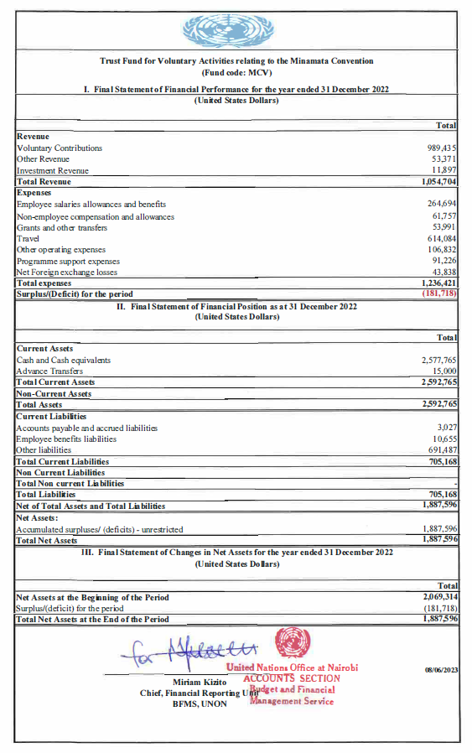

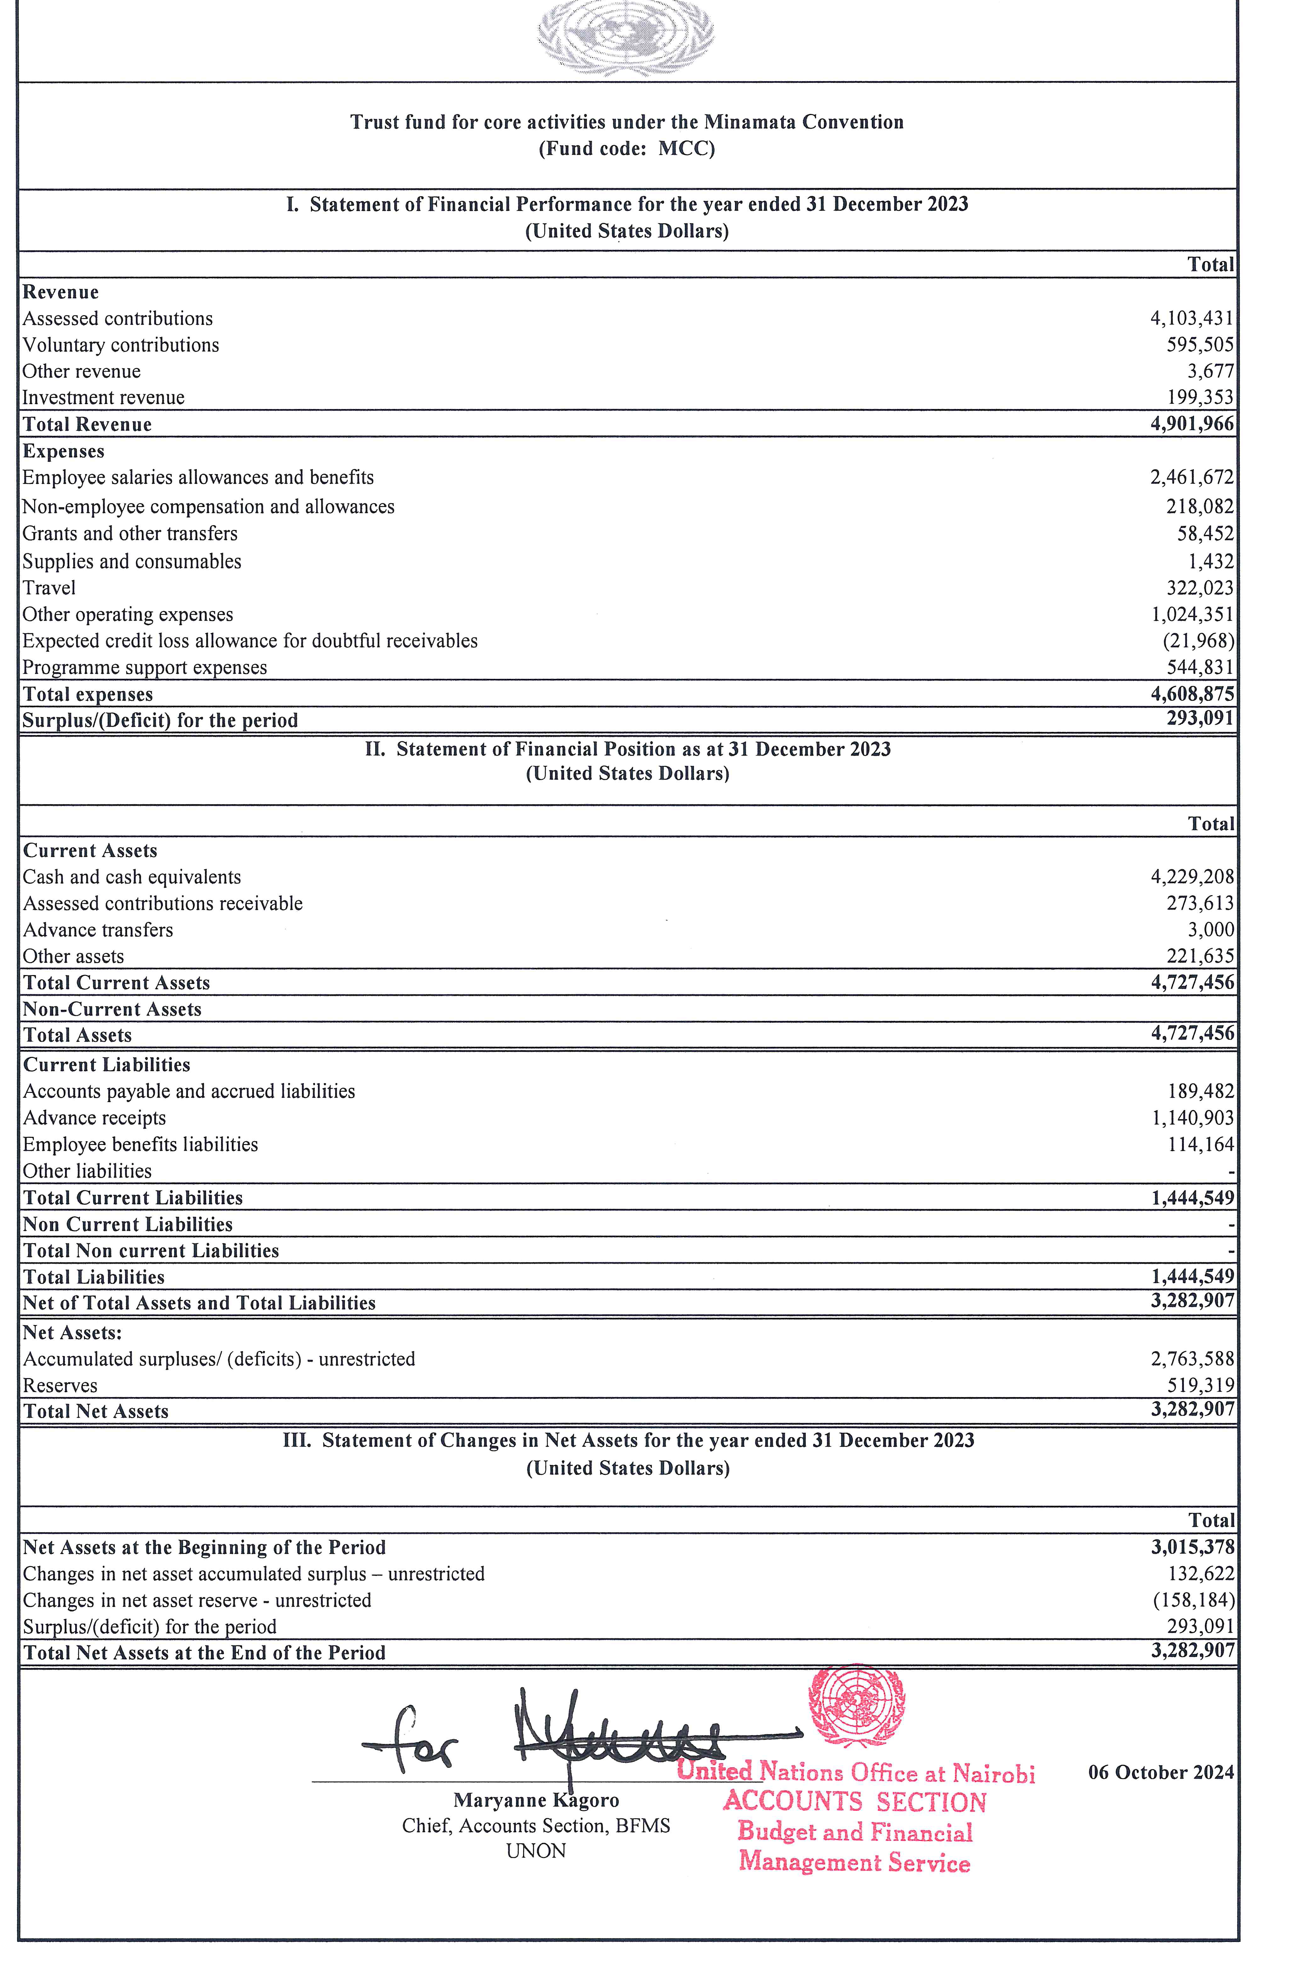

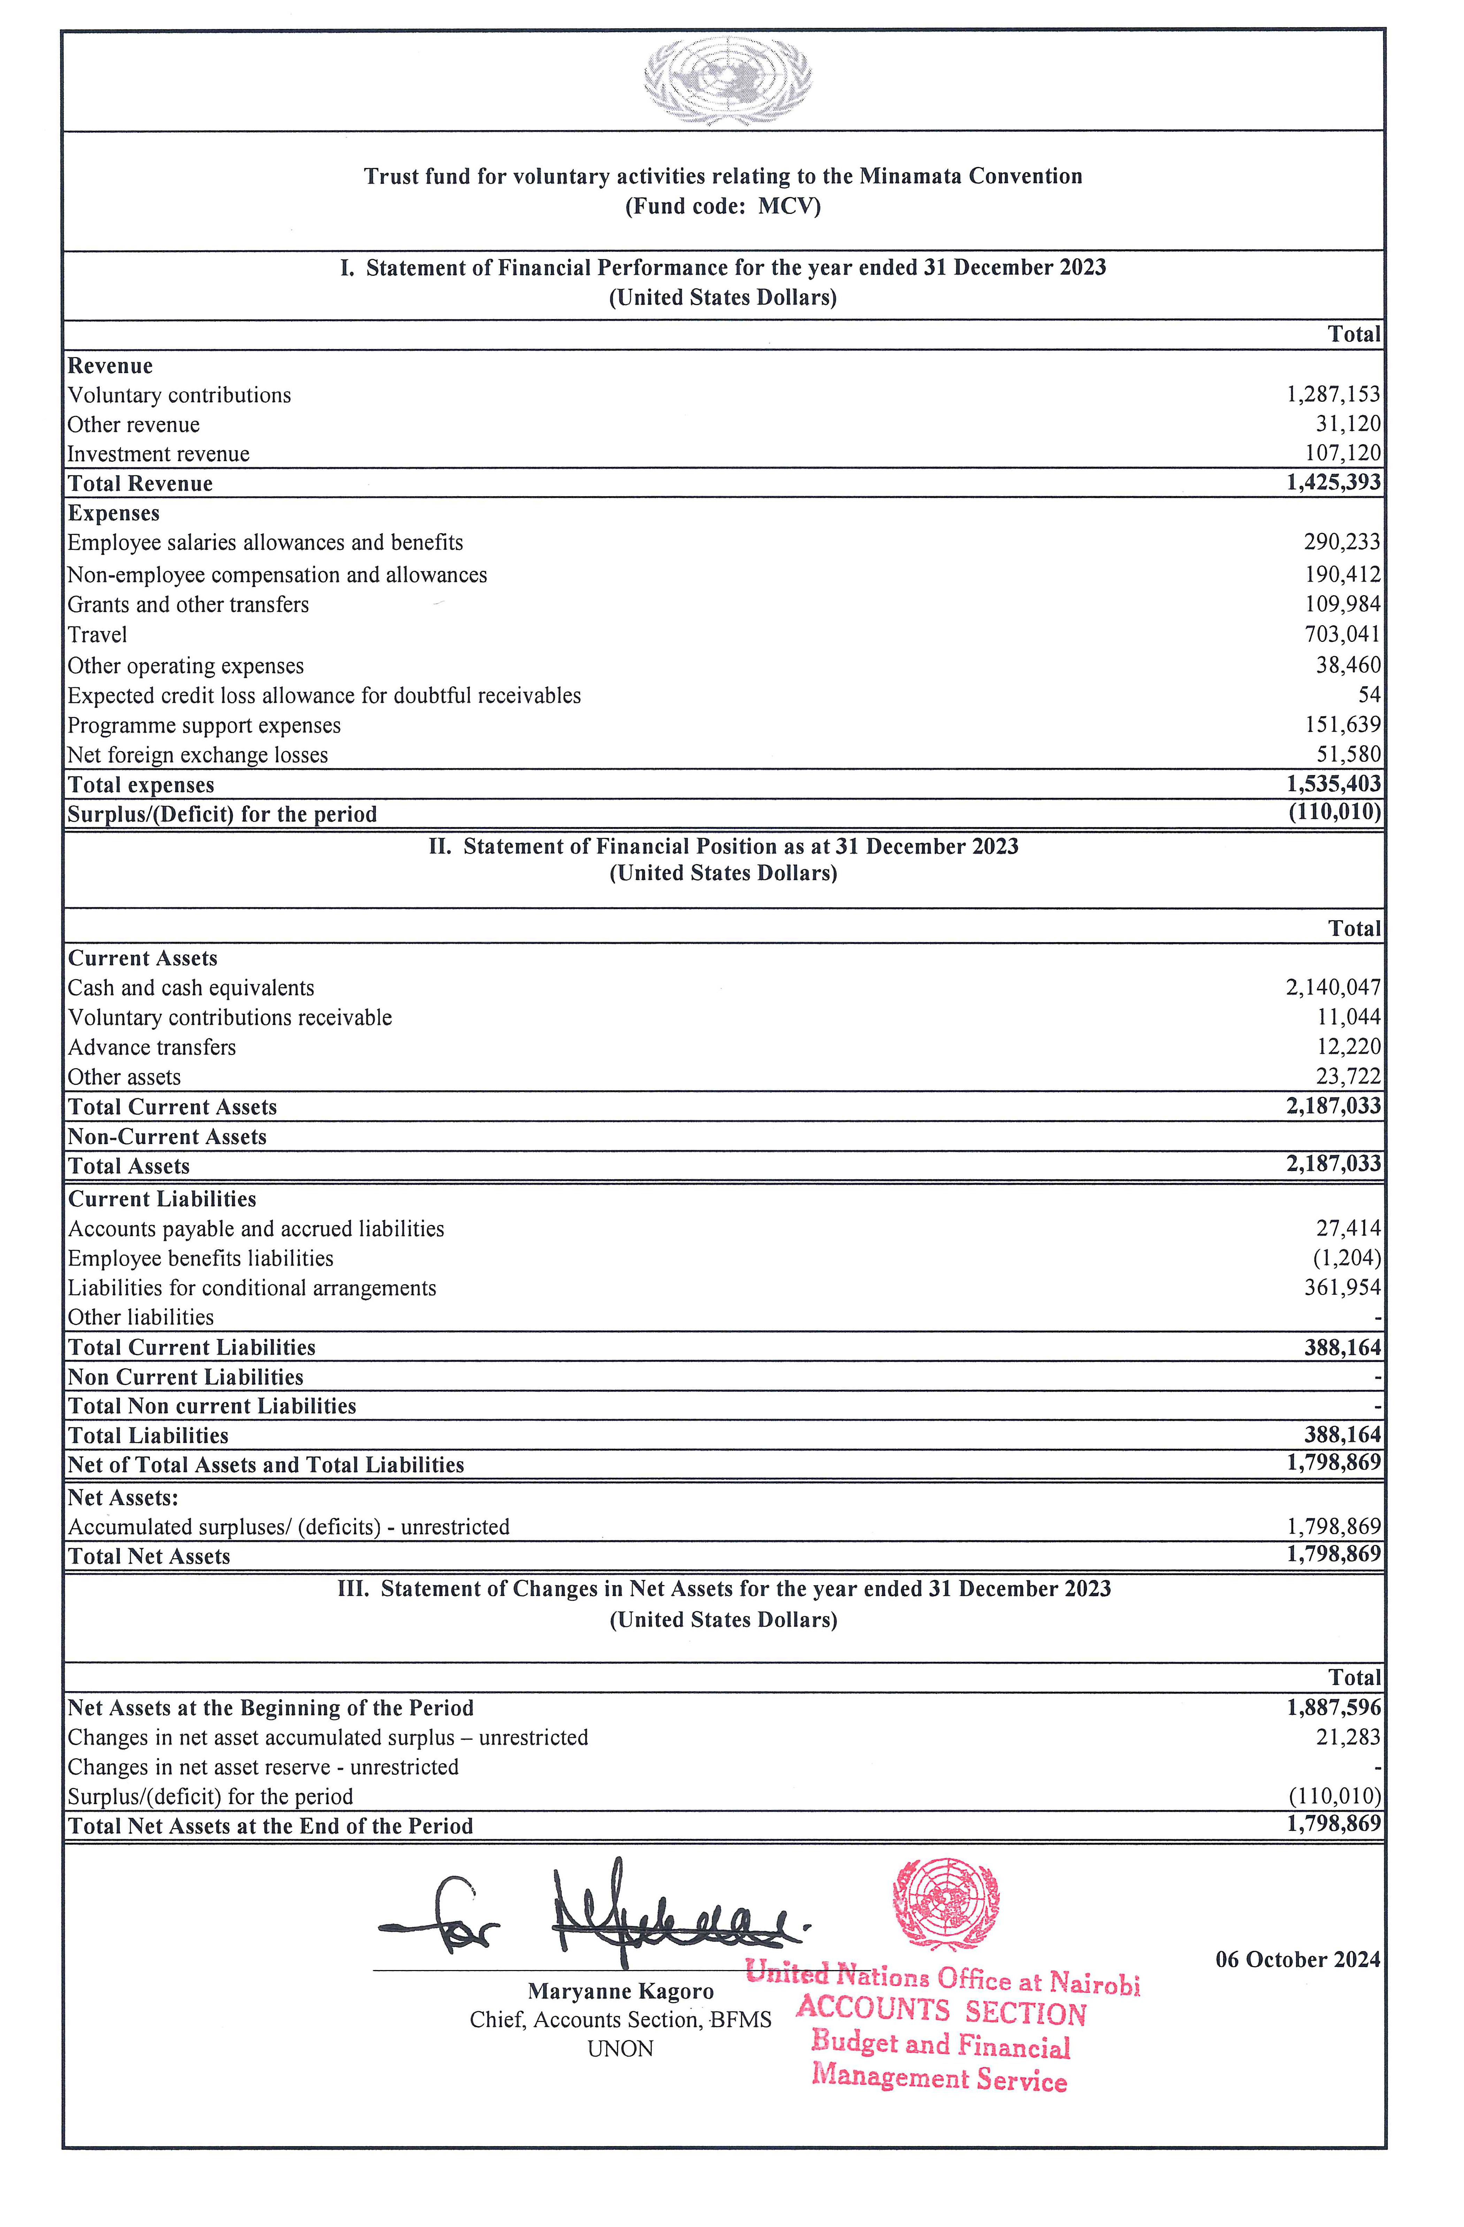

Annex II
Interim certified audited accounts of the Minamata Convention general and special trust funds for 2024 prepared in accordance with International Public Sector Accounting Standards
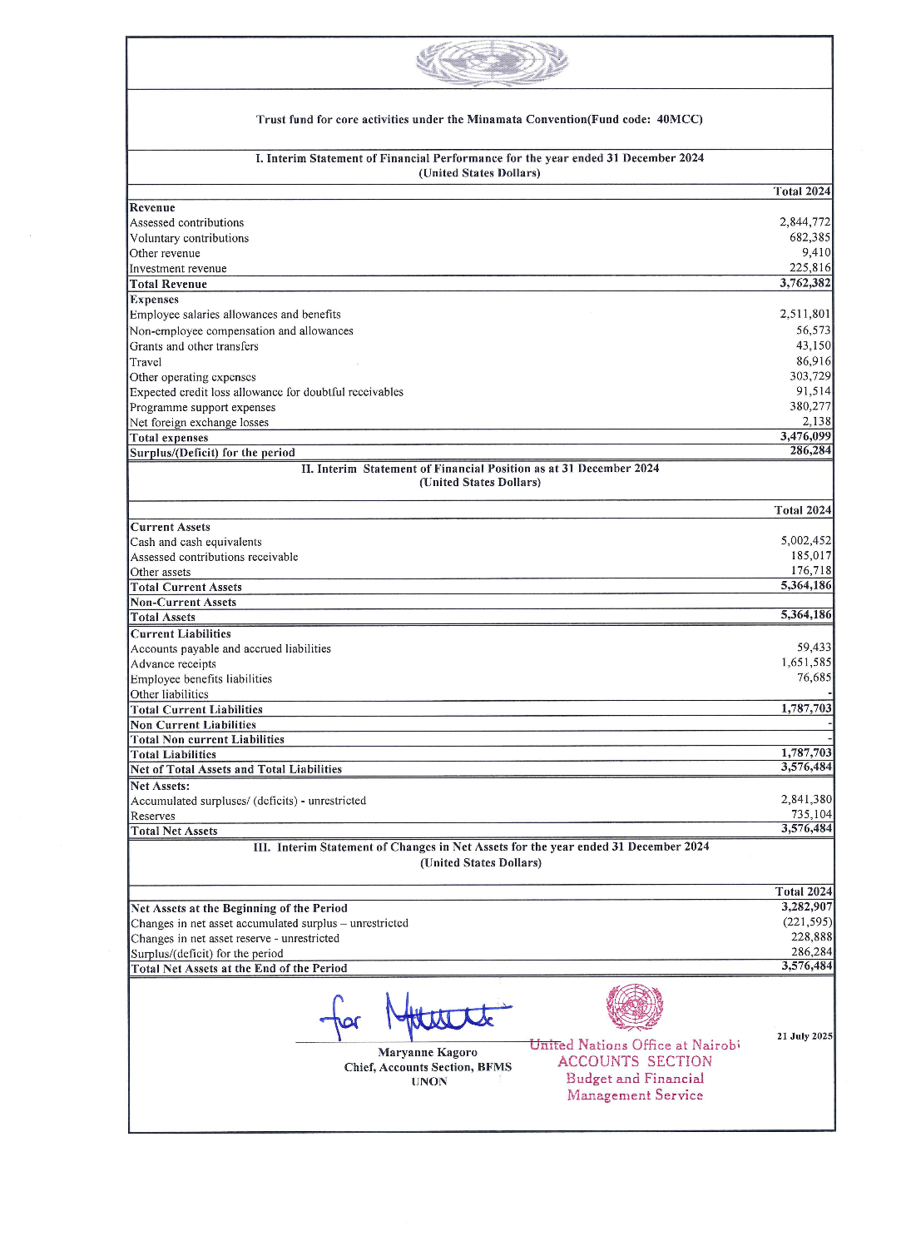

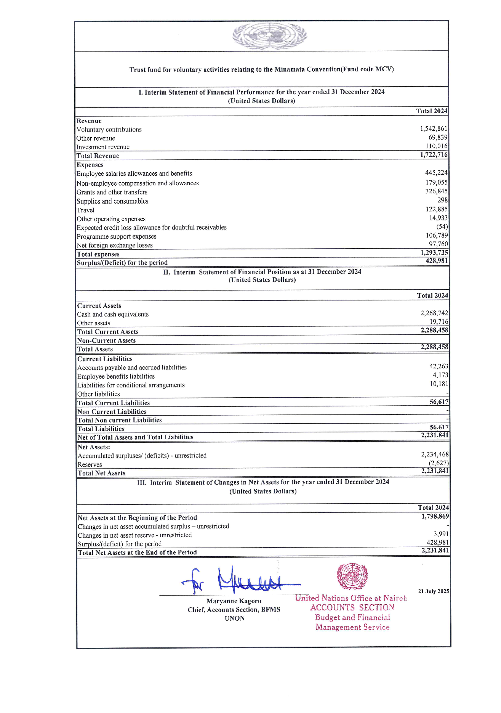

Annex III
Status of contributions to the general trust fund of the Minamata Convention as at 30 June 2025
Table III.1
Overview of the status of contributions to the general trust fund as at 30 June 2025
Party |  | PRIOR YEARS (2018-2024) |  |  | 2025 |  |  |  | Total unpaid contribution as of 30 June 2025
Party |  | Unpaid Contribution as of 31.12.2024  (in USD) | Received in 2025  (in USD) | Balance  (in USD) | Contribution  (in USD) | Received in 2023/24  (in USD) | Received in 2025  (in USD) | Balance  (in USD) | Total unpaid contribution as of 30 June 2025
 | AFRICAN STATES
1 | Algeria | 6 958 |  | 6 958 | 4 767 |  |  | 4 767 | 11 725
2 | Benin | 711 |  | 711 | 431 |  |  | 431 | 1 142
3 | Botswana | 433 |  | 433 | 656 |  |  | 656 | 1 089
4 | Burkina Faso |  |  |  | 431 | 322 |  | 109 | 109
5 | Burundi |  |  |  | 431 |  |  | 431 | 431
6 | Cameroon | 467 |  | 467 | 569 |  |  | 569 | 1 036
7 | Central African Republic | 1 080 |  | 1 080 | 431 |  |  | 431 | 1 511
8 | Chad | 2 255 |  | 2 255 | 431 |  |  | 431 | 2 686
9 | Comoros | 1 648 |  | 1 648 | 431 |  |  | 431 | 2 078
10 | Congo | 1 620 |  | 1 620 | 431 |  |  | 431 | 2 051
11 | Côte d'Ivoire | 15 | 15 | 0 | 962 |  | 983 | -21 | -21
12 | Djibouti | 2 255 |  | 2 255 | 431 |  |  | 431 | 2 686
13 | Equatorial Guinea | 2 567 |  | 2 567 | 525 |  |  | 525 | 3 092
14 | Eritrea |  |  |  | 431 | 431 | 431 | -431 | -431
15 | Eswatini |  |  |  | 431 |  |  | 431 | 431
16 | Ethiopia | 24 |  | 24 | 437 |  |  | 437 | 461
17 | Gabon | 4 158 |  | 4 158 | 569 |  |  | 569 | 4 727
18 | Gambia | 1 922 |  | 1 922 | 431 |  |  | 431 | 2 353
19 | Ghana | 2 853 |  | 2 853 | 1 050 |  |  | 1 050 | 3 903
20 | Guinea | 2 255 |  | 2 255 | 431 |  |  | 431 | 2 686
21 | Guinea-Bissau | 1 894 |  | 1 894 | 431 |  |  | 431 | 2 325
22 | Kenya |  |  |  | 1 312 |  |  | 1 312 | 1 312
23 | Lesotho |  |  |  | 431 |  |  | 431 | 431
24 | Liberia |  |  |  | 431 |  |  | 431 | 431
25 | Madagascar | 9 |  | 9 | 431 |  |  | 431 | 439
26 | Malawi | 386 |  | 386 | 431 |  |  | 431 | 817
27 | Mali | 2 028 |  | 2 028 | 431 |  |  | 431 | 2 459
28 | Mauritania | 2 255 |  | 2 255 | 431 |  |  | 431 | 2 686
29 | Mauritius |  |  |  | 831 |  | 831 | 0 | 0
30 | Mozambique | 166 |  | 166 | 431 |  |  | 431 | 597
31 | Namibia |  |  |  | 431 |  |  | 431 | 431
32 | Niger | 2 255 |  | 2 255 | 431 |  |  | 431 | 2 686
33 | Nigeria | 23 670 |  | 23 670 | 7 959 |  |  | 7 959 | 31 629
34 | Rwanda | 691 |  | 691 | 431 |  |  | 431 | 1 122
35 | Sao Tome and Principe | 1 922 |  | 1 922 | 431 |  |  | 431 | 2 353
36 | Senegal | 1 549 | 1 549 | 0 | 431 | 594 |  | -163 | -163
37 | Seychelles | 691 |  | 691 | 431 |  |  | 431 | 1 122
38 | Sierra Leone |  |  |  | 431 | 716 |  | -285 | -285
39 | South Africa | 7 050 |  | 7 050 | 10 671 |  |  | 10 671 | 17 721
40 | Togo | 1 593 | 1 593 | 0 | 431 |  |  | 431 | 431
41 | Uganda |  |  |  | 437 |  | 437 | 0 | 0
42 | United Republic of Tanzania |  |  |  | 437 | 365 |  | 72 | 72
43 | Zambia | 691 |  | 691 | 431 |  |  | 431 | 1 122
44 | Zimbabwe | 981 |  | 981 | 431 |  |  | 431 | 1 412
 | Total African States | 79 050 | 3 157 | 75 893 | 44 105 | 2 428 | 2 682 | 38 996 | 114 889
 | ASIA - PACIFIC STATES
45 | Afghanistan | 1 922 |  | 1 922 | 431 |  |  | 431 | 2 353
46 | Bahrain | 5 668 |  | 5 668 | 2 362 |  |  | 2 362 | 8 029
47 | Bangladesh | 429 |  | 429 | 437 |  |  | 437 | 866
48 | Cambodia |  |  |  | 431 |  |  | 431 | 431
49 | China |  |  |  | 667 105 |  |  | 667 105 | 667 105
50 | Cyprus |  |  |  | 1 574 |  |  | 1 574 | 1 574
51 | India |  |  |  | 45 657 |  |  | 45 657 | 45 657
52 | Indonesia |  |  |  | 24 009 |  |  | 24 009 | 24 009
53 | Iran (Islamic Republic of) | 114 079 | 47 480 | 66 599 | 16 225 |  |  | 16 225 | 82 824
54 | Iraq | 7 422 | 7 422 | 0 | 5 598 |  |  | 5 598 | 5 598
55 | Japan |  |  |  | 351 308 |  | 351 308 | 0 | 0
56 | Jordan | 636 |  | 636 | 962 |  |  | 962 | 1 598
57 | Kiribati | 1 593 |  | 1 593 | 431 |  |  | 431 | 2 024
58 | Kuwait |  |  |  | 10 234 |  |  | 10 234 | 10 234
59 | Lao People's Democratic Republic | 2 255 |  | 2 255 | 431 |  |  | 431 | 2 686
60 | Lebanon | 11 652 |  | 11 652 | 1 574 |  |  | 1 574 | 13 226
61 | Maldives |  |  |  | 431 |  |  | 431 | 431
62 | Marshall Islands | 284 |  | 284 | 431 |  |  | 431 | 715
63 | Mongolia | 285 |  | 285 | 431 |  |  | 431 | 716
64 | Oman | 7 861 | 7 861 | 0 | 4 854 |  |  | 4 854 | 4 854
65 | Pakistan | 8 986 |  | 8 986 | 4 986 |  |  | 4 986 | 13 971
66 | Palau | 948 |  | 948 | 431 |  |  | 431 | 1 379
67 | Philippines |  |  |  | 9 271 |  | 9 271 | 0 | 0
68 | Qatar |  |  |  | 11 764 |  | 11764 | 0 | 0
69 | Republic of Korea |  |  |  | 112 569 |  | 75 873 | 36 696 | 36 696
70 | Samoa |  |  |  | 431 |  |  | 431 | 431
71 | Saudi Arabia |  |  |  | 51 780 |  |  | 51 780 | 51 780
72 | Singapore |  |  |  | 22 041 |  | 22 041 | 0 | 0
73 | Sri Lanka | 4 457 | 4 457 | 0 | 1 968 |  |  | 1 968 | 1 968
74 | State of Palestine |  |  |  | 481 |  |  | 481 | 481
75 | Syrian Arab Republic | 4 169 |  | 4 169 | 431 |  |  | 431 | 4 600
76 | Thailand |  |  |  | 16 094 |  | 16 780 | -686 | -686
77 | Tonga | 1 593 |  | 1 593 | 431 |  |  | 431 | 2 024
78 | Tuvalu | 1 593 |  | 1 593 | 431 |  |  | 431 | 2 024
79 | United Arab Emirates | 18 348 | 18 348 | 0 | 27 771 |  |  | 27 771 | 27 770
80 | Vanuatu | 948 |  | 948 | 431 |  |  | 431 | 1 379
81 | Viet Nam | 1 176 | 1 162 | 14 | 4 067 |  |  | 4 067 | 4 081
 | Total Asia - Pacific States | 196 302 | 86 730 | 109 573 | 1 400 293 | - | 487 037 | 913 256 | 1 022 828
 | EASTERN EUROPEAN STATES
82 | Albania |  |  |  | 431 |  | 431 | 0 | 0
83 | Armenia |  |  |  | 431 | 431 |  | 0 | 0
84 | Bulgaria |  |  |  | 2 449 |  | 2449 | 0 | 0
85 | Croatia |  |  |  | 3 980 |  | 3 980 | 0 | 0
86 | Czechia |  |  |  | 14 869 | 14 869 |  | 0 | 0
87 | Estonia |  |  |  | 1 924 |  | 1 924 | 0 | 0
88 | Georgia |  |  |  | 431 |  | 431 | 0 | 0
89 | Hungary |  |  |  | 9 971 |  |  | 9 971 | 9 971
90 | Latvia |  |  |  | 2 187 |  | 2 187 | 0 | 0
91 | Lithuania |  |  |  | 3 367 |  | 3367 | 0 | 0
92 | Montenegro |  |  |  | 431 |  |  | 431 | 431
93 | North Macedonia |  |  |  | 431 |  |  | 431 | 431
94 | Poland |  |  |  | 36 605 |  | 36 605 | 0 | 0
95 | Republic of Moldova |  |  |  | 431 |  |  | 431 | 431
96 | Romania |  |  |  | 13 645 |  |  | 13 645 | 13 645
97 | Slovakia |  |  |  | 6 779 |  | 6 779 | 0 | 0
98 | Slovenia |  |  |  | 3 455 | 6204 | 3455 | -6 204 | -6 204
99 | Ukraine | 1 814 |  | 1 814 | 2 449 |  |  | 2 449 | 4 263
 | Total Eastern European States | 1 814 | - | 1 814 | 104 264 | 21 504 | 61 608 | 21 152 | 22 966
 | LATIN AMERICAN AND CARIBBEAN STATES
100 | Antigua and Barbuda | 284 | 284 | 0 | 431 |  | 431 | 0 | 0
101 | Argentina | 20 774 |  | 20 774 | 31 444 |  |  | 31 444 | 52 218
102 | Bahamas | 1 865 |  | 1 865 | 831 |  |  | 831 | 2 696
103 | Belize | 386 |  | 386 | 431 |  |  | 431 | 817
104 | Bolivia (Plurinational State of) | 4 210 |  | 4 210 | 831 |  |  | 831 | 5 041
105 | Brazil |  |  |  | 88 035 |  |  | 88 035 | 88 035
106 | Chile | 29 745 |  | 29 745 | 18 368 |  |  | 18 368 | 48 112
107 | Colombia |  |  |  | 10 758 |  | 10 758 | 0 | 0
108 | Costa Rica | 5 590 | 5 590 | 0 | 3 018 |  | 1 011 | 2 007 | 2 006
109 | Cuba | 20 177 |  | 20 177 | 4 155 |  |  | 4 155 | 24 332
110 | Dominican Republic |  |  |  | 2 930 | 27 | 3020 | -117 | -117
111 | Ecuador | 17 000 | 16 999 | 1 | 3 367 |  |  | 3 367 | 3 368
112 | El Salvador | 376 | 376 | 0 | 569 |  |  | 569 | 569
113 | Guyana | 52 | 52 | 0 | 431 |  | 456 | -25 | -25
114 | Honduras | 1 266 | 1 266 | 0 | 431 |  | 300 | 131 | 131
115 | Jamaica |  |  |  | 431 |  |  | 431 | 431
116 | Mexico |  |  |  | 53 398 |  |  | 53 398 | 53 398
117 | Nicaragua | 284 |  | 284 | 431 |  |  | 431 | 715
118 | Panama |  |  |  | 3 936 |  |  | 3 936 | 3 936
119 | Paraguay |  |  |  | 1 137 |  |  | 1 137 | 1 137
120 | Peru | 23 176 | 7 184 | 15 992 | 7 128 |  |  | 7 128 | 23 120
121 | Saint Kitts and Nevis |  |  |  | 431 |  |  | 431 | 431
122 | Saint Lucia | 751 |  | 751 | 431 |  |  | 431 | 1 182
123 | Saint Vincent and the Grenadines | 318 |  | 318 | 431 |  |  | 431 | 749
124 | Suriname | 948 |  | 948 | 431 |  |  | 431 | 1 379
125 | Uruguay |  |  |  | 4 023 |  |  | 4 023 | 4 023
 | Total Latin American and Caribbean States | 127 204 | 31 751 | 95 453 | 238 236 | 27 | 15 976 | 222 233 | 317 686
 | WESTERN EUROPEAN AND OTHER STATES
126 | Australia |  |  |  | 92 321 |  | 92 321 | 0 | 0
127 | Austria |  |  |  | 29 695 |  | 29 695 | 0 | 0
128 | Belgium |  |  |  | 36 211 |  |  | 36 211 | 36 211
129 | Canada |  |  |  | 114 931 | 114 931 |  | 0 | 0
130 | Denmark |  |  |  | 24 184 |  | 24 184 | 0 | 0
131 | European Union |  |  |  | 107 695 |  | 107 695 | 0 | 0
132 | Finland |  |  |  | 18 237 |  | 18 237 | 0 | 0
133 | France |  |  |  | 188 840 |  |  | 188 840 | 188 840
134 | Germany |  |  |  | 267 253 |  | 267 253 | 0 | 0
135 | Greece |  |  |  | 14 213 |  | 14 213 | 0 | 0
136 | Iceland | 1 040 |  | 1 040 | 1 574 |  |  | 1 574 | 2 615
137 | Ireland |  |  | - | 19 199 | 19 199 |  | 0 | 0
138 | Italy |  |  | - | 139 465 |  |  | 139 465 | 139 465
139 | Liechtenstein |  |  | - | 437 |  |  | 437 | 437
140 | Luxembourg |  |  | - | 2 974 | 1 953 | 1 021 | 0 | 0
141 | Malta |  |  | - | 831 |  |  | 831 | 831
142 | Monaco |  |  | - | 481 |  | 481 | 0 | 0
143 | Netherlands |  |  | - | 60 220 |  | 60 220 | 0 | 0
144 | Norway |  |  | - | 29 695 |  | 29 695 | 0 | 0
145 | Portugal | 27 004 |  | 27 004 | 15 438 |  |  | 15 438 | 42 442
146 | Spain |  |  | - | 93 326 |  |  | 93 326 | 93 326
147 | Sweden |  |  | - | 38 092 |  | 38 092 | 0 | 0
148 | Switzerland |  |  | - | 49 593 |  | 49 593 | 0 | 0
149 | Türkiye | 56 891 |  | 56 891 | 36 954 |  |  | 36 954 | 93 846
150 | United Kingdom |  |  | - | 191 332 | 191 332 |  | 0 | 0
151 | United States of America |  |  | - | 947 718 | 176 358 |  | 771 360 | 771 360
 | Total Western European and other States | 84 935 | - | 84 935 | 2 520 910 | 503 773 | 732 700 | 1 284 437 | 1 369 372
 | Total | 489 305 | 121 638 | 367 667 | 4 307 808 | 527 732 | 1 300 003 | 2 480 074 | 2 847 741

Table III.2
Parties with outstanding contributions for two or more years as at 30 June 2025
Party | 2018 | 2019 | 2020 | 2021 |  | 2022 |  | 2023 | 2024 | 2025 | Total (USD)
AFRICAN STATES (26)
Algeria |  |  |  |  |  |  |  | 3 808 | 3 149 | 4 767 | 11 724
Benin |  |  |  |  |  | 257 |  | 170 | 284 | 431 | 1 142
Botswana |  |  |  |  |  |  |  |  | 433 | 656 | 1 089
Cameroon |  |  |  |  |  |  |  | 91 | 376 | 569 | 1 036
Central Africa Republic |  |  |  | 132 |  | 257 |  | 407 | 284 | 431 | 1 511
Chad | 333 | 329 | 248 | 397 |  | 257 |  | 407 | 284 | 431 | 2 686
Comoros |  | 55 | 248 | 397 |  | 257 |  | 407 | 284 | 431 | 2 079
Congo (Republic of the) |  | 27 | 248 | 397 |  | 257 |  | 407 | 284 | 431 | 2 051
Djibouti | 333 | 329 | 248 | 397 |  | 257 |  | 407 | 284 | 431 | 2 686
Equatorial Guinea |  |  | 487 | 768 |  | 462 |  | 503 | 347 | 525 | 3 092
Gabon | 876 | 752 | 456 | 720 |  | 433 |  | 545 | 376 | 569 | 4 727
Gambia |  | 329 | 248 | 397 |  | 257 |  | 407 | 284 | 431 | 2 353
Ghana |  |  |  | 720 |  | 433 |  | 1 006 | 693 | 1 050 | 3 902
Guinea | 333 | 329 | 248 | 397 |  | 257 |  | 407 | 284 | 431 | 2 686
Guinea-Bissau |  | 302 | 248 | 397 |  | 257 |  | 407 | 284 | 431 | 2 326
Malawi |  |  |  |  |  |  |  | 102 | 284 | 431 | 817
Mali | 106 | 329 | 248 | 397 |  | 257 |  | 407 | 284 | 431 | 2 459
Mauritania | 333 | 329 | 248 | 397 |  | 257 |  | 407 | 284 | 431 | 2 686
Niger | 333 | 329 | 248 | 397 |  | 257 |  | 407 | 284 | 431 | 2 686
Nigeria |  |  |  | 3 564 |  | 7 217 |  | 7 631 | 5 259 | 7 959 | 31 630
Rwanda |  |  |  |  |  |  |  | 407 | 284 | 431 | 1 122
Sao Tome and Principe |  | 329 | 248 | 397 |  | 257 |  | 407 | 284 | 431 | 2 353
Seychelles |  |  |  |  |  |  |  | 407 | 284 | 431 | 1 122
South Africa |  |  |  |  |  |  |  |  | 7 050 | 10 671 | 17 721
Zambia |  |  |  |  |  |  |  | 407 | 284 | 431 | 1 122
Zimbabwe |  |  |  | 33 |  | 257 |  | 407 | 284 | 431 | 1 412
Total African States | 2 647 | 3 768 | 3 671 | 10 304 |  | 12 143 |  | 20 368 | 22 795 | 34 524 | 110 220
ASIA - PACIFIC STATES (16)
Afghanistan |  | 329 | 248 | 397 |  | 257 |  | 407 | 284 | 431 | 2 353
Bahrain |  |  |  | 400 |  | 1 443 |  | 2 264 | 1 560 | 2 362 | 8 029
Bangladesh |  |  |  |  |  |  |  | 140 | 289 | 437 | 866
Iran (Islamic Republic of) |  |  | 9 728 | 19 108 |  | 11 489 |  | 15 555 | 10 720 | 16 225 | 82 825
Jordan |  |  |  |  |  |  |  |  | 636 | 962 | 1 598
Kiribati |  |  | 248 | 397 |  | 257 |  | 407 | 284 | 431 | 2 024
Lao People's Democratic Republic | 333 | 329 | 248 | 397 |  | 257 |  | 407 | 284 | 431 | 2 686
Lebanon | 2 026 | 2 033 | 1 430 | 2 256 |  | 1 357 |  | 1 509 | 1 040 | 1 574 | 13 225
Marshall Islands |  |  |  |  |  |  |  |  | 284 | 431 | 715
Mongolia |  |  |  |  |  |  |  |  | 284 | 431 | 715
Pakistan |  |  |  |  |  | 947 |  | 4 780 | 3 294 | 4 986 | 14 007
Palau |  |  |  |  |  | 257 |  | 407 | 284 | 431 | 1 379
Syrian Arab Republic | 1 237 | 1 061 | 335 | 528 |  | 318 |  | 407 | 284 | 431 | 4 601
Tonga |  |  | 248 | 397 |  | 257 |  | 407 | 284 | 431 | 2 024
Tuvalu |  |  | 248 | 397 |  | 257 |  | 407 | 284 | 431 | 2 024
Vanuatu |  |  |  |  |  | 257 |  | 407 | 284 | 431 | 1 379
Total Asia-Pacific States | 3 596 | 3 752 | 12 733 | 24 277 |  | 17 353 |  | 27 504 | 20 379 | 30 856 | 140 450
EASTERN EUROPEAN STATES (1)
Ukraine |  |  |  |  |  |  |  | 196 | 1 618 | 2 449 | 4 263
Total Eastern European States |  |  |  |  |  |  |  | 196 | 1 618 | 2 449 | 4 263
LATIN AMERICAN AND CARIBBEAN STATES (11)
Argentina |  |  |  |  |  |  |  |  | 20 775 | 31 444 | 52 219
Bahamas |  |  |  |  |  | 520 |  | 797 | 549 | 831 | 2 697
Belize |  |  |  |  |  |  |  | 102 | 284 | 431 | 817
Bolivia (Plurinational State of) | 618 | 530 | 487 | 768 |  | 462 |  | 797 | 549 | 831 | 5 042
Chile |  |  |  |  |  |  |  | 17 609 | 12 136 | 18 368 | 48 113
Cuba | 1 992 | 2 873 | 2 434 | 3 841 |  | 2 309 |  | 3 983 | 2 745 | 4 155 | 24 332
Nicaragua |  |  |  |  |  |  |  |  | 284 | 431 | 715
Peru |  |  |  | 60 |  | 4 388 |  | 6 834 | 4 710 | 7 128 | 23 120
Saint Lucia |  |  |  |  |  | 60 |  | 407 | 284 | 431 | 1 182
Saint Vincent and the Grenadines |  |  |  |  |  |  |  | 34 | 284 | 431 | 749
Suriname |  |  |  |  |  | 257 |  | 407 | 284 | 431 | 1 379
Total Latin American and Caribbean States | 2 610 | 3 403 | 2 921 | 4 669 |  | 7 996 |  | 30 970 | 42 884 | 64 912 | 160 365
WESTERN EUROPEAN AND OTHER STATES (3)
Iceland |  |  |  |  |  |  |  |  | 1 040 | 1 574 | 2 614
Portugal |  |  |  |  |  | 2 004 |  | 14 800 | 10 200 | 15 438 | 42 442
Türkiye |  |  |  |  |  |  |  | 32 476 | 24 415 | 36 954 | 93 845
Total Western European and Other States |  |  |  |  |  | 2 004 |  | 47 276 | 35 655 | 53 966 | 138 901
TOTAL (57 Parties) | 8 853 | 10 923 | 19 325 |  | 39 250 |  | 39 496 | 126 314 | 123 331 | 186 707 | 554 199

Annex IV
Status of contributions to the special trust fund of the Minamata Convention as at 30 June 2025
Table IV.1
Contributions to the special trust fund for the 2022−2023 biennium
Year | Donor | Currency | Amount | Amount | Date Received
 |  |  |  | received in USD | Date Received
2022 | Australia | AUD | 25 000 | 18 272 | 09.03.2022
2022 | Japan | USD | 400 000 | 400 000 | 10.08.2022
2022 | Sweden | SEK |  | 11 413 | 18.08.2022
2022 | Switzerland* | CHF | 400 000 | 426 796 | 10.03.2022
2022 | Switzerland | USD | 70 000 | 70 000 | 18.07.2022
2023 | Canada | CAD | 25 000 | 18 159 | 24.03.2023
2023 | Finland | EUR | 10 000 | 10 953 | 17.01.2024
2023 | Japan | USD | 300 000 | 300 000 | 13.09.2023
2023 | Norway | NOK | 150 000 | 14 620 | 07.08.2023
2023 | Sweden | SEK | 437 566 | 39 502 | 28.09.2023
2023 | Switzerland* | CHF | 400 000 | 430 154 | 23.02.2023
 |  | TOTAL (in USD) |  | 1 739 869
* Switzerland, as host country, pays CHF 400,000 to the special trust fund and CHF 600,000 to the general trust fund on an annual basis.

Table IV.2
Contributions to the special trust fund for the 2024−2025 biennium as at 30 June 2025
Year | Donor | Currency | Amount | Amount | Date Received
 |  |  |  | received in USD | Date Received
2024 | Canada | CAD | 55 000 | 40 506 | 15.02.2024 & 27.08.2024
2024 | Japan | USD | 400 000 | 400 000 | 20.08.2024
2024 | Netherlands | EUR | 20 000 | 22 026 | 13.09.2024
2024 | Spain | EUR | 30 000 | 31 646 | 04.12.2024
2024 | Sweden | SEK | 368 270 | 34 999 | 15.07.2024
2024 | Switzerland* | CHF | 400 000 | 453 220 | 27.03.2024
2025 | Finland | EUR | 10 000 |  | Pledged
2025 | Switzerland* | CHF | 400 000 | 463 504 | 21.03.2025
 |  | TOTAL (in USD) |  | 1 445 901
* Switzerland, as host country, pays CHF 400,000 to the special trust fund and CHF 600,000 to the general trust fund on an annual basis.

Annex V
Status of contributions to the specific trust fund of the Minamata Convention as at 30 June 2025
Table V.1
Contributions to the third round of the Specific International Programme
Year | Donor | Currency | Amount | Amount | Date Received
 |  |  |  | received in USD | Date Received
2019 | Austria | EUR | 10 000 | 11 111 | 21.11.2019
2019 | Denmark | DKK | 200 000 | 29 679 | 23.12.2019
2019 | France | EUR | 100 000 | 110 011 | 09.12.2019
2019 | Norway | NOK | 5 000 000 | 565 694 | 31.12.2019
2019 | Switzerland | CHF | 100 000 | 101 492 | 16.12.2019
2020 | Austria | EUR | 100 000 | 117 371 | 19.10.2020
2020 | Denmark | DKK | 200 000 | 32 863 | 12.01.2021
2020 | Germany | EUR | 100 000 | 108 290 | 21.04.2020
2020 | Netherlands | EUR | 30 000 | 35 545 | 23.09.2020
2020 | Norway | NOK | 4 500 000 | 522 897 | 31.12.2020
2020 | Sweden | SEK | 1 396 969 | 148 217 | 12.11.2020
2020 | USA | USD | 66 508 | 66 508 | 05.05.2020
2020 | USA | USD | 81 500 | 81 500 | 24.09.2020
2021 | Austria | EUR | 95 000 | 111 372 | 06.04.2021
2021 | Germany | EUR | 127 000 | 154 978 | 24.05.2021
2021 | Netherlands | EUR | 30 000 | 35 799 | 06.07.2021
2021 | Norway | USD | 14 757 | 14 757 | 02.09.2021
2021 | Sweden | SEK | 1 495 475 | 169 148 | 20.09.2021
2021 | USA | USD | 25 000 | 25 000 | 04.08.2021
2022 | Netherlands | EUR | 30 000 | 31 679 | 20.05.2022
 |  | TOTAL (in USD) |  | 2 473 912
Table V.2
Contributions to the fourth round of the Specific International Programme
Year | Donor | Currency | Amount | Amount | Date Received
 |  |  |  | received in USD | Date Received
2021 | Denmark | DKK | 200 000 | 30 388 | 13.01.2022
2021 | Norway | NOK | 1 000 000 | 110 522 | 29.12.2021
2022 | Austria | EUR | 90 000 | 87 634 | 13.10.2022
2022 | Germany | EUR | 167 000 | 166 048 | 31.08.2022
2022 | Sweden | SEK |  | 84 541 | 18.08.2022
2022 | Switzerland | USD | 100 000 | 100 000 | 18.07.2022
2022 | USA | USD | 70 000 | 70 000 | 31.10.2022
2023 | Austria | EUR | 75 000 | 97 087 | 15.12.2023
2023 | France | EUR | 200 000 | 214 133 | 16.03.2023
2023 | Germany | EUR | 183 000 | 200 916 | 22.12.2023
2023 | Netherlands | EUR | 50 000 | 65 240 | 22.05.2023
2023 | Sweden | SEK | 562 434 | 50 774 | 28.09.2023
2023 | UK | GBP | 75 000 | 95 235 | 17.01.2024
2023 | USA | USD | 80 000 | 80 000 | 27.09.2023
2023 | USA | USD | 200 000 | 180 075 | 02.11.2023 /  11.06.2024
2024 | Denmark | DKK | 150 000 | 20 604 | 16.01.2025
2024 | Germany | EUR | 257 686 | 276 755 | 11.06.2024
2024 | Netherlands | EUR | 50 000 | 53 996 | 22.05.2024
2024 | Netherlands | EUR | 50 000 | 53 591 | 05.07.2024
2024 | Sweden | SEK | 631 730 | 58 358 | 15.07.2024
2024 | Switzerland | CHF | 26 000 | 28 276 | 13.01.2025
2024 | USA | USD | 150 000 | 150 000 | 12.11.2024
2025 | France | EUR | 100 000 |  | Pledged
 |  | TOTAL (in USD) |  | 2 274 172

Annex VI
Budget performance of the general trust fund for the biennium 2022−2023
Activity Number | Activity |  | Approved Budget  (2022-2023)  (A) | Authorized use of accumulated surplus in 2022-2023 biennium  (B)* | Approved Budget 2022 | Approved Budget 2023 |  | Expenditures  (2022-2023)  (C) |  | Expenditures 2022 |  | Expenditures 2023 |  | Performance Variance  ((A) +(B) - (C)) |  | Performance Variance  (in %)
 | A. Conferences and meetings |  | 1 224 300 | 98 300 | 98 300 | 1 12000 |  | 1464350 |  | 396747 |  | 1067604 |  | (141750) |  | -11,58%
1 | Fifth meeting of the Conference of the Parties** |  | 1 153 300 | 98 300 | 98 300 | 1055 000 |  | 1430584 |  | 396747 |  | 1033837 |  | (178984) |  | -15,52%
2 | Bureau of the Conference of the Parties |  | 26 000 |  |  | 26 000 |  | 14598 |  |  |  | 14598 |  | 11402 |  | 43,85%
3 | Implementation and compliance committee |  | 45 000 |  |  | 45 000 |  | 19169 |  |  |  | 19169 |  | 25831 |  | 57,40%
 | B. Capacity-building and technical assistance |  | - |  | - | - |  | - |  | - |  | - |  | - |  | -
4 | Capacity-building and technical assistance programme of the Minamata Convention |  | - |  |  |  |  | - |  |  |  |  |  | - |  | 0,00%
 | C. Scientific and technical activities |  | 425 000 | 100000 | 320 000 | 105 000 |  | 252561 |  | 18920 |  | 233641 |  | 272439 |  | 64,10%
5 | Scientific support to the States parties to the Minamata Convention |  | - |  | - | - |  | - |  | - |  | - |  | - |  | 0,00%
6 | Effectiveness evaluation and global monitoring plan |  | 295 000 | 100000 | 265 000 | 30 000 |  | 200 055 |  | 12120 |  | 187935 |  | 194945 |  | 66,08%
7 | National reporting under the Minamata Convention |  | 130 000 |  | 55 000 | 75 000 |  | 52506 |  | 6800 |  | 45706 |  | 77494 |  | 59,61%
 | D. Knowledge and information management and outreach |  | 196 000 | - | 104 000 | 92 000 |  | 176257 |  | 53975 |  | 122282 |  | 11230 |  | 5,73%
8 | Publications |  | 50 000 |  | 25 000 | 25 000 |  | 48506 |  | 8532 |  | 39974 |  | 1494 |  | 2,99%
9 | Communication, outreach and public awareness |  | 76 000 |  | 34 000 | 42 000 |  | 66264 |  | 6788 |  | 59476 |  | 9736 |  | 12,81%
10 | Digital presence |  | 70 000 |  | 45 000 | 25 000 |  | 61487 |  | 38655 |  | 22832 |  | 8513 |  | 12,16%
 | E. Overall management |  | 4712567 | 245029 | 2274000 | 2438567 |  | 5000579 |  | 2391589 |  | 2608990 |  | (42983) |  | -0,91%
11 | Executive direction and management |  | 4665 567 | 245029 | 2227 000 | 2438 567 |  | 4935172 |  | 2346439 |  | 2588733 |  | (24576) |  | -0,53%
12 | International cooperation and coordination*** |  | - |  | - | - |  | 19958 |  |  |  | 19958 |  | (19958) |  | 0,00%
13 | Financial resources and mechanism |  | 47 000 |  | 47 000 |  |  | 45450 |  | 45150 |  | 300 |  | 1550 |  | 3,30%
 | F. Legal and policy activities |  | - |  | - | - |  | - |  | - |  | - |  | - |  | -
14 | Legal and policy activities |  | - |  |  |  |  | - |  |  |  | - |  | - |  | 0,00%
 | G. Office maintenance and services |  | 446 000 | - | 210 500 | 235 500 |  | 316765 |  | 159 656 |  | 157 110 |  | 129 235 |  | 28,98%
15 | Office maintenance and services |  | 330 000 |  | 155 000 | 175 000 |  | 214 887 |  | 128 012 |  | 86875 |  | 115113 |  | 34,88%
16 | Information technology services |  | 116 000 |  | 55 500 | 60 500 |  | 101 878 |  | 31 643 |  | 70235 |  | 14122 |  | 12,17%
 | Total direct costs (excluding Programme Support Costs) |  | 7 003 867 | 443 329 | 3 006 800 | 3 997 067 |  | 7 210 513 |  | 3 020 886 |  | 4 189 627 |  | 228 170 |  | 3,26%
 | Programme Support Costs (13%) |  | 910 503 | 57 633 | 390 884 | 519 619 |  | 937 367 |  | 392 715 |  | 544 652 |  | 29 662 |  | 3,26%
 | Grand total |  | 7 914 370 | 500 962 | 3 397 684 | 4 516 686 |  | 8 147 880 |  | 3 413 601 |  | 4 734 279 |  | 257 832 |  | 3,26%
Notes:
* |  | As per decision MC-4/2
** |  | The overspending from COP-4 in 2022 is offset by savings from CoP-4 in previous biennium of USD 368,214 due to some expenditures entering in 2022  instead of 2021 for COP-4 having been held in two parts
*** |  | Spending in line with the discretion of the Executive Secretary to move budget of up to 20% between budget lines as per the Minamata financial rules  and regulations (annex to decision MC-1/10)

Annex VII
Projected budget performance of the general trust fund for the biennium 2024−2025
Activity Number | Activity |  | Approved Budget  (2024-2025)  (A) |  | Approved Budget 2024 | Approved Budget 2025 |  | Expenditures  (2024-2025)  (C) | Expenditures 2024 |  | Estimated expenditures 2025 |  | Performance Variance  ((A) +(B) - (C)) |  |  | Performance Variance  (in %)
 | A. Conferences and meetings |  | 1 213 000 |  | - | 1 213 000 |  | 1 012 540 | 29 944 |  | 982 596 |  | 200 460 |  |  | 16,53%
1 | Sixth meeting of the Conference of the Parties* |  | 1 142 000 |  |  | 1 142 000 |  | 975 741 | 25 741 |  | 950 000 |  | 166 259 |  |  | 14,56%
2 | Bureau of the Conference of the Parties |  | 26 000 |  |  | 26 000 |  | 11 680 |  |  | 11 680 |  | 14 320 |  |  | 55,08%
3 | Implementation and compliance committee |  | 45 000 |  |  | 45 000 |  | 25 119 | 4 203 |  | 20 916 |  | 19 881 |  |  | 44,18%
 | B. Capacity-building and technical assistance |  | - |  | - | - |  | - | - |  | - |  | - |  |  | -
4 | Capacity-building and technical assistance programme of the Minamata Convention |  | - |  |  |  |  | - |  |  |  |  | - |  |  | 0,00%
 | C. Scientific and technical activities |  | 356 500 |  | 282 000 | 74 500 |  | 220 131 | 48 895 |  | 171 236 |  | 136 369 |  |  | 38,25%
5 | Scientific support to the States parties to the Minamata Convention** |  | - |  | - | - |  | 631 | 895 |  | (264) |  | (631) |  |  | 0,00%
6 | Effectiveness evaluation and global monitoring plan*** |  | 231 500 |  | 227 000 | 4 500 |  | 146 500 | 20 000 |  | 126 500 |  | 85 000 |  |  | 36,72%
7 | National reporting under the Minamata Convention |  | 125 000 |  | 55 000 | 70 000 |  | 73 000 | 28 000 |  | 45 000 |  | 52 000 |  |  | 41,60%
 | D. Knowledge and information management and outreach |  | 196 000 |  | 101 500 | 94 500 |  | 182 759 | 56 840 |  | 125 920 |  | 13240 |  |  | 6,75%
8 | Publications |  | 50 000 |  | 25 000 | 25 000 |  | 50 000 | 7 210 |  | 42 789 |  | 0 |  |  | 0,00%
9 | Communication, outreach and public awareness |  | 76 000 |  | 34 000 | 42 000 |  | 76 000 | 15 909 |  | 60 090 |  | 0 |  |  | 0,00%
10 | Digital presence |  | 70 000 |  | 42 500 | 27 500 |  | 56 760 | 33 720 |  | 23 040 |  | 13 240 |  |  | 18,91%
 | E. Overall management |  | 5 217 637 |  | 2 454 829 | 2 762 808 |  | 5 299 732 | 2 631 089 |  | 2 668 643 |  | (82 095) |  |  | -1,57%
11 | Executive direction and management** |  | 5 217 637 |  | 2 454 829 | 2 762 808 |  | 5 299 732 | 2 631 089 |  | 2 668 643 |  | (82 095) |  |  | -1,57%
12 | International cooperation and coordination |  |  |  |  |  |  | - |  |  | - |  | - |  |  | 0,00%
13 | Financial resources and mechanism |  | - |  |  |  |  | - |  |  | - |  | -
 | F. Legal and policy activities |  | - |  | - | - |  | - | - |  | - |  | - |  |  | -
14 | Legal and policy activities |  | - |  |  |  |  | - |  |  | - |  | - |  |  | 0,00%
 | G. Office maintenance and services |  | 451 866 |  | 225 500 | 226 366 |  | 381 424 | 162 023 |  | 219 401 |  | 70 442 |  |  | 15,59%
15 | Office maintenance and services |  | 330 866 |  | 165 000 | 165 866 |  | 272 808 | 127 223 |  | 145 585 |  | 58 058 |  |  | 17,55%
16 | Information technology services |  | 121 000 |  | 60 500 | 60 500 |  | 108 616 | 34 800 |  | 73 816 |  | 12 384 |  |  | 10,23%
 | Total direct costs (excluding Programme Support Costs) |  | 7 435 003 |  | 3 063 829 | 4 371 174 |  | 7 096 586 | 2 928 791 |  | 4 167 795 |  | 338 416 |  |  | 4,55%
 | Programme Support Costs (13%) |  | 966 550 |  | 398 298 | 568 253 |  | 922 556 | 380 743 |  | 541 813 |  | 43 994 |  |  | 4,55%
 | Grand total |  | 8 401 554 |  | 3 462 127 | 4 939 427 |  | 8 019 142 | 3 309 534 |  | 4 709 608 |  | 382 410 |  |  | 4,55%
Notes:
* |  | Contains expenditure of USD 25,741 pertaining to COP-5 due to late invoicing from UNON
** |  | Spending in line with the discretion of the Executive Secretary to move budget of up to 20% between budget lines as per the Minamata financial rules and regulations  (annex to decision MC-1/10)
*** |  | Includes USD 70K for a meeting of the effectiveness evaluation group which did not take place in 2024; USD 85,000 is proposed to be carried-forward to the 2026-2027 biennium

Annex VIII
Budget performance of the special trust fund of the Minamata Convention
Table VIII.1
Budget performance of the special trust fund of the Minamata Convention for the biennium 2022-2023
 | Activity | Agreed Budget  (2022-2023) | Agreed Budget  (2022) | Agreed Budget  (2023) | Realised Budget  (2022-2023)  (A) | Realised Budget  (2022) | Realised Budget  (2023) | Expenditures  (2022-2023)  (B) | Expenditures  (2022) | Expenditures  (2023) | Performance Variance  (A-B) | Performance Variance  (in %)
 | A. Conferences and meetings | 930 000 | 0 | 930 000 | 2 105 578 | 1 256 661 | 848 917 | 1 280 119 | 724 987 | 555 132 | 825 458 | 39%
1 | Fifth meeting of the Conference of the Parties*** | 425 000 | 0 | 425 000 | 2 105 578 | 1 256 661 | 848 917 | 1 280 119 | 724 987 | 555 132 | 825 458 | 39%
2 | Bureau of the Conference of the Parties | 420 000 |  | 420 000 | 0
3 | Implementation and compliance committee | 85 000 |  | 85 000 | 0
 | B. Capacity-building and technical assistance | 1 520 000 | 785 000 | 735 000 | 710 954 | 710 954 | 0 | 394 672 | 104 223 | 290 449 | 316 282 | 44%
4 | Capacity-building and technical assistance programme of the Minamata Convention** | 1 520 000 | 785 000 | 735 000 | 710 954 | 710 954 |  | 394 672 | 104 223 | 290 449 | 316 282 | 44%
 | C. Scientific and technical activities | 1 430 000 | 750 000 | 680 000 | 1 279 435 | 814 135 | 465 300 | 764 458 | 370 602 | 393 857 | 514 976 | 40%
5 | Scientific support to the States parties to the Minamata Convention** | 1 300 000 | 700 000 | 600 000 | 1 105 678 | 656 448 | 449 230 | 715 538 | 370 602 | 344 937 | 390 139 | 35%
6 | Effectiveness evaluation ** | 130 000 | 50 000 | 80 000 | 157 687 | 157 687 |  | 32 850 |  | 32 850 | 124 837 | 79%
7 | National reporting under the Minamata Convention | 0 | 0 | 0 | 16 070 |  | 16 070 | 16 070 |  | 16 070 | 0 | 0%
 | D. Knowledge and information management, and outreach | 185 000 | 95 000 | 90 000 | 0 | 0 | 0 | 0 | 0 | 0 | 0
8 | Publications | 0 |  |  | 0 |  |  | 0 |  |  | 0
9 | Communication, outreach and public awareness | 0 |  |  |  |  |  | 0 |  |  | 0
10 | Digital presence | 185 000 | 95 000 | 90 000 |  |  |  | 0 |  |  | 0
 | E. Overall management | 50 000 | 0 | 50 000 | 84 090 | 15 600 | 68 490 | 52 724 | 15 000 | 37 724 | 31 365 | 37%
11 | Executive direction and management | 0 |  |  | 0 |  |  | 0 |  |  | 0
12 | International cooperation and coordination | 15 000 | 0 | 15 000 | 84 090 | 15 600 | 68 490 | 52 724 | 15 000 | 37 724 | 31 365 | 37%
13 | Financial resources and mechanism | 35 000 | 0 | 35 000 | 0 |  |  | 0 |  | 0 | 0
 | F. Legal and policy activities | 100 000 | 70 000 | 30 000 | 10 100 | 10 100 | 0 | 10 100 | 10 100 | 0 | 0 | 0%
14 | Legal and policy activities | 100 000 | 70 000 | 30 000 | 10 100 | 10 100 |  | 10 100 | 10 100 |  | 0 | 0%
 | G. Office maintenance and services | 0 | 0 | 0 | 0 | 0 | 0 | 0 | 0 | 0 | 0
15 | Office maintenance and services | 0 |  |  | 0 |  |  | 0 |  |  | 0
16 | Information technology services | 0 |  |  | 0 |  |  | 0 |  |  | 0
 | Total direct costs (excluding Programme Support Costs) | 4 215 000 | 1 700 000 | 2 515 000 | 4 190 157 | 2 807 450 | 1 382 707 | 2 502 074 | 1 224 913 | 1 277 162 | 1 688 082 | 40%
 | Programme Support Costs * | 547 950 | 221 000 | 326 950 | 429 913 | 250 161 | 179 752 | 238 814 | 93 087 | 145 726
 | Grand total | 4 762 950 | 1 921 000 | 2 841 950 | 4 620 070 | 3 057 611 | 1 562 459 | 2 740 888 | 1 318 000 | 1 422 888
Notes:
*Programme support costs are usually 13 per cent, except for the European Union funding for which programme support costs are charged at 7 per cent.
**Projects funded by the European Union and Japan will continue beyond the 2022-2023 biennium.
*** The balance of the Swiss host country contribution is carried-forward into the next biennium.

Table VIII.2
Projected budget performance of the special trust fund of the Minamata Convention for the biennium 2024-2025
 | Activity | Agreed Budget  (2024-2025) | Agreed Budget  (2024) | Agreed Budget  (2025) | Realised Budget  (2024-2025)  (A) | Realised Budget  (2024) | Realised Budget (2025)** | Expenditures  (2024-2025)  (B) | Expenditures  (2024) | Estimated Expenditures  (2025) | Performance Variance  (A-B) | Performance Variance  (%)
 | A. Conferences and meetings | 845 000 |  | 845 000 | 1 619 974 | 1 209 793 | 410 181 | 660 673 | 4 063 | 656 610 | 959 301 | 59%
1 | Sixth meeting of the Conference of the Parties*** | 845 000 |  | 845 000 | 1 619 974 | 1 209 793 | 410 181 | 660 673 | 4 063 | 656 610 | 959 301 | 59%
2 | Bureau of the Conference of the Parties
3 | Implementation and compliance committee |  |  |  | -
 | B. Capacity-building and technical assistance | 1 520 000 | 770 000 | 750 000 | 384 580 | 384 580 |  | 329 008 | 319 927 | 9 081 | 55 572 | 14%
4 | Capacity-building and technical assistance Programme of the Minamata Convention* | 1 520 000 | 770 000 | 750 000 | 384 580 | 384 580 |  | 329 008 | 319 927 | 9 081 | 55 572 | 14%
 | C. Scientific and technical activities | 1 485 000 | 795 000 | 690 000 | 897 591 | 897 591 |  | 853 530 | 503 271 | 350 259 | 44 061 | 3%
5 | Scientific support to the parties to the Minamata Convention* | 1 420 000 | 795 000 | 625 000 | 772 754 | 772 754 |  | 725 360 | 375 101 | 350 259 | 47 394 | 6%
6 | Effectiveness evaluation* | 65 000 |  | 65 000 | 124 837 | 124 837 |  | 128 170 | 128 170 |  | (3 333) | -3%
7 | National reporting under the Minamata Convention
 | D. Knowledge and information management and outreach | 210 000 | 112 500 | 97 500
8 | Publications | 25 000 | 12 500 | 12 500
9 | Communication, outreach and public awareness
10 | Digital presence | 185 000 | 100 000 | 85 000
 | E. Overall management | 144 000 | 74 000 | 70 000 | 134 256 | 123 894 | 10 362 | 141 045 | 130 683 | 10 362 | 4 206 | 3%
11 | Executive direction and management |  |  |  | 123 894 | 123 894 |  | 119 688 | 119 688 |  | 4 206 | 3%
12 | International cooperation and coordination | 100 000 | 30 000 | 70 000 | 10 362 |  | 10 362 | 21 357 | 10 995 | 10 362 |  | 0%
13 | Financial resources and mechanism | 44 000 | 44 000
 | F. Legal and policy activities | 73 000 | 43 000 | 30 000 | 104 515 | 104 515 |  | 104 466 | 61 268 | 43 198 | 49 | 0%
14 | Legal and policy activities | 73 000 | 43 000 | 30 000 | 104 515 | 104 515 |  | 104 466 | 61 268 | 43 198 | 49 | 0%
 | G. Office maintenance and services
15 | Office maintenance and services
16 | Information technology services
 | Total direct costs (excluding Programme Support Costs) | 4 277 000 | 1 794 500 | 2 482 500 | 3 140 917 | 2 720 374 | 420 543 | 2 088 722 | 1 019 212 | 1 069 510 | 1 063 190 | 34%
 | Programme support costs* | 556 010 | 233 285 | 322 725 | 381 852 | 327 181 | 54 671 | 248 201 | 109 165 | 139 036
 | Grand total | 4 833 010 | 2 027 785 | 2 805 225 | 3 522 769 | 3 047 555 | 475 213 | 2 336 923 | 1 128 377 | 1 208 546
Note:
* Programme support costs are usually 13 per cent, except for the European Union funding for which programme support costs are charged at 7 per cent.
** Based on contributions pledged / received as of 30 June 2025.
*** The balance of the Swiss host country contribution is carried-forward into the next biennium.

* Reissued for technical reasons on 22 August 2025.
** UNEP/MC/COP.6/1/Rev.1.
*** This document has not been formally edited.

