UNITED  NATIONS | 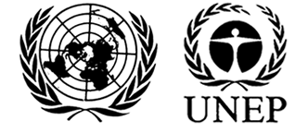 |  |  | MC
 |  |  | UNEP/MC/COP.6/INF/24
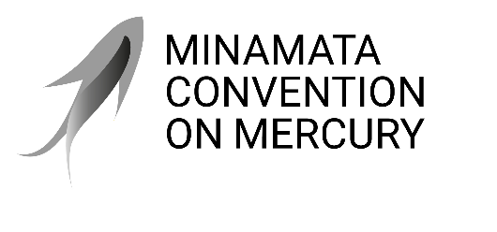 |  |  | Distr.: General  2 September 2025  English only
Conference of the Parties to the
Minamata Convention on Mercury
Sixth meeting
Geneva, 3–7 November 2025
Item 4(j) of the provisional agenda*
Matters for consideration or action by the Conference of the Parties: cross-cutting matters: implementation of decision MC-5/1
Report on the results of the survey on the needs and priorities of Indigenous Peoples, as well as local communities, with a view to future work on identifying possible solutions**
Note by the secretariat
The annex to the present note sets out a report on the results of the survey on the needs and priorities of Indigenous Peoples, as well as local communities, with regard to the effects of mercury on their health, livelihoods, culture and knowledge. The report was prepared by the secretariat pursuant to paragraph 4 of decision MC-5/1.
Annex
Report on the results of the survey on the needs and priorities of Indigenous Peoples and local communities
I. Introduction
- Decision MC-5/1, paragraph 4, requested the secretariat, subject to the availability of resources, to compile views, and to report to the Conference of the Parties at its sixth meeting on the needs and priorities of Indigenous Peoples, as well as local communities, with regard to the effects of mercury on their health, livelihoods, culture and knowledge, with a view to future work on identifying possible solutions.
- The secretariat developed a survey to compile the views of Indigenous Peoples as well as local community organizations. The survey was informed by the analysis in the note by the secretariat on the needs and priorities of Indigenous Peoples and local communities regarding the use of mercury in artisanal and small-scale gold mining (UNEP/MC/COP.5/INF/8). The note outlined the diverse impacts of mercury use in artisanal and small-scale gold mining (ASGM) on Indigenous Peoples and local communities and provided an initial framework of priority intervention areas, which was further refined and elaborated in the survey to allow respondents to rank their specific priorities based on their unique contexts.
- On 18 December 2024, an invitation to participate in the survey was sent to Indigenous Peoples’ organizations, local community organizations, relevant Intergovernmental Organizations and stakeholders. The survey was prepared in Bahasa Indonesia, English, French, Portuguese, and Spanish. It was also posted on the Minamata Convention on Mercury website. Respondents had until 28 February 2025 to complete the survey.
- A total of 171 responses from 33 countries were received by the deadline. The responses were from organizations in the following countries: Belgium (1), Bolivia (Plurinational State of) (1), Brazil (26), Burkina Faso (1), Cameroon (1), Canada (2), Colombia (1), Democratic Republic of the Congo (9), Dominican Republic (1), Eswatini (1), Finland (1), Honduras (2), India (1), Indonesia (13), Kenya (2), Liberia (1), Madagascar (1), Mexico (66), Nepal (1), Nigeria (4), Pakistan (1), Panama (1), Papua New Guinea (1), Peru (6), Philippines (6), Suriname (2), Tanzania (United Republic of) (2), Uganda (2), United States of America (8), Venezuela (Bolivarian Republic of) (4), Yemen (1), Zimbabwe (1).
- Of the 171 respondents, 151 were from Indigenous Peoples’ organizations and 18 from local communities. Figure 2 below indicates the percentage of Indigenous People’s organization and local community organization respondents and Figure 3 show female and male distribution of respondents.
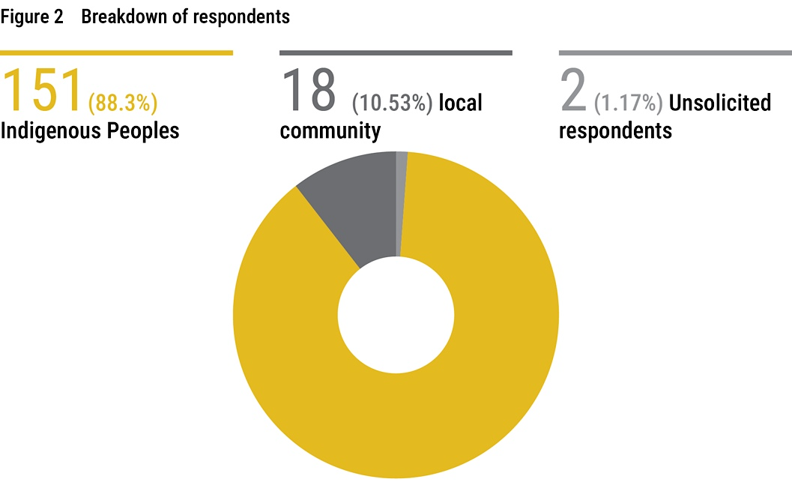

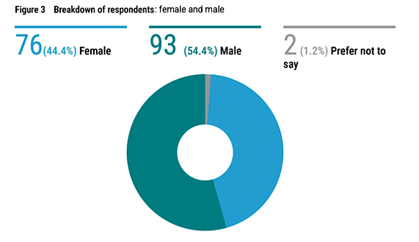
II. Survey structure
- The survey (see Annex A for a copy of the survey) listed a total of 35 Indigenous and community needs in relation to mercury pollution under the following 10 categories:
  - Food and water security
  - Environmental protection and restoration
  - Awareness-raising among community members, especially women of child-bearing age
  - Medical and social services
  - Income generation and livelihoods
  - Law enforcement
  - Human rights
  - Knowledge and spiritual and cultural identity
  - Effective participation and engagement in work under the Minamata Convention on Mercury
  - Others
- At the start of the survey, respondents were asked whether they were aware of any source of mercury pollution located near the communities which their organization represents or work with, and whether their organization was currently working on, or plans to work, on issues related to mercury, including trade, use and impacts on health, livelihoods, culture and knowledge of the communities and its members.
- Following the preliminary questions, respondents were asked to assign a score by level of priority, the needs listed in the survey. The scoring scale ranged from 0 to 10, where '0' indicates that the need is not a priority, '5' indicates medium priority, and '10' indicates urgent priority. It should be noted that any score from 1 to 10 reflects that the need is considered a priority; only a score of '0' signifies that the need is not a priority."
III. Survey results and observations
A. Survey results
- The results of the first two questions of the survey are reflected in the charts below. The number of responses received for each item are indicated in the respective coloured boxes of the charts:
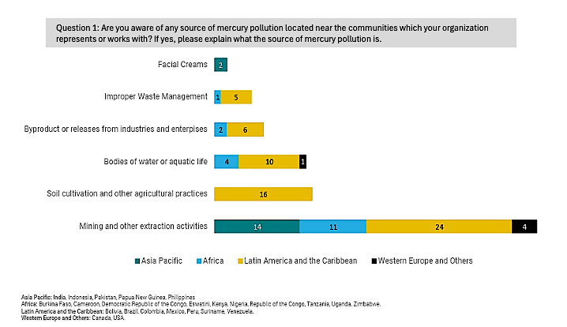
- The following charts show the responses of Indigenous People and local community respondents to each of the needs:
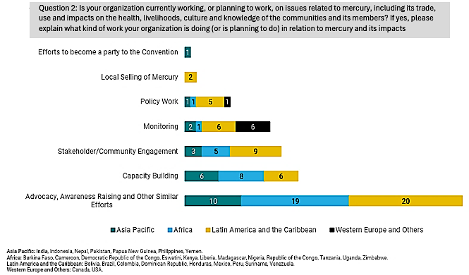

  - Food and water security
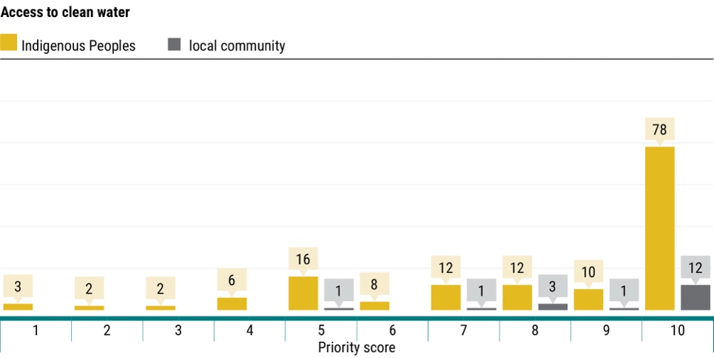
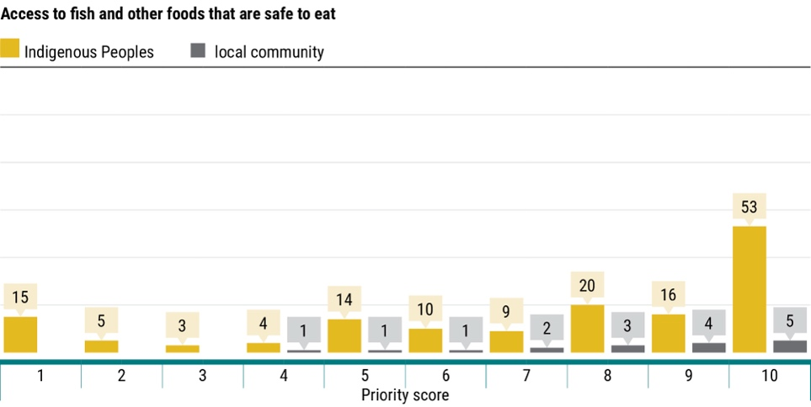
  - Environmental protection and restoration
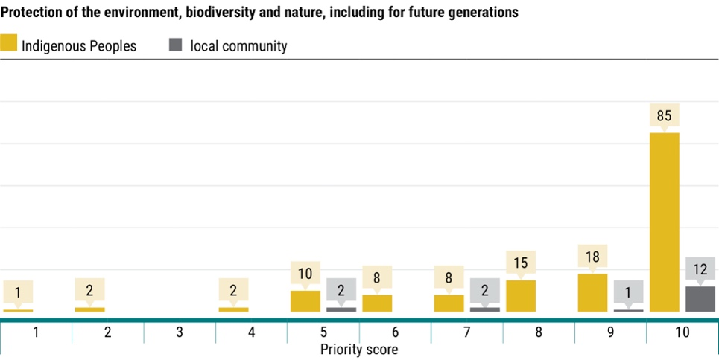
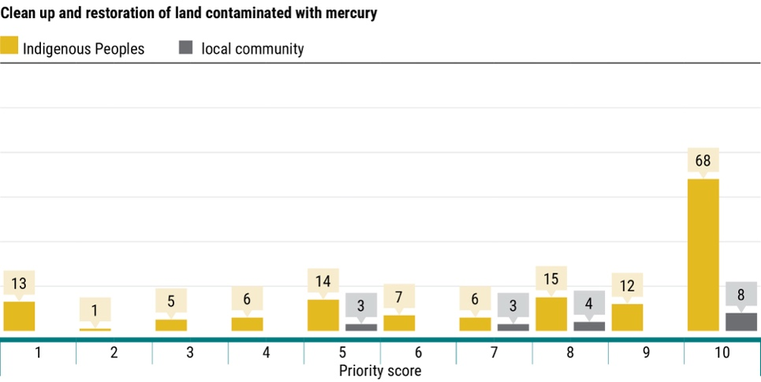
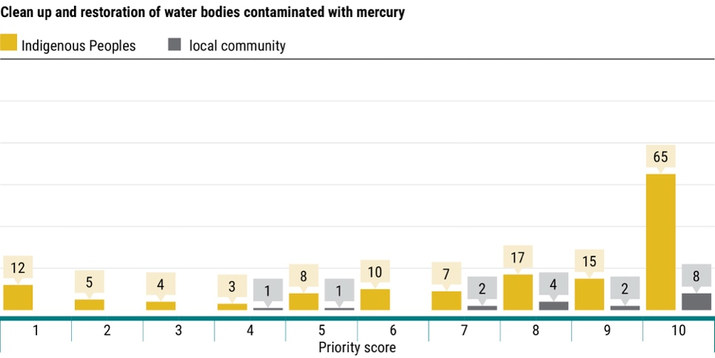
  - Awareness raising among community members, especially women of child-bearing age
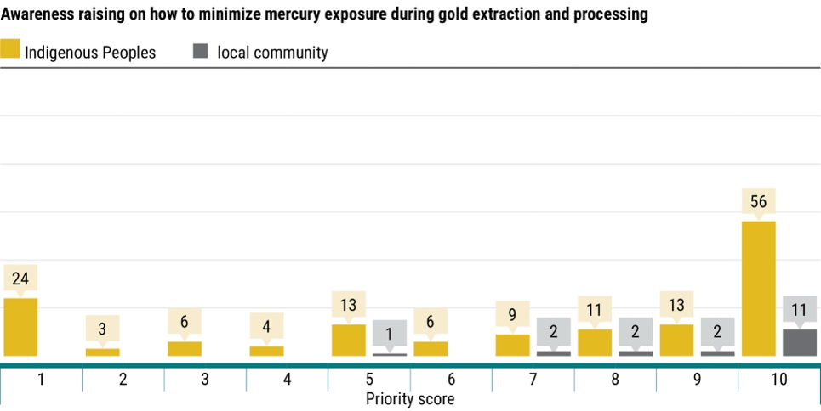
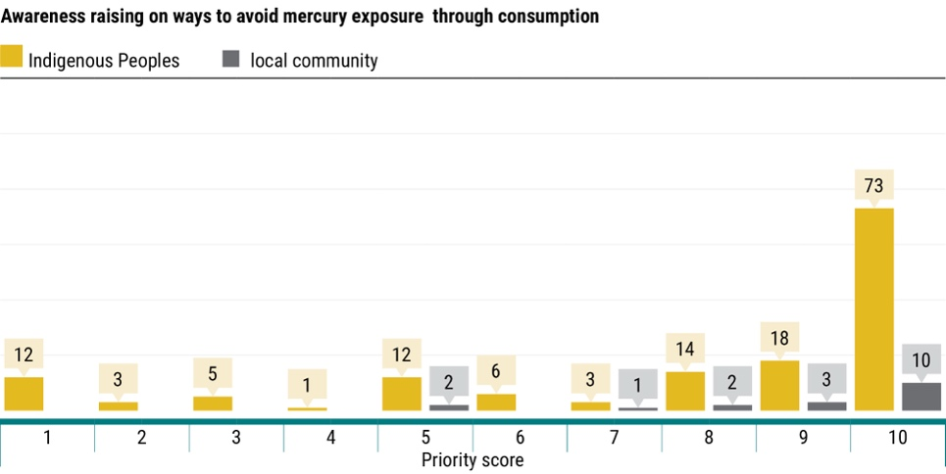
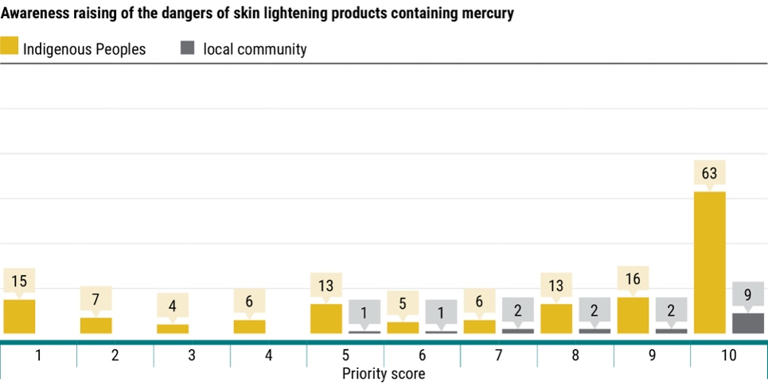
  - Medical and social services
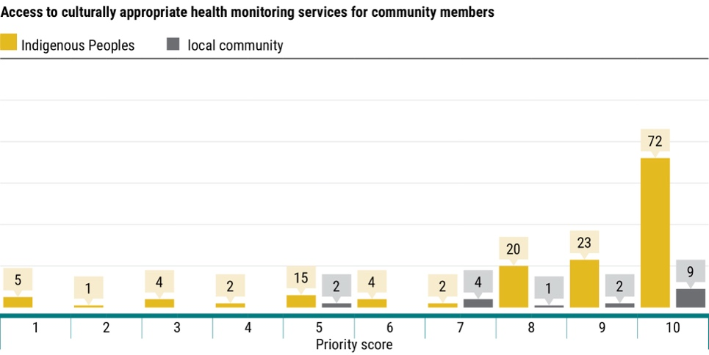
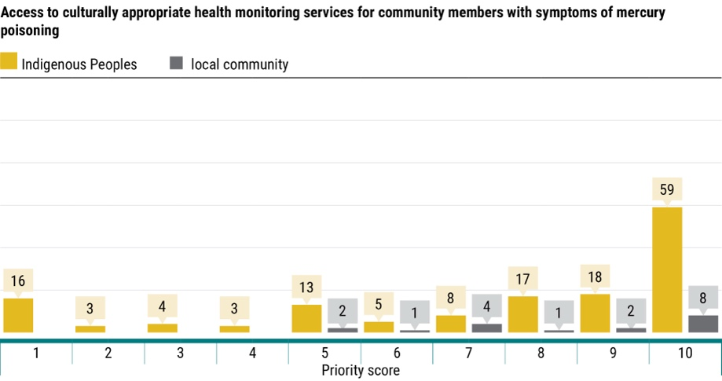
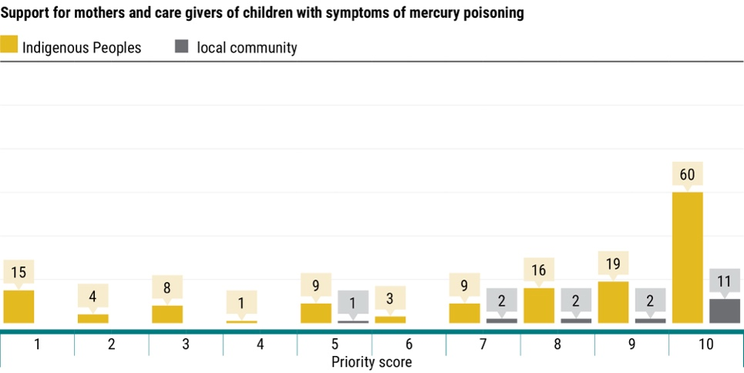
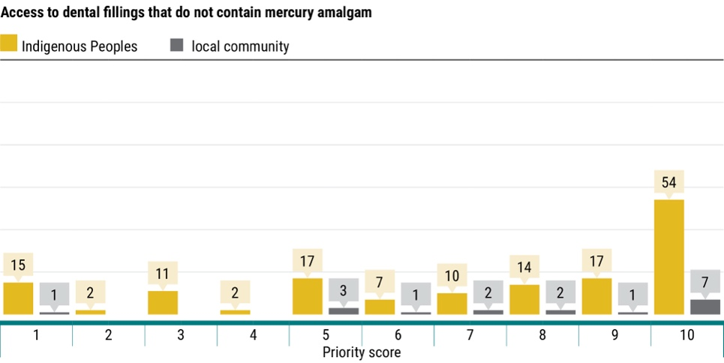
  - Income generation and livelihoods
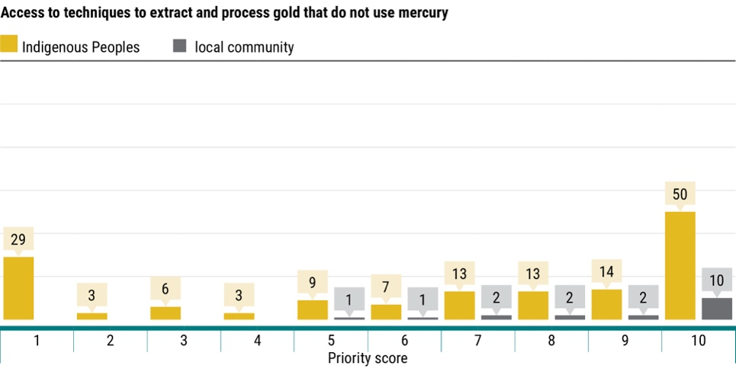
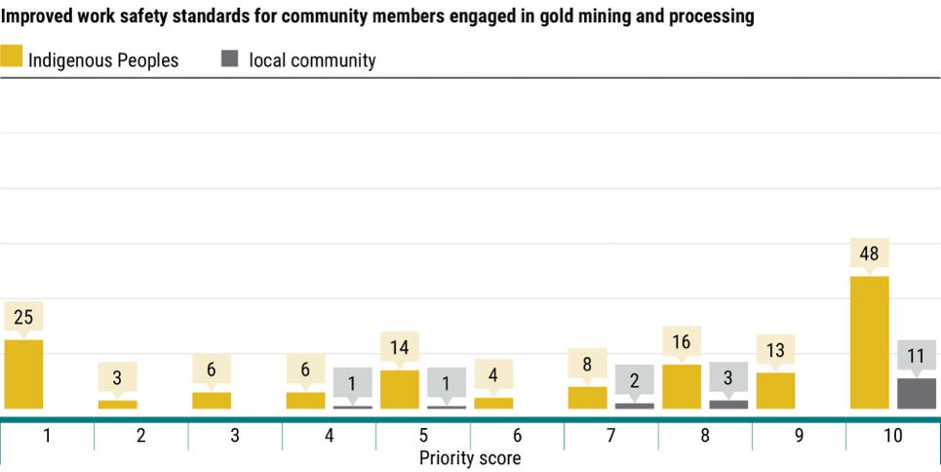
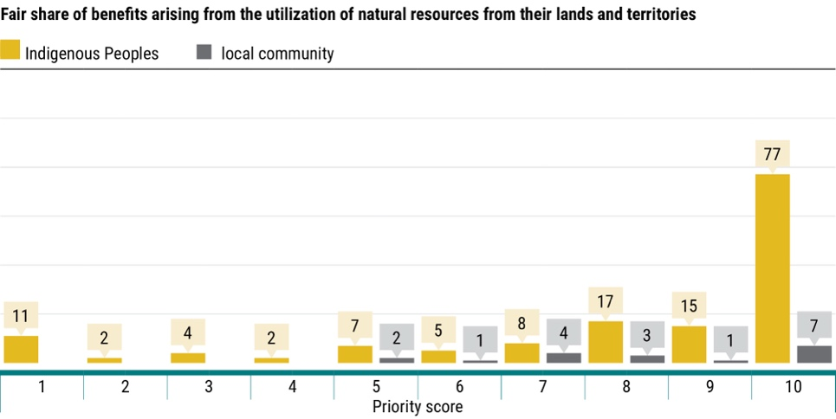
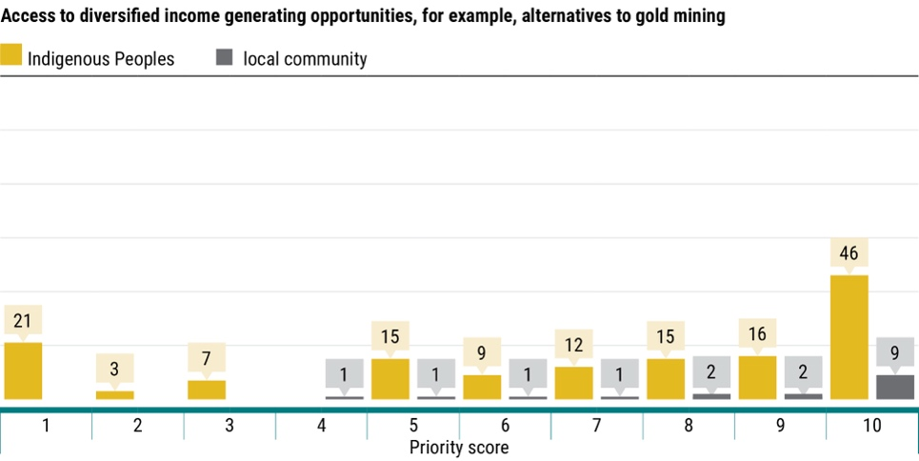
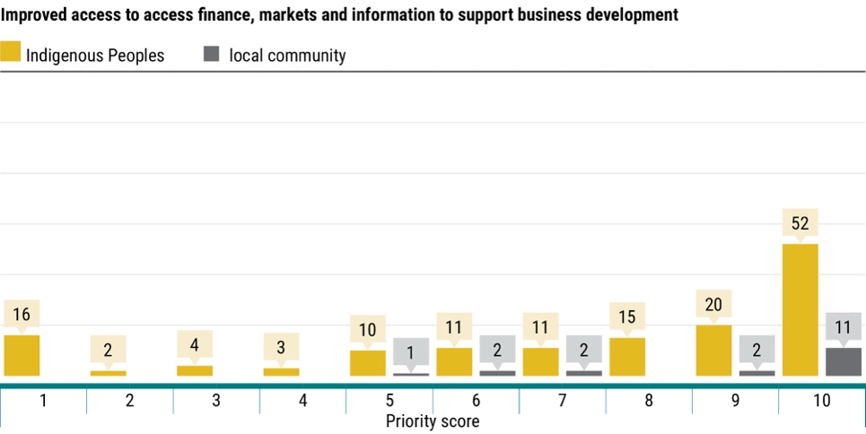
  - Law enforcement
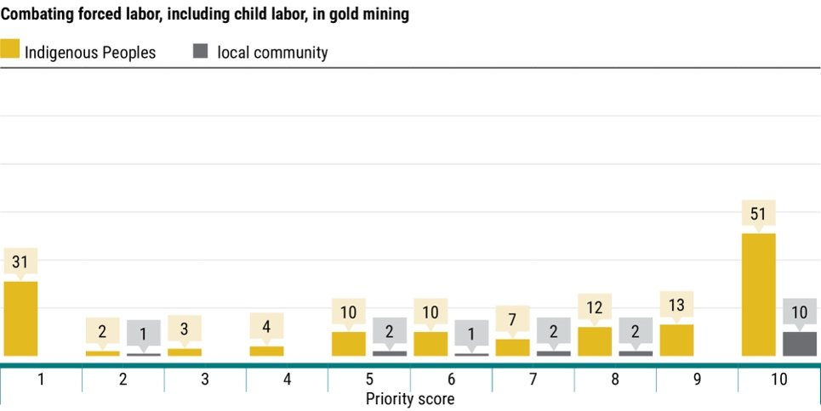
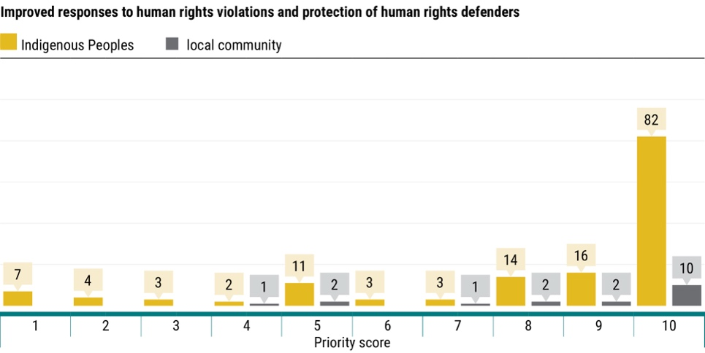
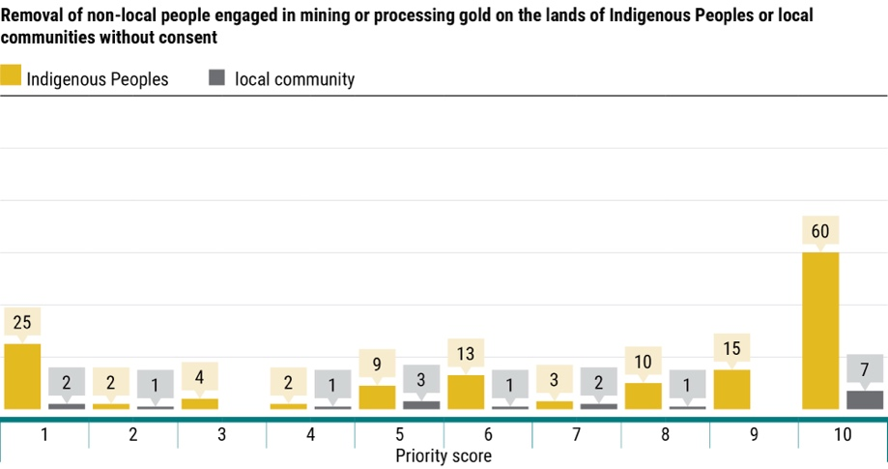
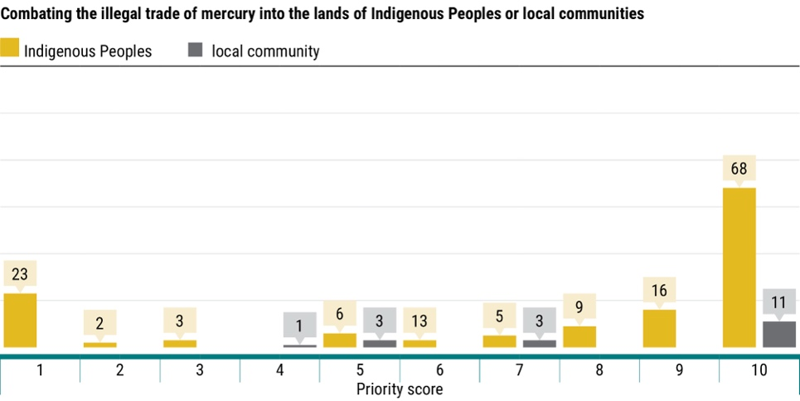
  - Human rights
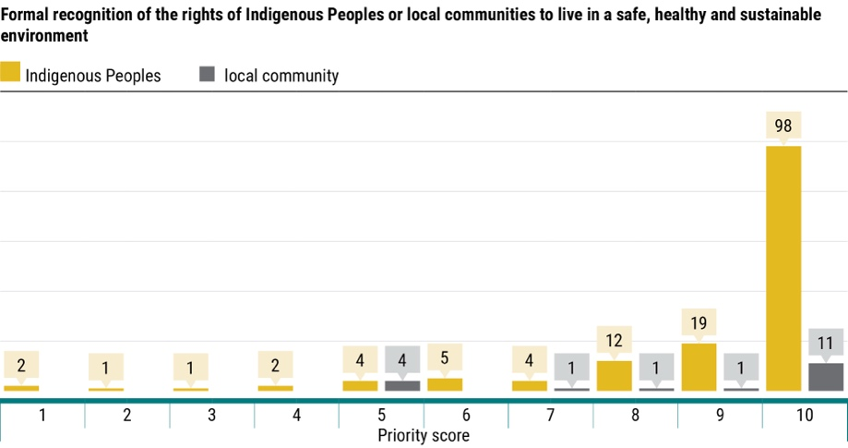
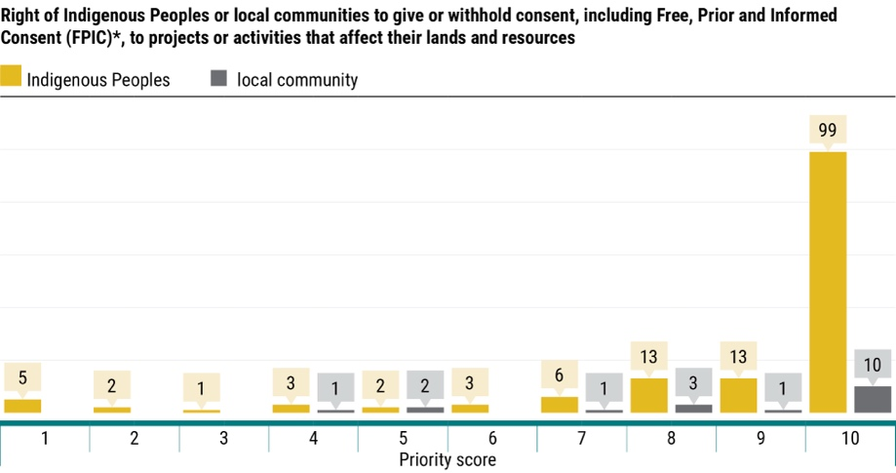
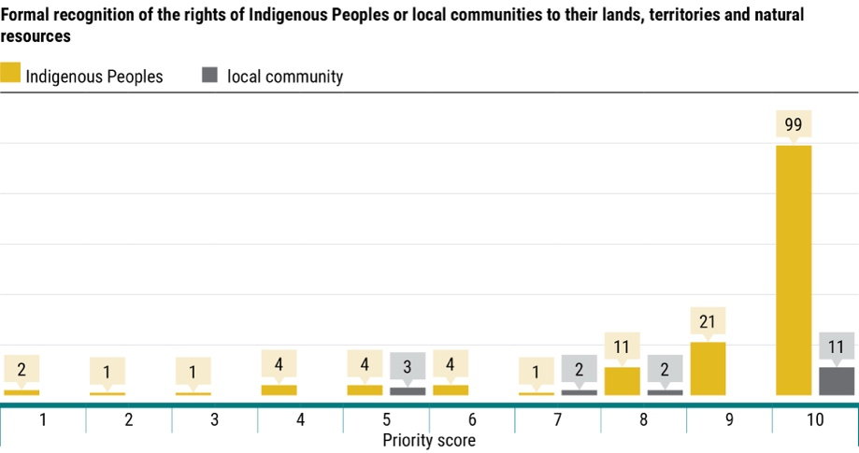
  - Knowledge and spiritual and cultural identity
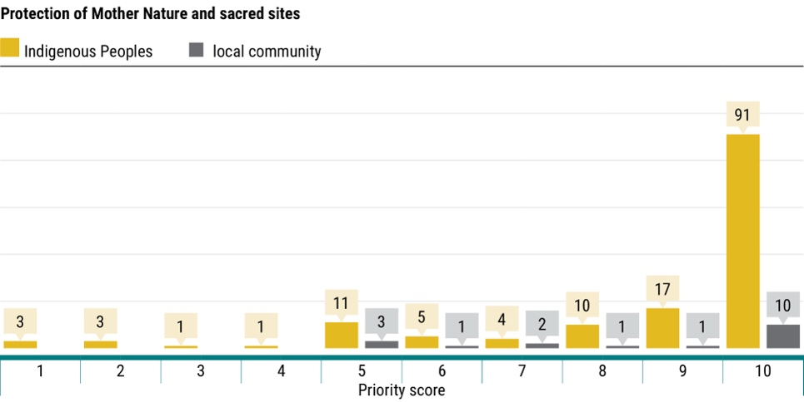
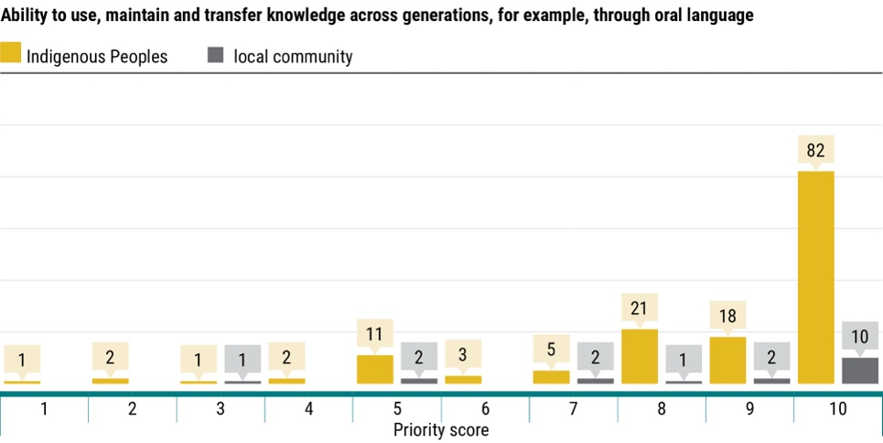
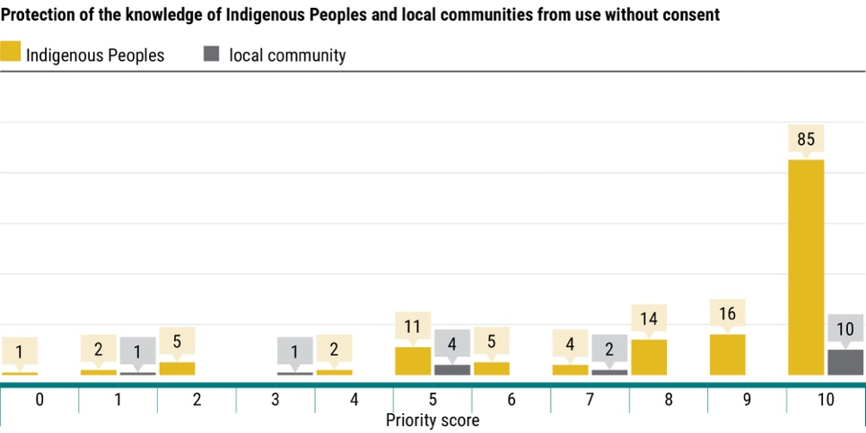
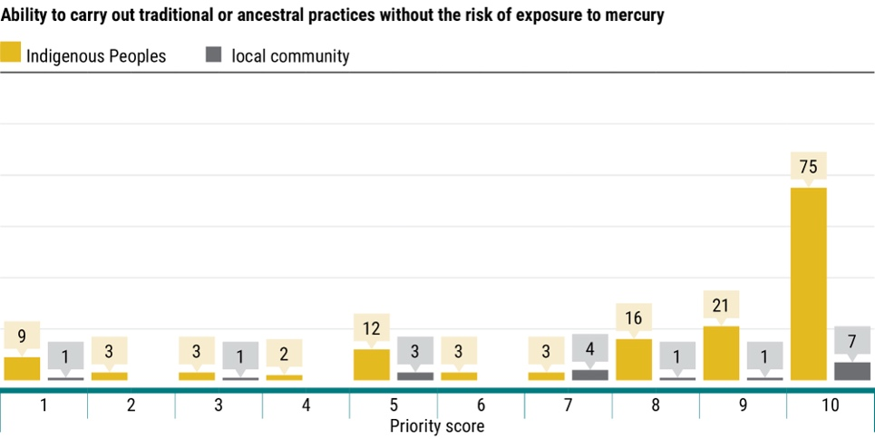
  - Effective participation and engagement in work under the Minamata Convention on Mercury
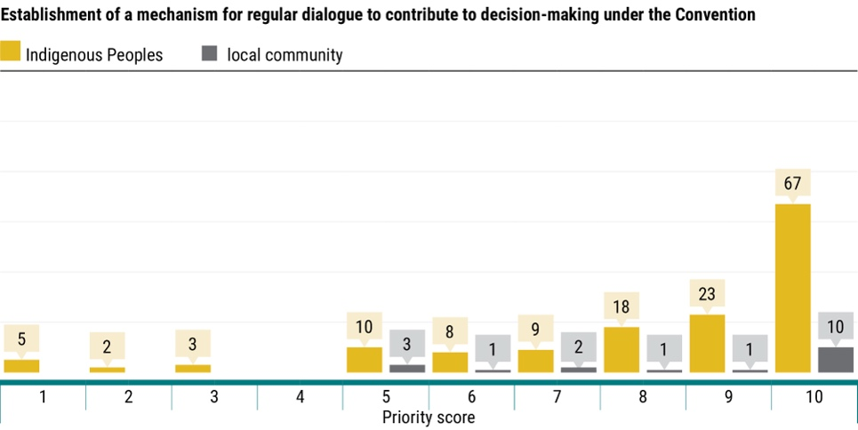
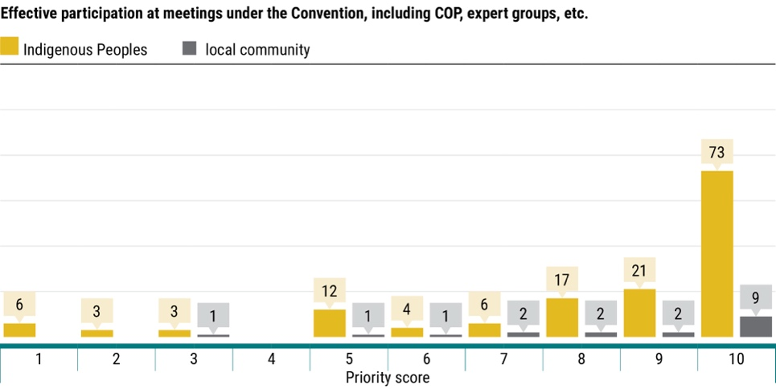
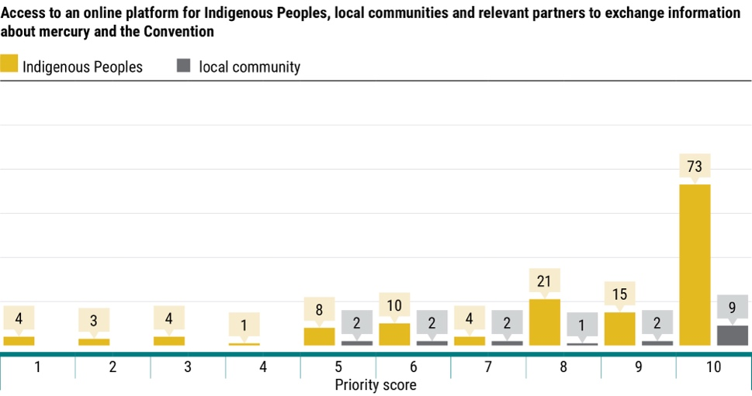
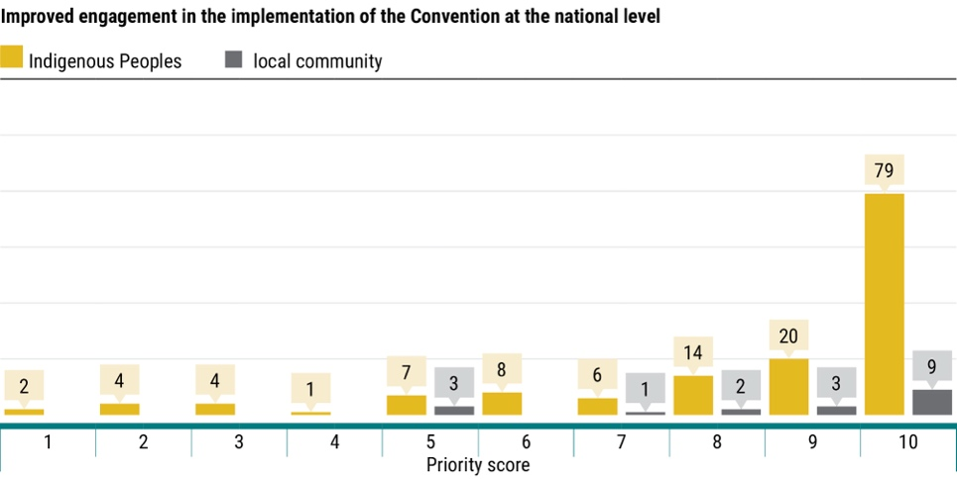
- The following other needs were listed by the respondents in addition to those mentioned in the survey:
- Make Indigenous Peoples, as well as local communities, a priority for governments.
- Include Indigenous Peoples, as well as local communities, in decision-making
- Eliminate mercury use.
- Eradicate mining.
- Provide assistance in policy and legal frameworks.
- Provide assistance in organizing and formalizing mining communities.
- Provide technical and financial assistance.
- Conduct regular mercury monitoring of the environment or conduct inventory of mercury sources and notify communities of results.
- Conduct human biomonitoring for mercury
- Provide capacity building or training to communities.
- Provide specialized medical care, including diagnosis, treatment and follow-up.
- Strengthen local health systems to respond to special needs of communities.
- Sustainable or environmentally sound waste management.
- Provide economic opportunities to communities so they do not have to rely on mining.
- Prevent tailings dam failure.
B. Observations
- All of the needs enumerated under the “human rights” category received a consistent high ranking, followed by those under the categories “knowledge and spiritual and cultural identity”, and “effective participation and engagement in the work under the Minamata Convention on Mercury”.
- The priorities ranked lower than those in the three categories mentioned above were closely clustered together. The marginal nature of those differences suggests that respondents perceive all the areas included in the survey as important, with a majority of respondents’ ranking reflecting subtle variations.
- Of the 151 Indigenous respondents, only one respondent indicated that a need is not a priority by assigning it a rank of “0”, “protection of the knowledge of Indigenous Peoples and local communities from use without consent.”
- In response to question 1 of the survey, which asked respondents to identify sources of mercury pollution near the communities they work with, 53 reported awareness of mercury from mining activities, while only 2 mentioned mercury in skin-lightening creams. The disparity in the responses on the awareness of mercury sources may have likely influenced the prioritization of needs and highlights a potential gap in awareness that can be addressed through targeted outreach on mercury sources beyond artisanal and small-scale gold mining.
- Needs related to the effective participation and engagement of Indigenous Peoples and of local communities in the Minamata Convention’s received consistently high ranking from respondents, which indicates a strong interest in engaging in the work under the Convention.
- The participation of only 18 local community respondents represents a limited sample size, highlighting the need for broader engagement efforts with these communities.

* UNEP/MC/COP.6/1/Rev.1.
** This document has not been formally edited.

