UNITED  NATIONS | 

UNEP/MC/COP.6/INF/23

 |  | Distr.: General  31 October 2025  English only

Conference of the Parties to the
Minamata Convention on Mercury
Sixth meeting
Geneva, 3–7 November 2025
Item 4 (i) of the provisional agenda*
Matters for consideration or action by the Conference of the Parties: effectiveness evaluation
Update on the work of the Open-ended Scientific Group**
Note by the secretariat
- The Conference of the Parties to the Minamata Convention on Mercury, in decision MC-4/11, established the Open-ended Scientific Group (hereinafter referred to as the “Group”) to develop a scientific report and draw conclusions thereon for the consideration of the Effectiveness Evaluation Group. This document provides an update on the work of the Group after the fifth meeting of the Conference of the Parties.
- The Group is co-chaired by Alexandra Steffen (Canada) and Dominique Bally Kpokro (Cote d’Ivoire). During the intersessional period between the fifth and sixth meetings of the Conference of the parties, the Group met online 10 times and held the second face-to-face meeting from 17 to 21 March 2025 in Minamata, hosted by Japan.
- The Group had started collecting data on mercury monitoring, emissions and releases in line with the plans submitted to the Conference of the Parties, by inviting parties and observers to identify relevant data and express an intent to submit data. Having received expressions of intent to submit data from 36 individuals from 15 parties, the secretariat issued on 31 May 2024 a renewed call for expression of intent to parties and observers. The Group also reached out to potential data providers and collected some datasets available through open-access internet sites and published literature. The collected data were stored in an online data repository established by the secretariat with the support of the Biodiversity Research Institute.
- In compiling, analysing and synthesizing the collected data, as well as identifying data gaps and lessons learned, the Group worked in the following seven teams:
- Air monitoring team
- Biota monitoring team
- Human biomonitoring team
- Other media monitoring team
- Emission and release team
- Integrated analysis team
- Future vision team
- The Group developed a draft report Overview of monitoring, emission and release data, which was posted on the Convention website for review and comments by parties on 24 June 2025, as well as submitted to the Effectiveness Evaluation Group. The deadline for comments was 24 July 2025. Comments were received from two parties. The report, revised based on the comments, is set out as the annex to the present note.
- The co-chairs attended seven online meetings of the Effectiveness Evaluation Group as observers, in line with its terms of reference.
- The Group is currently developing the scientific report, called for in decision MC-4/11, to be made available for review by parties in December 2025. The scientific report addresses the following questions, as set out in the Group’s data analysis plan:
  - Current levels
    - What are the current levels of Hg emissions and releases and levels of Hg observed in air, biota, humans, and other media in sites that are
      - remote from anthropogenic sources?
      - affected by local anthropogenic sources?
  - Temporal trends
    - How have levels of Hg emissions and releases and Hg observed in air, biota, humans, and other media changed over the available record?
    - How do those changes compare to the timeline of the Minamata Convention?
    - What specific mitigation measures have contributed to changes in emissions and releases?
    - How are levels of Hg emissions and releases and Hg observed in air, biota, humans and other media expected to change in the future?
  - Spatial patterns
    - How do current levels and temporal trends vary geographically at the global scale?
  - Source or process attribution
    - What is the fractional contribution of contemporary anthropogenic emissions and releases to current Hg levels observed in air, biota, humans, and other media?
    - How have these contribution levels changed over the timeline of the Minamata Convention?
    - How do the contribution levels and their trends vary geographically at the global scale?
    - How have drivers other than changes in emissions and releases contributed to the trend in observed Hg levels?
  - Exposure and adverse impacts
    - How do current levels of Hg observed in air, biota, humans, and other media compare to levels in established guidelines, as well as to observed and projected thresholds for effects to humans, other living organisms and biodiversity based on recent research and knowledge?
    - How do changes in Hg levels over the timeline of the Minamata Convention compared to those guideline levels and effect thresholds?
  - Process understanding
    - How consistent are current levels, temporal trends, and spatial patterns of Hg emissions and releases and Hg levels in air, biota, humans, and other media with estimates from current mechanistic models?
- The Group also worked on an analysis of data gaps and lessons learned, as mandated in the Group’s terms of reference.
- The progress on the draft scientific report was presented at an online session on 15 October 2025. The draft scientific report will be made available for review by parties on the Convention website.

Annex
Overview of monitoring, emission and release data
I. Introduction
- The Open-Ended Scientific Group (OESG) of the Minamata Convention, in accordance with its mandate in decision MC-4/11, developed plans for collecting available data on mercury emissions and releases and mercury levels in air and other abiotic environmental media, biota, and humans as set forth in UNEP/MC/COP.5/INF/24. This document presents an overview of the data collection process as it has been carried out and a summary of the data that the OESG has been able to identify and collect. The summary is organized to inform Parties of the data that has been collected from each country, which will serve as the basis for the OESG to develop the scientific report by analyzing and synthesizing the data addressing the questions identified in its data analysis plan set forth in UNEP/MC/COP.5/INF/24.
- Parties were invited to provide comments about the data that has been collected or identified and, if appropriate, to identify additional data sources. Comments were received from two parties. Additional data identified during the comment process, as well as those collected by OESG, are to be acknowledged in the OESG’s scientific report and incorporated into the data analysis.
II. Data collection process
- The OESG began collecting data by inviting Parties to identify relevant data and express an “intent to submit” data to the OESG process. On 26 September 2023, the Executive Secretary of the Minamata Convention issued a letter to the national focal points and observer organizations to the Conference of the Parties to invite them to submit an expression of intent to provide data by 20 October 2023. The following types of data were listed in the letter: national inventories of mercury emissions to air and releases to land and water and observational data for mercury levels in air, biota (animals and plants), humans, soil, sediments (including sediment cores), fresh water, and ocean water. Potential providers of data were invited to submit a brief description of the dataset, along with data type, time span, geographic scope, and conditions for use of the data. This information was originally requested using a Microsoft Word or Portable Document Format (pdf) template, but was later converted to an online Microsoft Form.
- The secretariat, with the support of the Biodiversity Research Institute, established an online data repository where data submissions can be collected for use by the OESG. Those who submitted an expression of intent were invited to submit data using data format templates developed by the OESG, or alternatively submit data in their own format providing sufficient documentation so that the OESG can compile the data with other submissions. Data providers were also requested to submit a data use authorization form (implemented through Microsoft Forms), giving permission to the OESG and participating experts to use the submitted data for purposes of the effectiveness evaluation and indicating any specific data use restrictions. The OESG and participating experts accessing the data submitted to the repository were required to sign a complimentary agreement to abide by the data use restrictions identified by data providers. Within the online data repository, a process was established to track contact with potential data providers, record data that was submitted and its associated data use restrictions, identify quality or completeness issues, and track any reformatting or other transformations performed on the submitted data.
- The secretariat received expressions of intent to submit data from 36 individuals from 15 Parties in response to its initial invitation. Expressions of intent were not submitted for many existing data sets that the OESG had identified in their data collection plans. On 31 May 2024, a renewed call for expression of intent was sent to national focal points and observers, and the OESG and participating experts began more actively reaching out to potential data providers and collecting some datasets available through open-access internet sites and published literature. The OESG data collection effort was highlighted at the International Conference on Mercury as a Global Pollutant in Cape Town, South Africa, 21-26 July 2024.
- The effort to collect available data has been limited by the time and resources available to support the data collection process, the lack of harmonized data reporting formats and existing infrastructure for data management, and limited awareness of Convention activities in the relevant national and international scientific communities.
- The data that has been identified and collected in this process can been divided into two categories:
- Received or Acquired: This category includes data that has been submitted to or obtained by the OESG. For each analysis question, the OESG and participating experts will assess each of the datasets in this category in terms of its completeness and quality to determine whether the data is fit for the purpose of addressing the analysis question. The criteria used to determine which data to include in a particular analysis will be described for each analysis question.
- Identified: This category comprises data for which the sources have been identified but for which the data is not available for analysis at this time. This category includes data that has been submitted to or obtained by the OESG, but that is either insufficiently complete or requires reformatting or transformation that is not possible to complete at this time; data that was identified through an expression of intent to submit, but that has not been submitted; or data that has been identified or obtained by the OESG for which OESG has not been granted permission to use the data in their analysis.
- Annex I, available on the Convention website, provides links to the online documents developed to implement the process, including the intent to submit form, the data use agreement for the provider, the data use agreement for the analysts, and the data format templates and instructions.
III. Summary of data available
- The available data is summarized below in separate sections for mercury emissions to air, mercury releases to land and water, and observations of mercury in air, biota, human populations, marine water, soil, water (inland and estuary), freshwater sediment cores, peat cores, ice cores, and tree rings. Annex II, available on the Convention website, provides a listing of the individual datasets that are available in each of these categories sorted by country to facilitate Party review and comment.
A. Emissions
- There is more data on emissions of mercury to air compared to releases of mercury to land and water. Data available for Hg emissions to air include: Pollutant Release and Transfer Registries (PRTRs), the Minamata Initial Assessments (MIA), the Convention on Long-range Transboundary Air Pollution (CLTRAP) database, the Global Mercury Assessment (GMA), and the Emissions Database for Global Atmospheric Research (EDGAR). Of these, EDGAR provides the most robust/holistic data set for trend analysis. However, some countries have detailed inventories that may be more accurate, particularly for specific sectors or source types.
- The EDGAR Global Mercury Emissions v8.1, which provides mercury emissions across all countries for the period from 1970 to 2022, is available at https://edgar.jrc.ec.europa.eu/dataset_tox81. It includes total mercury (Hg) and mercury species, i.e. gaseous elemental mercury (Hg0), gaseous oxidised mercury (Hg2+) and particle-bound mercury (Hg-P). It provides yearly and monthly time series of emissions by sector and country and gridded emissions maps at a 0.1 x 0.1-degree global resolution. These emissions are aggregated according to IPCC 2006 and 1996 classifications and the Minamata recommendations.
- The methodology for mercury emissions estimation in EDGAR aligns primarily with the recommendations from the Long-Range Transboundary Air Pollution Convention and the EMEP/EEA guidebook., The mercury emissions are provided for the key emitting anthropogenic sources. The trends by IPCC continental region for the period 2010-2020 are shown in Figure 1.
- Regions with increasing mercury emissions, such as Africa, Latin America and the Caribbean, and South-East Asia, are characterized by significant growth in the artisanal and small-scale gold mining (ASGM) sector, which contributes substantially to their total emissions. Conversely, regions like North America and Europe, which have reduced emissions, have managed significant reductions in the power generation sector and other industrial activities. The Asia-Pacific Developed and Middle East IPCC continental regions were not included in this analysis because their contributions to the total global mercury emissions are small (<2%).
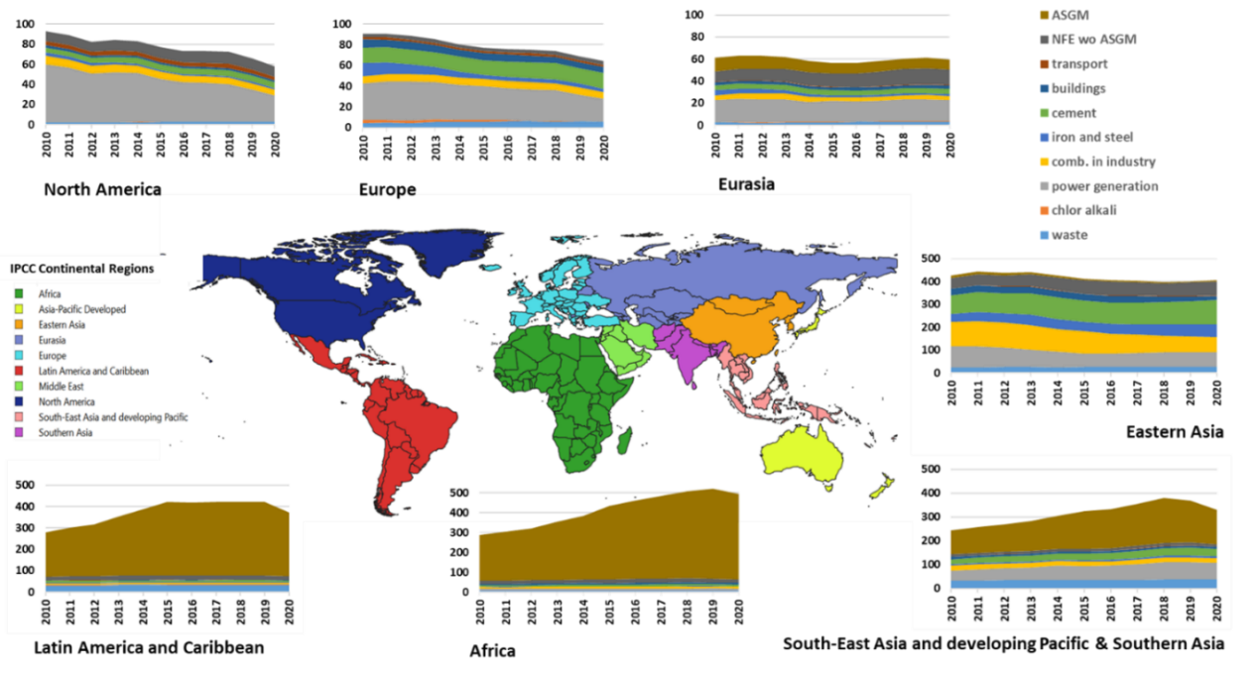
Figure 1. EDGAR mercury emissions in tonnes per year by IPCC continental region for the period 2010-2020.
- The purpose of EDGAR inventory is to complete the global picture with emissions time-series for each country and global grid maps. This helps in understanding trends in global emissions by sector and identifying emissions hotspots and top emitters. EDGAR contributes to enhanced transparency and provides an additional source with which national and other global estimates can be compared. The granularity of EDGAR allows meaningful comparisons that can foster a better understanding of the differences in the methodologies, emissions factors used, and sectors/sub-sectors included or missing in different air emissions inventories.
- EDGAR datasets and CLRTAP emissions for selected countries were compared to quantify differences. For most countries, the difference is significant and the CLTRAP emissions are higher. The trends between 1990 and 2022 and between 2014 and 2022 are also different for CLRTAP (decreasing) and EDGAR (increasing). E-PRTR also shows decreasing trend of emissions to air in Europe – 33.87 t/yr in 2007 to 16.05 t/yr in 2022. The trend in MIA inventories cannot be compared as most countries completed the inventory for a single year during the period 2015-2019.
- Sub-Saharan Africa, Latin America and the Caribbean and South-East Asia, are regions with ASGM activities. The increasing Hg emissions from these regions are a result of the significant growth in their ASGM sector. Literature reporting on the contribution of ASGM to Hg emission and releases from the ASGM sector has been very limited prior to the year 2000; but data on this sector increased rapidly from 2001 until recently. ASGM National Action Plans include baseline estimates of the use of mercury in this sector. These estimates are only for the base year, but since the implementation of Article 7 of the Convention is to be reviewed every three years, updated estimations are expected to become available in the future.
B. Releases
- United Nations Environment Programme (UNEP) Global Mercury Assessment 2018 provides estimates of mercury releases to freshwater environments.​ The GMA 2018 contains information on the distribution of the estimated global anthropogenic Hg releases to aquatic systems in 2015 according to sub-continental regions and per sectors (Oil refining, Mercury production, Large scale gold, Non-ferrous metal production (Al, Cu, Pb, Zn), Coal-fired power plants, Municipal waste water, Coal washing, Mercury-added products, Chlor-alkali (Hg cell). The methodology used for this estimation was the UNEP toolkit (levels 1&2) for the identification and quantification of emissions and releases of mercury and its compounds. As no update of global mercury release inventory was undertaken, the emission and release group of OESG is working to update the information using the same methodology.
C. Air
- Atmospheric mercury data has been collected as 3 types: 1) Total Gaseous Mercury (TGM) collected with active sampling methods; 2) Gaseous mercury collected with passive sampling methods; and 3) Total mercury in precipitation. The table in Annex II indicates the type of data submitted or collected, the country the data was collected in and the geographic scope of the data. Figure 2, Figure 3, Figure 4 show the locations of submitted data for TGM, precipitation and passive sampling, respectively. Figure 4 presents Gantt plots of the data availability timelines for the data received. It is understood that there is full speciated mercury data available as well as some other forms, but for the purposes of the first effectiveness evaluation scientific report, the data analysis will be limited to the 3 data types listed above.
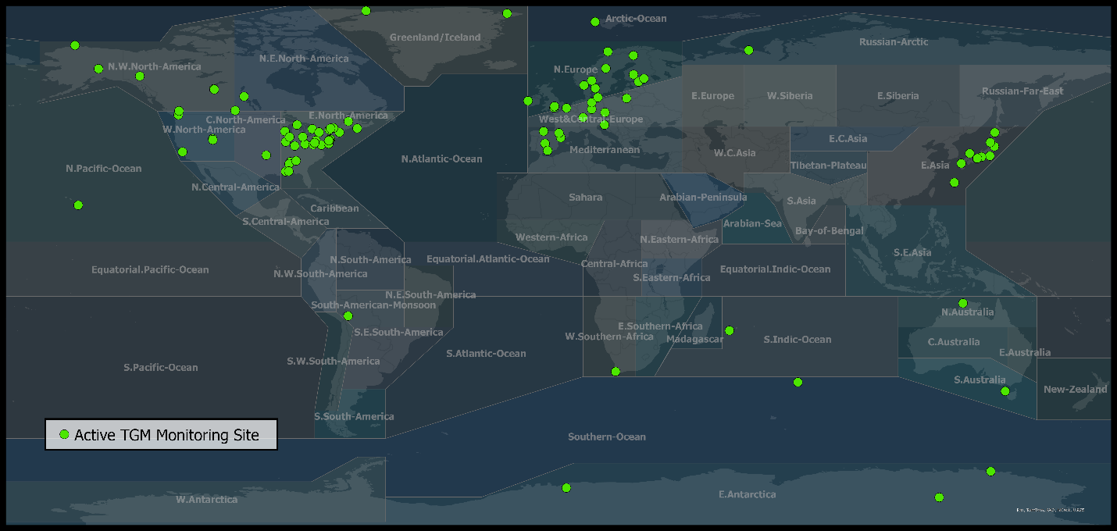
Figure 2. Active Total Gaseous Mercury (TGM) air monitoring data received or acquired for the purposes of the effectiveness evaluation scientific report.

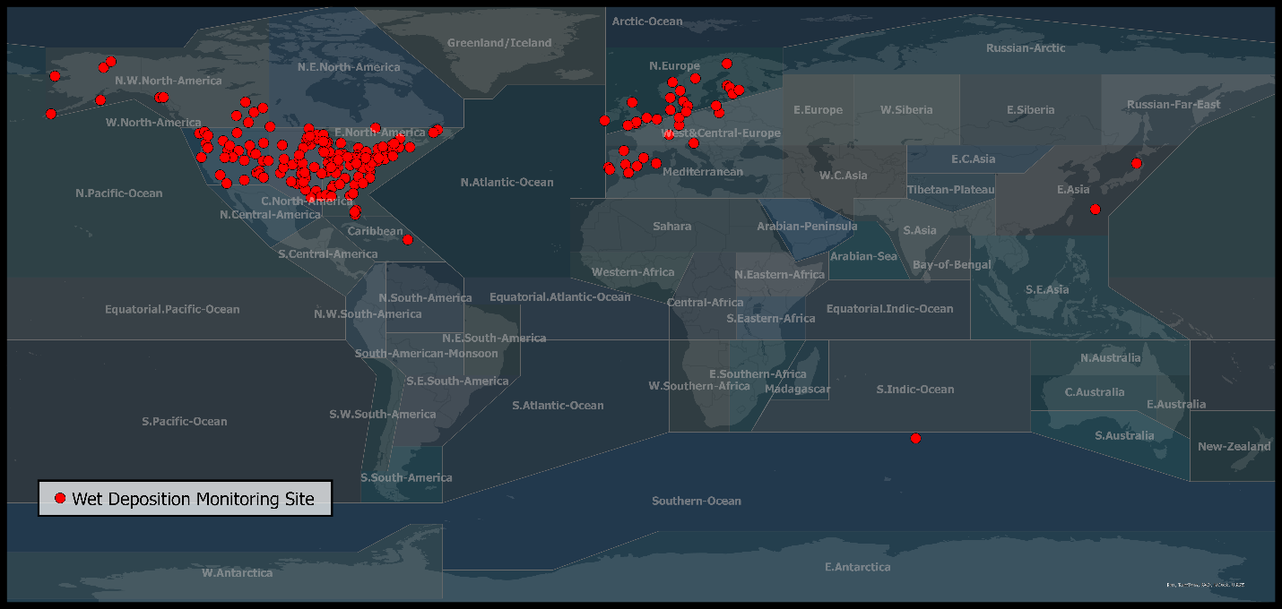
Figure 3. Mercury in precipitation data received or acquired for the purposes of the effectiveness evaluation science report.
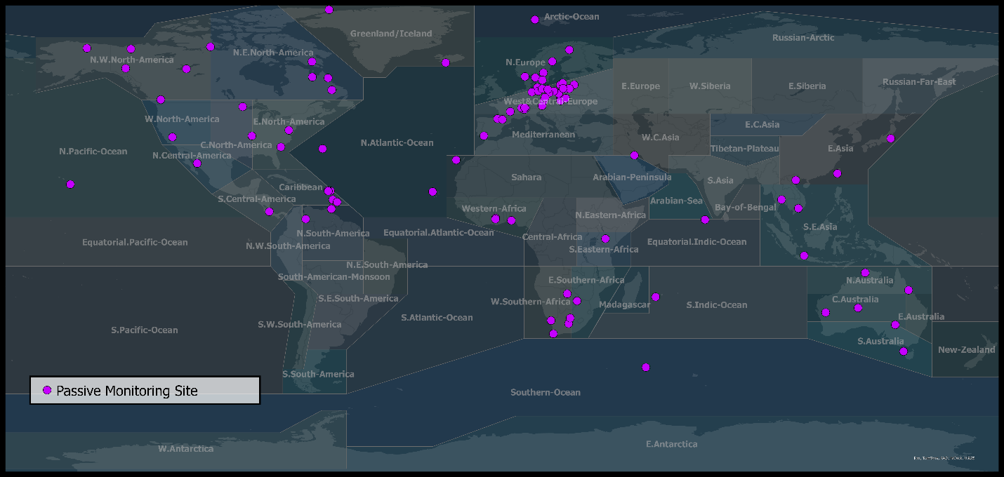
Figure 4. Gaseous mercury data from passive sampling methods received or acquired for the purposes of the effectiveness evaluation science report.
- The data has been consolidated in a database housed with Environment and Climate Change Canada for data consolidation, arrangement and analysis. This data consists of sets received from Parties and acquired from databases that include multiple countries and were publicly available. Countries for which data was received directly include Australia, Canada, Cote d’Ivoire, France, Japan, Ireland, Italy, Peru, South Africa, Sweden, Switzerland and the United States. Data was downloaded from the EBAS database, housed in Norway. Countries for which data was acquired via EBAS include Belgium, Czech Republic, Germany, Denmark, Estonia, Finland, Ireland, Latvia, the Netherlands, Norway, Poland, Portugal, Slovenia, Spain, Sweden and the United Kingdom. Further, data from passive sampling programs were acquired as a collection of data from Antigua, Austria, Australia, Barbados, Bermuda, Botswana, Canada, Cape Verde, China, Columbia, Costa Rica, Czech Republic, Finland, France, Germany, Ghana, Iceland, Indonesia, Italy, Japan, Kenya, Kuwait, Lithuania, Maldives, Mexico, Nigeria, Norway, Poland, Saint Lucia, St Kitts, Spain, South Africa, Sri Lanka, Sweden, Switzerland, Thailand, Trinidad, Vietnam, and United States..
- Some datasets that are known to exist were not accessible or made available; thus, the data from some countries is not included in this summary. Currently, data held in the GOS4M database were not accessible (due to the site being modified), and data from the Asia Pacific Mercury Monitoring Program (APMMN) has not yet been received, although members have committed to providing the data. Annex II indicates intentions to submit data that have not been received at the date of this report.
- An intensive search through known databases was conducted, and Figures Figure 7 and Figure 8 show the data that has been received or acquired, as well as the data known to exist but that has not been received, for TGM and precipitation data, respectively.
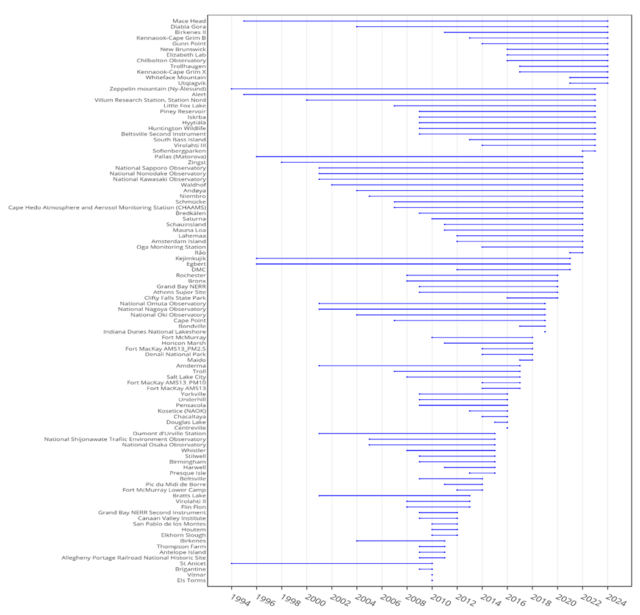
Figure 5. Gantt plot of time spans of data sets submitted for TGM (top), passive mercury in air (middle), and mercury in precipitation (bottom).
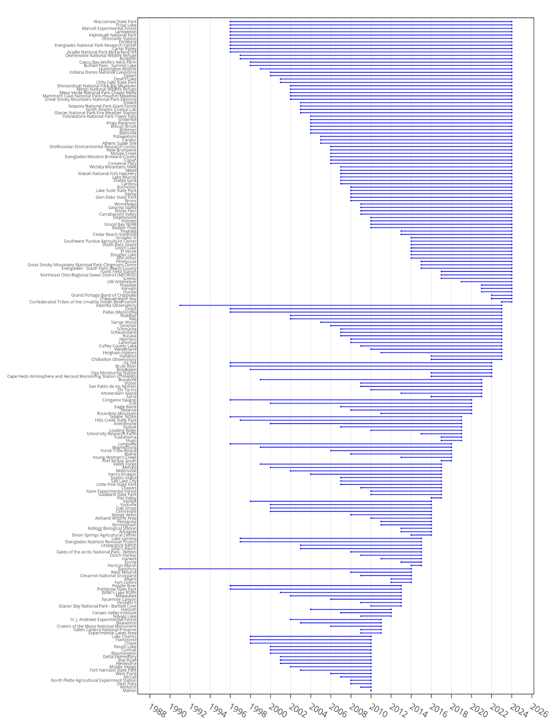
Figure 6. Gantt plot of time spans of data sets submitted for TGM (top), passive mercury in air (middle), and mercury in precipitation (bottom).

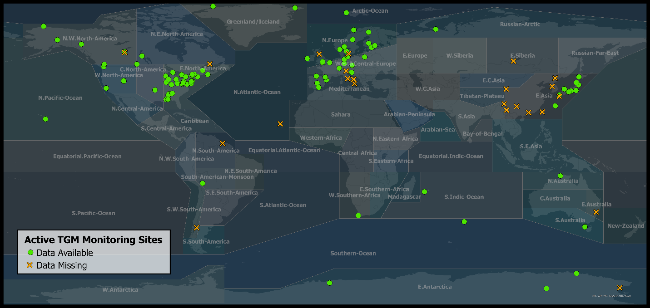
Figure 7. Total Gaseous Mercury (TGM) from active sampling that has been received or acquired (green dots) and those that have been identified but not received (orange cross).
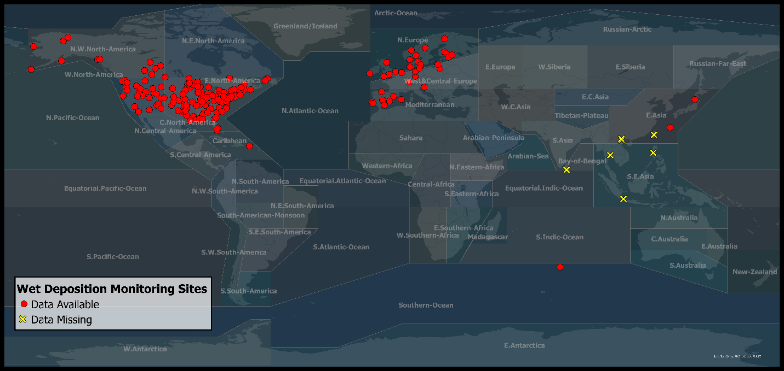
Figure 8. Total Mercury data from precipitation or wet deposition measurements that has been made received or acquired (red dots) and those that have not been received (yellow cross).
D. Biota
- Observations of mercury in various types of biota have submitted or acquired and potential sources of additional data have been identified. For purposes of comparison to these observed levels, toxicity benchmarks were also collected from a variety of sources. Each of these types of data is discussed below.

1. Received and acquired data
- The OESG has received 47 submissions on total and methyl mercury measurements across a range of taxa, including invertebrates, fish, amphibians, reptiles, birds, mammals, and plants. Most of the long-term biota time-series are associated with monitoring of different tissues and organs of marine species (invertebrates, fish, seabirds and higher trophic level species, including marine mammals) or freshwater fish and terrestrial birds. However, data on mercury concentrations in amphibians (3 observations) and aquatic plants (28 observations) remains limited. For the purpose of the first cycle of the effectiveness evaluation scientific report, the data analysis will focus on total mercury measurements in invertebrates, fish, birds, reptiles, and mammals.
- Several multinational monitoring programs, including the Arctic Monitoring and Assessment Programme (AMAP), the Oslo and Paris Convention for the Protection of the Marine environment of the North-East Atlantic (OSPAR), and the Helsinki Commission (HELCOM), together with national and subnational organizations from Canada, the United States, Norway, France, Finland, Switzerland, the Netherlands, the United Kingdom, Germany, Peru, Australia and Japan have contributed data to the temporary OESG repository. The Biodiversity Research Institute (BRI) has provided data spanning 37 years, derived mainly from about 1648 published articles, covering a diverse range of taxa and tissue types. The collected data represent a compilation of repeated monitoring activities and scientific research projects.
- Most biota datasets were submitted following the OESG biota template, which is desirable for data integration and analysis. However, some submissions lacked key details, such as trophic level classifications, anthropogenic source data, or standardized coding (e.g., countries, ecosystems, tissues). These issues suggest that the template may require further refinement to improve data consistency and usability.
- Figure 9 shows sampling locations of submitted data, including both individual mercury measurements and mean values. Subsets of the submitted data visualized in Figure 9 will be used in analyses. Only datasets, both from the published literature and direct submissions, meeting minimum data requirements (e.g., appropriate spatial or temporal resolution, ancillary data for standardization, etc.) for an analysis will be used for answering a particular question. This highlights the need to align scientific mercury research, as well as the critical role of national and international monitoring programs in ensuring comprehensive and reliable data collection.
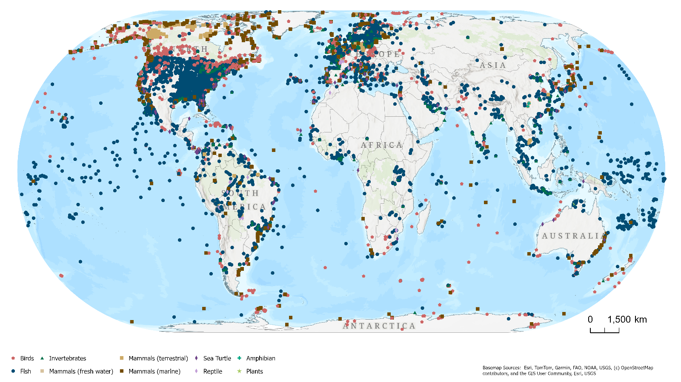

Figure 9. Locations of available biota data.
- Individual mercury measurements that meet the minimum data requirements will be used for temporal analyses and compared against toxicity reference values. Both, individual and mean mercury levels may be utilized for spatial analyses. For spatial assessments, we will select bioindicators (e.g., fish muscle), ensuring standardization and consistency within the same genus to maintain data comparability
- Following a collation of long-term data supplied to the OESG, significant gaps have been identified in several regions, including the Pacific, Asia, western and central Africa, and Central and South America. Data available for assessing temporal trends remain limited. Monitoring of temporal trends in biota generally requires a long-term commitment to a consistent programme, ensuring standardized sampling and analytical procedures to minimize sources of variability that could confound temporal trend interpretation. Experience from international monitoring programmes has shown that, for time series based on annual sampling, a period more than 10-years is typically required to reliably detect the expected level of annual change at sites not directly affected by local sources, even when changes in mercury levels are in the range of 5-10% per year.
- Although numerous peer-reviewed articles are publicly available, limited resources constrained the extraction and standardization of these data. However, key publications have been identified that will support the interpretation of submitted data and the analysis of temporal trends.

2. Contributions of Indigenous Knowledge
- Research and monitoring efforts on mercury, led or co-led by Indigenous Peoples, provide valuable contributions to effectiveness evaluations. Measures are being taken to ensure the utilization of this important information in the scientific report. Indigenous Knowledge offers a holistic perspective, enhancing the understanding of ecological interrelationships and may help explain changes in mercury levels. One example is the Beluga Monitoring Program, one of the longest-running and most comprehensive datasets on a beluga population. The Fisheries Joint Management Committee (FJMC) assumed responsibility for this program in 1987. The FJMC, comprising both Inuvialuit members and federal government representatives, was established in the Inuvialuit Final Agreement to oversee the management of fish and marine mammals within the Inuvialuit Settlement Region.

3. Identified data that has not been acquired
- The OESG has received intentions from various international institutions to submit datasets on mercury concentrations in fish, invertebrates, birds and plants, that have not yet been formally completed. Additionally, some known datasets remain inaccessible or have not been provided in a standardised format. The missing data includes both local studies and broader national or regional programs across the Arctic, North America, Europe, Asia, Africa, and Australia. The datasets span from historical to ongoing monitoring, with timeframes ranging from the 1960s to the present.

4. Selection of toxicity benchmarks
- Toxicity benchmarks were selected by choosing Toxicity Reference Values that were mathematically derived using a benchmark dose analysis framework when available, as recommended by the U.S. Environmental Protection Agency and European Food Safety Authority. When mathematically derived Toxicity Reference Values were not available, we selected the best available benchmarks from subjectively derived Toxicity Reference Values from the following recent review papers:
- U.S. Environmental Protection Agency 2012 Benchmark dose technical guidance. EPA/100/R-12/001. Risk Assessment Forum, Washington, D.C.
- Davis, J. A., J. S. Gift, and Q. J. Zhao. 2011. Introduction to benchmark dose methods and U.S. EPA’s benchmark dose software (BMDS) version 2.1.1. Toxicology and Applied Pharmacology 254:181–191.
- Hardy, A., D. Benford, T. Halldorsson, M. J. Jeger, K. H. Knutsen, S. More, A. Mortensen, H. Naegeli, H. Noteborn, C. Ockleford, A. Ricci, G. Rychen, V. Silano, R. Solecki, D. Turck, M. Aerts, L. Bodin, A. Davis, L. Edler, U. Gundert‐Remy, S. Sand, W. Slob, B. Bottex, J. C. Abrahantes, D. C. Marques, G. Kass, and J. R. Schlatter. 2017. Update: use of the benchmark dose approach in risk assessment. EFSA Journal 15:1–41.
- Mayfield, D. B., and D. G. Skall. 2018. Benchmark dose analysis framework for developing wildlife toxicity reference values. Environmental Toxicology and Chemistry 37:1496–1508.
- Gift, J., J. A. Davis, T. Blessinger, M. Wheeler, L. Olszyk, C. Simmons, Y. Xu, B. Allen, and M. E. Brown. 2020. Benchmark Dose Software (BMDS). Version 3.2 User Guide. EPA/600/R-20/216. U.S. Environmental Protection Agency.
- Dillon, T, N Beckvar, and J Kern. 2010. Residue based mercury dose-response in fish: An analysis using lethalityequivalent test endpoints. Environmental Toxicology and Chemistry 29:2559–2565.
- Depew, DC, N Basu, NM Burgess, LM Campbell, EW Devlin, PE Drevnick, CR Hammerschmidt, CA Murphy, MB Sandheinrich, and JG Wiener. 2012. Toxicity of dietary methylmercury to fish: Derivation of ecologically meaningful threshold concentrations. Environmental Toxicology and Chemistry 31:1536–47.
- Shore, RF, E Pereira, LA Walker, and DR Thompson. 2011. Mercury in nonmarine birds and mammals. Pages 609–626 in WN Beyer and JP Meador, editors. Environmental Contaminants in Biota: Interpreting Tissue Concentrations, Second Edition. CRC Press, Boca Raton, Florida.
- Basu N, AM Scheuhammer, SJ Bursian, J Elliott, K Rouvinen-Watt, and HM Chan. 2007. Mink as a sentinel species in environmental health. Environ Res 103:130–144.
- Scheuhammer, AM, MW Meyer, MB Sandheinrich, and MW Murray. 2007. Effects of environmental methylmercury on the health of wild birds, mammals, and fish. Ambio 36:12–18.
- Wiener, JG, DP Krabbenhoft, GH Heinz, and AM Scheuhammer. 2003. Ecotoxicology of mercury. In: Handbook of Ecotoxicology (2nd ed). Hoffman, D.J., Rattner, B.A., Burton, G.A. and Cairns, J. (eds). CRC Press, Boca Raton, Florida, pp. 409–463.
- Basu, N, AM Scheuhammer, C Sonne, RJ Letcher, EW Born, and R Dietz. 2009. Is dietary mercury of neurotoxicological concern to wild polar bears (Ursus maritimus)? Environmental Toxicology and Chemistry 28:133–140.
- Scheuhammer, AM, MW Meyer, MB Sandheinrich, and MW Murray. 2007. Effects of environmental methylmercury on the health of wild birds, mammals, and fish. Ambio 36:12–18.
- USEPA. 1997. Mercury Study Report to Congress Vol. VII: Characterization of Human Health and Wildlife Risks from Mercury Exposure in the United States. Office of Air Quality Planning and Standards and Office of Research and Development, U.S. Environmental Protection Agency, EPA-452/R-97–009. EPA, Washington, DC.

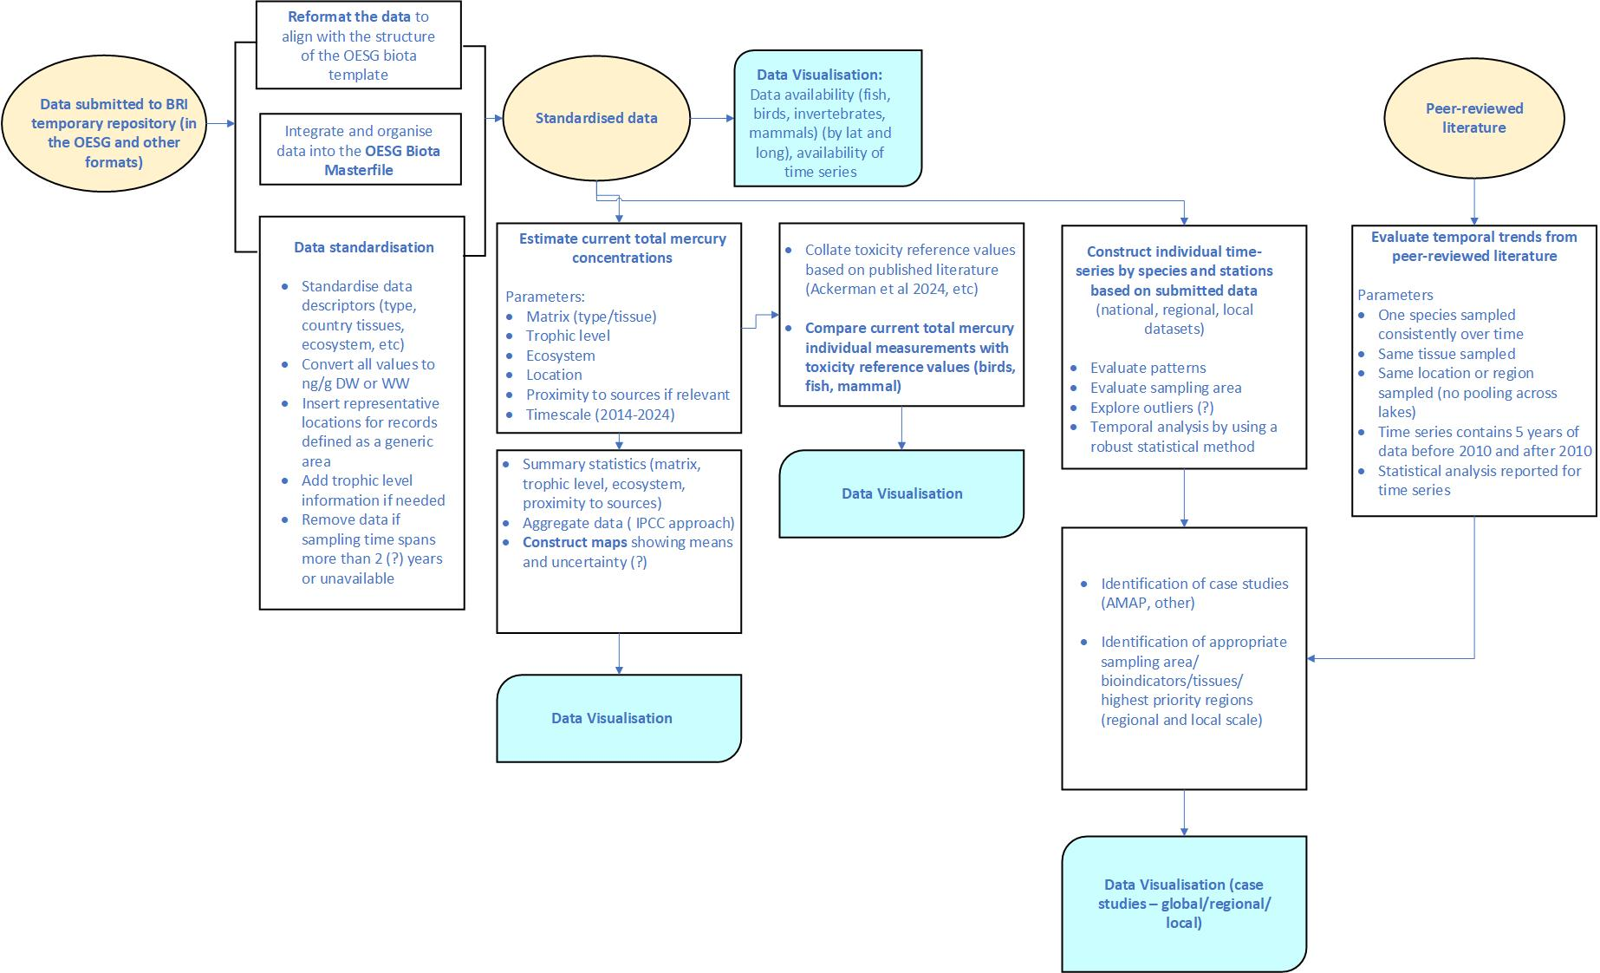
Figure 10. Biota data processing roadmap.
E. Human
- The data submitted through the online data repository managed by BRI include 13 data sets of biomonitoring data from nine countries: Canada, Japan, Brazil (Amazon region), Lithuania, Arctic region (Canada, Faroe Islands, Iceland, Greenland, United States, Sweden, Russia). All together 21 intend to submit forms has been received, and the countries that have not yet submitted their data are: Peruvian Amazon, Palau, Switzerland, Norway, Zimbabwe, Lithuania, Japan, Canada. The data from the received datasets represent the period from 2000 to 2023. The data collected is described in Annex II. In summary, most of the data represent indigenous and other Arctic population, and indigenous populations from the Amazon region. Two datasets received from Japan and Lithuania represent national human biomonitoring programs.
- In addition to data submission through the OESG template, a systematic literature search was conducted to collect all publicly available data on mercury exposure in various human populations across the globe published from 2018 onwards to complement data collected for the Global Mercury Assessment 2018 by Basu et al.. Adopting the methodological approach described by Basu et al., the Web of Science database was screened for publications using the following keywords: (ALL=("mercury") OR ALL=("methylmercury") OR ALL=("methyl" AND "mercury") OR ALL=("MeHg")) AND (ALL=("blood") OR ALL=("hair") OR ALL=("urine")). The search resulted in 3.288 records, after selecting only for articles and proceedings papers, we got 2.980 papers. First, the titles were screened and after excluding non-human, in-vitro or cell lines research, analytical or modelling papers, papers dealing with poisoning events and blood pressure related studies (Hg-containing devices) and national HBMs (collected separately), we reached 1.153 papers, which were further screened by reading through the abstracts. After excluding the papers following the same criteria as described above for title screening, we got 652 papers for the full read. From these, 346 were found eligible as cross-sectional studies, later one more was identified by one of the members of the OESG group. We excluded the papers that contained data collected before year 2000, had sample size <50, had improper biomarker for Hg exposure, didn’t report central tendency values, or were unable to locate, and of course papers for which the data was already reported by the OESG template. The papers of eligible cross-sectional and birth cohort studies are listed in Annex II and were used to extracted data according to the OESG template. The flow diagram of the search is presented in the Figure 11. In summary the data from the papers represent 66 countries, and covers the entire target time period – from 2000 to 2024. Summary of data is provided in the Table H1. Most studies represent general population (background) (n=156 studies), followed by pregnant women (n=67), indigenous populations (Arctic n=13, Other n=17), ASGM sites (n=29), contaminated sites (n=26), Coastal populations (n=15), and those occupationally exposed (Dental workers n=2, Other n=22) (please note, that one study can represent different populations). Only three eligible studies were found on the Hg exposure in relation to cosmetics use. Most of the studies used Hg in whole blood as a biomarker of Hg exposure (n=164), followed by hair (n=110), urine (n=64), and cord blood Hg measurement (n=10).
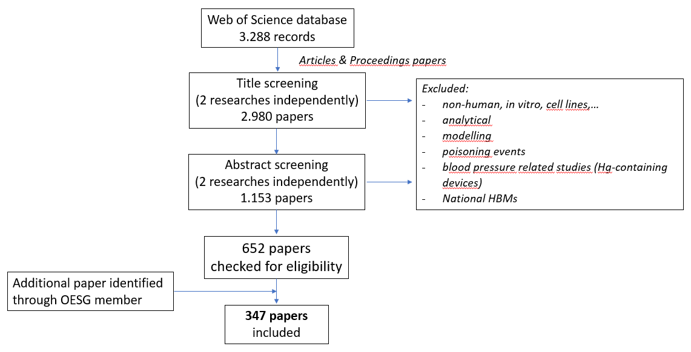
Figure 11. Flow diagram of literature search for human biomonitoring data indicating the number of papers that were identified, screened, and included in the metadata file.
- Data collections for the national HBM programs were obtained from different sources: 1) reports (United States, Canada), 2) publications (France, Republic of Korea, Spain), and 3) European HBM dashboard (Belgium, Czech Republic, Germany). For Slovenia, the data on Hg was not yet submitted as the laboratory analysis were completed just recently (the data will be available for the assessment of exposure within OESG). The data of the national programs span from 2007 to 2024.
- The data from publications listed in the Annex II will be combined with the data identified and used in the last assessment by Basu et al. (2018) to form a common database for the current assessment within the Minamata convention, which will be particularly useful to evaluate time trends and patterns for the general population (background exposure) from nationally representative data and also in the most vulnerable population groups, e.g. indigenous Arctic populations.

Table 1. Summary of human biomonitoring papers or datasets obtained through the OESG repository and literature search (the datasets that were identified but not received or acquired are not listed).
Country | No. papers, datasets | Population types covered (number of papers/datasets) | Time period covered
Argentina | 2 | General population | 2011-2014
Australia | 1 | General population | 2018
Bangladesh | 4 | General population (3), pregnant women (1), Occupation exposure (1) | 2014-2022
Belgium | 4 | General population (4), National HBM – adults and children (2) | 2007-2017
Brazil | 42 | Indigenous (14), ASGM and contaminated sites (11), general population (9), pregnant women and newborns (3), Coastal (1), Occupational (3), Other (1) | 2003-2022
Canada | 30 | Indigenous (15), General population (8) incl. national HBM, Pregnant women (4), Coastal (1), Occupational (1), Other (1) | 2000-2021
Chile | 1 | Contaminated site | 2014-2016
China | 78 | General population (48), Pregnant women (15), Contaminated sites (12), Other (1), Occupational exposure (4) incl. dental, Coastal (3), Users of cosmetics (1) | 2000-2023
Colombia | 17 | General population (2), ASGM and contaminated sites (14), Indigenous (2) | 2011 - >2019
Croatia | 3 | General population (1), Pregnant women (2) | 2007-2010
Czech Republic | 6 | General population (6), including national HBM | 1996-2020
Democratic Republic of Congo | 2 | General population (2) | 2019-2020
Denmark | 7 | Indigenous (5), including pregnant women, Coastal (2) | 2005-2020
Ecuador | 1 | General population (1), ASGM (1) | 2007-2008
Egypt | 1 | General population (1) | 2018-2021
Ethiopia | 1 | General population (1) | 2019
France | 10 | General population (9) incl. national HBM, Newborns (1) | 2004-2020
Germany | 5 | General population (5) incl. national HBM, Occupational (1) | 1998-2021
Ghana | 5 | General population (1), ASGM (3), Occupational (1) | 2014-2020
Greece | 3 | General population (2), Pregnant women (2) | 2007-2012
Guyana | 1 | Indigenous (1) | 2017
Iceland | 2 | Pregnant women (2) | 2014-2015
India | 6 | General population (5), Occupational (1) | 2003-2022
Indonesia | 5 | Pregnant women (2), ASGM (2), Skin-lightening cream users (1) | 2018-2022
Iran | 8 | General population (4), Pregnant women (1), Use of cosmetics (1), Other (2) | 2016-2022
Ireland | 1 | General population (1) | 2011-2014
Israel | 1 | Pregnant women (1) | >2016
Italy | 7 | General population (3), Pregnant women (1), Coastal (1), Contaminated site (1), Other (1) | 2017-2021
Jamaica | 3 | General population (1), Coastal (2) | 2009-2017
Japan | 10 | General population (6) incl. national HBM, Pregnant women (2), Coastal (2) | 2001-2023
Kazakhstan | 2 | General population (1), Occupational (1) | 2016-2021
Kenya | 2 | ASGM (1), Indigenous (1) | 2015-2022
Kyrgyzstan | 1 | General population (1) | 2016
Lithuania | 2 | General population (2) incl. national HBM | 2013-2021
Mexico | 4 | General population (2), Pregnant women (1), Contaminated site (1) | 2008-2015
Mongolia | 1 | ASGM (1) | 2017
Morocco | 2 | General population (2), Contaminated site (1) | 2007-2008
New Zealand | 1 | General population (1) | 2014-2016
Nicaragua | 1 | Indigenous (1) | 2014
Nigeria | 2 | Pregnant women (1), Cosmetics use (1) | 2014-2016, unknown
Norway | 13 | General population (9), Pregnant women (3), Coastal (1) | 1999-2017
Pakistan | 1 | General population (1) | unknown
Peru | 8 | General population (2), ASGM (5), Indigenous (2) | 2011-2027
Poland | 6 | General population (5), Pregnant women (1), Occupational (2) | 2007-2019
Portugal | 2 | Pregnant (1), Occupational (1) | 2012-2022
Republic of Korea | 26 | General population (17) incl. national HBM, Pregnant (7), Contaminated site (1), Coastal (1), Other (1) | 2006-2022
Russian Federation | 11 | General population (8), Pregnant women (2), Indigenous (2) | 2005-2022
Saudi Arabia | 1 | General population (1) | 2005-2006
Serbia | 1 | General population (1) | >2020
Seychelles | 7 | Pregnant women (7) | 2008-2011
Slovakia | 3 | General population (2), Pregnant (1), Contaminated site (1) | 2007-2017
Slovenia | 4 | General population (3) incl. national HBM, Pregnant women (1), Contaminated site (1) | 2007-2024
Spain | 26 | General population (20) incl. national HBM, Pregnant (4), Coastal (1), Occupational (1) | 2003-2019
State of Palestine | 1 | Pregnant (1) | 2015
Suriname | 8 | Pregnant (5), ASGM (2), Indigenous (2) | 2009-2019
Sweden | 4 | General population (3) incl. national HBM, Pregnant (1) | 1996-2019
Switzerland | 2 | General population (1), Other (1) | 2003-2015
Thailand | 7 | General population (4), Pregnant (1), Occupational (2), Contaminated site (1) | 2010-2018
Tunisia | 1 | Coastal (1) | 2018
Turkey | 5 | General population (2), Coastal (2), Occupational (1) | 2017-2019
United Kingdom | 1 | General population (1), Pregnant (1) | 2007-2016
United Republic of Tanzania | 2 | Pregnant women (1), ASGM (1) | 2015-2017
United States of America | 32 | General population (10), incl. national HBM, Pregnant (16) incl. indigenous population of Alaska, Contaminated site (3), Occupational – dental (1) | 2002-2019
Vietnam | 1 | General population (1), Occupational (1) | 2013-2014
Zimbabwe | 1 | ASGM (1) | 2019
- Remark: one study or dataset can represent multiple population types.
- Disclaimer: The numbers of population types per country might change after the final cleaning and checking of the metadata is done (checking for duplicates and correct categorization of study population type).

F. Marine water
- A total of 60 datasets containing information on total Hg and methyl Hg measurements in the marine water column were identified (Appendix II). The data covers 20 years and spans the period 2005-2024 (Figure 12). Most datasets were obtained from public repositories (22; with the GEOTRACES data hosted at the British Oceanographic Data Centre contributing data from 11 campaigns). Another 23 datasets have been obtained from tables and supporting information presented in published scientific publications, and 15 datasets have been contributed directly by authors. All datasets are from scientific work and none from regular monitoring.
Figure 12. Years with available observations for ocean basins. The number of observations within a year vary and the data are spatially scattered within the basins.
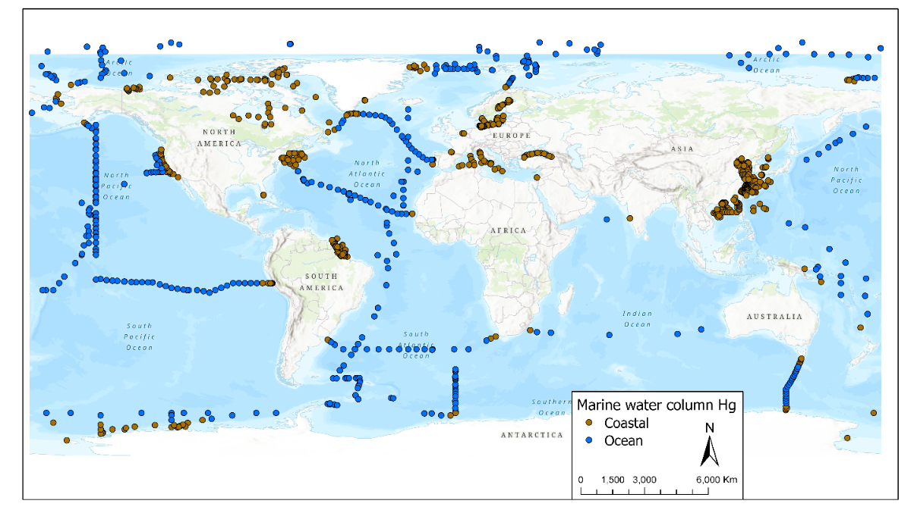
- These datasets cover campaigns that a) move in space (and time) along a cruise track, b) cover a time period at a specific location or c) represent one or a few profiles in time and space. There are observations from all major ocean basin with the North Atlantic being represented by the largest number of observations (2400 THg observations), and the Indian Ocean being represented by the least number of observations 112 THg observations) (Figure 13). Many coastal areas around the world do not have any observations.
Figure 13. A map showing the distribution of available marine water column data.
G. Soil
- Soil data are available for analysis from Australia, Africa, Europe, New Zealand, North America, and South America (Figure 14 and Appendix II). Submissions include measurements for total Hg in soil. Ancillary data for pH, carbon content, and percentage of clay, silt and sand are available for a very limited number of sites. The datasets span different time periods depending on the region. For Latin America, data were submitted for Ecuador for the years 2012 to 2023 and a dataset from Peru was identified that spans from 2015 to 2023. For Australia, available data spans from 2007 to 2009 (Figure 15). Publicly available data for Europe was accessed from the FOREGS Geochemical database and contains data for soil samples taken between 1997 and 2001 from the following countries: Albania, Austria, Belgium, Croatia, Czech Republic, Denmark, Estonia, Finland, France, Germany, Greece, Hungary, Ireland, Italy, Latvia, Lithuania, The Netherlands, Norway, Poland, Portugal, Slovak Republic, Slovenia, Spain, Sweden, Switzerland and the UK. The publicly available data from the USA covers the period between 2007 and 2010.
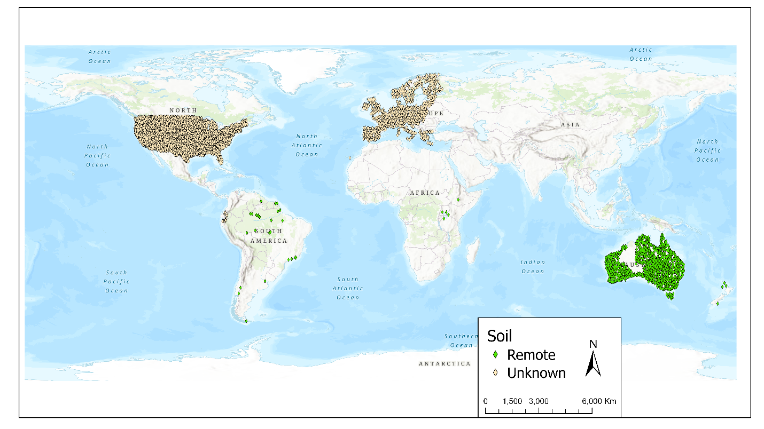
- Limited data for Argentina, French Guyana, Brazil, New Zealand, Tanzania, Uganda and Venezuela was obtained from tables and supporting information presented in published scientific publications and spans from 1978 to 2020 (Figure 14).
Figure 14. A map showing the distribution of the available soil data.
- Additional datasets with more recent soil Hg data from Europe (LUCAS database) as well as individual European monitoring program (e.g. Switzerland, Germany, Poland) were identified but could not be accessed. Existing data from monitoring programs in China, Canada and Peru either were not submit or are pending data use authorization.
Figure 15. Years with available observations for soil.
H. Water (Inland and estuary)
- Seven (7) submissions for surface water measurements were received from four (4) continents – Australia, Europe, North America, and South America (Figure 16 and Appendix II). They represent a mixture of inland and estuary sites. All submissions have data for total Hg but not for methyl Hg. Ancillary data (pH, dissolved oxygen, conductivity) is only available for the datasets from Belgium and Bulgaria.
- The majority of the submissions were from the Northern Hemisphere, primarily Canada (24%), Europe (34%) and USA (59%). Southern Hemisphere is represented by Ecuador (4%) and Australia (4%). Submissions do not provide good spatial coverage because majority of the data is from a single site (Australia, Belgium) or local monitoring (Canada, USA).
- The data record spans different time periods Figure 17), beginning as early as 1970 for a dataset from Northeastern USA and 1978 for Northeastern Canada.
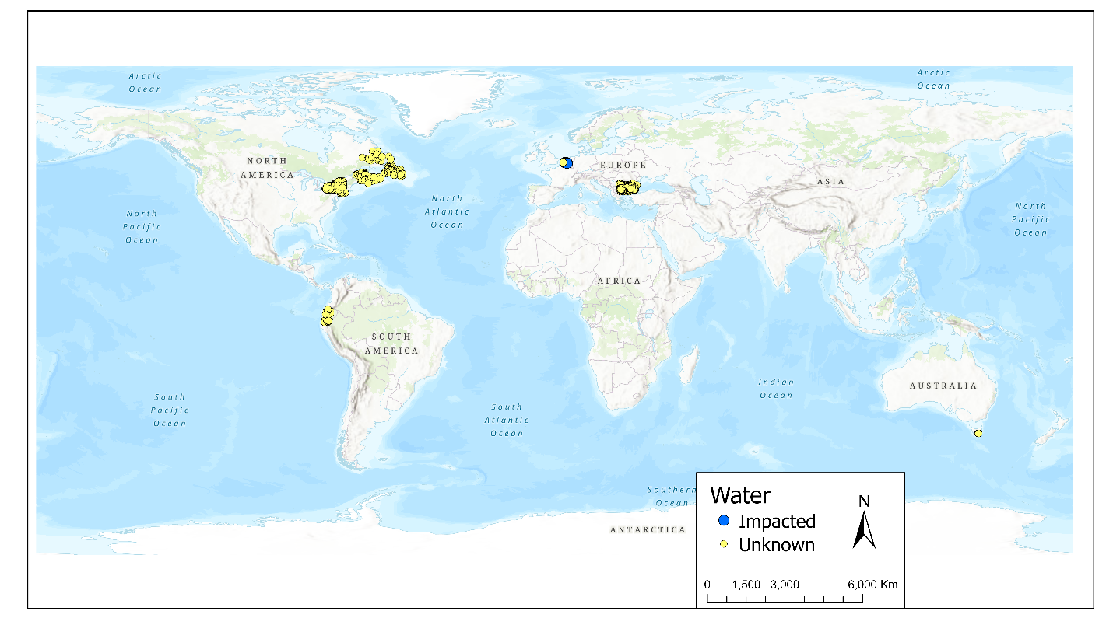
Figure 16. A map showing the distribution of the available freshwater data.
- The only data received from South America (Ecuador) is from a national monitoring program of effluents of treatment plants. This data was included in the total count and is presented on the map (Figure 16 and Appendix II) but it cannot be used to assess freshwater because samples were not collected from the receiving waterbody.
- Three additional inland monitoring programs for individual waterbodies were identified in the United States and one in Sweden which are awaiting data authorization and submission.
Figure 17. Years with available observations for freshwater.
I. Freshwater sediments
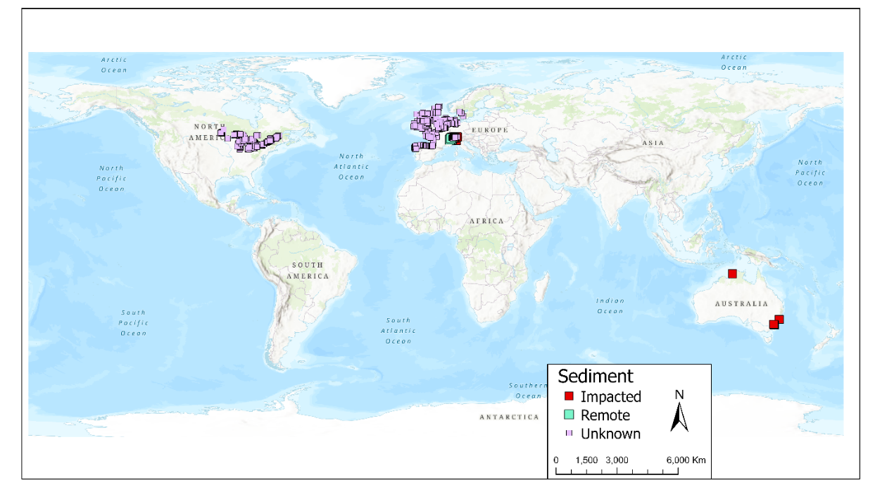
- A total of seven (7) datasets contain information on total mercury concentrations in surface freshwater sediments (Figure 18). All datasets, except for Australia, originated from long-term monitoring programmes and span the years 1985 to 2021 (Figure 19). For Australia, data are available from a one-off sampling campaign. Most of the data represent sites with unknown contamination status. A few sites in Switzerland are located in remote areas, while others in both Switzerland and Australia were sampled from known contaminated locations. Approximately half of the sites have restrictions on data use, whereas the remaining data are unrestricted.
Figure 18. A map showing the distribution of the available lake sediment data.
- The datasets include information from Canada, Spain, the United Kingdom, Belgium, Germany, France, Ireland, the Netherlands, Sweden, and Australia (Appendix II).
Figure 19. Years with available observations for freshwater sediments.
J. Sediment cores
- The lake sediment core archive has global geographic coverage, with core data from every continent (Figure 20). Of the 446 cores compiled, the majority (390 cores, 87%) were collected from the Northern Hemisphere, primarily from Canada (182 cores, 40.8% of the total), the USA (161 cores, 36%), and China (20 cores, 4.5%) (Figure 21). Cores from the Tropics (defined as between -30° and +30° latitude) accounted for 10.5% of the dataset (47 cores), with the majority originating from Brazil (13 cores) and Peru (5 cores). The Southern Hemisphere contributed the fewest cores (9 cores, 2%), with samples from Argentina (3 cores), New Zealand (3 cores), Australia (2 cores), and the South Shetland Islands (1 core) (Figure 22). Ancillary measurements for other environmental variables, such as Total Organic Carbon (TOC), aluminum (Al), and percent loss on ignition (%LOI) are available for most of the cores.
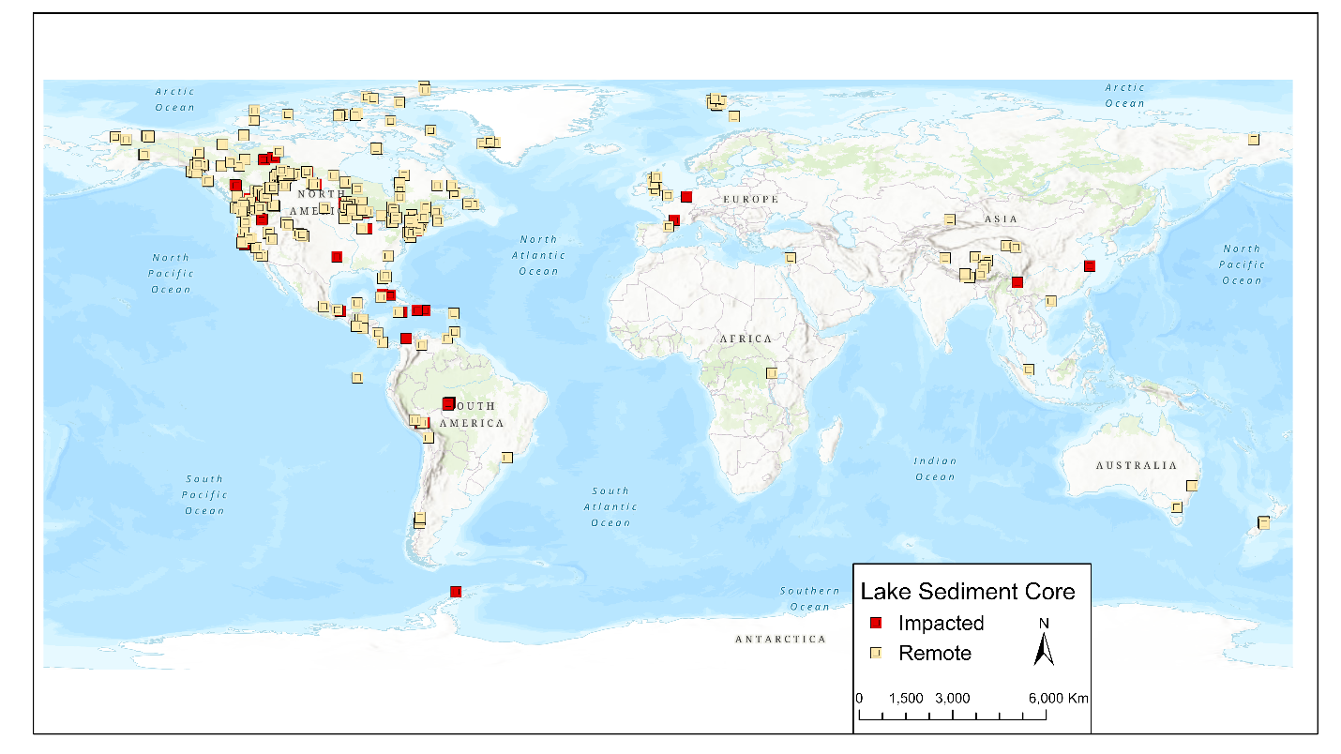
Figure 20. A map showing the distribution of the available data for sediment cores.
- From the total 446 cores, 339 were collected from lakes, 28 from coastal regions and mangrove estuaries, and 19 from reservoirs. A total of 347 cores (77.8%) were collected from locations without a known nearby anthropogenic source, while 99 cores (22.2%) were influenced by local industry. Cores collected from extremely remote regions—where no human settlements or infrastructure, including roads or rudimentary camps, were present—represented 168 cores (37.7%) of the dataset. In contrast, cores collected from areas within dense human settlements, characterized by buildings, roads, and agricultural activities, accounted for 52 cores (11.7%).
- The dataset was compiled from publicly available data sourced from 110 peer-reviewed journal articles, government reports, and thesis publications. An additional 86 publications that reported mercury concentrations in dated lake sediment cores were identified but not included because the raw data was not publicly available.
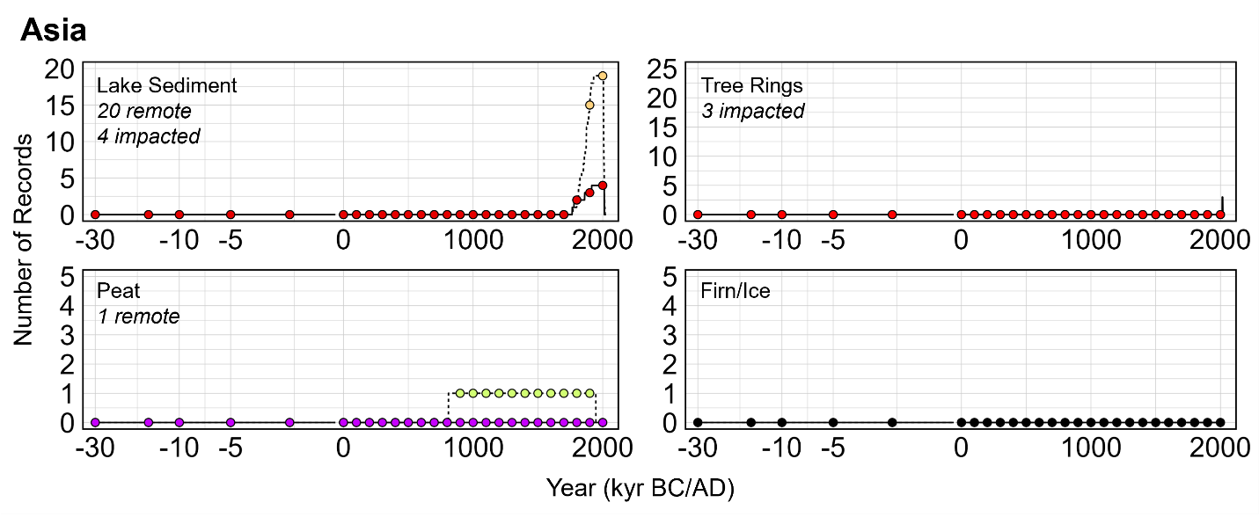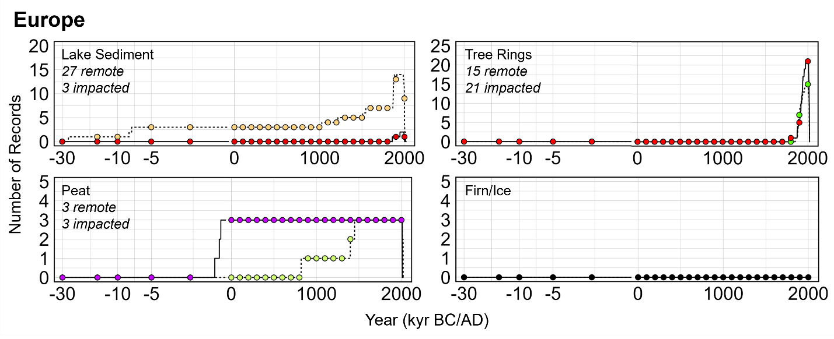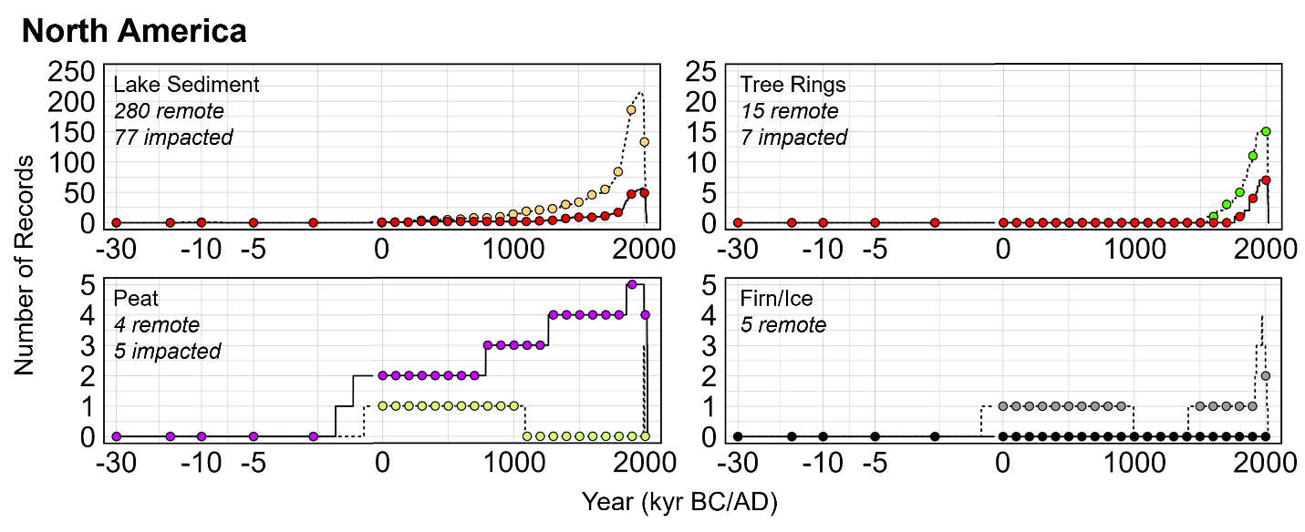

Figure 21. Number and length of peat cores from impacted (purple) and unimpacted (light green) areas; sediment cores from impacted (red squares) and unimpacted (yellow) areas; and tree rings from impacted (red circles) and unimpacted (green circles) areas from Asia, Europe, and North America.
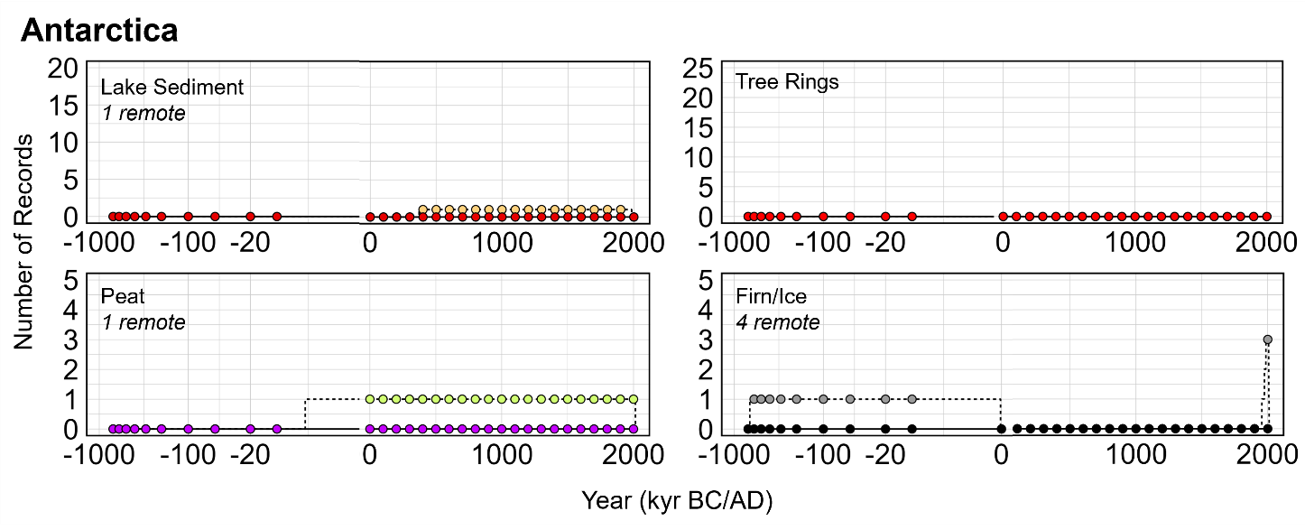
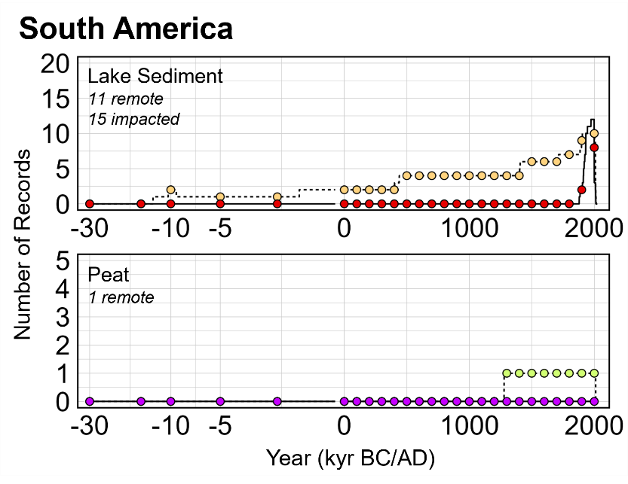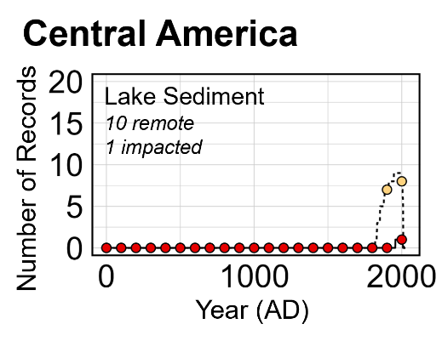
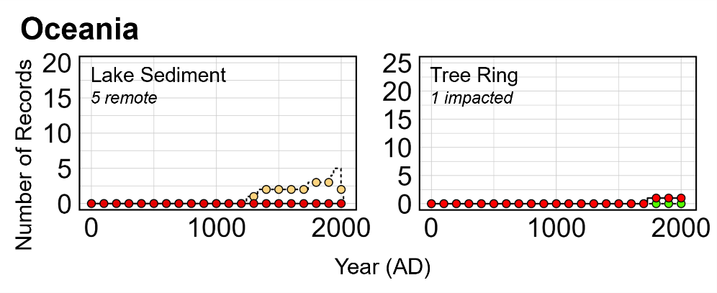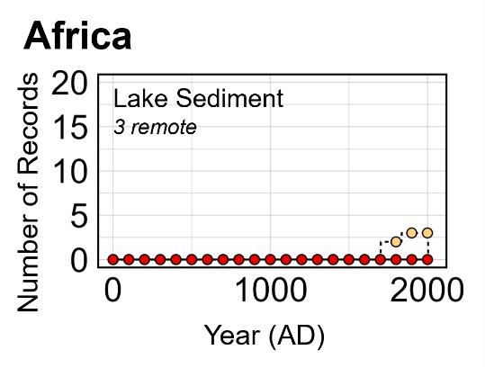

Figure 22. Number and length of peat cores from impacted (purple) and unimpacted (light green) areas; sediment cores from impacted (red squares) and unimpacted (yellow) areas; tree rings from impacted (red circles) and unimpacted (green circles) areas from South and Central America, Africa and Oceania. Number and length of ice cores from Antarctica.

K. Peat cores
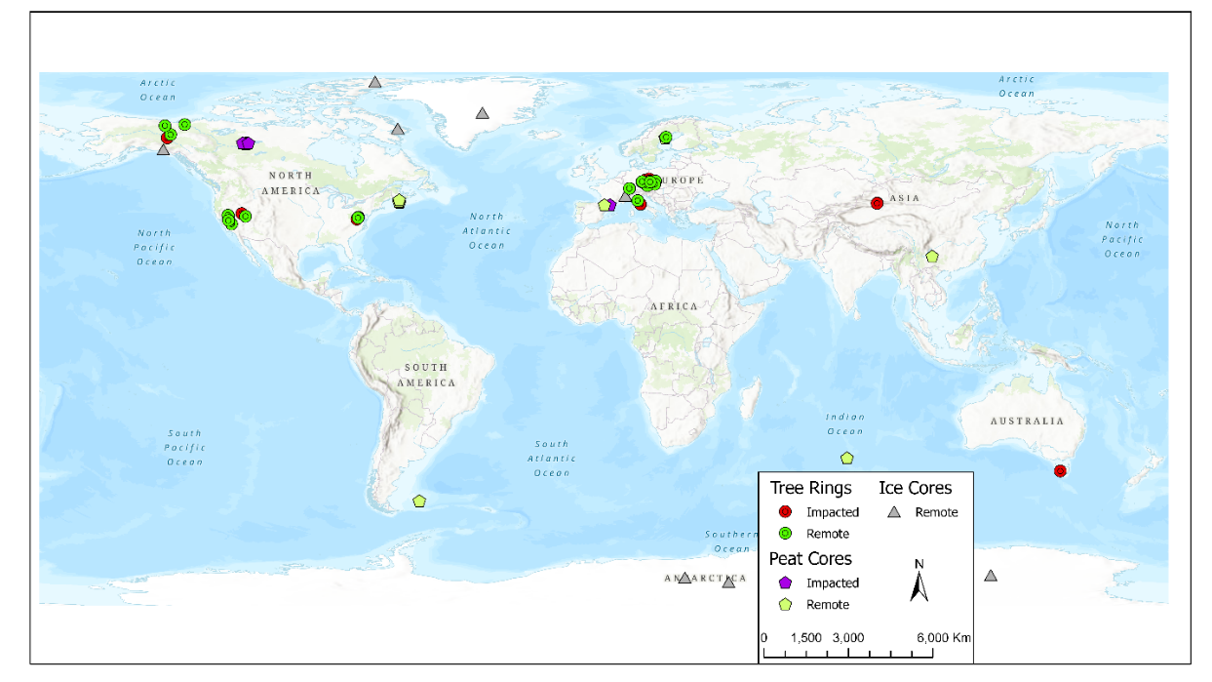
- A total of 18 cores across six (6) datasets are available for analysis (Figure 23 and Appendix II). Measurements include total Hg concentrations (n = 6 datasets), total mercury fluxes (n = 4), inorganic mercury flux (n = 1) and mercury stable isotopes (n = 2) representing ten (10) remote sites and eight (8) impacted sites. Peat records cover the period 4650 BC to 2018 AD, and cores have been retrieved from the following countries: France (2), Falkland Islands (1; the only core in the Southern Hemisphere), China (1), Canada (2), and Sweden (1). All compiled data are publicly available.
Figure 23. A map showing the distribution of the available data for peat cores, ice cores and tree ring. Tree rings cores depicted with circles. Ice cores depicted with triangles, and peat cores depicted with stars.
- Forty-five (45) additional datasets have been identified but are in the possession of private data holders and have not been obtained and/or are awaiting Data Use Authorization. These datasets represent a total of 98 cores. 85 cores are in the Northern Hemisphere in 14 different countries, covering the period 16240 BC to 2019 AD (Figure 8). Nearly 70% (n = 58) of these cores are in five countries: Spain (16), Canada (13), China (10), Sweden (10), Czech Republic (9). Thirteen (13) cores are located in the Southern Hemisphere: Chile (6), South Africa (3), Bolivia (2), Brazil (1), and Lesotho (1), spanning the period 69050 BC to 2018 AD (Figure 21 and Figure 22).
L. Ice cores
- A total of 10 records (unique cores or snow pits) across 8 datasets are available for analysis (Figure 23). Measurements include total Hg concentrations (n = 9 datasets), inorganic mercury concentrations (n = 3), methyl Hg concentrations (n = 4), and total mercury flux (n = 4) in ice/firn cores (6) and snowpits (4), in 10 remote sites (Appendix II). Ice records cover the period 670050 BC to 2017 AD (Figure 10). Ice records are found primarily in the Northern Hemisphere, including Canada (3), Greenland (1), and France (1). Three records in the Southern Hemisphere are found solely in Antarctica. Compiled ice data are publicly available (n = 7) or have been shared by private data holders (n = 1).
- Fifteen (15) additional datasets have been identified but are in the possession of private data holders and have not been obtained and/or are awaiting Data Use Authorization. These datasets include total mercury measurements in 18 ice/firn cores and 18 snowpits, as well as a single dataset of Hg stable isotopes, together spanning the period 13636 BC to 2012 AD. These privately held datasets originate from the following locations: Antarctica (4 datasets), Greenland (5), China (3), Canada (2), and one each in Russia and United States. In addition, two of these datasets include measurements of gaseous elemental mercury measured in the pores of two ice cores retrieved from Greenland and represent unique archives of historic trends in atmospheric mercury.
M. Tree rings
- A total of 62 records (records identified as Hg time series of a unique tree species and unique site) across 16 datasets are available for analysis (Figure 23). Measurements include total Hg concentrations (n = 16 datasets) and stable isotopes (n = 1) in tree rings, representing 30 remote sites and 32 impacted sites with point source(s) of mercury identified by authors in published literature (Appendix II). Tree ring records cover the period 1550 to 2020. All records are in the Northern Hemisphere, excluding one, and include the following countries: Italy (1), Germany (1), Canada (4), United States (2), China (1), Czech Republic (5), Switzerland (1), and Tasmania (1; only South Hemisphere record) (Figure 21 and Figure 22). Compiled tree ring data are publicly available (n = 11) or have been shared by private data holders (n = 5).
- Seventeen (17) additional datasets have been identified but are in the possession of private data holders and have not been obtained and/or are awaiting Data Use Authorization. These private datasets include at least 21 records representing remote locations and 37 records reflecting one or more point sources, spanning the period 1790 to 2022 AD. Private datasets originate primarily from the Northern Hemisphere, and include data in the following countries: China (3), France (2), Italy (2), Republic of Korea (2), United States (2), and one each in Austria, Canada, Russia, Serbia, and Turkey. A single dataset in Peru represents the only privately held dataset in the Southern Hemisphere and is awaiting publication.

* UNEP/MC/COP.6/1/Rev.1.
** This present document has not been formally edited.
The work of the group before the fifth meeting of the Conference of the Parties has been reported in UNEP/MC/COP.4/16/Add.2, UNEP/MC/COP.5/INF/24 and UNEP/MC/COP.4/INF/37.
She replaced Terry Keating (the United States of America), who resigned from the Group in July 2025.
Before the fifth meeting of the Conference of the Parties, the Group met online nine times and had a face-to-face meeting from 17 to 21 March 2023 in Geneva, Switzerland.
Annex I and II to UNSP/MC/COP.5/INF/24.
The presentation is available from https://minamataconvention.org/sites/default/files/documents/2025-10/Presentation_20251015_13h00_MCS.pdf. The video recording is available from https://www.youtube.com/watch?v=CtAefuETqCo
https://minamataconvention.org/en/intersessional-work-and-submissions-cop-6#sec2417
Annexes to this report are available from the Convention website https://minamataconvention.org/en/intersessional-work-and-submissions-cop-6#sec2417
A comment from a Party observed that data set of inventories provided by Parties shall be given priority in trend analysis. For emission from China, data from the following paper are used for data analysis report. Cui, Y., Wu, Q., Wang, S., Liu, K., Li, S., Shi, Z., Ouyang, D., Li, Z., Chen, Q., Lü, C., Xie, F., Tang, Y., Wang, Y., and Hao, J.:Integrating point sources to map anthropogenic atmospheric mercury emissions in China, 1978–2021, Earth Syst. Sci. Data, 17, 3315–3328, https://doi.org/10.5194/essd-17-3315-2025, 2025
Marilena Muntean, Greet Janssens-Maenhout, Shaojie Song, Amanda Giang, Noelle E. Selin, Hui Zhong, Yu Zhao, Jos G.J. Olivier, Diego Guizzardi, Monica Crippa, Edwin Schaaf, Frank Dentener, Evaluating EDGARv4.tox2 speciated mercury emissions ex-post scenarios and their impacts on modelled global and regional wet deposition patterns, Atmospheric Environment, Volume 184, 2018, Pages 56-68, ISSN 1352-2310, doi:10.1016/j.atmosenv.2018.04.017.
Muntean, M., Janssens-Maenhout, G., Song, S., Selin, N. E., Olivier, J. G. J., Guizzardi, D., Maas, R., Dentener, F.: Trend analysis from 1970 to 2008 and model evaluation of EDGARv4 global gridded anthropogenic mercury emissions., Science of the Total Environment 494–495 (2014) 337–350, doi:10.1016/j.scitotenv.2014.06.014
Specifically for the Artisanal Small Scale Gold Mining (ASGM) sector, there is scarce information in scientific literature and publicly available reports, in particular on the achievements related to emissions mitigation in the latest years; in order to provide a more realistic view on global mercury emissions from ASGM, a refinement of these emissions based on the information from official national reporting to the Minamata Convention on Mercury in the framework of the First Effectiveness Evaluation is needed.
Note for the purposes of this report we have collected gas phase mercury data from various methods and are collectively calling it TGM. In some instances, the data has been reported to the databases as gaseous elemental mercury (GEM) but for the purposes here we have chosen to combine it all as TGM. We recognize this does add some uncertainty to the data but given that Gaseous Oxidized Mercury (GOM) or Reactive Gaseous Mercury (RGM) are primarily a very small fraction of the TGM reported, this was a decision made for the purposes of a global report in the absence of a common method used and is unlikely to affect the large-scale findings reported here.
Basu N., Horvat M., Evers D.C., Zastenskaya I., Weihe P., Tempowski J. A State-of-the Science Review of Biomarkers in Human Populations Worldwide between 2000 and 2018. Environmental Health Perspectives 126 (10), 2018.
Flanders Marine Institute (2021). Global Oceans and Seas, version 1. Available online at https://www.marineregions.org/. https://doi.org/10.14284/542).

