UNITED  NATIONS | 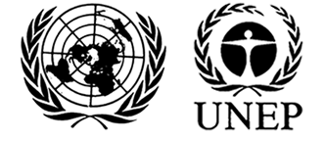 |  |  | MC
 |  |  | UNEP/MC/COP.6/INF/20
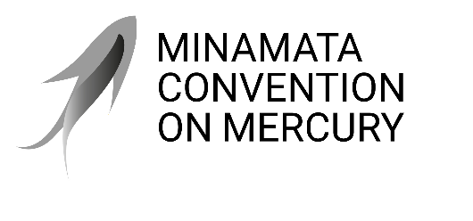 |  |  | Distr.: General  21 July 2025  English only
Conference of the Parties to the
Minamata Convention on Mercury
Sixth meeting
Geneva, 3–7 November 2025
Item 4 (h) of the provisional agenda*
Matters for consideration or action by the
Conference of the Parties: national reporting
National reporting (article 21)
Report on the second short national reports under article 21 of the Minamata Convention on Mercury**
Note by the secretariat
- The annex to the present note sets out the information from the second short national reports submitted by parties under their article 21 obligation, covering the period from 1 January 2021 to 31 December 2022, to complement the secretariat’s periodic report to the Conference of the Parties as set out in document UNEP/MC/COP.6/15.
- The report took into consideration reports submitted and clarifications to responses sent to the secretariat by 31 May 2025.

Annex
Report on the second short national reports under article 21 of the Minamata Convention on Mercury
I. Introduction
- Paragraph 1 of article 21 of the Minamata Convention on Mercury provides that each party shall report to the Conference of the Parties, through the secretariat, on the measures taken to implement the provisions of the Convention and on the effectiveness of such measures and the possible challenges in meeting the objectives of the Convention.
- The Conference of the Parties, in decision MC-1/8, agreed on the timing and format of national reporting by parties. The full reporting format comprises 43 questions to be answered by all parties every four years, while the short reporting format comprises four recurrent questions (indicated by an asterisk in the full format) that are to be answered every two years. Parties were to submit their second short national reports, covering the reporting period from 1 January 2021 to 31 December 2022, by 31 December 2023.
- The secretariat completed a review of the submitted national reports and prepared the present report, which summarise the parties’ responses to the four recurrent questions on measures taken to implement the relevant provisions and on the effectiveness of such measures in meeting the objective of the Convention for the second short reporting period. The review entailed checking and follow-up on the completeness and clarity of the responses contained in the reports. Submitted national reports that are deemed complete by the party and the secretariat are available on the Convention website.
- For the purposes of the sixth meeting of the Conference of the Parties, the secretariat prepared this report to inform the Conference of the following: reporting performance, overview of the results of the second short national reports and the findings of the secretariat based on its review of the responses submitted by parties to the four recurrent questions on control measures as per articles 3.3, 3.5, 3.6 and 11.2, as well as responses to parts C and D of the reporting format.
II. Reporting performance of parties for the second short national reports
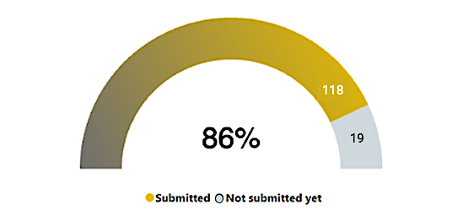
Figure 1: Second short national reports – Reporting rate (as at 31 May 2025)
- Regarding the reporting performance of parties, the secretariat reports that, of the 137 parties to the Convention that were parties during the second short reporting period ending 31 December 2023, 91 parties submitted their reports by the deadline, while an additional 27 parties submitted their reports by 31 May 2025., Therefore, to date, 118 of 137 parties have submitted their reports to the secretariat. In total this represents an 86 per cent reporting rate for the second short reporting period,
- Parties that submitted their reports for the second short reporting period are: Afghanistan, Albania, Antigua and Barbuda, Argentina, Armenia, Australia, Austria, Bahrain, Belgium, Benin, Bolivia (Plurinational State of), Botswana, Brazil, Bulgaria, Burkina Faso, Burundi, Cambodia, Cameroon, Canada, Chad, Chile, China (including Hong Kong SA and Macao SAR), Colombia, Comoros, Congo, Costa Rica, Côte d'Ivoire, Croatia, Cyprus, Czechia, Denmark, Dominican Republic, Ecuador, El Salvador, Equatorial Guinea, Estonia, Eswatini (Kingdom of), European Union, Finland, France, Gabon, Germany, Ghana, Greece, Guinea, Guinea-Bissau, Guyana, Honduras, Hungary, Iceland, India, Indonesia, Iran (Islamic Republic of), Iraq, Ireland, Italy, Jamaica, Japan, Kuwait, Latvia, Lesotho, Liechtenstein, Lithuania, Luxembourg, Madagascar, Mali, Malta, Marshall Islands, Mauritius, Mexico, Monaco, Mongolia, Montenegro, Namibia, Netherlands, Nicaragua, Niger, Nigeria, North Macedonia, Norway, Oman, Palau, Panama, Peru, Philippines, Poland, Portugal, Qatar, Republic of Korea, Republic of Moldova, Romania, Rwanda, Saint Kitts and Nevis, Saint Lucia, Saudi Arabia, Senegal, Seychelles, Sierra Leone, Singapore, Slovakia, Slovenia, South Africa, Spain, Sri Lanka, State of Palestine, Sweden, Switzerland, Thailand, Togo, Tuvalu, Uganda, United Arab Emirates, United Kingdom of Great Britain and Northern Ireland, United Republic of Tanzania, United States of America, Uruguay, Viet Nam, and Zambia.
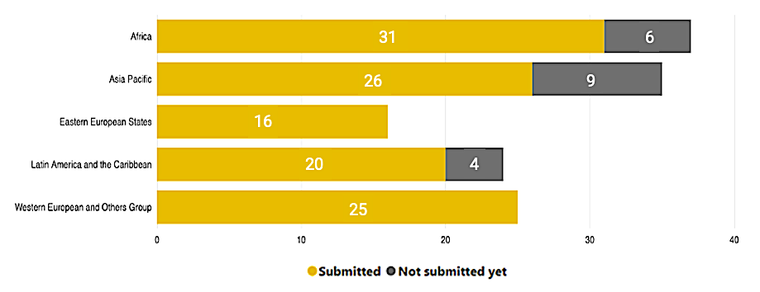
Figure 2: Second short national reports submission by region (as at 31 May 2025)

- The reporting rates by region were as follows: 31 of 37 parties from the group of African States (84 per cent), 26 of 35 parties from the group of Asia-Pacific States (74 per cent), 16 of 16 parties from the group of Eastern Europe States (100 per cent), 20 of 24 parties from the group of Latin American and Caribbean States (83 per cent), and 25 of 25 parties from the group of Western European and other States (100 per cent).
- Twenty-three of the submitted reports were incomplete (Armenia, Bulgaria, Comoros, Czechia, Eswatini (Kingdom of), Ghana, Guyana, Iraq, Lithuania, Malta, Marshall Islands, Mexico, Mongolia, Namibia, Norway, Republic of Moldova, Rwanda, Senegal, State of Palestine, Togo, United Arab Emirates, United Kingdom of Great Britain, and Viet Nam). Eleven (50% ,11 of 22) parties with incomplete reports have responded to the secretariat’s follow-up and provided the missing information to their reports as of 31 May 2025 (Armenia, Bulgaria, Comoros, Guyana, Lithuania, Malta, Marshall Islands, Mexico, Namibia, Senegal, United Kingdom, and Viet Nam). Eleven reports remain incomplete, as of 31 May 2025.
- As at 31 May 2025, the secretariat had not received national reports from the following 19 parties: (Bahamas, Central African Republic, Cuba, Djibouti, Gambia, Jordan, Kiribati, Lao People’s Democratic Republic, Lebanon, Mauritania, Pakistan, Paraguay, Samoa, Sao Tome and Principe, Suriname, Syrian Arab Republic, Tonga, Vanuatu and Zimbabwe).
- It should be noted that one new party (Kenya) submitted reports to the secretariat even though the Convention was not yet in effect for them during the second short reporting period. The party became party to the Convention in 2023. The responses contained in their reports are tallied separately by the secretariat.
- Regarding the process of reporting, on 5 April 2023 the national focal points were provided the personalised log-in credentials to the online reporting tool for the second short reports. A total of 116 parties (98%, 116 of 118) utilised the online reporting tool while two parties submitted the offline paper version by email (Congo and South Africa).
- The secretariat received a submission by email which purports to be from one party (Zimbabwe). The submission, however, was not made by the designated national focal point nor contact officer. As the submission was not made by the national focal point, the report has not been included in the analysis for this report. The secretariat is still awaiting to hear from the officially designated national focal point.
- To support parties in the preparation of information for the second short national reports, the secretariat provided two online sessions and a web-training in 2023. The secretariat also engaged in dedicated and regular follow-up with parties in the run-up to and after the deadline.
- In accordance with the activities to address health concerns of women and children under the Minamata Convention, the secretariat developed a statistic on the participation of reporting officers as an indicator towards the achievement of the goal of promoting meaningful, inclusive and balanced representation of men and women in the Convention’s processes and activities (Secretariat’s goal 4). The distribution of reporting officers (national focal points and contact officers) for the current reporting period is as follows: 58 female reporting officers (52.75%, 58/110) and 52 male reporting officers (47.3%, 52/110).
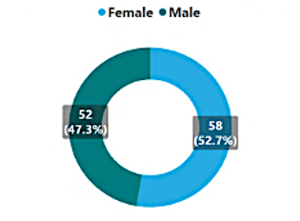
Figure 3: Second short national reports – Distribution of reporting officers (as at 31 May 2025)

III. Overview of the results and findings of the secretariat
A. Article 3: Mercury supply sources and trade
Question 3.1: Does the party have any primary mercury mines that were operating within its territory at the date of entry into force of the Convention for the party? (para. 3)
- Yes
- No
If yes, please indicate:
a) The anticipated date of closure of the mine(s): (month, year) OR
b) The date upon which the mine(s) closed: (month) (year)
c)*Total amount of mercury mined _______ metric tons per year

- In terms of parties’ responses to question 3.1:
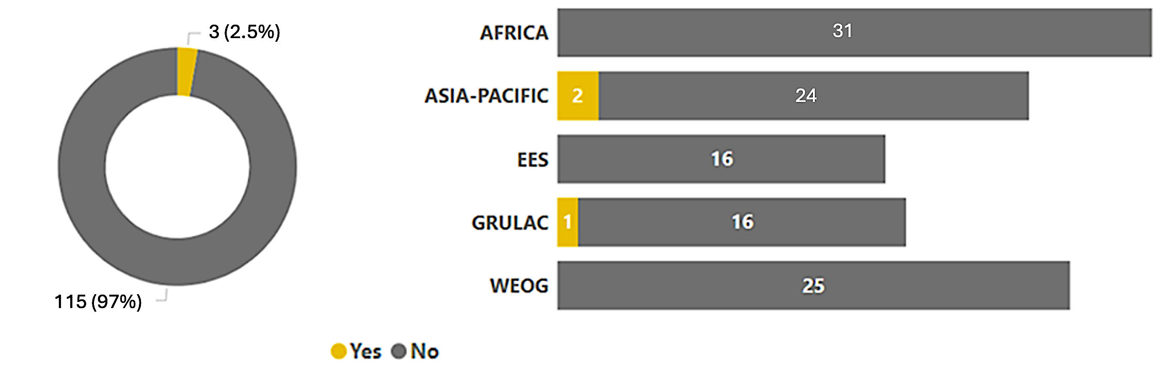
  - “Yes” - 3 parties (2.5%, 3/118) and “No” - 115 parties (97%, 115/118).
  - The breakdown of the responses by region is as follows:
Region | "Yes" | "No" | Total parties
Africa | 0 (0%) | 31 (100%) | 31
Asia-Pacific | 2 (8%) | 24 (92%) | 26
Eastern European States | 0 (0%) | 16 (100%) | 16
Latin America and the Caribbean | 1 (5%) | 19 (95%) | 20
Western Europe and Others | 0 (0%) | 25 (100%) | 25

- The table below shows the quantities of primary mined mercury reported by parties for the second short report (2021 and 2022) and the prior reports (2017-2020).
Table 1: Quantities of primary mined mercury reported MT/yr (2027–2022)
 | First Full Report
 | First Short Report |  |  |  | Second Short Report
Party | 2017 | 2018 | 2019 | 2020 | 2021 | 2022
China | NA  (85,000)* | NA  (144,500)* | NA  (134,000)* | 250 | 193 | 171
Indonesia | - | - | - | - | No data available** | No data available**
Mexico | 442 | 0.5 | 0 | 0 | 0 | 0
* Reported on quantities of mined mercury ore
** Illegal primary mercury mining reported, no data available
- Based on its review of parties’ responses to question 3.1 and their submissions, the secretariat presents the following findings:
  - There is an increase in the number of parties reporting on the existence of primary mining of mercury in their territory, regardless of the status of the mine, from two parties (China and Mexico) to three (China, Indonesia and Mexico) for the second short reporting cycle. Notably:
    - A party (Indonesia) in its past reports responded “No” to question 3.1. In its second short national report, the party responded “Yes” and provided information that conformed to paragraph 1 of decision MC-5/2, where the party acknowledged and reported the presence of illegal primary mercury mining in its territory and relayed that “it is difficult for the government to know exactly how much primary mercury mining is in Indonesian territory”. The party suggested the need for specific methods to quantify the primary mined mercury, including by using remote sensing or other methods. The party also reported on its progress in enforcing its law not allowing the primary mercury mines, confiscating 36.29 tonnes of illegally mined cinnabar to date.
  - One party (Mexico) responded “Yes” the reported data is for formal mines. No data is available for informal primary mercury mining production. The party had mentioned in its full report (2021) the persistence of mercury production through its environmental monitoring efforts that may be additional to its known closed mines.
  - Quantities reported by one party (China) conform to decision MC-4/8 which clarified that the unit of measure under question 3.1 is to be the amount of mercury mined.
  - Trend analysis:
    - A comparison of the quantities of primary mined mercury from formal sources show a decreasing trend since 17 August 2017.
    - There is no comparable reported data on other sources of primary mined mercury, e.g., informal, illegal, or unrecognized, to derive a comparison over the three reporting cycles limited the trend analysis from these sources.
  - Reporting format amendment: The amended reporting format adopted by the Conference of Parties in its decision MC-5/13, which added a response option that covers a scenario where there is primary mercury mining that is occurring in the party’s territory, but there is no available data due to the informal or illegal nature of the operation, is expected to continue to facilitate the way in which a party with informal or illegal primary mercury mining can respond. The amended reporting format will be operational in the second full report version of the Online Reporting Tool (ORT).
Question 3.3: Has the party endeavoured to identify individual stocks of mercury or mercury compounds exceeding 50 metric tons and sources of mercury supply generating stocks exceeding 10 metric tons per year that are located within its territory? (para. 5)
- Yes
- No
a) *If the party answered yes to question 3.3 above:
i. Please attach the results of your endeavour or indicate where it is available on the internet, unless unchanged from a previous reporting round.
ii. Supplemental: Please provide any related information – for example, on the use or disposal of mercury from such stocks and sources.
b) If the party answered no above, please explain.

- In terms of parties’ responses to question 3.3:
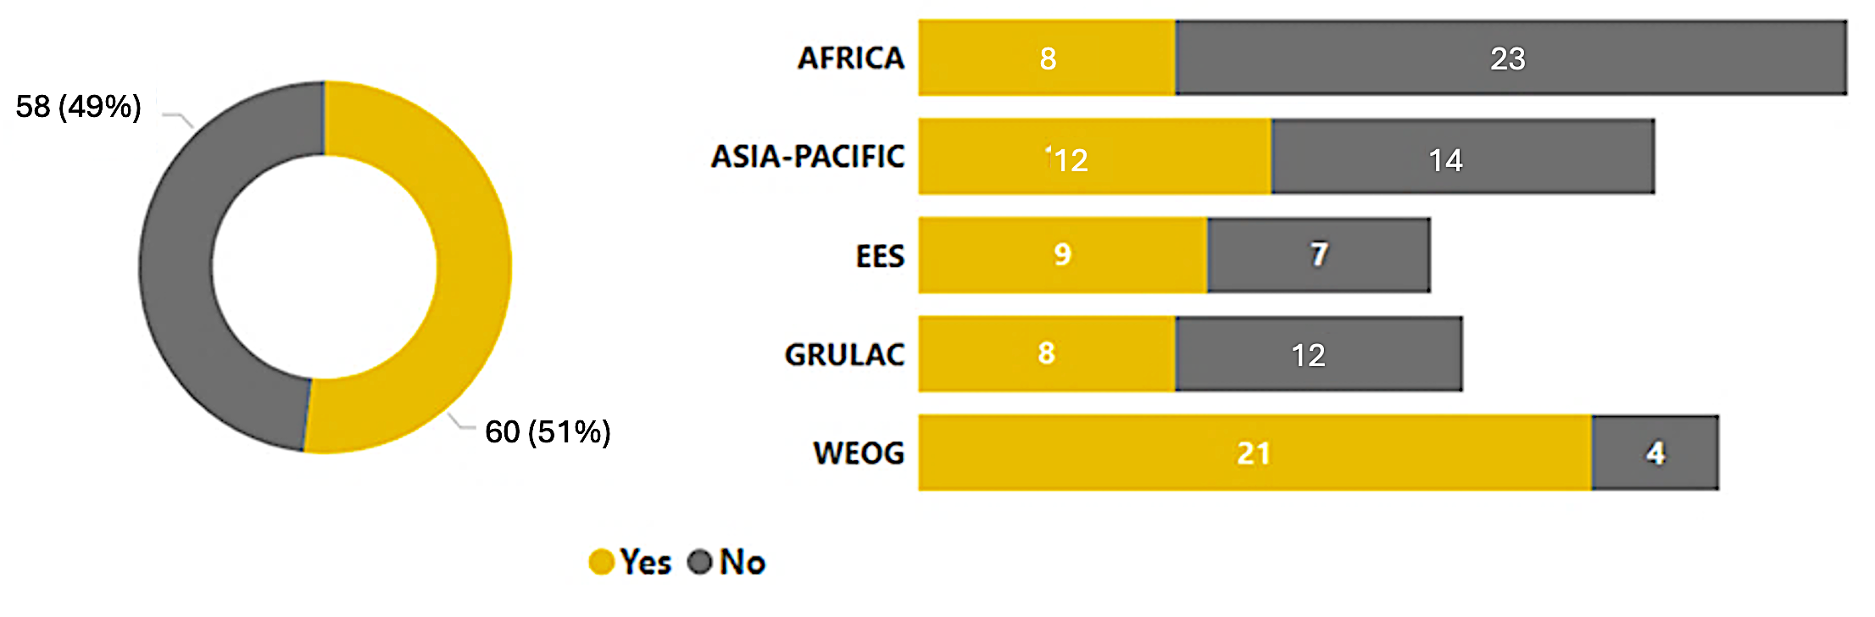
  - “Yes” - 58 parties (49%, 58/118) and “No” - 60 parties (51%, 60/118).
  - The breakdown of the responses by region is as follows:
Region | "Yes" | "No" | Total parties
Africa | 8 (26%) | 23 (75%) | 31
Asia-Pacific | 12 (46%) | 14 (54%) | 26
Eastern European States | 9 (56%) | 7 (44%) | 16
Latin America and the Caribbean | 8 (40%) | 12 (60%) | 20
Western Europe and Others | 21 (84%) | 4 (16%) | 25

- Based on its review of parties’ responses to question 3.3 and their submissions, the secretariat presents the following findings:
  - The totals of the “Yes” or “No” responses do not accurately reflect the number of parties that have endeavoured to identify individual stocks of mercury and sources of mercury supply generating stocks (stocks and sources). This trend is similar to how parties responded to question 3.3 in the first full report. In the first full report 53 parties responded “no”, but after a closer review of the reports most parties provided explanation or descriptions of their endeavour to identify stocks and sources of mercury.
  - A closer review of the second short national reports, including targeted follow-up by the secretariat with some parties, revealed that there is also a fair number of parties who responded “No” but provided explanations indicating they have endeavoured or taken steps to endeavour to identify stocks and sources of mercury. These parties are as follows:
    - Twenty parties responded “No” to the question because they based their response on the result of their study or inventory, i.e., after undertaking steps to identify stocks and sources they did not find any, or that the quantities were below 50 metric tons (stocks) and 10 metric tons (sources of mercury supply generating stocks). (Argentina, Belgium, Cameroon, Chile, Ecuador, Guyana, Kuwait, Jamaica, Latvia, Madagascar, Mexico, Nicaragua, Nigeria, Saint Kitts and Nevis, Senegal, Seychelles, Sierra Leone, Slovakia, Sri Lanka, and United Republic of Tanzania)
    - Fourteen parties responded “No”, because they think the question does not apply to them. These parties took steps to identify the presence of stocks and sources of mercury in their territory and arrived at the conclusion that they do not have industries that hold stocks or sources of mercury in their territory. (Armenia, Bahrain, Burundi, Colombia, Comoros, Cote d’Ivoire, Cyprus, Lithuania, Luxembourg, Mali, Palau, Portugal, Romania, and Uruguay)
    - Six parties responded “No” but have completed and submitted their Minamata Initial Assessments (MIAs) to the secretariat. The MIAs constitute an endeavour to identify stocks and sources of mercury. (Bolivia (Plurinational State of), Republic, Guinea, Guinea-Bissau, Niger, and Uganda)
    - Four parties responded “No” and explained that they have no financial resources or lacked technical capacity to conduct the inventory of stocks and sources (Burkina Faso, Cambodia, Dominican Republic, and Tuvalu). Upon review, all four parties appear to have received support to conduct their MIAs. Three of the four parties (Burkina Faso, Dominican Republic, and Tuvalu) have completed and submitted their MIAs to the secretariat.
    - Two parties (Saudi Arabia and Zambia) reported that their inventories are still in progress.
  - Of the 58 parties who responded “Yes”, 22 parties provided information on the quantities of stocks and sources of mercury in their territories:
    - 14 parties reported on the quantities and sources of mercury stocks, as follows:
Table 2: Reported quantities of identified stocks
Stocks | Quantity
Chlor-alkali facility
Finland  Greece  Indonesia  Iran  Peru  Spain | 0 (stocks sent for final disposal)  36 tons  2,937.6 tons  249.9335 tons (unchanged from previous report)  2021: 120 tons 2022: Inventory in progress  Facility 3:  2021 - 11.264t  2022 - 12.697t  Facility 2:  2021 - 145.180t  2022 - 0t  Facility 1:  2021 - 330.614t  2022 - 27.590t
Held by enterprises or companies
China  Japan  Republic of Korea  Peru  Thailand  United States | 2021: 198 tons approx. 2022: 171 tons  2021: 108.375 t 2022: Inventory in progress  2021: 73.66 tons  2021: 3,184.5 tons 2022: Inventory in progress  2021: 52.4495 t 2022: 36.19965 t (remaining in warehouse)  2021-2022 inventory additional info:  - 1 company - 78 metric ton of elemental mercury: manufactured (including imported) approximately  - 17 metric tons - distributed in domestic commerce approximately  - Stored on site between 54 and 77 metric tons (also reported approximately 47 metric tons of compound-related activity)
Held by facility for stabilization or from mercury waste recycling
Germany  Switzerland | NOTE: values fluctuate. Reported quantities are peak amounts.  Facility 3:  2021 - 353 tonnes  2022 – 0 tonnes  Facility 2:  2021 - 33.8 tonnes  2022 - 148.8 tonnes  Facility 1:  2021 - 317.2 tonnes  2022 -119.3 tonnes  Could exceed temporarily 50 metric tons (unchanged from previous report)
Government stocks
United States  Ecuador | US DOD: 4,400 metric tons of elemental mercury approximately  US DOE: 1,200 metric tons of elemental mercury  2021: 11.15 kg (confiscated Hg) 2022: 0.17 kg (confiscated Hg)
Lighting industry
Indonesia | 2022: 1.22 kg
Laboratory, research
Indonesia | 2021-2022: 2.46 kg

    - Six parties reported on the quantities of the identified sources of mercury supply generating stocks in their territories, as follows:
Table 3: Reported quantities of identified sources of mercury supply generating stocks

Sources of mercury supply generating stocks | Quantity
By-product mercury
Ecuador  Thailand  Peru | 2021: 22.80 kg 2022: 8.50 kg  2021 - 43.589 t 2022 - 8.27965 t  2021 – 18.5 tons (Note: other companies were identified by the quantities did not exceed 10 tons per year)
Zinc smelter
Finland | 2021 > 10 MT 2022 > 10 MT
Enterprise
Australia  China | 10 enterprises identified: data gathering in progress  3 enterprises:  - - has > 10 MT 2022 - has > 10 MT
    - Six parties reported that the quantities they identified for individual stocks do not exceed the threshold (Brazil, Canada, El Salvador, France, Netherlands, and United Kingdom) and one party (European Union) referred to the reports of its member states.
    - One party (Iraq) reported on the existence of 87 mercury components with a total amount of 39,000 kg which can be found in governmental sector ministries (industry, oil, health, municipalities). It is not clear if the reported amount relates solely to stocks and sources of mercury or if it includes or consists of mercury-added products.
    - Based on the reported quantities, the following information can be highlighted:
- One party (Peru) had a substantial increase in its reported stock in 2021. Comparing the quantity the party reported in its first full report against its second short report, there is a sharp increase in quantity of stocks, from 294.8 tons in 2017 to 3,184.5 tons in 2021. The party also reported an increase in the number of facilities that have stocks of mercury from 5 to 6 facilities during the current reporting period.
- One party (United States) reported an increase in stocks ranging from 54 and 77 MT, and the party also included in its report stocks of 47 MT of mercury compound.
- Parties vary on how they reported on quantities below the 50 MT for individual stocks and 10 MT for sources of mercury supply generating stocks. Some parties (Ecuador, Indonesia) indicated source categories and provided specific quantities, while other parties only provided a general description, e.g., below threshold, small quantity, etc. of their inventory.
- Data or inventory on stocks and sources from MIA, inventory report or studies were not consistently reflected in the response to question 3.3. This occurs when parties merely provide the link to the document or attach the MIA, report, or study without summarizing or specifying the concluding result of the study in the space provided in question 3.3 of the ORT. The ORT is not able to draw data from external sources and requires parties to encode or input the relevant data.
  - One party (Benin) indicated that their initial inventory covered the period from 2017 to 2019, and that no new inventory has been conducted for the current reporting period. Another party (Seychelles) indicated their need to update their MIA report of 2016.
  - Of the 54 parties who responded “No”, 12 parties did not include an explanation on why they did not endeavour to identify stocks and sources of mercury.
- Below is a summary of the secretariat’s findings under question 3.3:
  - Overall, the second short national reports show an improvement on how parties responded to question 3.3, i.e., a good number of parties provided additional explanation on their results, some parties provided annual and monthly data, some parties reported on identified stocks not exceeding 50 metric tons and sources of mercury supply generating stocks not exceeding 10 metric tons, and some parties either described steps they took or informed the secretariat that they are in the process of completing their inventories. The details reported provided a better understanding of the context to the responses and efforts undertaken.
  - There is also an improvement in the quality of the information shared by parties in response to question 3.3, with clearer distinctions in the reports between identified stocks and sources, quantities of mercury identified, and additional descriptions of the type of endeavour taken. The quality of information in the current reporting cycle has provided better insight on the measures taken to identify stocks and sources compared to the previous reporting cycles.
  - While there is an improvement in the description of endeavours, the totality of information still provides an incomplete status of the stocks and sources globally. Some issues that lead to this observation include, variability of stocks at a given time, lack of consistency in reporting particularly on stocks of mercury that are traded, and results of MIAs or inventories that are not summarized and manually entered in the ORT. As seen in tables 2 and 3 above, the aggregated results under the second short national reports cannot be taken as providing a meaningful overview of current global stocks and sources.
  - The amended reporting format adopted by the Conference of Parties in its decision MC-5/13, which added response options that covers scenarios that is applicable to many parties, is expected to further clarify question 3.3 and facilitate the way how parties can respond to question 3.3. The amended reporting format will be operational in the second full report version of the ORT.
  - There are parties who cited their MIAs in the second short report whose information may be outdated. Fifteen parties cited their MIA, of the 15, 12 parties (Albania, Antigua and Barbuda, Cameroon, Eswatini, Lesotho, Mauritius, Montenegro, North Macedonia, Peru, Saint Lucia, South Africa, and Sri Lanka) cited MIAs that were completed before 2023. As the obligation to endeavour to identify stocks and sources of mercury has been clarified by decision MC-4/8 as a continuing obligation, parties who solely rely on their MIA results may need to update the information.
Question 3.5: *Has the party received consent, or relied on a general notification of consent, in accordance with article 3, including any required certification from importing non-parties, for all exports of mercury from the party’s territory in the reporting period. (Para. 6, para. 7.)
- Yes, exports to parties
- Yes, exports to non-parties
- No
- No, no export
If yes,
(a) and the party has submitted copies of the consent forms to the secretariat, then no further information is needed.
If the party has not previously provided such copies, it is recommended that it do so.
Otherwise, please provide other suitable information showing that the relevant requirements of paragraph 6 of article 3 have been met.
Supplemental: Please provide information on the use of the exported mercury.
(b) If exports were based on a general notification in accordance with article 3, paragraph 7, please indicate, if available, the total amount exported and any relevant terms or conditions in the general notification related to use.

- In terms of parties’ responses to question 3.5:
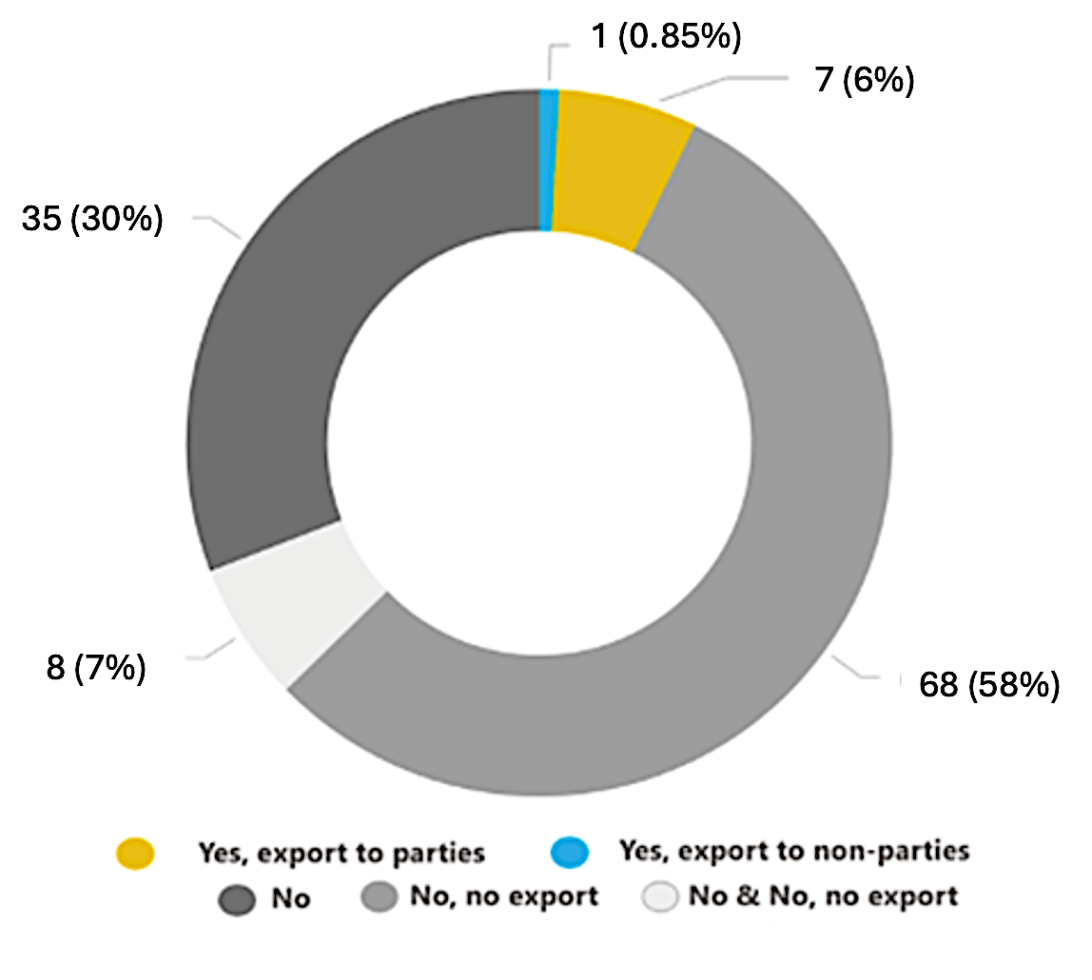

  - The breakdown of responses to each question as follows:
“Yes, export to parties” | 7 parties | (6%, 7/118)
“Yes, export to non-parties” | 1 party | (0.85%, 1/118)
“No” | 35 parties | (30%, 35/118)
“No, no export” | 68 parties | (58%, 68/118)
“No” and “No, no export” | 8 parties | (7%, 8 of 118)

  - The breakdown of the responses by region is as follows:

Region | "Yes, export to parties" | "Yes, export to non-parties" | "No" | "No, no export" | "No” and “No, no export" | Total parties
Africa | - | - | 14 (46%) | 14 (46%) | 3 (10%) | 31
Asia-Pacific | 2 (8%) | - | 8 (31%) | 15 (58%) | 1 (4%) | 26
Eastern European States | - | - | 2 (13%) | 13 (81%) | 1 (6%) | 16
Latin America and the Caribbean | 2 (10%) | - | 8 (40%) | 9 (45%) | 1 (5%) | 20
Western Europe and Others | 3 (12%) | 1 (4%) | 3 (12%) | 17 (68%) | 2 (8%) | 25

- Based on its review of parties’ responses to question 3.5 and their submissions, the secretariat presents the following findings:
  - Suitable information in lieu of trade forms
    - Of the seven parties who responded “Yes”, the table below shows whether the parties exported to another party or to a non-party, if the trade form has been submitted to the secretariat, and if information was provided in lieu of submitting the trade forms.
Table 4: Tabulation of consent form submission
Party | Export to parties | Export to  non-parties | Trade consent form submitted | Information provided
Canada | Yes |  | No | In part E of its report, Canada explained that it relied on a general notification of consent.
Italy | Yes |  | No | As new party to the Convention, Italy reported mercury waste trade that occurred prior to becoming a party. The forms submitted relate to the transboundary movement of waste falling under the Basel Convention.
Japan | Yes |  | Yes | NA
Mexico | Yes |  | Yes | NA
Peru | Yes |  | Yes | NA
Switzerland | Yes | Yes | Yes | NA
Thailand | Yes |  | No | Table with various information submitted as an attachment

    - Of the seven parties who responded “Yes”, three parties did not submit trade consent forms. Of the three parties, one party (Canada) indicated that it relied on a general notification of consent, one party (Italy) was not yet a party when its reported trade took place, and one party provided information in lieu of the trade consent forms (Thailand). Below is a table indicating the information submitted by the party along with an indication of whether it aligns with the requirements outlined in the respective trade consent forms:
Table 5: Information required under forms A or B and information submitted
Information required under  form A / B | Information submitted by Thailand
Contact information to be provided by the importing party | No
Contact information to be provided by the exporting party or non-party | No
Shipment information to be provided by the exporting country:  - Please indicate approximate total quantity of mercury to be shipped:  - Please indicate approximate date of shipment:  - Please indicate if the mercury is from primary mercury mining:  - Please indicate if the mercury has been determined by the exporting party to be excess mercury from the decommissioning of chlor-alkali facilities: | Yes  No  No  No
Information to be provided by the importing party:  What is the purpose of the import of the mercury?  - Environmentally sound interim storage in accordance with article 10  - Use allowed to a party under the Convention | Yes  No
Shipping information, as appropriate (Importer/Exporter) | No
Indication of consent by importing party | No
Section D: Certification and information to be provided by an importing non-party | NA

  - Information contained in the submitted trade consent forms and completeness of the submitted forms
    - One party (Peru) provided forms where it showed:
- Imports destined for use in ASGM in its territory
- Export of mercury salts (catalizadores) and dental amalgam. The form was not signed.
- Export for dental amalgam. The form was missing confirmation of consent and signature.
- Imports for use in the party’s chlor-alkali sector.
- Export form of mercury proceeding from a party. The form was not signed. According to the description in the submission, consent was denied.
    - One party (Japan) provided trade consent forms where it showed:
- Exports of mercury with reported use in phased-out mercury-added products (sphygmomanometers and blood pressure measuring instruments) to another party, who has an exemption until 2025.
- Exports with reported uses in the traded mercury which included: high pressure short arc lamp, high pressure UV lamp, and chlor-alkali process. Some of the submitted forms had missing information on the use of the mercury and one form was not signed.
    - One party (Switzerland) provided trade consent forms that redacted specific names of exporter and importer, but showed, all relevant trade consent form information including:
- Exports of mercury with reported use in the manufacture of pre-dosed capsules for dental amalgam fillings.
- Exports of mercury with reported use for mercury porosimetry (for analytical and research purposes).
  - Trade not conforming to article 3
Reports on illicit trade (2023)
    - 10 parties raised the issue of illicit trafficking, illegal trade or smuggling of mercury and mercury-added products in their respective territories either in their response to question 3.5 or in part C of their reports (Antigua and Barbuda, Burkina Faso, Colombia, Cote d’Ivoire, Indonesia, Lesotho, Nigeria, Peru, Philippines, and Uganda). Of the 10 parties, four parties (40%, 4 of 10) provided information on trade not conforming to article 3 as follows:
- One party (Antigua and Barbuda) reported an export without consent in 2022. The party reported that subsequent documents submitted to its national focal point satisfied the latter that the stocks were disposed of in an environmentally sound manner.
- One party (Burkina Faso) reported on illegal domestic trade of mercury in small quantities. The report confirmed it has no primary mercury mining in its territory.
- One party (Philippines) reported that online trading platforms facilitate trade in prohibited mercury-added products, and the continued illegal trade of mercury for use in ASGM which is sold by dental clinics.
- One party (Uganda) reported on smuggled mercury from another country that ends up in its ASGM sector.
Historical trends (2019-2021)
    - In reviewing responses related to trade not conforming to article 3 or illegal trade for the past reporting cycles, a total of 9 parties either reported on illegal trade or trade not conforming to the Convention or raised it as a challenge in implementing the Convention. In the first short national report one party (Canada) reported a case of trade of mercury in contravention of its laws in its response to question 3.5. Four parties (Colombia, Ecuador, Indonesia, and Peru) cited illegal trade as a challenge to implementing the Convention in part C of their reports (2019). One party (Indonesia) cited its vulnerability to illegal activities as an archipelagic state, while another party (Peru) provided a recommendation for optimizing the written consent procedure for the import of mercury, including the provision of information on transit countries, re-export points and the role of free-trade zones, and the establishment of a deadline for receipt of response from parties concerned. The party had also raised the need to improve identification of intended uses of traded mercury, strengthening of capacities of border control agents along with the development of protocols to identify, seize, transport, handle, and label mercury.
    - For the full national report (2021) an additional three parties (Eswatini, South Africa, and Uganda) raised concerns over illegal trade which were not raised in the first reporting cycle. One party (South Africa) noted that there were known informal flows of mercury in their region and illegal imports of mercury into their territory. Another party (Eswatini) reported on illegal mercury trade in the context of illegal mining occurring at the border, which leads to the illegal cross-border trade of mercury it is experiencing. One party (Uganda) acknowledged that smuggling of mercury into its borders is occurring.
Data gap in the current reporting period (2023)
    - Beyond reports of illegal trade, 35 parties responded “No”, to questions about mercury exports, but 16 provided no further explanation. It is not possible to determine from the reports of these parties if their response meant that there were no exports, or if there were trade not conforming to article 3. (Burundi, Costa Rica, Eswatini (Kingdom of), Guinea-Bissau, Madagascar, Mali, Malta, Marshall Islands, Portugal, Republic of Moldova, Rwanda, Sri Lanka, State of Palestine, United Arab Emirates, Viet Nam, and Zambia)
- Below is a summary of the secretariat’s findings under question 3.5:
  - It is not clear from the information provided by the party who did not submit copies of the relevant trade forms and based on the available data that all requirements under article 3 have been fully met.
  - As reflected in table 5 (Tabulation of information required under forms A or B and information submitted), while all parties provided details on the quantity of mercury traded, other required information under the trade forms was inconsistently provided. Some of the submitted trade forms had missing information on the source of mercury exported and some lacked the signature of the national focal point. Considering these issues, further work to support implementation of paragraph 6 of article 3 on mercury trade may be needed.
  - It was not possible to determine from the reports of parties who responded “No” and who did not provide an explanation, if their response referred to trade not conforming to article 3. The amended reporting format adopted by the Conference of Parties in its decision MC-5/13, added response options that covers both: “No – no export took place” and “No – consent was not given” scenarios. These added response options are expected to further improve response and information sharing under question 3.5 in the succeeding reporting cycle. The amended reporting format will be operational in the second full report version of the ORT.

B. Article 11: Mercury wastes
Question 11.2: *Are there facilities for final disposal of waste consisting of mercury or mercury compounds in the Party’s territory?
- Yes
- No
- Do not know (please explain)
If yes, if available, how much waste consisting of mercury or mercury compounds has been subjected to final disposal under the reporting period? Please specify the method of the final disposal operation/operations.

- In terms of parties’ responses to question 11.2:
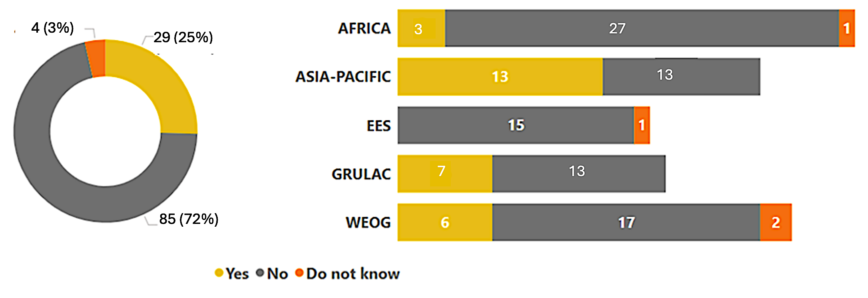
  - The breakdown of responses is as follows:
“Yes” | 29 parties | (25%, 29/118)
“No” | 85 parties | (72%,85/118)
“Do not know” | 4 parties | (3%, 4/118)

  - The breakdown of the responses by region is as follows:
Region | "Yes" Responses | "No" Responses | "Do not know" | Total parties
Africa | 3 (10%) | 27 (87%) | 1 (3%) | 31
Asia-Pacific | 13 (50%) | 13 (50%) | - | 26
Eastern European States | - | 15 (94%) | 1 (6%) | 16
Latin America & Carib. | 7 (35%) | 13 (65%) | - | 20
Western Europe & Others | 6 (24%) | 17 (68%) | 2 (8%) | 25

- Based on its review of parties’ responses to question 11.2 and their submissions, the secretariat has the following findings:
  - The following parties reported on the amount of waste consisting of mercury or mercury compounds subject to final disposal during the reporting period, see table 6 below, which also includes information from the two prior reports for ease of reference:
Table 6: Comparison of reported amounts of waste consisting of mercury or mercury compounds subject to final disposal
 | Second short report | First full report | First short report
Canada | 2021-2022: 79 tonnes of mercury and 153 tonnes of mercury compounds | 2017 - 2020: 123.712 metric tons of waste consisting of mercury or mercury compounds. Breakdown per year:  2017: 24.936 MT  2018: 31.274 MT  2019: 24.462 MT  2020: 43.030 MT | 2017: 56.2 tonnes  2018: 56.4 tonnes
Germany | 2021: 561.5 tonnes  2022: 425 tonnes | None reported | 2018: 443.2 tonnes of solidified mercury waste
Norway | 2020: 286 tonnes  2021: 15 tonnes  2022: 620 tonnes | 2018: 385 tonnes  2019: 725 tonnes  2020: 293 tonnes  2021: 217 tonnes | 2017-2019: 1,172 tonnes

  - The following parties also reported on the amount of mercury waste; however, it is unclear from their report whether the mercury waste reported consists predominantly of wastes consisting of mercury or mercury compounds or contains a mixture of other hazardous wastes:
Table 7: Tabulation of mercury waste reported (including waste other than that consisting of mercury or mercury compounds)
 | Amount of mercury waste reported
Australia | 2021-2022: 311 tonnes (in the process of further identifying the waste streams)
Colombia | 2022: Hazardous waste 531 t of which 61% is waste containing mercury
Qatar | 2021: 44.406 MT mercury waste  2022: 45.608 MT mercury waste
Republic of Korea | 2021: 26.5 tonnes mercury waste  2022: 50.5 tonnes mercury waste
Singapore | 2021-2022: 111,300.72 kg toxic industrial waste containing mercury
South Africa | 2021-2022: 16.7 tons of waste consisting of mercury or mercury compounds processed. No information about final disposal.
Thailand | 2021: 369.59 tons  2022: 362.45 tons  Discarded equipment containing hazardous components disposed of by secure landfill of stabilized and/or solidified waste.

  - The following parties reported on the disposal methods for waste consisting of mercury or mercury compounds:
Table 8: Disposal methods reported
 | Second Short Report Information | Clarification of response
Australia | Specially engineered landfills or cells. Regulation requires stabilization and solidification but no such facility so far | No clarification needed
Brazil | Specially engineered landfill | No facilities in territory dedicated to the final disposal of metallic mercury or waste consisting of mercury compounds.
Canada | Physico-chemical treatment and specially engineered landfill | No clarification needed
China (Macao SAR) | Mercury waste is treated by licensed toxic industrial waste collectors (i.e., via incineration followed by fixation and storage of incineration ash). | No additional information provided.
Colombia | Specially engineered landfill requiring stabilization | Waste containing Hg: Main disposal operation for these wastes is under entry D5 (specially designed landfills). Pre-treatment of these wastes (prior to entering the safety cell) consists of stabilisation with the components of an insoluble matrix (cement, phosphate, ceramics, magnesia binder).
Ecuador | No information on disposal methods. | No additional information provided.
European Union | Referred to individual member state reports | No clarification needed
Germany | Disposal of mercury sulfide in underground storage facility | No clarification needed
India | No information on disposal methods. | No additional information provided.
Indonesia | No facility in territory; has access to final disposal facilities located in other countries | <260 ppm concentration of waste containing mercury or mercury compounds follows treatment process that uses stabilization and compaction by macroencapsulation,  >260 ppm concentration of waste containing mercury or mercury compounds: no waste management facility; exports are made for these types of hazardous waste.
Iran | Neutralization and encapsulation | No clarification needed
Kuwait | No information on disposal methods. | No additional information provided.
Mexico | Stabilization and solidification by encapsulation before being sent to the final disposal cells | No clarification needed.
Norway | Deposit of mercury sulfide into specifically engineered landfills | No clarification needed.
Panama | Security landfill for hazardous wastes | No additional information provided.
Qatar | By treatment and landfill, where waste is solidified and then buried in hazardous waste landfill | Hg containing waste: Class 1 landfill after solidification.  Waste consisting of Hg; Class 1 landfill after stabilization and encapsulation.
Republic of Korea | Stored in mercury-dedicated container permanently | No additional information provided.
Saudi Arabia | No information on disposal methods. | No additional information provided.
South Africa | No information on disposal methods. | No additional information provided.
Singapore | Treated by licensed toxic industrial waste collectors (e.g., via incineration followed by fixation of incineration ash) | Waste consisting of Hg: undergoes incineration to reduce volume subject to high temperature incineration to reduce the overall volume of the waste. Flue gases generated from incineration process would pass through pollution control facilities (e.g. scrubbers) to ensure that emissions follow the local air emissions limits.  Incineration residues (e.g. bottom ash and fly ash) that do not meet the landfill acceptance criteria (i.e. Toxicity Characteristics Leaching Procedure (TCLP) limits) are subject to stabilisation (also known as fixation), which is considered a form of physico-chemical treatment, through the addition of stabilisers such as cement. Stabilised waste that meets the TCLP, which includes the leaching limit of 0.2mg/L for mercury, would then be conveyed to the final disposal site at Semakau Landfill, which is a specially-engineered, offshore, sanitary landfill.
State of Palestine | No information on disposal methods. | Requested clarification. No response.
Thailand | Multiple methods including Secure landfill of stabilized and/or solidified wastes | No additional information provided.
Uganda | Incineration in most cases where flue gas is not condensed, and sludge is stabilized and solidified | Composite waste (sources include oil and gas waste and medical waste). Physical Chemical pretreatment methods of hazardous waste prior to landfilling at this facility covers the  following methods:  a) Hydrolysis  b) Evaporation  c) Decantation  d) Neutralisation  e) Stabilization / Solidification
United Arab Emirates | No information on disposal methods. | No additional information provided.
United States of America | Long-term waste elemental mercury storage facility | No clarification needed.
Viet Nam | No information on disposal methods. | Concerning physico-chemical treatment and other measures, Vietnam has established a systematic approach to hazardous waste treatment that aligns with our international commitments.

  - Four parties (Belgium, Iceland, Mali and Poland) responded that they do not know whether such facilities exist. Mali said in the explanatory field that there is no such facility, so their response may be changed. Belgium does not know the situation in Brussels Capital. Poland is verifying the information.
  - One party (Peru) provided an update on a pilot project to stabilize mercury waste.
  - Some parties highlighted the challenges they faced as follows:
    - Lack of knowledge on what constitutes proper mercury waste disposal facility;
    - Lack of inventories including the challenge of identifying the mercury waste;
    - Lack of technical resources and need for capacity-building;
    - Challenge of establishing a waste collection infrastructure to better collect and manage household waste;
    - Cost of exporting mercury waste for final disposal to other parties;
    - Lack of financial resources to establish proper waste facilities;
    - Defective project designs which fail to tackle the challenges of mercury at the national level; and
    - Challenge of disaggregating mercury waste volumes from other wastes.
- Below is a summary of the secretariat’s findings under question 11.2:
  - There is an improvement in the information reported on the final disposal methodologies being employed since the previous reporting. Some parties reported on specifically engineered landfills or permanent storage as final disposal operations in their territories, together with explanation on the requirements for stabilization, solidification and storage before final disposal.
  - Some parties mentioned landfilling but did not provide details, while other parties did not provide any information on the disposal methods. Parties may consider using the Basel Convention definition of annex IV final disposal operations, i.e., D5 – specifically engineered landfill or D12 – permanent storage, and specifying whether stabilization and solidification is undertaken together as part of the final disposal operation in future reporting to help facilitate identification of the disposal operation reported on.
  - The Committee requested the secretariat to follow-up with parties who reported to have final disposal facilities on the amount of mercury waste disposed of. The secretariat reached out to 10 parties from September to October 2022, with two parties responding to the request for clarification: one party (Germany) reported that 4,042 tonnes of mercury sulfide were disposed of though underground depository, as chemically stabilized mercury sulfide, in its territory during the reporting period; and another party (Oman) provided information on quantities disposed of via municipal/industrial engineered landfills in its territory. The quantity reported by the party appears to be for all waste received and not specific to mercury waste only.
C. Responses to part C and part D of the reporting format
- This section provides an overview of the responses to parts C and D of the second short national reports. Part C provides an opportunity for parties to comment on possible challenges in meeting the objectives of the Convention. Part D provides an opportunity for parties to comment on the reporting format and possible improvements.
- In terms of parties’ responses to parts C and D:
  - In part C, 51 parties provided comments on possible challenges in meeting the objectives of the Convention;
  - In part D, 39 parties provided comments on the reporting format and possible improvements.

- Based on its review of parties’ responses to part C and part D, the secretariat has the following findings:
  - Part C: (Total responding parties: 51)
Category | Specific issues | No. of parties | Percentage
Financial constraints | Lack of financial resources/access | 22 | 43%
Institutional capacity gaps | Enforcement, legal updates, coordination | 16 | 31%
Technical resource shortages | Data, equipment, training, risk assessment | 14 | 27%
Mercury trade issues | Illicit trafficking/illegal trade | 14 | 27%
Waste management | Lack of disposal/interim storage | 9 | 18%
Awareness and alternatives | Lack of mercury-free alternative information | 8 | 16%
ASGM sector challenges | Behaviour change, financing mercury-free processing | 6 | 12%
Domestic mercury trade | Online sales of prohibited products | 3 | 6%
Human resource shortages | Lack of skilled personnel | 3 | 6%
Minamata Convention assessments | Delays in Initial Assessments/National Action Plan | 3 | 6%
Contaminated site management | Remediation challenges | 2 | 4%
National Focal Point issues | Communication difficulties | 2 | 4%
Weak regional coordination | Low sub-regional agency participation | 1 | 2%
COVID-19 disruptions | Pandemic-related delays | 1 | 2%
Unique national challenges | Country-specific barriers | 1 | 2%
Part C not applicable | - | 2 | 4%
No challenges reported | - | 1 | 2%

  - Part D: (Total responding parties: 39)
Feedback category | Details | No. of parties | Percentage
Found format suitable/user-friendly | No issues reported | 22 | 56%
No additional comments | Neutral response | 9 | 21%
Technical login/navigation issues | Problems with multiple devices | 2 | 6%
Offline paper version helpful | Used for report preparation | 1 | 3%
Suggested working group for improvements | Recommended format enhancement team | 1 | 3%
Internet connection difficulties | Access challenges | 1 | 3%
Comments outside part D scope | Unrelated feedback | 1 | 3%

* UNEP/MC/COP.6/1/Rev.1.
** This document has not been formally edited.
By 31 December 2023, 147 States and regional economic integration organizations had deposited their instruments of ratification, acceptance or approval of or accession to the Convention with the Depositary. As the Convention comes into force 90 days after the deposit of an instrument, Algeria, Bangladesh, Belize, Eritrea, Georgia, Kenya, Malawi, Saint Vincent and the Grenadines, Türkiye, and Ukraine were not obliged to submit the second short reports due by 31 December 2023, as they became parties after the reporting period.
At its sixth meeting on 24-25 September 2024, the Implementation and Compliance Committee in its review of the results of the second short national reports welcomed the high rate of reporting performance by parties, noted the importance of timely submission of national reports and acknowledged that there was room for further improvement in the reporting rate, requested the secretariat to follow up and to reach out to parties who had not yet submitted their second short national reports and requested parties who had not yet submitted their second short national reports to do so by 31 May 2025.
The online reporting tool auto-generates the submission dates. For submissions by email, the date stamp on receipt is taken as the submission date. These submission dates are confirmed by the secretariat once the reports have been checked for completeness.
Question 3.1 was amended under MC-5/13: National reporting pursuant to article 21 of the Minamata Convention on Mercury. For the text of the amended question, please go to: https://minamataconvention.org/en/documents/national-reporting-pursuant-article-21-minamata-convention-mercury-0
One new party (Kenya) voluntarily submitted its report and responded “No” to question 3.1.
The party indicated illegal primary mercury mining as a challenge in part C: Comments regarding possible challenges in meeting the objectives of the Convention in its first short and first full national reports.
Question 3.3 was amended under MC-5/13: National reporting pursuant to article 21 of the Minamata Convention on Mercury. For the text of the amended question, please go to: https://minamataconvention.org/en/documents/national-reporting-pursuant-article-21-minamata-convention-mercury-0
One new party (Kenya) voluntarily submitted its report and responded “No” to question 3.3.
The secretariat followed up with parties who responded “No” and who did not provide an explanation to their response to get clarity on why no endeavour was taken.
Due to the interim nature of stocks, reported quantities differed or fluctuated during the reporting period.
The case of one party is illustrative and applies to other parties. In its response to question 3.3, the party indicated that their MIA was submitted to the secretariat without including a summary of the pertinent result in the ORT. As part of the secretariat’s task to check for completeness of the report and viability of links or attachments, the secretariat conducted a check of the links and attachments received as part of the report. The party’s MIA was sent separately as an attachment. A cursory review of the MIA revealed that a section of its MIA was devoted to its inventory of stocks and sources that included quantity approximations of the remaining stocks of mercury from the closed Thor Chemicals chlor-alkali plant, and other sectors in the country. While the secretariat has access to the document, the Party is responsible to assess the relevant results it has and to include a summary of the result in its report. Further, the ORT is not yet able to draw information from external data sources, e.g., links or attachments, and would require parties to manually enter the data in the ORT.
Question 3.5 was amended under MC-5/13: National reporting pursuant to article 21 of the Minamata Convention on Mercury. For the text of the amended question, please go to: https://minamataconvention.org/en/documents/national-reporting-pursuant-article-21-minamata-convention-mercury-0
One new party (Kenya) voluntarily submitted its report and responded “No, no export” to question 3.5.
Question 11.2 was amended under MC-5/13: National reporting pursuant to article 21 of the Minamata Convention on Mercury. For the text of the amended question, please go to: https://minamataconvention.org/en/documents/national-reporting-pursuant-article-21-minamata-convention-mercury-0
One new party (Kenya) voluntarily submitted its report and responded “No” to question 11.2
This table reflects data from second short reports submitted to the Secretariat by 31 December 2024, including clarifications received by 31 January 2025.
Information provided in this section reflects data from second short reports submitted to the secretariat by 31 December 2024.

