UNITED  NATIONS | 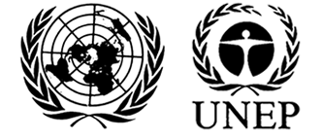 |  |  | MC
 |  |  | UNEP/MC/COP.6/INF/17
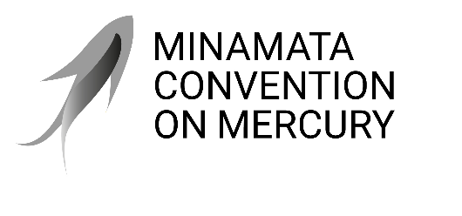 |  |  | Distr.: General  16 August 2025  English only
Conference of the Parties to the
Minamata Convention on Mercury
Sixth meeting
Geneva, 3–7 November 2025
Item 4 (e) (ii) of the provisional agenda*
Matters for consideration or action by the Conference of the Parties: financial resources and mechanism: Specific International Programme to Support Capacity-Building and Technical Assistance
Update on the Global Framework on Chemicals Fund**
Note by the secretariat
The annex to the present note sets out the update on the Global Framework on Chemicals Fund and its first round of applications. The document was submitted by UNEP’s Global Framework on Chemicals Secretariat. It is presented as received, without formal editing.

Annex
Update on the Global Framework on Chemicals Fund
I. Introduction
- The Global Framework on Chemicals – For a Planet Free of Harm from Chemicals and Waste (GFC) was adopted in September 2023 at the fifth International Conference on Chemicals Management (ICCM5). It provides the essential building blocks for a future where chemicals are used in a safe, sustainable manner, while preventing or minimizing their harmful impacts on human health and the environment.
- At ICCM5, the International Conference adopted resolution V/3 on financial considerations. In the resolution, the Conference established the Global Framework on Chemicals Fund to support the Framework’s implementation in developing countries, least developed countries, Small Island Developing States, and countries with economies in transition. The Fund aims to finance projects that deliver transformative change to prevent, or where not feasible, minimize harm from chemicals and waste—particularly for vulnerable groups and workers.
- The Fund provides financial support of USD 300,000 to 800,000 for projects with an implementation period of up to three years. Governments from developing countries, Small Island Developing States, and countries with economies in transition may apply for funding. On an exceptional basis, civil society networks may also apply, provided they have the agreement of the respective government. The Fund encourages regional or multi-country applications.
- The Fund is governed by an Executive Board composed of representatives from regions, donor countries, and other contributors. It operates with a transparent application and selection process, guided by a set of eligibility and assessment criteria. Funding is allocated to projects that demonstrate strong potential for sustainability, replication, and contribution to the objectives of the GFC.
- With an initial capitalization of close to USD 30 million, the GFC Fund occupies a strategic niche. It offers an agile, accessible, and targeted funding modality for countries and stakeholders needing catalytic support to advance specific elements of the Framework. The goal is to achieve substantial and visible impacts that promote the safe and sustainable management of chemicals and waste with measurable results – nationally, regionally and globally.
II. Status of Implementation
- The secretariat of the Global Framework on Chemicals has provided administrative services and other support to the Fund, including facilitating meetings of the Executive Board, launching the first round of applications, screening applications for eligibility and completeness and conducting a high-level review of each application.
- The Executive Board of the Fund has held three meetings. The first took place on 8 and 9 April 2024 and the second from 12 to 14 June 2024. Key outcomes of those meetings were: the agreement on the ad interim composition of the Executive Board; the workplan, staffing and budget of the Fund’s secretariat; and the adoption of the strategic priorities for the Fund and the relevant documents for the first round of applications. The third meeting was split into two sessions: the first was held from 19 to 21 March 2025 in Geneva, and the second was held online from 26 to 28 May 2025. During the third meeting, the Board considered the eligible and complete applications of the first round and approved 4 regional/multi-country projects for funding. Furthermore, the Board decided on modalities for the second round of applications. Further information on these aspects is provided in the sections below.
- In response to paragraph 5 of UNEA resolution 6/9, UNEP has arranged for two informal meetings, held on 9 April 2024 and 19 March 2025 respectively, between the Global Framework on Chemicals Fund Executive Board, the Special Programme Executive Board and the Minamata Convention Secretariat representing the Specific International Programme to Support Capacity-Building and Technical Assistance of the Minamata Convention on Mercury. These meetings provided an opportunity for sharing of information and discussion of common issues, in an effort to promote complementarity and avoid duplication among the three funding mechanisms.
III. Overview of the first round of applications
- The first round of applications to the Fund was launched on 1 October 2024, with a closing date of 31 January 2025. The launch was accompanied by a United Nations Environment Programme press release, three webinars for applicants, and broader awareness-raising across various sectors and regions. To support applicants during the project development phase, the secretariat provided a “frequently asked questions” document and operated a help desk to provide assistance via email and in one-on-one consultations.
- A total of 105 applications from 77 countries were received by the closing of the application period, reflecting broad global interest. Of these, 80 applications met eligibility and completeness requirements and proceeded to the next stage of assessment by the Global Framework on Chemicals Executive Board.
The applications included:
  - 59 from government entities
  - 46 from non-government entities
  - Africa: 45 applications from 32 countries
  - Asia-Pacific: 39 applications from 20 countries
  - Eastern Europe: 8 applications from 8 countries
  - Latin America and the Caribbean: 12 applications from 17 countries
  - Multi-country: 1 cross-regional application

Figure 1: Regional breakdown of round 1 applications
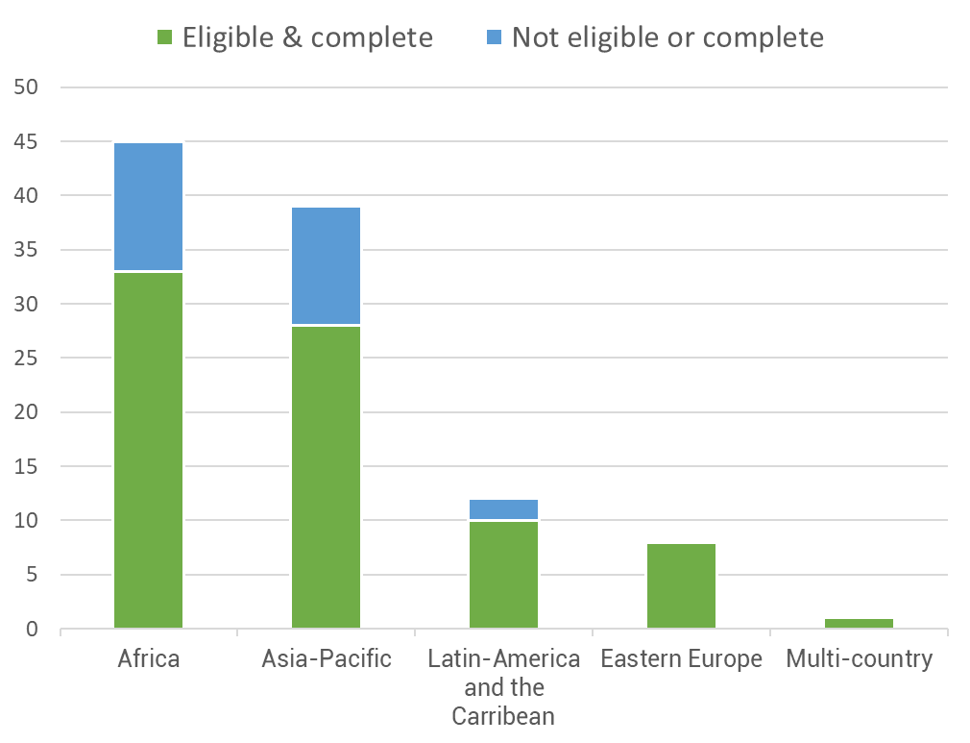

- The Board took its final decisions in May 2025 after reviewing the eligible and complete applications. The Board approved the following four projects in 11 countries of the African and Latin American region. The two projects in Latin America will be implemented by Basel and Stockholm Convention Regional Centers while the projects in Africa will be implemented by civil society organisations:
  - Colombia and Peru – “Strengthening Industrial Chemicals Management through Regional Cooperation: Action Plans, Legislation, IT Systems and Capacity Building”
  - El Salvador and Honduras – “Strengthening Capacities to Implement the Globally Harmonized System of Classification and Labelling of Chemicals in El Salvador and Honduras”
  - Benin, Burkina Faso, Guinea and Senegal – “Highly Hazardous Pesticides: Analysis, Regulation and Sustainable Alternatives”
  - Ethiopia, Kenya and Tanzania – “Building Capacity for Replacing Highly Hazardous Pesticides with Agroecology”
IV. Second round of applications and outlook
- The high number of applications in the first round demonstrates strong global interest in the Global Framework on Chemicals Fund and validates its creation. There is strong complementarity with the Global Environment Facility, the Special Programme, the Specific International Programme under the Minamata Convention and other existing financial mechanisms for chemicals and waste. The Global Framework on Chemicals Fund adds value by engaging stakeholders and initiatives that often fall outside the scope of larger funding channels, including from non-governmental stakeholders, which are considered under the GFC Fund on an exceptional basis.
- For the second round, the Executive Board has agreed to streamline the application process. This will entail the initial submission of a short concept note. Successful applicants from the concept note stage will be invited to submit full project proposals for the Board’s final appraisal and potential approval. Based on the Board’s discussions, a new application package for the second round has been developed. The Fund will launch its next call for applications in October 2025. The application package and further details on the application process and deadlines will be shared through the Fund’s website.

* UNEP/MC/COP.6/1/Rev.1.
** This document has not been formally edited.
An overview of the status of contributions is available in the document UNEP/GFC/OEWG.1/3, available at: https://documents.un.org/doc/undoc/gen/k25/005/56/pdf/k2500556.pdf
The reports of the first and second meeting are available at: https://www.unep.org/events/conference/first-meeting-executive-board-global-framework-chemicals-fund and https://www.unep.org/events/conference/second-meeting-executive-board-global-framework-chemicals-fund
The draft report of the third meeting is available at: https://www.unep.org/events/conference/third-meeting-executive-board-global-framework-chemicals-fund-resumed
Available at: https://www.unep.org/news-and-stories/press-release/new-fund-support-chemicals-and-waste-management-developing-economies
Available at: https://www.unep.org/global-framework-chemicals/gfc-fund

