UNITED  NATIONS |  |  |  | MC
 |  |  | UNEP/MC/COP.6/INF/7
 |  |  | Distr.: General  22 August 2025  English only
Conference of the Parties to the
Minamata Convention on Mercury
Sixth meeting
Geneva, 3–7 November 2025
Item 4 (a) of the provisional agenda*
Matters for consideration or action by the Conference of the Parties: mercury supply sources and trade
Additional information on types of actions that could be taken to fulfill the ongoing obligation of parties to identify individual stocks and sources of mercury and mercury compounds**
Note by the secretariat
- The annex to the present note provides additional information to the draft updates to the guidance on the identification of individual stocks of mercury or mercury compounds exceeding 50 metric tons and sources of mercury supply generating stocks exceeding 10 metric tons per year (UNEP/MC/COP.6/5). The additional information includes:
(a) Examples of how parties conducted their endeavours to identify stocks and sources of mercury, and
(b) Examples of methodologies for quantification of large amounts of mercury or mercury compounds.
- The annex also contains on the types of actions that could be taken to fulfill the ongoing obligation of parties to identify individual stocks and sources of mercury and mercury compounds and methods of calculating stocks of mercury under paragraph 5 (a) of article 3. The document has not been formally edited.

Annex
Additional information on types of actions that could be taken to fulfill the ongoing obligation of Parties to identify individual stocks and sources of mercury and mercury compounds
I. Introduction
- This document was developed by the secretariat of the Minamata Convention on Mercury to provide additional information to the guidance on the identification of individual stocks of mercury or mercury compounds exceeding 50 metric tonnes and sources of mercury supply generating stocks exceeding 10 metric tonnes per year.
- The Conference of the Parties, in decision MC-5/2, requested the secretariat to update the existing guidance on stocks adopted in decision MC-1/2 to include types of action that could be taken to fulfil the continuing obligation to endeavour to identify stocks and sources as per paragraph 5 (a) of Article 3 of the Convention. The proposed updates to the guidance are included in document UNEP/MC/COP.6/5.
- The Implementation and Compliance Committee, at its fifth meeting in 2023, requested the secretariat to collect information on accumulated stocks and methods for calculating stocks of mercury, which could provide a first step to further clarify the accumulated stockpiles meaning and calculation method. Information on calculation methods would support efforts to identify individual stocks and sources benefitting Parties that have not yet undertaken these assessments.
- This document provides additional information on the types of actions mentioned in the proposed updates to the guidance, as well as on calculation methods used by parties.
II. Types of actions that could be taken to fulfill the ongoing obligation of Parties to identify individual stocks and sources of mercury
- The types of actions that may be undertaken to fulfill the ongoing obligation of Parties to identify individual stocks and sources of mercury following the initial endeavour may include:
(a) Identification and quantification of sources in national hazardous substances regulations or implementation plans under article 20 of the Convention;
(b) Updating or sustaining inventories conducted under the Minamata Convention initial assessments;
(c) Specific surveys for mercury inventories; and
(d) Additional verification of information related to inventories of mercury stocks and sources.
A. Implementation of national hazardous substances regulations
- National hazardous substances regulations typically enforce measures to control supply and trade, manage the use of substances in industrial processes, and ensure the environmentally sound storage of stocks and waste. These regulations may include specific mechanisms for identifying mercury stocks and sources. Such mechanisms can provide valuable information for updating national inventories of mercury supply, use, and trade, and support the effective tracking stocks and sources. Examples are as follows:
- Environmental licensing and permits
Example: European Union Mercury Regulation
Article 18(1)(d)(i) of the EU Mercury Regulation (Regulation (EU) 2017/852 on mercury) requires EU Member States to provide a report to the Commission and make publicly available on the internet. This report includes the following information, among others:
- Information needed for the fulfilment by the Union of its reporting obligation under Article 21 of the Convention;
- Information regarding mercury located in their territories:
  - A list of sites where stocks of more than 50 metric tonnes of mercury other than mercury waste are located as well as the amount of mercury at each site;
  - A list of sites where more than 50 metric tonnes of mercury waste is accumulated as well as the amount of mercury waste at each site; and
- A list of sources supplying more than 10 metric tonnes of mercury per year, where Member States are made aware of such sources.
Commission Implementing Decision (EU) 2019/1752 further establishes questionnaires, format and frequency of reports to be prepared by Member States, in accordance with Regulation (EU) 2017/852 on mercury. Following is the timetable for the reports:
- The first report covering the reporting years 2017 available by 1 January 2020;
- The second report covering the reporting period 2019-2020 available by 30 September 2021;
- The third report covering the reporting period 2021-2022 available by 30 September 2023;
- The fourth report covering the reporting period 2023-2024 available by 30 September 2025;
- The fifth report covering the reporting period 2025-2028 available by 30 September 2029.
The information reported under these obligations are presented in the European Environment Agency (EEA) data viewer making it accessible to stakeholders, as shown in fig.1.
This system is supported by EU directives establishing a permit-based tracking framework, under which industrial installations must obtain permits disclosing quantities, locations, supply sources, and where best available techniques and monitoring protocols are incorporated into permit conditions. These permits require the submission of periodic compliance reports to authorities allowing for Member States to publish aggregated data online as per EU Mercury Regulation. Moreover, enforcement mechanisms include environmental inspections to verify reports and reviews of permit update records to reflect changes.
Figure 1. EEA data viewer dashboard
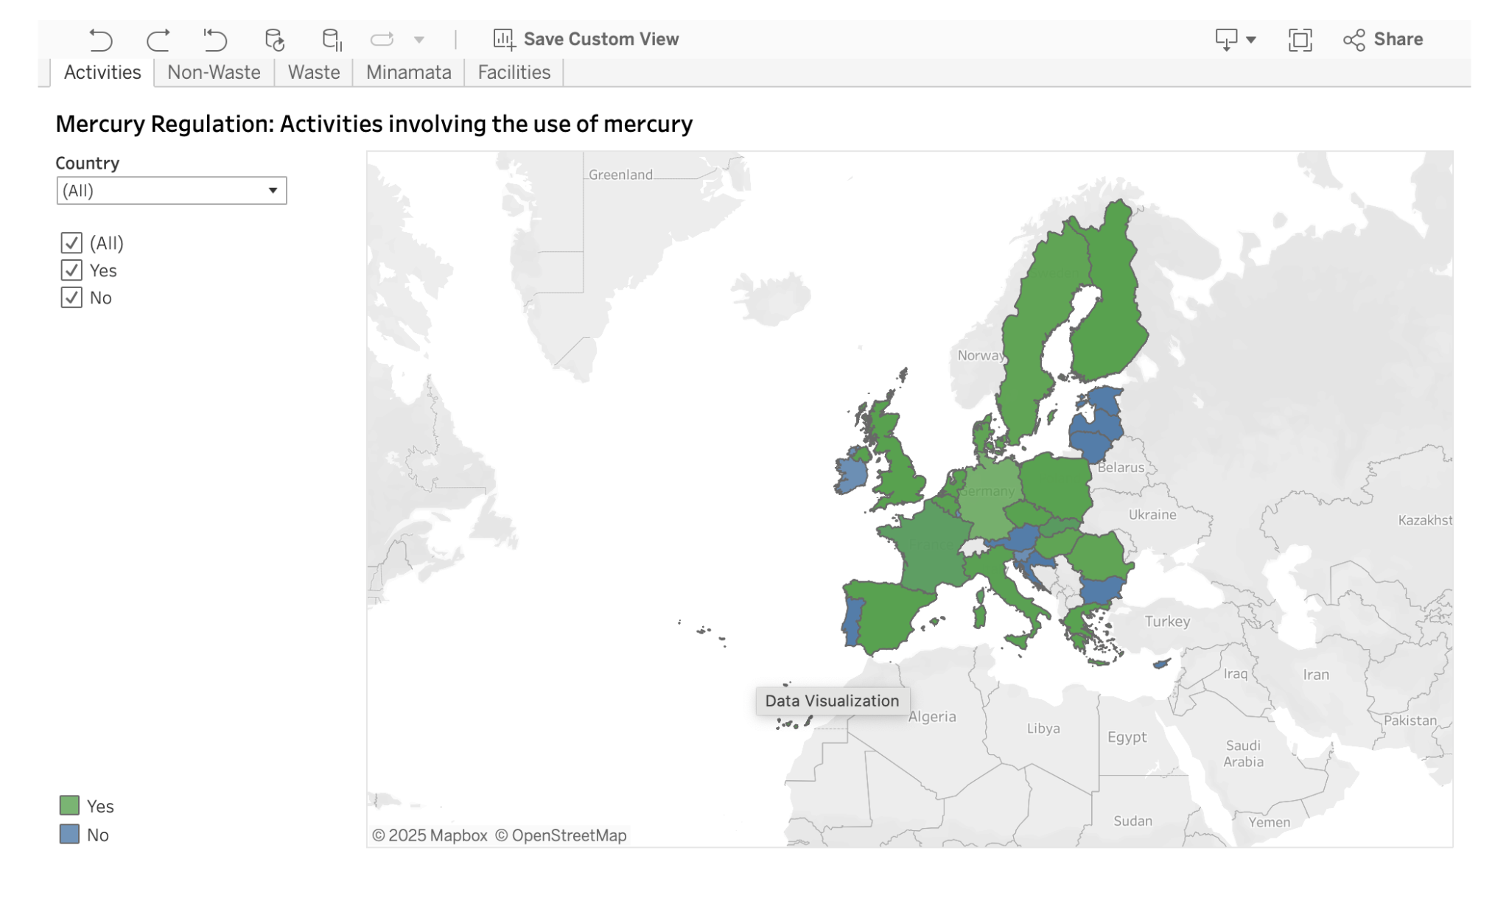

- Mercury inventory reporting rules and publication of inventory reports
Example: the United States Mercury Reporting Rule
Since 2018, the United States has enforced a mercury reporting rule (40 CFR Part 713) under the Toxic Substances Control Act (TSCA) to assist in the preparation of an inventory of mercury supply, use, and trade in the United States. This rule specifies reporting and recordkeeping procedures for certain manufacturers (including importers) and processers of mercury and mercury compounds. It authorizes the US Environmental Protection Agency (EPA) to require any person who manufactures mercury or mercury-added products, or otherwise intentionally uses mercury in a manufacturing process, to compile and publish an inventory of mercury supply, use, and trade in the Federal Register. The rule requires them to use the online Mercury Electronic Reporting (MER) application.
The reporting requirements apply to the import, manufacture, intentional use in manufacturing process, distribution in commerce, storage of mercury, and export of a mercury compound and mercury-added product.
General requirements for which information must be reported are as follows:
- Amount of mercury stored
- Amount of mercury distributed in commerce
- Amount of mercury manufactured
- Amount of mercury in manufactured products
- Amount of mercury imported
- Amount of mercury exported
- Amount of mercury in imported and exported products
- Amount of mercury in products distributed in commerce
- Amount of mercury otherwise intentionally used in a manufacturing process
Data from the 2018 reporting year was used for the U.S. 2020 mercury inventory; data from the 2021 reporting year was be used for the 2023 mercury inventory; and so forth at three-year intervals. The EPA published its initial mercury inventory in 2017, followed by subsequent reports in 2021 and 2023 (the most recent). The 2017 inventory report relied on publicly available data on the mercury market in the United States, while the later reports contain data collected directly from persons who manufacture or import mercury or mercury-added products, or otherwise intentionally use mercury in a manufacturing process. This has helped the EPA narrow data gaps and limitations noted in its initial inventory and has supported its national reporting efforts.
- Implementation of mercury regulatory frameworks
Example: Finland
Finland’s first endeavour to identify stocks and sources of supply was carried out in 2005, during open stakeholder consultations held by the European Commission in preparation of the Mercury Export Ban Regulation.
Further data was collected from Member States in 2007 for the “Impact Assessment to the Proposal for a Regulation of the European Parliament and the Council on the Banning of Exports and the Safe Storage of Metallic Mercury” (SEC (2006) 1369). This report identified Finland as the largest producer of by-product mercury in the EU-25, mainly from zinc and copper ores refining, including zinc concentrates imported from another country. Finland supported the proposed legislation, which then entered into force on 22 October 2008 (EC No 1102/2008).
In 2013, the EU launched a public consultation on issues related to the ratification and implementation of the Minamata Convention. Stakeholders were invited to comment on the ratification package, which addressed:
- Ratification;
- Import restrictions;
- Product exports;
- Mercury use in new products/processes;
- Restrictions on certain processes using mercury;
- Dental amalgam;
- Feedback on current legal framework; and
- Other issues
In preparation of the EU Regulation on Mercury (Regulation (EU) 2017/852, the European Commission carried out a study on EU implementation of the Minamata Convention. Finland, along with other countries, responded to a Commission questionnaire, providing updated information on mercury sources and stocks. As part of its national engagement, Finland’s Ministry of the Environment also conducted a survey with the industry to inform both the EU questionnaire response and national implementation of the new EU regulation.
In 2020, Finland undertook an additional effort to compile and review the results of earlier studies and to gather other existing information on mercury. In its 2023 short report, it identified two facilities relevant to the identification of stocks and sources—a chlor-alkali facility and a zinc smelter. The chlor-alkali facility was shut down in 2017, as required by EU Regulation on Mercury, while the zinc smelter generates mercury, with quantities exceeding 10 metric tonnes in both 2021 and 2022. Mercury from both facilities is considered waste under the EU Regulation on Mercury.

Example: Australia’s Consultations
Since 2010, the Department of Agriculture, Water and the Environment (DAWE) has conducted several stakeholder consultation rounds—both public and targeted—to support Australia’s signing and later ratifying the Minamata Convention. These consultations included public workshops in every state and territory, increasing the likelihood of uncovering site-specific information relevant to mercury stocks and sources of supply. This approach was repeated during the preparation of Australia’s 2023 national report.
A 2014 consultation paper issued by DAWE sought public input on the potential impacts of meeting the Convention’s obligations. It extracted and reproduced relevant articles in the Convention’s text and posed related questions. For Article 3, one question specifically asked:
Paragraph 5 requires Parties to identify stocks of mercury and mercury compounds, and sources of mercury supply; where may be such stocks and sources in Australia?
Through these consultations, potential problems identified by government, industry and non-government organizations were documented and informed the consideration and development of possible pathways to ratification. Targeted stakeholder consultation in 2020 further explored:
- The impacts on industry of the Convention’s prohibition on the import, export and manufacture of certain mercury-added products;
- The development of guidance material to aid the interpretation of some articles in the Convention.
In December 2020, the Department issued the final Regulation Impact Statement on the ratification of the Minamata Convention. This included identified sources of mercury pollution and industry contributions based on information provided to its National Pollutant Inventory (NPI).
What’s new:
Australia is currently holding consultation on proposed standards for industrial chemicals, including mercury and mercury compounds, under the development of the Industrial Chemicals Environmental Management Standard (IChEMS). IChEMS aims to establish nationally consistent standards for managing import, manufacture, export, use, and disposal of chemicals of concern, including mercury.
Similar consultations as this can assist in enhancing the identification and control of mercury supply sources. By engaging directly with stakeholders, they offer a mechanism for updating inventories and addressing any emerging sources.
In this example, consultations have served as a practical tool for gathering information on mercury stocks and sources, supporting both the development and implementation of national mercury inventory and reporting systems.
- Implementation plans under article 20 of the Convention
Implementation plans and identification of stocks and sources
Australia, Japan, Montenegro, and Peru have submitted their NIPs to inform the COP and the public about their implementation of the Convention obligations, including related measures on identification and assessment of stocks and sources and information sharing measures.
- Montenegro’s National Implementation Plan of the Minamata Convention on Mercury with the Action Plan for the period 2022-2023 and the Minamata Initial Assessment Report (December 2021) incorporated a mercury inventory as an integral component of its NIP.
- Japan’s National Implementation Plan for Preventing Environmental Pollution of Mercury and Mercury Compounds (October 2017) explicitly included the identification of individual stocks and sources through legally mandated regular reporting of mercury and mercury compounds storage.
- Australia’s National Implementation Plan (Minamata Convention on Mercury) (October 2024) has a section on existing regulatory and assessment schemes.
- Peru’s National Implementation Plan (Minamata Convention on Mercury) established its regulatory framework for mercury stock identification and supply source monitoring. The document (Decreto Supremo N° 004-2019-MINAM) constitutes Peru’s first comprehensive update to its 2017 baseline inventory report, evaluating current mercury stocks and active supply sources. These documents are available in the Minamata Convention website.
B. Updating or sustaining inventories conducted under the Minamata Convention initial assessments
- Minamata Convention initial assessments (MIA) were designed to help countries identify the requirements for ratifying the Convention and provide basis for implementation. To support this, the Global Environmental Fund (GEF) released the Initial Guidelines for Enabling Activities for the Minamata Convention on Mercury in 2014. These guidelines outline the elements that may be included in a MIA and the type of data to be collected during its development. These guidelines also address the national action plans (NAP) on Artisanal and Small-Scale Gold Mining (ASGM) required under article 7 of the Convention.
- The mercury inventory component of MIAs is important to compliance with Article 3 of the Convention. Both the GEF guidelines and the United Nations Development Programme’s Suggested Structure and Contents for MIA Reports recommend that inventories cover the following:
    - Stocks of mercury and/or mercury compounds, including current storage and potential future storage needs;
    - Sources of supply of mercury, including sources, recycling activities and quantities;
    - Sectors using mercury or mercury compounds and the amounts per year, such as manufacturing, ASGM, and production of mercury added products; and
    - Trade in mercury and mercury containing compounds, including imports and exports of mercury-added products.
- Countries that have completed their MIAs and established baseline mercury inventories should update this information periodically using new data sources. Updates can draw from facility-level reports, local authority submissions, or national stakeholders’ consultations.
Example: Indonesia’s MIA/NAP
In 2020, Indonesia identified and inventoried potential sources of mercury, as detailed in its MIA and National Action Plan for Mercury Reduction and Elimination (Rencana Aksi Nasional Pengurangan dan Penghapusan Merkuri or RAN-PPM) documents submitted in 2022. The MIA also includes several recommended action plans that have not been included in its NAP (RAN-PPM), which aims to eliminate the use of mercury in ASGM and illegal mining in Indonesia by 2025, to support the fulfillment of the provisions of the Minamata Convention.
The MIA document includes specific sections on:
- Stocks of mercury and/or mercury compounds, and storage conditions; and
- Supply and trade of mercury and mercury containing compounds, including sources, recycling activities and quantities.
The first section provides records of arrests and confiscated quantities of cinnabar ore and mercury illegally distributed for use in the ASGM sector. It also refers to the temporary storage of mercury-containing medical devices in health care facilities.
The second section offers a historical account of mercury trade in Indonesia and highlights both legal and illegal sources, including online sales of mercury and emerging domestic sources of mercury from cinnabar mining.
Similarly, the NAP document addresses domestic sources of mercury supply, citing cinnabar mining and smelting activities. It documents measures to prevent illegal cinnabar ore trade and monitor local mercury traders.
Indonesia’s 2022 RAN-PPM focuses on four priority sectors: manufacturing, energy, ASGM and health, and ensures that mercury use in these sectors is updated annually. Additionally, Indonesia has developed policies requiring provincial governments to establish corresponding Local Action Plan for Mercury Reduction and Elimination (RAD-PPM). The amount of mercury identified is updated when new information from RAD-PPMs becomes available, ensuring that national inventories reflect local developments.
C. Conducting specific surveys for mercury inventories
- National inventory periodically updated, or a survey provides a quantitative assessment of mercury use, quantities of stocks, supply, and flows, and therefore directly inform the identification of individual stocks and sources. Actions may include statistical survey, sector or industry-specific survey, emissions survey (identification and quantification of mercury releases), digital tracking systems, trade and supply chain analysis, and mapping of locations of institutions or facilities with stocks and/or sources (e.g., GIS datasets, database reports, and other geographical resources). Inter-agency reports and digital platforms may facilitate information exchange and collaboration.
Example: Canada
Canada has endeavoured to identify stocks of mercury or mercury compounds exceeding 50 metric tonnes and sources of mercury supply generating stocks exceeding 10 metric tonnes per year. It follows the "Guidance on the identification of individual stocks of mercury or mercury compounds exceeding 50 metric tons and source of mercury supply generating stocks exceeding 10 metric tons per year."
To support this effort, Canada conducts comprehensive reviews of mercury import and export data using the Canadian International Merchandise Trade Database. This ongoing monitoring, supplemented by routine inspections, helps identify potential imports and exports of mercury.
A key element of Canada’s system is the National Pollutant Release Inventory (NPRI)— a publicly accessible database mandated under the Canadian Environmental Protection Act, 1999 (CEPA). The NPRI requires annual reporting of releases, disposals, and transfers.
In monitoring production facilities for mercury-added products, Canada’s regulations, which prohibit the import and manufacture of most products containing mercury, require these importers and manufacturers to report on the quantity of mercury containing products every three years. For facilities that may produce mercury by-products, they are required to report annually on the amount of by-product mercury and mercury compounds that are transferred off-site through the NPRI.
Further regulatory support comes from the Products Containing Mercury Regulations, also under CEPA. These regulations govern the import and manufacture of products containing mercury, with mandatory reporting by importers and manufacturers every three years, starting in 2016.
In the same year, Canada released its first comprehensive scientific evaluation and synthesis of mercury in the Canadian environment—The Canadian Mercury Science Assessment. This assessment provided a scientific baseline to measure future changes in mercury levels in the environment. The assessment involved a series of workshops involving scientists and policymakers from the federal, provincial, and territorial governments and from universities. Science questions were developed that articulate the information needs of the science and policy communities, to provide a national context for regional environmental mercury information.
Canada’s efforts are coordinated by Environment and Climate Change Canada (ECCC), which collaborates with federal partners and provincial and territorial governments. These entities provide data that ECCC analyzes to assess potential sources and quantities of mercury before reporting to Minamata Convention.
For example, authorization for facilities that recover mercury from end-of-life products and other wastes falls under provincial and territorial jurisdictions. All mercury recycling and recovery operations must comply with applicable provincial and federal laws and regulations. Canada works with provinces and territories to collect information from these authorized facilities as part of its national mercury inventory process.

Example: China
China’s Ministry of Ecology and Environment (MEE) has conducted surveys to collect information of chemical substances and asses their associated risks. The Statistical Survey System on Environmental Information of Chemical Substances incorporates Convention compliance information, covering mercury and mercury compounds.
Mercury is subject to mandatory reporting as “mercury and mercury compounds” are included in the List of Priority Control Chemicals (first batch). To support this process, an online platform has been developed for enterprises to report the chemicals manufacture and use. Following submission by enterprises, local environmental authorities may conduct on-site audits to verify the information. The collected information is then compiled and submitted to provincial-level authorities, and to the MEE.
- Some Parties have submissions related to their endeavours to identify significant mercury stocks and supply sources, either as short annexes to national reports or through dedicated studies.
Example: Peru’s Reporting on Individual Stocks and Sources
Assessments identifying significant mercury stocks and supply sources may be conducted, as exemplified by Peru's case. It has developed reports in 2017 and 2021 assessing mercury stocks and supply sources under the Minamata Convention. These studies particularly focused on the key thresholds: (1) stocks exceeding 50 metric tonnes, and (2) supply sources generating over 10 metric tonnes annually.
For the 2021 report, the methodology combined descriptive and analytical approaches. It drew from the following key frameworks: the Minamata Convention (Article 3), Peru’s National Implementation Plan (Supreme Decree No. 004-2019-MINAM), and UNEP (DTIE)/Hg/INC.6/9 - factors which may be considered in the identification of stocks of mercury or mercury compounds. While no standardized template exists, they defined parameters for inventorying significant mercury stocks (>50 metric tonnes/year) and major supply sources (>10 metric tonnes/year). The process incorporated the identification factors from the UNEP document, inventory development approaches from the Guidance on stocks and sources, and baseline references from Peru's 2017 national report.
In this report, four primary mercury sources were identified: mining operations recovering mercury as a byproduct (mainly large-scale gold mining), industrial users like chlor-alkali plants, storage sites for confiscated illegal mercury, and commercial traders handling imports/exports. After identifying potential mercury stocks and supply sources, a list of key public institutions and private enterprises potentially holding data on mercury storage, usage, or trade were then compiled. The compiled information was systematically processed and compared to 2017 baseline data to track inventory trends.
The results identified such stocks in two primary categories: mining entities, where mercury is recovered as a byproduct during mineral processing and mercury use in ASGM operators and domestic traders; and non-mining entities, including the domestic chlor-alkali producer and chemical distributors.
D. Conducting additional verification of information
- Additional verification of information may be conducted to support the identification of mercury stocks and sources. These verification efforts may include, among others, review of mercury import and export data, routine inspections, environmental sampling, data tracking (e.g., creation of timestamps and audit logs), and field data verification.
- Site assessments and field surveys in ASGM areas, for example, can help estimate mercury use and gold production at the plant level, directly informing estimates of mercury use. Data tracking systems or maintaining logs of data submissions and modifications can help confirm the origin or accuracy of mercury stock and flow information. Field data verification validation can identify discrepancies or confirm reported figures. For example, data from inventories can be compared with findings from on-site inspections or environmental audits to verify quantities of declared mercury stockpiles or identify sources not previously captured.
E. Reporting and monitoring frequency
- Due to the fluctuations of mercury stocks, establishing the timing or frequency of conducting inventories is important. In determining the timing or frequency here are some factors to consider: resources needed for data collection, existence of methods for tracking changes in stocks and supplies over time, capacity to report on data gathered, and Minamata Convention national reporting cycles
III. Methodologies for quantification of large amounts of mercury or mercury compounds
A. UNEP Mercury Inventory Toolkit for Identification and Quantification of Mercury Releases
- To support countries in preparing their MIAs, the United Nations Environment Programme (UNEP) developed the Toolkit for Identification and Quantification of Mercury Releases. This Toolkit is designed to assist countries in identifying and quantifying mercury emissions and releases across sectors, and to guide users through all stages of inventory development. Based on the mass balance principle (“what comes in must come out”), it enables countries to track mercury inputs (i.e. via raw materials and fuels) and their subsequent outputs to the environmental or product streams, helping establish comprehensive national mercury inventories.
- The Toolkit has been widely used by developing countries and countries with economies in transition as part of the MIA process. The following approaches are employed, with most MIA reports utilizing Inventory Levels 1 and 2. The full application of Inventory Level 2 is often constrained by country-specific data limitations:
- Inventory Level 1 provides preliminary assessments using default input (mercury concentration in materials) and output distribution (release pathways) factors, yielding simplified results.
- Inventory Level 2 refines Inventory Level 1 and offers more comprehensive analysis through detailed source category descriptions and customizable factors that better reflect national data.
- Inventory Level 3 integrates all mercury sources into their entire mass flow through and out of society to the environment, highlighting the links between different mercury sources.
- Although the Toolkit’s primary focus is on identifying mercury emissions and releases, it also supports the identification of major source categories relevant to Article 3 of the Convention. In particular, Inventory Level 2 and Level 3 facilitate the identification of significant sources of mercury stocks and supply through more detailed sectoral analysis and mercury flows, respectively.
- A key limitation of the Toolkit Inventory Level 2, in relation to the obligation under Article 3, is its exclusion of certain economic activities such as mercury trade, production, sales, and manufacturing. In Level 2, import, production, and export data are combined to calculate mercury input, without disaggregating these activities or addressing trade flows and stockpiles in detail. The UNEP Reporting Template categories do not include the categories mentioned, as detailed in the GEF Initial Guidelines and UNDP’s Suggested Structure and Contents for MIA reports (mentioned in the implementation of MIA section above). To address this, countries are encouraged to prioritize the identification of large mercury stocks and sources of supply, in line with the updates to the guidance on identification of individual stocks of mercury or mercury compounds exceeding 50 metric tonnes and sources of mercury supply generating stocks exceeding 10 metric tonnes per year. They may also consider utilising Inventory Level 3, which tracks mercury flows throughout the system—except for a few flows not in focus for exposure—as discussed in the following section.
Example: MIA reports using UNEP Toolkit
- Mauritius’ 2018 Minamata initial assessment document specified categories for mercury stockpiles, and supply and trade and stocks of mercury and/or mercury compounds, and storage conditions in its mercury inventory. Furthermore, its implementation plan was structured according to the Convention’s articles, enabling a succinct assessment of measures to fulfill its obligations, particularly those under Article 3.
- Ghana’s 2018 MIA report utilized Toolkit Levels 1 and 2 and included the categories related to Article3. Its inventory quantified the amount of mercury circulating in primary metal production and analyzed mercury import and export trade data, including tracking transient stocks held by individual traders in informal networks. While the inventory has not identified specific stocks of mercury or industrial sectors holding significant quantities, it emphasized that it is necessary to consider how mercury is being traded for ASGM.
- Honduras’ 2015 inventory report employed Toolkit Levels 1 and 2 to assess mercury sources and releases, combining field inspections with data collection from organizations and institutions. Level 2 was finalized under the MIA-National Action Plan to provide for more precise and country-specific results.
The inventory employed a two-phase validation approach. Site visits to industries and companies identified as potential mercury emitters established baseline profiles in Level 1. For the more detailed Level 2 assessment, follow-up visits were conducted at prioritized sites, with complete material flow balances achieved for select companies (enabling precise tracking of mercury inputs, outputs, and losses). Data from remaining facilities were used to address gaps and inconsistencies in Level 1 estimates, particularly where process-specific information was initially lacking. This validation strategy optimized resource allocation while ensuring representative sectoral coverage, using material balance completeness as the key criterion for methodological rigor.
- Inventory Level 3 of the Toolkit provides a quantitative assessment of all key mercury flows through society. It offers improved inventory and mass flow accuracy with built-in quantification of changes in accumulation, data checks, and calculations. Level 3 allows for separate quantification of mercury imports, exports, and production contributions, which are individually calculated before being aggregated. Additionally, it enables comparisons between estimated mercury inputs for manufacturing and other processes using mercury and mercury compounds with mercury trade data. Developing Inventory Level 3 requires the collection of statistics data on import, export, and production rates.
Figure 2. Conceptual diagram of UNEP Mercury Toolkit Inventory Level 3 (source: UNEP)
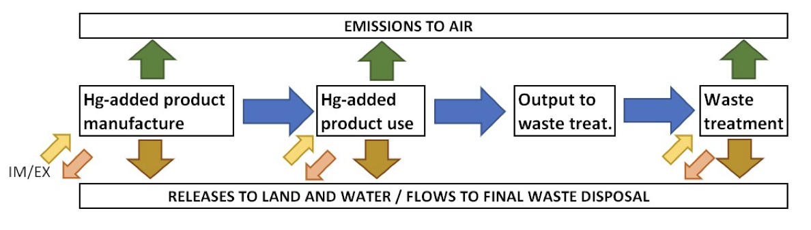
- Inventory Level 3 also estimates the accumulation of mercury in society over time, including mercury currently in use in products and processes and mercury stockpiles awaiting final disposal. This approach could be useful for identifying and quantifying potential sources of mercury supply and existing stockpiles.
B. Mercury material flow
- Mercury material flow (MMF) analysis is a systematic method to quantify the flows and stocks of mercury across a country’s economy. It applies the principles of material flow analysis, a method that tracks material flows and stocks of material. By building a comprehensive mass flow model, MMF characterizes a country’s mercury situation across its full life cycle—from import and production to use and final disposal. It accounts for mercury involved in economic activities such as mercury trade, production, use (sales), and manufacturing, and the accumulation of mercury in products and in processes.
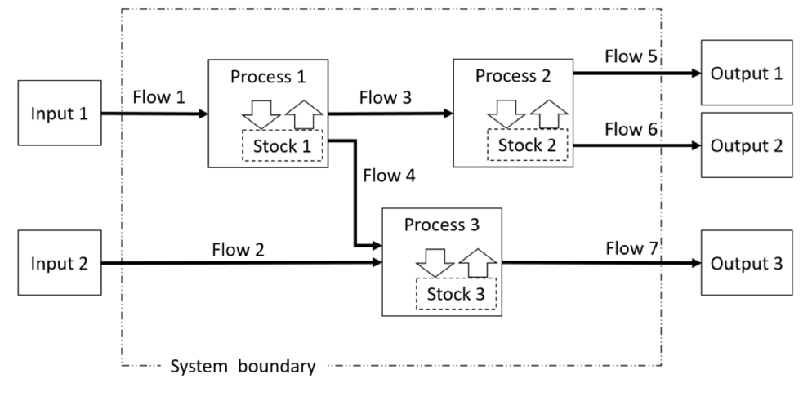
Figure 3: Conceptual diagram of material flow (source: MMF in Japan)
- Using the mass balance principle, an MMF helps to show the complex and intricate links between sources and releases in the life cycle of mercury within the territorial boundary. The inflow to (e.g. imports, domestic mining) and outflow (exports, emissions, landfill) from a boundary will affect the accumulation (e.g. mercury stores in facilities or accumulated in the economy) or depletion of the stock within the boundary if the mass balance is maintained.
- MMF can provide key insights for implementing Article 3. By tracking mercury flows, MMF can help detect quantities accumulated in industrial processes, mercury recovered from recycling or treatment facilities, surplus mercury from closed industries or confiscated mercury from illegal activities (e.g. from illegal trade or mining), stockpiled mercury in manufacturing processes or storage, or mercury flows through import and export streams. These data allow Parties to determine whether significant stocks and sources of supply exist, or pinpoint supply sources that exceed 10 metric tonnes per year, as required under Article 3. MMF may also complement trade reporting under the Convention by integrating import/export data directly into its analysis.
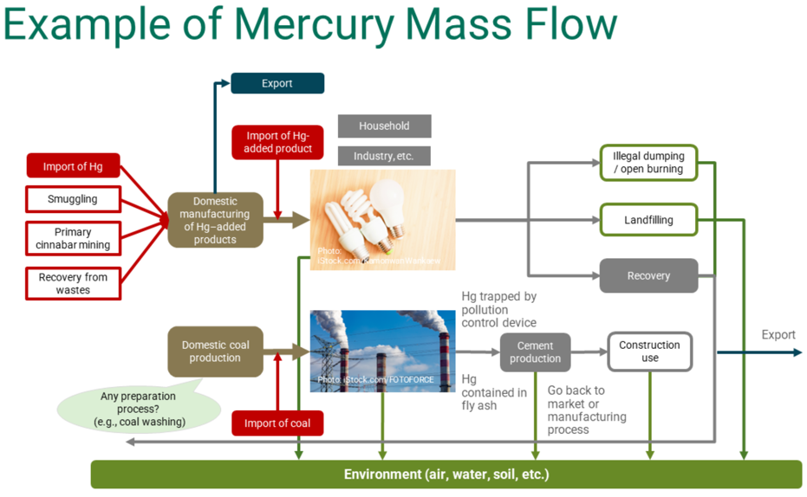
Figure 4. Example of MMF diagram
(source: UNEP/UNITAR Training Package for mercury flow analysis)

- Developing an MMF requires comprehensive data from multiple sectors. Data collection typically uses a combination of national statistics, stakeholder interviews, review of existing literature, and targeted surveys and questionnaires.
- For technical guidance, countries may refer to the UNEP/UNITAR Training Package for Mercury Flow Analysis, which provides templates, case studies, and step-by-step instructions. This resource is available online and supports capacity building for countries implementing MMF in line with the Minamata Convention.
Example: Japan’s MMF
Figure 5. Simplified MMF in Japan (FY 2016)
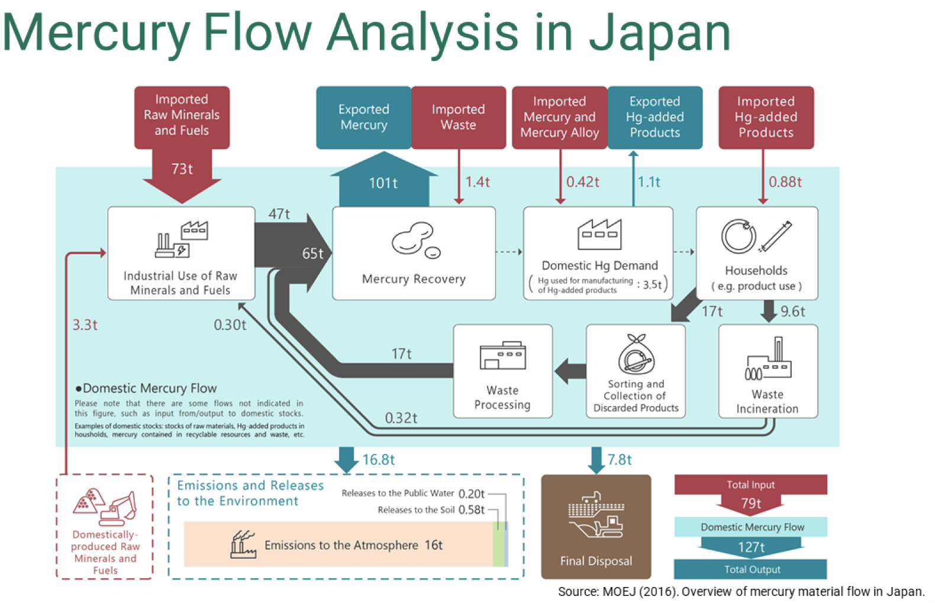
In response to its obligations under the Minamata Convention to implement comprehensive mercury control measures, the Ministry of the Environment, Japan (MOEJ) has developed and published a series of Mercury Material Flow in Japan reports. These reports aim to capture and quantify mercury flows across the country.
The first MMF, covering fiscal year (FY) 2010, was published in 2013, followed by the FY2014 version in 2016. A further MMF for FY2016 was developed to assess the progress of domestic measures before and after the enactment of the Act on Preventing Environmental Pollution of Mercury (Act No.42 of 2015). The most recent MMF covers FY 2019.
Japan has utilized MMF analysis specifically to identify mercury sources exceeding 10 metric tonnes per year, in line with Article 3.
An excerpt from the MMF in Japan (FY 2016) outlines its intent:
“The material flow is intended to comprehensively capture domestic mercury flows, including emissions obtained in the inventory. In this material flow, the mercury flow within the economic zone of Japan is referred to as “domestic mercury flow”, and the estimation in the material flow covers domestic mercury flow, the amount of input from the environment, and output to the economic zone. Inputs for domestic mercury flow include mercury in imported and domestically produced raw minerals and fuels. Outputs from domestic mercury flow include emissions and releases to the environment and final disposal (landfill).”
To compile these flows, Japan collected data through interviews with industries, covering items such as amounts of mercury used for manufacturing products, the amounts of mercury in the imported/exported products, among others. Additionally, a questionnaire survey for waste treaters gathered information on mercury recovery from different types of mercury waste, indicating how much mercury was recovered.
While Japan’s MMF reports do not directly integrate estimates of mercury stocks as defined in Article 3 (i.e., stocks exceeding 50 metric tonnes), Japan has made efforts to estimate “stock” or “accumulation,” including further developing the estimates of mercury stored at household or business levels. “Stock” values are maintained as reference value in Japan’s MMF.

* UNEP/MC/COP.6/1/Rev.1.
** This document has not been formally edited.
UNEP/MC/COP.1/5, Annex IV.
Retrieved from the following website: https://www.eea.europa.eu/en/analysis/maps-and-charts/mercury-regulation-data-viewer-dashboards
Retrieved from the following website: https://certifico.com/component/attachments/download/2764
See Appendix 3: Summary of stakeholder replies to questionnaire on impacts of the mercury export ban. Document available on the following website: https://www.certifico.com/component/attachments/download/2767
Taken from Finland’s 2023 national report available in the following website: https://minamataconvention.org/sites/default/files/2024-02/FIN_3.3.pdf
Retrieved from: https://oia.pmc.gov.au/sites/default/files/posts/2021/03/ratifying-minamata-convention-mercury.pdf
Taken from Australia’s 2023 national report available in the following website: https://minamataconvention.org/sites/default/files/2024-02/AUS_3.3.pdf Link to survey responses: https://drive.google.com/file/d/1m8B8pBe7hOlH9saaNNdj6TYoLSeSPGRu/view?usp=share_link
Retrieved from: https://www.dcceew.gov.au/sites/default/files/env/pages/192a327d-3646-4eb6-8648-4c2747541a2f/files/minamata-convention-invitation-comment-2014.pdf
Retrieved from: https://www.dcceew.gov.au/environment/protection/chemicals-management/national-standard
Document available on the following website: https://minamataconvention.org/sites/default/files/documents/national_implementation_plan/Montenegro_MIA_NIP_2021_EN_0.pdf
Document available on the following website: https://minamataconvention.org/sites/default/files/documents/national_implementation_plan/Japan_NIP_EN.pdf
Available on the following website: https://minamataconvention.org/sites/default/files/documents/national_implementation_plan/Australia_NIP_2024_EN.pdf
Available on the following website: https://minamataconvention.org/sites/default/files/documents/national_implementation_plan/Peru_NIP_ES.pdf
GEF, 2014. Guidelines for Minamata Convention initial assessment activities (MIA). Retrieved from: https://www.thegef.org/sites/default/files/council-meeting-documents/GEF.C.45.Inf_.05.Rev_.1_Initial_Guidelines_for_Enabling_Activities_for_the__Minamata_Convention_on_Mercury_Jan_23_2014.pdf
UNDP, 2020. Minamata Initial Assessment Report: Suggested Structure and Contents. Available on the following website: https://www.undp.org/sites/g/files/zskgke326/files/publications/2020%20MIA%20Guidance.pdf
Available on the following website: https://minamataconvention.org/sites/default/files/documents/minamata_initial_assessment/Indonesia_MIA_2022.pdf
Available on the following website: https://minamataconvention.org/sites/default/files/documents/national_action_plan/Indonesia_ASGM_NAP_2022.pdf
Some Parties refer to their measures for information exchange through their National Implementation Plans (Australia and Japan).
Document available on the following website: https://www.stats.gov.cn/fw/bmdcxmsp/bmzd/202308/t20230822_1942201.html
Taken from Peru’s national report, available on the following website: https://minamataconvention.org/sites/default/files/documents/national_report/Report_Peru_2023_Spanish.pdf
Document available in the following website: https://minamataconvention.org/sites/default/files/2024-12/PER_3.3.pdf
All the UNEP Mercury Toolkit documents (including the new Level 3) can be found on UNEP’s website: https://www.unep.org/topics/chemicals-and-pollution-action/pollution-and-health/heavy-metals/mercury/mercury-inventory
Mauritius 2018 MIA. Retrieved from: https://minamataconvention.org/sites/default/files/documents/minamata_initial_assessment/Maruritius-MIA-2019.pdf
Ghana 2018 MIA. Document available from the following website: https://minamataconvention.org/sites/default/files/documents/minamata_initial_assessment/Ghana-MIA-2018.pdf
Taken from UNEP/UNITAR Training package for mercury flow analysis to identify and monitor national mercury situation in its entire life cycle, available on the following website: https://wedocs.unep.org/bitstream/handle/20.500.11822/42257/mercury_flow_user_manual.pdf?sequence=3&isAllowed=y
Ibid.
Link to survey responses: https://drive.google.com/file/d/1m8B8pBe7hOlH9saaNNdj6TYoLSeSPGRu/view?usp=share_link
Document available on the following website: https://www.env.go.jp/content/000073050.pdf
Survey on mercury recovery from industrial waste. Retrieved from: https://www.e-stat.go.jp/statistics/00650406

