UNITED  NATIONS |  |  |  | MC
 |  |  | UNEP/MC/COP.4/INF/4
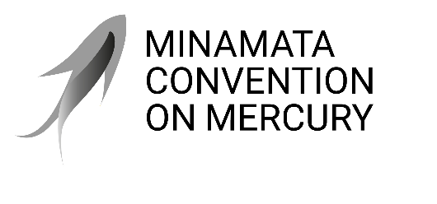 |  |  | Distr.: General  17 August 2021  English only
Conference of the Parties to the
Minamata Convention on Mercury
Fourth meeting
Online, 1–5 November 2021*
Item 4 (a) (ii) of the provisional agenda**
Matters for consideration or action by the Conference of the Parties: mercury-added products and manufacturing processes in which mercury or mercury compounds are used: information on dental amalgam
Information on the implementation of any additional measures taken by parties and on non-mercury alternatives to dental amalgam
Note by the secretariat
As is mentioned in the note by the secretariat on the matter (document UNEP/MC/COP.4/5), the information received from Governments on the implementation of any additional measures taken by parties is set out in annex I to the present note, and information on non-mercury alternatives to dental amalgam is set out in annexes II and III. The submission is reproduced as received, without formal editing.
Annex I
Information on the implementation of any other measures taken by parties
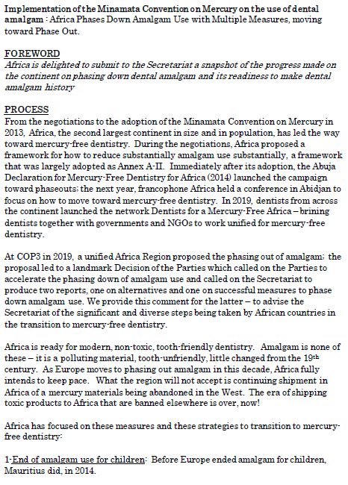

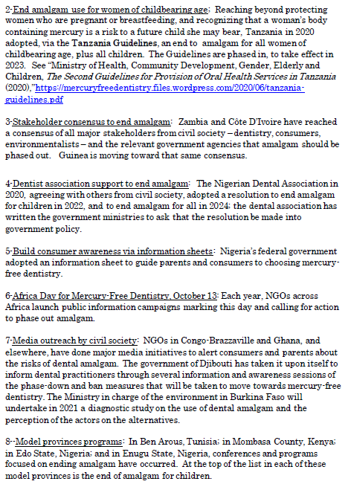

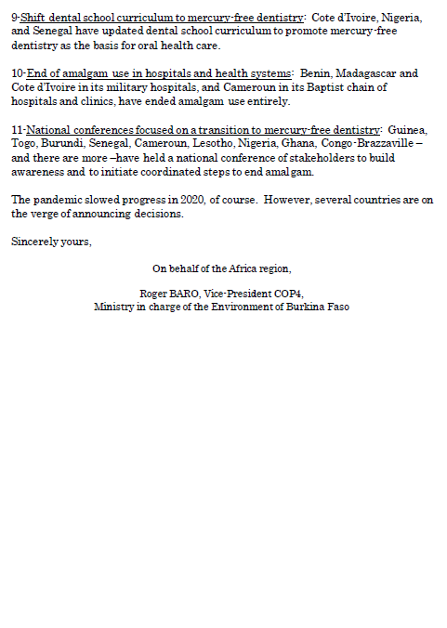

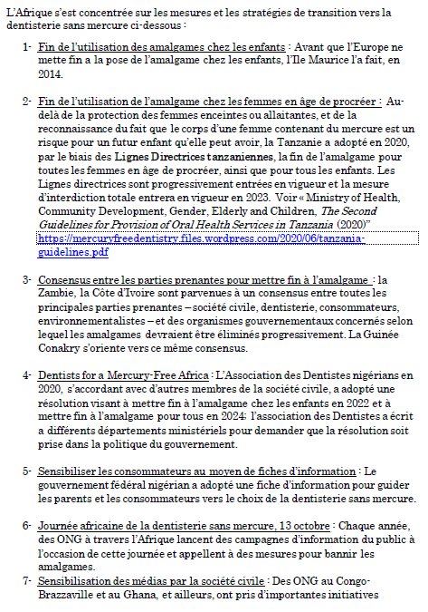

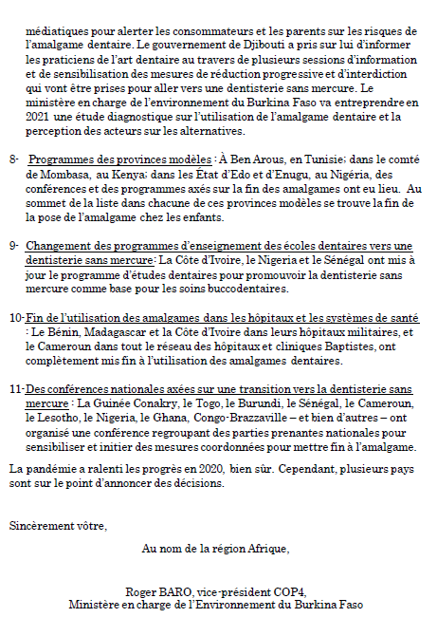

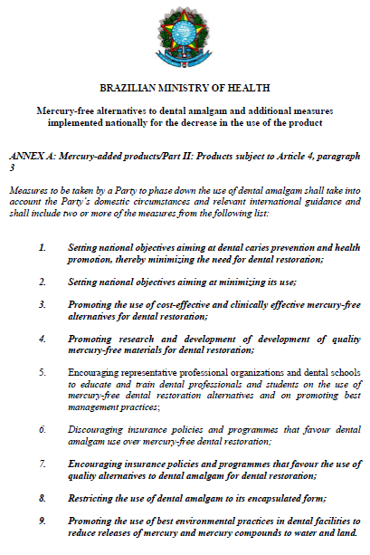

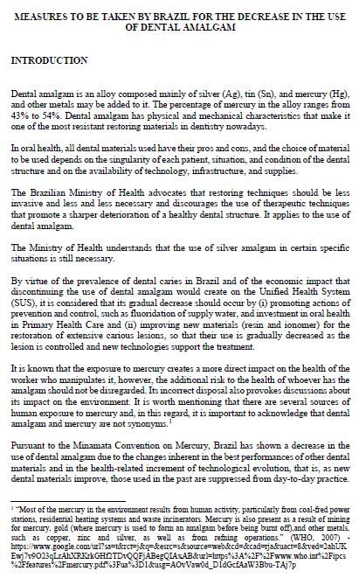

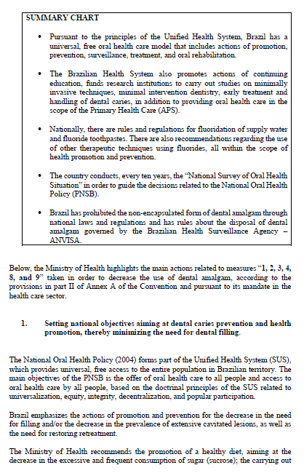

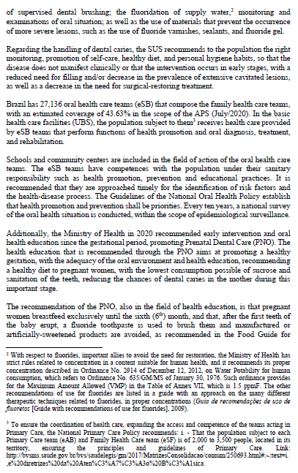

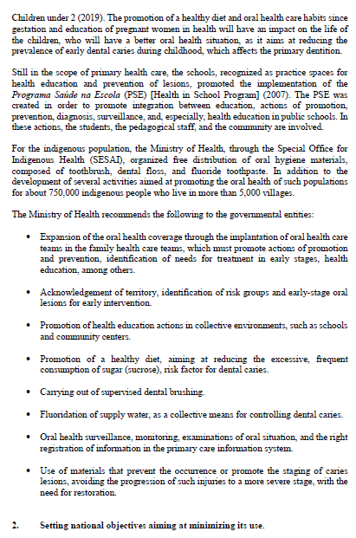

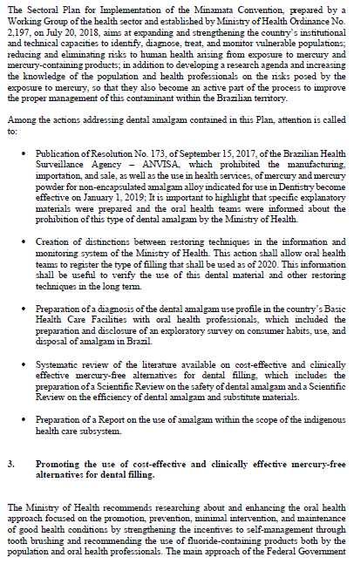

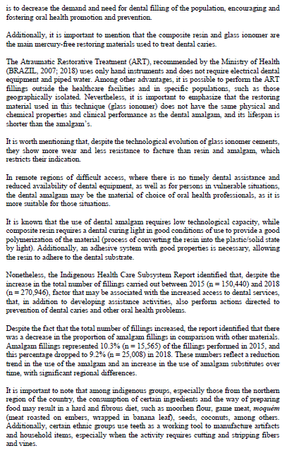

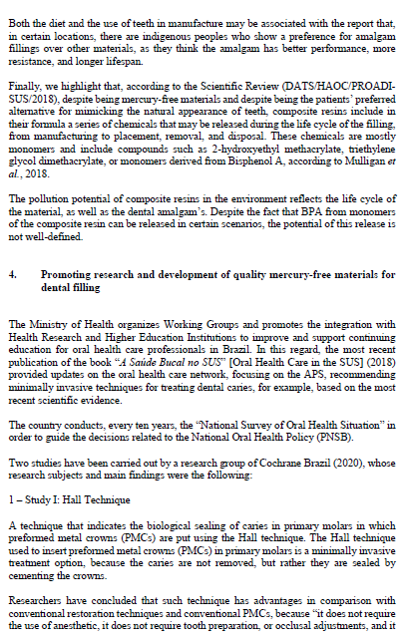

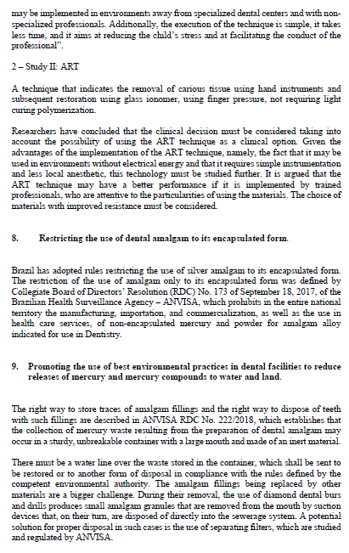

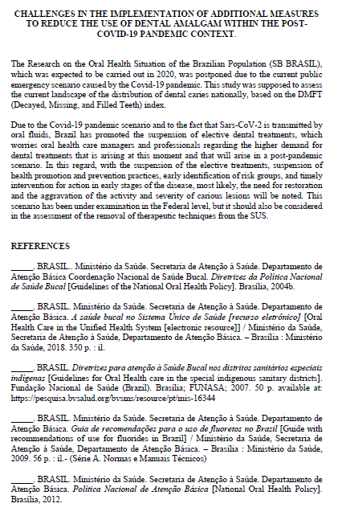

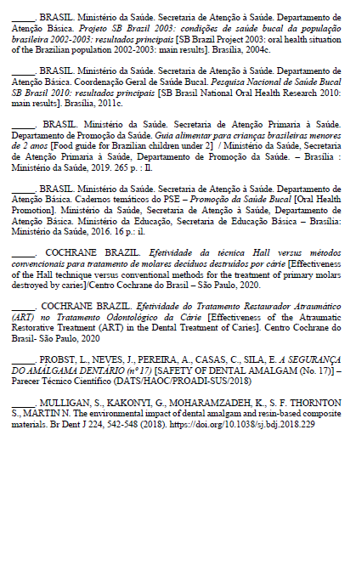

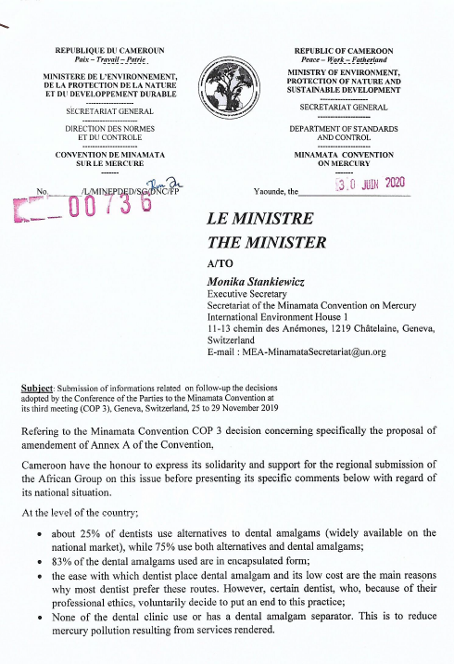

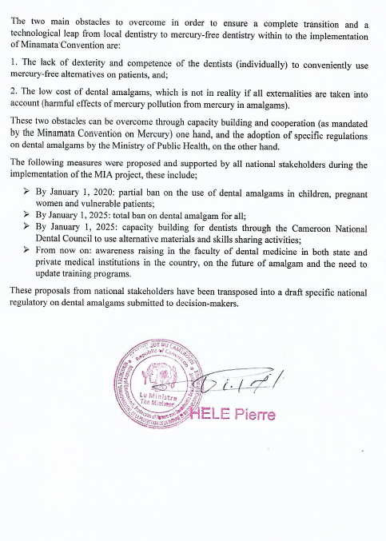

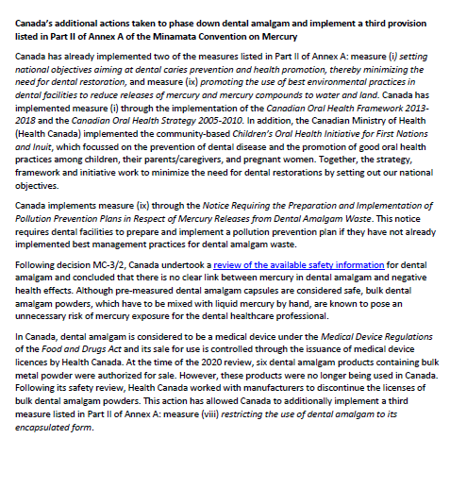

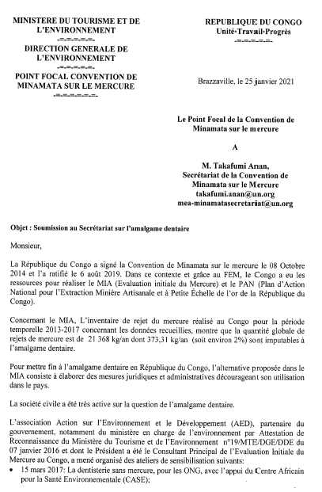

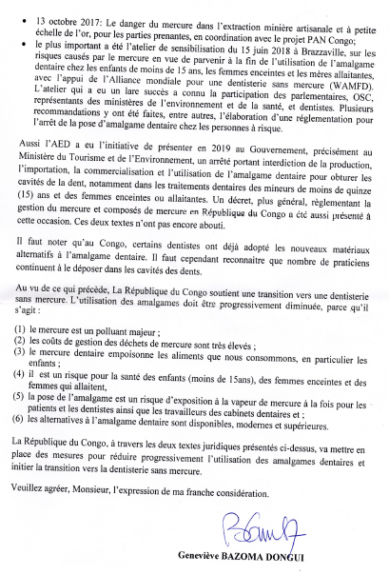

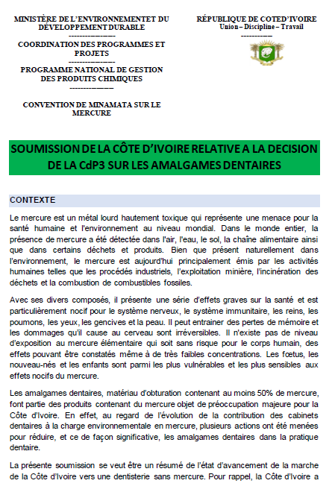

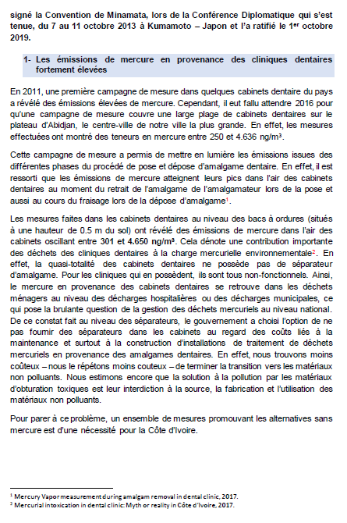

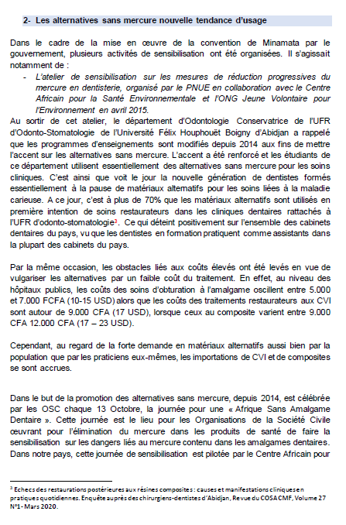

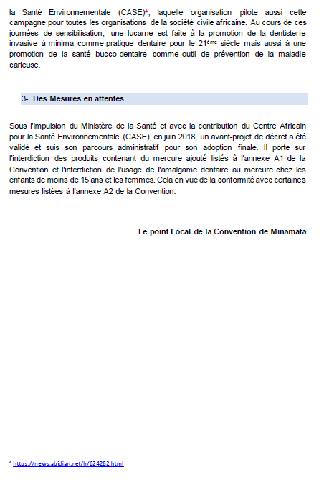

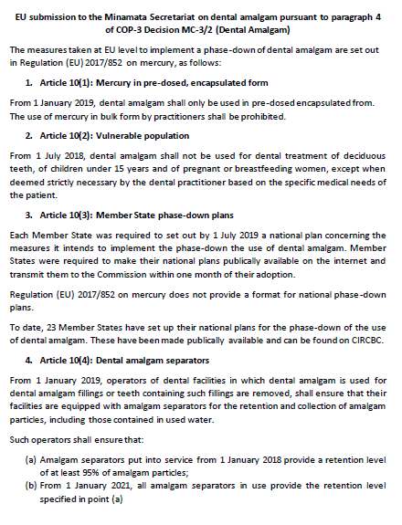

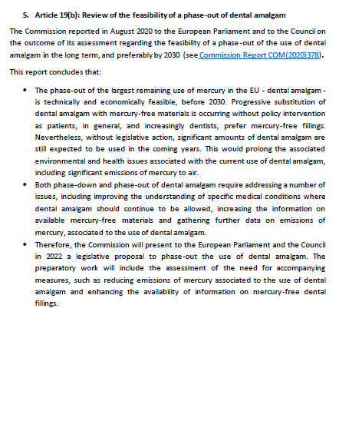

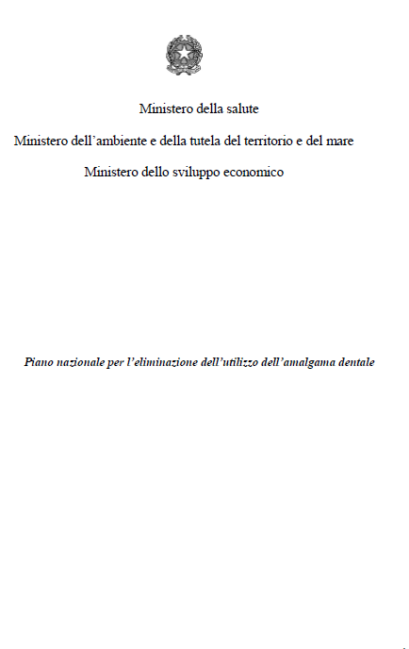



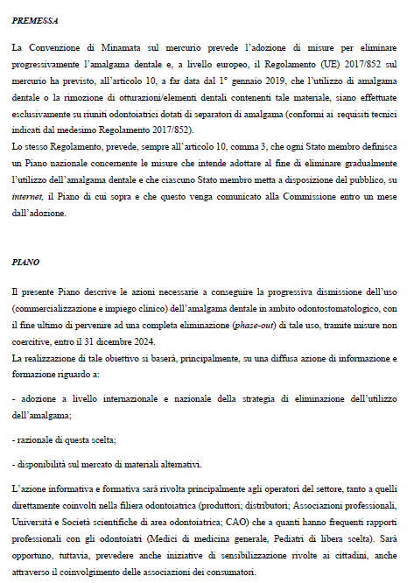

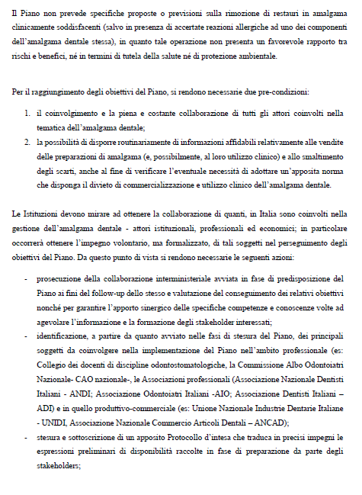

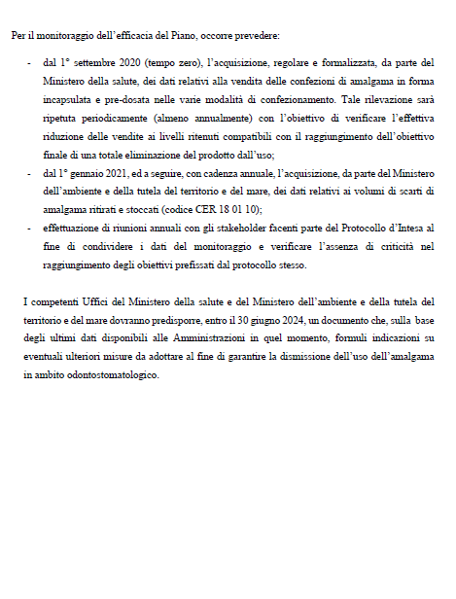

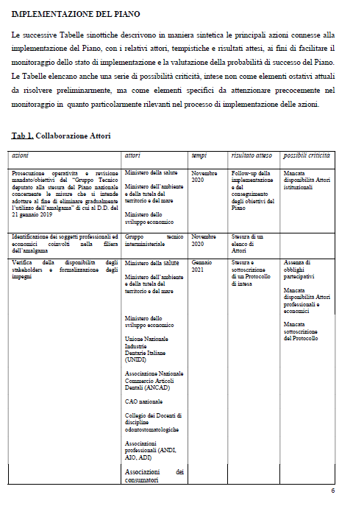

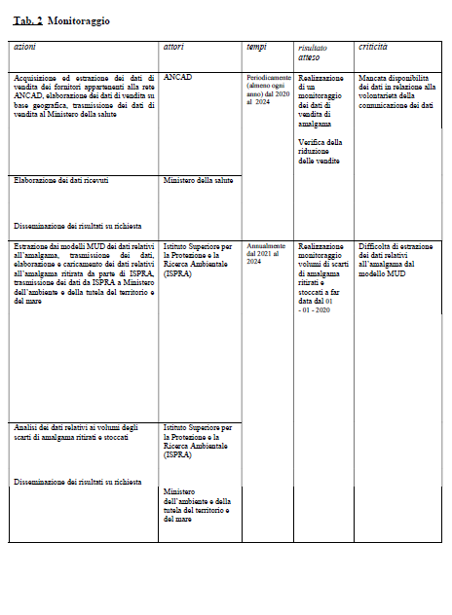

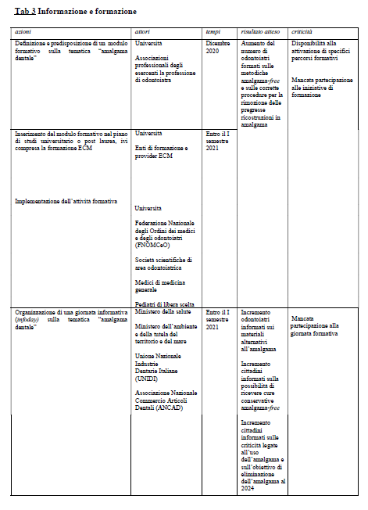

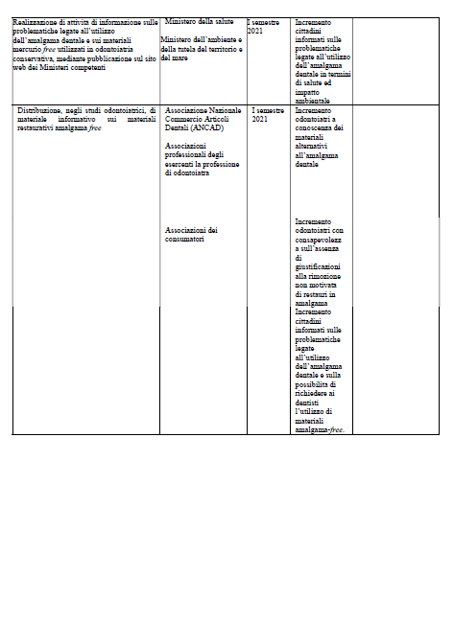

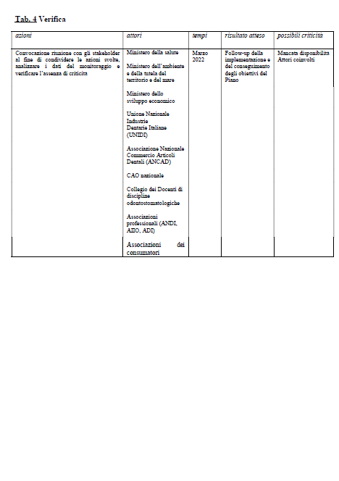

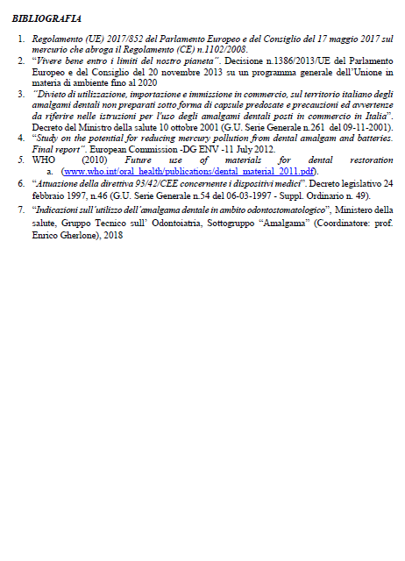

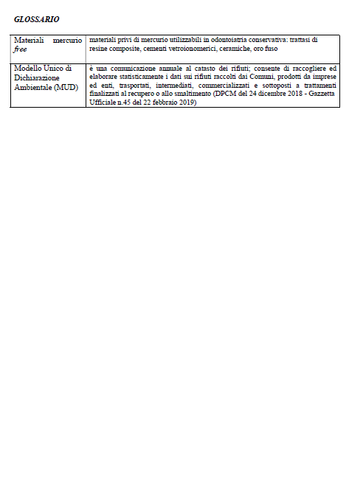

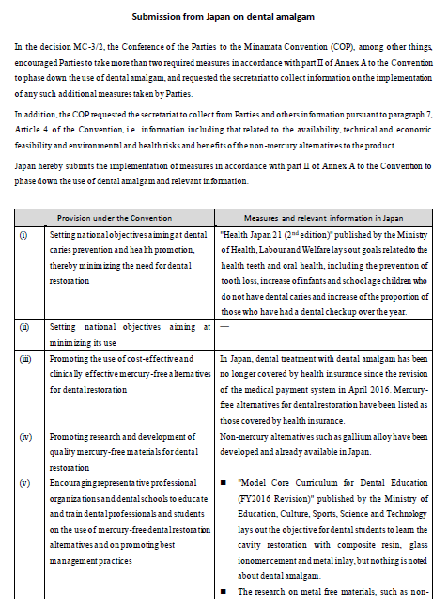

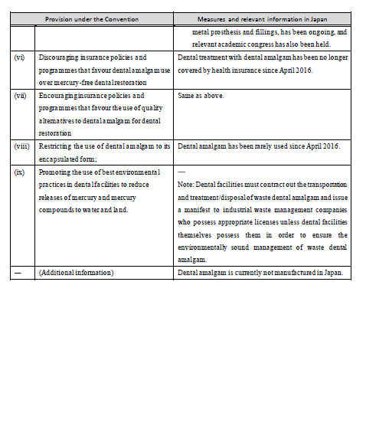

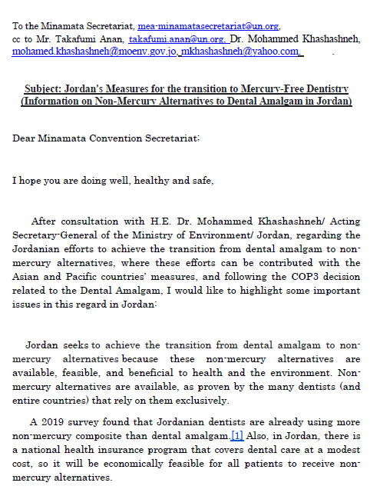

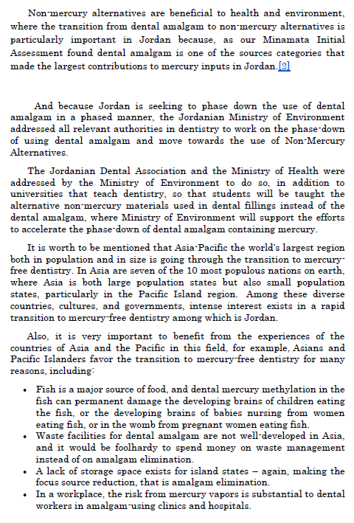

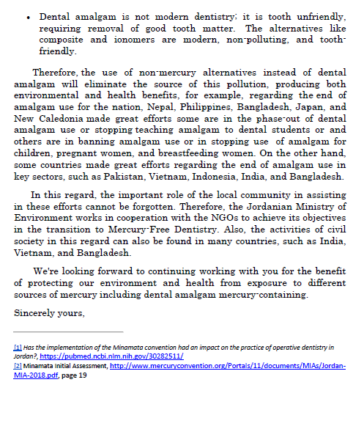

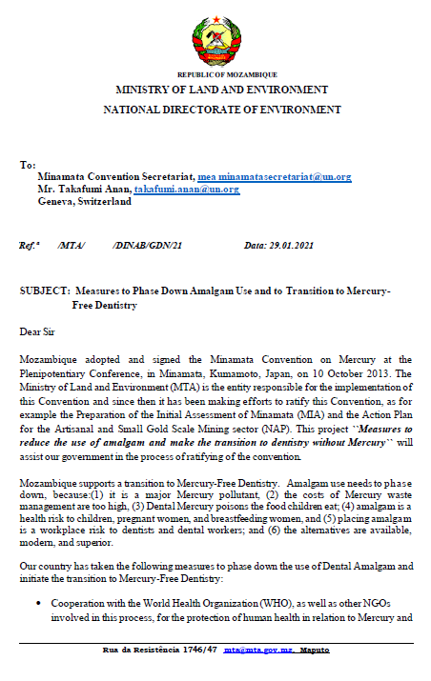

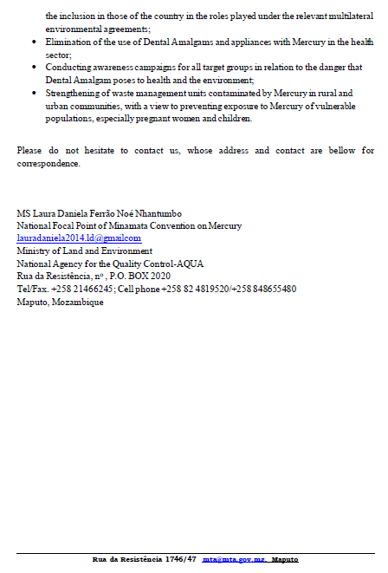

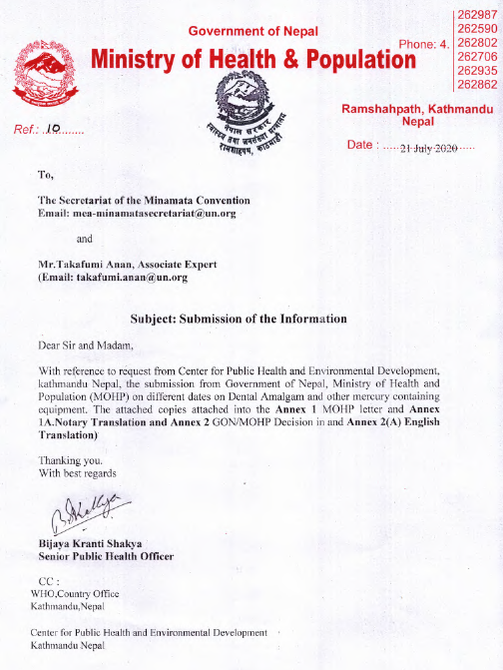

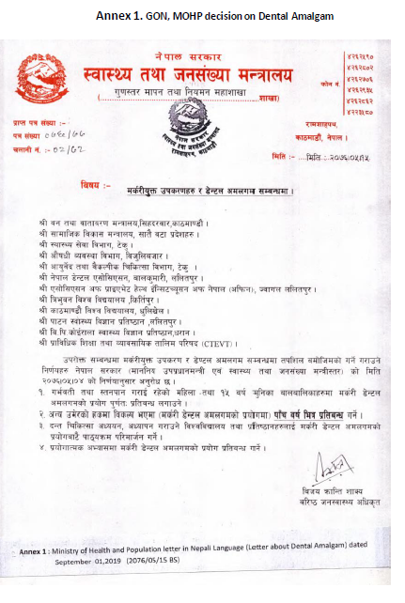

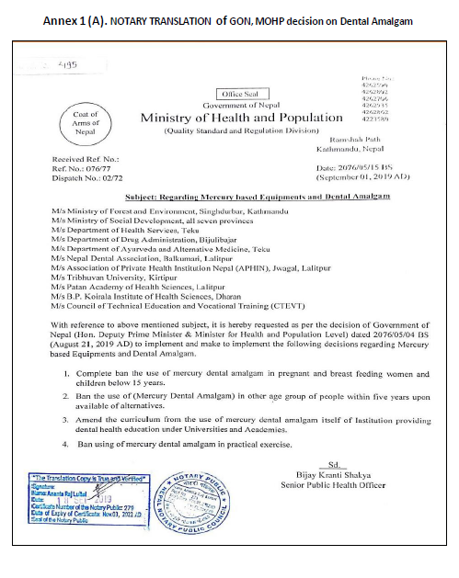

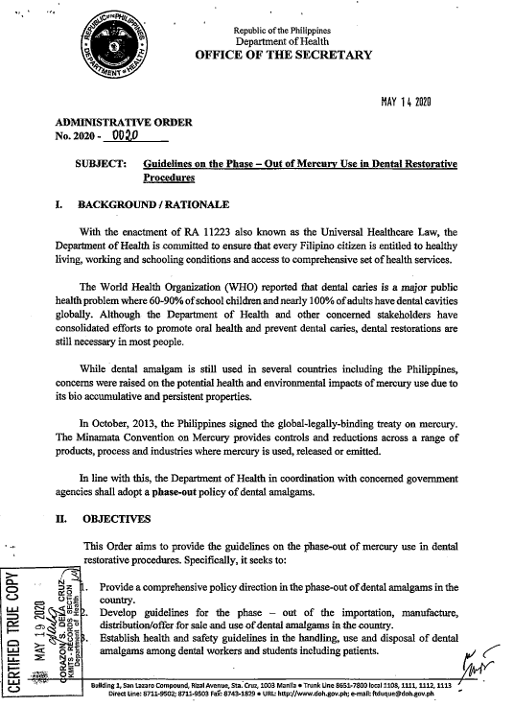

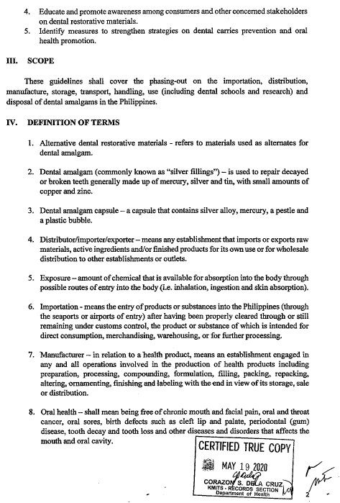

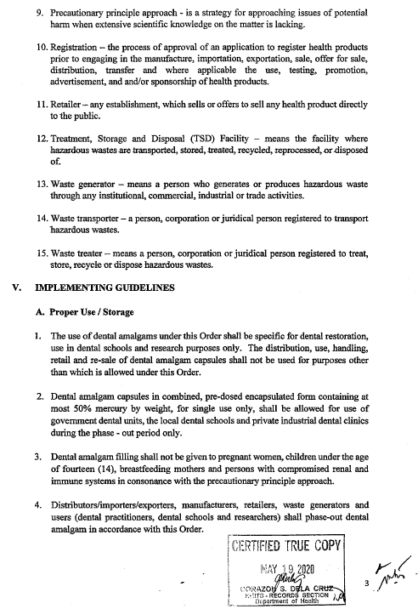

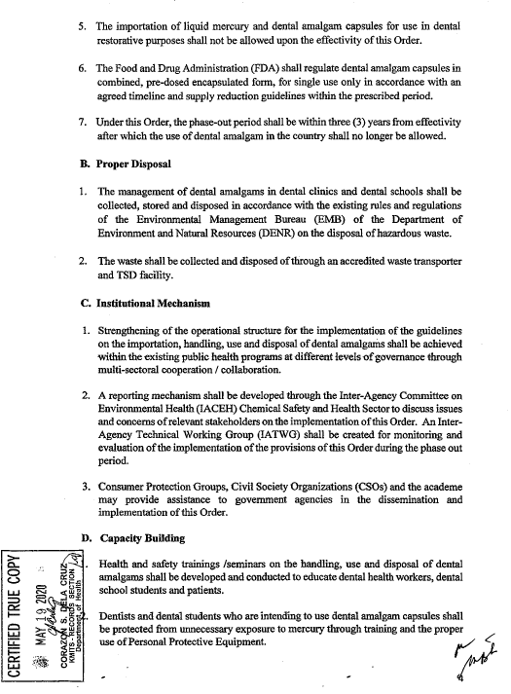

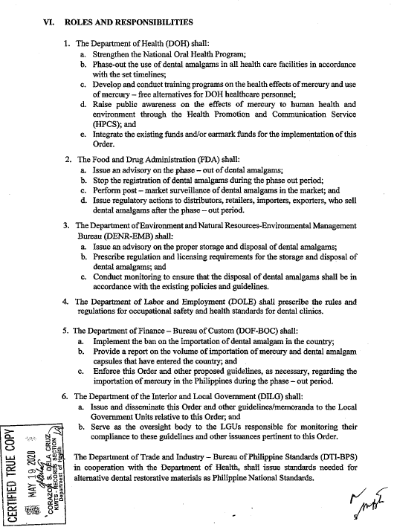

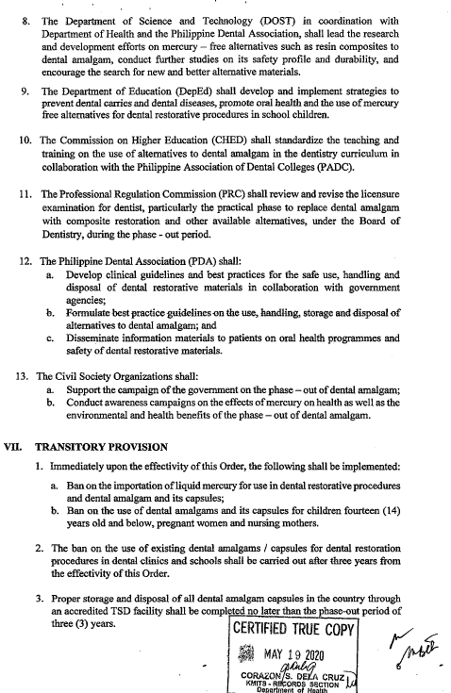

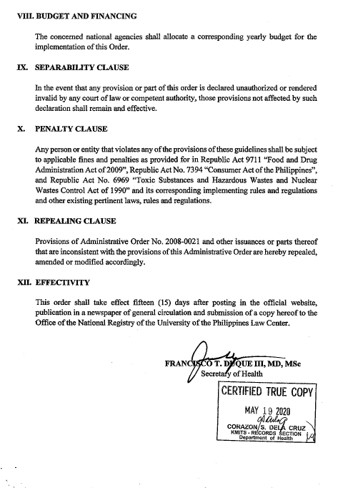

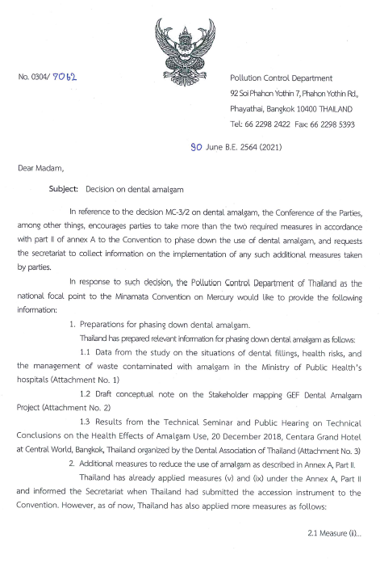

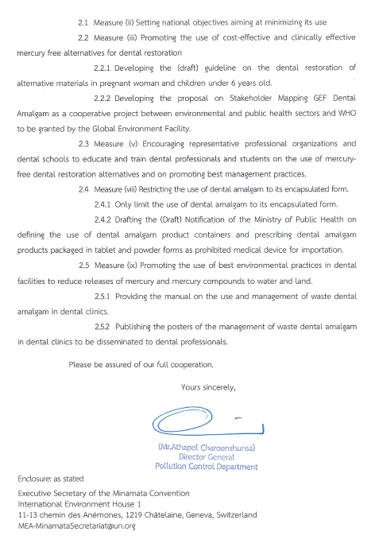

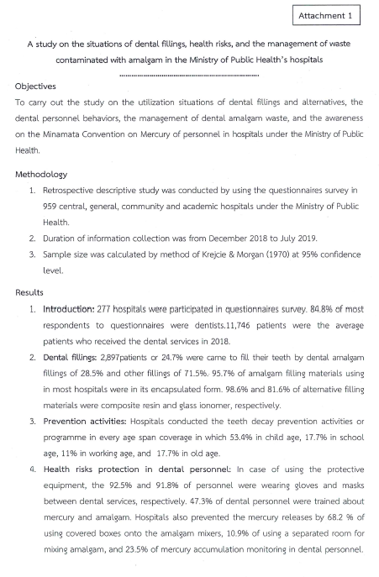
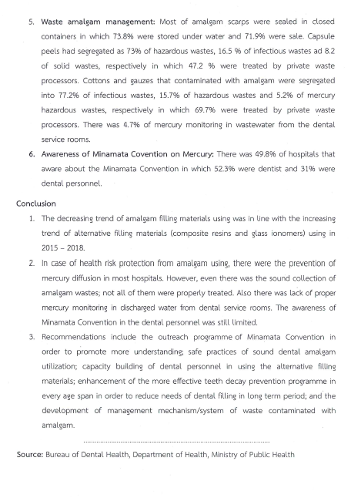

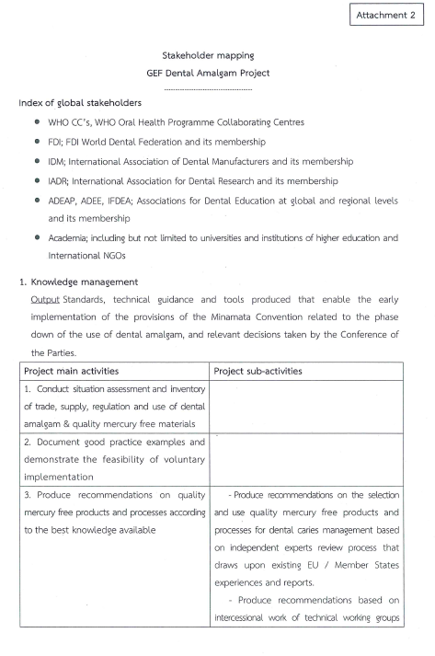
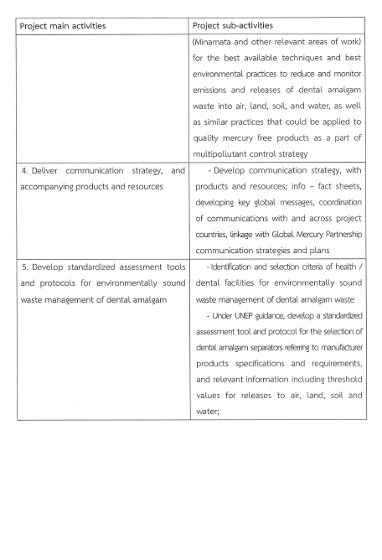
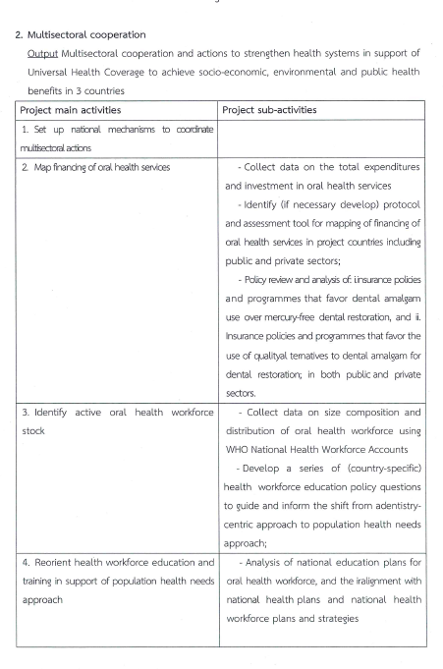
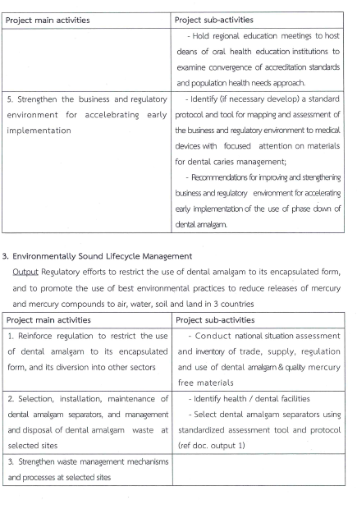

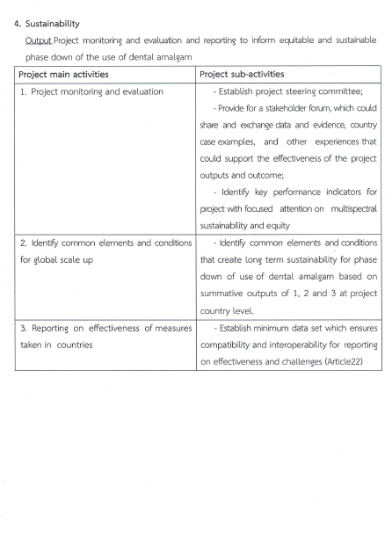

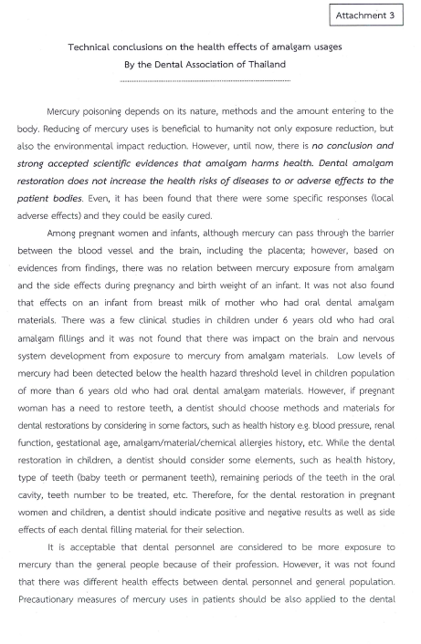
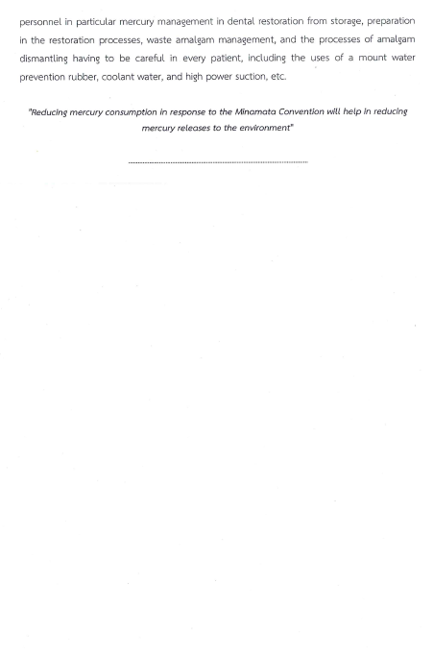

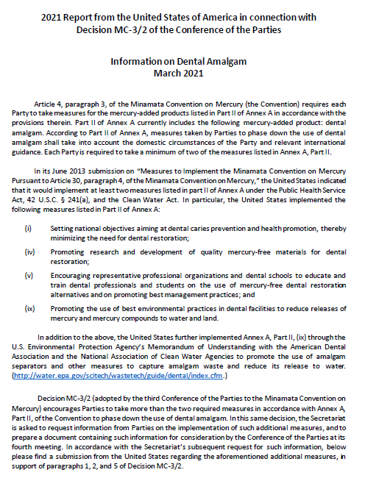

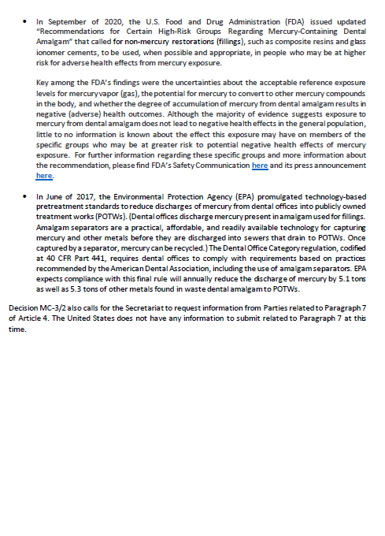

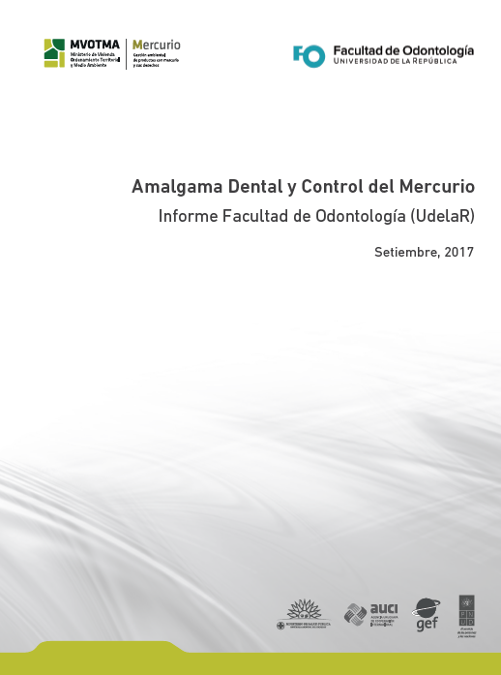

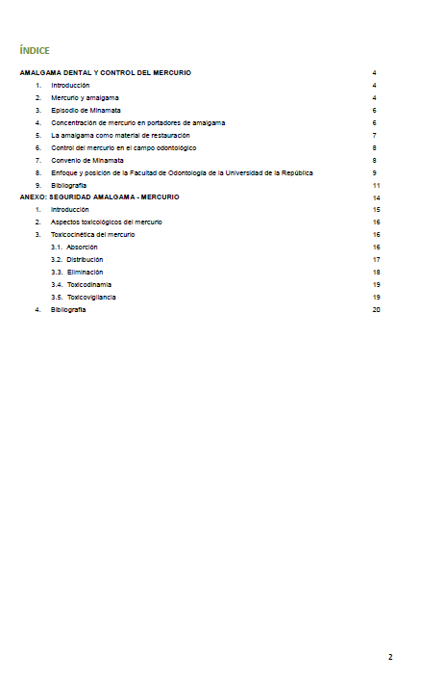
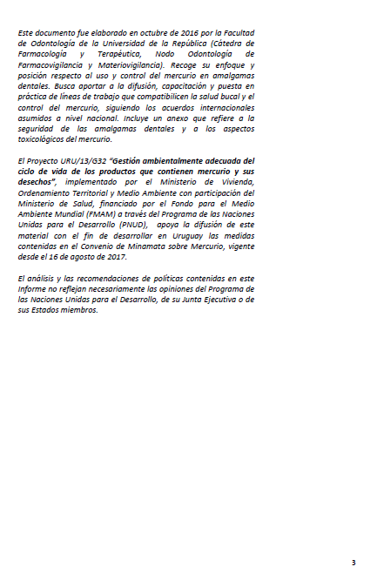

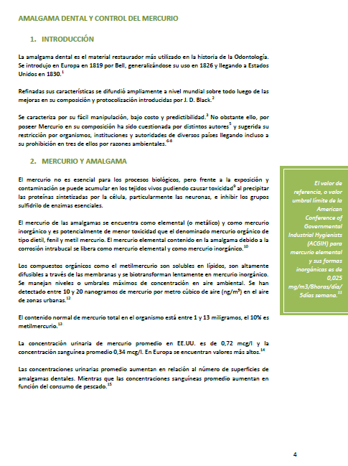

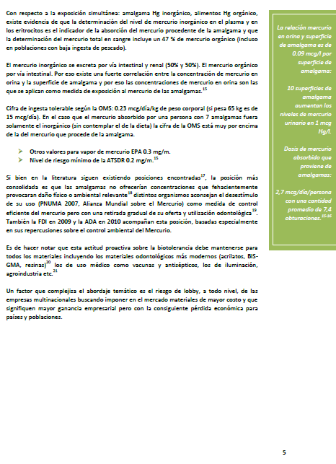

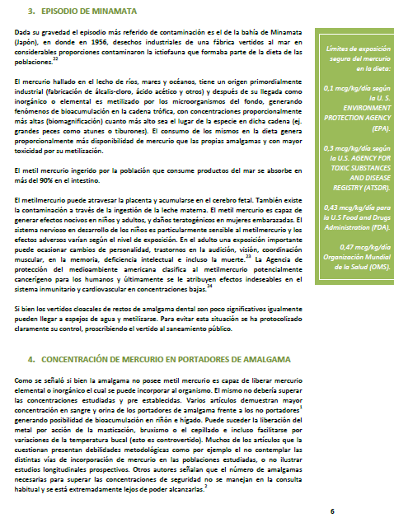

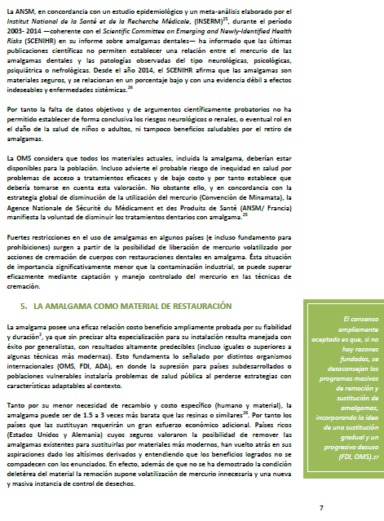

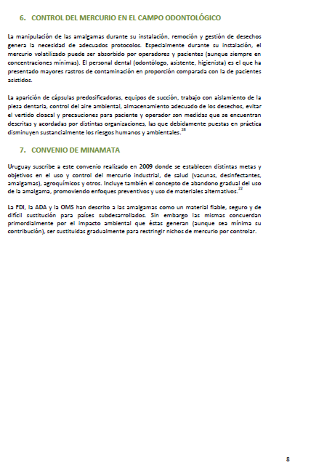

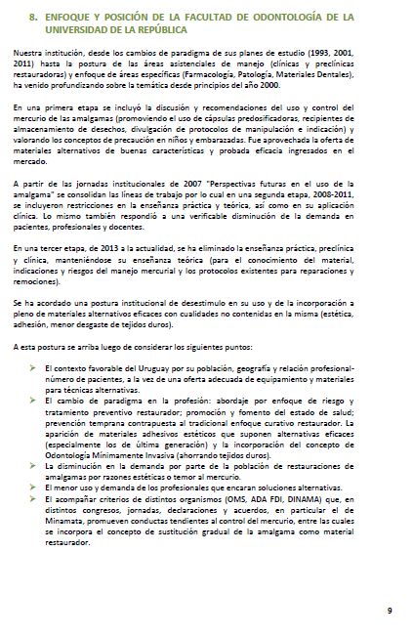

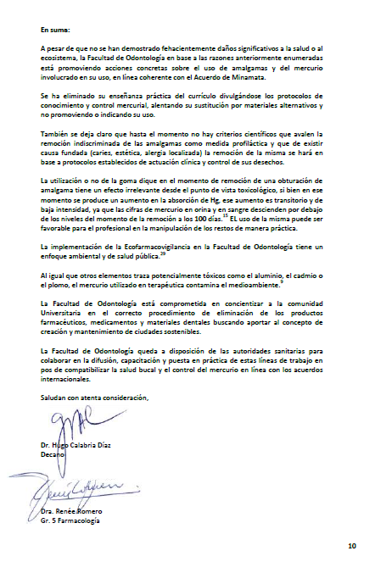

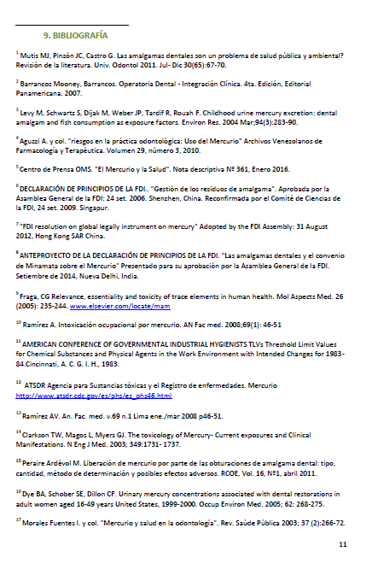
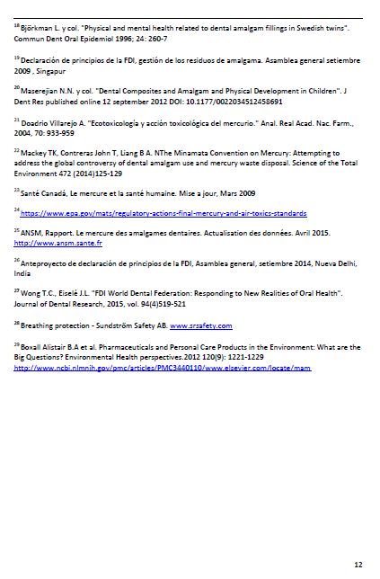


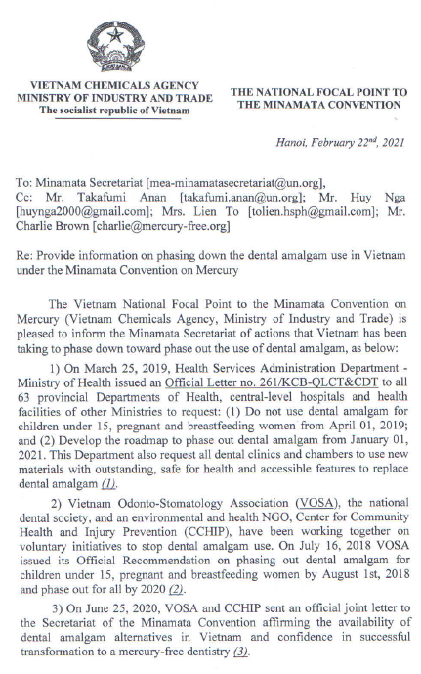

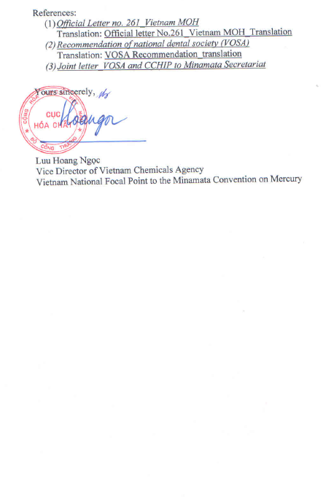

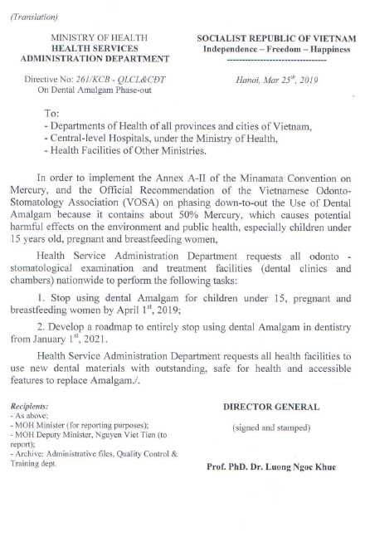

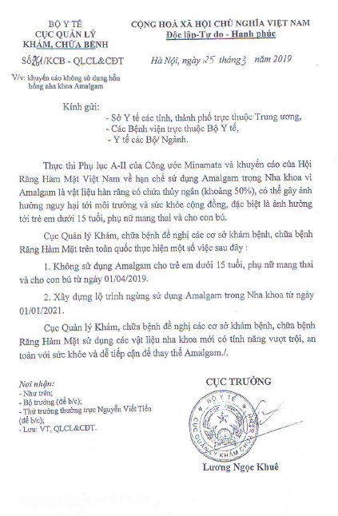

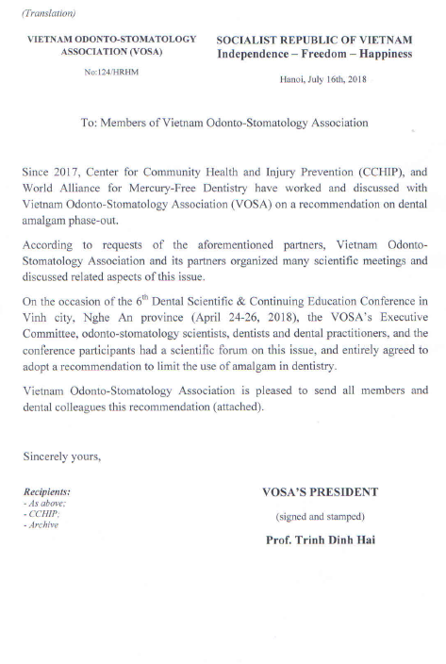

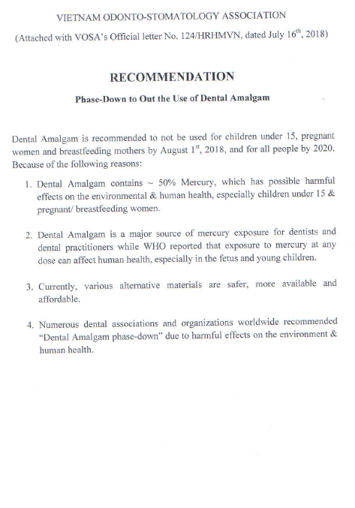

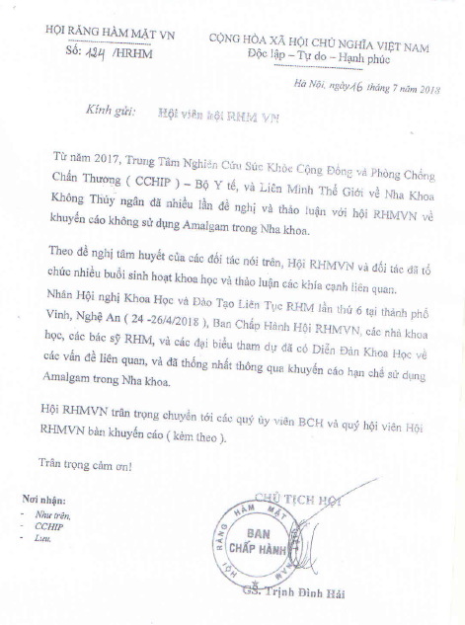

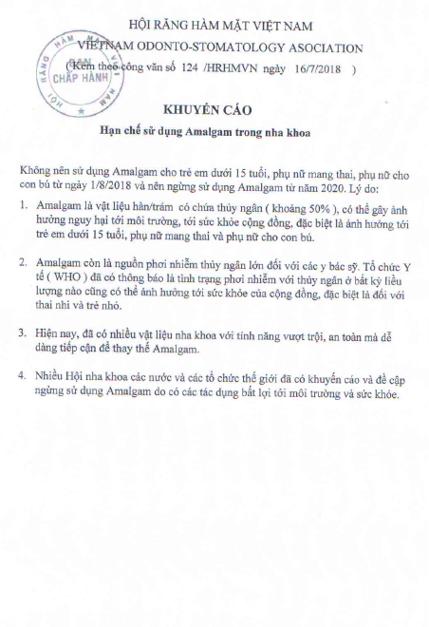

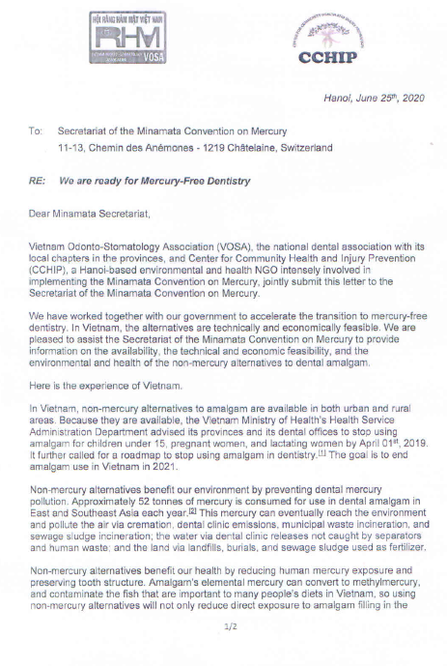
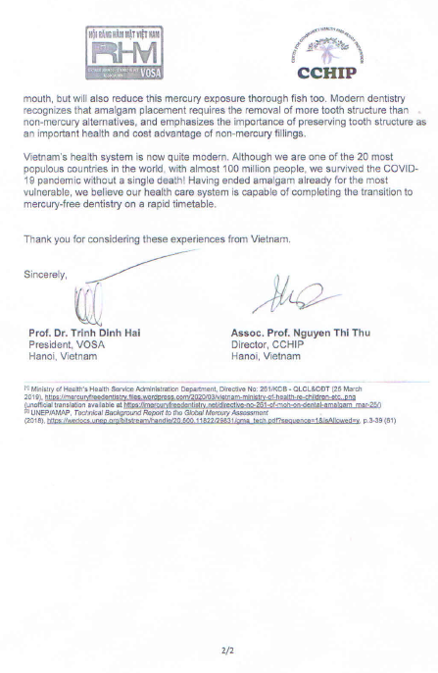
Annex II
Information on non-mercury alternatives to dental amalgam – submissions from Governments

Submissions from governments (African Region, Argentina, Brazil, Canada, EU, Japan, Jordan, Kenya, Moldova, Norway)
1. Mercury-added product | Dental amalgam
2. Further description of the product | Dental amalgam has been used as a restorative material for centuries, in order to fill cavities caused by tooth decay and to repair tooth surfaces. It is an alloy of mercury and other metals (e.g. silver, tin, copper).  Amalgam fillings are also known as “silver fillings” because of their silver-like appearance. Approximately 50 percent of dental amalgam is elemental mercury by weight. Mercury’s unique properties (it is the only metal that is a liquid at room temperature and that bonds well with powdered metal alloys) have made it an important component of dental amalgam that contributes to its longevity.
3. Information on the use of the product | Jordan  In Jordan, the use and disposal of dental amalgam fillings (1,356 kg) is the main source of Mercury released to water (2,520 kg) and one of the main sources (246 kg) of mercury released to land (430 kg)¹.  EU  Dental amalgam is the largest remaining use of mercury in the EU. The estimated annual demand for dental amalgam (EU28) amounted to 27-58 t of mercury in 2018. This represents a significant decrease, by approximately 43%, compared to the previous estimate 55-95 t of mercury a year in 2010¹. It is estimated that in 2018, approximately 372 million dental restorations were carried out in EU28. Of these, only between 10% and 19% would have used dental amalgam. This share, however, varies significantly among Member States.  Moldova  The dentistry in Republic of Moldova, having been part of the Soviet Union, which rarely used any amalgam at all, has been very close to be mercury-free since the proclamation of independence in 1991. Due to complicated technology and harmful action on workers’ health care, amalgams were not used broadly in dentistry¹. In addition, the dental amalgam raised aesthetic concerns and was applied only to molar teeth positioned distally in the oral cavity. In 2019, the country proudly stepped up and made the decision to end all amalgam use, by making a relevant prohibition in the Chemicals Law no. 277/2018². It should be noted that even though other European countries ended amalgam with exceptions, the Republic of Moldova went further, ending all amalgam use as of this year, 2020.  Argentina  In Argentina, the Ministry of Health seeks to establish a plan to minimize the use of mercury in dentistry, setting goals with terms and reduction percentages, aimed at eliminating the use of dental amalgam by 2025.  Japan  In Japan, dental treatment with dental amalgam has no longer been covered by health insurance since the revision of the medical payment system in April 2016. Mercury-free alternatives for dental restoration have been listed as those covered by health insurance.  Norway  In Norway, dental amalgam has been used as a restorative material in dentistry for more than a century (Norwegian Board of Health, 1999). Most Norwegians today aged 50 years and older have many and extensive amalgam fillings in their teeth. The estimated use of mercury in new tooth fillings has been considerably reduced over the years (from 2 000 kg in 1985 to 840 kg in 1995, and close to zero in 2008, when the general use was banned) (Klif 2010a, 2010c). The quantity of amalgam in the population represents approximately 10 tons of mercury in Norway today, and it is expected that mercury release from existing fillings will continue for up to at least 30 years. (Skjelvik, 2012)
4. Information on the availability of mercury-free (or less-mercury) alternatives | EU  The progressive substitution of dental amalgam with mercury-free materials (such as e.g. composite resins, ceramics, and glass ionomer cements) is already taking place. The overwhelming majority of EU manufacturers (95%) produce mercury-free materials, which represent a major share of the market.  Moldova  The materials used for dental restorations are mostly polymers, represented mostly by composite resin fillings and glass ionomer fillings. Today compomers, giomers, and dental porcelain inlays, gold inlays and full crowns are also used as alternatives to dental amalgam.  Canada  Non-mercury alternatives to dental amalgam, most commonly composite resins, are widely used in Canadian dental practices. Today, it is estimated that over 90% of sales of filling material in Canada are composite resin and less than 10% are dental amalgam.¹ The increase in frequency of use of non-mercury restoration materials is also reflected by imports of dental amalgam which have declined drastically over the last 12 years.² Nonetheless, there are still situations where composite resins, glass ionomers and other non-mercury alternatives to dental amalgam are not suitable or available for use due to technical, economic, and/or health reasons.  Japan  - Materials, primarily composed of resin, inorganic filler or resin and composite filler, polymerized chemically by mixing or by external energy, are used for filling of a tooth cavity or repair of artificial crowns.  - Dental filling glass polyalkeonate cement, a type of cement that cures by a reaction between aluminosilicate glass powder and alkenoic acid aqueous solution or between a mixture of aluminosilicate glass-polyacid powder and water or organic acid aqueous solution, is used for tooth filling and restoration.  - A dental filling material composed of a resin component and glass polyalkenoate cement for dental filling material may be used in the repair of artificial crowns.  - A material made primarily of acrylic ester monomer and polymer, polymerized chemically by mixing or by external energy, is mainly used for filling of a tooth cavity or repair of artificial crowns.  Brazil  - The main approach of the Federal Government is to decrease the demand and need for dental filling of the population, encouraging and fostering oral health promotion and prevention. Additionally, it is important to mention that the composite resin and glass ionomer are the main mercury-free restoring materials used to treat dental caries.  - The Atraumatic Restorative Treatment (ART), recommended by the Ministry of Health (BRAZIL, 2007; 2018) uses only hand instruments and does not require electrical dental equipment and piped water. Among other advantages, it is possible to perform the ART fillings outside the healthcare facilities and in specific populations, such as those geographically isolated. Nevertheless, it is important to emphasize that the restoring material used in this technique (glass ionomer) does not have the same physical and chemical properties and clinical performance as the dental amalgam, and its lifespan is shorter than the amalgam’s. It is worth mentioning that, despite the technological evolution of glass ionomer cements, they show more wear and less resistance to facture than resin and amalgam, which restricts their indication.
5.(i) Information on the technical feasibility of alternatives | EU  - Given the high use of mercury-free materials across the EU, it can be assumed that the vast majority of dental facilities in the EU already have the equipment required for mercury-free restorations and that most, if not all, dentists master the necessary techniques.  - Evidence has shown that mercury-free materials exhibit satisfactory mechanical properties, with a lower cavity preparation requirement for composites² as well as better aesthetics³. Four main factors influence the longevity of a filling: the material, the method of restoration, the dentist’s skills, and the patient’s dental hygiene. Mercury free materials are nowadays of good quality, effective restoration methods are widely available and dental schools are increasingly teaching the necessary skills. Dental hygiene should continue improving, thanks to public health communication. Hence, the longevity of restorations should further improve.  Norway  - Composite resin fillings are made of a type of plastic (an acrylic resin) reinforced with powdered glass. The color (shade) of composite resins can be customized to closely match surrounding teeth. They easily blend in with surrounding teeth and require minimal removal of healthy tooth structure for placement compared with dental amalgam. Composites require a bonding system for micromechanical adhesion to the tooth structure. But they may be less durable than dental amalgam and may need to be replaced more frequently.  - Glass ionomer cement fillings are based on the reaction of silicate glass powder and polyalkenoic acid. These tooth-coloured materials were introduced in 1972 for use as restorative materials for small cavities. Glass ionomer cements have the ability to bond chemically to dental hard tissues and to release fluoride for a relatively long period. Their chief disadvantage is that they are limited to use in small restorations due to low resistance to fracture.  - Resin-modified glass ionomers combine the traditional glass ionomer with a resin material. Such materials undergo both an acid-base ionomer reaction supplemented by a second resin polymerization initiated (usually) by a light-curing process. These materials are more fracture resistant than glass ionomers and combined with the ability of chemical bond to tooth substance, they are used for small restorations, especially in pediatric dentistry, in addition to the same indications as glass ionomers.  African region  - Mercury-free alternatives provide superior dentistry to rural Africa. Mercury-free alternatives like glass ionomer can be less expensive and more accessible than amalgam. Atraumatic restorative treatment (ART) was developed in eighties in East Africa to address this weakness of amalgam, because (i) ART does not need electricity or expensive equipment; (ii) ART can address most cavities in children; and (iii) its clinics can be portable, reaching into remote villages. The World Health Organization’s Collaborating Centre for Oral Health Services Research praises ART in its training manual, which explains, “ART offers an opportunity for preventive and restorative dental treatment under field conditions where there is lack of electricity and modern dental facilities.”¹ As African countries are now moving to the paradigm of prevention and no more through cure response in dental caries treatment, it is high time to spread prevention techniques using mercury-free alternatives. ART is one of the suitable methods to achieve this goal.  - For African dentists and African dental schools, mercury-free alternatives mean superior dentistry, 21st century dentistry, for this region. The governments work closely with, and consult with, dentists and dental schools. African dentists know how to use the alternatives, and in general prefer them; many of them have stopped using amalgam for a decade already.  Canada  Non-mercury alternatives to dental amalgam have been shown to have higher rates of failure and secondary caries and so must be replaced more frequently than amalgam restorations.³ It is for this reason that non-mercury alternatives to dental amalgam may not be suitable for certain individuals or populations; particularly for those with a high frequency of caries and poor oral hygiene or for those for whom regular dental visits are unavailable.^{4, 5} Financial and physical access to dental care remains a barrier for vulnerable groups including: remote communities, Indigenous peoples, refugees and immigrants, people with disabilities, elderly people, and low-income Canadians.⁶  Argentina  In Argentina, dental professionals continue to show some reluctance to replace dental amalgam, since in terms of occlusion of dental cavities it continues to be the material that shows the best performance.  Brazil  - In remote regions of difficult access, where there is no timely dental assistance and reduced availability of dental equipment, as well as for persons in vulnerable situations, the dental amalgam may be the material of choice of oral health professionals, as it is more suitable for those situations. It is known that the use of dental amalgam requires low technological capacity, while composite resin requires a dental curing light in good conditions of use to provide a good polymerization of the material (process of converting the resin into the plastic/solid state by light). Additionally, an adhesive system with good properties is necessary, allowing the resin to adhere to the dental substrate.  - The Indigenous Health Care Subsystem Report identified that, despite the increase in the total number of fillings carried out between 2015 (n=150,440) and 2018 (n=270,946), factor that may be associated with the increased access to dental services, that, in addition to developing assistance activities, also perform actions directed to prevention of dental caries and other oral health problems. Despite the fact that the total number of fillings increased, the report identified that there was a decrease in the proportion of amalgam fillings in comparison with other materials. Amalgam fillings represented 10.3% (n=15,565) of the fillings performed in 2015, and this percentage dropped to 9.2% (n=25,008) in 2018. These numbers reflect a reduction trend in the use of the amalgam and an increase in the use of amalgam substitutes over time, with significant regional differences.
5.(ii) Information on the economic feasibility of alternatives | EU  The difference between the prices of dental restorations per type of material is relatively small due to improvements in mercury-free restoration techniques. Furthermore, the price difference between dental amalgam and mercury-free materials has decreased.  Moldova  Moldova is a small country and at an income level below other countries in Europe. Yet, this country could be an example to the world that the transition to mercury-free dentistry is economically feasible.  African region  - The cost of keeping amalgam is much greater than the transitional cost to mercury-free dentistry. To have amalgam-based dentistry will be very expensive: (1) continuing amalgam means buying separators for every dentist, at 1000 to 2000 US dollars, and servicing them for hundreds of dollars per year; (2) building multi-million dollar mercury-waste facilities: (3) building a transportation infrastructure to get the mercury waste from dental clinics and hospitals to the waste facilities. It is important to note that these infrastructure costs will only catch the mercury waste from dental clinics; the mercury coming from human bodies during their lives and after burial or cremation will not be caught and will go into the environment. By contrast, the cost to shift to alternatives – some of which cost more, some of which do not – is a far less costly approach for Africa, and much of it (adjusting dental schools and clinics) is a one-time expense.  - Because of the environmental damage from amalgam’s mercury, mercury-free alternatives cost much less. Amalgam’s price is lower than composite only because the polluter does not pay – so we governments must pay for amalgam’s environmental damage. Counting environmental damages, amalgam is much more expensive than composite.²  Canada  - Restorations performed with non-mercury materials are generally more expensive than dental amalgam in Canada (about $171 for amalgam compared to $219 for composite) and do not last as long (11.5 year lifespan for amalgam compared to 8 year lifespan for composite).⁷ The higher costs of placement as well as the need to replace composite fillings more frequently is an important consideration for the discussion on the availability and economic feasibility of non-mercury alternatives to dental amalgam. About 94% of dental care in Canada is provided by the private sector, but 32% of Canadians do not have dental insurance and pay the total cost of dental visits out-of-pocket.^{8,9} Even with dental insurance, there are typically costs associated with visits as insurers only cover a portion of dental fees.¹⁰ The use of dental care services in Canada is largely influenced by insurance coverage and the ability to pay out-of-pocket for the expenses. Over six million Canadians (or about one in five) avoid dental visits each year because of the cost. ^{11, 12}  - In addition to the concerns about the affordability of dental care for individuals, the cost differential between composite fillings and amalgam fillings can have real financial implications on the sustainability and effectiveness of publicly funded oral health programs which have the goal of providing low cost or no cost dental care to vulnerable populations. Increased operational costs to these programs mean that fewer patients can be treated. Poor oral health can lead to impaired physical health, low self-esteem, increased absences and poor performance at school or work.¹³ The health risks from untreated caries are much higher than the risks from dental restorations, regardless of their material.  - In discussing the economic feasibility of non-mercury alternatives to dental amalgam, it is important to consider the cost implications of using more expensive non-mercury restoration materials in the broader context of overall health and accessibility of dental care, for both publicly funded programs as well as individuals. In Canada, access to dental care can also be limited by physical distance. For example, the Inuit Oral Health Survey conducted in 2008-2009 found that fewer than half of the study participants received dental care in the past year, even though few reported that costs were a factor in their decision. ¹⁴ For Inuit and other First Nations groups, the federal government provides some health and dental insurance. However, many Inuit and remote communities do not have a resident dentist and rely on irregular visits from fly-in dentists who reside in southern Canada. Often only the most serious cases can be seen due to time limitations, otherwise people must be flown in and out of the community for treatment and dental emergencies.¹⁵ The issues of access to care shown in this example applies to other remote and Indigenous communities in Canada who do not have resident dentists.
6. Information on environmental and health risks and benefits of alternatives | EU  - Dentist representative organisations have expressed concerns regarding a lack of available information on mercury-free materials, as well as the safety profile and biocompatibility of certain materials, some of which contain Bisphenol A (BPA) and nano-sized particles (particles with a size from 1 to 100 nm). Due to a lack of comprehensive scientific evidence, the potential direct and indirect impacts of mercury-free materials remain uncertain. Available scientific reviews concluded that release of BPA from certain dental materials was associated with only negligible health risks⁴ and exposure to BPA is within the Tolerable Daily Intake⁵. However, the 2015 BPA risk assessment by the European Food Safety Authority, which reduced the Tolerable Daily Intake for BPA from 50 to 4 μg/kg bw/day, is currently under review.  - Dental amalgam, on the other hand, causes significant emissions of mercury to air, water, and soil. Emissions to air were estimated⁶ to be 19 t over the dental amalgam life cycle (2012, EU27⁷). Emissions to water⁸ by dental clinics were estimated to be 3 t (2010, EU27), which will reduce as the Regulation mandates dental practices to be equipped with high level retention dental amalgam separators.  - The presence of mercury in wastewaters is problematic for the residues (sludge) from urban wastewater treatment plants. Depending on the type of wastewater treatment, mercury may end up in sludge from wastewater plants. Mercury emissions from dental amalgam to soil, estimated at 8 t (2010, EU27), are primarily due to the spreading on land of such sludge.  Canada  - In terms of the health risks of non-mercury alternatives to dental amalgam, concerns have been raised about the safety of composite resins as restoration materials because many composite resin materials contain BPA derivatives, most commonly bisphenol A glycidyl methacrylate (Bis‐GMA; CAS no. 1565‐94‐2), bisphenol A ethoxylate dimethacrylate (Bis‐EMA, CAS no. 41637‐38‐1), and bisphenol A dimethacrylate (Bis‐DMA; CAS no. 3253‐39‐2).^{16,17} A number of studies have shown that several substances, including BPA, can leak from some composite filling materials.^{18, 19} However, in 2010 the World Health Organization concluded that dental materials were unlikely to be an important source of BPA exposure to humans and likened the exposure risks from composite resins to food packaging and drink containers.²⁰ A subsequent assessment conducted by the European Food Safety Authority agreed with this conclusion.²¹  - The environmental risks of non-mercury alternatives to dental amalgam have not been well studied. Part of the difficulty in quantifying the risk to the environment is that there are many formulations of composite material and their chemical compositions are often proprietary.²³ This poses a challenge to assess the environmental risks of the substances used both individually and as mixtures. For example, BPA is used as a raw material to synthesize resin monomers that are used in composite fillings; however, there is limited information about how much BPA enters the environment as a result of the manufacture, use, and disposal of composite fillings.²⁴ The lack of information on non-mercury alternatives does not allow for a robust environmental risk assessment to be performed.^{25,26,27}  - Unlike dental amalgam, there are no separators, chairside traps or special disposal protocols for waste consisting of composite materials, meaning the majority of composite waste material is ultimately deposited in municipal wastewater systems or landfills.²⁸ The creation of microparticulates (including microplastics) and nanoparticles during the filing and shaping, CADCAM milling, and removal of composite fillings are an additional consideration in discussing the environmental risks of non-mercury filling materials. The contributions of dental materials to BPA and micro/nanoparticulate concentrations in landfills and wastewater are unknown and may warrant further investigation.²⁹  African region  Mercury-free alternatives means Africa will not be the dumping ground for mercury amalgam, nor the “charity” center for other regions wanting to offload amalgam, nor a source for illegal gold mining.
7. Other relevant information pursuant to Decision MC-3/2 | African region  As proof of the feasibility of mercury-free alternatives, across the continent the transition to mercury-free dentistry has begun in Africa. Mercury-free alternatives work in Africa. Many years ago, Zambia (2016) and Mauritius (2013) ended amalgam use for children. Going farther, the Tanzania Guidelines (2020) end amalgam for all children and for all women of childbearing age in 2023. Dental schools, such as the Université de Félix Houphouët-Boigny in Abidjan and all Federal universities of Nigeria, are shifting their curriculum to mercury-free dentistry. Entire hospital systems, such as the Cameroun Baptist Convention, and public dental clinics of Madagascar, have ended amalgam use entirely. Military hospitals in Abidjan, Antananarivo (Madagascar), Cotonou (Benin) have definitively abandoned amalgam use for several years. In the region famous for leapfrogging technologies, mercury-free alternatives are a prime example of skipping an unneeded step.  Norway  - Norway has phased out the use of dental amalgam. New filling materials were introduced in Norway in the 1970s and were gradually preferred for aesthetic reasons. Focus on dental amalgam as an environmental problem emerged during the 1980s as part of a broader policy to limit emissions of mercury.  - In 1991 the health authorities issued guidelines recommending dentists to reduce the use of dental amalgam, and new guidelines from 2003 required that other materials than dental amalgam should be considered as the first choice in tooth fillings. Preventive use of fluoride has also contributed to improved dental health and reduced use of dental amalgam.  - A requirement to have an approved dental amalgam separator installed in all dental clinics was introduced in 1994. Requirements to control the mercury air emissions from crematoria with more than 200 cremations per year were implemented in 2007.  - Norway introduced a general ban on the use of mercury in products from 2008. Limited exemptions for dental amalgam use were applied until the end of 2010.

8. References
EU
- Bio Intelligence Service (2012), Study on the potential for reducing mercury pollution from dental amalgam and batteries.
- Mulligan, S., et al. "The environmental impact of dental amalgam and resin-based composite materials." British Dental Journal 224.7 (2018): 542.
- Milosevic, Milos. "Polymerization mechanics of dental composites–advantages and disadvantages." Procedia Engineering 149 (2016): 313-320.
- SCENIHR, 2015. Scientific opinion on the Safety of Dental Amalgam and Alternative Dental Restoration Materials for Patients and Users.
- Bisfenol a i dentala material socialstyrelsen, 2015.
- BIO Intelligence Service (2012), Study on the potential for reducing mercury pollution from dental amalgam and batteries.
- Does not include Croatia that joined the EU in 2013.
- Mercury passes from the dental clinics through waste water treatment plants. Treatment technologies employed reach different removal efficiencies, and mercury, as other heavy metals tend not degrade but to adsorb in sludge. (Pistocchi et al. 2019; Hargraeves et al. 2016).

Japan
- Pharmaceuticals and Medical Devices Agency. Criteria for Medical Devices https://www.std.pmda.go.jp/stdDB/index_en.html (2020/8/6 access)
- https://www.std.pmda.go.jp/stdDB/Data_en/InfData/Infetc/JMDN_en.pdf (2020/8/13 access)

Canada
- Personal communication from the two largest dental supply companies in Canada.
- Government of Canada. 2019. Products Containing Mercury Regulations 2016 summary report: key results
- Canadian Agency for Drugs and Technologies in Health (CADTH). 2018. Composite resin versus amalgam for dental restorations: a health technology assessment.
- Bernardo, M., et al. 2007. Survival and reasons for failure of amalgam versus composite posterior restorations placed in a randomized clinical trial. J Am Dent Assoc. 138(6): p. 775-83.
- Soares, A.C. and Cavalhiero, A. 2010. A review of amalgam and composite longevity of posterior restorations. Revista Portuguesa de Estomatologica, Medicina Dentaria e Cirugia Maxilofacial 51:3 155-164.
- Canadian Academy of Health Sciences. 2014. Improving access to oral health care for vulnerable people living in Canada.
- Canadian Agency for Drugs and Technologies in Health (CADTH). 2018. Composite resin versus amalgam for dental restorations: a health technology assessment.
- Canadian Academy of Health Sciences. 2014. Improving access to oral health care for vulnerable people living in Canada.
- Canadian Dental Association. 2018. State of Oral health in Canada.
- Blomqvist A, Woolley F. Filling the Cavities: Improving the Efficiency and Equity of Canada’s Dental Care System. C.D. Howe Institute 2018 Commentary No 510
- Canadian Academy of Health Sciences. 2014. Improving access to oral health care for vulnerable people living in Canada.
- Statistics Canada. 2019. Health Fact Sheets: Dental Care, 2018. CANADA 4
- Canadian Academy of Health Sciences. 2014. Improving access to oral health care for vulnerable people living in Canada.
- Health Canada. 2011. Inuit oral health survey report 2008-2009.
- ibid
- Bowen RL. Properties of a silica‐reinforced polymer for dental restorations. J Am Dent Assoc 1963; 66: 57–64.
- Fleisch AF, Sheffield PE, Chinn C, Edelstein BL, Landrigan PJ. Bisphenol A and related compounds in dental materials. Pediatrics 2010; 126: 760–768
- Berge, TLL, Lygre, GB, Lie, SA, Lindh, CH, Björkman, L. Bisphenol A in human saliva and urine before and after treatment with dental polymer‐based restorative materials. Eur J Oral Sci 2019; 127: 435– 444
- Lofroth, M., Ghasemimehr, M., Falk, A., Vult von Steyern, P. Bisphenol A in dental materials – existence, leakage and biological effects. Heliyon 2019; 5(5)
- Joint FAO/WHO expert meeting to review toxicological and health aspects of bisphenol A: final report, including report of stakeholder meeting on bisphenol A, 1-5 November 2010, Ottawa, Canada. World Health Organization; 2011.
- Scientific opinion on the risks to public health related to the presence of bisphenol A (BPA) in foodstuffs: executive summary. EFSA Journal. 2015 Mar 25;13(1):3978.
- Canadian Agency for Drugs and Technologies in Health (CADTH). 2018. Composite resin versus amalgam for dental restorations: a health technology assessment.
- Fleisch AF, Sheffield PE, Chinn C, Edelstein BL, Landrigan PJ. Bisphenol A and related compounds in dental materials. Pediatrics 2010; 126: 760–768
- Canadian Agency for Drugs and Technologies in Health (CADTH). 2018. Composite resin versus amalgam for dental restorations: a health technology assessment.
- ibid
- Scientific Committee on Health and Environmental Risks (SCHER). Opinion on the environmental risks and indirect health effects of mercury from dental amalgam (update 2014). European Commission; 2014.
- Schmalz G, Hickel R, van Landuyt K, Reichl F. Dental Materials 2017; 33; 1298-1314.
- ibid
- UNEP/MC/COP.3/INF/25
Moldova
- The official data on the use of dental amalgam fillings in the Republic of Moldova was provided by the Republican Dental Clinic, which was founded in 1967.
- https://www.legis.md/cautare/getResults?doc_id=112668&lang=ro

Jordan
- http://www.mercuryconvention.org/Portals/11/documents/MIAs/Jordan-MIA-2018.pdf

African region
- https://www.mah.se/upload/fakulteter/od/avdelningar/who/art/artmanual/artmanual2008.pdf
- Concorde (2012) The real cost of dental mercury – Report prepared for the European Environmental Bureau (EEB), The Mercury Policy Project and Consumers for Dental Choice. Available at https://www.toxicteeth.org/CMSTemplates/ToxicTeeth/pdf/The-Real-Cost-of-Dental-Mercury-final.aspx

Norway
- Klif (2010a): Norwegian action plan for reducing mercury releases – 2010. TA 2731 – 2010, Norwegian Climate and Pollution Agency, Oslo.
- Klif (2010c): Prioriterte miljøgifter i produkter – data for 2008 (Hazardous substances in products – data for 2008). In Norwegian only. TA 2743-2010, Norwegian Climate and Pollution Agency, Oslo.
- Norwegian Board of Health (1999): The use of dental fillings material in Norway. Report IK-2675.
- Skjelvik. (2012). Review of Norwegian Experiences with the Phase-Out of Dental Amalgam Use. The Norwegian Climate and Pollution Agency. Available at https://vista-analyse.no/site/assets/files/5867/va-rapport_2011-28_review_amalgam.pdf

Brazil
- _____. BRASIL.. Ministério da Saúde. Secretaria de Atenção à Saúde. Departamento de Atenção Básica Coordenação Nacional de Saúde Bucal. Diretrizes da Política Nacional de Saúde Bucal [Guidelines of the National Oral Health Policy]. Brasília, 2004b.
- _____. BRASIL. Ministério da Saúde. Secretaria de Atenção à Saúde. Departamento de Atenção Básica. A saúde bucal no Sistema Único de Saúde [recurso eletrônico] [Oral Health Care in the Unified Health System [electronic resource]] / Ministério da Saúde, Secretaria de Atenção à Saúde, Departamento de Atenção Básica. – Brasília : Ministério da Saúde, 2018. 350 p. : il.
- _____. BRASIL. Diretrizes para atenção à Saúde Bucal nos distritos sanitários especiais indígenas [Guidelines for Oral Health care in the special indigenous sanitary districts]. Fundação Nacional de Saúde (Brazil). Brasília; FUNASA; 2007. 50 p. available at: https://pesquisa.bvsalud.org/bvsms/resource/pt/mis-16344
- _____. BRASIL. Ministério da Saúde. Secretaria de Atenção à Saúde. Departamento de Atenção Básica. Guia de recomendações para o uso de fluoretos no Brazil [Guide with recommendations of use for fluorides in Brazil] / Ministério da Saúde, Secretaria de Atenção à Saúde, Departamento de Atenção Básica. – Brasília : Ministério da Saúde, 2009. 56 p. : il.- (Série A. Normas e Manuais Técnicos)
- _____. BRASIL. Ministério da Saúde. Secretaria de Atenção à Saúde. Departamento de Atenção Básica. Política Nacional de Atenção Básica [National Oral Health Policy]. Brasília, 2012.
- _____. BRASIL. Ministério da Saúde. Secretaria de Atenção à Saúde. Departamento de Atenção Básica. Projeto SB Brazil 2003: condições de saúde bucal da população brasileira 2002-2003: resultados principais [SB Brazil Project 2003: oral health situation of the Brazilian population 2002-2003: main results]. Brasília, 2004c.
- _____. BRASIL. Ministério da Saúde. Secretaria de Atenção à Saúde. Departamento de Atenção Básica. Coordenação Geral de Saúde Bucal. Pesquisa Nacional de Saúde Bucal SB Brasil 2010: resultados principais [SB Brasil National Oral Health Research 2010: main results]. Brasília, 2011c.
- _____. BRASIL. Ministério da Saúde. Secretaria de Atenção Primaria à Saúde. Departamento de Promoção da Saúde. Guia alimentar para crianças brasileiras menores de 2 anos [Food guide for Brazilian children under 2] / Ministério da Saúde, Secretaria de Atenção Primaria à Saúde, Departamento de Promoção da Saúde. – Brasília : Ministério da Saúde, 2019. 265 p. : Il.
- _____. BRASIL. Ministério da Saúde. Secretaria de Atenção à Saúde. Departamento de Atenção Básica. Cadernos temáticos do PSE – Promoção da Saúde Bucal [Oral Health Promotion]. Ministério da Saúde, Secretaria de Atenção à Saúde, Departamento de Atenção Básica. Ministério da Educação, Secretaria de Educação Básica – Brasília: Ministério da Saúde, 2016. 16 p.: il.
- _____. COCHRANE BRAZIL. Efetividade da técnica Hall versus métodos convencionais para tratamento de molares decíduos destruídos por cárie [Effectiveness of the Hall technique versus conventional methods for the treatment of primary molars destroyed by caries]/Centro Cochrane do Brasil – São Paulo, 2020.
- _____. COCHRANE BRAZIL. Efetividade do Tratamento Restaurador Atraumático (ART) no Tratamento Odontológico da Cárie [Effectiveness of the Atraumatic Restorative Treatment (ART) in the Dental Treatment of Caries]. Centro Cochrane do Brasil- São Paulo, 2020
- _____. PROBST, L., NEVES, J., PEREIRA, A., CASAS, C., SILA, E. A SEGURANÇA DO AMÁLGAMA DENTÁRIO (nº 17) [SAFETY OF DENTAL AMALGAM (No. 17)] – Parecer Técnico Científico (DATS/HAOC/PROADI-SUS/2018)
- _____. MULLIGAN, S., KAKONYI, G., MOHARAMZADEH, K., S. F. THORNTON S., MARTIN N. The environmental impact of dental amalgam and resin-based composite materials. Br Dent J 224, 542-548 (2018). https://doi.org/10.1038/sj.bdj.2018.229

Annex III
Information on non-mercury alternatives to dental amalgam – submissions from non-party and other organizations

Submissions from non-party and other organizations
Submitter | Non-mercury alternatives referred in the submission | Technical and Economic Feasibility | Environmental and Health Risks and Benefits | Other information
AGENDA, Tanzania | - Composite resin  - Glass ionomer | Mercury-free dental fillings are available and in use in Tanzania.
American Dental Association (ADA) and International Association for Dental Research (IADR) | - Composite resin | - Amalgam fillings have a higher survivability rate and longevity.  - Amalgam fillings have advantage in cost and ease of placement.  - Composite resin fillings are deemed more attractive.  - Expenditures toward prevention are cost saving. | Although amalgam remains a safe, effective, and inexpensive restorative option, there are general environmental concerns relating to mercury.
Asian Center for Environmental Health | - Composite resin  - Glass ionomer  - Compomer | The complete phase out of mercury amalgam is feasible to implement.
Ban Toxics |  |  |  | The Department of Health, the Philippines, issued Administrative Order (AO20), adopting a three-year national phase-out of dental amalgam.
Center for Public Health and Environmental Development (CEPHED), Nepal |  | Most reliable and safer non-mercury alternatives are increasingly available in Nepal at competitive prices. |  | MOHP, Nepal, took a decision on banning uses of Mercury Dental Amalgam in Nepal from August 21, 2019.  - For pregnant and breast-feeding women and children below 15 years: complete ban  - For other age groups: ban within 5 years upon the availability of alternatives.
Chicago Declaration for Ending Mercury Use in the Dental Industry (North American Dental Professionals) |  | Non-mercury alternatives are available, and technically and economically feasible. | Non-mercury filling materials prevent mercury exposure to our patients and dental personnel and allow for less tooth destruction than amalgam. | Approximately half of American dentists never use dental amalgam.
Children’s Environmental Health Foundation (CEHF), Zambia | - Glass ionomer cement (GIC)  - Composites  - Cention N | - GICs are readily available, technically feasible, and cost (15-17 USD per item).  - Composites are readily and locally available, technically feasible, esthetically good, and cost (40-60 USD).  - Cention N is capable of releasing acid—neutralizing ions, and costs (24.50 USD) | - Alternatives are environmentally friendly.  - GIC releases fluoride, thus promotes tooth strength.  - For GIC and composites, there is no need to cut healthy tooth structure.  - Cention N involves strong material for posterior load-bearing restoration, high flexural strength. | Zambian dentists ended amalgam for children 20 years ago.
Consumers for Dental Choice, US |  |  | - Dental amalgam’s elemental mercury can convert to methylmercury in the human body.  - Dental Amalgam poses a risk to vulnerable populations.  - Dental amalgam’s mercury pollutes water via dental clinic releases and human waste.  - Dental amalgam’s mercury pollutes air via cremation, dental clinic emissions, and sludge incineration.
Centre de Recherche et d’Education pour le Development (CREPD) | - Glass ionomers  - Composites | - The ART technique does not require dental drill, plumbed water, or electricity.  - The treatment process needs no anaesthetic because pain and discomfort are rare.  - This approach is entirely consistent with modern concepts of preventive and restorative oral care.  - The installation and running cost of a separator (for dental amalgam) is very high and few dentists can afford that.  - There is a lack of dexterity and/or instrumentation of individual dentists to appropriately place mercury-free alternatives on the patient teeth.  - If externalities are excluded in the cost calculation, the cost of dental amalgam is lower. | - Mercury from dental amalgam can harm the human health and the environment.  - Dental amalgam waste management in Cameroon was not the best.
DCMFA | - Glass ionomer  - Dental nanocomposites  - Giomers | - High viscosity glass ionomer restoratives are now widely available and affordable in developing economies.  - Glass ionomer restoratives are biocompatible restoratives that bind chemically to tooth tissues.  - Glass ionomers have hydrophilic properties, they can be placed in the wet oral environment.  - The restoration matures with time (increasing hardness).  - It is capable of ionic exchange with demineralized dentine and enamel. | - There is unnecessary removal of healthy tooth tissue to enhance the retention of dental amalgam.  - Amalgam is an environmental and clinic pollutant because it is 41%-50% mercury.  - There is a lack of systems and technologies for sorting, collection, transport and treatment of mercury wastes generated from dental clinics in developing countries.  - Mercury-free dentistry (minimum intervention dentistry) enhances infection control. | A ‘leapfrogging’ phase down strategy with direct transition to mercury free dentistry will safeguard human health and the environment.
Environment and Social Development Organization (ESDO), Bangladesh | - Composite  - GIC | - More than 75% of dentists in Bangladesh use composites.  - In Bangladesh, non-mercury alternatives are available in both urban and rural regions. |  | - Bangladesh Dental Society (BDS) stopped using amalgam for children under 15, pregnant women, and lactating women from 30.06.2018.  - Bangladesh Army, NAVY and Air force have combinedly phased out dental amalgam in their treatments in 2018.
European Center for Environmental Medicine | - Composits  - Glass ionomers  - Compomers | - Non-mercury alternatives to amalgam are available and feasible.  - Most dentists in Europe practice mercury-free dentistry, and all dentists (certainly all under age 70) know how to use mercury-free fillings.  - The annual failure rate of composite fillings in the posterior region (2.2%) is statistically not different from that of amalgam fillings (3.0%). | - Amalgam damages healthy tooth matter, weakens tooth structure, and fractures teeth.  - Mercury-free materials offer benefits of preserving tooth structure and strengthening teeth.  - Many studies have warned against the use of amalgam in people with kidney impairments.  - Amalgam’s known risks keep increasing while no harm from mercury-free fillings has been found in half a century. | - Sweden and Norway have phased out amalgam use.  - Finland, the Netherlands, and Denmark use amalgam for only 1% of all fillings.  - 70% of the EU Member States have less than 10% amalgam use or have filed phase-out plans.
FDI World Dental Federation |  | - Alternative restorative materials are still not “technically and economically feasible” for many resource-limited settings  - Dental amalgam is the most affordable treatment option in many cases both in terms of cost of placement and how long it lasts. | Increased research and development of quality mercury-free materials for dental restorations, including their potential environmental impact is needed.
Action Group for Promotino and Protection to Flora and Fauna (GAPROFFA), Benin | - Composite  - Glass Ionomer Cement (GIC) | - Accessibility to alternatives in Benin is limited by patients' lack of information and sometimes on “supposed” financial means.  - Alternatives to amalgams are available in Benin even if few dentists have strong knowledge and practice on how to fill patients’ cavities.  - The price of composite varies between 50-120 USD, which is relatively expensive for a common citizen. | Non-mercury alternatives are good for health and the environment. | Generally, it is patients with a fairly high education and with very rigorous oral hygiene who are requesting for composites (used in about 90% of dental clinics in Cotonou-Benin).
International Academy of Oral Medicine and Toxicology (IAOMT) | - Composite  - Gold alloys  - Ceramics | - Composite fillings perform as well as amalgam when comparing failure rates and replacement filling rates.  - The real cost of using amalgam far outweighs the cost of using mercury-free composite. | - Scientific literature shows the health hazards of using dental mercury amalgam.  - Composite resins present a lower risk for chemical exposures. | The Precautionary Principle is essential to consider when evaluating environmental and health risks and benefits.
Kisiwani Conservation Network, Kenya | - Composites  - GIC  - Artificial dental crowns  - Porcelain  - Gold | - Alternatives exist, are in active use and affordable in both public and private clinics in Mombasa, Kenya.  - Practitioners are well-trained and possess requisite infrastructure.  - Composites and some crowns are cheaper than amalgam.  - County Department of Health offered fair fiscal investments for alternatives. | - Mercury from dental amalgam gets to the environment, due to poor waste collection, weak compliance and also through cremation.
Latin American Centre for Environmental Health (LACEH) | - Glass ionomer (ART technique) | - ART uses only hand instruments to place the filling.  - ART can be done in villages without electricity and outside of dental clinic setting.  - Amalgam can be costly and is not always widely available, especially for disadvantaged populations.  - ART costs only half as much as amalgam.  - Glass ionomers, whether via ART or otherwise, have a preventive component. |  | - Uruguay uses a small percentage of dental amalgam and is moving quickly towards eliminating it.  - In Chile, very little percentage of dental amalgam is used, nearly none.  - Bolivia has already got a regulation to end dental amalgam in children and pregnant women.
SRADev Nigeria |  | - 89% of the dental clinics in Enugu State of Nigeria now use non-mercury alternatives, which are available.  - UBTH, one of the largest public hospital in Edo State of Nigeria, has phased out amalgam use for children since 2018.
Timis County College of Dentists (TCCB), Romania |  | Despite environmental concerns, for some patients in specific groups, the use of dental amalgam may be the only feasible treatment option that can best meet all clinical circumstances and patient needs. | - There is no evidence that dental amalgam presents a direct health risk to people who have amalgam restorations.  - However, through contamination of the environment, dental amalgam may contribute indirectly to the risk to human health due to mercury. | The use of dental amalgam is no longer allowed in Romania for the treatment of children under 15, pregnant or breastfeeding women or temporary teeth, unless the dentist considers it strictly necessary.
Vietnam Odonto-Stomatology Association (VOSA) and Center for Community Health and Injury Prevention (CCHIP), Viet Nam |  | In Vietnam, non-mercury alternatives are available in both urban and rural areas and technically and economically feasible. | - Mercury from dental amalgam can eventually reach the environment and pollute the air via cremation, dental clinic emissions, municipal waste incineration, and sewage sludge incineration; the water via dental clinic releases not caught by separators and human waste; and the land via landfills, burials, and sewage sludge used as fertilizer.  - Amalgam’s elemental mercury can convert to methylmercury and contaminate the fish that are important to many people’s diet in Vietnam.  - Amalgam placement requires the removal of more tooth structure than non-mercury alternatives. | Vietnam MoH advised its provinces and its dental offices to stop using amalgam for children under 15, pregnant women, and lactating women by 1 April 2019.
World Alliance for Mercury Free Dentistry (WAMFD): Arab States | - Composites  - Glass ionomers  - Copolymers (modified composites) | - Alternatives are readily available and widely used in Arab countries.  - Alternatives help to preserve natural tooth structure. | - A study on air of dental clinics in Lebanon and Morocco finds that the use of mercury containing amalgam in the dentistry sector leads to high concentrations of mercury inside the closed spaces of dental care clinics.
Dentist’s Committee for a Mercury Free Africa (DCMFA) | - Glass ionomer  - Dental nanocomposites  - Giomers | - High viscosity glass ionomer restoratives are now widely available and affordable in developing economies.  - Glass ionomer restoratives are biocompatible restoratives that bind chemically to tooth tissues.  - Glass ionomers have hydrophilic properties, they can be placed in the wet oral environment.  - The restoration matures with time (increasing hardness).  - It is capable of ionic exchange with demineralized dentine and enamel. | - There is unnecessary removal of healthy tooth tissue to enhance the retention of dental amalgam.  - Amalgam is an environmental and clinic pollutant because it is 41%-50% mercury.  - There is a lack of systems and technologies for sorting, collection, transport and treatment of mercury wastes generated from dental clinics in developing countries.  - Mercury-free dentistry (minimum intervention dentistry) enhances infection control. | A ‘leapfrogging’ phase down strategy with direct transition to mercury free dentistry will safeguard human health and the environment.
WAMFD: SIDS-CSOs |  | The danger of dental mercury in limited-space societies of island states makes the transition to mercury-free dentistry essential. | The mercury from dental amalgam going into fish is called a “secondary poisoning” by SCHER, the European Union Committee of Scientists, who studied amalgam’s harms. | - By order of its president, the self-governing territory of New Caledonia stopped all amalgam use in September 2019.  - Via voluntary agreement of its dentists and the government, St. Kitts and Nevis Islands ended all amalgam use.  - In 2014, the Mauritius Ministry of Health and Quality of Life ended the use of amalgam for children under age 10 and for pregnant women.  - Madagascar ended amalgam use in public programs and in military hospitals.
WAMFD | - Composite (mostly used)  - Glass ionomer materials (mostly for children)  - Compomers | - The Swedish Chemical Agency stated at INC1 in 2010 that the alternatives to dental amalgam are “Available, Affordable and Effective”.  - Increasingly available in both developed and developing nations.  - Alternatives are now available as a liquid/powder to be mixed together by hand prior to use.  - The materials are also available in a light hardening form and premixed in tubes or capsules.  - Alternatives, e.g. through ART, can serve population lacking traditional dental care.  - Like amalgam, the use of the light hardening materials, however, does require an equipped dental clinic and access to electricity.  - A variety of shades are available when aesthetics is a consideration.  - Composites and dental amalgam can be considered equal when considering the cost of a filling, but today’s composite fillings have been shown to last longer than dental amalgam.  - Bulk-fill composites can be placed into a cavity slightly quicker than amalgam.  - Non-mercury alternatives to dental amalgam require less healthy tooth tissue removal than dental amalgam and in the case of composite produce a stronger filled tooth.  - The real cost of dental amalgam is not borne by the user or recipient but by society as a whole and is and will be substantial. | - The mercury from dental amalgam can pollute the environment, and high levels of mercury vapour exposure may cause potential toxic effects endangering patients and dental professionals.  - Mercury can be both toxic and allergenic at the same time.  - Low-dose chronic mercury exposure from dental amalgam can be associated with a number of neurological and developmental conditions.  - There have been no reports of any damage to the environment from the use of composite, compomer or glass ionomers.  - Alternative materials present no risk to human health. | - The “Precautionary Principle” must apply to all dental materials especially as dental amalgam is the source of the greatest body burden of mercury in humans.
WAMFD: Scientific literature review |  | - Mercury-free dental fillings are available in both developed and developing nations.  - Many countries have phased-out amalgam, while many others are ending amalgam in programs.  - Mercury-free fillings are long lasting, user-friendly and facilitate future repairs.  - The technical superiority of mercury-free alternatives eliminates cost differences.  - Mercury-free filling techniques (e.g. ART) can be less expensive and more accessible.  - Mercury-free fillings eliminate the high environmental costs of dental mercury that governments must bear. | - Mercury-free fillings preserve tooth structure.  - Mercury-free fillings can help prevent future caries.  - Mercury-free fillings are safe for health and the environment.

* The resumed fourth meeting of the Conference of the Parties to the Minamata Convention on Mercury is to convene in-person in Bali, Indonesia, and is tentatively scheduled for the first quarter of 2022.
** UNEP/MC/COP.4/1.

