UNITED  NATIONS | 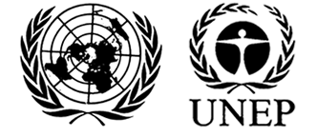 |  |  | MC
 |  |  | UNEP/MC/COP.4/INF/26
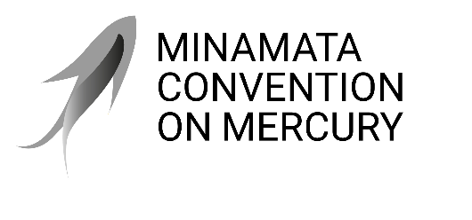 |  |  | Distr.: General  30 September 2021  English only
Conference of the Parties to the
Minamata Convention on Mercury
Fourth meeting
Online, 1−5 November 2021*
Item 4 (a) (ii) of the provisional agenda**
Matters for consideration or action by the Conference of the Parties: mercury-added products and manufacturing processes in which mercury or mercury compounds are used: information on dental amalgam
Dental amalgam: information from the World Health Organization
Note by the secretariat
As is mentioned in the note by the secretariat on the matter (UNEP/MC/COP.4/5), the World Health Organization held an informal consultation with chief dental officers and public oral health leaders regarding the progress achieved in the phase-down in the use of dental amalgam, with the aim of informing the Conference of the Parties. The report of that consultation is set out in the annex to the present note and is presented without formal editing.

Annex

Report of the Informal
Global WHO consultation
with policymakers in dental
public health
Monitoring country progress in phasing
down the use of dental amalgam

September 2021

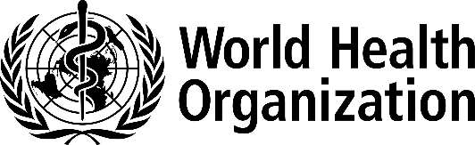

Report of the Informal Global WHO consultation with policymakers in dental public health, 2021. Monitoring Country Progress in Phasing Down the Use of Dental Amalgam
© World Health Organization, 2021
Some rights reserved. This work is available under the Creative Commons Attribution-NonCommercial-ShareAlike 3.0 IGO licence (CC BY-NC-SA 3.0 IGO; https://creativecommons.org/licenses/by-nc-sa/3.0/igo).
Under the terms of this licence, you may copy, redistribute and adapt the work for non-commercial purposes, provided the work is appropriately cited, as indicated below. In any use of this work, there should be no suggestion that WHO endorses any specific organization, products or services. The use of the WHO logo is not permitted. If you adapt the work, then you must license your work under the same or equivalent Creative Commons licence. If you create a translation of this work, you should add the following disclaimer along with the suggested citation: “This translation was not created by the World Health Organization (WHO). WHO is not responsible for the content or accuracy of this translation. The original English edition shall be the binding and authentic edition”.
Any mediation relating to disputes arising under the licence shall be conducted in accordance with the mediation rules of the World Intellectual Property Organization. (http://www.wipo.int/amc/en/mediation/rules).
Suggested citation. Report of the Informal Global WHO consultation with policymakers in dental public health, 2021. Monitoring country progress in phasing down the use of dental amalgam. Geneva: World Health Organization; 2021. Licence: CC BY-NC-SA 3.0 IGO.
Cataloguing-in-Publication (CIP) data. CIP data are available at http://apps.who.int/iris.
Sales, rights and licensing. To purchase WHO publications, see http://apps.who.int/bookorders. To submit requests for commercial use and queries on rights and licensing, see http://www.who.int/about/licensing.
Third-party materials. If you wish to reuse material from this work that is attributed to a third party, such as tables, figures or images, it is your responsibility to determine whether permission is needed for that reuse and to obtain permission from the copyright holder. The risk of claims resulting from infringement of any third-party-owned component in the work rests solely with the user.
General disclaimers. The designations employed and the presentation of the material in this publication do not imply the expression of any opinion whatsoever on the part of WHO concerning the legal status of any country, territory, city or area or of its authorities, or concerning the delimitation of its frontiers or boundaries. Dotted and dashed lines on maps represent approximate border lines for which there may not yet be full agreement. The mention of specific companies or of certain manufacturers’ products does not imply that they are endorsed or recommended by WHO in preference to others of a similar nature that are not mentioned. Errors and omissions excepted, the names of proprietary products are distinguished by initial capital letters.
All reasonable precautions have been taken by WHO to verify the information contained in this publication. However, the published material is being distributed without warranty of any kind, either expressed or implied. The responsibility for the interpretation and use of the material lies with the reader. In no event shall WHO be liable for damages arising from its use.
This publication contains the report of the informal global WHO consultation with policymakers in dental public health, 2021. Monitoring Country Progress in Phasing Down the Use of Dental Amalgam and does not necessarily represent the decisions or policies of WHO.

Contents

Acknowledgements v
Abbreviations vi
Executive Summary vii
1. Background 1
1.1. The Minamata Convention on Mercury 1
1.2. The 2019 informal global WHO consultation with policymakers in dental public health 2
1.3. The Third Meeting of the Conference of the Parties to the Minamata Convention on Mercury 2
1.4. The 2021 informal global WHO consultation with policymakers in dental public health 2
2. Methods 3
3. Results 3
3.1. Characteristics of informal consultation participants and countries 3
3.2. The Minamata Convention and phase-down in use of dental amalgam 4
3.3. Insurance and regulatory information 14
3.4. Dental education and training 19
3.5. Mercury / hazardous waste management 21
3.6. Knowledge sharing and information exchange 24
4. Discussion 26
4.1. Comparison of findings from the 2019 and 2021 consultations with policymakers 26
4.2. Progress in ratification and implementation of the Minamata Convention on Mercury 26
4.3. Challenges in implementation of the Minamata Convention on Mercury 26
4.4. Accelerating the phase-down in use of dental amalgam 27
4.5. Strengths and limitations of the informal global consultation with policymakers in dental public health 28
4.6. Conclusion 29
References 30
Annex. English Questionnaire of the 2021 Informal Global WHO Consultation with Policymakers in Dental Public Health 31

Acknowledgements
The World Health Organization (WHO) wishes to express its gratitude to the participants for their contributions.

Abbreviations

AFR African Region
AMR Region of the Americas
COP3 Third Meeting of the Conference of Parties of the Minamata Convention
COP4 Fourth Meeting of the Conference of Parties of the Minamata Convention
EMR Eastern Mediterranean Region
EUR European Region
HIC high-income countries
LIC low-income countries
LMIC lower-middle-income countries
SEAR South-East Asia Region
UMIC upper-middle-income countries
WHA World Health Assembly
WHO CC WHO Collaborating Centres
WHO World Health Organization
WPR Western Pacific Region

Executive Summary
Background: The Minamata Convention on Mercury is a global treaty that entered into force in 2017 with the aim to protect human health and the environment from anthropogenic emissions and releases of mercury and mercury compounds.1 The Convention requires that countries that are parties to it implement at least two of nine measures to phase down the use of dental amalgam, a dental restorative material that is 50% mercury.
In 2019, the World Health Organization (WHO) Oral Health Programme conducted an informal consultation with policymakers in the field of dental public health in order to better understand global, regional, and national experiences and perspectives about the Minamata Convention on Mercury.2 In total, 79 individuals from 71 countries and territories participated in the 2019 consultation. In the 2019 consultation, almost all respondents were aware of the Convention, and half reported that their countries were currently implementing activities related to the phase-down in use of dental amalgam. However, almost all participants reported that dental amalgam was still used in their countries, including all participants from low-income countries. Three-quarters of participants reported that mercury-free alternatives were available in their countries, of whom one-third indicated that these were not affordable for the most vulnerable and marginalized population groups. Most participants who reported that mercury-free alternatives were not available in their countries were from low- and middle-income countries.
At the Third Meeting of the Conference of the Parties to the Minamata Convention on Mercury in November 2019, a decision was adopted encouraging parties to implement more than the two required measures to phase down the use of dental amalgam.3 The conference requested its secretariat to request information from parties on the implementation of any additional measures, to compile the information received and to prepare a document on it for consideration by the Fourth Meeting of the Conference of Parties of the Minamata Convention.
In March 2021, the WHO Oral Health Programme again conducted an informal consultation with policymakers in the field of dental public health to better understand progress in phasing down the use of dental amalgam at global, regional, and national levels. This report describes the 2021 consultation, which had objectives to understand the extent of implementation of the nine phase-down measures; to gather knowledge of the use of mercury-free alternatives to dental amalgam; and to identify additional measures being implemented to phase down the use of dental amalgam.
Methods: A questionnaire was developed focused on country-specific use of dental amalgam and mercury-free alternatives, as well as related insurance and regulatory information, dental education and training, mercury / hazardous waste management, and knowledge sharing and information exchange. An online, self-administered survey was designed to include both close-ended and open-ended (write-in) responses. Participants could complete the survey in English, Spanish or French.
In March 2021, invitations to complete the questionnaire were emailed to all Chief Dental Officers, Directors of WHO Collaborating Centres and senior dental public health members of the WHO global oral health network. Descriptive analysis of quantitative data included global overviews and subgroup analyses by region and country income group. The six WHO regions are the African Region (AFR), the Region of the Americas (AMR), the Eastern Mediterranean Region (EMR), the European Region (EUR), the South-East Asia Region (SEAR) and the Western Pacific Region (WPR). Country income groups were defined by World Bank high-income (HIC), upper-middle-income (UMIC), lower-middle-income (LMIC) and low-income (LIC) country status. Qualitative data were summarized and analysed thematically.
Results: The 2021 consultation included 93 participants from 80 countries and territories, 89% of which were Signatories or Parties to the Convention at the time of the consultation. Close to half of all countries in each WHO region were represented in the consultation, with the exception of EMR (14%). Globally, 44% of all HIC, 24% of all UMIC, 40% of all LMIC, and 37% of all LIC were represented in the consultation.
Use of dental amalgam: 84% of countries covered by this survey were reported to still use dental amalgam. This was most frequently reported in EMR and SEAR (both 100%) and least frequently reported in AMR (64%). Use of dental amalgam was most common in LIC and least common in HIC. 14% of countries covered by this survey were reported to have completely phased out the use of dental amalgam, compared to 73% which were in the process of phasing it down, and 14% which had no plan to phase it down. Of the 11 countries with no plan, 7 were Parties to the Convention, 2 were Signatories but not Parties, and 2 were neither Signatories nor Parties at the time of the consultation. One-third of countries covered by this survey in AFR and EMR had no plan to phase down the use of dental amalgam, followed by 14% in AMR and 8% in the WPR. Among country income groups covered by this survey, 40% of LIC and 23% of LMIC had no plans to phase down the use of dental amalgam, while no UMIC and only 6% of HIC were in this category.
In one-quarter of countries participating in the consultation, the proportion of dental amalgam of all dental restorative materials used was higher in the public sector than in the private sector, while the opposite was reported in only 1% of countries. Of the 16 countries for which dental amalgam was estimated to make up most of the dental restorative materials used in the public sector, countries in AFR and EMR were disproportionately represented, as were LMIC and LIC.
Reported challenges and barriers to phasing down the use of dental amalgam included:
- For patients: insufficient knowledge and awareness; greater affordability or accessibility of dental amalgam relative to mercury-free alternatives; and better coverage of it under insurance plans.
- For oral healthcare providers: preference for dental amalgam due to its perceived ease of handling, durability, familiarity, and emphasis within dental training. Familiarity was reported to be a particular challenge for older providers who did not want to change their established practices.
- For policymakers: lack of a national plan for phase-down; its low priority within national health policies; insufficient inter-ministerial coordination and initiatives; inadequate funding; long processes to develop statutory instruments and approvals; strong lobbying by dental associations and the dental industry against phase-down; and dental amalgam’s continued inclusion within licensing and certification requirements for dentists.
- For public dental services: insufficient funding within national budgets, and inadequate advocacy for and promotion and availability of mercury-free alternative restorative materials.
- For private dental services: weak monitoring systems to ensure regulations are followed; a belief that dental amalgam is safe, cheap, and has unmatched longevity; and difficulty in convincing patients to use relatively costly mercury-free alternatives.
- For other stakeholders: phase-down in use of dental amalgam being of lower priority than other mercury phase-down projects and programs; lack of power to enact related policies and regulations; and dental associations prioritizing evidence of safety and durability of dental amalgam over environmental concerns, and/or being influenced by the manufacturing industry that produces and distributes dental amalgam.
Insurance policies and programmes: Over two-thirds of countries covered by this survey have some insurance policies and programmes that cover costs of use of dental amalgam or mercury-free alternatives. This was most often reported for countries in AMR and EUR and least often reported in WPR, AFR and EMR. Insurance policies and programmes were reported for 80% of HIC, compared to only 30% of LIC. Overall, policies more frequently allowed patient reimbursement for the cost of restorative care in the private sector than in the public sector.
Regulations: In one-third of countries participating in the consultation, regulations exist to restrict the use of elemental/bulk mercury for dental care or to restrict dental amalgam to in its encapsulated form. Fewer countries (18%) have regulations related to dental amalgam supply chain management, such as restrictions on the procurement and distribution of imported dental amalgam to avoid its diversion into sectors (e.g. artisanal and small-scale gold mining sector). Countries in EUR were the most likely to have regulations restricting elementary mercury and/or restricting dental amalgam to its encapsulated form, while countries in SEAR were the most likely to have regulations restricting dental amalgam supply chain management. HIC had the highest frequency of regulation in all categories.
Over half of countries covered by this survey were reported to have regulations for disposal of dental amalgam waste from private facilities, public facilities and dental schools in an environmentally sound manner. Such regulations varied greatly by region and country income level. Almost all of the countries participating in the consultation in EUR have each of these regulations, but only 17% to 26% have such regulations in AFR. Three-quarters of HIC and UMIC regulate disposal of dental amalgam waste, compared to only one-quarter of LMIC and 10% or fewer LIC.
Dental education and training: Two-thirds of countries covered by this survey were reported to have dental schools that teach about use of dental amalgam in restorative care. Of these, three-quarters also teach about best environmental practice for handling, use, management and disposal of dental amalgam. The region with the most frequent reports of teaching and training about use of dental amalgam was SEAR, while this was least frequently reported in AMR. By country income level, teaching about use of dental amalgam was most frequently reported in UMIC and LMIC.
Participants reported that dental schools teach about mercury-free alternatives to dental amalgam in three-quarters of countries. Of these, three-quarters also teach about environmental and health risks and benefits of the mercury-free alternatives. All EUR countries covered by this survey were reported to teach about mercury-free alternatives to dental amalgam in dental schools; the least frequent reporting of this was for SEAR countries. Differences by country income status followed a clear gradient, from 89% of HIC to 50% of LIC teaching about mercury-free alternatives to dental amalgam in dental schools.
Mercury / hazardous waste management: Almost all EUR countries participating in the consultation had dental amalgam separators to collect waste in all or some dental facilities. This was only reported for one-third to two-thirds of countries in other regions. Half of AMR and AFR countries covered by the survey reported no dental facilities in their country had installed dental amalgam separators. Two-thirds of HIC reported that all dental facilities had separators, compared to one-third of UMIC, one-seventh of LMIC, and no LIC. Half of LMIC and LIC reported that none of their dental facilities had dental amalgam separators.
Almost half of countries covered by this survey were reported to have best environmental practices established in dental services, but only one-fifth reported such practices in crematoria.
Knowledge sharing and information exchange: Half of participating countries were reported to have collaboration between the Ministry of Environment and the Ministry of Health to evaluate the progress on implementation of the Minamata Convention on Mercury. One-quarter of countries were reported to have a technical report, guidance or guideline on the selection and use of mercury-free alternatives to dental amalgam.
Discussion: The 2021 informal global WHO consultation with policymakers in dental public health found both progress and challenges in the ongoing implementation of the Minamata Convention on Mercury. In line with the previous consultation carried out in 2019, countries covered by this survey are progressively phasing down the use of dental amalgam and implementing other Convention measures in varying ways and to varying extents. Promisingly, about one-half of the participating countries have: some insurance policies and programmes that cover costs of mercury-free alternatives to dental amalgam; regulations for dental amalgam waste and disposal in dental facilities and schools; and/or best environmental practices established in dental services. Also, a higher percent of countries teach about mercury-free alternatives than about dental amalgam in dental schools
However, the consultation also highlighted challenges and barriers to phasing down the use of dental amalgam. The Minamata Convention recommends that parties restrict the use of dental amalgam to its encapsulated form, but only one-third of countries covered by this survey have regulations restricting the use of elemental/bulk mercury or restricting dental amalgam to its encapsulated form. Similarly, one-third of countries do not have dental amalgam separators installed in any dental facilities.
For most dental amalgam phase-down measures, there is a strong and consistent gradient related to country income status, with a relatively high level of implementation in HIC and progressively lower levels from UMIC through LMIC and LIC. There also is substantial variation within and between regions. For almost all measures, in the framework of this survey, the European Region showed the greatest progress, and AMR also showed high levels of implementation for some measures, but most regions had more limited reports of implementation. For example, countries in AMR and EUR had the highest reported phase-out of use of dental amalgam, and almost all countries in SEAR and WPR were reported to be in the process of phasing it down. However, all countries participating in the consultation in EMR and SEAR were reported to still use dental amalgam, and one-third of countries in AFR had no plan to phase it down. AFR and EMR also had the highest percentages of countries still using dental amalgam for the majority of their dental restorations in the public sector.
Importantly, the 2021 informal global WHO consultation with policymakers in dental public health shows that phase-down - and even phase-out – of the use of dental amalgam is achievable. At the country level, national policy makers have both the ability and the will to implement measures recommended by the Minamata Convention, and effective, cost-effective and simple-to-use mercury-free alternatives to dental amalgam are increasingly available. The phase-down process has the potential to be accelerated by further strengthening multisectoral leadership and collaboration, as well as establishing clear timelines to achieve the nine phase-down measures. To facilitate this process at the global and regional levels, it is critical to increase support to low-income countries and other countries which have severe funding and resource limitations and a high prevalence of untreated dental caries. Through such comprehensive, stepwise, and inclusive initiatives, most of the countries can accelerate the phase-down in use of dental amalgam and make critical progress in reducing risks and better protecting our environment and human health.
Establishing concrete timelines for country phase-down and even possibly for complete phase-out in use of dental amalgam may also accelerate the process. While phase-out in use of dental amalgam is not required in the Minamata Convention on Mercury, at least two of the nine recommended measures are required, and more than two are encouraged. Setting a time-bound agenda to achieve such measures will help drive progress at the country level.

1. Background

1.1. The Minamata Convention on Mercury
The Minamata Convention on Mercury, which entered into force on 16 August 2017, is a global treaty that aims to protect human health and the environment from anthropogenic emissions and releases of mercury and mercury compounds.^{1, 4} Mercury pollution is harmful to the environment, and mercury poisoning can cause people to have long-term and sometimes permanent neurological damage.⁵
Article 4 of the Convention addresses mercury-added products, including dental amalgam, a direct restorative material alloy that is 50% mercury. Annex A Part II of the Convention outlines the provision that, to phase down the use of dental amalgam, a Party to the Convention shall implement two or more of nine measures (Box 1), taking into account the Party’s domestic circumstances and relevant international guidance.
Box 1. Minamata Convention on Mercury measures to phase down the use of dental amalgam
Measures to be taken by a Party to phase down the use of dental amalgam shall take into account the Party’s domestic circumstances and relevant international guidance and shall include two or more measures from the following list:
      - Setting national objectives aiming at dental caries prevention and health promotion, thereby minimizing the need for dental restoration;
      - Setting national objectives aiming at minimizing its use;
      - Promoting the use of cost-effective and clinically effective mercury-free alternatives for dental restoration;
      - Promoting research and development of quality mercury-free materials for dental restoration;
      - Encouraging representative professional organizations and dental schools to educate and train dental professionals and students on the use of mercury-free dental restoration alternatives and on promoting best management practices;
      - Discouraging insurance policies and programmes that favour dental amalgam use over mercury-free dental restoration;
      - Encouraging insurance policies and programmes that favour the use of quality alternatives to dental amalgam for dental restoration;
      - Restricting the use of dental amalgam to its encapsulated form; and
      - Promoting the use of best environmental practices in dental facilities to reduce releases of mercury and mercury compounds to water and land.
Source: The Minamata Convention on Mercury text, Annex A, Part II.¹

The Minamata Convention guidance on phase-down of use of dental amalgam does not have an indicative implementation timetable. It provides a transitional period for countries to strengthen oral disease prevention and oral health promotion, reshape curricula of dental schools, adapt national health insurance schemes, and improve mercury waste management practices while effective and affordable mercury-free alternatives become increasingly available.^{5, 6}
Article 16 of the Convention states that, in considering health-related issues or activities, the Conference of Parties should consult, collaborate, and promote cooperation and exchange of information with the World Health Organization (WHO). In order to facilitate the involvement of the health sector in this process, the World Health Assembly, the main governing body of WHO, adopted resolution WHA 67.11 (2014) on the public health impacts of exposure to mercury and mercury compounds as well as resolution WHA74.5 (2021) on oral health.^{7, 8}

1.2. The 2019 informal global WHO consultation with policymakers in dental public health
In 2019, the WHO Oral Health Programme conducted an informal consultation with policymakers in the field of dental public health to better understand global, regional, and national experiences and perspectives about the Minamata Convention on Mercury.² The 2019 survey asked stakeholders about awareness, discussions, and/or implementation of the Minamata Convention on Mercury in their countries, and particularly the process of phasing down use of dental amalgam.
In total, 79 individuals from 71 countries and territories participated in the 2019 consultation. The majority of participants (89%, or 70/79) reported that dental amalgam was still used in their countries, including all participants from low-income countries. Three-quarters (77%, or 61/79) of respondents reported that mercury-free alternatives were available in their countries, of whom 38% (23/61) indicated that these were not affordable for the most vulnerable and marginalized population groups. Sixteen percent (13/79) of participants, most of whom were from low- and middle-income countries (85% or 11/13), specified that mercury-free alternatives were not available in their countries.
In the 2019 consultation, 87% (69/79) of respondents were aware of the Convention and about half (53%, or 42/79) reported that their countries were currently implementing activities related to the phase-down in use of dental amalgam. Of the 38% (30/79) of participants who reported no Minamata Convention activities were being implemented in their countries, 77% (23/30) were from low- and middle-income countries. Reported activities were in line with the nine measures recommended by the Convention (Box 1). The most frequently reported measure was, “Setting national objectives aiming at dental caries prevention and health promotion, thereby minimizing the need for dental restoration”. The least commonly reported measures related to amending insurance policies and promoting research on mercury-free alternatives.

1.3. The Third Meeting of the Conference of the Parties to the Minamata Convention on Mercury
At the Third Meeting of the Conference of the Parties to the Minamata Convention on Mercury in November 2019, a decision was adopted encouraging parties to take more than the two required measures to phase down the use of dental amalgam. The conference further requested the secretariat to request information from parties on the implementation of any such additional measures, and to compile the information received and to prepare a document on it for consideration by the Conference of the Parties at its fourth meeting.³

1.4. The 2021 informal global WHO consultation with policymakers in dental public health
In preparation for the Fourth Meeting of the Conference of Parties of the Minamata Convention, a second informal global consultation took place with policymakers in dental public health in March 2021. The objectives of this consultation were:
- to understand the extent of country implementation of the nine phase-down measures proposed by the Convention (Box 1);
- to gather knowledge of the use of mercury-free alternatives to dental amalgam in countries; and
- to identify additional measures being implemented to phase down the use of dental amalgam in countries.
- Methods
A questionnaire was developed focused on country-specific use of dental amalgam and mercury-free alternatives, as well as related insurance and regulatory information, dental education and training, mercury/hazardous waste management, and knowledge sharing and information exchange (Annex 1). An online, self-administered survey was designed to include both close-ended and open-ended (write-in) responses. Participants could complete the questionnaire in English, Spanish or French. In March 2021, invitations to complete the questionnaire were emailed to all Chief Dental Officers, Directors of WHO Collaborating Centres and senior members of the WHO Global Oral Health Network Platform.
Analysis of quantitative data was carried out in Microsoft Excel. Descriptive analysis included global overviews and subgroup analyses by WHO region and World Bank country income group. Responses were merged for countries that were represented by more than one participant. Subgroup percentages were rounded up to the nearest whole number, so in some instances the totalled responses do not add up to 100%. Qualitative data were summarised thematically and briefly described, with examples and quotes excerpted to illustrate key quantitative and qualitative findings.
The opinions that were expressed in the informal consultation were the views of participants alone and do not necessarily represent the formal views, decisions, or policies of their institutions or countries. Responses were confidential and identifying information was removed from findings included in this report.

3. Results
In total, 143 dental public health experts from 132 countries and territories were sent invitations to participate in the consultation. Ninety-three individuals from 80 countries and territories (hereafter referred to as “countries”) participated in the consultation, resulting in a participant response rate of 65%.

3.1. Characteristics of informal consultation participants and countries
Table 1 summarizes the socio-demographic characteristics of the participants and countries represented in the consultation, drawing on their responses to Question 1 (“Country”) and Question 2 (“What is the position that you currently hold?”). At the time of the consultation, there were 128 Signatories and 130 Parties to the Minamata Convention on Mercury. Seventy-one (89%) of the countries that were represented in the consultation either were Signatories or Parties to the Convention. Forty-seven (59%) of the countries were represented by a Chief Dental Officer at the Ministry of Health or an equivalent national government health ministry. Most of the remaining participants were senior dental stakeholders in oral health, including acting Chief Dental Officers, academics or advisors to the government.
Of all countries in each WHO region globally, close to half (40-50%) were represented in the consultation, with the exception of the Eastern Mediterranean region, for which only three of 21 (14%) countries were represented (Table 1). Within the consultation, countries in the African and European regions together made up over half (57%) of the countries (23/80 or 29%, and 22/80 or 28%, respectively).
Globally, 44% (35/80) of all high-income countries, 24% (13/55) of all upper-middle-income countries, 40% (22/55) of all lower-middle-income countries, and 37% (10/27) of all low-income countries were represented in the consultation (Table 1). The composition of all countries represented in the consultation was 44% (35/80) high-income, 16% (13/80) upper-middle-income, 28% (22/80) lower-middle-income, and 13% (10/80) low-income countries.

Table 1. Characteristics of consultation participants and countries
Characteristics | Participant  No. (%)  N=93 | Country  No. (%)  N=80
Country’s Minamata Convention ratification status
Party | 68 (73) | 57 (71)
Signatory but not Party | 16 (17) | 14 (18)
Neither Signatory nor Party | 9 (10) | 9 (11)
Professional position
Chief Dental Officer | 48 (52) | 47 (59)
Senior dental stakeholders | 37 (40) | 28 (35)
Director of WHO Collaborating Centre | 8 (9) | 5 (6)
WHO region (Total no. Member States in region)
WHO African Region (N=46) | 27 (29) | 23 (29)
WHO Region of the Americas (N=35) | 15 (16) | 14 (18)
WHO Eastern Mediterranean Region (N=21) | 3 (3) | 3 (4)
WHO European Region (N=53) | 29 (31) | 22 (28)
WHO South-East Asia Region (N=11) | 6 (7) | 5 (6)
WHO Western Pacific Region (N=27) | 13 (14) | 13 (16)
Country income group (Total no. countries in group)
High-income (N =80) | 42 (45) | 35 (44)
Upper-middle-income (N =55) | 15 (16) | 13 (16)
Lower-middle-income (N =55) | 23 (25) | 22 (28)
Low-income (N =27) | 13 (14) | 10 (13)

3.2. The Minamata Convention and phase-down in use of dental amalgam
Table 2 and Figure 1 summarize the results for Question 3 (“Is dental amalgam used in your country?”), by region and country income status. The large majority of countries which participated in the consultation (67/80, or 84%) still use dental amalgam. Use of dental amalgam was universally reported in the Eastern Mediterranean (3/3, or 100%) and South-East Asia (5/5, or 100%) regions and was least frequently reported in the region of the Americas (9/14, or 64%). Use of dental amalgam is still very common across all country income levels, but is most common in low-income countries (9/10, or 90%) and least common in high-income countries (28/35, or 80%).

Table 2. Dental amalgam use, by region and country income status
Countries represented  in the consultation | Use amalgam  No. (%) | Do not use amalgam  No. (%) | Do not know  No. (%)
All countries (N=80) | 67 (84) | 12 (15) | 1 (1)
Countries by WHO region
African (N=23) | 20 (87) | 2 (9) | 1 (4)
Americas (N=14) | 9 (64) | 5 (36) | 0 (0)
Eastern Mediterranean (N=3) | 3 (100) | 0 (0) | 0 (0)
European (N=22) | 18 (82) | 4 (18) | 0 (0)
South-East Asia (N=5) | 5 (100) | 0 (0) | 0 (0)
Western Pacific (N=13) | 12 (92) | 1 (8) | 0 (0)
Countries by income status
High-income (N=35) | 28 (80) | 7 (20) | 0
Upper-middle-income (N=13) | 11 (85) | 2 (15) | 0
Lower-middle-income (N=22) | 19 (86) | 2 (9) | 1 (5)
Low-income (N=10) | 9 (90) | 1 (10) | 0
Figure 1. Dental amalgam use, by region and country income status
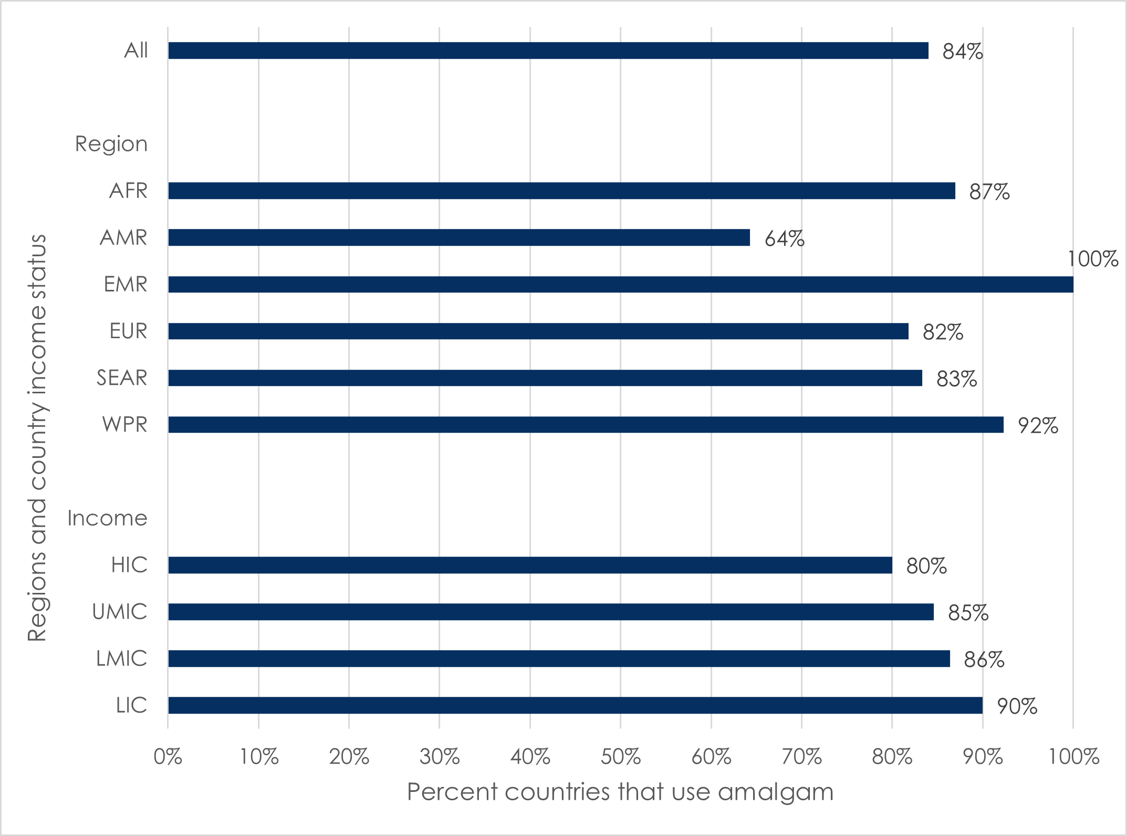
Key: AFR=African region; AMR=region of the Americas; EMR=Eastern Mediterranean region; EUR=European region; HIC=high-income countries; LIC=low-income countries; LMIC=lower-middle-income countries; SEAR=South-East Asia region; UMIC=upper-middle-income countries; WPR=Western Pacific region.

3.2.1 Proportion of all dental restorative materials used that is dental amalgam
In Question 9, participants were asked, “According to the information available / you have access to, what percentage does dental amalgam represent of all dental restorative materials used in clinical restorative care per year in your country? i.e. use of dental amalgam / total use of dental restorative materials.” Table 3 and Figure 2 summarize these responses. In 25% (20/80) of countries, the proportion of all dental restorative materials used that is dental amalgam was estimated to be higher in the public sector than in the private sector, while the opposite was reported in 1% (1/80) of countries.
Table 3. Proportion of all dental restorative materials used that is dental amalgam, by private and public sector
Percent of all dental restorative materials used that is dental amalgam | COUNTRY SECTOR
 | Public / government  No. (%) | Private  No. (%) | Both  No. (%)
up to 25% | 33 (41) | 39 (49) | 34 (43)
up to 50% | 9 (11) | 9 (11) | 9 (11)
up to 75% | 14 (18) | 1 (1) | 4 (5)
up to 100% | 2 (3) | 0 (0) | 1 (1)
Do not know | 22 (28) | 31 (39) | 32 (40)
Figure 2. Proportion of all dental restorative materials used that is dental amalgam, by private and public sector
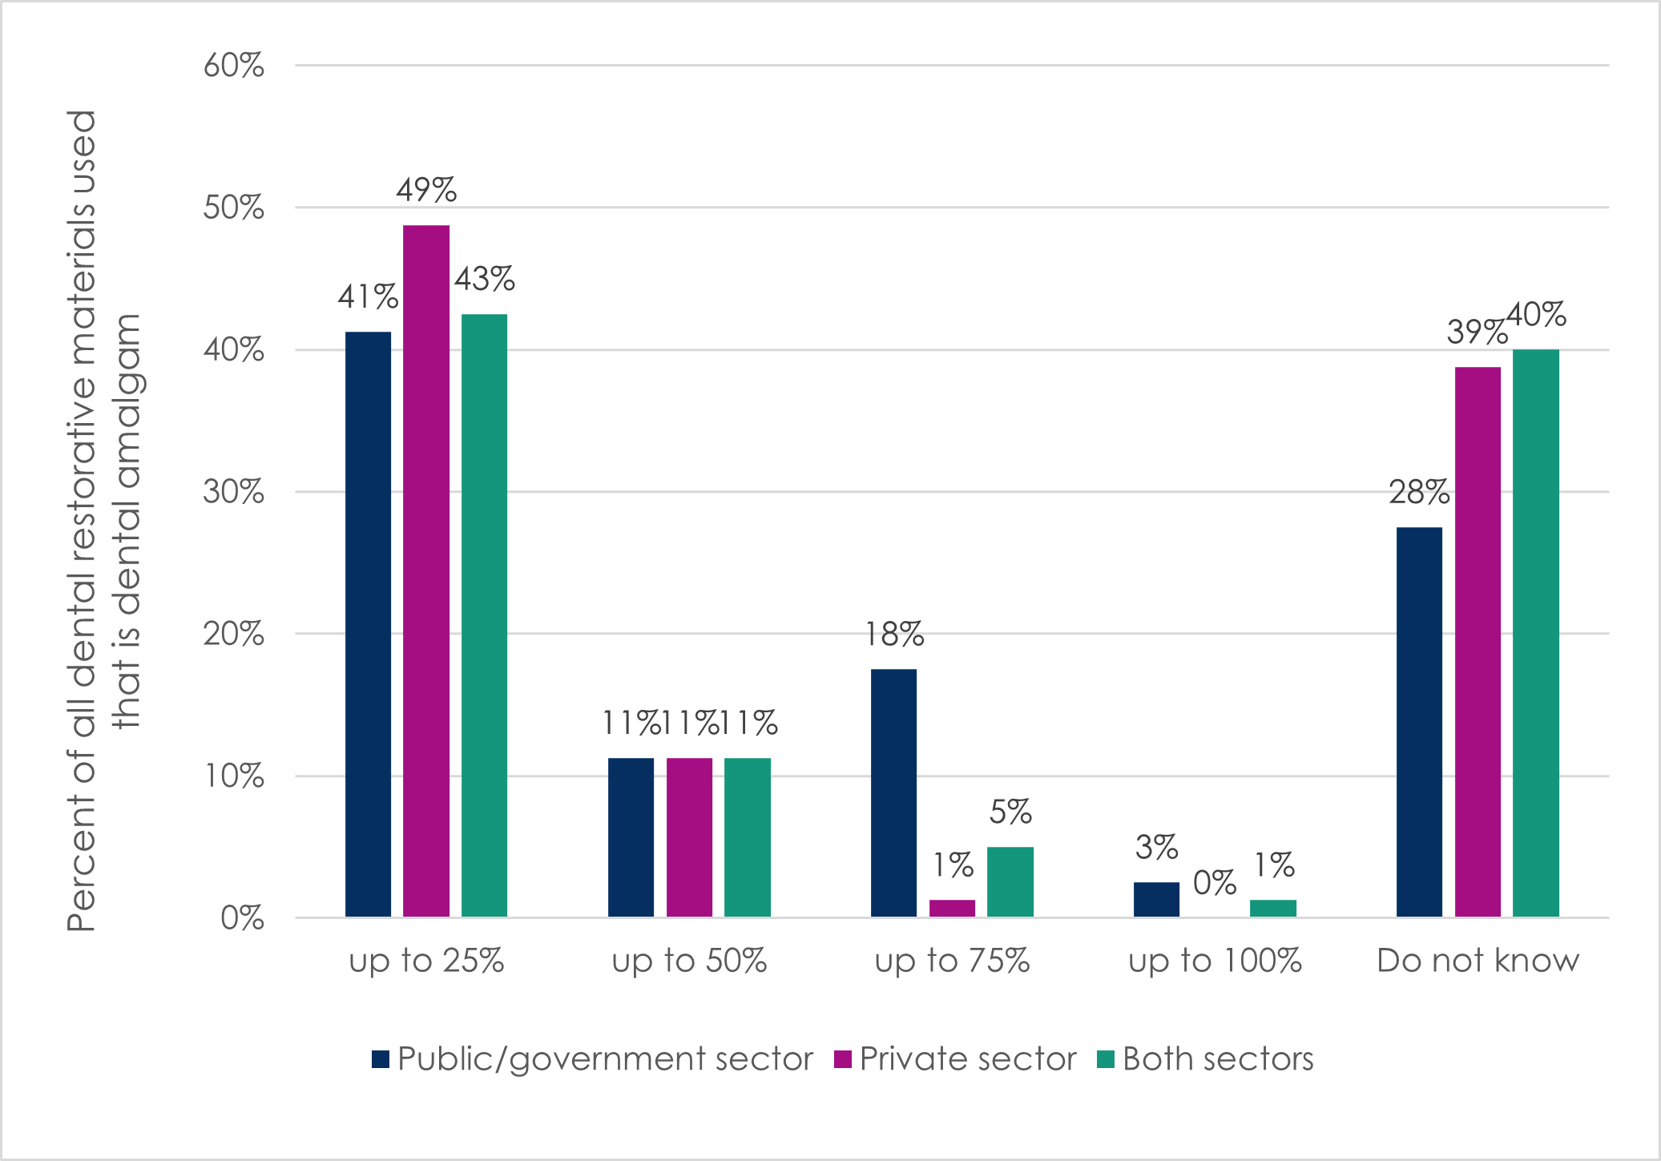
For the 16 countries for which dental amalgam was estimated to make up most of the dental restorative materials used in the public sector (i.e. for which participants selected “up to 75%” or “up to 100%”), Table 4 and Figure 3 show differences by region and country income status. Countries in the African region (39%, or 9/23) and Eastern Mediterranean region (33%, or 1/3) were disproportionately represented in this category, as were lower-middle-income countries (36%, or 8/22) and low-income countries (30%, or 3/10).
Table 4. Countries for which dental amalgam makes up most of the dental restorative materials used in the public sector, by region and country income status
Countries represented  in the consultation | Dental amalgam makes up most* of the dental restorative materials used in the public sector  No. (%)
All countries (N=80) | 16 (20)
Countries by region
African (N=23) | 9 (39)
Americas (N=14) | 1 (7)
Eastern Mediterranean (N=3) | 1 (33)
European (N=22) | 2 (9)
South-East Asia (N=5) | 1 (20)
Western Pacific (N=13) | 2 (15)
Countries by income status
High income (N=35) | 3 (9)
Upper-middle income (N=13) | 2 (15)
Lower-middle income (N=22) | 8 (36)
Low income (N=10) | 3 (30)
* i.e. countries for which participants estimated “up to 75%” or “up to 100%”.
Figure 3. Countries for which dental amalgam makes up most of the dental restorative materials used in the public sector
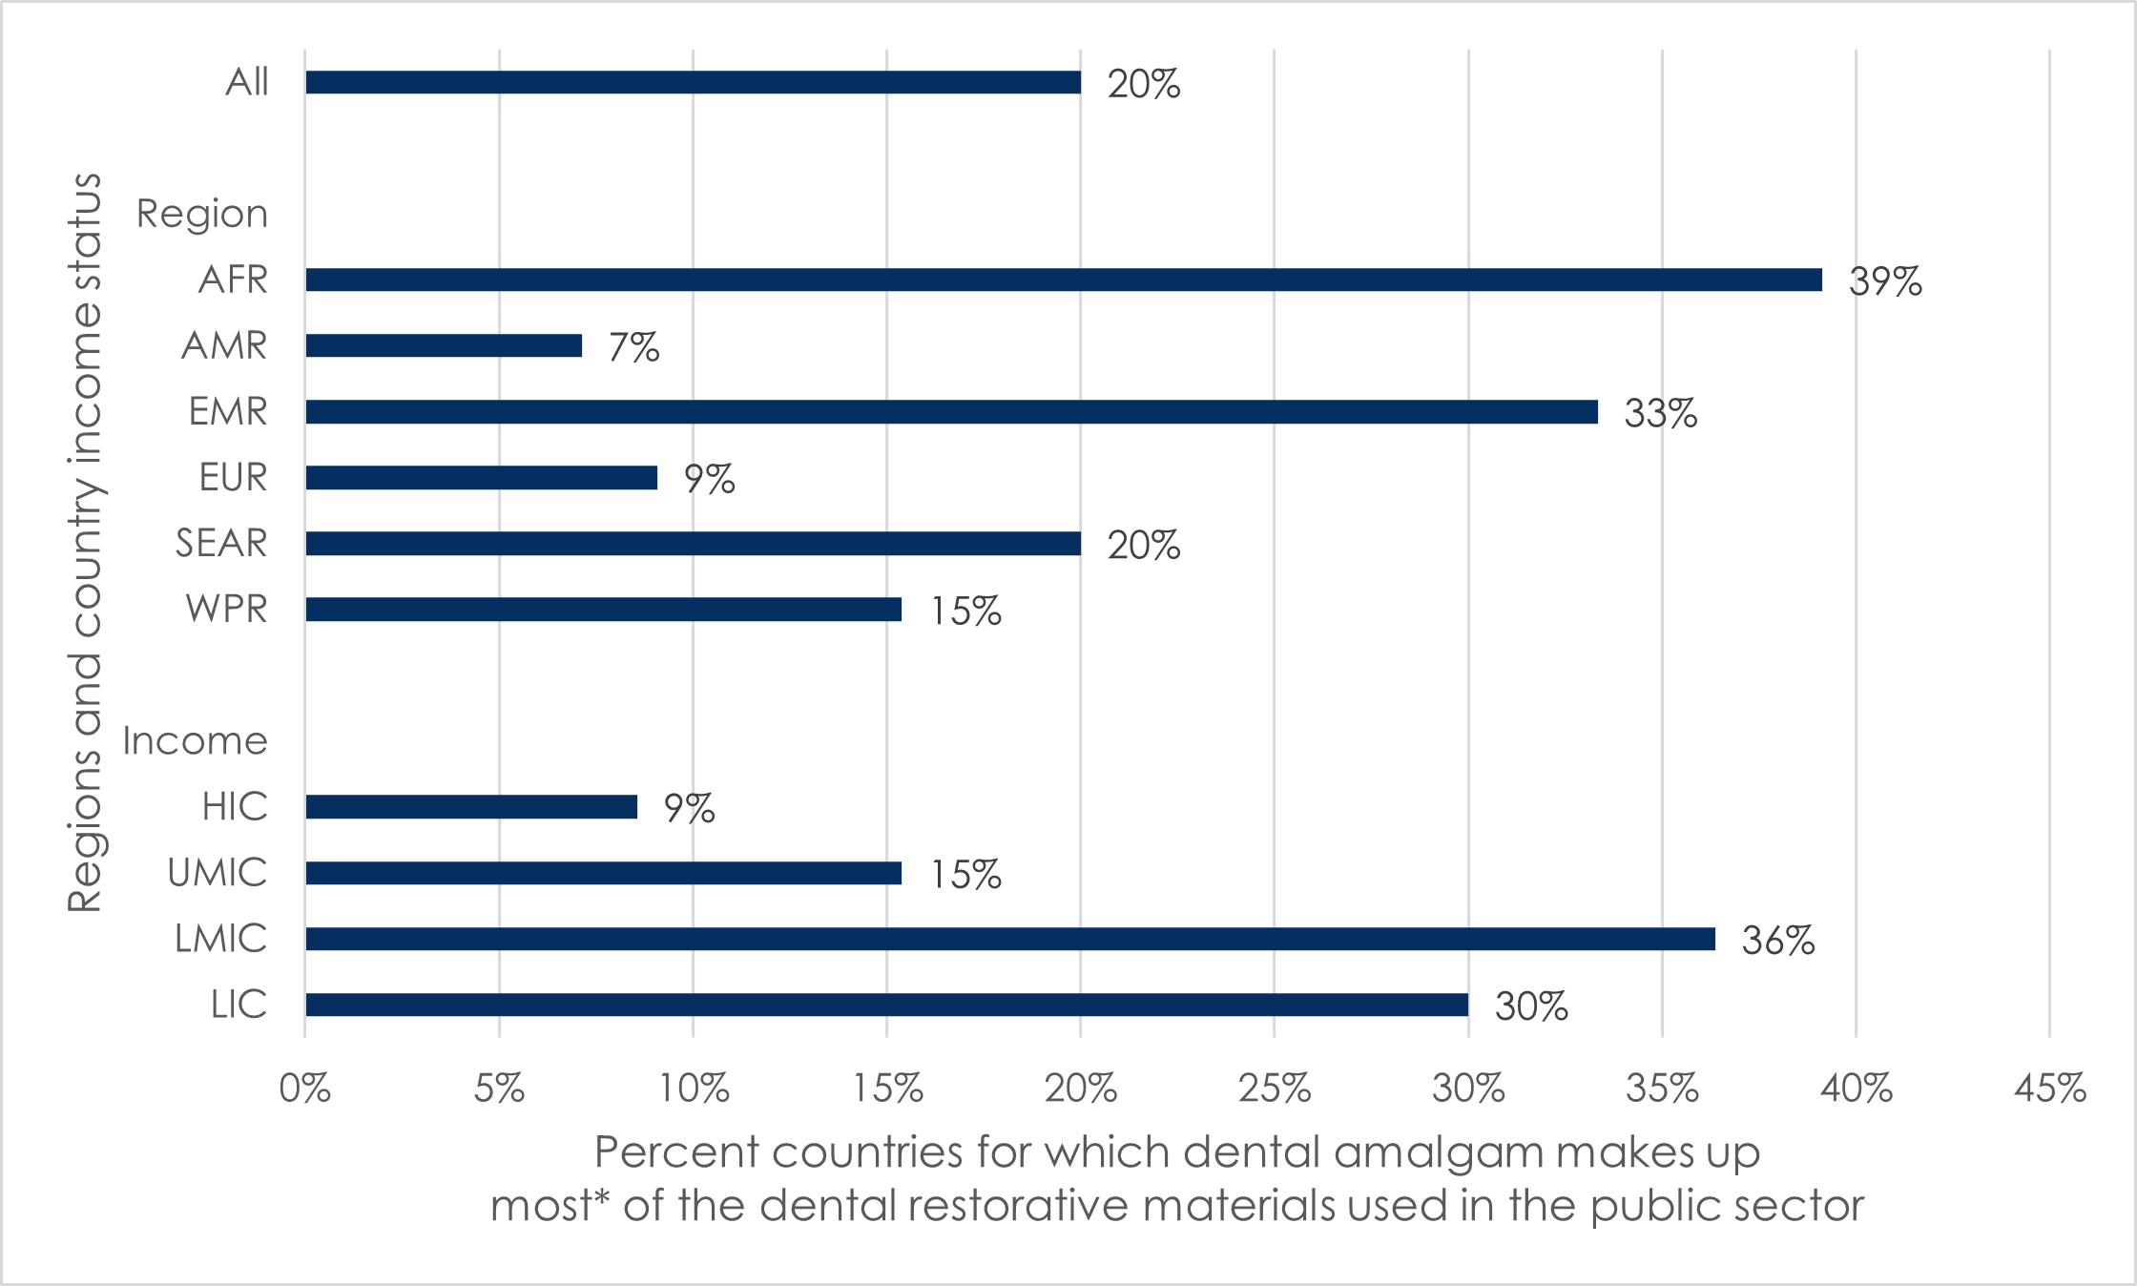
*i.e. countries for which participants estimated “up to 75%” or “up to 100%”.
Key: AFR=African region; AMR=region of the Americas; EMR=Eastern Mediterranean region; EUR=European region; HIC=high-income countries; LIC=low-income countries; LMIC=lower-middle-income countries; SEAR=South-East Asia region; UMIC=upper-middle-income countries; WPR=Western Pacific region.

3.2.2 Stage of phase-down in dental amalgam use
In Question 4, participants were asked “In your opinion, where would you place your country regarding phasing down the use of dental amalgam?”, based on the nine measures recommended in Annex A, Part II of the Minamata Convention (Box 1). Three-quarters (58/80, or 73%) of countries were in the process of phasing down use of dental amalgam. The remaining countries were evenly divided between those that had no plan to phase down use of dental amalgam, and those that had already completed it (11/80 or 14% for both). Of the eleven countries which did not have a plan to phase down use of dental amalgam, seven were Parties to the Convention, two were Signatories but not Parties, and two were neither Signatories nor Parties at the time of the consultation in March 2021. However, by September 2021, one of these Signatories had ratified the Convention
Country stage of phase-down was markedly different by region and country income status, as shown in Table 5 and Figure 4. One-third of countries in the African region (7/23, or 30%) and Eastern Mediterranean region (1/3, or 33%) had no plan to phase down use of dental amalgam, followed by 14% (2/14) in the Region of the Americas, and 8% (1/13) in the Western Pacific region. In contrast, one-fifth of countries in the European region (5/22, or 23%) and Region of the Americas (3/14, or 21%) have completely phased out use of dental amalgam, followed by 15% (1/13) of countries in the Western Pacific region and 4% (1/23) of countries in the African region.
Forty percent (4/10) of low-income countries and 23% (5/22) of lower-middle-income countries have no plans to phase down use of dental amalgam, while no upper-middle-income countries and only 6% (2/35) of high-income countries are in this category. Instead, one-fifth (7/35, or 20%) of high-income countries have already phased out use of dental amalgam, compared to 5-15% for the other income categories.
Table 5. Stage of phase-down in use of dental amalgam, by region and country income status
Countries represented  in the consultation | No plan to phase down  No. (%) | In process of phase down  No. (%) | Completed phase-out  No. (%)
All countries (N=80) | 11 (14) | 58 (73) | 11 (14)
Countries by region
African (N=23) | 7 (30) | 15 (65) | 1 (4)
Americas (N=14) | 2 (14) | 9 (64) | 3 (21)
Eastern Mediterranean (N=3) | 1 (33) | 2 (66) | 0 (0)
European (N=22) | 0 (0) | 17 (77) | 5 (23)
South-East Asia (N=5) | 0 (0) | 5 (100) | 0 (0)
Western Pacific (N=13) | 1 (8) | 10 (77) | 2 (15)
Countries by income status
High-income (N=35) | 2 (6) | 26 (74) | 7 (20)
Upper-middle-income (N=13) | 0 (0) | 11 (85) | 2 (15)
Lower-middle-income (N=22) | 5 (23) | 16 (73) | 1 (5)
Low-income (N=10) | 4 (40) | 5 (50) | 1 (10)

Figure 4. Stage of phase-down in use of dental amalgam, by region and country income status
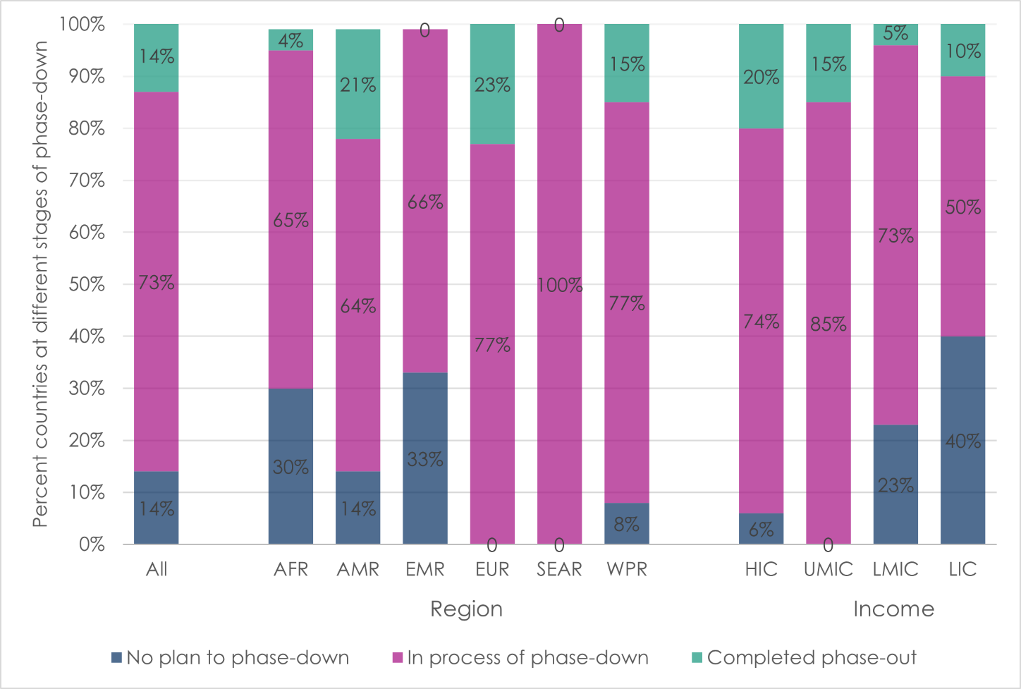
Key: AFR=African region; AMR=region of the Americas; EMR=Eastern Mediterranean region; EUR=European region; HIC=high-income countries; LIC=low-income countries; LMIC=lower-middle-income countries; SEAR=South-East Asia region; UMIC=upper-middle-income countries; WPR=Western Pacific region.

3.2.3 Additional measures to phase down use of dental amalgam
In Question 5, participants were asked, “Are there any additional measures / phasing down the use of dental amalgam initiatives currently being implemented or already implemented in your country?” If they responded affirmatively (i.e. that there were additional measures beyond the nine listed in the Minamata Convention, Annex A, Part II (Box 1)), then in Question 6 they were then asked to write in the additional measures. One-third (28/80, or 35%) of countries were reported to be implementing additional measures, while one-half (41/80, or 51%) were not doing so, and participants did not know for the remaining 14% (11/80) of countries. Box 2 provides some examples. Although the question asked about measures beyond the nine listed by the Minamata Convention, some participants wrote-in Minamata Convention measures.

Box 2. Examples of additional measures to phase down the use of dental amalgam
Governance:
Stakeholder engagement.
Phasing out plan formulated.
Disease prevention:
Strengthened specific promotion, prevention, and protection actions to reduce dental caries so that dental amalgam or other types of materials are not required.
Limits on use of dental amalgam:
Dental amalgam is now only allowed to be used when other restorative materials are not indicated, and then only the encapsulated form of dental amalgam is allowed.
The use of dental amalgam was banned for younger age groups, pregnant women and specific population subgroups, such as people with neurological problems.
A national law was introduced prohibiting the export and use of products containing mercury.
Incentives to use alternatives to amalgam:
The social insurance scheme no longer covers dental amalgam treatment.
In developing the national list of dental products and materials, dental amalgam was replaced with other mercury-free alternative materials, such as composites.
Mercury-free alternative materials, such as composites, can now be reimbursed by insurance scheme (previously it required an additional out-of-pocket payment).
Dental amalgam waste management:
A national guideline specific to dental amalgam waste management was introduced.
Applying for mandatory waste discharge certification.
Obligatory use of dental amalgam separators in all dental facilities.
Recalling dental amalgam materials stored in public facilities and practices.

3.2.4 Challenges and barriers to phasing down the use of dental amalgam
In Question 7, participants were asked, “Are there any specific challenges and/or barriers to phase down in the use of dental amalgam in your country?”. In Question 8, they were specifically asked to write in challenges and/or barriers to phase down in their countries for different stakeholders. Reported challenges to phase down in use of dental amalgam included:
Reported challenges and barriers to phase down in use of dental amalgam included:
- For patients: insufficient knowledge and awareness; greater affordability or accessibility of dental amalgam relative to mercury-free alternatives; and better coverage of it under insurance plans.
- For oral healthcare providers: preference for dental amalgam due to its perceived ease of handling, durability, familiarity, and emphasis within dental training. Familiarity was reported to be a particular challenge for older providers who did not want to change their established practices.
- For policymakers: lack of a national plan for phase-down; its low priority within national health policies; insufficient inter-ministerial coordination and initiatives; inadequate funding; long processes to develop statutory instruments and approvals; strong lobbying by dental associations and the dental industry against phase-down; and dental amalgam’s continued inclusion within licensing and certification requirements for dentists.
- For public dental services: insufficient funding within national budgets, and inadequate advocacy for and promotion and availability of mercury-free alternative restorative materials.
- For private dental services: weak monitoring systems to ensure regulations are followed; a belief that dental amalgam is safe, cheap, and has unmatched longevity; and difficulty in convincing patients to use relatively costly mercury-free alternatives.
- For other stakeholders (e.g. national dental associations, environmental non-governmental organizations): phase-down of use of dental amalgam being of lower priority than other mercury phase-down projects and programs; lack of power to enact related policies and regulations; and dental associations prioritizing evidence of safety and durability of dental amalgam over environmental concerns, and/or being influenced by the manufacturing industry that produces and distributes dental amalgam.

3.2.5 Opinion on phase-out timeline
Although phase-out in use of dental amalgam is not required by the Convention, Question 32 asked participants, “In your opinion, by which year would ‘phase-out the use of dental amalgam’ be achievable in your country?”, with the answer options being “already phased out”, “by 2025” (short-term), “by 2030” (mid-term), or “after 2030” (long-term). Table 6 and Figure 5 detail the responses by region and country income category. Two-thirds of countries in the European region were either had already phased out use of dental amalgam (5/22, or 23%) or were expected to phase it out by 2025 (9/22, or 41%). This was also reported for two-thirds of countries in the Region of the Americas, i.e. 29% (4/14) for both “already phased out” and “phased out by 2025”. Almost half of high-income countries (17/35, or 48%) and upper-middle-income countries (6/13, or 46%) reported this. The majority of countries in the remaining regions (67%-80%) and country income levels (63%-80%) reported dental amalgam use would be phase-out by 2030 or later. Some countries were reported to be experiencing delays in phasing down use of dental amalgam because of the COVID-19 pandemic.
Table 6. Opinion of when dental amalgam use will be phased out in participant’s country, by region and country income status
Countries represented  in the consultation | Already phased out  No. (%) | Phased out by 2025  No. (%) | Phased out by 2030  No. (%) | Phased out after 2030  No. (%) | Do not know  No. (%)
All countries (N=80) | 10 (13) | 22 (28) | 27 (34) | 19 (24) | 2 (3)
Countries by region
African (N=23) | 0 (0) | 5 (22) | 9 (39) | 8 (35) | 1 (4)
Americas (N=14) | 4 (29) | 4 (29) | 4 (29) | 1 (7) | 1 (7)
Eastern Mediterranean (N=3) | 0 (0) | 1 (33) | 1 (33) | 1 (33) | 0 (0)
European (N=22) | 5 (23) | 9 (41) | 4 (18) | 4 (18) | 0 (0)
South-East Asia (N=5) | 0 (0) | 1 (20) | 3 (60) | 1 (20) | 0 (0)
Western Pacific (N=13) | 1 (8) | 2 (15) | 6 (46) | 4 (31) | 0 (0)
Countries by income status
High income (N=35) | 6 (17) | 11 (31) | 9 (26) | 8 (23) | 1 (3)
Upper-middle income (N=13) | 3 (23) | 3 (23) | 4 (31) | 3 (23) | 0 (0)
Lower-middle income (N=22) | 1 (5) | 6 (27) | 8 (36) | 6 (27) | 1 (5)
Low income (N=10) | 0 (0) | 2 (20) | 6 (60) | 2 (20) | 0 (0)
Figure 5. Opinion of when dental amalgam use will be phased out in participant’s country, by region and country income status
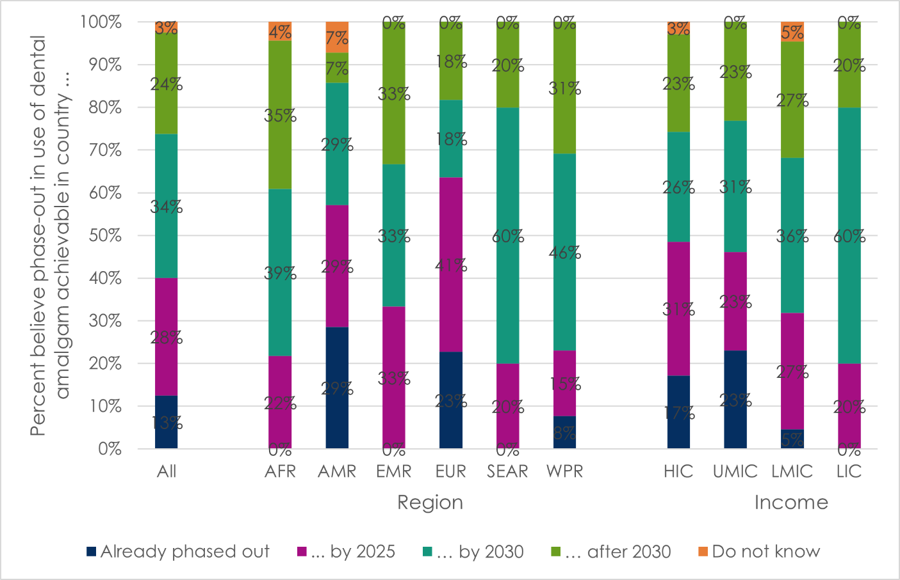
Key: AFR=African region; AMR=region of the Americas; EMR=Eastern Mediterranean region; EUR=European region; HIC=high-income countries; LIC=low-income countries; LMIC=lower-middle-income countries; SEAR=South-East Asia region; UMIC=upper-middle-income countries; WPR=Western Pacific region.

Reporting whether a country had completely phased out use of dental amalgam was somewhat inconsistent. There were three times in the questionnaire when a country might have been reported to have completely phased out use of dental amalgam: Question 3 (“Is dental amalgam used in your country?” – Table 2), Question 4 (“In your opinion, where would you place your country regarding phasing down the use of dental amalgam?” – Table 5), and Question 32 (“In your opinion, by which year would ‘phase-out the use of dental amalgam’ be achievable in your country?” – Table 6). For Questions 3, 4, and 32, twelve, eleven, and ten countries were reported to have completely phased out use of dental amalgam, respectively. In total, only five countries (Japan, Norway, the Russian Federation, Saint Kitts and Nevis, and Sweden) were consistently reported to have phased out use of dental amalgam in response to all three questions. Another twelve countries were reported to have completely phased out use of dental amalgam once or twice in response to the three questions.
Participants were invited to write in additional comments regarding the current readiness of their country to phase down the use of dental amalgam in their countries. A selection of responses is shown in Box 3.

Box 3. Examples of participant comments on their country’s current readiness to phase down use of dental amalgam
Promising signs of progress:
“All it will take is for the government to have the political will to pass the right laws to phase out the use of dental amalgam. We have started a consultation group amongst the clinicians and intend to ask the Ministry [of Health] to look into the required changes.”
“There’s been a change in our dental facilities since a few years ago in line with the Minamata Convention.”
“There continues to be a movement away from dental amalgam use in our country. Discussions with private practitioners indicate increased requests for ‘tooth-coloured’ restorations from patients. This, along with training of dentists more focused on alternatives to dental amalgams, provides good movement in the direction of reduction of dental amalgam use. National policies and guidelines would improve this movement.”
“We are currently phasing down the use of dental amalgam in our clinics by reducing orders of encapsulated amalgam and increasing the number of tooth-coloured materials, such as composite resin. Also, we are using fluoride mouth rinses in all primary schools weekly and tooth-brushing to reduce dental caries, hence reducing the need for amalgam restorations. There’s already discussion on ways to completely phase out the use of dental amalgam use in our dental clinics.”
Governance, regulation and coordination challenges:
“There is no current readiness for phase down in use of dental amalgam.”
“We have to make the private sector more aware of the dangers of dental amalgam restorations. In the public health section of the Ministry of Health we do not purchase mercury (amalgam) fillings.”
“There is a need to implement surveillance of the importation of mercury destined for dental amalgam as there is a possibility of diversion to artisanal mining.”
Funding and resource challenges:
“High cost of the mercury-free alternatives to dental amalgam is one of the reasons for continually acquiring dental amalgam.”
‘’More than government, one private organization is working on phasing out the use of dental amalgam. They have been holding meetings, making pamphlets, and lobbying the government. Government does not seem very dedicated to phase out the use of dental amalgam. Due to the high cost of substitutes for dental amalgam restorative material in the public sector, it will be difficult to phase out the use of dental amalgam, so phase-down would be better.’’
“There are general nationwide activities to reduce mercury emissions throughout the country (for example the United Nations Environment Programme country initiatives), and various ‘educational’ initiatives for oral health care professionals and at dental training institutions. However, these are usually ad hoc, and there have not been any comprehensive, uniform national guidelines for the phasing out of the use of dental amalgam.”
“It would be helpful if the state would subsidize mercury-free alternatives to dental amalgam, owing to the high cost of those materials and equipment.”

3.3. Insurance and regulatory information

3.3.1 Insurance that covers restorative care using dental amalgam or mercury-free alternatives
Question 11 asked participants, “According to the information available / you have access to, are there any insurance policies and programmes that cover the cost of restorative care using dental amalgam or mercury-free alternatives to dental amalgam in your country?” Table 7 shows the number and percent of countries that have some insurance policies and programmes that cover the cost of restorative care using dental amalgam or mercury-free alternatives to dental amalgam, by region and country income status. In total, two-thirds of countries (54/80, or 68%) had some insurance policies and programmes that covered costs either partially or completely, compared to 24% (19/80) that do not and 9% (7/80) for which participants did not know.
Countries in the region of the Americas (12/14, or 86%) and the European region (18/22, or 82%) were most frequently reported to have dental insurance coverage of dental amalgam or alternatives. In contrast, only half of countries in the Western Pacific region (6/13, or 46%) and one-third of countries in both the African (8/23, or 35%) and Eastern Mediterranean (1/3, or 33%) regions were reported to have insurance policies or programmes. Insurance policies and programmes were reported for 80% (28/35) of high-income countries, compared to only 30% (3/10) of low-income countries.
Table 7. Insurance policies and programmes that cover costs of dental amalgam or alternatives, by region and country income status
Countries represented  in the consultation | No policy or programme  No. (%) | Some policy / programme  No. (%) | Do not know  No. (%)
All countries (N=80) | 19 (24) | 54 (68) | 7 (9)
Countries by region
African (N=23) | 8 (35) | 14 (61) | 1 (4)
Americas (N=14) | 0 (0) | 12 (86) | 2 (14)
Eastern Mediterranean (N=3) | 1 (33) | 2 (67) | 0 (0)
European (N=22) | 3 (14) | 18 (82) | 1 (5)
South-East Asia (N=5) | 1 (20) | 3 (60) | 1 (20)
Western Pacific (N=13) | 6 (46) | 5 (38) | 2 (15)
Countries by income status
High-income (N=35) | 3 (9) | 28 (80) | 4 (11)
Upper-middle-income (N=13) | 3 (23) | 8 (62) | 2 (15)
Lower-middle-income (N=22) | 6 (27) | 15 (68) | 1 (5)
Low-income (N=10) | 7 (70) | 3 (30) | 0 (0)
Question 12 asked participants the proportion of restorative care cost that public and private insurance policies reimburse to patients in their country, for both dental amalgam and mercury-free alternatives. Table 8 and Figure 6 show that the percent reimbursement was quite similar for the four categories (i.e. public sector – dental amalgam; public sector – mercury-free alternative; private sector – dental amalgam; and private sector – mercury-free alternative). For each category, approximately half (43%-51%) of countries did not have policies or programmes allowing patient reimbursement, while approximately one-quarter (21%-26%) allowed up to 100% reimbursement. Overall, policies more frequently allowed patient reimbursement for cost of restorative care in the private sector (46%-48%) than in the public sector (40%-41%). Within these categories, there were only slight differences in reimbursement for dental amalgam and mercury-free alternatives.
Table 8. Insurance policy allowance of patient reimbursement for restorative care using dental amalgam and mercury-free alternatives, in public and private sectors
Percent reimbursement of cost | COUNTRY HAS POLICIES ALLOWING REIMBURSEMENT
Percent reimbursement of cost | Through public insurance |  | Through private insurance
Percent reimbursement of cost | For dental amalgam  No. (%) | For mercury-free alternative  No. (%) | For dental amalgam  No. (%) | For mercury-free alternative  No. (%)
None | 41 (51) | 40 (50) | 36 (45) | 34 (43)
up to 25% | 5 (6) | 5 (6) | 7 (9) | 5 (6)
up to 50% | 0 (0) | 3 (4) | 1 (1) | 4 (5)
up to 75% | 6 (8) | 8 (10) | 9 (11) | 9 (11)
up to 100% | 21 (26) | 17 (21) | 20 (25) | 21 (26)
Do not know | 7 (9) | 7 (9) | 7 (9) | 7 (9)

Figure 6. Insurance policy allowance of patient reimbursement for restorative care using dental amalgam and mercury-free alternatives, in public and private sectors
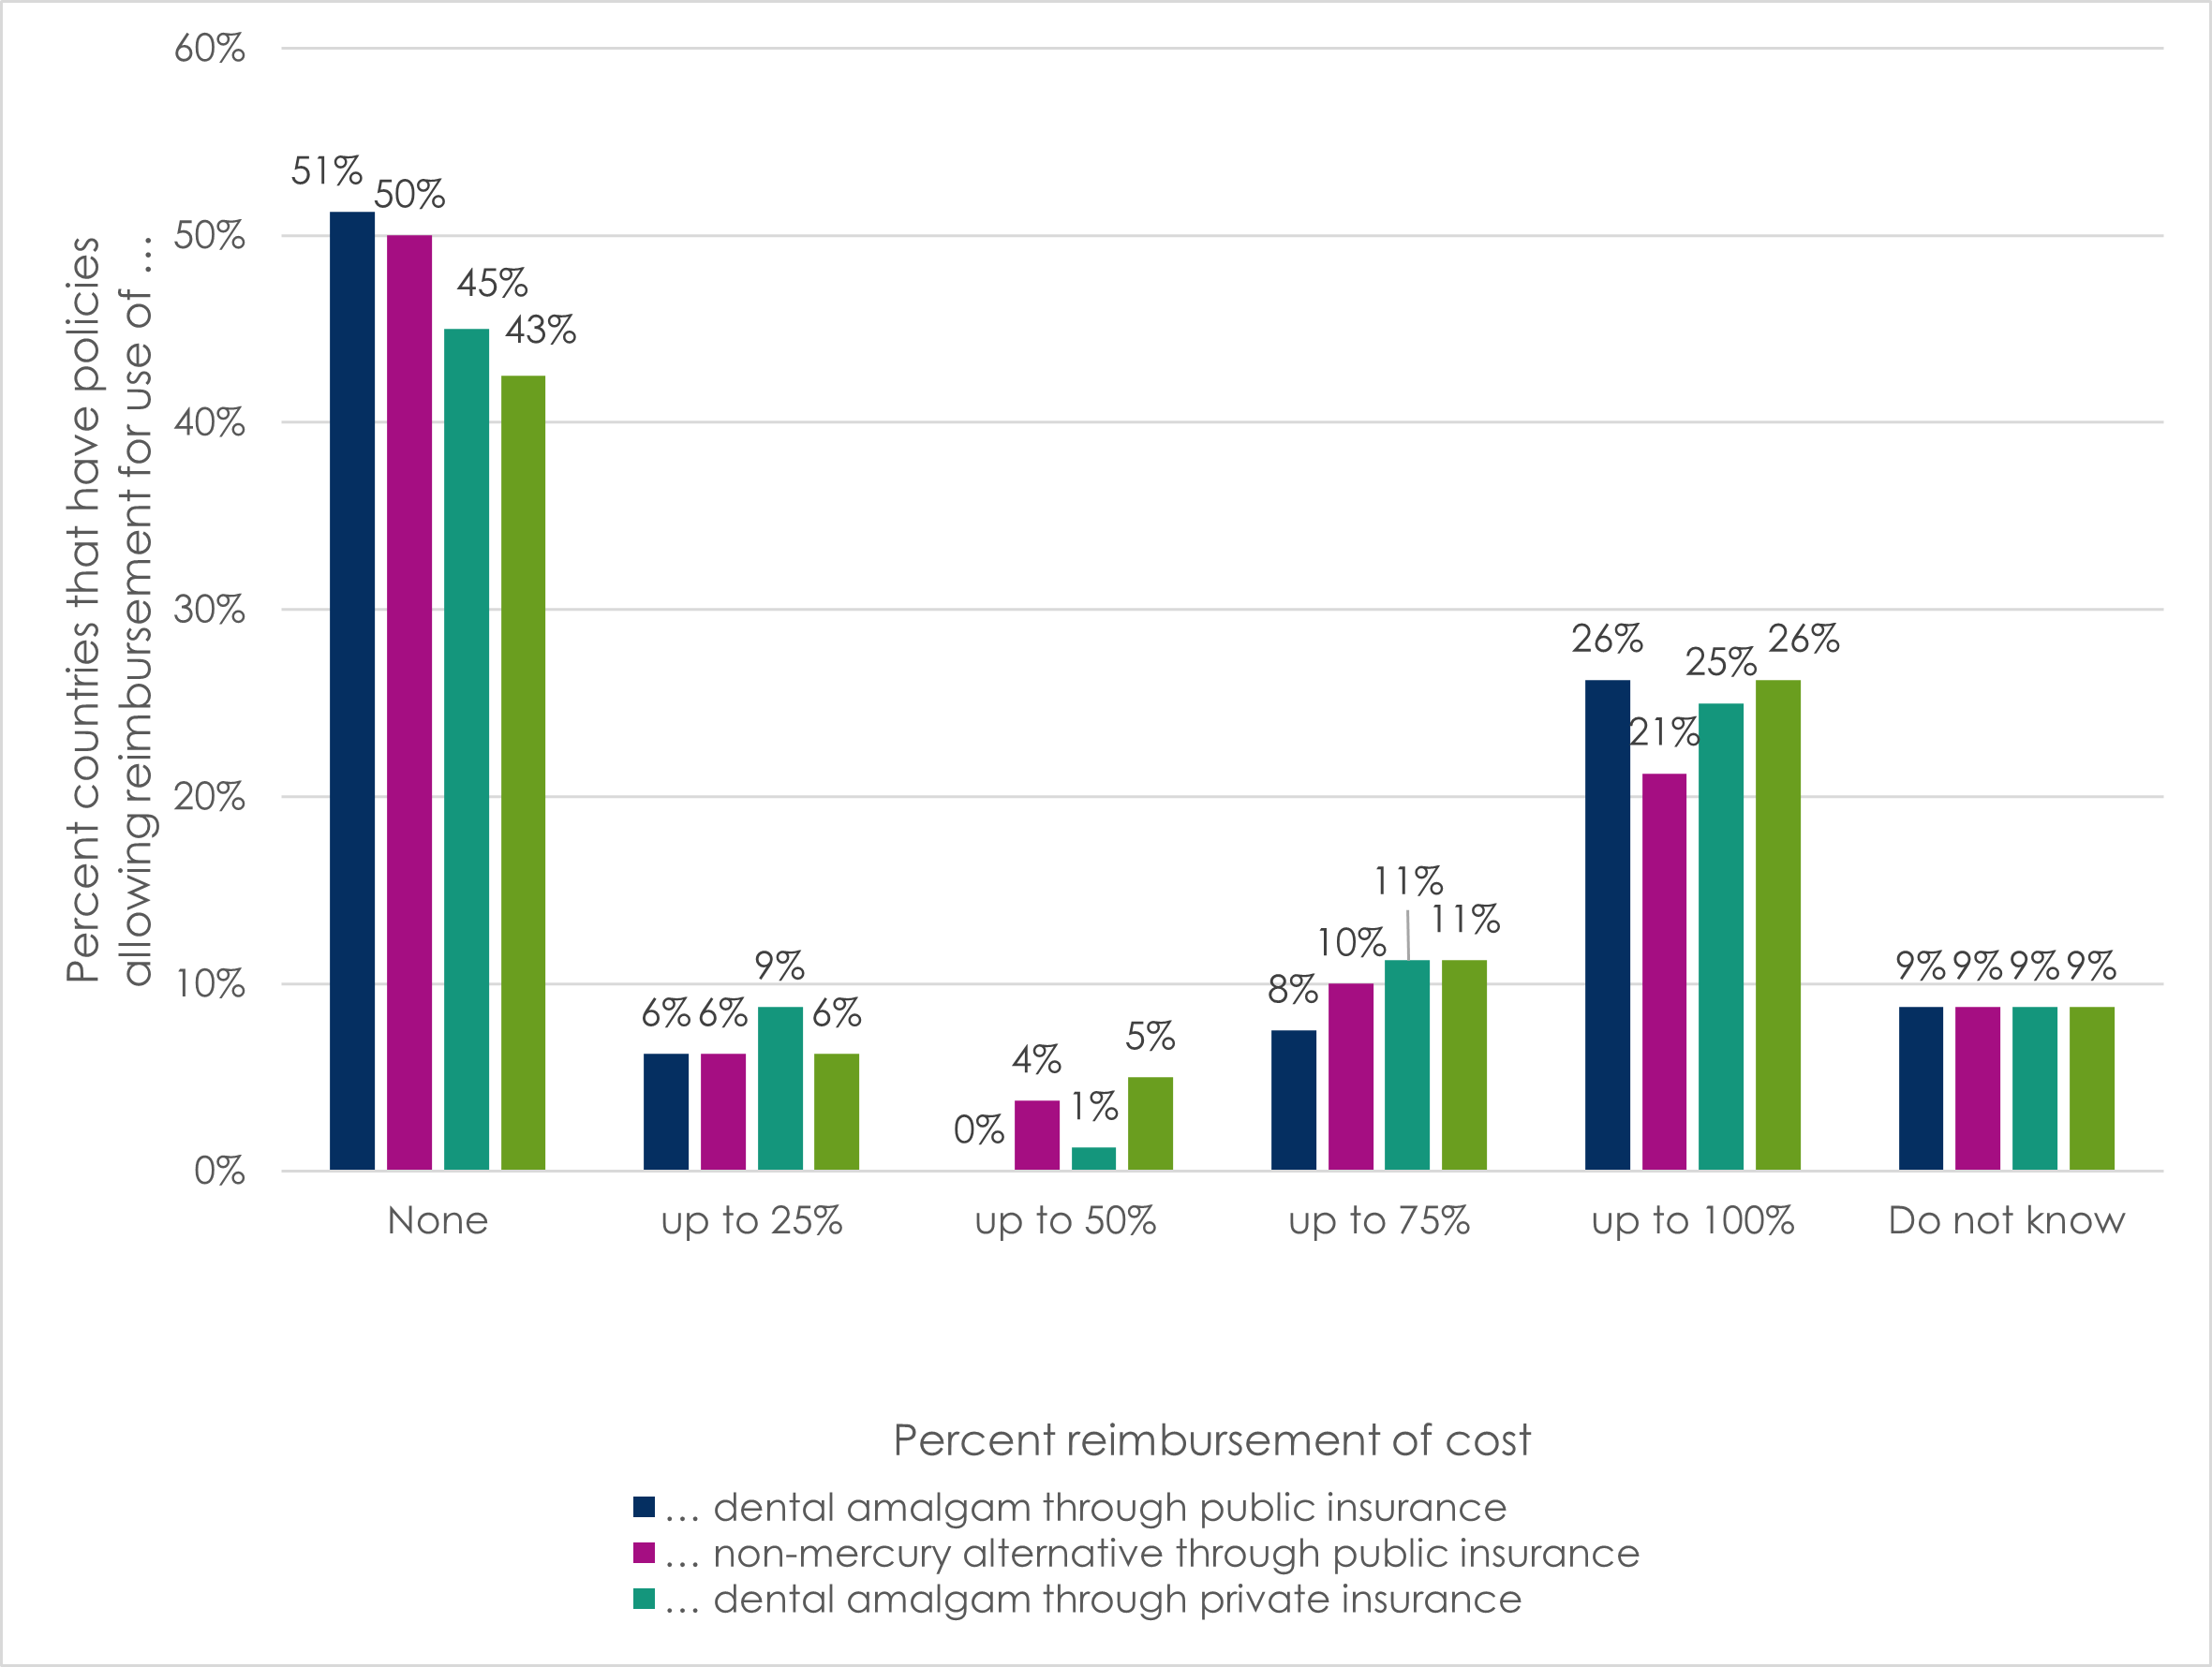
Question 13 asked, “According to the information available / you have access to, are there any initiatives to encourage national insurance policies and programmes that favour the use of mercury-free alternatives to dental amalgam in your country?” One-quarter (21/80, or 26%) of countries were reported to have such initiatives, including greater reimbursement for the use of mercury-free alternatives than for the use of dental amalgam, and public insurance policies that only reimburse the use of mercury-free alternatives and not also amalgam.

3.3.2 Regulations restricting elemental/bulk mercury for dental care, encapsulated dental amalgam, and dental amalgam supply chains
One of the nine measures recommended for parties of the Minamata Convention on Mercury is to restrict the use of dental amalgam to its encapsulated form (Box 1). Consultation participants were asked, “According to the information available / you have access to, are there any regulations: to restrict the use of elemental/bulk mercury for dental care (Question 14); to restrict dental amalgam to its encapsulated form (Question 15); or with regards to dental amalgam supply chain management in your country (Question 16) in your country?” An example of regulation of dental amalgam chains was provided, i.e. restrictions on the procurement and distribution of imported dental amalgam to avoid its diversion into other sectors, such as artisanal and small-scale gold mining sector or for other uses.
Most countries did not have regulations restricting elemental/bulk mercury for dental care (44/80, or 55%), restricting dental amalgam to its encapsulated form(47/80, or 59%), or restricting the dental amalgam supply chain management (48/80, or 60%). In at least one-third of countries, regulations exist to restrict the use of elemental/bulk mercury for dental care (27/80, or 34%) or to restrict dental amalgam in its encapsulated form (28/80 or 35%). Fewer countries (14/80 or 18%) were reported to have regulations related to dental amalgam supply chain management. For the remaining countries, participants did not know how to answer questions about these regulations. In some countries, participants reported that discussions had started about such regulations, but none had come into effect yet.
Table 9 and Figure 7 detail country regulations by region and country income status. Countries in the European Union were the most likely to have regulations restricting elementary mercury for dental care (13/22, or 59%) or restricting dental amalgam to its encapsulated form (14/22, or 64%), while countries in South-East Asia were the most likely to have regulations related to the dental amalgam supply chain management (2/5, or 40%). High-income countries had the highest frequency of regulation in all categories (43%, 51%, and 20%, respectively).
Table 9. Regulations restricting elemental/bulk mercury for dental care, restricting dental amalgam to its encapsulated form, and restricting the dental amalgam supply chain, by region and country income status
Countries represented  in the consultation | REGULATIONS RESTRICTING ...
Countries represented  in the consultation | … elemental/bulk mercury for dental care | … dental amalgam to its encapsulated form | … the dental amalgam supply chain
All countries (N=80) | 27 (34) | 28 (35) | 14 (18)
Countries by region
African (N=23) | 4 (17) | 5 (22) | 2 (9)
Americas (N=14) | 5 (36) | 6 (43) | 2 (14)
Eastern Mediterranean (N=3) | 1 (33) | 0 (0) | 1 (33)
European (N=22) | 13 (59) | 14 (64) | 6 (27)
South-East Asia (N=5) | 2 (40) | 1 (20) | 2 (40)
Western Pacific (N=13) | 2 (15) | 2 (15) | 1 (8)
Countries by income status
High-income (N=35) | 15 (43) | 18 (51) | 7 (20)
Upper-middle-income (N=13) | 5 (38) | 3 (23) | 2 (15)
Lower-middle-income (N=22) | 6 (27) | 4 (18) | 4 (18)
Low-income (N=10) | 1 (10) | 3 (30) | 1 (10)

Figure 7. Regulations restricting elemental/bulk mercury for dental care, restricting dental amalgam to its encapsulated form, and restricting the dental amalgam supply chain, by region and country income status
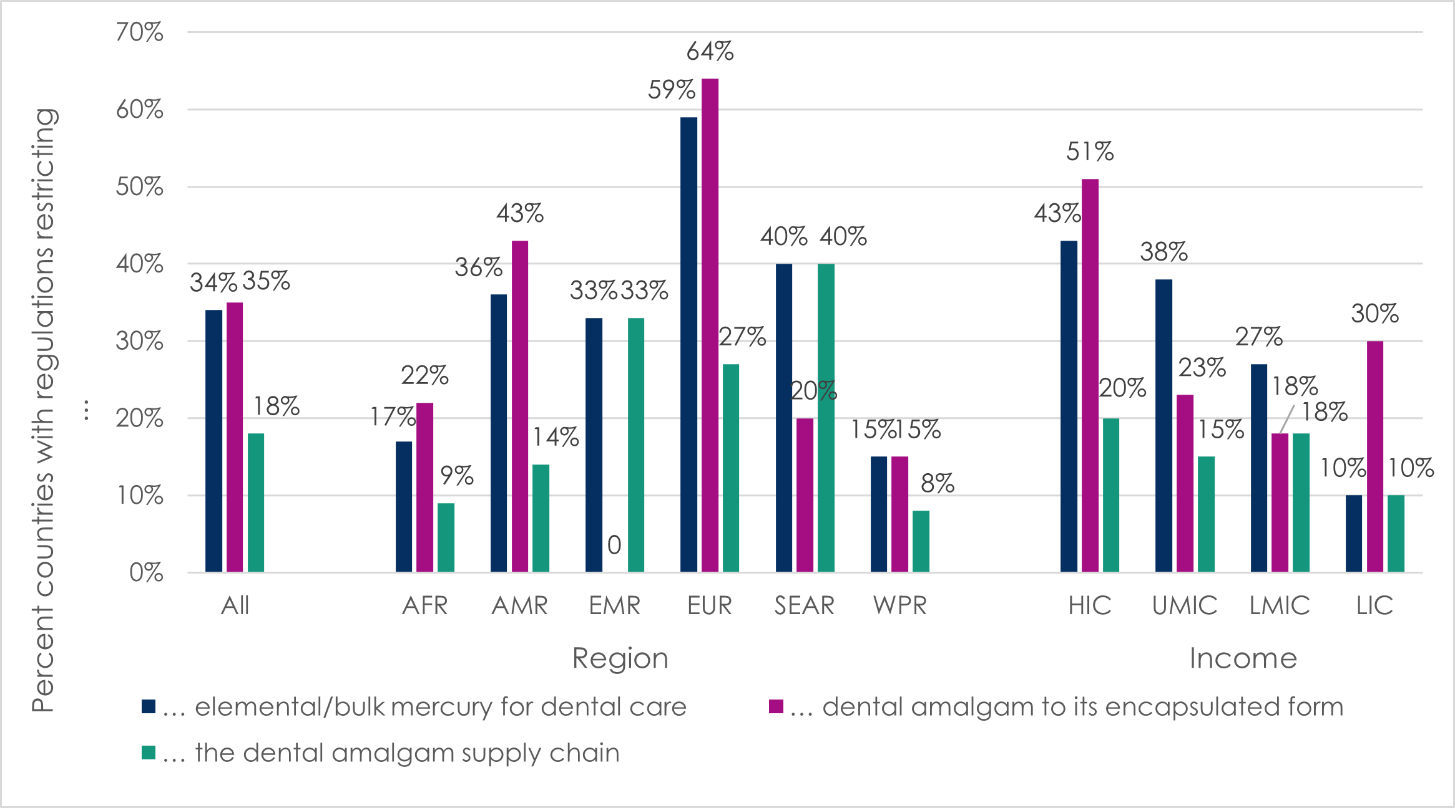
Key: AFR=African region; AMR=region of the Americas; EMR=Eastern Mediterranean region; EUR=European region; HIC=high-income countries; LIC=low-income countries; LMIC=lower-middle-income countries; SEAR=South-East Asia region; UMIC=upper-middle-income countries; WPR=Western Pacific region.

3.3.3 Regulation of dental amalgam waste and disposal
Question 17 asked participants, “According to the information available / you have access to, are there any regulations for dental amalgam waste and disposal in an environmentally sound manner in your country? For example, a requirement for dental offices to install dental amalgam separators or other measures to control the collection, storage, transport and final disposal or stabilisation of dental amalgam waste to ensure that it does not reach the environment”.
Over half of countries were reported to have regulations for disposal of dental amalgam waste from private facilities (44/80, or 55%), public facilities (42/80, or 53%), and dental schools (45/80, or 56%) in an environmentally sound manner. However, these regulations varied greatly by region and country income level, as shown in Table 10 and Figure 8. Almost all of the countries in the European region (20/22, or 91%) were reported to have such regulations, but only 17% to 26% (4-6 of 23 countries) were reported to have them in the African region.
Regulation of dental amalgam waste and disposal was also very common in high-income countries (71%-77%, or 25-27 of 35 countries) and upper-middle-income countries (77%-85%, or 10-11 of 13 countries). In contrast, such regulations were relatively infrequent in lower-middle-income (23%-32%, or 5-7 of 22 countries) and especially infrequent in low-income countries (0-10%, or 0-1 of 10 countries).

Table 10. Regulation of dental amalgam waste and disposal in public dental facilities, private dental facilities, and dental schools, by region and country income status
Countries represented  in the consultation | REGULATIONS FOR AMALGAM WASTE AND DISPOSAL:
Countries represented  in the consultation | In private dental facilities  No. (%) | In public dental facilities  No. (%) | In dental schools  No. (%)
All countries (N=80) | 44 (55) | 42 (53) | 45 (56)
Countries by region
African (N=23) | 4 (17) | 5 (22) | 6 (26)
Americas (N=14) | 9 (64) | 7 (50) | 7 (50)
Eastern Mediterranean (N=3) | 1 (33) | 1 (33) | 2 (67)
European (N=22) | 20 (91) | 20 (91) | 20 (91)
South-East Asia (N=5) | 2 (40) | 2 (40) | 2 (40)
Western Pacific (N=13) | 8 (62) | 7 (54) | 8 (62)
Countries by income status
High-income (N=35) | 27 (77) | 25 (71) | 26 (74)
Upper-middle-income (N=13) | 10 (77) | 11 (85) | 11 (85)
Lower-middle-income (N=22) | 7 (32) | 5 (23) | 7 (32)
Low-income (N=10) | 0 (0) | 1 (10) | 1 (10)
Figure 8. Regulation of dental amalgam waste and disposal in public dental facilities, private dental facilities, and dental schools, by region and country income status
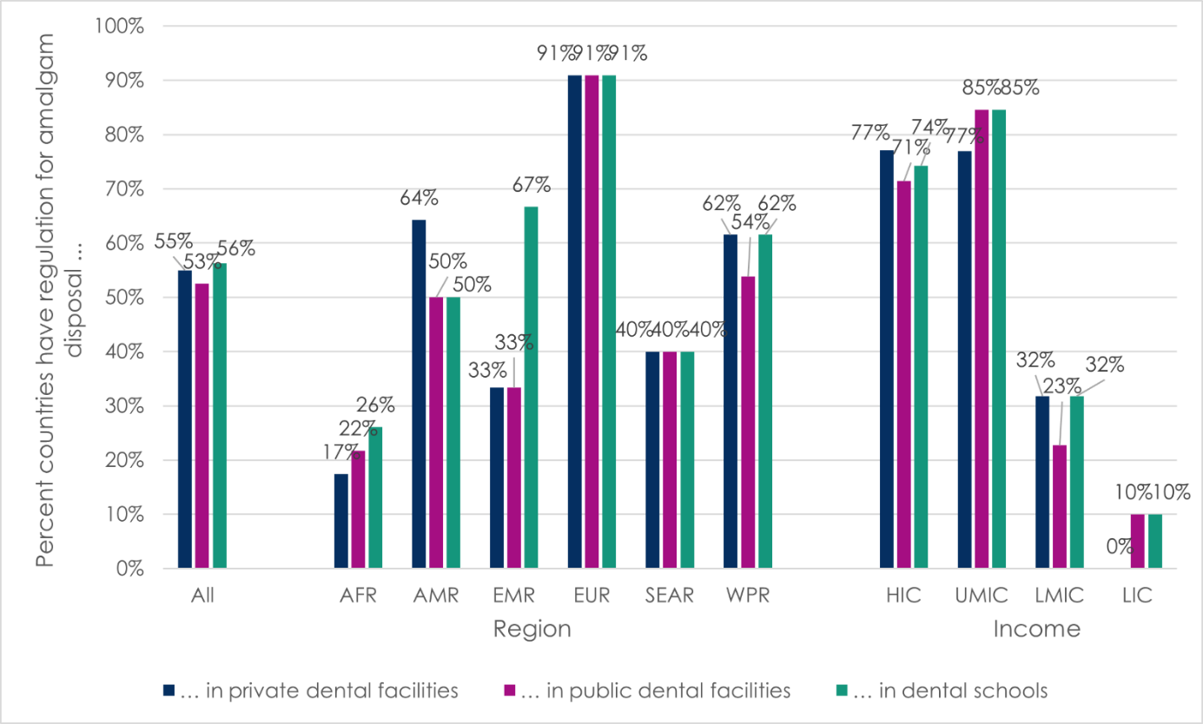
Key: AFR=African region; AMR=region of the Americas; EMR=Eastern Mediterranean region; EUR=European region; HIC=high-income countries; LIC=low-income countries; LMIC=lower-middle-income countries; SEAR=South-East Asia region; UMIC=upper-middle-income countries; WPR=Western Pacific region.
In write-in responses, participants provided examples of regulation of dental amalgam waste and disposal in their countries, including: educating dental practitioners to promote dental amalgam waste handling and collection by an authorized waste management establishment; mandatory installation of dental amalgam separators; dental amalgam waste collection in specific containers; strict control of storage, transportation and final disposal of dental amalgam waste under the supervision of health boards; stabilization of dental amalgam waste to ensure that it does not reach the environment; and undertaking and use of centralized systems to bin, seal, and dispose of dental amalgam waste.

3.4. Dental education and training
In Questions 18 and 20, participants were asked whether dental school curricula for restorative dental care in their countries include teaching and training on: (a) dental amalgam and/or (b) mercury-free alternatives. Participants who replied affirmatively to (a) and/or (b) were further asked (a) “Are dental students trained on best environmental practice for handling, use, of dental amalgam and management and disposal dental amalgam waste in an environmentally sound manner?” (Question 19), and/or (b) “Are dental students trained on environmental and health risks and benefits of the mercury-free alternatives to dental amalgam?” (Question 21).
Table 11 and Figure 9 show the number and percent of countries reported to have curricula for restorative dental care teaching and training on dental amalgam and mercury-free alternatives, by region and country income status. Two-thirds (55/80, or 69%) of countries were reported to have dental schools that teach about dental amalgam in restorative care. Of these, 78% (43/55) also teach about best environmental practice for handling, use, management and disposal of dental amalgam, whereas for 9% (7/80) of countries, participants said they did not know, and for 6% (5/80) of countries, participants reported that dental students were not taught about best environmental practice. These latter five countries were low-income (n=3), lower-middle-income (n=1), and upper-middle-income (n=1); three were in the African region, one in the European Region, and one in the South-East Asia Region.
Most of the countries that have stopped using dental amalgam (9/12, or 75%) do not train students in how to use it. The region with the most frequent reports of teaching and training about dental amalgam was South-East Asia (4/5, or 80%), while this was least frequently reported in the region of the Americas (7/14, or 50%). By country income level, teaching about dental amalgam was most frequently reported in upper- and lower- middle income countries (10/13 and 17/22, or 77%, respectively).
Participants reported that dental schools teach about mercury-free alternatives to dental amalgam in restorative care in 76% (61/80) of countries. Of these, 72% (44/61) also teach about environmental and health risks and benefits of the mercury-free alternatives in dental schools. Participants did not know for 15% (12/80) of countries, and for 6% (5/80) participants reported that dental students were not taught about these risks and benefits. These latter five countries were lower-middle-income (n=2), and high-income (n=3); two were in the African region, two in the European Region, and one in the Western Pacific Region.
All (22/22) European region countries were reported to teach about alternatives to dental amalgam in dental schools; the least frequent reporting of this was in South-East Asia (2/5, or 40%). Differences by country income status followed a clear gradient, from 89% (31/35) of high-income countries reporting this to 50% (5/10) of low-income countries.

Table 11. Dental education and training related to amalgam and alternatives, by region and country income status
Countries represented  in the consultation | DENTAL SCHOOL CURRICULA INCLUDES TEACHING ON:
Countries represented  in the consultation | Dental amalgam  No. (%) | Mercury-free alternatives to dental amalgam  No. (%)
All countries (N=80) | 55 (69) | 61 (76)
Countries by region
African (N=23) | 17 (74) | 16 (70)
Americas (N=14) | 7 (50) | 8 (57)
Eastern Mediterranean (N=3) | 2 (67) | 2 (67)
European (N=22) | 15 (68) | 22 (100)
South-East Asia (N=5) | 4 (80) | 2 (40)
Western Pacific (N=13) | 10 (77) | 11 (85)
Countries by income status
High-income (N=35) | 22 (63) | 31 (89)
Upper-middle-income (N=13) | 10 (77) | 11 (85)
Lower-middle-income (N=22) | 17 (77) | 14 (64)
Low-income (N=10) | 6 (60) | 5 (50)
Figure 9. Dental education and training related to amalgam and alternatives, by region and country income status
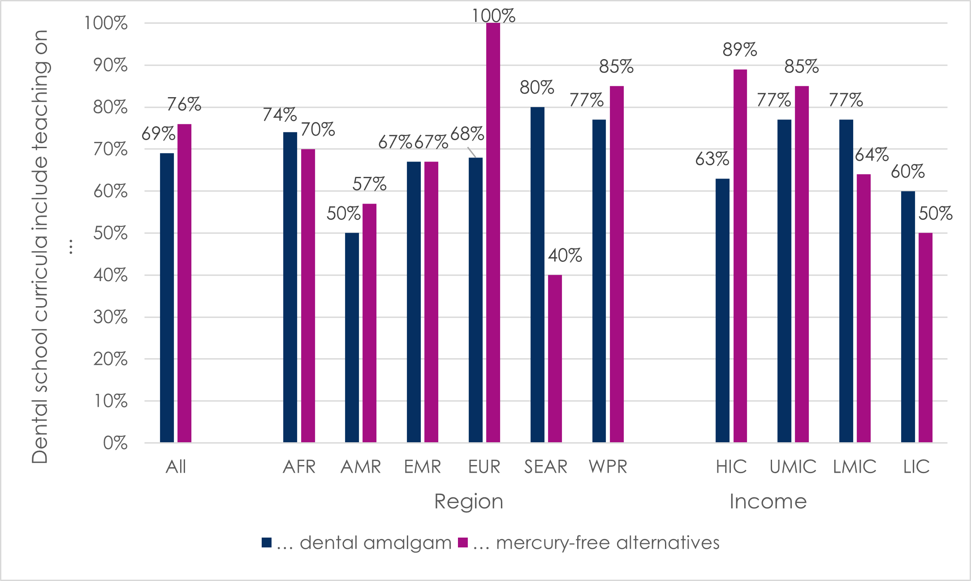
Key: AFR=African region; AMR=region of the Americas; EMR=Eastern Mediterranean region; EUR=European region; HIC=high-income countries; LIC=low-income countries; LMIC=lower-middle-income countries; SEAR=South-East Asia region; UMIC=upper-middle-income countries; WPR=Western Pacific region.
Some respondents explained more about the situation of dental training in their countries, including:
- Dental training schools may theoretically explain amalgam to students, so they understand the history of filling materials, but they do not practically train them to use amalgams for filling and restoration.
- Dental schools may phase down the use of dental amalgam by progressively reducing emphasis on dental amalgam while increasing emphasis on restorations with mercury-free alternatives.
- Teaching and training about dental amalgam remains fundamental to restorative care curricula in countries where dental amalgam use remains very common.

3.5. Mercury / hazardous waste management
Question 22 asked participants “Are dental amalgam separators installed at dental facilities in your country?” One-third (29/80, or 36%) of countries were reported to have dental amalgam separators installed in all dental facilities, while 19% (15/80) were reported to have them installed in some public and/or private facilities. However, 36% (29/80) of countries were reported to have no separators installed in facilities, and participants reported they did not know for the remaining countries (9%, or 7/80).
Table 12 and Figure 10 detail the findings for the installation of separators in dental facilities. Responses varied greatly by region and country-income status. All but three of 22 countries in the European either had separators in all facilities (18/22, or 82%) or in some facilities (1/22, or 5%). This was only reported for one-third to two-thirds of countries in other regions. One-half of countries in the region of the Americas (8/14, or 57%) and the African region (11/23, or 48%) reported that no dental facilities in their country had installed dental amalgam separators.
Differences by country income status followed a clear gradient. Two-thirds (22/35, or 63%) of high-income countries reported that all dental facilities had separators, compared to 31% (4/13) of upper-middle-income countries, 14% (3/22) of lower-middle-income countries, and no low-income countries. Half of lower-middle-income and low-income countries reported that none of their dental facilities had dental amalgam separators (12/22 or 55%, and 5/10 or 50%, respectively).
Table 12. Installation of dental amalgam separators in dental facilities, by region and country income status
Countries represented  in the consultation | DENTAL AMALGAM SEPARATORS INSTALLED:
Countries represented  in the consultation | In all dental facilities  No. (%) | In some dental facilities  No. (%) | In no dental facilities  No. (%) | Do not know  No. (%)
All countries (N=80) | 29 (36) | 15 (19) | 29 (36) | 7 (9)
Countries by region
African (N=23) | 4 (17) | 5 (22) | 11 (48) | 3 (13)
Americas (N=14) | 4 (29) | 0 (0) | 8 (57) | 2 (14)
Eastern Mediterranean (N=3) | 0 (0) | 2 (67) | 1 (33) | 0 (0)
European (N=22) | 17 (77) | 1 (5) | 2 (9) | 2 (9)
South-East Asia (N=5) | 0 (0) | 3 (60) | 2 (40) | 0 (0)
Western Pacific (N=13) | 4 (31) | 4 (31) | 5 (38) | 0 (0)
Countries by income status
High-income (N=35) | 22 (63) | 3 (9) | 8 (23) | 2 (6)
Upper-middle-income (N=13) | 4 (31) | 3 (23) | 4 (31) | 2 (15)
Lower-middle-income (N=22) | 3 (14) | 7 (32) | 11 (50) | 1 (5)
Low-income (N=10) | 0 (0) | 2 (20) | 6 (60) | 2 (20)
Figure 10. Installation of dental amalgam separators in dental facilities, by region and country income status
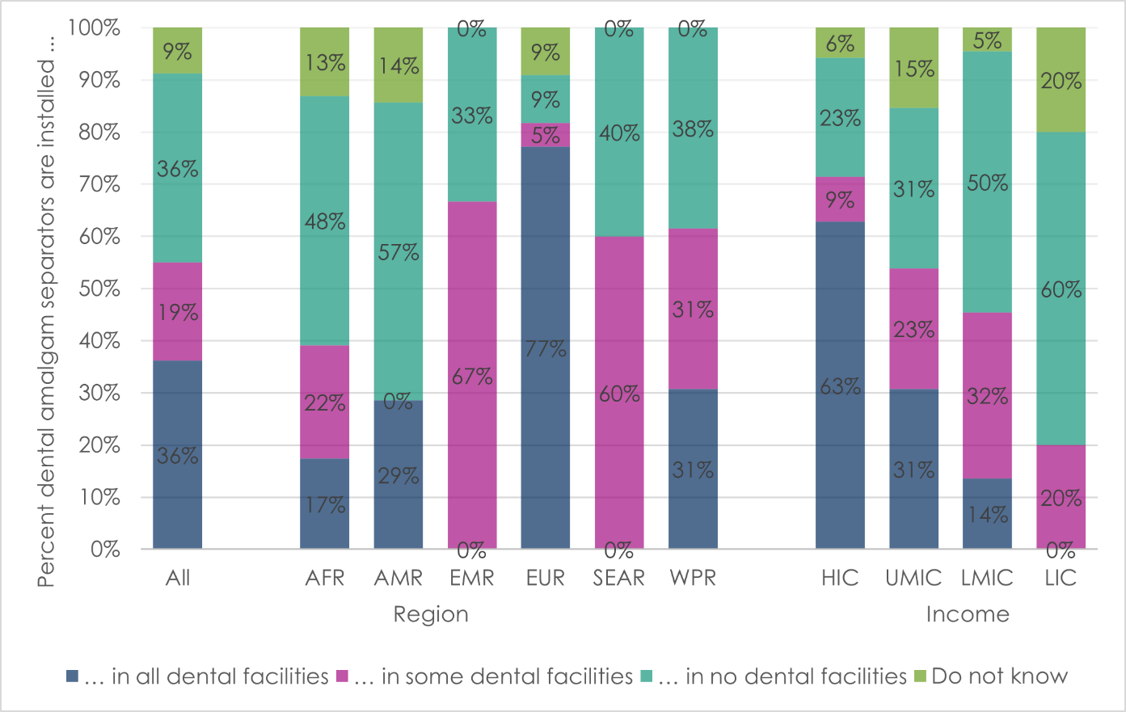
Key: AFR=African region; AMR=region of the Americas; EMR=Eastern Mediterranean region; EUR=European region; HIC=high-income countries; LIC=low-income countries; LMIC=lower-middle-income countries; SEAR=South-East Asia region; UMIC=upper-middle-income countries; WPR=Western Pacific region.
For both dental services and crematoria, Question 23 asked, “Do you know about the best environmental practices established in your country to reduce and monitor emissions and releases of dental amalgam waste into air, land, soil, and water?” Participants were also provided with a few examples, i.e. the proper handling and disposal of dental amalgam waste; installing dental amalgam separators and conducting periodic inspections of dental practices; and having mercury removal techniques in crematoria for individuals with dental amalgam restorations.
Table 13 and Figure 11 show responses to this question by region and country income status. Almost half (35/80, or 44%) of countries were reported to have the best environmental practices established in dental services, while they were not established in 30% (36/80) of countries, and participants did not know for 25% (20/80) of countries. In contrast, only one-fifth (14/80, or 18%) of countries were reported to have the best environmental practices established in crematoria, while they were not established in 29% (23/80) of countries, and participants did not know for 54% (43/80) of countries.

Table 13. Best environmental practices established to reduce and monitor emissions and releases of dental amalgam waste, by region and country income status
Countries represented  in the consultation | BEST ENVIRONMENTAL PRACTICES ESTABLISHED:
Countries represented  in the consultation | In dental services  No. (%) | In crematoria  No. (%)
All countries (N=80) | 35 (44) | 14 (18)
Countries by region
African (N=23) | 6 (26) | 2 (9)
Americas (N=14) | 6 (43) | 2 (14)
Eastern Mediterranean (N=3) | 2 (67) | 0 (0)
European (N=22) | 6 (27) | 8 (36)
South-East Asia (N=5) | 1 (20) | 0 (0)
Western Pacific (N=13) | 5 (38) | 2 (15)
Countries by income status
High income (N=35) | 22 (63) | 11 (31)
Upper-middle income (N=13) | 8 (62) | 1 (8)
Lower-middle income (N=22) | 4 (18) | 1 (5)
Low income (N=10) | 2 (20) | 1 (10)

Figure 11. Best environmental practices to reduce and monitor emissions and releases of dental amalgam waste, by region and country income status
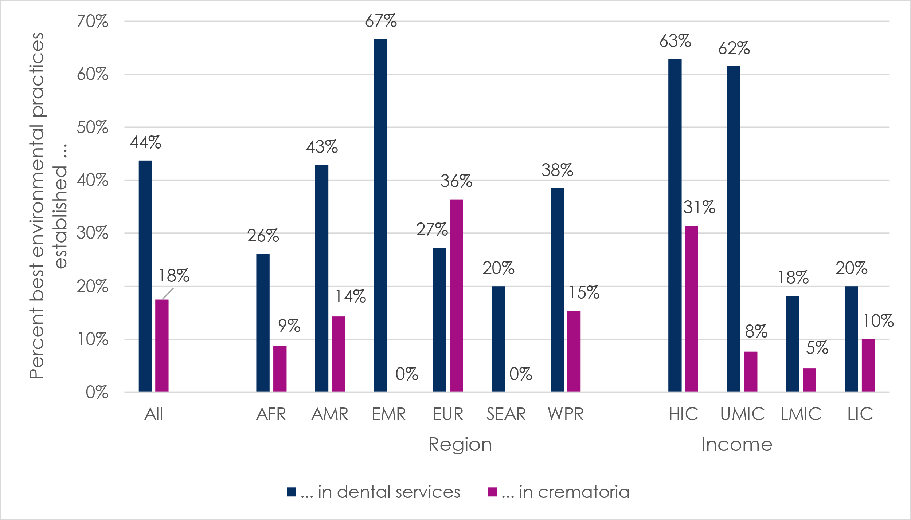
Key: AFR=African region; AMR=region of the Americas; EMR=Eastern Mediterranean region; EUR=European region; HIC=high-income countries; LIC=low-income countries; LMIC=lower-middle-income countries; SEAR=South-East Asia region; UMIC=upper-middle-income countries; WPR=Western Pacific region.
When asked to write-in examples of best environmental practices in dental services in their country, responses included promotion of safe handling and disposal of dental amalgam waste; use of dental amalgam capsules and separators; control of dental amalgam management by a dental regulatory authority; annual inspection of dental services by a national environmental body; and relevant laws and regulations related to environmental protection and medical waste disposal. In one case, national health and welfare authorities, regional administrative authorities monitored dental service compliance, while the environmental ministry was responsible for disposal of mercury-related dental materials in landfills. However, another participant noted, “There is no policy in our country governing the proper handling of dental amalgam waste and its safe disposal. There may be general policies on hazardous waste handling which may apply”.
When asked to write-in examples of best environmental practices in crematoria in their country, participant responses included: crematoria comply with agreed emission restrictions; and crematoria have been fitted with filtering systems so as not to exceed a certain quantity of pollutants (including from dental amalgam). One respondent reported that such practices are not mandatory nationally, but local authorities can request installation of mercury filters to reduce the concentration in emissions.

3.6. Knowledge sharing and information exchange
Questions 24-31 asked participants about different kinds of knowledge sharing and information exchange related to phasing down use of dental amalgam in their countries, as shown in Table 14. About one half (37/80, or 46%) of countries were reported to have collaboration between the Ministry of Environment and Ministry of Health to evaluate the progress on Minamata Convention on Mercury, and one-quarter (22/80 or 28%) of countries were reported to have a technical report, guidance or guideline on the selection and use of mercury-free alternatives to dental amalgam. The other types of case studies, reports, databases, indicators, and meetings were less frequently reported.
Table 14. Availability of knowledge sharing and information exchange about phase-down in use of dental amalgam
QUESTION AND NUMBER | RESPONSE
In your country, according to the information available / that you have access to, are there: | Yes | No | Do not know
Q24. Any published case studies (with lessons learnt) or research (including best practices) that demonstrate the feasibility of phasing-down the use of dental amalgam | 4 (5) | 47 (59) | 29 (36)
Q25. Any published case studies (with lessons learnt) or research including best practices that demonstrate the environmentally sound dental amalgam waste management | 5 (6) | 42 (53) | 33 (41)
Q26. A technical report, guidance or guideline on the selection and use of mercury-free alternatives to dental amalgam for dental restoration across the full spectrum of dental caries over the life course (i.e. for children, adults, elders or vulnerable groups) | 22 (28) | 43 (51) | 15 (19)
Q27. Any reports, decrees, factsheets, published case studies or research reports or any other documents from Governmental organizations or dental associations or any other private organizations regarding the environmental and health risks and benefits of mercury-free alternatives to dental amalgam | 15 (19) | 41 (51) | 24 (30)
Q28. Any database to collect, monitor and manage information on the measures taken to phase down in use of dental amalgam and the effectiveness of such measures in order to report to the Minamata Secretariat | 12 (15) | 46 (58) | 22 (28)
Q29. Any key performance indicators and /or monitoring and evaluation framework to measure the progress for phasing down the use of dental amalgam | 16 (20) | 47 (59) | 17 (21)
Q30. Any inter-ministerial collaboration between Ministry of Environment and Ministry of Health to evaluate the progress on Minamata Convention on Mercury | 37 (46) | 22 (28) | 21 (26)
Q31. Any upcoming national or regional meetings or conferences, in 2021 and 2022, that could serve as a venue to share and exchange information for phasing down the use of dental amalgam | 17 (21) | 31 (37) | 32 (40)

Box 4 provides examples of the materials participants reported in Table 14.

Box 4. Examples of national and subnational publications related to phasing down the use of dental amalgam
    - Ministry of Health guidelines promoting non-amalgam restorative material in young children, pregnant women and/or people with chronic diseases.
    - Ministry of Health guidelines on the clinical application of composite resin
    - Expert consensus publications on selecting filling materials
    - National dental authority recommendations for dental health professionals stressing the need for a significant reduction of the use of mercury-based amalgams in the treatment of dental caries.
    - Mention of the dental amalgams and the toxicity of mercury within several relevant government directives.
    - Issuance of a ministerial agreement that restricts the formulation, manufacture, commercialization, storage, usage and possession of mercury, with a plan for the gradual elimination of the use of mercury in the country, especially in mining.
    - A dental association factsheet regarding on the use of alternatives that focused on patient perspectives and environmental aspects of their use.
    - General public sector guidance for dentists using alternative materials for children.
    - A guide, technical factsheets and reports for healthcare professionals on the usage and health effects of mercury-free alternatives to dental amalgam for dental restoration.

4. Discussion
The 2021 informal global WHO consultation with policymakers in dental public health found that promising steps are being taken in all regions to implement the Minamata Convention on Mercury and to phase down the use of dental amalgam, but there also remain challenges. Both progress and challenges are discussed more below.

4.1. Comparison of findings from the 2019 and 2021 consultations with policymakers
The specific questions, survey populations and countries of the 2019 and 2021 consultations differed, so their results are not directly comparable and we cannot closely examine trends over time. At a broad level, however the results of the two consultations suggest that conditions have held steady and/or some progress has been made in line with the Minamata Convention.
In 2019, for example, 89% of participants reported that their countries still use dental amalgam, while this was only reported for 84% of countries in 2021. Similarly, in 2019, 15% (12/79) of respondents reported that their country did not have an action plan to implement the Minamata Convention, while in 2021 this was reported for 14% (11/80) of the countries represented in the consultation (Table 5). Further, in 2019, almost half (44%-46%) of the 79 participants reported they had been involved in discussions between the Ministry of Health and Ministry of Environment in their country related to the Convention, while in 2021, 46% (37/80) of countries were reported to have collaboration between the two ministries related to the Convention (Table 14).

4.2. Progress in ratification and implementation of the Minamata Convention on Mercury
At the time of the consultation in March 2021, there were 128 Signatories and 130 Parties to the Minamata Convention on Mercury, but six months later the number of Parties to the Convention had risen to 133.⁹ The 2021 consultation found other examples of progress towards phasing down the use of dental amalgam, including that one-half of countries have regulations for amalgam waste and disposal in dental facilities and dental schools, and/or best environmental practices established in dental services (Tables 10 and 13).
Consultation findings on dental education and training related to dental amalgam and mercury-free alternatives are not straightforward to interpret, because countries in the process of phasing out the use of dental amalgam may or may not continue to teach about it in dental schools. Also, some low- or lower-middle-income countries may not report teaching about dental amalgam or alternatives if they do not have dental schools. Nonetheless, it is broadly relevant that a higher percent of the countries represented in the consultation teach about mercury-free alternatives than about dental amalgam in dental schools (Table 11).

4.3. Challenges in implementation of the Minamata Convention on Mercury
For some aspects of implementation of the Minamata Convention, the 2021 consultation suggests that progress has only been made by a minority of countries. Only one-third of countries have regulations to restrict the use of elemental/bulk mercury for dental care or to restrict dental amalgam to its encapsulated form, and only one-fifth have regulations related to the dental amalgam supply chain (Table 9). Similarly, one-third of participating countries do not have dental amalgam separators installed in any dental facilities (Table 12). With the exception of the European region (9%), this represents a substantial proportion of countries (33%-57%) in all regions. Across all of the regions, the range of countries covered by the survey reported to have best environmental practices established in dental services and crematoria was also low (20%-67% and 0-36%, respectively) (Table 13). Only a small minority of countries (15%-28%) were reported to have best practices research, guidelines for the selection of mercury-free alternatives, databases to monitor measures, a monitoring and evaluation framework, or planned meetings or conferences related to the Minamata Convention on Mercury (Table 14).
In some instances, the public sector may face greater challenges than the private sector in phasing down the use of dental amalgam. For example, while the proportion of dental amalgam use out of all dental restorative materials use was often the same within the public and private sectors of a country, in 25% (20/80) of countries it was higher in the public sector, compared to only 1% (1/80) of countries where the opposite was reported (Table 3). Write-in comments by participants identified other challenges and barriers to implementation of the Convention within countries, including insufficient political will, policies, guidelines, and surveillance, and funding and resource challenges, particularly related to the cost of mercury-free alternatives in low- and middle-income countries.
The consultation highlighted great inequities between countries, regions, and particularly country income levels in ability and progress in phasing down the use of dental amalgam, as described more below.

4.3.1 Differences between country income levels
For almost all aspects of implementation of the Minamata Convention, the consultation found a strong and consistent gradient related to country income status, with a relatively high level of implementation in high-income countries and progressively lower levels through upper-middle- and lower-middle-, and low-income countries. In one example, three-quarters (74%) of high-income countries were reported to have regulations for dental amalgam waste and disposal in dental facilities and dental schools, while only 10% of low-income countries reported this (Table 10).

4.3.2 Differences within and between regions
The consultation found substantial variation in progress in implementing the Minamata Convention within and between regions. Participating countries in the region of the Americas and the European region had the highest reported phase-out of use of dental amalgam, and almost all countries in South-East Asia and the Western Pacific regions were reported to be in the process of phasing down use of dental amalgam (Tables 5 and 6). However, 100% of the countries covered by this survey in Eastern Mediterranean or South-East Asia regions were reported to still use amalgam, and - while 9% of countries in the African region were reported to have phased out use of dental amalgam - 30% had no plan to phase it down (Tables 5 and 6). The African and Eastern Mediterranean regions also had the highest percentages of countries reported to still be using dental amalgam for the majority of their dental restorations in the public sector (Table 4).
These regional patterns were roughly similar across other measures related to the Minamata Convention, with some variation. For almost all measures, the European Union showed the greatest progress, including for measures related to most regulations, dental school curricula on mercury-free alternatives to amalgam, the installation of dental amalgam separators in dental facilities, and best environmental practices in crematoria (Tables 9-13).
One-third to two-thirds of countries covered by the consultation in the region of the Americas had most of the regulations related to phase down in use of dental amalgam (Tables 9 and 10). The remaining regions typically have made good progress on specific regulations, namely: regulation of dental amalgam waste in dental facilities and schools in the Western Pacific region; regulation of elemental/bulk mercury and the dental amalgam supply chain in the South-East Asia region; and regulation of waste in dental schools and the dental supply chain in the Eastern Mediterranean region (Tables 9 and 10). The African region was the least likely to have any of the regulations (Tables 9 and 10).

4.4.Accelerating the phase-down in use of dental amalgam
The results of the consultation with policymakers in dental public health highlight that phase-down and even phase-out of use of dental amalgam is achievable, especially as effective, cost-effective and simple-to-use mercury-free alternatives are increasingly available. By the end of 2021, the WHO Oral Health Programme will support the increasing use of such products by publishing a briefing note series on evidence-based prevention and treatment of tooth decay with mercury-free products and minimal intervention procedures. This series will include briefing notes on glass ionomer cement and composite resin for tooth restoration, noting their specific benefits and risks relative to dental amalgam. Glass ionomer cement, for example, has negligible risks or adverse effects but has multiple benefits, including that it is mercury-free; it can be applied with hand instruments alone (protecting more of the natural tooth structure than conventional methods); it is unique in slowly releasing fluoride to prevent future tooth decay, and, of relevance to aesthetics; is it tooth-colored.^{5, 10-15}
The 2021 consultation also suggests how progress in phasing down the use of dental amalgam could be accelerated through practical steps, such as bringing together partners to make a more concerted push to achieve the nine measures recommended by the Minimata Convention on Mercury. At the country level, this includes strengthening the collaboration of the Ministry of Health and the Ministry of Education, because phasing down the use of dental amalgam is a complex, multisectoral challenge that requires high-level planning and coordination of joint initiatives.
Establishing concrete timelines for country phase-down and even possibly for complete phase-out in use of dental amalgam may also accelerate the process. While phase-out in use of dental amalgam is not required in the Minamata Convention on Mercury, at least two of the nine recommended measures are required, and more than two are encouraged. Setting a time-bound agenda to achieve such measures will help drive progress at the country level.
At the regional and global levels, it is critical for the oral health community and other partners to prioritize low-income countries and other countries which have severe funding and resource limitations and a high prevalence of untreated dental caries. These countries need strong support to develop and implement comprehensive, stepwise, and inclusive initiatives to phase down the use of dental amalgam.

4.5. Strengths and limitations of the informal global consultation with policymakers in dental public health
This consultation succeeded in collecting valuable information about implementation of the Minamata Convention on Mercury from a large and diverse group of dental public health experts in an efficient and affordable way. The participation of experts from 80 countries across all WHO regions and World Bank income levels made it possible to monitor progress in implementation of the Convention globally, regionally, and in terms of country income status. The administration of the questionnaire in English, Spanish and French helped increase its accessibility and participation of a large and diverse global audience.
This consultation had a number of limitations, however. The eighty countries were not necessarily representative of all countries globally, limiting the potential to compare and interpret differences between regions and country income categories. There was particularly low representation of countries in the Eastern Mediterranean region (n=3) and the South-East Asia Region (n=5), as well as in the low-income (n=10) and upper-middle-income (n=13) country categories, so the generalizability of findings from those categories may be particularly weak. Non-response bias also cannot be ruled out, as it is possible that the individuals who chose to participate in the consultation (and the countries they represent) were more engaged in implementation of the Minamata Convention than the invited individuals who chose not to participate (and the countries they represent).
Moreover, although many national chief dental officers participated in this consultation, countries did not participate formally and reports for many countries depended on the informal opinion of other regional or national dental public health experts. Even chief dental officers who participated in the consultation may not have had access to relevant information for their countries, because some governments lack an integrated, centralized monitoring strategy and information can be fragmented. For example, for half of the countries represented in the consultation, participants did not know enough information to answer the question about the establishment of best environmental practices in crematoria (Table 13).
It is also worth noting that some participant reports were inconsistent, particularly in response to essentially the same question about country phase-out in use of dental amalgam, asked with different or more complex answer options as the questionnaire progressed (Tables 2, 5, and 6). The process of phase-down is complicated and dynamic, and participant reflection about it may have become more subtle with increasingly complex questions over the course of completing the questionnaire, contributing to inconsistent responses. However, these inconsistencies were limited and do not seem to have affected the broad findings and comparisons.

4.6.Conclusion
Importantly, the 2021 informal global WHO consultation with policymakers in dental public health shows that phase-down - and even phase-out – of the use of dental amalgam is achievable. At the country level, national policy makers have both the ability and the will to implement measures recommended by the Minamata Convention, and effective, cost-effective and simple-to-use mercury-free alternatives to dental amalgam are increasingly available. The phase-down process has the potential to be accelerated by further strengthening multisectoral leadership and collaboration, as well as establishing clear timelines to achieve the nine phase-down measures. To facilitate this process at the global and regional levels, it is critical to increase support to low-income countries and other countries which have severe funding and resource limitations and a high prevalence of untreated dental caries. Through such comprehensive, stepwise, and inclusive initiatives, most of the countries can accelerate the phase-down in use of dental amalgam and make critical progress in reducing risks and better protecting our environment and human health.

References

  - United Nations Environment Programme, Minamata Convention on Mercury: Texts and Annexes. 2013, Nairobi: United Nations Environment Programme.
  - United Nations Environment Programme, Perception and perspective of policymakers in the field of dental public health regarding the phase-down in use of dental amalgam and the proposal to amend Annex A to the Minamata Convention on Mercury (UNEP/MC/COP.3/INF/25). 2019, Nairobi: United Nations Environment Programme.
  - United Nations Environment Programme, Report of the Conference of the Parties to the Minamata Convention on Mercury on the work of its third meeting (UNEP/MC/COP.3/23). 2020, Nairobi: United Nations Environment Programme.
  - Fisher, J., et al., The Minamata Convention and the phase down of dental amalgam. Bulletin of the World Health Organization, 2018. 96(6): p. 436-438.
  - Prüss-Üstün, A., et al., Preventing disease through healthy environments: a global assessment of the burden of disease from environmental risks. 2016, Geneva: World Health Organization.
  - United Nations Environment Programme, Lessons from countries phasing down dental amalgam use. 2016, Nairobi: United Nations Environment Programme.
  - World Health Assembly, Public health impacts of exposure to mercury and mercury compounds: the role of WHO and ministries of public health in the implementation of the Minamata Convention (WHA 67.11). 2014, Geneva: World Health Organization.
  - World Health Assembly, Oral health (WHA74.5). 2021, Geneva: World Health Organization.
  - United Nations Environment Programme. Parties and Signatories. 2021; Available from: www.mercuryconvention.org/en/parties.
  - Niederman, R., M. Feres, and E. Ogunbodede, Dentistry, in Disease Control Priorities, Third Edition (Volume 1): Essential Surgery. 2015.
  - Ahovuo-Saloranta, A., et al., Pit and fissure sealants for preventing dental decay in permanent teeth. The Cochrane database of systematic reviews, 2017. 7(7): p. CD001830-CD001830.
  - Frencken, J.E., S.C. Leal, and M.F. Navarro, Twenty-five-year atraumatic restorative treatment (ART) approach: a comprehensive overview. Clinical oral investigations, 2012. 16(5): p. 1337-1346.
  - World Health Organization, Ending childhood dental caries: WHO implementation manual. 2019, Geneva: World Health Organization.
  - Kashbour, W., et al., Pit and fissure sealants versus fluoride varnishes for preventing dental decay in the permanent teeth of children and adolescents. Cochrane Database Syst Rev, 2020. 11: p. Cd003067.
  - World Health Organization, Atraumatic restorative treatment (ART) for tooth decay: a global initiative 1998-2000. 1998, Geneva: World Health Organization.

Annex. English Questionnaire of the 2021 Informal Global WHO Consultation with Policymakers in Dental Public Health
Participant information statement
Dear [Participant Name],
You are invited to take part in this informal consultation.
Please read this page to fully understand why this work is being conducted and how you can be involved.
Introduction: The Minamata Convention on Mercury is a global treaty that aims to protect the human health and the environment from anthropogenic emissions and releases of mercury and mercury compounds. Article 4 of the Convention addresses mercury-added products, including dental amalgam which is a direct restorative material alloy containing 50% of mercury.
Annex A Part II of the Convention provides 9 provisions (Box 1) to effectively phase down the use of dental amalgam and various countries and regions have been progressively implementing them according to national circumstances.
In preparation of the COP4 of the Minamata Convention planned for November 2021, and in collaboration with the secretariat of Minamata Convention, WHO Oral Health Programme, will develop a report based on an informal consultation with chief dental officers and other oral public health stakeholders.
Methods: An online questionnaire
Purpose and objectives of the informal consultation: The purpose of the informal consultation is to guide and inform Parties during the COP4 about the latest progress achieved in relation to the phase-down in use of dental amalgam across regions and in countries. The objectives are i. to understand the level of implementing the 9 phase-down measures proposed by the Convention; ii. to gather knowledge on use of mercury-free alternatives to dental amalgam, and iii. any additional measures being implemented or already in use to phase down the use of dental amalgam in the countries.
Who are invited and why? All Chief Dental Officers, Directors of WHO Collaborating Centres (WHO CC) and other stakeholders who are members of the community of practice within the WHO Global Oral Health Network Platform, have been invited to participate.
We encourage you to participate in this informal consultation as your response will be valuable to gaining insight into the current situation in regions and countries to enable informed decision-making at COP4. The WHO Oral Health Programme is committed to understanding and sharing the views of oral public health leaders on this important public health topic at the global level.
What do you have to do? Kindly read the questionnaire as you may need to consult colleagues in your country before completing the questionnaire. Reminders will be sent twice every week on Monday and Thursday.
Reading and answering time: 45 - 60 minutes.
Structure of the questionnaire: The questionnaire is divided into 6 sections:
- Demographics and setting the context
- Minamata Convention and the phase-down in use of dental amalgam
- Insurance and regulatory information
- Dental education and training
- Mercury/hazardous waste management
- Knowledge sharing and information exchange
How will your privacy be protected? All information you provide will be confidential and the responses will be de-identified in the final report to ensure anonymity. Responses will be exported to password-protected files for data analysis.
How will my responses be used? Your responses will represent your views only and will not be treated as the position of the Government, Ministry of Health or WHO CC. Your responses will be combined with the responses of other Chief Dental Officers, Directors of WHO CCs and other stakeholders for data analysis purposes.
The results will be presented in a final report by WHO to guide and inform the discussions during the upcoming COP4. Some quotes may be included in the report to support the understanding of specific themes; however, the report will not contain any information that will identify you or your country.
Who do I contact for more information? If you have any questions regarding this consultation, please send an email at [two WHO email addresses provided].
Informed Consent: I understand the Participant Information Statement and the responses provided by me will represent my personal view and not the view of the organization I work for. My responses shall not be treated as the position of the Government, Ministry of Health or the WHO CC of my country.
I agree that the responses provided by me will be included in a final report on the condition that neither my name, the name of my country nor any other identifying information is used. I understand that the report will inform the discussions around phase-down of use of dental amalgam.
Do you agree with the statements described above and provide your consent to be involved in this survey?
You must click Yes in order to take the survey.
□ Yes
□ No (this will take you to the end of the survey)

SECTION 1: Demographics and setting the context
1. Country: _______________
2. What is the position that you currently hold?
Chief Dental Officer at the Ministry of Health
Director of a WHO CC
Other: _____________________
3. Is dental amalgam used in your country?
Yes
No
I don’t know
SECTION 2: Minamata Convention and the phase-down in use of dental amalgam
4. In your opinion, where would you place your country regarding phasing down the use of dental amalgam? For your answer, please consider the nine measures listed above. (Please select one option and explain your response)
No plans to start phase-down process. | Initial consultations have been organized to start phase-down process. | Few phase-down measures are underway (2 to 3 measures implemented). | Phase-down is underway in moderation (4 to 6 measures implemented). | Phase-down is at an advanced stage (7 to 9 measures implemented). | Ready to phase out dental amalgam. | Already phased out dental amalgam.
☐ | ☐ | ☐ | ☐ | ☐ | ☐ | ☐
Please justify your response:

5. Are there any additional measures/phasing down the use of dental amalgam initiatives currently being implemented/already implemented in your country?
- Yes
- No
- Do not know
6. A. If yes, what have been the additional measures/ phasing down the use of dental amalgam initiatives implemented in your country? (For example, ban use of dental amalgam for specific age groups or for specific groups of the population; introducing step-by-step legislation for phasing down the use of dental amalgam)
1.
2.
3.
No additional measures have been implemented
Do not know
6. B. If yes, what are the additional measures/phasing down the use of dental amalgam initiatives currently being implemented in your country?
1.
2.
3.
No additional measures are currently being implemented
Do not know
7. Are there any specific challenges and/or barriers to phase down the use of dental amalgam in your country?
Yes
No
Do not know
8. If yes, what are the specific challenges and/or barriers to phase down the use of dental amalgam in your country?
For patients:
Yes
No
Do not know
Please list the main challenges/barriers here:
-
-
-

For oral health care providers:
Yes
No
Do not know
Please list the main challenges/barriers here:
-
-
-

For policymakers:
Yes
No
Do not know
Please list the main challenges/barriers here:
-
-
-
For public dental health services
Yes
No
Do not know
Please list the main challenges/barriers here:
-
-
-
For private dental health services
Yes
No
Do not know
Please list the main challenges/barriers here:
-
-
-
For other relevant stakeholders (national dental associations, environmental non-governmental organizations)
Yes
No
Do not know
Please list the main challenges/barriers here:
-
-
-
9. According to the information available / you have access to, what percentage does dental amalgam represent of all dental restorative materials used in clinical restorative care per year in your country? i.e. use of dental amalgam / total use of dental restorative materials.
a. In public/government sector:
up to 25% ☐; up to 50% ☐; up to 75% ☐; up to 100%; ☐ Do not know
b. In private sector
up to 25% ☐; up to 50% ☐; up to 75% ☐; up to 100%; ☐ Do not know
c. For both sectors
up to 25% ☐; up to 50% ☐; up to 75% ☐; up to 100%; ☐ Do not know
Verification – please provide further information and figures to support your response.
Please explain your response: | [insert link to documentation here or attach relevant document when you return the questionnaire]
10. According to the information available / you have access to, what is the estimated total amount of dental amalgam (kilograms) imported per year in your country?
Amount in Kilograms : _______________________
Do not know

Verification – please provide further information and figures to support your response.
Please explain your response: | [insert link to documentation here or attach relevant document when you return the questionnaire]

SECTION 3: Insurance and regulatory information
11. According to the information available / you have access to, are there any insurance policies and programmes that cover the cost of restorative care using dental amalgam or mercury-free alternatives to dental amalgam in your country?
Yes
No
Do not know

12. If yes, then please select which of the following statements regarding insurance policies and programmes are relevant to the current situation in your country (Tick all that apply):
Public insurance policies in my country allow patient to be reimbursed from the cost of dental care using dental amalgam up to 25% ☐; up to 50% ☐; up to 75% ☐; up to 100% ☐
Public insurance policies in my country allow patient to be reimbursed from the cost of dental care using mercury-free alternatives to dental amalgam up to 25% ☐; up to 50% ☐; up to 75% ☐; up to 100% ☐
Verification – please provide further information to support your response.
Please explain your response: | [insert link to documentation here or attach relevant document when you return the questionnaire]

Private insurance policies in my country allow patient to be reimbursed from the cost of dental care using dental amalgam up to 25% ☐; up to 50% ☐; up to 75% ☐; up to 100% ☐
Private insurance policies in my country allow patient to be reimbursed from the cost of dental care using mercury-free alternatives to dental amalgam up to 25% ☐; up to 50% ☐; up to 75% ☐; up to 100% ☐
Verification – please provide further information to support your response.
Please explain your response: | [insert link to documentation here or attach relevant document when you return the questionnaire]

13. According to the information available / you have access to, are there any initiatives to encourage national insurance policies and programmes that favour the use of mercury-free alternatives to dental amalgam in your country?
Yes
No
Do not know
Verification – please provide further information to support your response.
Please explain your response: | [insert link to documentation here or attach relevant document when you return the questionnaire]
14. According to the information available / you have access to, are there any regulations to restrict the use of elemental/bulk mercury for dental care in your country?
Yes
No
Do not know
Verification – please provide further information to support your response.
Please explain your response: | [insert link to documentation here or attach relevant document when you return the questionnaire]
15. According to the information available / you have access to, are there any regulations to restrict dental amalgam to its encapsulated form in your country?
Yes
No
Do not know
Verification – please provide further information to support your response.
Please explain your response: | [insert link to documentation here or attach relevant document when you return the questionnaire]
16. According to the information available / you have access to, are there any regulations with regards to dental amalgam supply chain management in your country? For example, restrictions on the procurement and distribution of imported dental amalgam to avoid its diversion into other sectors e.g. artisanal and small-scale gold mining sector or for other uses.
Yes
No
Do not know
Verification – please provide further information to support your response.
Please explain your response: | [insert link to documentation here or attach relevant document when you return the questionnaire]
17. According to the information available / you have access to, are there any regulations for dental amalgam waste and disposal in an environmentally sound manner in your country? For example, a requirement for dental offices to install dental amalgam separators or other measures to control the collection, storage, transport and final disposal or stabilisation of dental amalgam waste to ensure that it does not reach the environment.
In public/government dental facilities:
Yes
No
Do not know
Verification – please provide further information to support your response.
Please explain your response: | [insert link to documentation here or attach relevant document when you return the questionnaire]
In private dental facilities
Yes
No
Do not know
Verification – please provide further information to support your response.
Please explain your response: | [insert link to documentation here or attach relevant document when you return the questionnaire]
In dental schools
Yes
No
Do not know
Verification – please provide further information to support your response.
Please explain your response: | [insert link to documentation here or attach relevant document when you return the questionnaire]

SECTION 4: Dental education and training
18. Do curricula for restorative dental care include teaching and training on dental amalgam in dental schools of your country?
Yes
No
Do not know
Verification – please provide further information to support your response.
Please explain your response: | [insert link to documentation here or attach relevant document when you return the questionnaire]
19. If yes, are dental students trained on best environmental practice for handling, use, of dental amalgam and management and disposal dental amalgam waste in an environmentally sound manner?
Yes
No
Do not know
Verification – please provide further information to support your response.
Please explain your response: | [insert link to documentation here or attach relevant document when you return the questionnaire]

20. Do curricula for restorative dental care include teaching and training on mercury-free alternatives to dental amalgam in dental schools of your country?
Yes
No
Do not know
Verification – please provide further information to support your response.
Please explain your response: | [insert link to documentation here or attach relevant document when you return the questionnaire]

21. If yes, are dental students trained on environmental and and health risks and benefits of the mercury-free alternatives to dental amalgam?
Yes
No
Do not know
Verification – please provide further information to support your response.
Please explain your response: | [insert link to documentation here or attach relevant document when you return the questionnaire]

SECTION 5: Mercury / hazardous waste management
22. Are dental amalgam separators installed at dental facilities in your country?
(please choose all that apply)
Yes, in all public / government and private dental facilities
Yes, in all public / government dental facilities only
Yes, in all private dental facilities only
Yes, but only partially, in some dental facilities
No
Do not know
Verification – please provide further information to support your response.
Please explain your response: | [insert link to documentation here or attach relevant document when you return the questionnaire]

23. Do you know about the best environmental practices established in your country to reduce and monitor emissions and releases of dental amalgam waste into air, land, soil, and water? A few examples include the proper handling and disposal of dental amalgam waste, installing dental amalgam separators and conducting periodic inspections of dental practices, or having mercury removal techniques for crematoria of individuals with dental amalgam restorations.
In dental services
Yes
No
Do not know
Verification – please provide further information to support your response.
Please explain your response: | [insert link to documentation here or attach relevant document when you return the questionnaire]

In crematoria
Yes
No
Do not know
Verification – please provide further information to support your response.
Please explain your response: | [insert link to documentation here or attach relevant document when you return the questionnaire]

SECTION 6: Knowledge sharing and information exchange
24. According to the information available / you have access to, are there any published case studies (with lessons learnt) or research including best practices that demonstrate the feasibility of phasing down use of dental amalgam from your country?
Yes
No
Do not know
Verification – please provide further information to support your response.
Please explain your response: | [insert link to documentation here or attach relevant document when you return the questionnaire]

25. According to the information available / you have access to, are there any published case studies (with lessons learnt) or research including best practices that demonstrate the environmentally sound dental amalgam waste management from your country?
Yes
No
Do not know
Verification – please provide further information to support your response.
Please explain your response: | [insert link to documentation here or attach relevant document when you return the questionnaire]

26. According to the information available / you have access to, is there a technical report, guidance or guideline on the selection and use of mercury-free alternatives to dental amalgam for dental restoration across the full spectrum of dental caries over the life course (i.e. for children, adults, elders or vulnerable groups) in your country?
Yes
No
Do not know
Verification – please provide further information to support your response.
Please explain your response: | [insert link to documentation here or attach relevant document when you return the questionnaire]

27. According to the information available / you have access to, are there any reports, decrees, factsheets, published case studies or research reports or any other documents from Governmental organisations or dental associations or any other private organisations regarding the environmental and health risks and benefits of mercury-free alternatives to dental amalgam in your country?
Yes
No
Do not know
Verification – please provide further information to support your response.
Please explain your response: | [insert link to documentation here or attach relevant document when you return the questionnaire]

28. According to the information available / you have access to, is there any database to collect, monitor and manage information on the measures taken to phase down of dental amalgam use and the effectiveness of such measures in order to report to the Minamata Secretariat in your country?
Yes
No
Do not know
Verification – please provide further information to support your response.
Please explain your response: | [insert link to documentation here or attach relevant document when you return the questionnaire]

29. According to the information available / you have access to, are there any key performance indicators and /or monitoring and evaluation framework to measure the progress for phasing down the use of dental amalgam in your country?
Yes
No
Do not know
Verification – please provide further information to support your response.
Please explain your response: | [insert link to documentation here or attach relevant document when you return the questionnaire]

30. According to the information available / you have access to, is there any inter-ministerial collaboration between Ministry of Environment and Ministry of Health to evaluate the progress on the Minamata Convention on Mercury in your country? (please mention if a working group is present or any regular meetings held and any relevant information in the comment section)
Yes
No
Do not know
31. Are there any upcoming national or regional meetings or conferences, in 2021 and 2022, that could serve as a venue to share and exchange information for phasing down the use of dental amalgam?
Yes
No
Do not know
Name of event(s) | Location. | Date. | Event link/contact
[Add rows if needed]
32. In your opinion, by which year would ‘phase-out the use of dental amalgam’ be achievable in your country ?
already phased out (mention year in the comment section)
by 2025
by 2030
after 2030 (please mention the probable year)

33. Finally, if you have any further comments regarding the current readiness of your country to phase down the use of dental amalgam or would like to share evidence on phase-down initiatives that your country is currently implementing and have not been covered in the previous questions, please share it with us in the text box below:

Thank you. Those are all the questions we had for you. We sincerely appreciate your time and participation in this important questionnaire. We’ll share the report to you once available. Should you have any questions or further feedback, please send a message to [two WHO email addresses provided].

* The resumed fourth meeting of the Conference of the Parties to the Minamata Convention on Mercury is to convene in person in Bali, Indonesia, and is tentatively scheduled for the first quarter of 2022.
** UNEP/MC/COP.4/1.

