UNITED  NATIONS | 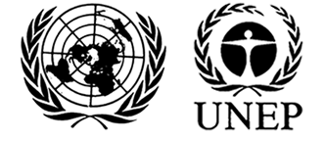 |  |  |  | MC
 |  |  | UNEP/MC/COP.4/INF/26/Add.1
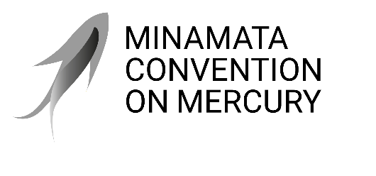 |  |  |  | Distr.: General  11 March 2022  English only
Conference of the Parties to the
Minamata Convention on Mercury
Fourth meeting
Online, 1–5 November 2021 and Bali, Indonesia,
21–25 March 2022
Agenda item 4 (a) (ii)
Matters for consideration or action by the Conference of the Parties: mercury-added products and manufacturing processes in which mercury or mercury compounds are used: information on dental amalgam
Dental amalgam: prevention and treatment of dental caries with mercury-free products and minimal intervention
Note by the secretariat
The World Health Organization has submitted to the secretariat the latest publication in its oral health briefing note series to support the Conference of the Parties in its consideration of agenda item 4 (a) (ii) on dental amalgam. The publication focuses on the prevention and treatment of dental caries (tooth decay) with mercury-free products and minimal interventions. It begins with background information on the importance of using mercury-free materials and products and minimally invasive intervention approaches, before setting out briefing notes on the use of six of those products and approaches in the prevention and treatment of dental caries: fluoride toothpaste, fluoride varnish, glass ionomer cement sealants, glass ionomer cement restorations, silver diamine fluoride and composite resin restorations. The publication is available at the following link: https://apps.who.int/iris/handle/10665/352480.

World Health Organization, Prevention and Treatment of Dental Caries with Mercury-Free Products and Minimal Intervention, WHO oral health briefing note series (Geneva, 2022).

