UNITED  NATIONS | 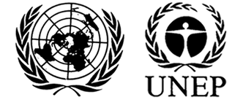 |  |  | MC
 |  |  | UNEP/MC/COP.4/INF/19
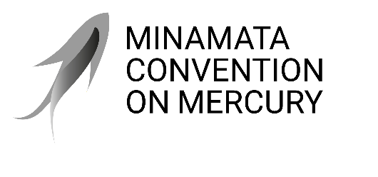 |  |  | Distr.: General  11 August 2021  English only
Conference of the Parties to the
Minamata Convention on Mercury
Online, 1–5 November 2021*
Item 5 of the provisional agenda**
International cooperation and coordination
Report on the activities on mercury of relevant international bodies
Note by the secretariat
- In paragraph 2 (c) of article 24, the Minamata Convention on Mercury includes among the functions of the secretariat the function of coordination, as appropriate, with the secretariats of relevant international bodies, particularly other chemicals and waste conventions.
- Since the entry into force of the Convention on 16 August 2017, numerous international entities have engaged in mercury-related activities. In order to bring those efforts to the attention of the Conference of the Parties, the secretariat invited those entities to submit reports on their activities for consideration by the Conference of the Parties. The reports of several such organizations are set out in the annexes to the present note, as follows: the Food and Agriculture Organization of the United Nations (annex I), the United Nations Development Programme (annex II), the United Nations Industrial Development Organization (annex III), the Convention on Long-range Transboundary Air Pollution (annex IV), the OSPAR Commission for the Protection of the Marine Environment of the North-East Atlantic (annex V), the Group on Earth Observations (annex VI), and the International Metals Study Groups (annex VII). The reports are presented as received, without formal editing.
- The reports set out in the annexes to the present note should be read alongside a number of other reports, including the report of the Executive Director of the United Nations Environment Programme (UNEP/MC/COP.4/INF/15), the report of the Global Environment Facility (UNEP/MC/COP.4/INF/7), the report of the Global Mercury Partnership (UNEP/MC/COP.4/INF/16), the joint report on cooperation and coordination between the secretariats of the Minamata Convention on Mercury and of the Basel, Rotterdam and Stockholm conventions (UNEP/MC/COP.4/INF/17); and the respective reports of the World Health Organization and the International Labour Organization (UNEP/MC/COP.4/INF/18).

Annexes
Annex I: Food and Agriculture Organization (FAO) 3
Annex II: United Nations Development Programme (UNDP) 10
Annex III: United Nations Industrial Development Organization (UNIDO) 13
Annex IV: UNECE Convention on Long-range Transboundary Air Pollution 17
Annex V: OSPAR Commission 20
Annex VI: Group on Earth Observation (GEO) 21
Annex VII: International Metals Study Groups 24

Annex I
Food and Agriculture Organization (FAO)
FAO work on Minamata Convention on Mercury
26 July 2021
FAO has paid great attention to the Minamata Convention on Mercury and continuously offered relevant support to member countries, particularly developing countries and countries with economic transition in efforts to decline the use and emission of mercury in agriculture, to enhance their national capacities to manage mercury and comply with national obligations of the Minamata Convention, for the purpose of minimize adverse effects of mercury and mercury-added products in agriculture in the world.
Minimata Convention implementation in agrochemical management
FAO firmly supports to substitute the mercury-based pesticides for promoting sustainable food and agriculture. All mercury-added pesticide products have been already banned for agricultural use in reality. Low-risk alternatives such as biopesticides, Integrated Pest Management (IPM) policies & strategies, and other environmental-friendly approaches have been developed and promoted to replace these pesticides.
Meanwhile, the project conducted jointly by FAO and European Environmental Bureau (EEB), supported ACP countries to implement Minamata Convention through specific field project activities focused on the key issues of mercury-added products and mercury use in artisanal and small-scale gold mining (ASGM). The project contributed to the implementation of mercury-added products phase-out provisions of the Minamata Convention, with the support of EEB that developed a series of tools to facilitate the phasing out of mercury-added products. The project also successfully raised awareness about Convention obligations among various stakeholders, including government agencies and officials, NGOs, traders, miners, and other relevant parties.
Fertilizers particular phosphate fertilisers and sewerage sludge based organic fertilisers are indeed sources of mercury among other heavy metals. However, the information suggests that the presence and concentration of mercury does not qualify it as a health-based risk. Some studies have shown increasing concentration of mercury in crops associated with soil uptake, but the attribution of Hg source, which can also be geogenic and concentration may not require health risk management.
FAO will continue to collaborate with all relevant stakeholders to implement the Minamata Convention on Mercury, consolidate achievements made in previous phases and jointly develop more options for effective initiatives against mercury threats to human health, environment and agriculture, with aims to achieving sustainable agriculture towards the entire Agenda 2030 and its Sustainable Development Goals.
Mercury compounds under the Rotterdam Convention:
The Food and Agriculture Organization (FAO) jointly with the United Nations Environment Programme (UNEP) introduced in 1989 the voluntary Prior Informed Consent (PIC) procedure. The PIC procedure included initially 12 pesticides and industrial chemicals, including mercury compounds, used as pesticides. The Rotterdam Convention on the Prior Informed Consent Procedure for Certain Hazardous Chemicals and Pesticides in International entered into force on 24 February 2004. Mercury was included into Annex III of the legally binding Convention. The basic principle of the Convention is that the export of a banned or severely restricted chemical that is included in Annex III to the Convention can only take place with the prior informed consent (PIC) of the importing Party.
The status of Import Responses, as published on 12 June 2021 in PIC Circular 53 is as follows:
153 Parties submitted PIC Import responses
146 Parties | No consent to import
5 Parties | Consent to Import only subject to specified conditions
1 Party | Consent to Import
1 Party | Interim decision without specified response
*RC has 164 Parties as of today
*EU counts on behalf of 27 MS
The list of Import responses on Mercury compounds from the all the submitting Parties is attached.
Import Responses
Mercury compounds, including inorganic mercury compounds, alkyl mercury compounds and alkyloxyalkyl and aryl mercury compounds (Pesticide)
View all details
Party | Party response |  | Decision | Date published
Albania | Final decision |  | No consent to import | 12/06/2013
Argentina | Interim decision |  | Consent to import only subject to specified conditions | 12/12/2006
Armenia | Final decision |  | No consent to import | 12/12/2016
Australia | Final decision |  | Consent to import only subject to specified conditions | 12/12/2004
Bahrain | Final decision |  | No consent to import | 12/07/1996
Belize | Final decision |  | No consent to import | 12/12/2005
Bolivia (Plurinational State of) | Final decision |  | No consent to import | 12/01/1994
Bosnia and Herzegovina | Final decision |  | No consent to import | 12/12/2011
Brazil | Final decision |  | No consent to import | 12/12/2004
Bulgaria | Final decision |  | No consent to import | 12/01/1995
Burkina Faso | Final decision |  | No consent to import | 12/12/2006
Burundi | Final decision |  | No consent to import | 12/12/2003
Cabo Verde | Final decision |  | No consent to import | 12/12/2008
Cambodia | Final decision |  | No consent to import | 12/06/2015
Cameroon | Final decision |  | No consent to import | 12/06/2016
Canada | Final decision |  | No consent to import | 12/01/1998
Chad | Final decision |  | No consent to import | 12/01/1998
Chile | Final decision |  | No consent to import | 12/07/1995
China | Final decision |  | No consent to import | 12/07/1993
Colombia | Final decision |  | No consent to import | 12/01/1998
Congo | Final decision |  | No consent to import | 12/07/1994
Cook Islands | Final decision |  | No consent to import | 12/01/1995
Costa Rica | Final decision |  | No consent to import | 12/01/1994
Côte d'Ivoire | Final decision |  | No consent to import | 12/06/2004
Croatia | Final decision |  | No consent to import | 12/06/2010
Cuba | Final decision |  | No consent to import | 12/12/2008
Cyprus | Final decision |  | No consent to import | 12/01/1998
Czechia | Final decision |  | No consent to import | 12/12/2001
Democratic People's Republic of Korea | Final decision |  | No consent to import | 12/12/2004
Democratic Republic of the Congo | Final decision |  | No consent to import | 12/06/2012
Dominica | Interim decision |  | Consent to import only subject to specified conditions | 12/01/1996
Dominican Republic | Final decision |  | No consent to import | 12/12/2014
Ecuador | Final decision |  | No consent to import | 12/06/2001
El Salvador | Final decision |  | No consent to import | 12/01/1994
Equatorial Guinea | Interim decision |  | No consent to import | 12/06/2016
Eritrea | Final decision |  | No consent to import | 12/06/2010
Ethiopia | Final decision |  | No consent to import | 12/12/2010
European Union | Final decision |  | No consent to import | 12/06/2010
Gabon | Interim decision |  | No consent to import | 12/06/1999
Gambia | Final decision |  | No consent to import | 12/07/1994
Georgia | Final decision |  | No consent to import | 12/12/2014
Ghana | Interim decision |  | Consent to import only subject to specified conditions | 12/12/2004
Guatemala | Final decision |  | No consent to import | 12/07/1993
Guinea | Final decision |  | No consent to import | 12/06/2006
Guinea-Bissau | Final decision |  | No consent to import | 12/12/2010
Guyana | Final decision |  | No consent to import | 12/12/2007
Honduras | Final decision |  | No consent to import | 12/07/1993
Hungary | Final decision |  | No consent to import | 12/07/1993
India | Interim decision |  |  | 12/07/1998
Indonesia | Final decision |  | No consent to import | 12/07/1995
Iran (Islamic Republic of) | Final decision |  | No consent to import | 12/12/2000
Iraq | Final decision |  | No consent to import | 12/07/1998
Israel | Final decision |  | No consent to import | 12/06/2012
Jamaica | Final decision |  | No consent to import | 12/06/1999
Japan | Final decision |  | No consent to import | 12/12/2004
Jordan | Final decision |  | No consent to import | 12/07/1995
Kazakhstan | Final decision |  | No consent to import | 12/07/1996
Kenya | Final decision |  | No consent to import | 12/07/1998
Kuwait | Final decision |  | No consent to import | 12/01/1998
Kyrgyzstan | Final decision |  | No consent to import | 12/06/2007
Lao People's Democratic Republic | Final decision |  | No consent to import | 12/06/2015
Lebanon | Final decision |  | No consent to import | 12/07/1993
Lesotho | Final decision |  | No consent to import | 12/06/2018
Libya | Final decision |  | No consent to import | 12/12/2010
Liechtenstein | Final decision |  | No consent to import | 12/06/2010
Madagascar | Final decision |  | No consent to import | 12/06/2011
Malawi | Interim decision |  | No consent to import | 12/06/2010
Malaysia | Final decision |  | No consent to import | 12/01/1994
Mali | Final decision |  | No consent to import | 12/12/2007
Malta | Final decision |  | No consent to import | 12/01/1994
Mauritania | Final decision |  | No consent to import | 12/12/2006
Mauritius | Final decision |  | No consent to import | 12/07/1993
Mexico | Final decision |  | No consent to import | 12/01/1994
Mongolia | Final decision |  | No consent to import | 12/07/1994
Montenegro | Final decision |  | No consent to import | 12/06/2019
Morocco | Final decision |  | No consent to import | 12/07/1994
Mozambique | Final decision |  | No consent to import | 12/01/1995
Nepal | Final decision |  | No consent to import | 12/01/1995
New Zealand | Final decision |  | No consent to import | 12/07/1993
Nicaragua | Final decision |  | No consent to import | 12/07/1993
Niger | Final decision |  | No consent to import | 12/01/1998
Nigeria | Final decision |  | No consent to import | 12/01/1998
North Macedonia | Final decision |  | No consent to import | 12/06/2012
Norway | Final decision |  | No consent to import | 12/07/1993
Oman | Final decision |  | No consent to import | 12/07/1993
Pakistan | Final decision |  | No consent to import | 12/07/1995
Panama | Final decision |  | No consent to import | 12/07/1998
Paraguay | Final decision |  | No consent to import | 12/07/1995
Peru | Final decision |  | No consent to import | 12/06/1999
Philippines | Final decision |  | No consent to import | 12/01/1994
Qatar | Final decision |  | No consent to import | 12/12/2005
Republic of Korea | Final decision |  | No consent to import | 12/01/1997
Republic of Moldova | Interim decision |  | No consent to import | 12/06/2012
Romania | Final decision |  | No consent to import | 12/12/2004
Russian Federation | Final decision |  | No consent to import | 12/06/2015
Rwanda | Final decision |  | No consent to import | 12/12/2002
Saint Kitts and Nevis | Final decision |  | No consent to import | 12/06/2020
Samoa | Final decision |  | No consent to import | 12/01/1996
Sao Tome and Principe | Final decision |  | No consent to import | 12/12/2015
Saudi Arabia | Final decision |  | No consent to import | 12/12/2007
Senegal | Final decision |  | No consent to import | 12/06/2007
Serbia | Final decision |  | No consent to import | 12/12/2011
Singapore | Final decision |  | Consent to import only subject to specified conditions | 12/12/2003
Slovakia | Final decision |  | No consent to import | 12/07/1998
Slovenia | Final decision |  | No consent to import | 12/06/1999
South Africa | Final decision |  | No consent to import | 12/06/2006
Sri Lanka | Final decision |  | No consent to import | 12/07/1994
State of Palestine | Final decision |  | No consent to import | 12/06/2020
Sudan | Final decision |  | No consent to import | 12/01/1994
Suriname | Final decision |  | No consent to import | 12/12/2003
Switzerland | Final decision |  | No consent to import | 12/12/2008
Syrian Arab Republic | Final decision |  | No consent to import | 12/06/2008
Thailand | Final decision |  | No consent to import | 12/07/1993
Togo | Final decision |  | No consent to import | 12/07/1994
Tonga | Final decision |  | No consent to import | 12/06/2015
Trinidad and Tobago | Interim decision |  | Consent to import | 12/06/2001
Tunisia | Final decision |  | No consent to import | 12/12/2017
Turkey | Final decision |  | No consent to import | 12/07/1994
Uganda | Final decision |  | No consent to import | 12/06/1999
United Arab Emirates | Final decision |  | No consent to import | 12/07/1998
United Republic of Tanzania | Final decision |  | No consent to import | 12/01/1995
Uruguay | Final decision |  | No consent to import | 12/07/1996
Vanuatu | Interim decision |  | No consent to import | 12/01/1998
Venezuela (Bolivarian Republic of) | Interim decision |  | No consent to import | 12/06/2010
Viet Nam | Final decision |  | No consent to import | 12/06/2010
Yemen | Final decision |  | No consent to import | 12/12/2007
Zimbabwe |  | Final decision | No consent to import | 12/07/1998

Annex II
United Nations Development Programme (UNDP)
UNDP and the Minamata Convention on Mercury
UNDP has been active in the area of mercury reduction efforts since the 1970s, when it administered the UN Revolving Fund for Natural Resources Exploration (UNRFNRE) from 1975 to 1995 and implemented a number of artisanal and small-scale gold mining (ASGM) projects financed by the revolving fund.
Since then, UNDP has continued assisting developing countries and countries with economies in transition in their efforts to reduce the use and release of mercury. Such efforts have mainly focused on the extractives sector, by supporting the phase-out of mercury used in mining to extract gold, and on the health sector, where we support the phase-out of mercury-containing medical devices and the reduction of mercury emissions. In addition, the adoption of the Minamata Convention on Mercury with the Global Environment Facility (GEF) as its financial mechanism has created new avenues and opportunities for providing financial and technical support to countries to assist them in reducing releases of mercury.
To assist countries meet their commitments under the Minamata Convention and reduce releases of mercury from various sectors and release sources, UNDP, with the financial support of the GEF, supports countries in:
- Conducting Minamata Initial Assessment (MIA) activities and ASGM National Action Plans (NAPs). MIAs include mercury inventories and assessments of the legal and regulatory frameworks as well as institutional and technical capacity needs.
- Reducing emissions of mercury and mercury compounds to the atmosphere from point sources (e.g. coal-fired industrial boilers, incinerators, smelting and roasting processes used in the production/recycling of non-ferrous metals).
- Phasing-out mercury-containing products in the healthcare sector (e.g. thermometers, blood pressure meters, dental amalgam, etc.).
- Lifecycle management (LCM) of mercury, mercury-containing products and wastes (including treatment and storage).
- Reducing and eliminating the use of mercury in ASGM, and minimizing mercury releases to the environment from mining and processing.
UNDP has already provided support or is initiating support to a total of 41 countries to implement mercury-related projects through national, regional and global projects. UNDP’s current mercury portfolio amounts to $141 million in GEF grants.
UNDP is also participating in the PlanetGOLD and GOLD+ programmes, which are programmatic approaches to tackle the use of mercury in the ASGM sector. These programmes involve three UN agencies and one NGO and support activities in countries that can help them generate global environmental benefits that correspond to more than one global environmental convention or GEF focal area, by tackling the underlying drivers of environmental degradation. Utilizing a programmatic approach offers more opportunities for exploring development links to multi-sectoral approaches, multi-stakeholder engagements and platforms, and increases the potential for delivering
socio-economic co-benefits along with enhancing the sustainability of the associated investments. As one of their main goals, the programmes will develop and connect responsible ASGM producers to international markets through transparent supply chains. Another key objective is to increase the access of small-scale miners and their communities to investment and finance for social and environmentally-friendly practices. Direct funding from the GEF is $89 million, with co-financing of more than $337 million from governments, sustainable finance institutions and the private sector.
UNDP’s key approaches to assisting countries to advance the sound management of mercury include:
Advocacy and Awareness Raising - Campaigning among stakeholders, decision-makers and population groups at risk on the importance of mercury reduction, phase-out and its management.
Capacity Building – Identification of innovative and successful practices; policy, regulatory and institutional enhancements to help countries put in place mercury management systems; identification of financing needs and options; application of lessons learned and experiences from other countries; and development and application of guidelines and tools to facilitate the management and monitoring of mercury.
Technical Assistance – Supporting countries in identifying and introducing Best Environmental Practices (BEP) and Best Available Technologies (BAT), along with customized training for their use and application, which have proven successful elsewhere and will help address national challenges and constraints with regards to the sound management of mercury.
Monitoring – Assisting countries to assess their situation relating to mercury and tracking their progress towards reducing its use and releases.
The Sustainable Development Goals (SDGs) and the Minamata Convention on Mercury
The Minamata Convention aims to protect human health and the environment from anthropogenic emissions and releases of mercury and mercury compounds. Supporting countries in their efforts to prepare for and meet their future commitments under the Minamata Convention is an important component of UNDP’s efforts to achieve sustainable, inclusive and resilient human development through the SDGs, which were adopted in September 2015. Some of the key linkages between UNDP’s work in support of the Minamata Convention’s efforts to reduce the use/phase-out of mercury and the SDGs are highlighted below.
SDG Goal 1: End poverty in all its forms everywhere
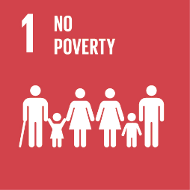
The urban and rural poor routinely face unacceptably high risks of exposure to mercury because of their occupations (e.g. mercury mining, artisanal and small-scale gold mining, waste management, recycling), living conditions (proximity to dumpsites and incinerators) and lack of knowledge of potential health impacts of exposure to mercury. At the same time, ecosystems that provide essential resources for the survival of the rural poor, are affected by mercury contamination. UNDP-supported interventions assist partners in introducing alternatives, best practices and techniques to minimize the use and release of mercury, and also address the underlying socio-economic challenges that are at the core of existing practices that use mercury.
SDG Goal 2: End hunger, achieve food security and improved nutrition and promote sustainable agriculture
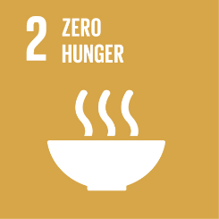
One of the main sources for exposure to mercury is through consumption of mercury-contaminated fish and shellfish. The consumption of fish containing high levels of mercury, in particular those high on the food chain as mercury bioaccumulates, can have serious health consequences (see SDG 3). This causes health concerns, in particular for pregnant women, the child in utero and young children, as well as for poor communities relying on subsistence fishing. UNDP helps countries decrease the use of mercury and its release into the environment from various sectors, indirectly halting and reducing the build-up of mercury in the food chain.
SDG Goal 3: Ensure healthy lives and promote well-being for all at all ages
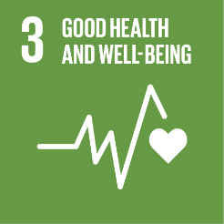
Mercury is toxic to human health, posing a particular threat to the development of the child in utero and early in life. Human exposure occurs mainly by inhaling elemental mercury vapors during industrial processes and by consuming contaminated fish and shellfish, and can lead to mercury poisoning. Mercury exists in various forms: elemental; inorganic; and organic, which all have different toxic effects, including on the nervous, digestive and immune systems, and on lungs, kidneys, skin and eyes. UNDP supports governments, the private sector and other partners, to reduce or preferably phase-out the use of mercury and mercury-containing products, and minimize its releases, to ultimately protect human and environmental health.
SDG Goal 7: Ensure access to affordable, reliable, sustainable and modern energy for all.
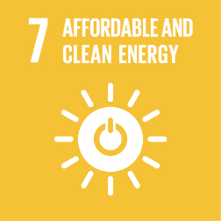
Coal burning, and to a lesser extent the use of other fossil fuels to generate energy, is the second most significant anthropogenic source of mercury emissions into the atmosphere. Use of air pollution controls and more stringent regulations, combined with improved combustion efficiency, can offset most of the mercury releases associated with the increase in coal use, particularly in Asia and South America. However, reductions in current mercury releases will only be achieved after a shift to cleaner and more sustainable energy sources and the introduction of more efficient technologies and products (e.g. mercury-free energy-efficient lighting). UNDP supports countries in strengthening their regulatory frameworks, revising outdated industrial processes and technologies to reduce releases and increase efficiency and, most importantly, in adopting clean energy solutions.
SDG Goal 8: Decent work and economic growth
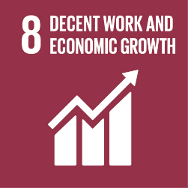
Exposure to mercury can occur through the inhalation of mercury vapors. Such exposure is most likely to happen in the workplace. Among the most dangerous professions and livelihoods in terms of mercury exposure are artisanal and small-scale gold mining, waste handling and recycling, mercury refining, and health and dental care. Phasing-out the production and use of products and processes which use mercury is the main way to reduce worker exposure. We assist governments and various sectors introduce mercury-free products and processes, while also supporting the development of workplace safety standards and procedures, introducing personal protective measures, and addressing the underlying socio-economic causes that led to the use of mercury and products containing mercury.
SDG Goal 12: Ensure sustainable consumption and production patterns
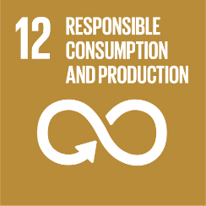
Sustainable consumption and production aims at “doing more with less,” increasing net welfare gains from economic activities by reducing resource use, degradation and pollution, while increasing the quality of life. An important aspect of our work is the reduction of mercury pollution and mercury-containing wastes by introducing alternative products, processes and technologies that are mercury-free, cost-effective and in line with best available technology guidelines. Such interventions are aligned with those that increase resource efficiency, use clean and renewable energy, and reduce waste generation, all of which have important mercury reduction co-benefits.
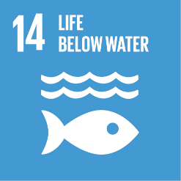
SDG Goal 14: Conserve and sustainably use the oceans, seas and marine resources for sustainable development
Over three billion people depend on marine and coastal biodiversity for their livelihoods, which are being threatened by marine pollution reaching alarming levels. Mercury levels in certain types of fish (e.g. bluefin tuna, swordfish) have become so high that some Governments advise against consumption or have introduced import bans. UNDP helps countries decrease the use and release of mercury from various land-based activities, prevent mercury from entering water sources, and reduce the build-up of mercury in the food chain.

Annex III
United Nations Industrial Development Organization (UNIDO)
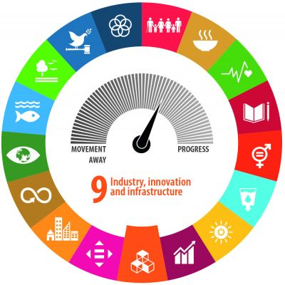
UNIDO input for the fourth meeting of the Conference of the Parties to the Minamata Convention on Mercury
UNIDO’s approach
The United Nations Industrial Development Organization (UNIDO) is a specialized agency of the United Nations with the mandate of promoting and accelerating inclusive and sustainable industrial development (ISID) in developing countries and economies in transition. UNIDO’s mission contributes strongly to Sustainable Development Goal 9 which calls to “Build resilient infrastructure, promote inclusive and sustainable industrialization and foster innovation”, but is also instrumental to the achievement of all the other goals.
The Mercury Programme at UNIDO benefits from the Organization’s extensive experience in assisting developing countries to comply with Multilateral Environmental Agreements (MEAs), such as the Montreal Protocol on Substances that Deplete the Ozone Layer and the Stockholm Convention on Persistent Organic Pollutants. UNIDO’s experience in mercury reduction and elimination started with the artisanal and small-scale gold mining (ASGM) sector more than 25 years ago. After developing a substantial portfolio in order to assist countries to fulfill their obligations under the Minamata Convention and expanding to other industrial areas including emissions from zinc smelting, mercury use in processes (chlor alkali and vinyl chloride monomer production sectors), and mercury waste management.
In addition, UNIDO has a strong international network of partners consisting of private sector entities, academia, research institutions, other UN and donor agencies, NGOs and governments complemented by its field representation in more than 47 countries. Together with its partners, UNIDO’s Mercury Programme is leading and facilitating the introduction of mercury-free technologies and policy reform to minimize the use, emissions, and releases of mercury. It promotes Best Available Technologies (BAT) and Best Environmental Practices (BEP) through awareness raising, capacity building, legislation strengthening and technology transfer.
Projects
In accordance with UNIDO’s commitment to support governments in fulfilling their legal obligations under the Minamata Convention on Mercury, the Organization has initiated, since the end of the GEF-5 replenishment period, Minamata Initial Assessments (MIA) projects and National Action Plans (NAP) projects on mercury in the ASGM sector. Moreover, the Mercury Programme portfolio includes large scale projects on ASGM, vinyl chloride monomer production, mercury contamination in freshwater and marine aquatic environments, and mercury waste management.
More details on the projects completed and currently under implementation by UNIDO can be found under www.unido.org/mercury.
A. Minamata Initial Assessments (MIA) and other support for ratification and early implementation
- UNIDO with financial support from the Global Environment Facility (GEF) has provided technical assistance to 27 countries to prepare their respective Minamata Initial Assessments over the past years. 23 of these countries supported by UNIDO have completed their mercury country profiles and four (4) countries will complete it in the next years. The completed MIA documents cleared by the respective Governments have been made available to the Secretariat of the Minamata Convention as well as to the GEF.
- The goal of the MIA is to complete pre- or post-ratification activities to enable policy and decision making and to prioritize areas for future interventions through a national mercury inventory. Since COP3, MIA Afghanistan and Nicaragua have been approved by the GEF Secretariat.
- With the support of Switzerland, UNIDO is implementing a global programme on promoting ratification and early implementation of the Minamata Convention since 2016. This programme has offered needs based assistance to countries and (sub) regions including eight (8) countries (Armenia, Bangladesh, Costa Rica, Guatemala, Malawi, Philippines, Tunisia and Vietnam) and two (2) sub-regions (Caribbean and ECOWAS) participate in this program. The thematic areas range from awareness raising on the ratification requirements, to the domestication of international Chemicals and Waste Conventions and extends to responsible management of mercury-containing products and waste. In addition, four (4) specific regional events have been organized. Since COP-3, two (2) additional countries (Nepal and Sri Lanka) and (1) sub-region (SADC) have been added. In Nepal, the Organization is working on phasing down mercury emissions from the gold plating sector which is the major source in the country. In Sri Lanka, the focus is set on reducing the use of mercury in the Ayuvedic medical sector, a traditional medicine system widespread across the local population. Certain member states and stakeholders from both ECOWAS and SADC have been identified for engaging in regional approaches to promote the environmentally sound management of mercury and e-waste.
B. Artisanal and Small-Scale Gold Mining (ASGM)
- UNIDO assists Governments in the development of the National Action Plans (NAP) by providing essential information and tools to enable policy and strategic decision making and by assisting the development of strategies and road maps within countries and regions. The projects strengthen the countries’ national capacity to fulfill obligations under Article 7 and Annex C and promote effective implementation of its provisions.
- The Organization works closely with 13 countries in the preparation of their NAPs for the artisanal and small-scale gold mining (ASGM) sector. Since COP3, 6 out of 13 UNIDO-implemented NAP projects are now completed: Burkina Faso, Ecuador, Gabon Ghana, Nigeria, and Peru. Regarding new projects, Afghanistan, Bolivia, Cameroon and Nicaragua NAPs have been approved by the GEF Secretariat.
- The GEF Global Opportunities for Long Term Development of the ASGM sector (GOLD) program more widely known as planetGOLD focuses on policy strengthening to support formalization of the sector, facilitating access to financing for miners, introducing mercury-free technologies and generating awareness raising and knowledge in the ASGM sector. The program officially launched in early 2019 is now at its
mid-term. UNIDO is implementing one (1) planetGOLD project in Burkina Faso, (1) planetGOLD project in Mongolia and the Philippines in collaboration with UN Environment. In addition, UNIDO is also one of the executing partners in the global project that aims at disseminating best practices and experiences on key ASGM topics.
- There is a second phase of the programme that was approved in June 2020 (GEF GOLD+) which will be led by Conservation International (CI). Under the upcoming phase, UNIDO will implement projects in six (6) countries: Bolivia, Ghana, Madagascar, Mali, Nicaragua and Nigeria.
- To promote a responsible business model as a basis for accessing international gold markets for miners, UNIDO has a Memorandum of Understanding (MoU) with Argor-Heraeus S.A., one of the world’s largest refiners of precious metals working together to achieve a sustainable adoption of mercury-free technologies in artisanal and small-scale gold mining.
- In addition to the above mentioned GEF-supported projects, UNIDO is working in Colombia in collaboration with the European Union to improve the conditions of artisanal and small-scale gold mining in the Chocó Department, including the reduction of mercury use.
- The Organization is also actively seeking other bilateral and multilateral funding opportunities to continue previous efforts and momentum built in several ASGM active countries. Potential donors include the European Commission, Switzerland, and Japan.
C. Waste management
- UNIDO supports countries in the establishment of adequate regulatory frameworks and national guidelines for the environmentally sound management (ESM) of mercury waste. Some of the projects have developed capacities for the implementation of remediation and stabilization techniques in mercury hot-spot areas through demonstration activities at the pilot scale (refer to GEF-5 project implemented in Mongolia).
- In Tunisia, UNIDO completed a project that aimed at reviewing and validation the remediation plan for a former chlor-alkali plant in Kasserine. The goal of the initiative was to reduce negative impacts of mercury contamination to human health and the environment by (a) strengthening the national capacity to manage mercury containing waste and comply with the provisions of the Minamata Convention; and (b) improving the remediation plan of the company SNCPA through the collection of complementary information during the project.
- With the support of the Swiss and Japanese governments, UNIDO organized an expert group meeting on sustainable management of mercury waste in September 2018 in Vienna. More than 70 people actively participated in the meeting to discuss interim disposal, treatment, and final disposal of mercury wastes. The meeting results can be found in the following publication. As a result of the expert group meeting, UNIDO is working with specific countries to develop mercury waste management initiatives.
- Recently, the Organization with support from the GEF, is working to promote the environmentally sound management of mercury waste in two (2) countries: Paraguay and the Philippines. The main objective of the initiative in Paraguay is to transform the linear, wasteful solid waste management sector in an environmentally sound and sustainable model by segregating and managing hazardous POPs and
mercury-containing fractions in an environmentally sound way while the project in the Philippines will support the national healthcare system to manage in an environmentally sound manner hazardous medical waste containing mercury. Innovative best available treatment technologies will be introduced and access to finance will be facilitated to link local governments and other stakeholders to public and private investments. The two projects are an important step to support countries in meeting their obligations contained under Article 4 and the phase out deadline of 2020.
- Since 2014, UNIDO and Nomura Kohsan Co. Ltd. have a Memorandum of Understanding (MoU) to prevent mercury-containing wastes entering the environment, to ensure BAT/BEP are applied to remove mercury from waste, and to identify long-term solutions for the storage of mercury.
D. Non-ferrous metal smelting
- From 2012 to 2015, national and local capacity was strengthened in China, enabling the country to effectively manage and reduce mercury emissions from zinc smelting operations in neighboring communities. BAT and BEP for cleaner zinc production were demonstrated at two (2) pilot sites. The project also established a coordination and monitoring system, and a proposed policy reform for mercury management in the zinc smelting sector. The initiative was funded by the GEF and co-financed by the Foreign Economic Cooperation Office (FECO) of the Ministry of Environment; Zhuzhou, Shuikoushan and Shangluo (zinc enterprises); Hunan, Shaanxi, and Guizhou provinces; Sino-Norwegian projects; and UNIDO.
E. Vinyl Chloride Monomer (VCM) production
- China is the only country in the world that uses calcium carbide based VCM production to produce polyvinyl chloride (PVC). This sector consumes more than half of the total mercury supply in the country, accounting for 30% of the global mercury use. In order to support the country to reduce the negative impacts to health and the environment in the industrial production of VCM, UNIDO is currently implementing a large scale project in collaboration with the Ministry of Ecology and Environment and its Foreign Environmental Cooperation Office (FECO) with funding from the GEF.
- Through the planned activities, the intervention will reduce the production costs of the involved enterprises and will promote the sustainable development of the PVC industry through reduction, recycling and replacement strategies that should lead to the production of clean-VCM green PVC products. Mercury use in the VCM sector will be reduced by 360 tons through circular economy approaches.
F. Mercury trade
- The adoption of the Minamata Convention has had profound implications for particular regions when it comes to mercury trade. West Africa, for example, is home to some of the richest gold- ore deposits in the world with ASGM being conducted in nearly every ECOWAS member state, and gold being a major regional export. Mercury plays a key role in ASGM, as it is used by the majority of the estimated 2 to 3 million artisanal miners to extract gold from ore. As it also happens in other areas of the world, mercury is often linked to the gold supply chain as a way of securing gold flows leading to unbalanced power relations between the mercury providers and the miners.
- Recognizing the need for a greater understanding of mercury and gold trade flows, regulation and taxation in this particular region, the UNIDO commissioned a study on mercury and gold trade flows and the existing regulatory frameworks. One of the key recommendations of the study is that greater cooperation and harmonization of the regulatory frameworks as well as coordination between relevant government bodies are needed to curb mercury trade and use, both at the regional and domestic levels.
- UNIDO has been working closely with ECOWAS Member States to pursue the implementation of a regional approach to address gold and mercury flows.
G. Air emissions
- UNIDO in cooperation with the China’s Ministry of Ecology and Environment and its Foreign Environmental Cooperation Office (FECO) is working on a project to control and reduce mercury emissions from the cement industry. The major global environmental benefits will be the reduction of at least 5 tons of mercury emissions to the environment. This project will be a pioneer initiative to demonstrate the control and reduction of mercury emissions from the cement production in China through the introduction of BAT/BEPs and awareness raising among the general public. The experiences, knowledge and lessons learned will provide the basis for the replication of these environmentally sound techniques across the nation. It will also contribute to the country’s responsibilities within Article 8.
Minamata beyond COP-4
Most of the identified issues related to mercury are industrial by nature, which reinforces the increasing and significant role that UNIDO has and will have in the coming years in assisting countries to reduce, and where feasible, eliminate the use of mercury, as well as its emissions and releases to the environment.
The MIA results (including the mercury inventory) have provided a basis for prioritization and development of sectoral intervention plans to be supported by future projects and strategies. In the context of the NAPs, a road map for the reduction of mercury use in the ASGM sector, including the required interventions and potential funding sources, will serve as the basis to develop follow-up actions that shall support the implementation of the Plans.
On ASGM, UNIDO has been working substantially towards a more responsible sector that contributes to economic and social development while protecting the environment. The approach covers the promotion of conducive regulatory and policy frameworks; institutional strengthening and capacity building at the relevant levels; technology transfer through pilot demonstration and access to financing; as well as awareness raising and knowledge exchange. One of the key elements has been the cooperation with the private sector, especially across the supply chain to ensure the sustainability of interventions. Additionally, UNIDO has expanded its partnerships with enforcement agencies to effectively respond to the multidimensional challenges present in the sector.
UNIDO has also been promoting circular economy approaches in various industrial sectors and supply chains including, but not limited to, textiles, plastics and cement. Based on the results of these projects, UNIDO has planned the development of a global concept on transforming the construction supply chain through circular economy solutions with the objective to achieve multiple environmental benefits including reduction of industrial emissions, POPs, mercury and GHG in the construction supply chain.
The Mercury Programme is moving to a more integrated approach through the implementation of thematic programmes where advantage can be taken from the occurring synergies.
UNIDO will continue to work in close collaboration with governments, the private sector, international organizations, civil society and academic, among other partners to support countries in their efforts to comply with their obligations under the Minamata Convention on Mercury.
Contact:
Mr. Jérôme STUCKI
Chief, Materials and Chemicals Management Division
Department of Environment, UNIDO
Email: j.stucki@unido.org
www.unido.org/mercury

Annex IV
UNECE Convention on Long-range Transboundary Air Pollution
Activities of the UNECE Convention on Long-range Transboundary Air Pollution on mercury
The UNECE Convention on Long-range Transboundary Air Pollution (Air Convention) was the first international treaty to deal with air pollution on a broad regional basis, tackling, at first, sulphur emissions, and later expanding to cover other pollutants, including heavy metals and among those, mercury. The Convention currently has 51 Parties in the UNECE region. Its Protocol on Heavy Metals, which entered into force in 2003 and was amended in 2012, contains stringent controls for the priority heavy metals cadmium, lead and mercury. The Convention’s work builds on sound scientific support provided by its scientific bodies, namely the Cooperative Programme for Monitoring and Evaluation of the Long-range Transmission of Air Pollutants in Europe (EMEP) and the Working Group on Effects (WGE).
Parties to the Protocol on Heavy Metals have the obligation to report annual emission data on mercury. Besides, continuous measurements of pollution levels are performed at sites of the EMEP monitoring network and regular model estimates of transboundary pollution of the Parties to the Air Convention are carried out. The data is checked and used for the scientific work under the Convention and it is publicly available on the internet. This data can be used by the Minamata Convention for its own effectiveness evaluation.
Cooperation between the various subsidiary bodies and experts under the UNECE Air Convention and the Minamata Convention is already ongoing. The Meteorological Synthesizing Centre – East of EMEP (EMEP/MSC-E) has been involved in a series of mercury assessments prepared by UN Environment (GMA 2002, 2008, 2012, 2015, 2018) to support the Minamata Convention. The Centre contributed to the assessments coordinating activities of the international group of experts on mercury fate and transport modelling on global and regional scales. EMEP/MSC-E also co-operates with other international bodies, including the Arctic Monitoring and Assessment Programme (AMAP), the HELCOM and OSPAR Conventions, on assessment of mercury pollution of the Arctic and the regional seas.
The global aspect of the mercury pollution is also addressed by the Air Convention. In particular, the Task Force on Hemispheric Transport of Air Pollution (TF HTAP) of EMEP recently hosted an exploratory workshop (13 April 2021) to identify near-term opportunities and longer-term research needs to improve the scientific basis for assessment of mercury pollution and trends (http://htap.org/tf-htap-workshop-on-hg-trends-and-source-attribution-agenda/). The workshop initiated cooperative research activities aimed at revealing additional issues or measures that might be addressed to protect the environment and human health. Among the activities that might facilitate a support provided by TF HTAP to the Minamata Convention is a development of medium/long term global scenarios of mercury emissions that would reflect an adoption of Hg-control policies as well as implications of decarbonisation of the global energy system; this work is planned by the Centre for Integrated Assessment Modelling (CIAM) as a contribution to TF HTAP activities.
The modelling of mercury emissions in the Greenhouse Gas-Air Pollution Interactions and Synergies Model (GAINS) framework is currently being updated to reflect complexities of interactions between controlling mercury and air pollutants such as SO2, NOx, and PM. Mercury specific control options have been revised and implemented for key sectors. In addition, cost components of Hg-controls have been added to the model. There has been a co-operation established with experts in China (Shandong University) to exchange data on effectiveness of various control strategies for mercury that will be simulated in the future GAINS scenarios.
EMEP took part in the Minamata Online initiative contributing to the session “Multimedia modeling of global mercury movement”. The session was aimed to bridge the scientific community and international policy for assessing the state of the environment and effectiveness of pollution control measures. EMEP/MSC-E presented the experience gained under the Air Convention on atmospheric modeling of mercury transport and fate in the environment.
On the side of the Working Group on Effects, the International Cooperative Programme for assessment and monitoring of the effects of air pollution on rivers and lakes (ICP Waters), led by Norway (Norwegian Institute for Water Research (NIVA)), contributes with inputs to guidance on monitoring of mercury to support the effectiveness evaluation of the Minamata Convention. This is in particular with regard to biota in freshwaters and builds in part on work done under ICP Waters. Comments on the proposed guidance is provided through a Norwegian expert group where experts with various backgrounds (air, marine ecosystems, freshwaters, etc) participate. The inputs are synthesized by an expert from the national EPA who also is the contact point to the Minamata Convention.
Closer integration of the relevant activities under the Air Convention and the Minamata Convention could facilitate resolving the Hg pollution problem both in the UNECE region and on a global scale.
Emission reporting
In 2021 forty-three Parties to the CLRTAP Convention reported full time series (1990-2019) for Hg emissions. In addition, three Parties reported Hg emissions for the year 2019 only. The reporting of Hg emissions improved over the last years (in 2009 only 34 Parties reported Hg emissions). The trend of reported Hg emissions between 2000 and 2018 is downward in the EMEP-West area. More information on trends of Hg emissions can be found in the EMEP Status Report.

Figure 1: Emission trends of priority heavy metals 2000-2018 in the EMEP West area (reported data); Figure taken from EMEP status report
Note: The continuous decrease of Hg emissions since the year 2010 is mainly due to decreases reported by France, Germany, Italy and the United Kingdom.
EMEP Status Report 2/2020 July 2020 Assessment of transboundary pollution by toxic substances: Heavy metals and POPs Oleg Travnikov, Nadezhda Batrakova, Aleksey Gusev, Ilia Ilyin, Mikhail Kleimenov, Olga Rozovskaya, Victor Shatalov, Irina Strijkina Wenche Aas, Knut Breivik, Pernilla Bohlin Nizzetto, Katrine Aspmo Pfaffhuber Katarina Mareckova, Stephan Poupa, Robert Wankmueller, Katrin Seuss
https://en.msceast.org/reports/2_2020.pdf
MERCURY MEASUREMENT IN SPAIN - AIR QUALITY
Mercury measurements in the field of air quality are carried out as a consequence, on one hand of the obligations of the air quality legislation, and on the other hand, of the obligations derived from the measurement programs of the EMEP Programme of the Air Convention and the CAMP Programme of the OSPAR Convention.
National Royal Decree 102/2011, of January 28, on the improvement of air quality, states in Article 9 that this Ministry, in collaboration with the autonomous communities, will establish a measurement point every 100,000 km² for the indicative measurement, in ambient air, of arsenic, cadmium, total gaseous mercury, nickel, benzo(a)pyrene, and the other polycyclic aromatic hydrocarbons referred to in paragraph 1, as well as their total deposition. The measurement of gaseous divalent and particulate mercury will also be carried out in coordination with the Continuous Monitoring and Measurement Strategy of the European Monitoring and Evaluation Programme (hereinafter EMEP).
The EMEP/VAG/CAMP network in Spain consists of 13 stations as shown in the following map, distributed homogeneously throughout the national territory.
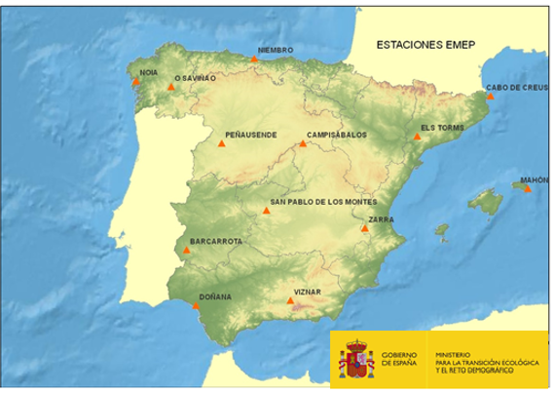
The EMEP/VAG/CAMP network in Spain carried out mercury campaigns since 2009 to comply with EMEP and CAMP measurement programmes, although since the approval of the Royal Decree 102/2011, it has been established that mercury measurements will be carried out at 5 stations.
After several campaigns to choose the location of the measurements, the following stations were selected for the determination of the total mercury deposition (in a monthly sample):
- ESO1, San Pablo de los Montes (Toledo)
- ES07, Víznar (Granada)
- ES08, Niembro (Asturias)
- ES12, Zarra (Com. Valenciana)
- ES14, Els Torms (Catalonia)
Several measurement campaigns of both particulate mercury and divalent gaseous mercury were carried out between 2010 and 2011 at San Pablo de los Montes station, but the difficulties of both, the sample collection process and the sample analysis, resulted in not repeated campaigns in the following years.
The measurement of total gaseous mercury is carried out at Niembro station (Asturias), requirement for the fulfillment of the CAMP measurement programme.
- Total gaseous mercury - continuous data (hourly).
- Mercury in precipitation - weekly precipitation data.
Therefore, the historical air quality series for mercury measurements are available:
Hg COMPOUNDS | UNIT | PERIODICITY | STATION | START TIME OF REGULAR MEASUREMENTS
Total mercury deposition | ng/m2·day | MONTHLY | ES01, San Pablo de los Montes | 01/05/2013
Total mercury deposition | ng/m2·day | MONTHLY | ES07, Víznar | 01/09/2013
Total mercury deposition | ng/m2·day | MONTHLY | ES08, Niembro | 01/03/2013
Total mercury deposition | ng/m2·day | MONTHLY | ES12, Zarra | 01/07/2015
Total mercury deposition | ng/m2·day | MONTHLY | ES14, Els Torms | 01/01/2013
Total gaseous mercury | ng/m3 | HOURLY | ES08, Niembro | 29/04/2009
Mercury in precipitation | ng/m2·year | WEEKLY | ES08, Niembro | 28/01/2008
The data is available at: http://ebas.nilu.no/
EBAS is a database hosting observation data of atmospheric chemical composition and physical properties.
Annex V
OSPAR Commission
OSPAR submission to the Fourth Meeting of the Conference of the Parties to the Minamata Convention
OSPAR List of Chemicals for Priority Action
The OSPAR Hazardous Substances Strategy is to prevent pollution by hazardous substances, by eliminating their emissions, discharges and losses, to achieve levels that do not give rise to adverse effects on human health or the marine environment. OSPAR identifies substances on the market that pose a risk for the marine environment and maintains a List of Chemicals for Priority Action, the purpose of which is to select hazardous substances that need to be addressed under the OSPAR Strategy and to identify the substances which should be given priority in OSPAR’s work; mercury and organic mercury compounds are listed substances.
Annual monitoring and assessment
OSPAR collects data annually on concentrations of certain hazardous substances in precipitation, air, rivers, and the marine environment, including mercury and its compounds. OSPAR has developed a monitoring strategy that sets out the best way to collect data and information on sources, pathways, concentrations, and effects, to track progress towards OSPAR’s strategic objectives for hazardous substances through annual assessments (Coordinated Environmental Monitoring programme – CEMP).
The levels and trends in marine contaminants and their biological effects, including mercury, are assessed annually, and are published online in CEMP Assessment reports, e.g., 2019 – 2020. The data and assessment results can also be explored online via the semi-automated OSPAR Hazardous Substances Assessment Tool: https://ocean.ices.dk/OHAT/.
Mercury from the chlor-alkali industry
The first assessment of emissions, discharges and losses of chemicals (2008) identified by OSPAR for priority action assessed progress towards the cessation target for hazardous substances.
OSPAR used to publish reports on losses of mercury from the chlor-alkali industry. However, all mercury cell chlor-alkali plants in the OSPAR Maritime Area have now been phased out completely as a result of its Contracting Parties fully implementing PARCOM Decision 90/3 on reducing atmospheric emissions from existing chlor-alkali plants.
The 2019 round of data reporting on discharges, emissions and losses of mercury by all routes from mercury-cell chlor-alkali plants operating within the OSPAR Maritime Area, revealed that chlor-alkali plants in the OSPAR Maritime Area no longer use mercury technology for the production of chlor-alkali. Therefore, these discharges, emissions and losses of mercury have ceased altogether.
Decisions, Recommendations and Agreements
OSPAR has a series of Decisions, Recommendations and Agreements related to mercury and its compounds, some of which have been set-aside either because they have been fully implemented, or they have been superseded by other international instruments. The following are still active:
- OSPAR Recommendation 2006/2 Amending OSPAR Recommendation 2003/4 on Controlling the Dispersal of Mercury from Crematoria.
- OSPAR Recommendation 2003/4 on Controlling the Dispersal of Mercury from Crematoria. Consolidated text.
- OSPAR Agreement 1997-08 Joint Assessment and Monitoring Programme (JAMP) Guidelines for the sampling and analysis of mercury in air and precipitation.
- PARCOM Recommendation 93/2 on Further Restrictions on the Discharge of Mercury from Dentistry.
Annex VI
Group on Earth Observation (GEO)
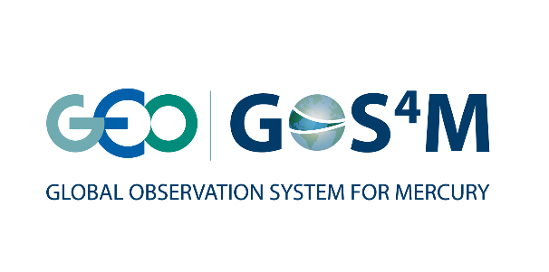
Submission by the Group on Earth Observations (GEO) to the Fourth Meeting of the Conference of the Parties to the Minamata Convention
Major highlights of the Global Observation System for Mercury (GOS4M activity relevant to the Minamata Convention on Mercury
Key messages:
- GOS⁴M has established formal governing bodies with representatives of recognized mercury scientists and environmental policy community.
- GOS⁴M has designed and developed the Knowledge Hub, an operational integrated
multi-model and multi-domain computational platform designed to evaluate the potential effectiveness of measures that nations may undertake to reduce the impact of mercury contamination on human health and ecosystems.
- GOS⁴M is expanding data sharing to improve Chemical Transport Model calibration.
- GOS⁴M is carrying out an intensive dissemination and outreach activity in the context of scientific research related to various aspects of the Hg cycle, as well as in the framework of the policy-making process by contributing to several expert ad-hoc groups such as the Effectiveness Evaluation of the MCM, the UNEP Global Mercury Partnership, the Task Force HTAP within the UNECE-LRTAP convention, and other national initiatives.
- GOS⁴M is also part of several ongoing national and international projects related to various aspects of mercury monitoring, modelling and policy implementation.

The GEO Flagship Global Observation System for Mercury (GOS4M) was designed to support nations, UNEP and all interested parties to characterize the linkages between impacts and effect of mercury contamination of Earth system on human health and provide EO data sets and validated interoperable tools to support policy makers in co-designing policy-driven scenarios that nations may implement for achieving the objectives of the MCM.
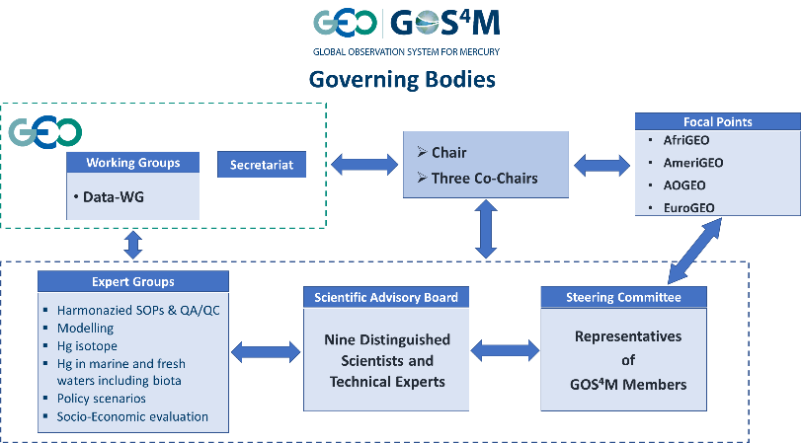
The GOS⁴M partnership is ensuring an efficient involvement of nations having established formal governing bodies as reported in the following chart.
Current GOS⁴M Members are well recognized scientists in mercury studies very active in the ongoing policy processes and responsible of existing regional and global monitoring networks (http://www.gos4m.org/management-and-governance/).

The Flagship is developing and implementing the GOS4M-Knowledge Hub (GOS4M-KH, an operational integrated multi-model and multi-domain computational platform where scientist, decision-makers and citizens can discover, analyse, and understand information for characterizing the linkages between emissions and effects of mercury contamination on Earth system and human health at different geographical and temporal scales.
The GOS⁴M-KH was designed to evaluate the potential effectiveness of measures that nations may undertake to reduce the impact of mercury contamination on human health and ecosystems. It provides information on mercury fate, from sources to receptors, and – in the future – an estimate of costs associated with selected policy scenarios. This platform includes various data-driven analytical tools able to analyse large data sets provided by complex chemo-physical atmospheric models, bio-geochemical models that simulate Hg-cycle processes occurring in the ocean and ecological models that estimate mercury uptake by the trophic net.
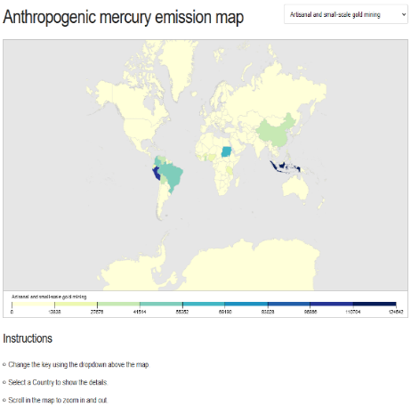
The GOS⁴M-KH is provided by including all key components of the mercury cycle in the environment and its assessment (http://gos4m.org/kh): information on emission, observational datasets and modelling outputs served through a data catalog, a statistical emulator of the Chemical Transport Model, a biogeochemical model and a trophic model coupled together.

All components GOS4M-KH are provided as widget (a graphical user-friendly software components).
The emission component (http://www.gos4m.org/kh/emissions) provides information on emissions by countries and activities in a graphical map. It is based on the most recent Global Mercury Assessment 2018 published by UN Environment. In a shot a user can be informed on the contribution of each activity to the global mercury budget.
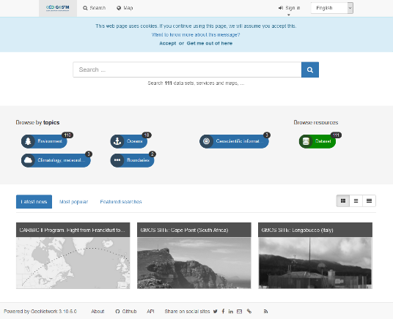
The GOS⁴M Catalog provides information and access to data and services with related metadata. The widest GMOS datasets are available for download and use. More networks (AMNET, CAMNET, APMNN) will be available in the near future. In addition, the dataset on output scenarios prepared with ECHMERIT model and AMAP 2010 database are currently available whereas more scenarios prepared with different models and different datasets will be provided. The GOS⁴M community portal under the GEO Portal provide a different way to explore datasets and services provided.
The statistical emulator HERMES is an application aimed to deposition scenario manipulation. The number of model outputs that give information on the fate of mercury as consequence of emission reduction in different regions and industrial sectors can be manipulated. Users can establish their own reduction scenario and look at the consequence on deposition over different land and oceans.
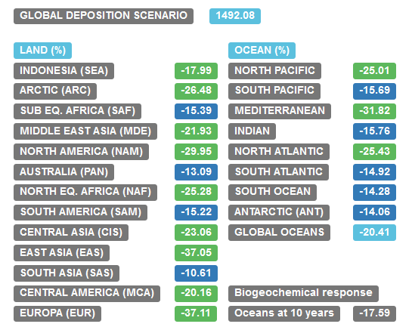
Results of HERMES are used as input for a six-box biogeochemical model adapted from Selin (2014). The model is run in real time to calculate the perturbation of the biogeochemical cycle Hg over a period of 30 years. Deposition of Hg over oceans and the Hg concentrations within the ocean layers due to natural and legacy sources is also calculated.
The plots report trends in deposition over oceans and Hg burden in the ocean and are compared against the BAU and DG scenarios.
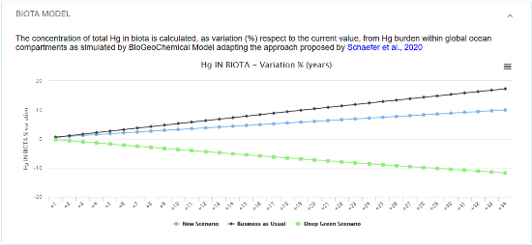
The last widget reports the concentration of total Hg in biota is calculated as a percentage variation (%) in respect to the current value following the lake-based bio-accumulation approach proposed by Schaefer et al. (2020).

Annex VII
International Metals Study Groups
International Metals Study Groups´ Activities Related to Implementation of Minamata Convention on Mercury
The first International Metals Study Groups was established in 1959 by the UN as the sole intergovernmental mechanism for the promotion of market transparency and provision of a forum for stakeholders including governments, industry and NGOs to discuss fundamental issues related to mineral extraction, base metal production, commodity trade and usage. Topics of common concern and interest ranging from environment, health, safety, social responsibility to market trends raised by member governments are addressed at the Groups´ biannual meetings and through specialized reports and studies. The outcome of the Groups´ activities supports member governments in their policy formulation and facilitates industry in policy implementation and compliance.
In past years, the Metals Study Groups´ activities related to containing mercury release and implementation of Minamata Convention include:
- Meetings and Seminars
Twice yearly meetings of the Environmental and Economics Committees of the Metals Study Groups in April and October to address the environmental, safety and health issues derived from mining, smelting and refining, trading, using and recycling of lead, zinc, copper and nickel. During the Study Groups´ seminar on “Addressing the Challenge of Lower Ore Grades and Rising Levels of Impurities in Concentrates” and ILZSG´s Economics and Environment Committee Meeting invited Minamata Convention on Mercury and UNEP presented a paper on “Overview of Minamata Convention on Mercury”. This provided an opportunity for direct triparty communications among the non-ferrous metal industry, governments and the Minamata Convention on Mercury.
- Publications
The Metals Study Groups provide member governments, industries and other related stakeholders with the most recent reference related to mercury release points from non-ferrous metal industry and relevant environment and health controls. These periodically-updated publications include:
- Lead and Zinc Mine and Smelter Database
- Directory of Copper Mines and Plants
- Environment and Health Controls on Lead
- Environment and Health Controls on Zinc
- Special Studies:
The Metals Study Groups call for and put forward proposals of special studies addressing issues of common concerns and interests to member governments and the industry. Finished studies related to containing the emissions of contaminants and pollutants including mercury include:
- The Social Acceptance for Mineral and Metal Projects
- Risk Factors in Developing Mineral and Metal Projects
- The By-Products of Lead, Zinc, Copper and Nickel
- Joint Study on Current Responsible Sourcing Initiatives along Minerals and Metals Supply Chains
- Solid Wastes in Base Metal Mining, Smelting and Refining: a Comprehensive Study for the Copper, Lead, Zinc and Nickel Industries
- Insights on Minamata Convention on Mercury
The Metals Study Groups have developed two issues of Insights focusing on awareness raising and promotion of Best Available Technology and Best Environment Practice to identify and reduce mercury emissions originating from non-ferrous metals production. These are:
- The Minamata Convention and Lead and Zinc
- Briefing on the Second Meeting of the Conference of the Parties to Minamata Convention on Mercury
These Insights have been widely disseminated among member governments, industries and other related stakeholders; they are also available on the Groups´ websites for wider knowledge diffusion.
- Coordinating the implementation of Minamata Convention and UNEP Engagement by Base Metals
- The Metals Study Groups coordinated online consultations with the International Zinc Association (IZA), International Council on Minerals and Metals (ICMM) and major industrial companies regarding the implementation of and compliance to the Minamata Convention on Mercury in May and June 2020 respectively.
- The Metals Study Groups held a teleconference with UNEP for the preparation of UNEP’s Mercury from Non-Ferrous Metals Mining and Smelting Expert consultations webinar under the UNEP Global Mercury Partnership in April 2020
- Presentation on the specific needs and challenges associated with the issue of managing mercury from non-ferrous metals mining and smelting at the Expert consultations webinar under the UNEP Global Mercury Partnership, 29 April 2020
- Participation in the expert consultations on draft study report on mercury from non-ferrous metals mining and smelting organized by the Global Mercury Partnership in April 2021

* The resumed fourth meeting of the Conference of the Parties to the Minamata Convention on Mercury is to convene in person in Bali, Indonesia, and is tentatively scheduled for the first quarter of 2022.
** UNEP/MC/COP.4/1.
Mercury compounds, including inorganic mercury compounds, alkyl mercury compounds and alkyloxyalkyl and aryl mercury compounds;
Database of Import responses/Import response per chemical (see below): http://www.pic.int/Procedures/ImportResponses/Database/tabid/1370/language/en-US/Default.aspx
In some cases, the management of mercury is a small component of a larger project focusing on reducing/phasing out other chemicals.
MIA countries (27) are: Afghanistan, Armenia, Benin, Burkina Faso, Lebanon, Niger, Togo, Chad, China, Cabo Verde, Colombia, Comoros, Guatemala, Guinea, Lebanon, Mali, Mongolia, Senegal, Nepal, Nigeria, Rwanda, Sao Tome & Principe, Sri Lanka, Sudan, Turkey, Vietnam, Yemen.
NAP countries (13) are: Afghanistan, Angola, Bolivia, Burkina Faso, Cameroon, Ecuador, Gabon, Ghana, Mozambique, Nicaragua, Nigeria, Peru, Rwanda.
CEMP guidelines for coordinated monitoring for hazardous substances. Revised in 2020: https://www.ospar.org/documents?v=35413
https://www.ospar.org/documents?v=45538
https://www.ospar.org/documents?d=7116
https://www.ospar.org/documents?v=40954
https://www.ospar.org/convention/agreements?q=90%2F3&t=&a=&s=
https://www.ospar.org/convention/agreements?q=2006%2F2&t=&a=&s=#agreements-search
https://www.ospar.org/convention/agreements?q=2003%2F4&t=&a=&s=#agreements-search
https://www.ospar.org/convention/agreements?q=1997-08&t=&a=&s=#agreements-search
https://www.ospar.org/convention/agreements?q=93%2F2&t=&a=&s=#agreements-search

