UNITED  NATIONS |  |  |  | MC
 |  |  | UNEP/MC/COP.4/INF/11
 |  |  | Distr.: General  16 July 2021  English only
Conference of the Parties to the
Minamata Convention on Mercury
Fourth meeting
Online, 1‒5 November 2021*
Item 4 (i) of the provisional agenda**
Matters for consideration or action by the
Conference of the Parties: effectiveness evaluation
Giving effect to Article 22 of the Minamata Convention on Mercury: effectiveness evaluation
Compilation of views on the proposed indicators for evaluating the effectiveness of the Minamata Convention on Mercury
Note by the secretariat
- Pursuant to paragraph 1 of decision MC-3/10, the annexes to the present note present a compilation of the views of parties on the indicators set out in the annex to that decision. The secretariat was requested to compile those views in advance of the fourth meeting of the Conference of the Parties to the Minamata Convention on Mercury. The annexes are presented without formal editing.
- The compilation of the views of parties is set out as follows:
  - Annex I contains the views submitted after the exchange sessions in 2021, compiled in alphabetical order by party, comprising the views of the following parties: Argentina, Canada, China, Colombia, European Union and its Member States, Japan, Norway, United Arab Emirates, United Kingdom of Great Britain and Northern Ireland, United States of America;
  - Annex II contains the views contributed by parties that decided not to add to or update the initial views they submitted following the information session in September 2020, compiled in alphabetical order by party, comprising the views of the following parties: Iran (Islamic Republic of), Kuwait, Mexico, Oman, Qatar, United Republic of Tanzania.

Annexes
Table of contents
Annex I: Parties’ views submitted after the exchange sessions in 2021 3
Views from Argentina 4
Views from Canada 21
Views from China 32
Views from Colombia 46
Views from the European Union and its Member States 55
Views from Japan 61
Views from Norway 72
Views from the United Arab Emirates 81
Views from the United Kingdom 82
Views from the United States 83
Annex II: Parties’ views submitted after the information session in 2020 93
Views from Iran 94
Views from Kuwait 96
Views from Mexico 97
Views from Oman 98
Views from Qatar 100
Views from Tanzania 101

Annex I: Parties’ views submitted after the exchange sessions in 2021

Views from Argentina

This report is issued in response to the request for comments from the Parties in framework of Decision MC-3/10 of the Minamata Convention on Mercury related to proposal of indicators to evaluate the effectiveness of the Convention.

In this regard, the comments that Argentina submits to the proposed indicators presented below, taking into account that it has collaborated in their elaboration within framework of the group of experts that was established at the time for their preparation:

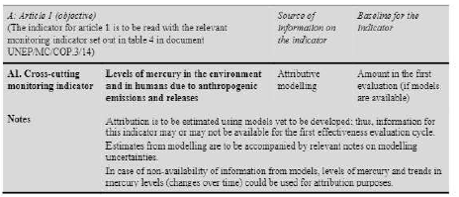
Comment:
Argentina considers this to be an important indicator; however, there is the technical challenge involved in carrying out the modelling and estimations necessary to study the contributions and attributions of the actions within the framework of the Convention. Therefore, it must be ensured that within the framework of the Convention there is a technical mechanism to develop this information.

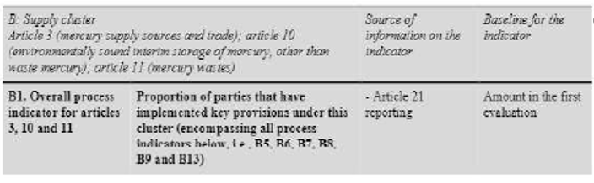
Comment:
Argentina supports this indicator.
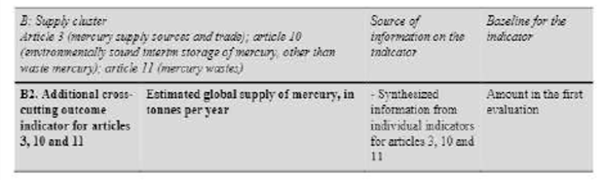
Comment:
Argentina supports this indicator and also supports the possibility of including other global reports as sources of information, provided that they are reviewed by peers and that they have the possibility of being validated or reviewed by the Parties.

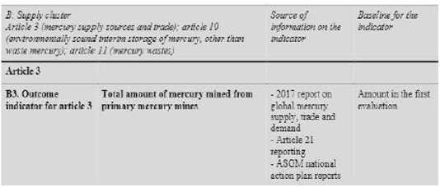
Comment:
Argentina supports this indicator.

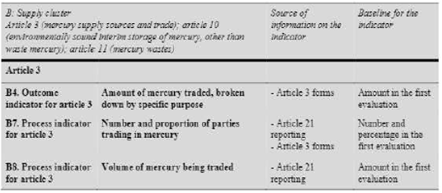
Comment:
Argentina proposes to merge B4 and B8. Also, this inclusion of global reports as a source of information is supported. The amendment proposal is also supported.
“Number and proportion of parties having appropriate measures to control trade of mercury with Article 3”.
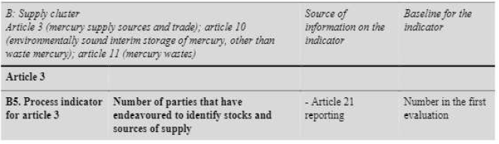
Comment:
The change “Number and proportion of parties” is supported.

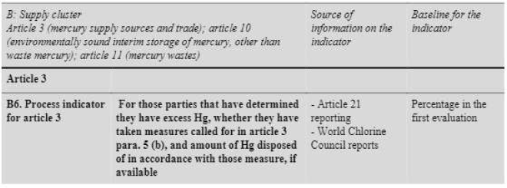
Comment:
It is supported without changes.

Comment:
The proposed change is supported: “for those countries that have mercury to store…”

Comment:
Its elimination can be accepted.
Comment:
The proposed corrections can be supported: “Amount of waste consisting of mercury and amount of waste consisting of mercury compounds subject to final disposal”. It is proposed to add as an alternative source the reports and information from the Basel Convention. This modification is supported: “subject to environmentally final disposal”.

Comment:
This indicator is supported, considering that it is important to know if there is installed capacity to manage mercury waste. Argentina understands that it is not the objective of the Convention to increase the number of countries, but it is the objective that the countries have access to final disposal technologies and they take measures to guarantee the proper management of mercury waste.
It is proposed to include the information from the Basel Convention as a source of information.

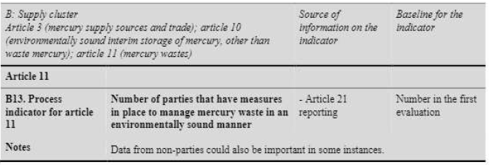
Comment:
This indicator is supported without changes..

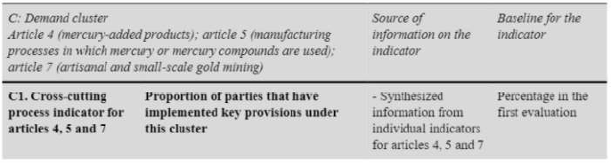
Comment:
It is supported to include: "proportion and number of..."
It is supported to give greater clarity of what the "key provisions" are.

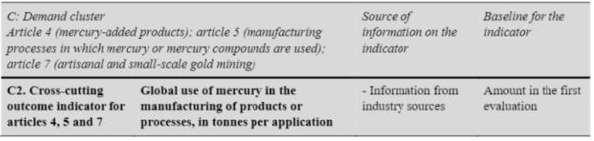
Comment:
Argentina supports the proposed change: “global use of Hg in products and annual consumption in processes in tonnes”.
It will be necessary to generate the necessary information sources to be able to evaluate this indicator.

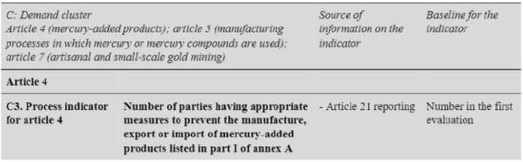
Comment:
Argentina supports this indicator. We support the change to "number and proportion of..."

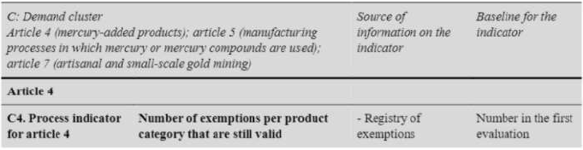
Comment:
Argentina supports this indicator.
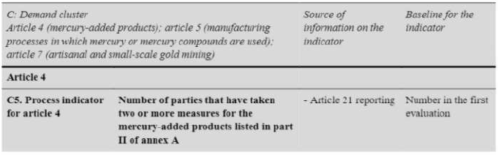
Comment:
Argentina supports this indicator. We support the change to “number and proportion of…”

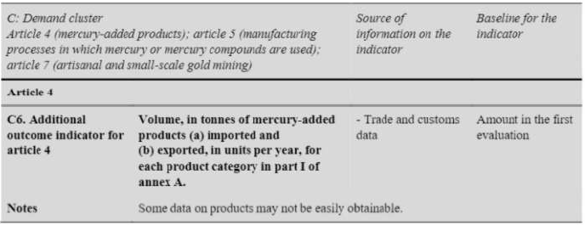
Comment:
Argentina supports this indicator. Technical work must be guaranteed and countries must be supported so that they can produce this information in collaboration with their respective customs and foreign trade offices.

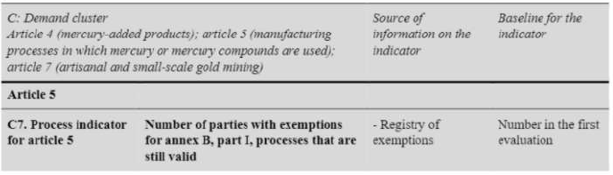
Comment:
Argentina considers that the information can be eliminated and is not relevant since it is duplicated in other indicators and the registry already exists without modification and identifies the States.

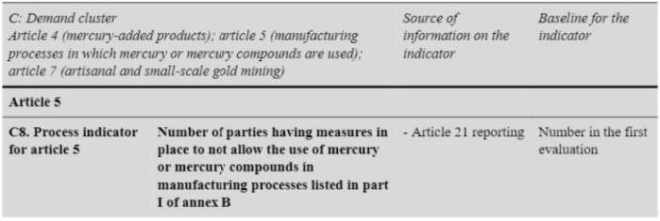
Comment:
Argentina supports this indicator.

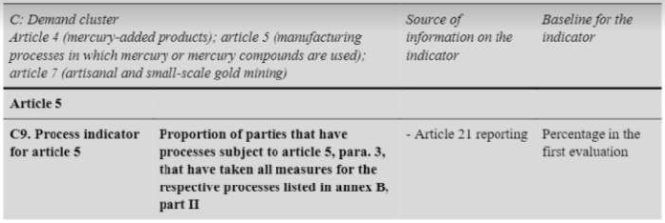
Comment:
Argentina supports this change: “number of parties having measures in place to restrict the use of mercury or mercury compounds in the processes listed in Part II of Annex B in accordance with the provisions set out therein”.

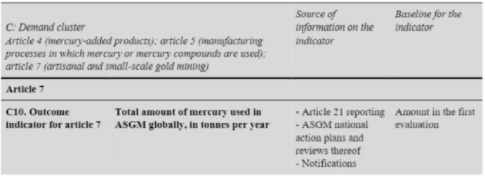
Comment:
Argentina supports this indicator. It should be ensured that the information sources allow the generation of this data.

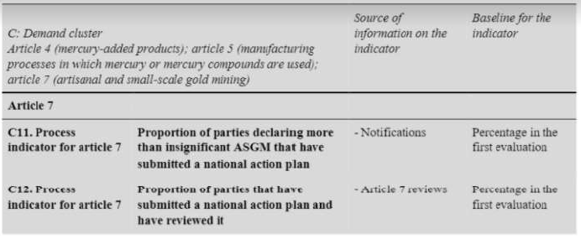
Comment:
Argentina supports the change proposals for indicators C11 and C12.
C11: “number and proportion of Parties that have notified the Secretariat about more than insignificant ASGM” and of those Parties, proportion that submitted a national action plan.
C12: “The number and proportion of Parties with a National Action Plan that have reviewed it (within the timeframe and specified in paragraph 3 c of article 7)”.

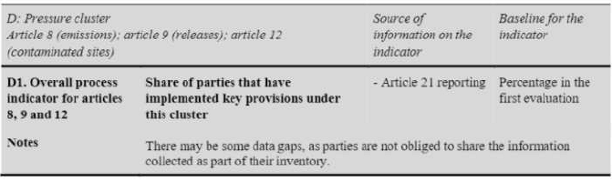
Comment:
Argentina supports the proposed modification: “number and proportion”. We state the importance of defining the scope of “key provision”.

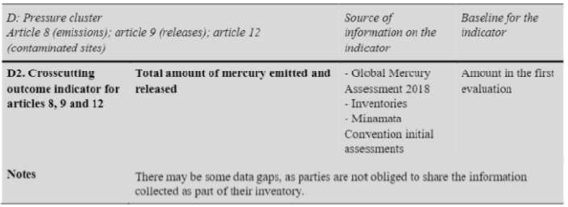

Comment:
Argentina supports the inclusion of the proposed term “relevant sources”.
The inventories that were carried out through the MIA are based on the UN Toolkit, but they are not exact sources, they are estimated data and, therefore, they are not realistic.

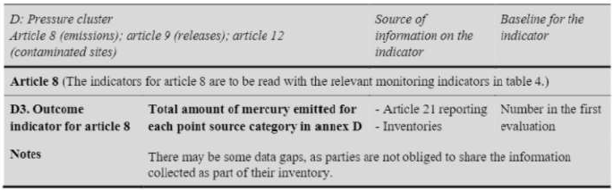
Comment:
Argentina supports the indicator.

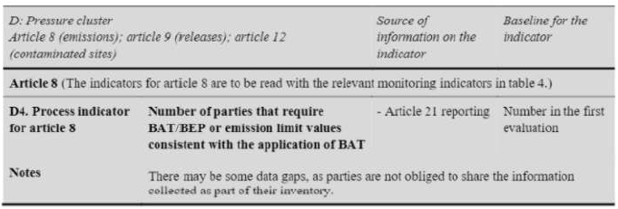
Comment:
Argentina supports the modification proposals to include “Number and proportion of parties…” and the proposal to add “For its new sources (per article 8, para. 4)”.

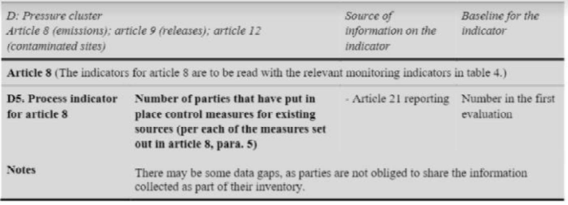
Comment:
Argentina supports the change to “Number and proportion of parties”.

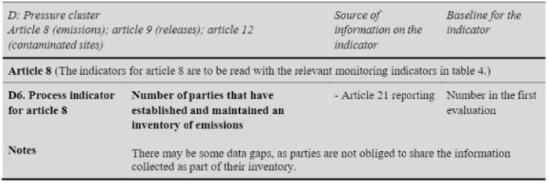
Comment:
Argentina supports the change to “Number and proportion of parties”.

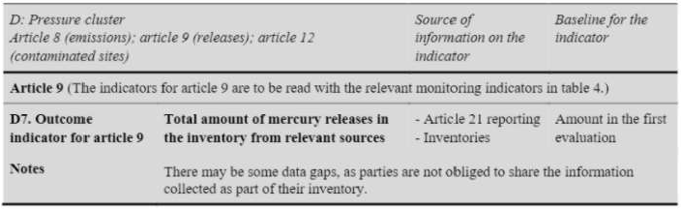
Comment:
Argentina supports the modification proposal: “Total amount of mercury releases in national inventories of Parties that have identified relevant sources”.

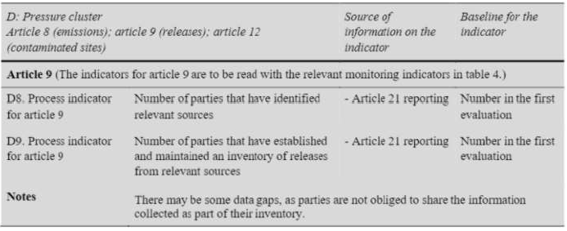
Comment:
Argentina supports the following change in both D8 and D9: “Number and proportion of parties”

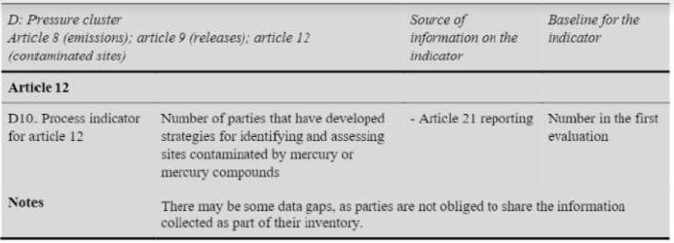
Comment:
Argentina supports the change “Number and proportion of parties that have endeavoured to develop strategies…”.

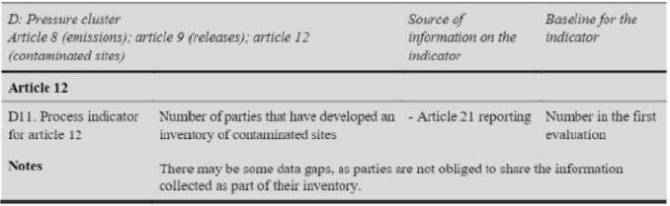
Comment:
Argentina accepts the elimination of this indicator, understanding that it is not an obligation to present inventories of contaminated sites.

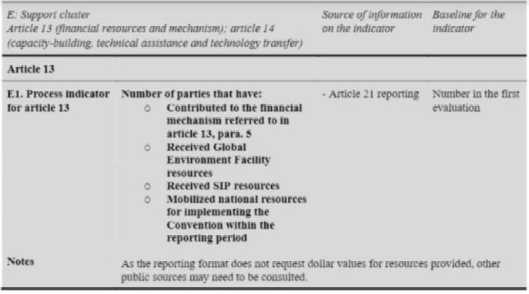
Comment:
Argentina supports this indicator.

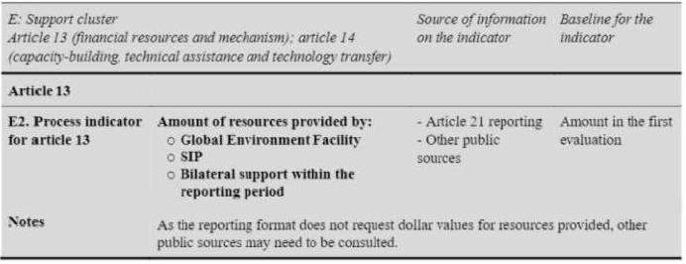
Comment:
Argentina considers that it is necessary to review this indicator since it is more important to provide appropriate assistance, knowing that these resources were able to achieve the objectives of Article 13, the challenges, but it cannot be evaluated solely by the amount of resources provided.

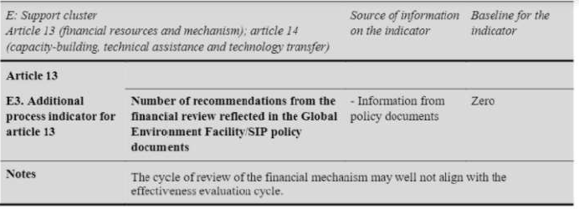
Comment:
Argentina shares the views expressed by several countries to eliminate this indicator.

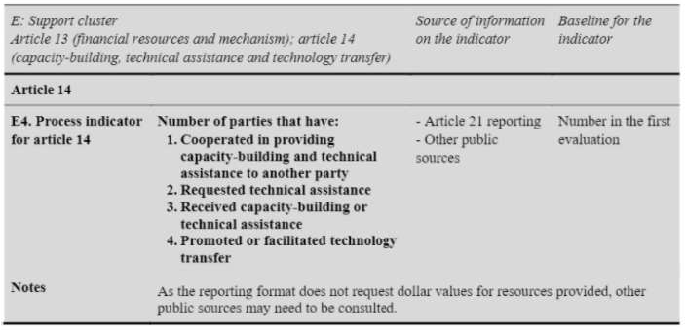
Comment:
Argentina supports the modifications: “Number and proportion of parties…”; & “Promoted or facilitated technology development, transfer, diffusion or access”.

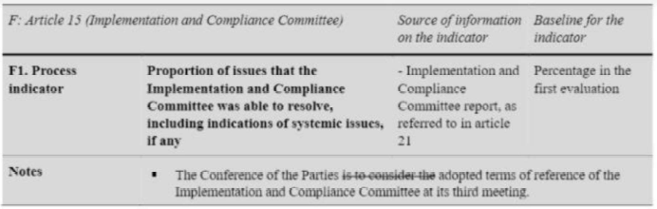
Comment:
Argentina supports this indicator with this change: “Number and proportion of issues for which the implementation and Compliance Committee facilitated resolution including indications of systemic issues, if any”.

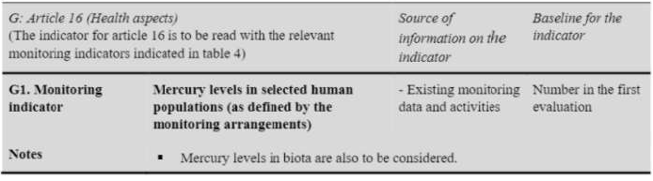
Comment:
Argentina supports this indicator. The MIA should be included as a source of information.

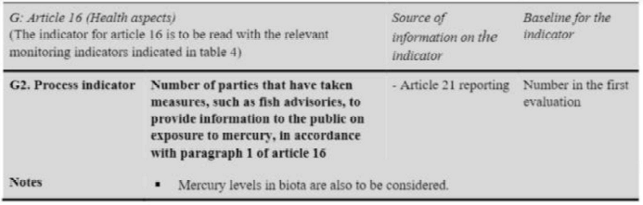
Comment:
Argentina supports this indicator with the following modification: “Number and proportion of parties that have taken measures, such as fich advisories, to provide information to the public on exposure to mercury, as encouraged by paragraph 1 of Article 16”.

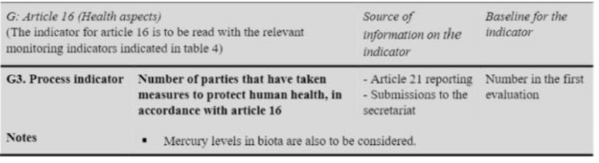
Comment:
Argentina supports this modification: “Number and proportion of parties that have taken other measures to protect human health”.

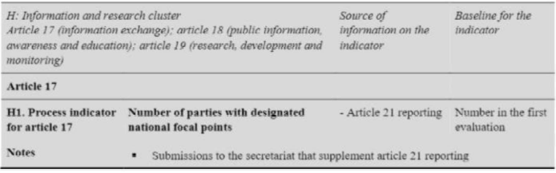
Comment:
Argentina supports this indicator.

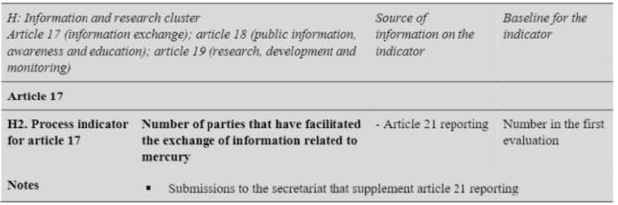
Comment:
Argentina supports this indicator without modifications.

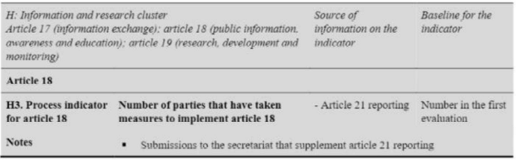
Comment:
Argentina supports this indicator with this modification: “Number of proportion of parties…”. It can be added as a source of information: Synergies with regional / international agreements that take into account this objective of access to public information and education.

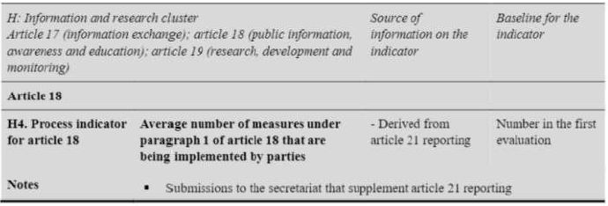
Comment:
Argentina supports its elimination as it seems repeated.

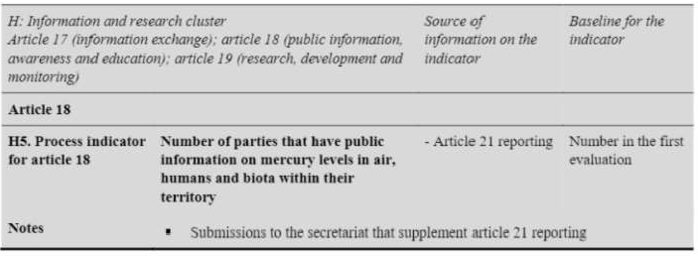
Comment:
Argentina proposes to modify: “number of countries that contribute information about…”

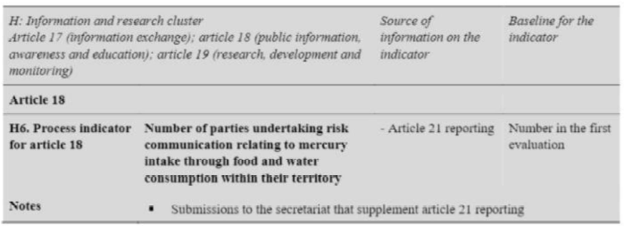
Comment:
Argentina supports its elimination, understanding that this information is repeated with the indicator G2.

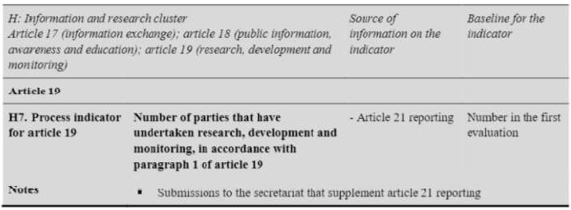
Comment:
Argentina supports the proposed modification: “Number and proportion of parties that have cooperated to develop and improve research, development and monitoring, in accordance with paragraph 1 of article 19”.

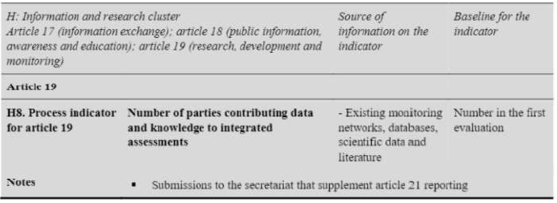
Comment:
Argentina suggests greater clarity with the objective of this indicator. In any case, the following change is suggested: “Percentage of Parties that were able to contribute to existing surveillance networks and research programs to carry out the activities defined on paragraph 1”. Since it is the closest to what is mentioned in art. 19 of the Convention. On the other hand, in accordance with the provisions of the agreement, it is optional and when appropriate.

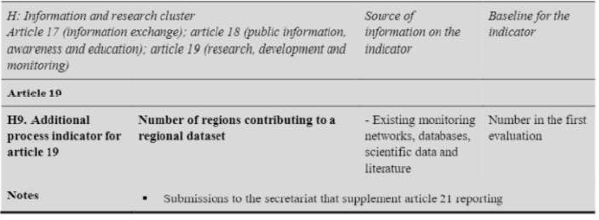
Comment:
Argentina recommends its elimination.

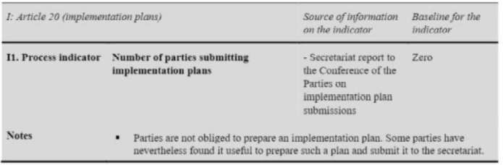
Comment:
Argentina supports this indicator.

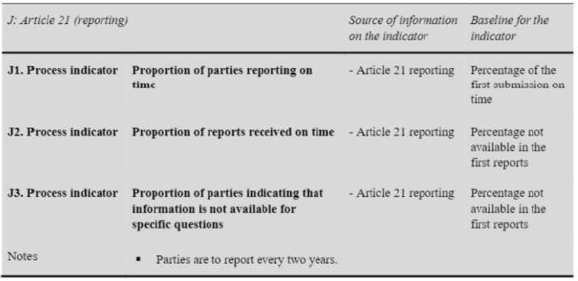
Comment:
Regarding indicators J1 and J2, Argentina considers that both indicators report the same issue and therefore it is suggested to eliminate J2.
Argentina supports the proposed change for indicator J3: “Number and proportion of parties indicating possible challenges in meeting the objectives of the Convention”.

Views from Canada
Further Comments from Canada on Proposed Indicators for Evaluating the Effectiveness of the Minamata Convention on Mercury

Canada appreciates the opportunity to provide further comments on the proposed list of indicators for the effectiveness evaluation of the Minamata Convention. As we have previously expressed, Canada is of the view that each treaty obligation contributes to achieving the treaty objective, and the sum of the information from all of the indicators will provide an integrated perspective of the treaty’s effectiveness.
To simplify and enhance understanding, Canada suggests that the proposed indicators be grouped under three broad categories: A. Monitoring Indicators, B. Lifecycle Indicators, and C. Enabling and Support Indicators. We also suggest that a column on Considerations be added to allow for additional explanation, as needed, on how an indicator should be used.
Canada sees the monitoring indicators as key to evaluating the treaty objective. It is therefore important to note that all indicators should be read in light of the monitoring indicators, as well as the four policy questions in the draft effectiveness evaluation framework proposed by the contact group at COP3. Canada recognizes that, during the first effectiveness evaluation process, these indicators may need to be refined as we gain real-world experience and clarity on the types and sources of information that are ultimately available.

After careful consideration of the views expressed by other parties in writing and during the exchange of views, some of Canada’s views on individual indicators have changed from our initial submission.
Canada’s detailed comments on the individual indicators can be found below.

Proposed indicators for evaluating the effectiveness of the Minamata Convention, by article

PREAMBLE

[Placeholder for preambular text to:
- Describe the three categories of: A. Monitoring Indicators; B. Lifecycle Indicators; and C. Enabling and Support Indicators.
- Describe the purpose of the Considerations column.
- Note that all indicators are to be read in light of the monitoring indicators and the four policy questions.
- Remind that the effectiveness evaluation is not a compliance check. There may be differences in some cases between the type and scope of information that would be collected for national reporting purposes and what could be examined as part of the effectiveness evaluation.]

 | - MONITORING INDICATORS
A: Article 1 (objective) (Monitoring cluster)  (The indicator for article 1 is to be read with the relevant monitoring indicator set out in table 4 in document UNEP/MC/COP.3/14) |  |  |  |  | Source of information on the indicator | Baseline for the indicator |  | Considerations
Delete the reference to table 4 in document UNEP/MC/COP.3/14 as this is now outdated.
A1. Cross-cutting monitoring indicator |  | Levels of mercury in the environment and in humans due to anthropogenic emissions and releases |  |  | - Information consistent with the effectiveness evaluation monitoring guidance Attributive modelling | Amount in the first evaluation (if models are available)
Notes |  | - Attribution is to be estimated using models yet to be developed; thus, information for this indicator may or may not be available for the first effectiveness evaluation cycle.  - Estimates from modelling are to be accompanied by relevant notes on modelling uncertainties.  - In case of non-availability of information from models, levels of mercury and trends in mercury levels (changes over time) could be used for attribution purposes. |  |  |  |  |  | These notes are not consistent with the Minamata draft monitoring guidance
G1. Monitoring indicator |  |  | Mercury levels in selected human populations (as defined by the monitoring guidance arrangements) | - Information consistent with the effectiveness evaluation monitoring guidance Existing monitoring data and activities |  |  | Number in the first evaluation | This indicator is important in order to assess levels of mercury in vulnerable populations, including women, children and Indigenous groups. Mercury levels and trends for these populations may differ from those in the general human population assessed in indicator A1
Move G1 from Article 16 (Health Aspects) to the Monitoring section so that all monitoring indicators are grouped together.

- LIFECYCLE INDICATORS
B: Supply cluster  Article 3 (mercury supply sources and trade); article 10 (environmentally sound interim storage of mercury, other than waste mercury); article 11 (mercury wastes) |  | Source of information on the indicator | Baseline for the indicator
B1. Overall process indicator for articles 3, 10 and 11 | Proportion of parties that have implemented key provisions under this cluster (encompassing all process indicators below, i.e., B5, B6, B7, B8, B9 and B13) | - Article 21 reporting | Amount in the first evaluation
We question the usefulness of B1 – it is difficult to sum up these subindicators to provide a meaningful metric.
Suggest deletion on the basis of duplication with the subsequent, more detailed, indicators.
B2. Additional cross-cutting outcome indicator for articles 3, 10 and 11 | Estimated global supply of mercury, in tonnes per year | - Synthesized information from individual indicators for articles 3, 10 and 11 as well as expert reports that are peer or publicly reviewed such the UNEP Global mercury supply, trade and demand report | Amount in the first evaluation
Article 3
B3. Outcome indicator for article 3 | Total amount of mercury mined from primary mercury mines | - UNEP 2017 reports on global mercury supply, trade and demand  - Article 21 reporting  - ASGM national action plan reports  - Minamata Initial Assessment (MIA) reports | Amount in the first evaluation
B4. Outcome indicator for article 3 | Amount of mercury traded, broken down by specific purpose | - Article 21 reporting  - Article 3 forms  - UN Comtrade database  - Chatham House Resourcetrade.earth database | Amount in the first evaluation | Discussion of this indicator should take note of the fact that trade is permitted for uses allowed under the Convention.
B5. Process indicator for article 3 | Number of parties that have endeavoured to identify individual stocks of mercury or mercury compounds exceeding 50 metric tons, and sources of supply generating stocks exceeding 10 metric tons per year that are located within its territory | - Article 21 reporting | Number in the first evaluation
B6. Process indicator for article 3 | For those parties that have determined they have excess Hg, whether they have taken measures called for in article 3 para. 5 (b), and amount of Hg disposed of in accordance with those measures, if available | - Article 21 reporting  - World Chlorine Council reports | Percentage in the first evaluation
B7. Process indicator for article 3 | Number and proportion of parties having appropriate measures to control import and export of mercury in accordance with Article 3 trading in mercury | - Article 21 reporting  - Article 3 forms  - Article 30 (4) forms  - UN Comtrade database | Number and percentage in the first evaluation
B8. Process indicator for article 3 | Volume of mercury being traded | - Article 21 reporting | Amount in the first evaluation
Delete B8 – duplicative with B4
Article 10
B9. Process indicator for article 10 | Number and proportion of parties that have taken measures to ensure sound interim storage | - Article 21 reporting | Number and percentage in the first evaluation | Only parties who have mercury to store on an interim basis would have to take such measures
B10. Outcome indicator for article 10 | Amount of mercury stored in an environmentally sound way (as identified in the inventory of stocks) | - Article 21 reporting | Amount in the first evaluation
Article 11
B11. Outcome indicator for article 11 | Amount of waste containing consisting of mercury or and amount of waste consisting of mercury compounds subject to final disposal | - Article 21 reporting  - Trade, Supply and Demand report, which will include Hg waste flows and stocks | Amount in the first evaluation
B12. Outcome indicator for article 11 | Number of parties with facilities for final disposal of waste containing mercury or mercury compounds | - Article 21 reporting | Number in the first evaluation | Not all parties need to have facilities for final disposal as the treaty allows for mercury waste to be transported across national boundaries for environmentally sound disposal.
B13. Process indicator for article 11 | Number and proportion of parties that have implemented measures outlined in article 11, paragraph 3, for the party's mercury waste in place to manage mercury waste in an environmentally sound manner | - Article 21 reporting | Number and percentage in the first evaluation
Notes | - Data from non-parties could also be important in some instances.

C: Demand cluster  Article 4 (mercury-added products); article 5 (manufacturing processes in which mercury or mercury compounds are used); article 7 (artisanal and small-scale gold mining) |  | Source of information on the indicator | Baseline for the indicator
C1. Cross-cutting process indicator for articles 4, 5 and 7 | Proportion of parties that have implemented key provisions under this cluster | - Synthesized information from individual indicators for articles 4, 5 and 7 | Percentage in the first evaluation
We question the usefulness of C1 – it is difficult to sum up these subindicators to provide a meaningful metric.
Suggest deletion on the basis of duplication with the subsequent, more detailed, indicators.
C2. Cross-cutting outcome indicator for articles 4, 5 and 7 | Global use of mercury in the manufacturing of products or and annual consumption in processes, in tonnes per application | - Information from industry sources | Amount in the first evaluation
Article 4
C3. Process indicator for article 4 | Number and proportion of parties subject to Article 4 paragraph 1 having appropriate measures to prevent the manufacture, export or import of mercury-added products listed in part I of annex A | - Article 21 reporting | Number and percentage in the first evaluation
C4. Process indicator for article 4 | Number of exemptions per product category that are still valid | - Registry of exemptions | Number in the first evaluation
C5. Process indicator for article 4 | Number of parties that have taken two or more measures for the mercury-added products listed in part II of annex A | - Article 21 reporting | Number in the first evaluation
C6. Additional outcome indicator for article 4 | Volume, in tonnes of mercury-added products (a) imported and (b) exported, in units per year, for each product category in part I of annex A. | - Trade and customs data  - Trade, Supply and Demand report | Amount in the first evaluation
Article 5
C7. Process indicator for article 5 | Number of parties with exemptions for annex B, part I, processes that are still valid | - Registry of exemptions | Number in the first evaluation
C8. Process indicator for article 5 | For each process listed in part I of annex B, the nNumber and proportion of parties having which conduct those processes that have measures in place to not allow the use of mercury or mercury compounds after the phase out date for it in manufacturing processes listed in part I of annex B | - Article 21 reporting | Number and percentage in the first evaluation
C9. Process indicator for article 5 | For each process listed in part II of annex B, the number and pProportion of parties which conduct those processes that have all measures in place to restrict the use of mercury or mercury compounds in accordance with the provisions set out therein processes subject to article 5, para. 3, that have taken all measures for the respective processes listed in annex B, part II | - Article 21 reporting | Number and percentage in the first evaluation
Article 7
C10. Outcome indicator for article 7 | Total amount of mercury used in ASGM globally, in tonnes per year | - Article 21 reporting  - ASGM national action plans and reviews thereof  - Notifications | Amount in the first evaluation
C11. Process indicator for article 7 | Number and pProportion of parties:  1. that have notified the Secretariat about more than insignificant ASGM in their territories,  2. of those parties, the proportion that have submitted a national action plan.  declaring more than insignificant ASGM that have submitted a national action plan | - Notifications | Number and percentage in the first evaluation
C12. Process indicator for article 7 | Number and pProportion of parties that have submitted with a national action plan and that have reviewed it within the timeframe specified in paragraph 3(c) of Article 7 | - Article 7 reviews  - Article 21 reporting | Number and percentage in the first evaluation
Notes | - Some data on products may not be easily obtainable.

D: Pressure cluster  Article 8 (emissions); article 9 (releases); article 12 (contaminated sites) |  | Source of information on the indicator | Baseline for the indicator
D1. Overall process indicator for articles 8, 9 and 12 | Share of parties that have implemented key provisions under this cluster | - Article 21 reporting | Percentage in the first evaluation
We question the usefulness of D1 – it is difficult to sum up these subindicators to provide a meaningful metric.
Suggest deletion on the basis of duplication with the subsequent, more detailed, indicators.
D2. Crosscutting outcome indicator for articles 8 and 9 and 12 | Total amount of mercury emitted and released | - Global Mercury Assessment 2018  - Party Inventories  - Minamata Convention initial assessments | Amount in the first evaluation | Information from different sources should be consolidated
Remove reference to Article 12 on contaminated sites, as emissions and releases from this source are not required to be included in an inventory, and information is not available.
Article 8 (The indicators for article 8 are to be read with the relevant monitoring indicators in table 4.)
Delete the reference to table 4 in document UNEP/MC/COP.3/14 as this is now outdated.
D3. Outcome indicator for article 8 | Total amount of mercury emitted for each point source category in annex D | - Article 21 reporting  - Party Inventories | Number Amount in the first evaluation
D4. Process indicator for article 8 | Number and proportion of parties that require BAT/BEP or emission limit values consistent with the application of BAT for new sources (per article 8, para. 4) | - Article 21 reporting | Number and percentage in the first evaluation
D5. Process indicator for article 8 | Number and proportion of parties that have put in place control measures for existing sources (per each of the measures set out in article 8, para. 5) | - Article 21 reporting | Number and percentage in the first evaluation
D6. Process indicator for article 8 | Number and proportion of parties that have established and maintained an inventory of emissions | - Article 21 reporting | Number and percentage in the first evaluation
Article 9 (The indicators for article 9 are to be read with the relevant monitoring indicators in table 4.)
Delete the reference to table 4 in document UNEP/MC/COP.3/14 as this is now outdated.
D7. Outcome indicator for article 9 | Total amount of mercury releases in the inventories of parties that have identified inventory from relevant sources | - Article 21 reporting  - Party Inventories | Amount in the first evaluation
D8. Process indicator for article 9 | Number of parties that have identified relevant sources, and of those parties, the proportion that have put in place control measures | - Article 21 reporting | Number and percentage in the first evaluation
D9. Process indicator for article 9 | Number of parties that have established and maintained an inventory of releases from relevant sources | - Article 21 reporting | Number in the first evaluation
Article 12
D10. Process indicator for article 12 | Number of parties that have endeavoured to develop developed strategies for identifying and assessing sites contaminated by mercury or mercury compounds | - Article 21 reporting | Number in the first evaluation
D11. Process indicator for article 12 | Number of parties that have developed an inventory of contaminated sites | - Article 21 reporting | Number in the first evaluation
Notes | - There may be some data gaps, as parties are not obliged to share the information collected as part of their inventory.

- ENABLING AND SUPPORT INDICATORS
E: Support cluster  Article 13 (financial resources and mechanism); article 14 (capacity-building, technical assistance and technology transfer) |  | Source of information on the indicator | Baseline for the indicator
Article 13
E1. Process indicator for article 13 | For each of the following sub-indicators, nNumber of parties that have:  - Contributed to the financial mechanism referred to in article 13, para. 5  - Received Global Environment Facility resources  - Received SIP resources  - Mobilized national resources for implementing the Convention within the reporting period | - Article 21 reporting | Number in the first evaluation
E2. Process indicator for article 13 | For each of the following sub-indicators, aAmount of resources provided by:  - Global Environment Facility  - SIP  - Bilateral support within the reporting period | - Article 21 reporting  - Other public sources | Amount in the first evaluation
E3. Additional process indicator for article 13 | Reduction of mercury emissions and releases due to support from Number of recommendations from the financial review reflected in the Global Environment Facility/SIP policy documents | - Information from policy documents | Zero
The mere number of recommendations from the financial review reflected in GEF/SIP documents would not be a helpful metric. Suggest refining to reflect the estimated reduction of mercury emissions and releases due to support provided by these funds.
Article 14
E4. Process indicator for article 14 | For each of the following sub-indicators, Nnumber of parties that have:  - Cooperated in providing capacity-building and technical assistance to another party  - Requested technical assistance  - Received capacity-building or technical assistance  - Promoted or facilitated technology development, transfer, diffusion or access | - Article 21 reporting  - Other public sources | Number in the first evaluation
Notes | - The cycle of review of the financial mechanism may well not align with the effectiveness evaluation cycle.  - As the reporting format does not request dollar values for resources provided, other public sources may need to be consulted.

F: Article 15 (Implementation and Compliance Committee) |  | Source of information on the indicator | Baseline for the indicator
F1. Process indicator | Proportion of issues for which that the Implementation and Compliance Committee was able to facilitate resolution resolve, including indications of systemic issues, if any | - Implementation and Compliance Committee report, as referred to in article 21 | Percentage in the first evaluation
The ICC does not resolve issues. Rather, their role is to examine compliance issues and make recommendations on how they can be resolved.
Notes | - The Conference of the Parties is to consider the terms of reference of the Implementation and Compliance Committee at its third meeting.

G: Article 16 (Health aspects)  (The indicator for article 16 is to be read with the relevant monitoring indicators indicated in table 4) |  | Source of information on the indicator | Baseline for the indicator
Delete the reference to table 4 in document UNEP/MC/COP.3/14 as this is now outdated.
G1. Monitoring indicator | Mercury levels in selected human populations (as defined by the monitoring arrangements) | - Existing monitoring data and activities | Number in the first evaluation
Move G1 to Monitoring section with A1.
G2. Process indicator | Number and proportion of parties that have taken measures, such as fish advisories, to provide information to the public on exposure to mercury, in accordance with as encouraged by paragraph 1 of article 16 | - Article 21 reporting | Number and percentage in the first evaluation
G3. Process indicator | Number and proportion of parties that have taken other measures to protect human health, in accordance with as encouraged by article 16 | - Article 21 reporting  - Submissions to the secretariat | Number and percentage in the first evaluation
Notes | - Mercury levels in biota are also to be considered.

H: Information and research cluster  Article 17 (information exchange); article 18 (public information, awareness and education); article 19 (research, development and monitoring) |  | Source of information on the indicator | Baseline for the indicator
Article 17
H1. Process indicator for article 17 | Number of parties with designated national focal points | - Article 21 reporting | Number in the first evaluation
H2. Process indicator for article 17 | Number and proportion of parties that have facilitated the exchange of information related to mercury | - Article 21 reporting | Number and percentage in the first evaluation
Article 18
H3. Process indicator for article 18 | Number and proportion of parties that have taken measures to implement article 18 | - Article 21 reporting | Number and percentage in the first evaluation
H4. Process indicator for article 18 | Average number of measures under paragraph 1 of article 18 that are being implemented by parties | - Derived from article 21 reporting | Number in the first evaluation
Delete due to duplication with H3
H5. Process indicator for article 18 | Number of parties that have public information on mercury levels in air, humans and biota within their territory | - Article 21 reporting | Number in the first evaluation
H6. Process indicator for article 18 | Number of parties undertaking risk communication relating to mercury intake through food and water consumption within their territory | - Article 21 reporting | Number in the first evaluation
Article 19
H7. Process indicator for article 19 | Number of parties that have undertaken research, development and monitoring, in accordance with paragraph 1 of article 19 | - Article 21 reporting | Number in the first evaluation
H8. Process indicator for article 19 | Number of parties contributing data and knowledge to integrated assessments Number of parties making monitoring data and scientific assessments publicly available | - Existing monitoring networks, databases, scientific data and literature | Number in the first evaluation
This indicator is unclear. If scientific work is conducted in a party’s territory, but the work is not done by the party itself, would the party be considered as having contributed its data and knowledge to integrated assessments?

Suggest refining the indicator to provide information on the number of parties for which data is publicly available.
H9. Additional process indicator for article 19 | Number of regions contributing to a regional dataset Number of parties contributing to regional or international monitoring networks | - Existing monitoring networks, databases, scientific data and literature | Number in the first evaluation
This indicator is unclear. Suggest refining the indicator to provide information on the number of parties who contribute to regional or international monitoring networks.
Notes | - Submissions to the secretariat that supplement article 21 reporting

I: Article 20 (implementation plans) |  | Source of information on the indicator | Baseline for the indicator
I1. Process indicator | Number of parties submitting implementation plans | - Secretariat report to the Conference of the Parties on implementation plan submissions | Zero
Delete as implementation plans are not required under the Convention.
Notes | - Parties are not obliged to prepare an implementation plan. Some parties have nevertheless found it useful to prepare such a plan and submit it to the secretariat.

J: Article 21 (reporting) |  | Source of information on the indicator | Baseline for the indicator
J1. Process indicator | Proportion of parties reporting on time | - Article 21 reporting | Percentage of the first submission on time
Delete “on time” to remove duplication from J2. It is important to know the proportion of parties who reported, even if they did not meet the deadline.
J2. Process indicator | Proportion of reports received on time with complete information | - Article 21 reporting | Percentage not available in the first reports
It is important to track the completeness of reports. Complete information would indicate that the reporting template and accompanying guidance is clear.
J3. Process indicator | Proportion of parties indicating that information is not available for specific questions | - Article 21 reporting | Percentage not available in the first reports
Notes | - Parties are to report every two years.
Abbreviations: ASGM, artisanal and small-scale gold mining; BAT/BEP, best available techniques/best environmental practices; SIP, Specific International Programme to Support Capacity-building and Technical Assistance.

Views from China
China’s Comments on Proposed Indicators for Evaluating the Effectiveness of the Minamata Convention on Mercury

I. General Comments
(I) It is suggested to add a column in the table to clarify relevance between each proposed indicator and the overall objective of effectiveness evaluation.
Reason: The purpose of some proposed indicators is not clear, which is not closely related to the objective of the Minamata Convention on Mercury, that is, Article 1 of the Convention “The objective of this Convention is to protect the human health and the environment from anthropogenic emissions and releases of mercury and mercury compounds”. Therefore, it is suggested that further clarification is added.

(II) It is recommended that “source of information on the indicator” should be limited to the information or reports submitted by the Parties to the Convention or relevant institutions under the Convention mechanism (such as the Global Environment Facility and the Implementation and Compliance Committee) in accordance with the requirements of the Convention, so as to ensure the reliability of information sources and maintain the authority of effectiveness evaluation results of the Convention.
Reason: The “source of information on the indicator” in the proposed indicators is wide-ranging, including “Trade and customs data”, “Other public sources”, “Existing monitoring data and activities” and other ambiguous information sources, therefore, it is impossible to judge the reliability of the information sources. In order to ensure reliability and authoritative of the effectiveness evaluation results, it is suggested to standardize and limit the scope of “source of information on the indicator”.

(III) It is suggested that the “comparable monitoring data” should comply with the monitoring guidelines for effectiveness evaluation adopted by the Conference of the Parties. In addition, the “comparable monitoring data” provided by the Focal Points of the Parties should be used as the prior information source.
Reason: The definition of “comparable monitoring data” in Article 22 (Effectiveness Evaluation) of the Convention has not been clearly defined, the monitoring guidelines for effectiveness evaluation of Convention compliance is still being prepared, and the “list of indicative monitoring indicators by media” mentioned in Table 4 of UNEP/MC/COP.3/14 in the draft proposed framework for the effectiveness evaluation has not been adopted by the Conference of the Parties. In addition, considering that under the Global Monitoring Plan for persistent organic pollutants, national monitoring data is often of higher quality than data from regional monitoring projects, Therefore, it is suggested that the “comparable monitoring data” should comply with monitoring guidelines for effectiveness evaluation adopted by the Conference of the Parties. And the “comparable monitoring data” monitoring reports provided by the Focal Points of the Parties should be used as the prior information source to ensure the credibility and reliability of effectiveness evaluation.

(IV) It is suggested to delete the content related to “attributive modelling”
Reasons: First, in Article 22 of the Convention (Effectiveness Evaluation), it states that “The evaluation shall be conducted on the basis of available scientific, environmental, technical, financial and economic information, including comparable monitoring data, national report, information and recommendations provided by the ICC, and reports and other relevant information on the operation of the financial assistance, technology transfer and capacity-building arrangements put in place under this Convention”. Therefore, attributive modelling is excluded from the description of information basis of effectiveness evaluation in the Convention. Second, there exists uncertainty of attributive modelling in the effectiveness evaluation, which lacks basic research and has a narrow application, and the theoretical and practical basis for establishing attributive correlation between measures and effect is insufficient, which does not belong to “available” information required by Article 22 of the Convention. Therefore, it is not recommended to carry out attributive analysis based on modelling.

(V) It is suggested that the wording and description of the proposed indicators be consistent with relevant expressions of the Convention text and the national report.
Reason: In order to avoid ambiguity or confusion.

II. Specific Suggestions
For specific suggestions, see the attached table below.

Annex
Specific suggestions on the proposed indicators for evaluating the effectiveness of the Minamata Convention
Article |  | Source of  information on the indicator | Suggestions for revision
A: Article 1 (objective)  (The indicator for article 1 is to be read with the relevant monitoring indicator in table 4.) |  |  | Delete “(The indicator for article 1 is to be read with the relevant monitoring indicator in table 4.)”.  【Reason】Neither UNEP/MC/COP.3/14 nor Table 4 in it has been deliberated on by the Conference of the Parties, thus cannot be used as a basis for interpretation.
A1.Cross-cutting monitoring indicator | Levels of mercury in the environment and  In humans due to anthropogenic  emissions and releases | Attributive  modelling | Delete the indicator.  【Reason】The Convention does not set a target value for mercury content in the environment or human body, and there is no authoritative data source recognized by all Parties on this indicator. In addition, attributive modelling in the effectiveness evaluation, lacks basic research, so it is not recommended as the information source of indicators.
Notes | - Attribution is to be estimated using models yet to be developed; thus, information for this indicator may or may not be available for the first effectiveness evaluation cycle.  - Estimates from modelling are to be accompanied by relevant notes on modelling uncertainties.  - In case of non-availability of information from models, levels of mercury and trends in mercury levels (changes over time) could be used for attribution purposes. |  | Delete the third note “In case of non-availability of information from models, levels of mercury and trends in mercury levels (changes over time) could be used for attribution purposes”.  【Reason】There exists uncertainty of attributive modelling in the effectiveness evaluation, which lacks basic research and has a narrow application, and the theoretical and practical basis for establishing attributive correlation between measures and effect is insufficient. Therefore, it is not recommended to carry out attributive analysis based on modelling.
B: Supply cluster
Article 3 (mercury supply sources and trade);
Article 10(environmentally sound interim storage of mercury other
than waste mercury);
Article 11 (mercury waste)
B1.Overall process  indicator for articles 3,10 and 11 | Proportion of parties that have implemented key provisions under this cluster (encompassing all process indicators below, i.e., B5, B6, B7, B8, B9 and B13) | -Article 21 reporting
B2.Additional cross-cutting outcome indicator for articles 3,10 and 11 | Estimated global supply of mercury, in tonnes per year | -Synthesized information from individual indicators for articles 3, 10 and 11 | Remove the indicator.  【Reason】The Convention is effective only for the Parties, and “global” indicators for effective evaluation is yet to be established. There is no authoritative data source recognized by all Parties for this indicator. At the same time, the relevance between this indicator and the overall objective of effectiveness evaluation is vague.
Article 3
B3.Outcome indicator for article 3 | Total amount of mercury mined from primary mercury mines | -2017 report on global mercury supply, trade and demand  - Article 21  reporting  -ASGM national action plan reports | Remove “2017 report on global mercury supply, trade and demand” in “source of information on the indicator”.  【Reason】“Source of information on the indicator” should be limited to the information or reports submitted by the Parties to the Convention or relevant institutions under the Convention mechanism (such as the Global Environment Facility and the Implementation and Compliance Committee) in accordance with the requirements of the Convention, so as to ensure the reliability of information sources.
B3.Outcome indicator for article 3 | Total amount of mercury mined from primary mercury mines |  | Remove “ASGM national action plan reports” in “source of information on the indicator”.  【Reason】 “ASGM” is one of the uses of mercury, rather than mercury mining. The correlation with primary mercury mining amount is unclear.
B4.Outcome indicator for article 3 | Amount of mercury traded, broken down by specific purpose | -Article 3 forms | Add “Article 21 reporting” in “source of information on the indicator”.  【Reason】The information on mercury import and export required by Article 3 under the Convention has been included in the national report and should be used as a prior source of information.
B5.Process indicator for article 3 | Number of parties that have endeavored to identify stocks and sources of supply | - Article 21  reporting
B6.Process indicator  for article 3 | For those Parties that have determined they have excess Hg, whether they have taken measures called for in article 3 para. 5(b), and amount of Hg disposed of in accordance with those measure, if available | - Article 21  reporting  -World Chlorine Council reports | Delete “World Chlorine Council reports” in “source of information on the indicator”.  【Reason】“Source of information on the indicator” should be from the information or reports submitted by the Parties to the Convention or relevant institutions under the Convention mechanism.
B7.Process indicator  for article 3 | Number and proportion of parties trading in mercury | -Article 21 Reporting  -Article 3 forms | Delete “proportion”.  【Reason】In different indicators, calculating “proportion” corresponds to different Parties as denominator, so the calculation results tend to cause ambiguity and is of little significance.
B7.Process indicator  for article 3 | Number and proportion of parties trading in mercury | -Article 21 Reporting  -Article 3 forms | Modify the wording to “Number of parties having appropriate measures to control trade of mercury in accordance with Article 3”.  【Reason】It is suggested that the wording and description of the indicator system be consistent with relevant expressions of the Convention text and the national report.
B8.Process indicator  for article 3 | Volume of mercury being traded | -Article 21  reporting
Article 10
B9.Process indicator for article 10 | Number and proportion of parties that have taken measures to ensure sound interim storage | -Article 21 reporting | Delete “proportion”.  【Reason】It is suggested that the wording and description of the indicator system be consistent with relevant expressions of the Convention text and the national report
B10.Outcome  indicator for article 10 | Amount of mercury stored in an environmentally sound way (as identified  in the inventory of stocks) | -Article 21 reporting | Delete this indicator  【Reason】Information in this indicator is not required by the Convention text and the Article 21 reporting.
Article 11
B11.Outcome  indicator for article 11 | Amount of waste containing mercury or  mercury compounds subject to final disposal | -Article 21 reporting | Change “waste containing mercury or mercury compounds” into “waste consisting of mercury or mercury compounds”.  【Reason】To be consistent with relevant expressions of the Convention text and the national report.
B12.Outcome  indicator for article 11 | Number of parties with facilities for final disposal of waste containing mercury or  mercury compounds | -Article 21 reporting | Delete this indicator.  【Reason】The relevance between this indicator and the overall objective of effectiveness evaluation is vague, thus the indicator cannot illustrate the measures taken by the Parties in terms of the environmentally sound management of wastes.
B13.Process indicator for article 11 | Number of parties that have measures in  place to manage mercury waste in an  environmentally sound manner | -Article 21 reporting
Notes
C: Demand cluster
Article 4 (mercury-added products);
Article 5 (manufacturing processes in which mercury or mercury compounds are used);
Article 7 (artisanal and small-scale gold mining)
C1.Cross-cutting  process indicator for  articles 4, 5 and 7 | Proportion of parties that have implemented key provisions under this cluster | -Synthesized information from individual indicators for articles 4, 5 and 7
C2.Cross-cutting  outcome indicator for articles 4, 5 and 7 | Global use of mercury in the manufacturing of products or processes,  in tonnes per application | - Information from industry sources | Delete this indicator.  【Reason】1) The Convention has not yet established relevant indicators, and information in this indicator is not required by the Convention text and the Article 21 reporting. 2) “Source of information on the indicator” should be from the information or reports submitted by the Parties to the Convention or relevant institutions under the Convention mechanism in accordance with the requirements of the Convention, so as to ensure the reliability of information sources and maintain the authority of effectiveness evaluation results of the Convention.
Article 4
C3.Process indicator for article 4 | Number of parties having appropriate measures to prevent the manufacture, export or import of mercury-added products listed in part I of annex A | -Article 21 reporting | Modify the wording to “Number of parties having appropriate measures to prevent the manufacture, export or import of mercury-added products listed in part I of annex A of the convention after the phase-out date specified for those products”.  【Reason】To be consistent with relevant expressions of the national report.
C4.Process indicator for article 4 | Number of exemptions per product category that are still valid | -Registry of exemptions | Delete this indicator.  【Reason】The relevance between this indicator and the overall objective of effectiveness evaluation is vague and the number of exemptions does not reflect Convention compliance of the Parties.
C5.Process indicator for article 4 | Number of parties that have taken two or more measures for the mercury-added products listed in part II of annex A | -Article 21 reporting
C6.Additional  outcome indicator for  article 4 | Volume, in tonnes of mercury-added products (a) imported and (b) exported, in units per year, for each product category in part I of annex A. | - Trade and customs data | Delete this indicator.  【Reason】1) The relevance between this indicator and the overall objective of effectiveness evaluation is vague. 2) Data are not available through national reports. 3) The description of “trade and customs data” as “source of information on the indicator” is not clear, so it’s impossible to judge the reliability of data source.
Article 5
C7.Process indicator  for article 5 | Number of parties with exemptions for annex B, part I, processes that are still valid | - Registry of  exemptions | Delete this indicator.  【Reason】The relevance between this indicator and the overall objective of effectiveness evaluation is vague and the number of exemptions does not reflect Convention compliance of the Parties.
C8.Process indicator for article 5 | Number of parties having measures in  place to not allow the use of mercury or mercury compounds in manufacturing processes listed in part I of annex B | -Article 21 reporting
C9.Process indicator for article 5 | Proportion of parties that have processes subject to article 5, para. 3, that have taken all measures for the respective processes listed in annex B, part II | -Article 21 reporting | Modify the wording to “Number of parties having measures in place to restrict the use of mercury or mercury compounds in the processes listed in Part II of Annex B in accordance with the provisions set out therein”.  【Reason】Related description needs to be consistent with expressions in the national report.
Article 7
C10.Outcome  indicator for article 7 | Total amount of mercury used in ASGM  globally, in tonnes per year | -Article 21 reporting  -ASGM national  action plans and reviews thereof  -Notifications | Delete “Notifications” in “source of information on the indicator”.  【Reason】The description of “Notifications” as “source of information on the indicator” is vague, so it is impossible to judge the reliability of the data source.
C11.Process indicator  for article 7 | Proportion of parties declaring more than insignificant ASGM that have submitted a national action plan | -Notifications  Article 21 reporting | Change “Notifications” into “Article 21 reporting” in “source of information on the indicator”.  【Reason】The description of “Notifications” as “source of information on the indicator” is vague, so it is impossible to judge the reliability of the data source. In addition, related indicators are available in national reports.
C12.Process indicator for article 7 | Proportion of parties that have submitted a national action plan and have reviewed  it | -Article 7 reviews
Notes
D: Pressure cluster
Article 8 (emissions);
Article 9 (releases);
Article 12(contaminated sites)
D1.Overall process  indicator for articles 8,9 and 12 | Share of parties that have implemented key provisions under this cluster | -Article 21 reporting
D2. Crosscutting  outcome indicator for  articles 8, 9 and 12 | Total amount of mercury emitted and  released | -Global Mercury  Assessment 2018  - Inventories  - Minamata  Convention initial assessments | Delete this indicator.  【Reason】1) The Convention has not yet established relevant indicators, and reliable data sources are not available under the Convention mechanism. 2) “Source of information on the indicator” should be from the information or reports submitted by the Parties to the Convention or relevant institutions under the Convention mechanism in accordance with the requirements of the Convention, so as to ensure the reliability of information sources
Article 8 (The indicators for article 8 are to be read with the relevant monitoring indicators in table 4.) |  |  | Delete “(The indicators for article 8 are to be read with the relevant monitoring indicators in table 4.)”.  【Reason】Neither UNEP/MC/COP.3/14 nor Table 4 in it has been deliberated on by the Conference of the Parties, thus cannot be used as a basis for interpretation.
D3.Outcome indicator  for article 8 | Total amount of mercury emitted for each point source category in annex D | -Article 21 reporting  - Inventories
D4.Process indicator  for article 8 | Number of parties that require BAT/BEP or emission limit values consistent with the application of BAT | -Article 21 reporting
D5.Process indicator  for article 8 | Number of parties that have put in place control measures for existing sources (per each of the measures set out in  article 8, para. 5) | -Article 21 reporting | Delete “(per each of the measures set out in article 8, para. 5)” in parentheses.  【Reason】Parties can take one or more control measures according to the Convention, and it is recommended to keep consistency with the requirements of the Convention.
D6.Process indicator  for article 8 | Number of parties that have established and maintained an inventory of emissions | -Article 21 reporting
Article 9 (The indicators for article 9 are to be read with the relevant monitoring indicators in table 4.) |  |  | Remove “(The indicators for article 9 are to be read with the relevant monitoring indicators in table 4.)”.  【Reason】Neither UNEP/MC/COP.3/14 nor Table 4 in it has been deliberated on by the Conference of the Parties, thus cannot be used as a basis for interpretation.
D7.Outcome indicator for article 9 | Total amount of mercury releases in the inventory from relevant sources | -Article 21 reporting  - Inventories
D8.Process indicator for article 9 | Number of parties that have identified relevant sources | -Article 21 reporting
D9.Process indicator for article 9 | Number of parties that have established and maintained an inventory of releases  from relevant sources | -Article 21 reporting
Article 12
D10.Process indicator for article 12 | Number of parties that have developed strategies for identifying and assessing sites contaminated by mercury or mercury compounds | -Article 21 reporting | Modify to “Number of Parties that have endeavored to develop…”.  【Reason】Wording need to be consistent with the Convention text.
D11.Process indicator  for article 12 | Number of parties that have developed an  inventory of contaminated sites | -Article 21 reporting | Remove the indicator.  【Reason】There are no relevant requirements in the Convention.
Notes
E: Support cluster
Article 13 (financial resources and mechanism);
Article 14(capacity-building, technical assistance and technology transfer)
Article 13
E1.Process indicator for article 13 | Number of parties that have:  o Contributed to the financial mechanism referred to in article 13,para. 5  o Received Global Environment  Facility resources  o Received SIP resources  o Mobilized national resources for implementing the Convention within the reporting period | -Article 21 reporting
E2.Process indicator  for article 13 | o Amount of resources provided by:  Global Environment Facility  o SIP  o Bilateral support within the reporting  period | -Article 21 reporting  -Other public sources  -GEF working report  -SIP working report | Delete “Other public sources” in “Source of information on the indicator”.  【Reason】The description of “Other public sources” as “Source of information on the indicator” is vague, so it is impossible to judge the reliability of the data source. It is suggested that “Source of information on the indicator” be limited to the information or reports submitted by the Parties to the Convention or relevant institutions under the Convention mechanism in accordance with the requirements of the Convention, so as to ensure the reliability of information sources and maintain the authority of effectiveness evaluation results of the Convention.
E3.Additional process indicator for article 13 | Number of recommendations from the financial review reflected in the Global Environment Facility/SIP policy  document | -Information from policy documents-  -COP guidelines for GEF | Remove “Information from policy documents” in “Source of information on the indicator”.  【Reason】The description of “Information from policy documents” as “source of information on the indicator” is vague, so it is impossible to judge the reliability of the data source.
Article 14
E4.Process indicator  for article 14 | Number of parties that have:  1.Cooperated in providing capacity- building and technical assistance to  another party  2.Requested technical assistance  3.Received capacity-building or technical assistance  4.Promoted or facilitated technology  transfer | -Article 21 reporting  - Other public  sources | Delete “2. Requested technical assistance”.  【Reason】It is not required in the national reporting and the data source is not available.
E4.Process indicator  for article 14 |  | -Article 21 reporting  - Other public  sources | Delete “Other public sources” in “Source of information on the indicator”.  【Reason】The description of “Other public sources” as “source of information on the indicator” is vague, so it is impossible to judge the reliability of the data source. It is suggested that “Source of information on the indicator” be limited to the information or reports submitted by the Parties to the Convention or relevant institutions (such as the Global Environment Facility and the Implementation and Compliance Committee) under the Convention mechanism in accordance with the requirements of the Convention, so as to ensure the reliability of information sources and maintain the authority of effectiveness evaluation results of the Convention.
F:Article 15 (Implementation and Compliance Committee)
F1.Process indicator | Proportion of issues that the Implementation and Compliance Committee was able to resolve, including indications of systemic issues, if any | -Implementation and Compliance Committee report, as referred to in article 21 | Revise the indicator into “Proportion of issues that the Implementation and Compliance Committee proposed, including indications of systemic issues, if any”.  【Reason】The ICC is not a problem-solving body.
Notes
G: Article 16 (Health aspects)  (The indicator for article 16 is to be read with the relevant monitoring indicators indicated in table 4) |  |  | Delete “(The indicator for article 16 is to be read with the relevant monitoring indicators indicated in table 4)”.  【Reason】Neither UNEP/MC/COP.3/14 nor Table 4 in it has not been deliberated on by the Conference of the Parties, thus cannot be used as a basis for interpretation.
G1. Monitoring  indicator | Mercury levels in selected human populations (as defined by the monitoring arrangements) | -Existing monitoring data and activities | Remove the indicator.  【Reason】1) The Convention does not set a target value for mercury content in the environment or human body; 2) The description of “Existing monitoring data and activities” as “source of information on the indicator” is vague, so it is impossible to judge the reliability of the data source; 3) It is suggested that “Source of information on the indicator” be limited to the information or reports submitted by the Parties to the Convention or relevant institutions (such as the Global Environment Facility and the Implementation and Compliance Committee) under the Convention mechanism in accordance with the requirements of the Convention, so as to ensure the reliability of information sources and maintain the authority of effectiveness evaluation results of the Convention.
G2.Process indicator | Number of parties that have taken measures, such as fish advisories, to provide information to the public on exposure to mercury, in accordance with paragraph 1 of article 16 | -Article 21 reporting | Revise the indicator to “Number of parties encouraged by Para 1 of Article 16 to have taken measures”.  【Reason】Wording need to be consistent with the Convention text.
G3.Process indicator | Number of parties that have taken measures to protect human health, in accordance with article 16 | -Article 21 reporting  -Submissions to the secretariat
Notes
H: Information and research cluster
Article 17 (information exchange);
Article 18 (public information,awareness and education);
Article 19 (research, development and monitoring)
Article 17
H1.Process indicator  for article 17 | Number of parties with designated national focal points | -Article 21 reporting
H2.Process indicator for article 17 | Number of parties that have facilitated  the exchange of information related to  mercury | -Article 21 reporting
Article 18
H3.Process indicator  for article 18 | Number of parties that have taken measures to implement article 18 | -Article 21 reporting
H4.Process indicator for article 18 | Average number of measures under paragraph 1 of article 18 that are being implemented by parties | -Derived from article 21 reporting
H5.Process indicator  for article 18 | Number of parties that have public information on mercury levels in air,  humans and biota within their territory | -Article 21 reporting | Remove the indicator.  【Reason】The indicator is not required in the national report.
H6.Process indicator  for article 18 | Number of parties undertaking risk  communication relating to mercury intake through food and water consumption within their territory | -Article 21 reporting | Remove the indicator.  【Reason】The indicator is not required in the national report.
Article 19
H7.Process indicator for article 19 | Number of parties that have undertaken research, development and monitoring, in accordance with paragraph 1 of article 19 | -Article 21 reporting
H8.Process indicator for article 19 | Number of parties contributing data and  knowledge to integrated assessments | -Existing monitoring networks, databases, scientific data and literature | Remove the indicator.  【Reason】1) There are no relevant requirements in the national report; 2) The existing monitoring network is not established according to the requirements under the Convention; 3) The description of “Existing monitoring networks, databases, scientific data and literature” as “source of information on the indicator” is vague, so it is impossible to judge the reliability of the data source; 4) “Source of information on the indicator” be from information or reports submitted by the Parties to the Convention or relevant institutions under the Convention mechanism in accordance with the requirements of the Convention, so as to ensure the reliability of information sources and maintain the authority of effectiveness evaluation results of the Convention.
H9.Additional  process indicator for article 19 | Number of regions contributing to regional dataset | -Existing monitoring networks, databases, scientific data and literature | Remove the indicator.  【Reason】1) There are no relevant requirements in the Convention; 2) The existing monitoring network is not established according to the requirements under the Convention; 3) The description of “Existing monitoring networks, databases, scientific data and literature” as “source of information on the indicator” is vague, so it is impossible to judge the reliability of the data source; 4) “Source of information on the indicator” be from information or reports submitted by the Parties to the Convention or relevant institutions under the Convention mechanism in accordance with the requirements of the Convention, so as to ensure the reliability of information sources and maintain the authority of effectiveness evaluation results of the Convention.
Notes
I: Article 20 (implementation plans) |  | Source of information on the indicator
I1.Process indicator | Number of parties submitting implementation plans | - Secretariat report to The Conference of the Parties on implementation plan submissions | Remove the indicator.  【Reason】The submission of implementation plan is not a mandatory requirement of the Convention.
Notes
J: Article 21 (reporting) |  | Source of information  on the indicator
J1.Process indicator | Proportion of parties reporting on time | -Article 21 reporting
J2.Process indicator | Proportion of reports received on time | -Article 21 reporting
J3.Process indicator | Proportion of parties indicating that information is not available for specific  questions | -Article 21 reporting
Notes

Views from Colombia
ARTICLE | Tipo de indicador | descripción del indicador | Comentarios de Colombia
A: Article 1 (objective)
Article 1 | A1. Cross-cutting  monitoring indicator | Levels of mercury in the environment and in humans due to anthropogenic emissions and releases | Regarding the availability of information, the Colombian Ministry of Health can give account, through the existing surveillance system, of the notification of mercury levels associated only with acute intoxication, no information is collected from intoxications associated with chronic exposures. On the other hand, Colombia considers that in order to comply with this indicator, particularly by developing countries, installed capacity is required for measurements in both the health and environmental sectors, so it is important to have support projects available to carry out monitoring and monitoring networks that progressively feed the inventories of emissions and releases.
B: Supply cluster: Article 3 (mercury supply sources and trade); article 10 (environmentally sound interim storage of mercury, other than waste mercury); article 11 (mercury wastes)
Articles 3,  10 and 11 | B1. Overall process | Proportion of parties that have  implemented key provisions under this  cluster (encompassing all process  indicators below, i.e., B5, B6, B7, B8, B9  and B13)
Articles 3,  10 and 11 | B2. Additional cross cutting outcome | Estimated global supply of mercury, in tonnes per year
Article 3 | B3. Outcome indicator | Total amount of mercury mined from primary mercury mines
Article 3 | B4. Outcome indicator | Amount of mercury traded, broken down by specific purpose | In Colombia we do not have official registration data of mercury commercialization, to the extent that the company that imports it (dedicated to dental services) uses it for the production of amalgams. In this vein, the proxy for these three indicators would be the information on the tons of mercury imported by the company that are registered in the Single National Registry of Authorized Mercury Importers and Traders (RUNIC).
Article 3 | B5. Process indicator | Number of parties that have endeavoured  to identify stocks and sources of supply
Article 3 | B6. Process indicator | For those parties that have determined they have excess Hg, whether they have taken measures called for in article 3 para. 5 (b), and amount of Hg disposed of in accordance with those measures, if available
Article 3 | B7. Process indicator | Number and proportion of parties trading in mercury | In Colombia we do not have official registration data of mercury commercialization, to the extent that the company that imports it (dedicated to dental services) uses it for the production of amalgams. In this vein, the proxy for these three indicators would be the information on the tons of mercury imported by the company that are registered in the Single National Registry of Authorized Mercury Importers and Traders (RUNIC).
Article 3 | B8. Process indicator | Volume of mercury being traded | In Colombia we do not have official registration data of mercury commercialization, to the extent that the company that imports it (dedicated to dental services) uses it for the production of amalgams. In this vein, the proxy for these three indicators would be the information on the tons of mercury imported by the company that are registered in the Single National Registry of Authorized Mercury Importers and Traders (RUNIC).
Article 10 | B9. Process indicator | Number and proportion of parties that have taken measures to ensure sound interim storage
Article 10 | B10. Outcome | Amount of mercury stored in an environmentally sound way (as identified in the inventory of stocks)
Article 11 | B11. Outcome  indicator | Amount of waste containing mercury or mercury compounds subject to final disposal | Compliance with this indicator implies installed capacity for the classification of waste, which includes the need for personnel, laboratories and logistics. We believe that this support should be provided by the Convention to strengthen this capacity in developing countries.
Article 11 | B12. Outcome  indicator | Number of parties with facilities for final disposal of waste containing mercury or mercury compounds
Article 11 | B13. Process indicator | Number of parties that have measures in  place to manage mercury waste in an  environmentally sound manner
C: Demand cluster Article 4 (mercury-added products); article 5 (manufacturing processes in which mercury or mercury compounds are used); article 7 (artisanal and small-scale gold mining)
Articles 4, 5 and 7 | C1. Cross-cutting  process indicatoR | Proportion of parties that have  implemented key provisions under this  cluster
Articles 4, 5 and 7 | C2. Cross-cutting  outcome indicator | Global use of mercury in the  manufacturing of products or processes,  in tonnes per application | The only industrial use of mercury that still persists in the country is in the health sector for the production of dental amalgams, authorized until 2023.
Article 4 | C3. Process indicator | Number of parties having appropriate measures to prevent the manufacture, export or import of mercury-added products listed in part I of annex A | The Colombian Ministry of Commerce through the Directorate of Foreign Trade has issued the pertinent regulations for the ban on the importation of mercury. In addition, the Draft Decree "that fulfills Colombia’s commitments under Annex A - Part I and II of the Minamata Convention on Mercury" is in the process of being signed.
Article 4 | C4. Process indicator | Number of exemptions per product  category that are still valid
Article 4 | C5. Process indicator | Number of parties that have taken two or  more measures for the mercury-added  products listed in part II of annex A | Regarding the availability of information, the Colombian Ministry of Health has information available to account for the measures adopted in accordance with the provisions listed in part II of Annex A. The Colombian Ministry of Commerce through the Directorate of Foreign Trade has issued the pertinent regulations for the ban on the importation of mercury. In addition, the Draft Decree "that fulfills Colombia’s commitments under Annex A - Part I and II of the Minamata Convention on Mercury" is in the process of being signed.
Article 4 | C6. Additional  outcome indicator | Volume, in tonnes of mercury-added  products (a) imported and (b) exported,  in units per year, for each product  category in part I of annex A. | The base information for the report would be the Single National Registry of Authorized Mercury Importers and Traders (RUNIC). To date, the only importer registered in the RUNIC registry is the company New Stetic and whose imports are intended for the production of dental amalgams.
Article 5 | C7. Process indicator | Number of parties with exemptions for  annex B, part I, processes that are still  valid
Article 5 | C8. Process indicator | Number of parties having measures in  place to not allow the use of mercury or  mercury compounds in manufacturing  processes listed in part I of annex B | The Colombian Ministry of Commerce through the Directorate of Foreign Trade has issued the pertinent regulations for the ban on the importation of mercury. In addition, the Draft Decree "that fulfills Colombia’s commitments under Annex A - Part I and II of the Minamata Convention on Mercury" is in the process of being signed.
Article 5 | C9. Process indicator | Proportion of parties that have processes  subject to article 5, para. 3, that have  taken all measures for the respective  processes listed in annex B, part II
Article 7 | C10. Outcome  indicator | Total amount of mercury used in ASGM  globally, in tonnes per year
Article 7 | C11. Process indicator | Proportion of parties declaring more  than insignificant ASGM that have  submitted a national action plan
Article 7 | C12. Process indicator | Proportion of parties that have submitted  a national action plan and have reviewed  it
D: Pressure cluster Article 8 (emissions); article 9 (releases); article 12 (contaminated sites)
Articles 8,  9 and 12 | D1. Overall process  indicator | Share of parties that have implemented  key provisions under this cluster
Articles 8,  9 and 12 | D2. Crosscutting  outcome indicator | Total amount of mercury emitted and  released | Based on Canada's comments, the indicator should refer to the main sectors (for reference, see Appendix D). This indicator must be accounted for and reported by the subsector to evaluate the effectiveness of the strategies for each one. Perhaps, it is more appropriate to define an indicator for each topic (emissions, releases and contaminated sites), since each category has restrictions in the collection and quantification of data as suggested by the United States. In this sense, Colombia proposes one of the following two options, taking into account that emissions are included in indicator D3 and releases in indicator D7: 1) Indicator D2 to be considered as the sum of D7 and D3 (the results must be consistent); or 2) Eliminate indicator D2 and replace it with D7 and D3 but individually, as they are included.
Article 8 (The indicators for article 8 are to be read with the relevant monitoring indicators in table 4.) | D3. Outcome indicator | Total amount of mercury emitted for  each point source category in annex D | We consider that for this indicator the baseline depends on the inventory of each Party. To make the indicator clearer, we suggest it to be expressed as total mercury (not in fractions as soluble or insoluble). We consider this indicator to be part of indicator D2 (see previous suggestions for indicator D2).
 | D4. Process indicator | Number of parties that require BAT/BEP or emission limit values consistent with the application of BAT | We agree with previous comments from Canada, Japan and the United States. We consider that the indicator refers to "new sources" as defined in Article 8.
 | D5. Process indicator | Number of parties that have put in place  control measures for existing sources  (per each of the measures set out in  article 8, para. 5) | We agree with previous comments from Canada, Japan and the United States. In addition, the indicator can be reported by subsector, since each source or industry needs targeted strategies.
 | D6. Process indicator | Number of parties that have established  and maintained an inventory of  emissions | No changes are needed. We consider that for this indicator the baseline depends on the inventory of each Party.
Article 9 (The indicators for article 9 are to be read with the relevant monitoring indicators in table 4.) | D7. Outcome indicator | Total amount of mercury releases in the  inventory from relevant sources | Both the meaning and what the term "relevant" includes are unclear. Sources must be exactly as defined in appendix D. We consider this indicator to be part of indicator D2 (see previous suggestions for indicator D2)
 | D8. Process indicator | Number of parties that have identified  relevant sources | As previous recommendations, we suggest combining D8 and D9
 | D9. Process indicator | Number of parties that have established  and maintained an inventory of releases  from relevant sources | As previous recommendations, we suggest combining D8 and D9
Article 12 | D10. Process indicator | Number of parties that have developed strategies for identifying and assessing sites contaminated by mercury or  mercury compounds. | It is necessary to specify the name of "contaminated site". Not all parties have regulated permissible limits on soils. Strategies may exist to identify and evaluate sites with "presence" of mercury, which once it has the permissible limits can be classified as "contaminated site".
Article 12 | D11. Process indicator | Number of parties that have developed an inventory of contaminated sites. | It is necessary to specify the name of "contaminated site". Not all parties have regulated permissible limits on soils. Strategies may exist to identify and evaluate sites with "presence" of mercury, which once it has the permissible limits can be classified as "contaminated site".
E: Support cluster Article 13 (financial resources and mechanism); article 14 (capacity-building, technical assistance and technology transfer)
Article 13 | E1. Process indicator | Number of parties that have:  o Contributed to the financial  mechanism referred to in article 13,  para. 5  o Received Global Environment  Facility resources  o Received SIP resources  o Mobilized national resources for  implementing the Convention within  the reporting period
Article 13 | E2. Process indicator | Amount of resources provided by:  o Global Environment Facility  o SIP  o Bilateral support within the reporting  period
Article 13 | E3. Additional process indicator | Number of recommendations from the  financial review reflected in the Global  Environment Facility/SIP policy  documents
Article 14 | E4. Process indicator | Number of parties that have:  1. Cooperated in providing  capacity-building and technical  assistance to another party  2. Requested technical assistance  3. Received capacity-building or  technical assistance  4. Promoted or facilitated technology  transfer
F: Article 15 (Implementation and Compliance Committee)
Article 15 | F1. Process indicator | Proportion of issues that the  Implementation and Compliance  Committee was able to resolve, including  indications of systemic issues, if any
G: Article 16 (Health aspects) (The indicator for article 16 is to be read with the relevant monitoring indicators indicated in table 4)
Article 16 | G1. Monitoring indicator | Mercury levels in selected human populations (as defined by the  monitoring arrangements) | There are no comments regarding the description of the indicator.  Regarding the availability of information, there is only information on the levels of mercury in populations that are prioritized through research studies in which the health sector has participated and where these levels have been evaluated, due to some risk situation or vulnerability identified and mainly associated with the development of illicit mineral (gold) exploitation activities. Although the information available is limited, it allows a general overview of vulnerable populations with an emphasis on women, children, indigenous populations and Afro-descendant populations.
Article 16 | G2. Process indicator | Number of parties that have taken measures, such as fish advisories, to  provide information to the public on exposure to mercury, in accordance with paragraph 1 of article 16 | It is suggested to eliminate this indicator, taking into consideration that it would be contained in G3 "" Number of parties that have taken  measures to protect human health, in accordance with article 16 "". In any case, we would like to know the rationale for this indicator, making specific reference to warnings about fish.
Article 16 | G3. Process indicator | Number of parties that have taken  measures to protect human health, in  accordance with article 16 | There are no comments regarding the indicator description.  From the health sector it is possible to account for this indicator by reporting on the measures adopted.
H: Information and research cluster Article 17 (information exchange); article 18 (public information, awareness and education); article 19 (research, development and monitoring)
Article 17 | H1. Process indicator | Number of parties with designated  national focal points
Article 17 | H2. Process indicator | Number of parties that have facilitated  the exchange of information related to  mercury
Article 18 | H3. Process indicator | Number of parties that have taken  measures to implement article 18
Article 18 | H4. Process indicator | Average number of measures under  paragraph 1 of article 18 that are being  implemented by parties
Article 18 | H5. Process indicator | Number of parties that have public  information on mercury levels in air,  humans and biota within their territory
Article 18 | H6. Process indicator | Number of parties undertaking risk  communication relating to mercury  intake through food and water  consumption within their territory | There are no comments regarding the indicator description.  From the health sector it is possible to account for this indicator by reporting on the measures adopted.
Article 19 | H7. Process indicator | Number of parties that have undertaken  research, development and monitoring, in  accordance with paragraph 1 of article 19
Article 19 | H8. Process indicator | Number of parties contributing data and  knowledge to integrated assessments
Article 19 | H9. Additional process indicator | Number of regions contributing to a  regional dataset
I: Article 20 (implementation plans)
Article 20 | I1. Process indicator | Number of parties submitting  implementation plans
J: Article 21 (reporting
Article 21 | J1. Process indicator | Proportion of parties reporting on time
Article 21 | J2. Process indicator | Proportion of reports received on time
Article 21 | J3. Process indicator | Proportion of parties indicating that  information is not available for specific  questions

Views from the European Union and its Member States
Submission by the EU and its Member States on the effectiveness evaluation indicators

According to Decision MC-3/10 on the arrangements for the first effectiveness evaluation of the Minamata Convention, Parties are invited to submit views on the indicators set out in Annex I to that Decision by 31 May 2021 (original deadline 31 March 2021). The Secretariat is requested to compile views in advance of the fourth meeting of the fourth Conference of the Parties (COP4).
The EU and its Member States recalls their appreciation of the work of the ad-hoc technical group in preparing the report on effectiveness evaluation (UNEP/MC/COP.3/14) in preparation for COP3 in November 2019. In our view, this report remains the basis for continued work under Decision MC-3/10, given that the figures in Annex II to MC-3/10 and the draft list of effectiveness evaluation indicators in Annex I to MC-3/10, are based on the report of the ad-hoc group.
We reiterate our understanding that because knowledge does not allow linking in a robust manner global monitoring data to the effectiveness of the Convention, the first effectiveness evaluation should principally aim at assessing whether the Convention is effective in reducing supply, use and emissions and releases, which we consider is the best available proxy for assessing the effectiveness of the Convention. In other words, is the Convention curbing/stopping anthropogenic addition of mercury to the existing stock of mercury present in the environment?
We acknowledge the work that has already been done on a list of effectiveness evaluation indicators and generally support this list. For the reasons above, we also support having a separate set of monitoring indicators that will be taken into account by the Effectiveness Evaluation Committee (EEC) for preparing their report to the COP on the effectiveness evaluation, in accordance with Figure 2 in Annex II to Decision MC-3/10. The EU and its Member States strongly emphasises the key role of the indicators linked to supply, use, emissions and releases.
Furthermore, we acknowledge merit in having indicators for other provisions to the Convention and thus generally accept the table of indicators referred to in the ad-hoc expert group report (UNEP/MC/COP.3/14). Taking into account the previous EU and its Member States’ submission on initial views on effectiveness evaluation indicators and considering the outcome of the small informal working group on the list effectiveness evaluation indicators, we have preferred language in Annex I concerning a number of indicators, for further streamlining.
Finally, we expect that a future refinement of the effectiveness indicators will be necessary, in light of experience in using them. We agree with §46 of the report from the ad hoc expert group experts (UNEP/MC/COP.3/14), that such refinement would be best done by the Effectiveness Evaluation Committee (EEC), whose report should include recommendations to the COP on the matter.

Annex I: Preferred text regarding the list of evaluation indicators for the effectiveness evaluation
 | MONITORING INDICATORS
A: Article 1 (objective) (Monitoring cluster)  (The indicator for article 1 is to be read with the relevant monitoring indicator set out in table 4 in document UNEP/MC/COP.3/14) |  |  |  |  | Source of information on the indicator | Baseline for the indicator |  | Considerations
A1. Cross-cutting monitoring indicator |  | Levels of mercury in the environment and in humans due to anthropogenic emissions and releases |  |  | - Information consistent with the effectiveness evaluation monitoring guidance Attributive modelling | Amount in the first evaluation (if models are available)
Notes |  | - Attribution is to be estimated using models yet to be developed; thus, information for this indicator may or may not be available for the first effectiveness evaluation cycle  - Estimates from modelling are to be accompanied by relevant notes on modelling uncertainties  - In case of non-availability of information from models, levels of mercury and trends in mercury levels (changes over time) could be used for attribution purposes
G1. Monitoring indicator |  |  | Mercury levels in selected human populations (as defined by the monitoring guidance arrangements) | - Information consistent with the effectiveness evaluation monitoring guidance Existing monitoring data and activities |  |  | Number in the first evaluation

LIFECYCLE INDICATORS
B: Supply cluster  Article 3 (mercury supply sources and trade); article 10 (environmentally sound interim storage of mercury, other than waste mercury); article 11 (mercury wastes) |  | Source of information on the indicator | Baseline for the indicator
B1. Overall process indicator for articles 3, 10 and 11 | Proportion of parties that have implemented key provisions under this cluster (encompassing all process indicators below, i.e., B5, B6, B7, B8, B9 and B13) | - Article 21 reporting | Amount in the first evaluation
B2. Additional cross-cutting outcome indicator for articles 3, 10 and 11 | Estimated global supply of mercury, in tonnes per year | - Synthesized information from individual indicators for articles 3, 10 and 11 as well as expert reports that are peer or publicly reviewed such as the UNEP global mercury supply, trade and demand report | Amount in the first evaluation
Article 3
B3. Outcome indicator for article 3 | Total amount of mercury mined from primary mercury mines | - UNEP 2017 reports on global mercury supply, trade and demand  - Article 21 reporting  - ASGM national action plan reports  - Minamata Initial Assessment (MIA) reports | Amount in the first evaluation
B4. Outcome indicator for article 3 | Amount of mercury traded [broken down by specific purpose] | - Article 21 reporting  - Article 3 forms  - UN Comtrade database  - Chatham House Resourcetrade.earth database | Amount in the first evaluation | Discussion of this indicator should take note of the fact that trade is permitted for uses allowed under the Convention.
B5. Process indicator for article 3 | Number of parties that have endeavoured to identify individual stocks of mercury or mercury compounds exceeding 50 metric tons, and sources of supply generating stocks exceeding 10 metric tons per year that are located within its territory | - Article 21 reporting | Number in the first evaluation
B6. Process indicator for article 3 | For those parties that have determined they have excess Hg, whether they have taken measures called for in article 3 para. 5 (b), and amount of Hg disposed of in accordance with those measures, if available | - Article 21 reporting  - World Chlorine Council reports | Percentage in the first evaluation
B7. Process indicator for article 3 | Number and proportion of parties having appropriate measures to control import and export of mercury in accordance with Article 3 trading in mercury | - Article 21 reporting  - Article 3 forms  - Article 30 (4) forms | Number and percentage in the first evaluation
B8. Process indicator for article 3 | Volume of mercury being traded | - Article 21 reporting | Amount in the first evaluation
Article 10
B9. Process indicator for article 10 | Number and proportion of parties that have taken measures to ensure sound interim storage | - Article 21 reporting | Number and percentage in the first evaluation | Only parties who have mercury to store on an interim basis would have to take such measures
B10. Outcome indicator for article 10 | Amount of mercury stored in an environmentally sound way (as identified in the inventory of stocks)  The proportion of Parties who according to Article 3 § 5(a) have identified Hg stocks and have reduced the number from the previous reporting period | - Article 21 reporting | Amount in the first evaluation
Article 11
B11. Outcome indicator for article 11 | Amount of waste containing consisting of mercury or and amount of waste consisting of mercury compounds subject to final disposal | - Article 21 reporting  - Trade, Supply and Demand report, which will include Hg waste flows and stocks | Amount in the first evaluation
B12. Outcome indicator for article 11 | Number of parties with facilities for final disposal of waste containing consisting of mercury or mercury compounds | - Article 21 reporting | Number in the first evaluation
B13. Process indicator for article 11 | Number and proportion of parties that have implemented measures outlined in article 11, paragraph 3, for the party's mercury waste in place to manage mercury waste in an environmentally sound manner | - Article 21 reporting | Number in the first evaluation
Notes | - Data from non-parties could also be important in some instances.

C: Demand cluster  Article 4 (mercury-added products); article 5 (manufacturing processes in which mercury or mercury compounds are used); article 7 (artisanal and small-scale gold mining) |  | Source of information on the indicator | Baseline for the indicator
C1. Cross-cutting process indicator for articles 4, 5 and 7 | Proportion of parties that have implemented key provisions under this cluster | - Synthesized information from individual indicators for articles 4, 5 and 7 | Percentage in the first evaluation
C2. Cross-cutting outcome indicator for articles 4, 5 and 7 | Global use of mercury in the manufacturing of products or and annual consumption in processes, in tonnes per application | - Information from industry sources | Amount in the first evaluation
Article 4
C3. Process indicator for article 4 | Number and proportion of parties subject to Article 4 paragraph 1 having appropriate measures to prevent the manufacture, export or import of mercury-added products listed in part I of annex A | - Article 21 reporting | Number in the first evaluation
C4. Process indicator for article 4 | Number of exemptions per product category that are still valid | - Registry of exemptions | Number in the first evaluation
C5. Process indicator for article 4 | Number of parties that have taken two or more measures for the mercury-added products listed in part II of annex A | - Article 21 reporting | Number in the first evaluation | This indicator should also be considered when evaluating the human biomonitoring data made available for the effectiveness evaluation
C6. Additional outcome indicator for article 4 | Volume, in tonnes of mercury-added products (a) imported and (b) exported, in units per year, for each product category in part I of annex A. | - Trade and customs data  - Trade, Supply and Demand report | Amount in the first evaluation
Article 5
C7. Process indicator for article 5 | Number of parties with exemptions for annex B, part I, processes that are still valid | - Registry of exemptions | Number in the first evaluation
C8. Process indicator for article 5 | Number of parties having measures in place to not allow the use of mercury or mercury compounds in manufacturing processes listed in part I of annex B | - Article 21 reporting | Number in the first evaluation
C9. Process indicator for article 5 | Proportion of parties that have processes subject to article 5, para. 3, that have taken all measures for the respective processes listed in annex B, part II | - Article 21 reporting | Percentage in the first evaluation
Article 7
C10. Outcome indicator for article 7 | Total amount of mercury used consumed in ASGM globally, in tonnes per year | - Article 21 reporting  - ASGM national action plans and reviews thereof  - Notifications | Amount in the first evaluation | Mercury is considered to be consumed in ASGM when it is not recycled or recovered for re-use  The indicators for Article 7 should be considered when evaluating the relevant monitoring indicators, including particularly human biomonitoring and associated surveys
C11. Process indicator for article 7 | Number and pProportion of parties:  1. that have notified the Secretariat about more than insignificant ASGM in their territories,  2. and of those parties, the proportion that have submitted a national action plan  declaring more than insignificant ASGM that have submitted a national action plan | - Notifications | Percentage in the first evaluation
C12. Process indicator for article 7 | Number and pProportion of parties that have submitted with a national action plan and that have reviewed it within the timeframe specified in paragraph 3(c) of Article 7 | - Article 7 reviews  - Article 21 reporting | Percentage in the first evaluation
Notes | - Some data on products may not be easily obtainable

D: Pressure cluster  Article 8 (emissions); article 9 (releases); article 12 (contaminated sites) |  | Source of information on the indicator | Baseline for the indicator
D1. Overall process indicator for articles 8, 9 and 12 | Share of parties that have implemented key provisions under this cluster | - Article 21 reporting | Percentage in the first evaluation
D2. Crosscutting outcome indicator for articles 8 and 9 and 12 | Total amount of mercury emitted and released | - Global Mercury Assessment 2018  - Party Inventories  - Minamata Convention initial assessments  - publicly available inventories from parties and scientific literature | Amount in the first evaluation | Information from different sources should be consolidated
Article 8 (The indicators for article 8 are to be read with the relevant monitoring indicators in table 4.)
D3. Outcome indicator for article 8 | Total amount of mercury emitted for each point source category in annex D | - Article 21 reporting  - Party Inventories | Number in the first evaluation
D4. Process indicator for article 8 | Number and proportion of parties that require BAT/BEP or emission limit values consistent with the application of BAT for new sources (per article 8, para. 4) | - Article 21 reporting | Number in the first evaluation
D5. Process indicator for article 8 | Number and proportion of parties that have put in place control measures for existing sources (per each of the measures set out in article 8, para. 5) | - Article 21 reporting | Number in the first evaluation
D6. Process indicator for article 8 | Number and proportion of parties that have established and maintained an inventory of emissions | - Article 21 reporting | Number in the first evaluation
Article 9 (The indicators for article 9 are to be read with the relevant monitoring indicators in table 4.)
D7. Outcome indicator for article 9 | Total amount of mercury releases in the inventories of parties that have identified inventory from relevant sources | - Article 21 reporting  - Party Inventories | Amount in the first evaluation
D8. Process indicator for article 9 | Number of parties that have identified relevant sources, and of those parties, the proportion that have put in place control measures | - Article 21 reporting | Number in the first evaluation
D9. Process indicator for article 9 | Number of parties that have established and maintained an inventory of releases from relevant sources | - Article 21 reporting | Number in the first evaluation
Article 12
D10. Process indicator for article 12 | Number of parties that have endeavoured to develop developed strategies for identifying and assessing sites contaminated by mercury or mercury compounds | - Article 21 reporting | Number in the first evaluation
D11. Process indicator for article 12 | Number of parties that have developed an inventory of contaminated sites | - Article 21 reporting | Number in the first evaluation
Notes | - There may be some data gaps, as parties are not obliged to share the information collected as part of their inventory

Views from Japan
Japan’s view on indicator list in the Decision MC-3/10
General comments
- Maintain one single list of indicators.
- Group monitoring indicators A1 and G1 in one cluster and add a note that the indicator is to be refined based on the monitoring guidance
- Keep related outcome and process indicators together

Proposed content

Preamble
- The proposed changes in indicators and sources of information without specific rationale are based on the reflections of the consistency with the Convention texts or/and reporting formats and texts in addition to the availability of data after through reviewing.
- [The EEC may consider refining these indicators further according to the types and sources of available information. Evaluation of this indicator should also be conducted in light of the four policy questions in the EE framework.]

Category | Cluster | Indicator | Proposed indicator text | Source of information on the indicator | Baseline for the indicator | Considerations | Comment
Monitoring indicators | Monitoring cluster | A1. Crosscutting monitoring indicator | Levels of mercury in the environment and in humans due to anthropogenic emissions and releases | Information consistent with the effectiveness evaluation monitoring guidance | Amount in the first evaluation (if models are available)
Monitoring indicators | Monitoring cluster | G1. Monitoring indicator | Mercury levels in selected human populations (as defined by the monitoring guidance) | Information consistent with the effectiveness evaluation monitoring guidance | Number in the first evaluation |  | G1 moved from Article 16 (Health Aspects) to Monitoring cluster
Lifecycle indicators | Supply cluster |  |  |  |  |  | Difficult to sum up sub-indicators to provide a meaningful metric  Could be deleted on basis of duplication with subsequent, more detailed, indicators
Lifecycle indicators | Supply cluster | B2. Additional crosscutting outcome indicator for articles 3, 10 and 11 | Estimated global supply of mercury, in tonnes per year | Synthesized information from individual indicators for articles 3, 10 and 11 as well as expert reports that are peer or publicly reviewed such the UNEP Global mercury supply, trade and demand report | Amount in the first evaluation
Lifecycle indicators | Supply cluster | B3. Outcome indicator for article 3 | Total amount of mercury mined from primary mercury mines | - UNEP reports on global mercury supply, trade and demand  - Article 21 reporting  - ASGM national action plan reports  - Minamata Initial Assessment (MIA) reports | Amount in the first evaluation
Lifecycle indicators | Supply cluster | B4. Outcome indicator for article 3 | Amount of mercury traded | - Article 21 reporting  - Article 3 forms  - UN Comtrade database  - Chatham House Resourcetrade.earth database | Amount in the first evaluation |  | For B4, Suggestion to remove “broken down by specific purpose” as this information is not available on a global basis
Lifecycle indicators | Supply cluster | B5. Process indicator for article 3 | Number and proportion of parties that have endeavored to identify individual stocks of mercury or mercury compounds exceeding 50 metric tons, and sources of supply generating stocks exceeding 10 metric tons per year that are located within its territory | Article 21 reporting | Number in the first evaluation
Lifecycle indicators | Supply cluster | B6. Process indicator for article 3 | For those Parties that have determined they have excess Hg, whether they have taken measures called for in Art 3 para 5(b), and amount of Hg disposed of in accordance with those measures, if available | - Article 21 reporting  - World Chlorine Council reports | Percentage in the first evaluation
Lifecycle indicators | Supply cluster | B7. Process indicator for article 3 | Number and proportion of parties having measures in place to control the trade of mercury in accordance with Article 3 | - Article 3 forms  - Article 21 reporting  - Article 30 (4) forms  [UN Comtrade database] | Number and percentage in the first evaluation |  | It is inappropriate to evaluate the process based on the number of the Parties trading in mercury because trade under control is allowed.  Whether the Parties have taken measures to control the trade is more appropriate in the light of actions by the Parties.
Lifecycle indicators | Supply cluster |  |  |  |  |  | Delete B8 – duplicative with B4
Lifecycle indicators | Supply cluster | B9. Process indicator for article 10 | Number of parties that have taken measures to ensure sound interim storage | Article 21 reporting | Number in the first evaluation | Only parties who have mercury to store on an interim basis would have to take such measures
Lifecycle indicators | Supply cluster |  |  |  |  |  | The Parties are not obligated to develop an inventory of stocks, and the Article 21 reporting format does not provide such information.
Lifecycle indicators | Supply cluster | B11. Outcome indicator for article 11 | Amount of waste consisting of mercury and amount of waste consisting of mercury compounds subject to final disposal | - Article 21 reporting  - Trade, Supply and Demand report, which will include Hg waste flows and stocks | Amount in the first evaluation
Lifecycle indicators | Supply cluster |  |  |  |  |  | While Article 21 reporting format provides this information, the number of Parties having facilities does not have values for answering policy questions.
Lifecycle indicators | Supply cluster | B13. Process indicator for article 11 | Number and proportion of parties that have implemented measures outlined in article 11, paragraph 3, for the party’s mercury waste | Article 21 reporting | Number in the first evaluation
Lifecycle indicators | Demand cluster |  |  |  |  |  | Difficult to sum up sub-indicators to provide a meaningful metric  Could be deleted on basis of duplication with subsequent, more detailed, indicators
Lifecycle indicators | Demand cluster | C2. Crosscutting outcome indicator for articles 4 and 5 | Global use of mercury in the manufacturing of products or processes, in tonnes per application | Information from industry sources | Amount in the first evaluation |  | At minimum, the use of mercury in the manufacturing of products or processes listed in Annex A or B to track the progress under the Convention.  However, global use of mercury in broader applications would be desirable in the case where information is available (from UNEP report etc.).
Lifecycle indicators | Demand cluster | C3. Process indicator for article 4 | Number and proportion of parties subject to Article 4 paragraph 1 having appropriate measures to prevent the manufacture, export or import of mercury-added products listed in part I of annex A | Article 21 reporting | Number in the first evaluation
Lifecycle indicators | Demand cluster | C4. Process indicator for article 4 | Number of exemptions per product category that are still valid | Registry of exemptions | Number in the first evaluation
Lifecycle indicators | Demand cluster | C5. Process indicator for article 4 | Number of parties that have taken two or more measures for the mercury-added products listed in part II of annex A | Article 21 reporting | Number in the first evaluation
Lifecycle indicators | Demand cluster |  |  |  |  |  | Currently, there is no HS code specifically for mercury-added products and the information is not available. The volume of mercury added products imported and exported does not provide much added value for answering policy questions.
Lifecycle indicators | Demand cluster | C7. Process indicator for article 5 | Number of parties with exemptions for annex B, part I, processes that are still valid | Registry of exemptions | Number in the first evaluation
Lifecycle indicators | Demand cluster | C8. Process indicator for article 5 | For each manufacturing process listed in part I of annex B, the proportion of parties having those processes that have measures in place to not allow the use of mercury or mercury compounds after the phase out date for it | Article 21 reporting | Number in the first evaluation
Lifecycle indicators | Demand cluster | C9. Process indicator for article 5 | For each process listed in part II of annex B, the Proportion of parties having those processes that have all measures in place to restrict the use of mercury or mercury compounds in accordance with the provisions set out therein | Article 21 reporting | Percentage in the first evaluation
Lifecycle indicators | Demand cluster | C10. Outcome indicator for article 7 | Total amount of mercury used in ASGM globally, in tonnes per year | - Article 21 reporting  - ASGM national action plans and reviews thereof  - Notifications | Amount in the first evaluation |  | The relevant information source used to develop UNEP Global Mercury Assessment may be potential source of information.
Lifecycle indicators | Demand cluster | C11. Process indicator for article 7 | Number and proportion of parties:  1. that have notified the Secretariat about more than insignificant ASGM in their territories,  2. of those parties, the proportion that have submitted a national action plan. | Notifications | Percentage in the first evaluation
Lifecycle indicators | Demand cluster | C12. Process indicator for article 7 | Number and proportion of parties with a national action plan that have reviewed it within the timeframe specified in paragraph 3(c) of Article 7 | - Article 7 reviews  - Article 21 reporting | Percentage in the first evaluation
Lifecycle indicators | Pressure cluster |  |  |  |  |  | Difficult to sum up sub-indicators to provide a meaningful metric  Could be deleted on basis of duplication with subsequent, more detailed, indicators
Lifecycle indicators | Pressure cluster | D2. Crosscutting outcome indicator for articles 8 and 9 | Total amount of mercury emitted and released | - Global Mercury Assessment 2018  - Party Inventories  - Minamata Convention initial assessments] | Amount in the first evaluation
Lifecycle indicators | Pressure cluster | D3. Outcome indicator for article 8 | Total amount of mercury emitted for each point source category in annex D | - Article 21 reporting  - Inventories | Number in the first evaluation
Lifecycle indicators | Pressure cluster | D4. Process indicator for article 8 | Number and proportion of parties that require BAT/BEP or emission limit values consistent with the application of BAT for new sources (per article 8, para 4) | Article 21 reporting | Number in the first evaluation
Lifecycle indicators | Pressure cluster | D5. Process indicator for article 8 | Number and proportion of parties that have put in place control measures for existing sources (per each of the measures set out in article 8, para. 5) | Article 21 reporting | Number in the first evaluation
Lifecycle indicators | Pressure cluster | D6. Process indicator for article 8 | Number and proportion of parties that have established and maintained an inventory of emissions | Article 21 reporting | Number in the first evaluation
Lifecycle indicators | Pressure cluster | D7. Outcome indicator for article 9 | Total amount of mercury releases in the inventories of parties that have identified relevant sources | - Article 21 reporting  - Party Inventories | Amount in the first evaluation
Lifecycle indicators | Pressure cluster | D8. Process indicator for article 9 | Number of parties that have identified relevant sources, and of those parties, the proportion that have in place control measures | Article 21 reporting | Number in the first evaluation
Lifecycle indicators | Pressure cluster | D9. Process indicator for article 9 | Number of parties that have established and maintained an inventory of releases from relevant sources | Article 21 reporting | Number in the first evaluation
Lifecycle indicators | Pressure cluster | D10. Process indicator for article 12 | Number of parties that have endeavoured to develop strategies for identifying and assessing sites contaminated by mercury or mercury compounds | Article 21 reporting | Number in the first evaluation
Lifecycle indicators | Pressure cluster |  |  |  |  |  | The Parties are not obligated to develop an inventory of contaminated sites, and the Article 21 reporting format does not provide sufficient information.
Enabling and support indicators | Support cluster | E1. Process indicator for article 13 | For each of the following sub-indicators, number of parties that have:  - Contributed to the financial mechanism referred to in article 13, para. 5  - Received Global Environment Facility resources  - Received SIP resources  - Mobilized national resources for implementing the Convention within the reporting period | Article 21 reporting | Number in the first evaluation
Enabling and support indicators | Support cluster | E2. Process indicator for article 13 | For each of the following sub-indicators, amount of resources provided by:  - Global Environment Facility/  - SIP  - Bilateral support within the reporting period | - Article 21 reporting  - Other public sources | Amount in the first evaluation
Enabling and support indicators | Support cluster | E3. Additional process indicator for article 13 | Reduction of mercury emissions and releases due to support from the Global Environment Facility/SIP | Information from policy documents | Zero
Enabling and support indicators | Support cluster | E4. Process indicator for article 14 | For each of the following sub-indicators, number of parties that have:  1. Cooperated in providing capacity-building and technical assistance to another party  3. Received capacity-building or technical assistance  4. Promoted or facilitated technology development, transfer, diffusion or access | - Article 21 reporting  - Other public sources | Number in the first evaluation
Enabling and support indicators | Support cluster |  |  |  |  |  | It is not the ICC that resolve the issues, and it is difficult to identify an alternative indicator.
Enabling and support indicators | Support cluster | G2. Process indicator | Number and proportion of parties that have endeavoured to take measures to provide information to the public on exposure to mercury, per paragraph 1 of article 16 | Article 21 reporting | Number in the first evaluation
Enabling and support indicators | Support cluster | G3. Process indicator | Number and proportion of parties that have endeavoured to take other measures to protect human health, per article 16 | - Article 21 reporting,  - Submissions to the secretariat | Number in the first evaluation
Enabling and support indicators | Support cluster | H1. Process indicator for article 17 | Number of parties with designated national focal points | Article 21 reporting | Number in the first evaluation
Enabling and support indicators | Support cluster | H2. Process indicator for article 17 | Number and proportion of parties that have facilitated the exchange of information related to mercury | Article 21 reporting | Number in the first evaluation
Enabling and support indicators | Support cluster | H3. Process indicator for article 18 | Number and proportion of parties that have taken measures to implement article 18 | Article 21 reporting | Number in the first evaluation
Enabling and support indicators | Support cluster |  |  |  |  |  | Article 21 reporting invites the Parties to indicate measures they have taken but it does not necessarily enable the determination of the number of measures. Therefore marked for deletion.
Enabling and support indicators | Support cluster |  |  |  |  |  | H5 is not included in national reporting. If there is no information source, this should be deleted.
Enabling and support indicators | Support cluster |  |  |  |  |  | H6 is not included in national reporting. If there is no information source, this should be deleted.
Enabling and support indicators | Support cluster | H7. Process indicator for article 19 | Number of parties that have undertaken research, development and monitoring, in accordance with paragraph 1 of article 19 | Article 21 reporting | Number in the first evaluation
Enabling and support indicators | Support cluster | H8. Process indicator for article 19 | Number of monitoring sites for which data are available for the purpose of the effectiveness evaluation of the Convention | [Monitoring report]  [Existing monitoring networks, databases, scientific data and literature] | Number in the first evaluation |  | The definition of “integrated assessments” is not clear. For the purpose of the effectiveness evaluation, it is not only the Parties but also other relevant organizations that would contribute to monitoring activities and data provision. In order to track the progress in monitoring activities, it would be better to track the number of monitoring sites for which data are available for the purpose of the effectiveness evaluation. The information may come from a “monitoring report” to be developed.
Enabling and support indicators | Support cluster |  |  |  |  |  | This indicator could be integrated into H8.
Enabling and support indicators | Support cluster |  |  |  |  |  | Delete as implementation plans are not required under the Convention.
Enabling and support indicators | Support cluster | J1 Process Indicators | Proportion of parties reporting | Article 21 reporting | Percentage of the first submission |  | Delete “on time” to remove duplication from J2. It is important to know the proportion of parties who reported, even if they did not meet the deadline.
Enabling and support indicators | Support cluster | J2. Process indicator | Proportion of reports received on time with complete information | Article 21 reporting | Percentage not available in the first reports |  | It is important to track the completeness of reports.
Enabling and support indicators | Support cluster | J3. Process indicator | Proportion of parties indicating that information is not available for specific questions | Article 21 reporting | Percentage not available in the first reports

Views from Norway
Norway's revised comments on the Indicator list
We appreciate the possibility to give revised comments to the indicator list. We believe the indicator list is already quite good and could be utilized as it is. Having considered it further, we have noticed a few additional areas that we would like to comment upon:

- It is important to maintain a single list of indicators, but it could be grouped in the following clusters: A: Monitoring indicators, B: Lifecycle Indicators, and C: Enabling and Support Indicators.
- Small tweaks to the indicator text should be made to better align them with the convention text and the reporting format.
- Some indicators are completely or partially overlapping. In these cases, rewording and combining them makes sense.
- Some indicators are dependent on information sources which haven't been compiled yet. These sources include the Trade, Supply and Demand Report, Including Waste Flows and Stocks (hereafter the "Trade-report") , as well as, the National Reports due in the end of this year. It is therefore difficult to judge at this point how complete the information from these sources will be. We see an important role for the EEC here to align the indicators further when the information becomes available.
- The information available for the indicators will have different levels of completeness. Depending on the sources there might also be uncertainties involved in some of the estimates. It is important that the EEC considers carefully both the representativeness and type of information available when evaluating the indicator, and when necessary refines them further accordingly. Particularly for indicators that relay on supplementary information from the reporting format, globally representative information might not be available. These indicators should still be included, and the available information presented in example-based manner where available.
- Most of indicators are based on requirements or recommendations found in the convention text and the data for them is therefore easily available from the national report. However, some indicators, particularly the overarching outcome indicators B2, C2 and D2 are constructed to capture the full breadth of mercury supply, use and emissions/releases. While these indicators aren't directly a measure of the effectiveness of the convention, they are essential to understand the effectiveness of the control measures for supply, use and emissions/releases that are included in the convention and therefore reflected in the other indicators of their respective clusters. They also relay on other information sources than Article 21 reports, improving the overall robustness of the effectiveness evaluation.
- Ensuring that the effectiveness evaluation relies on multiple complimentary information sources is important. Including information from all the envisioned reports in effectiveness evaluation framework into the indicators is therefore essential. How the information from those reports are shaped into meaningful indicators should therefore be considered when compiling these reports. The best way to present this information might not be in one single number. For example, the exact formulation of the monitoring indicators is a quite technical task that requires a recommendation from scientists, once the data compilation and analysis is further along. The same is true for how the information from the Trade-report and the emissions & releases report is utilized in the indicators. This is another reason why we believe it is important that the EEC (and the Monitoring & Modelling group, in the case of the monitoring indicators) is tasked with fine tuning of the indicators in an iterative manner, once all the reports envisioned for the EE are further along.

 | MONITORING INDICATORS
A: Article 1 (objective) (Monitoring cluster)  (The indicator for article 1 is to be read with the relevant monitoring indicator set out in table 4 in document UNEP/MC/COP.3/14) |  |  |  |  |  | Source of information on the indicator |  | Baseline for the indicator |  |  | Considerations
A1. Cross-cutting monitoring indicator |  |  | Levels of mercury in the environment and in humans due to anthropogenic emissions and releases |  |  | - Information consistent with the effectiveness evaluation monitoring guidance |  | Amount in the first evaluation (if models are available)
Notes |  |  | - Attribution is to be estimated using models yet to be developed; thus, information for this indicator may or may not be available for the first effectiveness evaluation cycle.  - Estimates from modelling are to be accompanied by relevant notes on modelling uncertainties.  - In case of non-availability of information from models, levels of mercury and trends in mercury levels (changes over time) could be used for attribution purposes.
G1. Monitoring indicator |  |  |  | Mercury levels in selected human populations (as defined by the monitoring guidance arrangements) | - Information consistent with the effectiveness evaluation monitoring guidance Existing monitoring data and activities |  |  |  |  | Number in the first evaluation
LIFECYCLE INDICATORS
B: Supply cluster  Article 3 (mercury supply sources and trade); article 10 (environmentally sound interim storage of mercury, other than waste mercury); article 11 (mercury wastes) |  |  |  |  |  |  | Source of information on the indicator |  | Baseline for the indicator
B1. Overall process indicator for articles 3, 10 and 11 |  | Proportion of parties that have implemented key provisions under this cluster (encompassing all process indicators below, i.e., B5, B6, B7, B8, B9 and B13) |  |  |  |  | - Article 21 reporting |  | Amount in the first evaluation
B2. Additional cross-cutting outcome indicator for articles 3, 10 and 11 |  | Estimated global supply of mercury, in tonnes per year |  |  |  |  | - Synthesized information from individual indicators for articles 3, 10 and 11 as well as expert reports that are peer or publicly reviewed such the UNEP Global mercury supply, trade and demand report |  | Amount in the first evaluation
Article 3
B3. Outcome indicator for article 3 |  | Total amount of mercury mined from primary mercury mines |  |  |  |  | - UNEP 2017 reports on global mercury supply, trade and demand  - Article 21 reporting  - ASGM national action plan reports  - Minamata Initial Assessment (MIA) reports |  | Amount in the first evaluation
B4. Outcome indicator for article 3 |  | Amount of mercury traded, broken down by specific purpose |  |  |  |  | - Article 21 reporting  - Article 3 forms  - UN Comtrade database  - Chatham House Resourcetrade.earth database |  | Amount in the first evaluation |  | Discussion of this indicator should take note of the fact that trade is permitted for uses allowed under the Convention.
B5. Process indicator for article 3 |  | Number of parties that have endeavoured to identify individual stocks of mercury or mercury compounds exceeding 50 metric tons, and sources of supply generating stocks exceeding 10 metric tons per year that are located within its territory |  |  |  |  | - Article 21 reporting |  | Number in the first evaluation
B6. Process indicator for article 3 |  | For those parties that have determined they have excess Hg, whether they have taken measures called for in article 3 para. 5 (b), and amount of Hg disposed of in accordance with those measures, if available |  |  |  |  | - Article 21 reporting  - World Chlorine Council reports |  | Percentage in the first evaluation
B7. Process indicator for article 3 |  | Number and proportion of parties having appropriate measures to control import and export of mercury in accordance with Article 3 trading in mercury |  |  |  |  | - Article 21 reporting  - Article 3 forms  - Article 30 (4) forms  - UN Comtrade database |  | Number and percentage in the first evaluation
B8. Process indicator for article 3 |  | Volume of mercury being traded |  |  |  |  | - Article 21 reporting |  | Amount in the first evaluation
Article 10
B9. Process indicator for article 10 |  | Number and proportion of parties that have taken measures to ensure sound interim storage |  |  |  |  | - Article 21 reporting |  | Number and percentage in the first evaluation |  | Only parties who have mercury to store on an interim basis would have to take such measures
B10. Outcome indicator for article 10 |  | Amount of mercury stored in an environmentally sound way (as identified in the inventory of stocks) |  |  |  |  | - Article 21 reporting |  | Amount in the first evaluation
Article 11
B11. Outcome indicator for article 11 |  | Amount of waste containing consisting of mercury or and amount of waste consisting of mercury compounds subject to final disposal |  |  |  |  | - Article 21 reporting  - Trade, Supply and Demand report, which will include Hg waste flows and stocks |  | Amount in the first evaluation
B12. Outcome indicator for article 11 |  | Number of parties with facilities for final disposal of waste containing mercury or mercury compounds |  |  |  |  | - Article 21 reporting |  | Number in the first evaluation
B13. Process indicator for article 11 |  | Number and proportion of parties that have implemented measures outlined in article 11, paragraph 3, for the party's mercury waste in place to manage mercury waste in an environmentally sound manner |  |  |  |  | - Article 21 reporting |  | Number in the first evaluation
Notes |  | - Data from non-parties could also be important in some instances.

C: Demand cluster  Article 4 (mercury-added products); article 5 (manufacturing processes in which mercury or mercury compounds are used); article 7 (artisanal and small-scale gold mining) |  | Source of information on the indicator | Baseline for the indicator
C1. Cross-cutting process indicator for articles 4, 5 and 7 | Proportion of parties that have implemented key provisions under this cluster | - Synthesized information from individual indicators for articles 4, 5 and 7 | Percentage in the first evaluation
C2. Cross-cutting outcome indicator for articles 4, 5 and 7 | Global use of mercury in the manufacturing of products or and annual consumption in processes and ASGM, in tonnes per application | - Information from industry sources | Amount in the first evaluation
Article 4
C3. Process indicator for article 4 | Number and proportion of parties subject to Article 4 paragraph 1 having appropriate measures to prevent the manufacture, export or import of mercury-added products listed in part I of annex A | - Article 21 reporting | Number in the first evaluation
C4. Process indicator for article 4 | Number of exemptions per product category that are still valid | - Registry of exemptions | Number in the first evaluation
C5. Process indicator for article 4 | Number of parties that have taken two or more measures for the mercury-added products listed in part II of annex A | - Article 21 reporting | Number in the first evaluation
C6. Additional outcome indicator for article 4 | Volume, in tonnes of mercury-added products (a) imported and (b) exported, in units per year, for each product category in part I of annex A. | - Trade and customs data  - Trade, Supply and Demand report | Amount in the first evaluation
Article 5
C7. Process indicator for article 5 | Number of parties with exemptions for annex B, part I, processes that are still valid | - Registry of exemptions | Number in the first evaluation
C8. Process indicator for article 5 | For each manufacturing process listed in part I of annex B, the proportion of parties having measures in place to not allow the use of mercury or mercury compounds after the phase out date for it. | - Article 21 reporting | Number in the first evaluation
C9. Process indicator for article 5 | For each process listed in part II of annex B, the proportion of parties that have all measures in place to restrict the use of mercury or mercury compounds in accordance with the provisions set out therein. | - Article 21 reporting | Percentage in the first evaluation
Article 7
C10. Outcome indicator for article 7 | Total amount of mercury used in ASGM globally, in tonnes per year | - Article 21 reporting  - ASGM national action plans and reviews thereof  - Notifications | Amount in the first evaluation
C11. Process indicator for article 7 | Number and pProportion of parties:  1. that have notified the Secretariat about more than insignificant ASGM in their territories,  2. of those parties, the proportion that have submitted a national action plan.  declaring more than insignificant ASGM that have submitted a national action plan | - Notifications | Percentage in the first evaluation
C12. Process indicator for article 7 | Number and pProportion of parties that have submitted with a national action plan and that have reviewed it within the timeframe specified in paragraph 3(c) of Article 7 | - Article 7 reviews  - Article 21 reporting | Percentage in the first evaluation
Notes | - Some data on products may not be easily obtainable.

D: Pressure cluster  Article 8 (emissions); article 9 (releases); article 12 (contaminated sites) |  | Source of information on the indicator | Baseline for the indicator
D1. Overall process indicator for articles 8, 9 and 12 | Share of parties that have implemented key provisions under this cluster | - Article 21 reporting | Percentage in the first evaluation
D2. Crosscutting outcome indicator for articles 8 and 9 and 12 | Total amount of mercury emitted and released | - Global Mercury Assessment 2018  - Party Inventories  - Minamata Convention initial assessments  -publicly available inventories from parties and scientific literature | Amount in the first evaluation | Information from different sources should be consolidated
Article 8 (The indicators for article 8 are to be read with the relevant monitoring indicators in table 4.)
D3. Outcome indicator for article 8 | Total amount of mercury emitted for each point source category in annex D | - Article 21 reporting  - Party Inventories | Number in the first evaluation
D4. Process indicator for article 8 | Number and proportion of parties that require BAT/BEP or emission limit values consistent with the application of BAT for new sources (per article 8, para. 4) | - Article 21 reporting | Number in the first evaluation
D5. Process indicator for article 8 | Number and proportion of parties that have put in place control measures for existing sources (per each of the measures set out in article 8, para. 5) | - Article 21 reporting | Number in the first evaluation
D6. Process indicator for article 8 | Number and proportion of parties that have established and maintained an inventory of emissions | - Article 21 reporting | Number in the first evaluation
Article 9 (The indicators for article 9 are to be read with the relevant monitoring indicators in table 4.)
D7. Outcome indicator for article 9 | Total amount of mercury releases in the inventories of parties that have identified inventory from relevant sources | - Article 21 reporting  - Party Inventories | Amount in the first evaluation
D8. Process indicator for article 9 | Number of parties that have identified relevant sources, and of those parties, the proportion that have put in place control measures | - Article 21 reporting | Number in the first evaluation
D9. Process indicator for article 9 | Number of parties that have established and maintained an inventory of releases from relevant sources | - Article 21 reporting | Number in the first evaluation
Article 12
D10. Process indicator for article 12 | Number of parties that have endeavoured to develop developed strategies for identifying and assessing sites contaminated by mercury or mercury compounds | - Article 21 reporting | Number in the first evaluation
D11. Process indicator for article 12 | Number of parties that have developed an inventory of contaminated sites | - Article 21 reporting | Number in the first evaluation
Notes | - There may be some data gaps, as parties are not obliged to share the information collected as part of their inventory.

ENABLING AND SUPPORT INDICATORS
E: Support cluster  Article 13 (financial resources and mechanism); article 14 (capacity-building, technical assistance and technology transfer) |  | Source of information on the indicator | Baseline for the indicator
Article 13
E1. Process indicator for article 13 | For each of the following sub-indicators, Nnumber of parties that have:  - Contributed to the financial mechanism referred to in article 13, para. 5  - Received Global Environment Facility resources  - Received SIP resources  - Mobilized national resources for implementing the Convention within the reporting period | - Article 21 reporting | Number in the first evaluation
E2. Process indicator for article 13 | For each of the following sub-indicators, Aamount of resources provided by:  - Global Environment Facility  - SIP  - Bilateral support within the reporting period | - Article 21 reporting  - Other public sources | Amount in the first evaluation
E3. Additional process indicator for article 13 | [Reduction of mercury emissions and releases due to support from Number of recommendations from the financial review reflected in the Global Environment Facility/SIP policy documents] | - Information from policy documents | Zero
Article 14
E4. Process indicator for article 14 | For each of the following sub-indicators, Nnumber of parties that have:  - Cooperated in providing capacity-building and technical assistance to another party  - [Requested technical assistance]  - Received capacity-building or technical assistance  - Promoted or facilitated technology development, transfer, diffusion or access | - Article 21 reporting  - Other public sources | Number in the first evaluation
Notes | - The cycle of review of the financial mechanism may well not align with the effectiveness evaluation cycle.  - As the reporting format does not request dollar values for resources provided, other public sources may need to be consulted.

F: Article 15 (Implementation and Compliance Committee) |  | Source of information on the indicator | Baseline for the indicator
F1. Process indicator | Proportion of issues for which that the Implementation and Compliance Committee was able to facilitate resolution resolve, including indications of systemic issues, if any | - Implementation and Compliance Committee report, as referred to in article 21 | Percentage in the first evaluation
Notes | - The Conference of the Parties is to consider the terms of reference of the Implementation and Compliance Committee at its third meeting.

G: Article 16 (Health aspects)  (The indicator for article 16 is to be read with the relevant monitoring indicators indicated in table 4) |  | Source of information on the indicator | Baseline for the indicator
G1. Monitoring indicator | Mercury levels in selected human populations (as defined by the monitoring arrangements) | - Existing monitoring data and activities | Number in the first evaluation
G2. Process indicator | Number and proportion of parties that have taken measures, such as fish advisories, to provide information to the public on exposure to mercury, in accordance with as encouraged by paragraph 1 of article 16 | - Article 21 reporting | Number in the first evaluation
G3. Process indicator | Number and proportion of parties that have taken other measures to protect human health, in accordance with as encouraged by article 16 | - Article 21 reporting  - Submissions to the secretariat | Number in the first evaluation
Notes | - Mercury levels in biota are also to be considered.

H: Information and research cluster  Article 17 (information exchange); article 18 (public information, awareness and education); article 19 (research, development and monitoring) |  | Source of information on the indicator | Baseline for the indicator
Article 17
H1. Process indicator for article 17 | Number of parties with designated national focal points | - Article 21 reporting | Number in the first evaluation
H2. Process indicator for article 17 | Number and proportion of parties that have facilitated the exchange of information related to mercury | - Article 21 reporting | Number in the first evaluation
Article 18
H3. Process indicator for article 18 | Number and proportion of parties that have taken measures to implement article 18 | - Article 21 reporting | Number in the first evaluation
H4. Process indicator for article 18 | Average number of measures under paragraph 1 of article 18 that are being implemented by parties | - Derived from article 21 reporting | Number in the first evaluation
H5. Process indicator for article 18 | Number of parties that have public information on mercury levels in air, humans and biota within their territory | - Article 21 reporting | Number in the first evaluation
H6. Process indicator for article 18 | Number of parties undertaking risk communication relating to mercury intake through food and water consumption within their territory | - Article 21 reporting | Number in the first evaluation
Article 19
H7. Process indicator for article 19 | Number of parties that have undertaken research, development and monitoring, in accordance with paragraph 1 of article 19 | - Article 21 reporting | Number in the first evaluation
H8. Process indicator for article 19 | Number of parties contributing data and knowledge to integrated assessments | - Existing monitoring networks, databases, scientific data and literature | Number in the first evaluation
H9. Additional process indicator for article 19 | Number of regions contributing to a regional dataset | - Existing monitoring networks, databases, scientific data and literature | Number in the first evaluation
Notes | - Submissions to the secretariat that supplement article 21 reporting

I: Article 20 (implementation plans) |  | Source of information on the indicator | Baseline for the indicator
I1. Process indicator | Number of parties submitting implementation plans | - Secretariat report to the Conference of the Parties on implementation plan submissions | Zero
Notes | - Parties are not obliged to prepare an implementation plan. Some parties have nevertheless found it useful to prepare such a plan and submit it to the secretariat.

J: Article 21 (reporting) |  | Source of information on the indicator | Baseline for the indicator
J1. Process indicator | Proportion of parties reporting on time | - Article 21 reporting | Percentage of the first submission on time
J2. Process indicator | Proportion of reports received on time with complete information | - Article 21 reporting | Percentage not available in the first reports
J3. Process indicator | Proportion of parties indicating that information is not available for specific questions | - Article 21 reporting | Percentage not available in the first reports
Notes | - Parties are to report every two years.
Abbreviations: ASGM, artisanal and small-scale gold mining; BAT/BEP, best available techniques/best environmental practices; SIP, Specific International Programme to Support Capacity-building and Technical Assistance.

Views from the United Arab Emirates
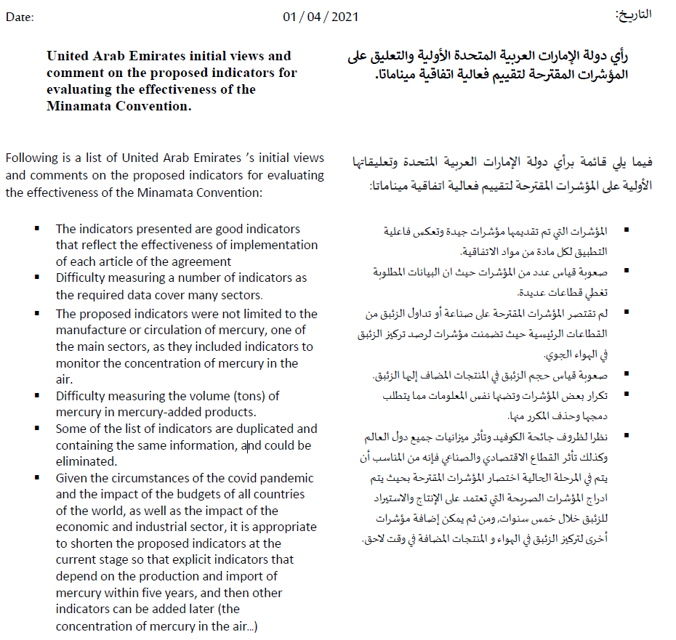

Views from the United Kingdom
Minamata Convention on Mercury
Initial comments on the proposed indicators - UK – 31 March 2021

- UK appreciates the opportunity to comment on the indicators that will be used to evaluate the effectiveness of the Minamata Convention. An effective treaty is in everyone’s best interest. The UK Government is committed to being part of international efforts to limit mercury emissions and releases on a global scale.

- We note that the 58 indicators proposed are largely based on existing reporting mechanisms; data sources identified for most indicators; matched against articles and are mostly process indicators.

- We agree that as stated in the slides here from recently the 3rd information exchange session, “The effectiveness evaluation is to assess the overall ability of the Convention at the global level to achieve the objective of the Convention.” i.e.

Art 1 The objective of the Convention is to protect the human health and the environment from anthropogenic emissions and releases of mercury and mercury compounds.

In this context it may be worth considering and discussing further whether further evidence on impacts/outcomes relating to effects from mercury on human health and on the environment, should be included, whether for evaluative purposes or as contextual descriptive information. We appreciate that global measures may be difficult to construct, and it may be appropriate to consider data or case studies at a regional or country level.

- In general, we support removing duplication between indicators, and appropriately using information available from other sources where this supplements information submitted by parties, e.g. where this then provides more reliable estimates. However, we note that a resolution mechanism may be needed where different data sources conflict.

- Lastly, we consider it important that lessons learned from other evaluations are applied, such as from Stockholm, in particular that the data used needs to be sufficiently robust and complete.

Views from the United States
Table 1. Proposed indicators for evaluating the effectiveness of the Minamata Convention, by article
Preamble text for Table 1.

These indicators are to be used by the Effectiveness Evaluation Committee (EEC) to conduct the first Effectiveness Evaluation.

Several different types of indicators are necessary to develop the overall picture of Convention effectiveness. “Monitoring Indicators” include information based on monitoring of mercury as found in humans, biota and the environment, and will be further refined based on the Monitoring Guidance. “Management Indicators” relate to the management of mercury as it relates to supply, demand and pressure. “Enabling and Support Indicators” support the work of the Convention but do not directly influence mercury emissions and releases and should therefore be reflected in the evaluation as such. To present a more complete picture, the Management Indicators and Enabling/Support Indicators should be read along with the relevant Monitoring Indicators, as presented in Cluster A.

Indicators should be reported at a global, not a sub-global, scale. Where needed, additional direction from the COP for the EEC regarding the use of specific indicators has been provided in the Considerations column.

In using these indicators, the EEC might identify challenges or opportunities for improvement to the indicators, for example with respect to data availability, or analysis implementation. The EEC should report these challenges to the COP for assessment in the preparations of the second Effectiveness Evaluation cycle.

 | MONITORING INDICATORS
A: Article 1 (objective) (Monitoring cluster)  (The indicator for article 1 is to be read with the relevant monitoring indicator set out in table 4 in document UNEP/MC/COP.3/14) |  |  |  |  |  | Source of information on the indicator |  | Baseline for the indicator |  |  | Considerations
A1. Cross-cutting monitoring indicator |  |  | Levels of mercury in the environment and in humans due to anthropogenic emissions and releases |  |  | - Information consistent with the effectiveness evaluation monitoring guidance |  | Amount in the first evaluation (if models are available)
Notes |  |  | - Attribution is to be estimated using models yet to be developed; thus, information for this indicator may or may not be available for the first effectiveness evaluation cycle.  - Estimates from modelling are to be accompanied by relevant notes on modelling uncertainties.  - In case of non-availability of information from models, levels of mercury and trends in mercury levels (changes over time) could be used for attribution purposes.
G1. Monitoring indicator |  |  |  | Mercury levels in selected human populations (as defined by the monitoring guidance arrangements) | - Information consistent with the effectiveness evaluation monitoring guidance |  |  |  |  | Number in the first evaluation
Relocate G1 from Article 16 (Health Aspects) to Monitoring cluster
- Multiple indicators related to monitoring should be consolidated in a single section called “Monitoring Indicators”

Remove the periodic notes within the document that reference linkages to the monitoring indicators in Table 4
- All indicators should be read along with the monitoring indicators, and include a statement in the preamble that indicates that Management Indicators and Enabling/Support Indicators should be read along with the relevant Monitoring Indicators, as presented in Cluster A.
MANAGEMENT INDICATORS
B: Supply cluster  Article 3 (mercury supply sources and trade); article 10 (environmentally sound interim storage of mercury, other than waste mercury); article 11 (mercury wastes) |  |  |  |  |  |  | Source of information on the indicator |  | Baseline for the indicator
B1. Overall process indicator for articles 3, 10 and 11 |  | Proportion of parties that have implemented key provisions under this cluster (encompassing all process indicators below, i.e., B5, B6, B7, B8, B9 and B13) |  |  |  |  | - Article 21 reporting |  | Amount in the first evaluation
Remove B1
- It is difficult to aggregate the sub-indicators into a single meaningful metric
B2. Additional cross-cutting outcome indicator for articles 3, 10 and 11 |  | Estimated global supply of mercury, in tonnes per year |  |  |  |  | - Synthesized information from individual indicators for articles 3, 10 and 11 as well as expert reports that are peer or publicly reviewed such the UNEP Global mercury supply, trade and demand report |  | Amount in the first evaluation
Article 3
B3. Outcome indicator for article 3 |  | Total amount of mercury mined from primary mercury mines |  |  |  |  | - UNEP 2017 reports on global mercury supply, trade and demand  - Article 21 reporting  - ASGM national action plan reports  - Minamata Initial Assessment (MIA) reports |  | Amount in the first evaluation
B4. Outcome indicator for article 3 |  | Amount of mercury traded, broken down by specific purpose |  |  |  |  | - Article 21 reporting  - Article 3 forms  - UN Comtrade database  - Chatham House Resourcetrade.earth database |  | Amount in the first evaluation |  | Discussion of this indicator should take note of the fact that trade is permitted under the Convention.
B4, remove “broken down by specific purpose”
- This information is not available on a global basis.
B5. Process indicator for article 3 |  | Number of parties that have endeavoured to identify individual stocks of mercury or mercury compounds exceeding 50 metric tons, and sources of supply generating stocks exceeding 10 metric tons per year that are located within its territory |  |  |  |  | - Article 21 reporting |  | Number in the first evaluation
B6. Process indicator for article 3 |  | For those parties that have determined they have excess Hg, whether they have taken measures called for in article 3 para. 5 (b), and amount of Hg disposed of in accordance with those measures, if available |  |  |  |  | - Article 21 reporting  - World Chlorine Council reports |  | Percentage in the first evaluation
B7. Process indicator for article 3 |  | Number and proportion of parties having appropriate measures to control import and export of mercury in accordance with Article 3 |  |  |  |  | - Article 21 reporting  - Article 3 forms  - Article 30 (4) forms |  | Number and percentage in the first evaluation
Edit B7
- Include information about parties having appropriate measures to control trade, based on information gathered by Questions 5 and 6 under Article 3 in the reporting form and Article 30(4) forms.
B8. Process indicator for article 3 |  | Volume of mercury being traded |  |  |  |  | - Article 21 reporting |  | Amount in the first evaluation
Delete B8
- It is duplicative with B4
Article 10
B9. Process indicator for article 10 |  | Number and proportion of parties that have taken measures to ensure sound interim storage |  |  |  |  | - Article 21 reporting |  | Number and percentage in the first evaluation |  | Only parties who have mercury to store on an interim basis would have to take such measures
B10. Outcome indicator for article 10 |  | Amount of mercury stored in an environmentally sound way (as identified in the inventory of stocks) |  |  |  |  | - Article 21 reporting |  | Amount in the first evaluation
Delete B10
- There is no requirement for parties to develop an inventory of stocks
Article 11
B11. Outcome indicator for article 11 |  | Amount of waste containing consisting of mercury or and amount of waste consisting of mercury compounds subject to final disposal |  |  |  |  | - Article 21 reporting  - Trade, Supply and Demand report, which will include Hg waste flows and stocks |  | Amount in the first evaluation
B12. Outcome indicator for article 11 |  | Number of parties with facilities for final disposal of waste containing mercury or mercury compounds |  |  |  |  | - Article 21 reporting |  | Number in the first evaluation
Remove B12
- The reporting form asks regarding parties with facilities for waste "consisting of" mercury or mercury compounds, so this information is not collected by the reporting form as written (“containing” mercury or mercury compounds). There will always be a limited number of parties with facilities that can take this type of high concentration mercury, and having such facilities is not required by the Convention. Recommend deletion.
B13. Process indicator for article 11 |  | Number and proportion of parties that have implemented measures outlined in article 11, paragraph 3, for the party's mercury waste |  |  |  |  | - Article 21 reporting |  | Number in the first evaluation
Notes |  | - Data from non-parties could also be important in some instances.

C: Demand cluster  Article 4 (mercury-added products); article 5 (manufacturing processes in which mercury or mercury compounds are used); article 7 (artisanal and small-scale gold mining) |  | Source of information on the indicator | Baseline for the indicator
C1. Cross-cutting process indicator for articles 4, 5 and 7 | Proportion of parties that have implemented key provisions under this cluster | - Synthesized information from individual indicators for articles 4, 5 and 7 | Percentage in the first evaluation
Remove C1
- It is difficult to aggregate the sub-indicators into a single meaningful metric
C2. Cross-cutting outcome indicator for articles 4, 5 and 7 | Total use of mercury in the manufacturing of products or processes listed in Annex A or B. | - Information from industry sources | Amount in the first evaluation
Limit C2 to the scope of the Convention.
- It is not the role of the effectiveness evaluation to gather information and analyze data from potentially hundreds of non-Convention products. Additionally, this information is not publicly available worldwide.
Article 4
C3. Process indicator for article 4 | Number and proportion of parties subject to Article 4 paragraph 1 having appropriate measures to prevent the manufacture, export or import of mercury-added products listed in part I of annex A | - Article 21 reporting | Number in the first evaluation
C4. Process indicator for article 4 | Number of exemptions per product category that are still valid | - Registry of exemptions | Number in the first evaluation
Move C4 to the section on Support and Enabling Indicators.
- Exemptions do not directly impact mercury emissions or releases, but rather support countries to ratify and implement the Convention,
C5. Process indicator for article 4 | Number of parties that have taken two or more measures for the mercury-added products listed in part II of annex A | - Article 21 reporting | Number in the first evaluation
C6. Additional outcome indicator for article 4 | Volume, in tonnes of mercury-added products (a) imported and (b) exported, in units per year, for each product category in part I of annex A. | - Trade and customs data | Amount in the first evaluation
Remove C6.
- The data is not broken out by product category in trade and customs data, and the Annex in question requires that all trade of this type not be allowed, as a general matter, after 2020, so the number should consistently be zero.
Article 5
C7. Process indicator for article 5 | Number of parties with exemptions for annex B, part I, processes that are still valid | - Registry of exemptions | Number in the first evaluation
Move C7 to the section on Support and Enabling Indicators
- As with C4, exemptions do not directly impact mercury emissions or releases, but rather support countries to ratify and implement the Convention,
C8. Process indicator for article 5 | For each manufacturing process listed in part I of annex B, the proportion of parties having those processes that have measures in place to not allow the use of mercury or mercury compounds after the phase out date for it | - Article 21 reporting | Number in the first evaluation
C9. Process indicator for article 5 | For each process listed in part II of annex B, the Proportion of parties having those processes that have all measures in place to restrict the use of mercury or mercury compounds in accordance with the provisions set out therein | - Article 21 reporting | Percentage in the first evaluation
Article 7
C10. Outcome indicator for article 7 | Total amount of mercury used in ASGM globally, in tonnes per year | - Article 21 reporting  - ASGM national action plans and reviews thereof  - Notifications | Amount in the first evaluation
C11. Process indicator for article 7 | Number and proportion of parties:  1. that have notified the Secretariat about more than insignificant ASGM in their territories,  2. of those parties, the proportion that have submitted a national action plan.  declaring more than insignificant ASGM that have submitted a national action plan | - Notifications | Percentage in the first evaluation
C12. Process indicator for article 7 | Number and pProportion of parties that have submitted with a national action plan and that have reviewed it within the timeframe specified in paragraph 3(c) of Article 7 | - Article 7 reviews  - Article 21 reporting | Percentage in the first evaluation
Notes | - Some data on products may not be easily obtainable.

D: Pressure cluster  Article 8 (emissions); article 9 (releases); article 12 (contaminated sites) |  | Source of information on the indicator | Baseline for the indicator
D1. Overall process indicator for articles 8, 9 and 12 | Share of parties that have implemented key provisions under this cluster | - Article 21 reporting | Percentage in the first evaluation
Remove D1
- It is difficult to aggregate the sub-indicators into a single meaningful metric
D2. Crosscutting outcome indicator for articles 8 and 9 and 12 | Total amount of mercury emitted and released | - Global Mercury Assessment 2018  - Party Inventories  - Minamata Convention initial assessments  -publicly available inventories from parties and scientific literature | Amount in the first evaluation | Information from different sources should be consolidated
Remove reference to article 12
- This indicator specifically refers to emissions and releases, addressed in Articles 8 and 9.
Article 8 (The indicators for article 8 are to be read with the relevant monitoring indicators in table 4.)
D3. Outcome indicator for article 8 | Total amount of mercury emitted for each point source category in annex D | - Article 21 reporting  - Party Inventories | Number in the first evaluation
D4. Process indicator for article 8 | Number and proportion of parties that require BAT/BEP or emission limit values consistent with the application of BAT for new sources (per article 8, para. 4) | - Article 21 reporting | Number in the first evaluation
D5. Process indicator for article 8 | Number and proportion of parties that have put in place control measures for existing sources (per each of the measures set out in article 8, para. 5) | - Article 21 reporting | Number in the first evaluation
D6. Process indicator for article 8 | Number and proportion of parties that have established and maintained an inventory of emissions | - Article 21 reporting | Number in the first evaluation
Article 9 (The indicators for article 9 are to be read with the relevant monitoring indicators in table 4.)
D7. Outcome indicator for article 9 | Total amount of mercury releases in the inventories of parties that have identified inventory from relevant sources | - Article 21 reporting  - Party Inventories | Amount in the first evaluation
D8. Process indicator for article 9 | Number of parties that have identified relevant sources, and of those parties, the proportion that have put in place control measures | - Article 21 reporting | Number in the first evaluation
D9. Process indicator for article 9 | Number of parties that have established and maintained an inventory of releases from relevant sources | - Article 21 reporting | Number in the first evaluation
Article 12
D10. Process indicator for article 12 | Number of parties that have endeavoured to develop developed strategies for identifying and assessing sites contaminated by mercury or mercury compounds | - Article 21 reporting | Number in the first evaluation
D11. Process indicator for article 12 | Number of parties that have developed an inventory of contaminated sites | - Article 21 reporting | Number in the first evaluation
Notes | - There may be some data gaps, as parties are not obliged to share the information collected as part of their inventory.
Delete D11.
- The Convention does not require parties to develop an inventory of contaminated sites, and this information is also not collected in the reporting form. Contaminated sites inventories are not mentioned in Article 12.

ENABLING AND SUPPORT INDICATORS
E: Support cluster  Article 13 (financial resources and mechanism); article 14 (capacity-building, technical assistance and technology transfer) |  | Source of information on the indicator | Baseline for the indicator
Article 13
E1. Process indicator for article 13 | For each of the following sub-indicators, Nnumber of parties that have:  - Contributed to the financial mechanism referred to in article 13, para. 5  - Received Global Environment Facility resources  - Received SIP resources  - Mobilized national resources for implementing the Convention within the reporting period | - Article 21 reporting | Number in the first evaluation
E2. Process indicator for article 13 | For each of the following sub-indicators, Aamount of resources provided by:  - Global Environment Facility  - SIP  - Bilateral support within the reporting period | - Article 21 reporting  - Other public sources | Amount in the first evaluation
E3. Additional process indicator for article 13 | Reduction of mercury emissions and releases due to support from Number of recommendations from the financial review reflected in the Global Environment Facility policy documents | - Information from provided by financial mechanism policy documents | Zero
Edit E3:
- The GEF Secretariat reflects all recommendations from all reviews of the financial mechanism in GEF Council policy documents as a matter of due process, including both recommendations that do, and that do not, receive management action. Therefore we are concerned that this indicator as originally proposed will convey little to no meaning for the Effectiveness Evaluation.
- Alternatively, the GEF Secretariat regularly estimates and makes available the estimated metric tons of mercury avoided through GEF financing in support of the Minamata Convention. This information should be incorporated in the Effectiveness Evaluation, as this is a direct reflection of the impact of financial support.
Article 14
E4. Process indicator for article 14 | For each of the following sub-indicators, Nnumber of parties that have:  - Cooperated in providing capacity-building and technical assistance to another party  - Requested technical assistance  - Received capacity-building or technical assistance  - Promoted or facilitated technology development, transfer, diffusion or access | - Article 21 reporting  - Other public sources | Number in the first evaluation
Remove E4, bullet #2.
- There is no source for this information, which is not included in the reporting format.
Notes | - The cycle of review of the financial mechanism may well not align with the effectiveness evaluation cycle.  - As the reporting format does not request dollar values for resources provided, other public sources may need to be consulted.

F: Article 15 (Implementation and Compliance Committee) |  | Source of information on the indicator | Baseline for the indicator
F1. Process indicator | Proportion Number of issues the Implementation and Compliance Committee was able to resolved including indications of systemic issues, if any | - Implementation and Compliance Committee report, as referred to in article 21 | Percentage in the first evaluation
We welcome further discussion on the best way to evaluate the work of the Implementation and Compliance Committee. We would prefer the deletion of this indicator and have provided alternative text in the spirit of compromise.

Our concerns with the original proposed language include:
1) What is the denominator for the "proportion"? Is this the total number of issues ever placed on the ICC's agenda (cumulative), or within an EE period? The ICC can only take up issues based on certain triggers, so the denominator needs to consist only of issues within the ICC's purview.
2) Who determines whether the ICC "facilitated resolution"? The ICC itself? Further, at what point is an issue considered “resolved”? For example, if the ICC finds that an out-of-compliance country is implementing its get-well plan and is on the path back to compliance, but hasn't yet returned to compliance, has the ICC "facilitated resolution"? Finally, does this indicator potentially create a perverse incentive for the ICC to wash its hands of issues as early as possible and say they are "resolved"?
Notes | - The Conference of the Parties is to consider the terms of reference of the Implementation and Compliance Committee at its third meeting.

G: Article 16 (Health aspects)  (The indicator for article 16 is to be read with the relevant monitoring indicators indicated in table 4) |  | Source of information on the indicator | Baseline for the indicator
G1. Monitoring indicator | Mercury levels in selected human populations (as defined by the monitoring arrangements) | - Existing monitoring data and activities | Number in the first evaluation
Moved G1 to Monitoring cluster with A1.
G2. Process indicator | Number and proportion of parties that have taken measures, such as fish advisories, to provide information to the public on exposure to mercury, in accordance with as encouraged by paragraph 1 of article 16 | - Article 21 reporting | Number in the first evaluation
G3. Process indicator | Number and proportion of parties that have taken other measures to protect human health, in accordance with as encouraged by article 16 | - Article 21 reporting  - Submissions to the secretariat | Number in the first evaluation
Notes | - Mercury levels in biota are also to be considered.

H: Information and research cluster  Article 17 (information exchange); article 18 (public information, awareness and education); article 19 (research, development and monitoring) |  | Source of information on the indicator | Baseline for the indicator
Article 17
H1. Process indicator for article 17 | Number of parties with designated national focal points | - Article 21 reporting | Number in the first evaluation
H2. Process indicator for article 17 | Number and proportion of parties that have facilitated the exchange of information related to mercury | - Article 21 reporting | Number in the first evaluation
Article 18
H3. Process indicator for article 18 | Number and proportion of parties that have taken measures to implement article 18 | - Article 21 reporting | Number in the first evaluation
H4. Process indicator for article 18 | Average number of measures under paragraph 1 of article 18 that are being implemented by parties | - Derived from article 21 reporting | Number in the first evaluation
Delete H4
- This indicator duplicates H3
H5. Process indicator for article 18 | Number of parties that have public information on mercury levels in air, humans and biota within their territory | - Article 21 reporting | Number in the first evaluation
Delete H5
- No information source
H6. Process indicator for article 18 | Number of parties undertaking risk communication relating to mercury intake through food and water consumption within their territory | - Article 21 reporting | Number in the first evaluation
Delete H6
- No information source
Article 19
H7. Process indicator for article 19 | Number of parties that have undertaken research, development and monitoring, in accordance with paragraph 1 of article 19 | - Article 21 reporting | Number in the first evaluation
H8. Process indicator for article 19 | Number of parties making monitoring data and scientific assessments publicly available | - Existing monitoring networks, databases, scientific data and literature | Number in the first evaluation
H9. Additional process indicator for article 19 | Number of parties contributing to international monitoring networks | - Existing monitoring networks, databases, scientific data and literature | Number in the first evaluation
Notes | - Submissions to the secretariat that supplement article 21 reporting

I: Article 20 (implementation plans) |  | Source of information on the indicator | Baseline for the indicator
I1. Process indicator | Number of parties submitting implementation plans | - Secretariat report to the Conference of the Parties on implementation plan submissions | Zero
Notes | - Parties are not obliged to prepare an implementation plan. Some parties have nevertheless found it useful to prepare such a plan and submit it to the secretariat.

Delete I1
- Implementation plans are not required by the Convention.

J: Article 21 (reporting) |  | Source of information on the indicator | Baseline for the indicator
J1. Process indicator | Proportion of parties reporting on time | - Article 21 reporting | Percentage of the first submission on time
J2. Process indicator | Proportion of reports received on time | - Article 21 reporting | Percentage not available in the first reports
J3. Process indicator | Proportion of parties indicating that information is not available for specific questions | - Article 21 reporting | Percentage not available in the first reports
Notes | - Parties are to report every two years.
Abbreviations: ASGM, artisanal and small-scale gold mining; BAT/BEP, best available techniques/best environmental practices; SIP, Specific International Programme to Support Capacity-building and Technical Assistance.

Annex II: Parties’ views submitted after the information session in 2020

Views from Iran
Submission of the Islamic Republic of Iran on the Effectiveness Evaluation indicators of the Minamata Convention on Mercury
Iran’s comments on the proposed indicators
The Islamic Republic of Iran appreciates the work done by the ad-hoc technical group in preparing the report on effectiveness evaluation for COP3 and also thanks the Secretariat of the Minamata Convention for following up on the proposed indicators of effectiveness evaluation. Iran would like to highlight its view as follows:
1- Indicators are mostly based on quantitative scales. It is also needed that qualitative scales to be taken into account appropriately. The latter scales can help to complement the possible shortcomings of quantitative indicators. For instance, there is no doubt that the number of Parties with a national implementation plan and program as a quantitative indicator is important to assess the effectiveness evaluation of the Minamata Convention.
At the same time the number of Parties developed such plans, necessarily are not per se an indication that certain objectives of the Convention have been met. In our view, along with that quantitative indicator, it is key to identify whether the national implementation plan is effective, efficient, relevant and coherent with the goals and objectives of the Convention.
2- To develop an articulated arrangement of indicators (process, input, impact and etc.) for each of defined indicators, some changes are needed. For example, it seems that the appropriate type of indicators under Article 13( E1& E3) and Article 14( E4) are input indicator not process indicator.
3- We are of the view that a comprehensive effectiveness evaluation mechanism should be able to identify the factors that drive or hinder achieving of each proposed indicators.
4- Creating regional centers of the Minamata Convention can play an essential role in providing the Parties with services related to capacity building and technology transfer. Mercury release and emissions has a strong regional impact and creating regional centers of the Convention could facilitate the effectiveness evaluation of the Convention. To that end the Conference of the Parties of the Convention shall explore ways and means along with the provisions of the Convention to agree on the establishment of the regional centers as necessary.
5- MC-3/10 decision on arrangements for the first effectiveness evaluation framework requires developing a detailed and functional annex on financial, technological and institutional arrangements taking into account the annex I on proposed indicators and annex II on information and analysis flow and institutional arrangement.
6- While there might be limited data availability, it is challenging for the developing Parties to access and collect data and analysis for monitoring, scientific and technical data reporting. To that end, providing valid data and information on mercury release and emission is needed. Also it is to be noted that indicators are defined and proposed based on core articles of the Convention, while the Articles have different implementing timeframe which makes reporting process complicated.
7- There are certain provisions with necessary arrangement to ensure implementation of the obligations of the member Parties under the Convention. The objectives of the Convention would not be achievable without full implementation of the above provisions. Global Facility Fund (GEF) as defined in the Convention plays an essential role in helping member Parties fulfilling their obligations.
To meet their obligations, it’s a matter of concern that GEF has systematically denied its resources to the certain developing countries including Iran.
This approach would jeopardize the efforts towards realization of the objective of the Convention. To this end, we are of the firm belief that the member States shall make every effort to ensure that the provisions of the Convention are not selectively implemented and member parties are not deprived of their rights under Convention. Conference of the Parties should consider this shortcoming and address it with a view to overcome the continued challenges and unjustified approach of the GEF.
8- Given the high importance of international cooperation in facilitating achieving the objectives of the Convention, the following indicators are suggested to be included in the proposed indicators as appropriate:
- Number of Parties ,that are in a position to do so, which included technology transfer and capacity building to other Parties in their national, plans, programs and laws and regulations for the implementation of the provisions of Minamata Convention.
- Number of Parties that have the capacity for sound management of wastes contained Mercury.

Views from Kuwait

UNOFFICIAL TRANSLATION BY THE SECRETARIAT

State of Kuwait

In response to the email sent regarding comments on indicators measuring the effectiveness of the Convention (Effectiveness Evaluation of the Convention).

The indicators mentioned in Paragraph 1 of Decision UNEP / MC-3/10, are good and reflect the effectiveness of the implementation for each article of the Convention, However, the following points need to be considered:

- Many countries lack a large amount of data required for the indicators.
- The global monitoring operations that were carried out previously did not cover all geographical locations, and, therefore, information on releases may not be available.
- The difference in technical capabilities and capabilities among the party-states
- Lack of systems to monitor and measure mercury concentrations in the atmosphere.
- Lack of national implementation plans.

The above points require financial and technical support to enable states to achieve and implement their obligations towards the Convention on the basis of which the effectiveness of the Convention can be evaluated.

Views from Mexico

UNOFFICIAL TRANSLATION BY THE SECRETARIAT
Mexico

Article 3 on Mercury supply sources and trade

Regarding the indicators set out in B4, B7 and B8, there is no problem in complying with them, since it is possible to determine the required information.

For process indicator B6, the fact is that there is currently no information system and communication mechanisms among the mining sector, importers, and exporters; in order to disseminate the actions taken, it is not possible to obtain the information for such indicator. Likewise, the existing chlor-alkali plants will have to be monitored in order to properly procure information in accordance with paragraph 3 a) of Article 11 of the Convention.

Article 11 on Mercury wastes

The proposed indicators are considered suitable, since the proposed objectives are in accordance with the purpose of the Convention, the required information can also be provided through the National Inventory and Register of Hazardous Waste and procedures for service providers in the management of mercury, in order to demonstrate, where appropriate, the decrease in the use of mercury.

Article 12 on Contaminated sites

In relation to indicator D10, which entails the number of parties that have developed strategies for identifying and assessing sites contaminated by mercury or mercury compounds, it is made known that the National Program for Remediation of Contaminated Sites, which derives from the 2019-2024 National Development Plan, contributes to meeting Mexico’s obligations in the Minamata Convention.

As for the identification of sites contaminated with mercury or its compounds, strategies such as the issuance of official requests have been implemented, through which information has been requested from the University of Zacatecas and the National Institute of Ecology and Climate Change respectively, on known sites contaminated with mercury considered environmental liabilities which have not yet been remediated. In the event that the sites have a remediation proposal, this is evaluated accordingly with the General Law For The Prevention And Integral Management Of Wastes and its Regulation, as well as with established technical and legal criteria and other applicable provisions, determining whether the application of the proposal to remediate said sites is viable and with it the feasibility of the rehabilitation of contaminated sites.

Regarding indicator D11, which entails the number of parties that have developed an inventory of contaminated sites, it is appropriate to indicate that there is a National Inventory of Contaminated Sites, including those contaminated with mercury and its compounds, that records the sites from which there is analytical evidence of the existing contamination, as well as the extent of it, which is constantly updated and will be enriched with the responses to the aforementioned communications. Therefore, Mexico is able to comply with articles 12 and 21 of the Minamata Convention and there is no problem in the implementation of the indicators already mentioned.
Views from Oman



Views from Qatar
Qatar’s initial views and comment on the proposed indicators for evaluating the effectiveness of the Minamata Convention (Annex I to decision MC-3/10)

Following is a list of Qatar’s initial views and comments on the proposed indicators for evaluating the effectiveness of the Minamata Convention:

            - Most of the indicators presented are effective, and comprehensive; and thus, will help to answer the policy questions.
            - Some of the list of indicators are duplicated and containing the same information, and could be eliminated (B4 and B8, C7 and C8, J1 and J2).
            - Some information cannot be obtained such as (C6) volume, in tonnes of mercury-added products, as it cannot be obtained from trade and customs data since mercury-added products do not have their own HS code.
            - It is worth noting that not all the required data are available for the parties, so there should be a flexible strategy for providing the available information while reporting.

Views from Tanzania
COMMENTS ON THE PROPOSED INDICATORS FOR EVALUATING THE EFFECTIVENESS OF THE MINAMATA CONVENTION ON MERCURY

INDICATOR NUMBER FROM  MC-3/10 | TYPE OF INDICATOR |  | DESCRIPTION OF INDICATOR |  | COMMENTS
A1 | Cross-cutting monitoring  indicator |  | Levels of mercury in the environment and in humans due to anthropogenic emissions and releases |  | This is very crucial indicator in assessing the effectiveness of the Minamata Convention.  With limited available data, information from various research conducted by academia institutions and other stakeholders can be used as baseline research to estimate the levels of mercury in the environment.
B4 | Outcome indicator for article 3. |  | Amount of mercury traded, broken down by specific purpose |  | This is the key indicator to assess the mercury trading post 2020.
B8 | Process indicator for article 3. |  | Volume of mercury being traded
C6 | Additional outcome indicator for article 4 |  | Volume, in tonnes of mercury-added products (a) imported and (b) exported, in units per year, for each product category in part I of annex A. |  | This is important indicator to show the trends of mercury added products post 2020.
C7 | Process indicator for article 5 |  | Number of parties with exemptions for annex B, part I, processes that are still valid |  | This indicator is key indicator to show the number of Parties with exemptions in the use of mercury. This information will produce information regarding the trend of mercury use.
C8 | Process indicator for article 5 |  | Number of parties having measures in place to not allow the use of mercury or mercury compounds in manufacturing processes listed in part I of annex B |  | This is important indicator to assess the effectiveness of Convention in the cut down of the use mercury and mercury added products.
D2 | Cross-cutting outcome indicator for articles 8, 9 and 12 |  | Total amount of mercury emitted and released |  | This indicator is crucial to assist Parties to put in place mechanisms to reduce the possible impacts to the human health and the environment.
D8 | Process indicator for article 9 |  | Number of parties that have identified relevant sources |  | This is important indicator to track the sources of mercury releases.
D9 | Process indicator for article 9 |  | Number of parties that have established and maintained an inventory of releases from relevant sources
J1 | Process Indicator |  | Proportion of parties reporting on time |  | This is key indicator to assess the compliance of the Parties under article 21
J2 | Process Indicator |  | Proportion of reports received on time

* The resumed fourth meeting of the Conference of the Parties to the Minamata Convention on Mercury is to convene in person in Bali, Indonesia, and is tentatively scheduled for the first quarter of 2022.
** UNEP/MC/COP.4/1.

