UNITED  NATIONS | 

UNEP/MC/COP.6/Dec.22

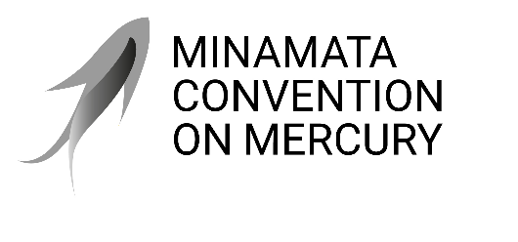 |  | Distr.: General  24 November 2025  Original: English

Conference of the Parties to the
Minamata Convention on Mercury
Sixth meeting
Geneva, 3–7 November 2025
Decisions adopted by the Conference of the Parties to the Minamata Convention on Mercury at its sixth meeting
Decision MC-6/22: Dates and venue of the seventh meeting of the Conference of the Parties to the Minamata Convention on Mercury
The Conference of the Parties
- Decides to convene the next meeting of the Conference of the Parties to the Minamata Convention on Mercury in Geneva from 14 to 18 June 2027;
- Requests the Executive Secretary, in order to assist parties in their preparations for the meeting, to support, subject to the availability of resources, regional meetings, held in coordination with other regional meetings, to facilitate regional preparatory processes;
- Invites the Executive Secretary, in order to further assist parties and regions in their preparations, to distribute the provisional agenda, together with supporting documents, to the parties, in the official languages of the United Nations, at least eight weeks before the opening of future meetings of the Conference of the Parties;
- Invites parties to submit offers to host the eighth meeting of the Conference of the Parties at least three months before the opening of the seventh meeting, for consideration by the Conference of the Parties at its seventh meeting.

Following the sixth meeting of the Conference of the Parties, new dates became available at the venue, the Geneva International Conference Centre, for the period 6–10 September 2027. In the light of this development, and to avoid altering the usual duration of the intersessional period, the Bureau agreed in December 2025 that the seventh meeting of the Conference of the Parties would be held at the Geneva International Conference Centre from 6 to 10 September 2027, with regional preparatory meetings taking place on 5 September 2027.

