UNITED  NATIONS | 

UNEP/MC/COP.6/Dec.20

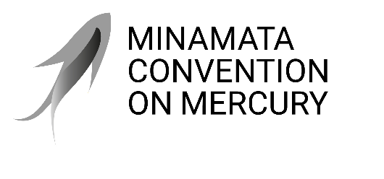 |  | Distr.: General  24 November 2025  Original: English

Conference of the Parties to the
Minamata Convention on Mercury
Sixth meeting
Geneva, 3–7 November 2025
Decisions adopted by the Conference of the Parties to the Minamata Convention on Mercury at its sixth meeting
Decision MC-6/20: Cooperation and coordination between the secretariats of the Minamata Convention on Mercury and of the Basel, Rotterdam and Stockholm conventions
The Conference of the Parties,
Recognizing that the sharing of services within a stable framework will enhance cooperation and coordination based on experience and proximity and can foster the effective implementation of the Minamata Convention on Mercury, the Basel Convention on the Control of Transboundary Movements of Hazardous Wastes and Their Disposal, the Rotterdam Convention on the Prior Informed Consent Procedure for Certain Hazardous Chemicals and Pesticides in International Trade and the Stockholm Convention on Persistent Organic Pollutants without undermining the autonomy of the secretariats or the accountability of their executive heads,
Recalling decisions MC-3/11, MC-4/9 and MC-5/19, on cooperation and coordination with the secretariat of the Basel, Rotterdam and Stockholm conventions,
            - Takes note of the joint report on cooperation and coordination between the secretariats of the Minamata Convention on Mercury and of the Basel, Rotterdam and Stockholm conventions, and of the outline of cooperation activities planned, including for the sharing and purchase of relevant services, between the two secretariats for the biennium 2026–2027;
            - Reaffirms the importance of continued cooperation on programmatic synergies, of the use of the task force between the two secretariats and the United Nations Environment Programme Chemicals and Health Branch, and of the possibility for the secretariat of the Minamata Convention on Mercury to provide secretariat support to the Basel, Rotterdam and Stockholm conventions on a cost recovery basis, in accordance with the programmes of work and budgets of the conventions for each biennium;
            - Welcomes the cooperation between the secretariat of the Minamata Convention on Mercury and the secretariat of the Basel, Rotterdam and Stockholm conventions regarding the training of potential chairs and negotiators for meetings of bodies, and requests the secretariat of the Minamata Convention on Mercury, subject to the availability of resources, to continue contributing to the implementation of such training;
            - Requests the Executive Secretary:
- To continue, with the secretariat of the Minamata Convention on Mercury and under the overall steering of the task force, as appropriate, to cooperate on relevant administrative, programmatic, scientific and technical, and technical assistance matters, in accordance with the programme of work and budget, and to explore ways of further strengthening cooperation and collaboration with the Basel, Rotterdam and Stockholm conventions;
- To continue to implement the sharing of services and of the purchase of relevant services with the secretariat of the Basel, Rotterdam and Stockholm conventions on a cost recovery basis, as appropriate and in accordance with the programme of work and budget for each biennium;
- To report on the implementation of the present decision, including on a stable framework for cooperation and for the sharing of services, providing an outline of the cooperation activities planned under such a framework for the biennium 2028–2029, for the consideration of and, as necessary, further guidance by the Conference of the Parties at its next meeting.

UNEP/MC/COP.6/INF/29, annex I.
Ibid., annex II.

