UNITED  NATIONS | 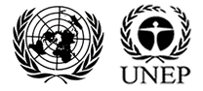

UNEP/MC/COP.6/Dec.19

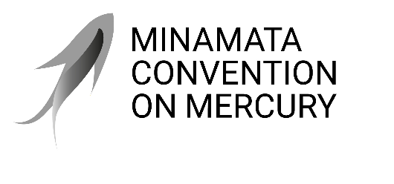 |  | Distr.: General  24 November 2025  Original: English

Conference of the Parties to the
Minamata Convention on Mercury
Sixth meeting
Geneva, 3–7 November 2025
Decisions adopted by the Conference of the Parties to the Minamata Convention on Mercury at its sixth meeting
Decision MC-6/19: International cooperation and coordination
The Conference of the Parties,
Recalling paragraph 5 (b) of article 23 of the Minamata Convention on Mercury, which provides that the Conference of the Parties and the secretariat are to cooperate, where appropriate, with relevant international organizations and intergovernmental and non-governmental bodies,
Expressing its appreciation to the international organizations and initiatives that conducted activities in 2024 and 2025 to promote ratification and implementation of the Convention, as reported to the Conference of the Parties at its sixth meeting, for conducting those activities,
Welcoming the cooperation between the secretariat and the United Nations Children’s Fund on a joint publication on the risk of mercury to children,
- Welcomes the adoption, by the United Nations Environment Assembly, at its sixth session, of resolutions on matters related to the Minamata Convention on Mercury, and requests the secretariat to contribute to the implementation of those resolutions, as appropriate;
- Also welcomes the establishment of the Intergovernmental Science-Policy Panel on Chemicals, Waste and Pollution in Punta del Este, Uruguay, on 20 June 2025, expresses its interest in establishing a partnership with the Panel to advance the work of reaching the objective of the Convention, and requests the secretariat of the Convention to cooperate with the secretariat of the Panel and seek observer status in the plenary of the Panel;
- Requests the secretariat of the Convention to conduct, subject to the availability of resources, a scoping study on possible areas where the strengthening of the science-policy interface would advance implementation of the Convention, with input from parties and others, as well as experts who collaborate in the framework of the International Conference on Mercury as a Global Pollutant, for consideration by the Conference of the Parties at its seventh meeting;
- Welcomes the proposal for activities that provide mutual benefits to the implementation of the Convention and the Global Framework on Chemicals – for a Planet Free of Harm from Chemicals and Waste, and requests the secretariat to carry out those activities and continue and further enhance cooperation and coordination with the secretariat of the Global Framework on Chemicals;
- Requests the Executive Secretary to take the necessary steps for membership of the Convention and participation of the secretariat of the Convention in the Inter-Organization Programme for the Sound Management of Chemicals, and invites the secretariat to continue to work in close cooperation with the Programme;
- Requests the secretariat, subject to the availability of resources, to continue cooperation and coordination with the Global Mercury Partnership, the Convention on Biological Diversity, the United Nations Framework Convention on Climate Change, the United Nations Convention to Combat Desertification in Those Countries Experiencing Serious Drought and/or Desertification, Particularly in Africa, the International Atomic Energy Agency and the United Nations Children’s Fund on issues of common interest, and with other international bodies in areas of relevance to the Minamata Convention on Mercury, including in the areas and with the organizations listed in document UNEP/MC/COP.5/INF/28;
- Also requests the secretariat to report on the implementation of the present decision to the Conference of the Parties at its seventh meeting, as appropriate.

Resolution 6/3 on enhancing the role and viability of regional forums of ministers of the environment and United Nations Environment Programme regional offices in achieving multilateral cooperation in tackling environmental challenges; resolution 6/4 on promoting synergies, cooperation or collaboration for national implementation of multilateral environmental agreements and other relevant environmental instruments; resolution 6/5 on environmental aspects of minerals and metals; resolution 6/6 on fostering national action to address global environmental challenges through increased cooperation between the United Nations Environment Assembly, the United Nations Environment Programme and multilateral environmental agreements; and resolution 6/9 on sound management of chemicals and waste.
As outlined in document UNEP/MC/COP.6/INF/28.

