UNITED  NATIONS | 

UNEP/MC/COP.6/Dec.18

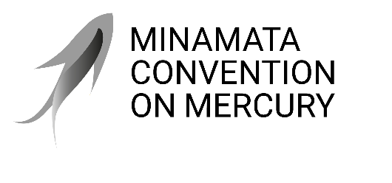 |  | Distr.: General  24 November 2025  Original: English

Conference of the Parties to the
Minamata Convention on Mercury
Sixth meeting
Geneva, 3–7 November 2025
Decisions adopted by the Conference of the Parties to the Minamata Convention on Mercury at its sixth meeting
Decision MC-6/18: Road map for enhancing co-benefits from implementation of the Minamata Convention and the Kunming-Montreal Global Biodiversity Framework
The Conference of the Parties,
Acknowledging with appreciation the work by the secretariat in response to decision MC-5/17 on mercury and the Kunming-Montreal Global Biodiversity Framework, including the input prepared in response to the calls by the Executive Secretary of the Convention on Biological Diversity on indicators, as reported to the Conference of the Parties to the Minamata Convention on Mercury at its sixth meeting,
Acknowledging the invitation by the Conference of the Parties to the Convention on Biological Diversity, in its decision 16/35, to the Conference of the Parties to the Minamata Convention, along with the governing bodies of the other chemical and waste conventions, the Food and Agriculture Organization of the United Nations and other relevant conventions and organizations, including the Global Framework on Chemicals – for a Planet Free of Harm from Chemicals and Waste, to collaborate with the three Rio conventions on target 7 of the Framework, “reduce pollution to levels that are not harmful to biodiversity”,
Acknowledging with appreciation the work facilitated by the United Nations Environment Programme under the Bern process, including the outcomes of the third conference under that process,
- Welcomes the road map for enhancing co-benefits from implementation of the Minamata Convention on Mercury and the Kunming-Montreal Global Biodiversity Framework by 2030, prepared by the secretariat pursuant to decision MC-5/17;
- Encourages parties and other relevant stakeholders, as appropriate, to carry out the actions suggested in the road map, on a voluntary basis, consistent with national priorities, circumstances and capacities, and under the leadership of national Governments;
- Encourages parties, and invites other Governments that have submitted notifications pursuant to paragraph 3 of article 7 on artisanal and small-scale gold mining, to make use of the technical support document prepared by the secretariat on integrating action to reduce mercury pollution from artisanal and small-scale gold mining into national biodiversity strategies and action plans aligned with the Kunming-Montreal Global Biodiversity Framework, as appropriate and without prejudice to national circumstances and policy frameworks;
- Welcomes the decision of the Conference of the Parties to the Convention on Biological Diversity to invite the Intergovernmental Science-Policy Platform on Biodiversity and Ecosystem Services to consider adding an assessment of pollution and biodiversity to its rolling work programme, and requests the secretariat to initiate cooperation with the secretariat of the Platform, without duplication of existing work under the Minamata Convention, with a view to exploring possible ways in which the work of the Platform might support the implementation of the Minamata Convention;
- Encourages parties to engage in the Bern process and actively promote cooperation and policy coherence among multilateral environmental agreements at the national level, taking into account national circumstances, needs and priorities, and fully respecting national sovereignty and policy space, through, as appropriate, a whole-of-government and whole-of-society approach, while avoiding unnecessary additional reporting burdens;
- Requests the secretariat, subject to the availability of resources, to contribute to the implementation of the road map and to continue its engagement in the Bern process, in collaboration with other multilateral environmental agreements and the United Nations Environment Programme, without creating new obligations for parties and subject to adequate financial and technical support, particularly for developing countries.

See https://www.unep.org/events/conference/bern-iii-conference-cooperation-among-biodiversity-related-conventions.
As presented in section III of document UNEP/MC/COP.6/20.
UNEP/MC/COP.6/INF/27.
Conference of the Parties to the Convention on Biological Diversity decision 16/11, para. 3.

