UNITED  NATIONS | 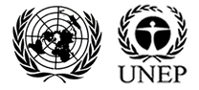

UNEP/MC/COP.6/Dec.17

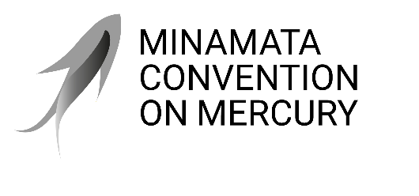 |  | Distr.: General  24 November 2025  Original: English

Conference of the Parties to the
Minamata Convention on Mercury
Sixth meeting
Geneva, 3–7 November 2025
Decisions adopted by the Conference of the Parties to the Minamata Convention on Mercury at its sixth meeting
Decision MC-6/17: Knowledge management and implementation of the digital strategy
The Conference of the Parties,
Recalling the digital strategy for the Minamata Convention on Mercury, as noted with appreciation in decision MC-5/16, to guide the work of the secretariat in leveraging technology and managing knowledge effectively to support the implementation of the Convention,
Emphasizing the benefits of digitalization in knowledge management and capacity-building for advancing progress towards the objective of the Convention, in accordance with the forward-looking vision of the United Nations 2.0 initiative of fostering innovation, collaboration, and a digital culture across the United Nations system,
Recognizing the need for information exchange in accordance with articles 17 and 24 of the Convention to facilitate cooperation in the exchange of information between parties and relevant stakeholders,
1. Welcomes the progress made by the secretariat in implementing the digital strategy during the biennium 2024–2025;
2. Requests the secretariat to continue the implementation of the digital strategy in accordance with the programme of work and budget for the Minamata Convention on Mercury for the biennium 2026–2027 and to prioritize relevant activities for progressive advancement of the strategy in future bienniums, including the potential for the use of artificial intelligence;
3. Recognizes the Convention website as the primary source of public information and knowledge about the Convention, and requests the secretariat to keep it updated in accordance with the digital strategy;
4. Agrees to support the development of the Minamata Convention Exchange Platform as a cost-effective and transparent vehicle for information exchange pursuant to articles 17 and 24, subject to the availability of resources;
5. Encourages the secretariat, subject to the availability of resources, to continue cooperation and coordination activities with the Global Mercury Partnership to advance shared knowledge initiatives concerning mercury-related issues, including the joint development of data products, communication tools and knowledge platforms, while ensuring complementarity;
6. Requests the secretariat to continue collaborating with the secretariats of other multilateral environmental agreements and other partners, including the United Nations Information Portal on Multilateral Environmental Agreements (InforMEA) initiative, on knowledge management, digitalization and information exchange;
7. Also requests the secretariat to continue collaborating with the secretariat of the Basel Convention on the Control of Transboundary Movements of Hazardous Wastes and Their Disposal, the Rotterdam Convention on the Prior Informed Consent Procedure for Certain Hazardous Chemicals and Pesticides in International Trade and the Stockholm Convention on Persistent Organic Pollutants to exchange information and share experiences and best practices relating to knowledge management and digitalization;
8. Further requests the secretariat to report on progress in the implementation of the digital strategy to the Conference of the Parties at its seventh meeting.

UNEP/MC/COP.5/19, annex I.
As outlined in document UNEP/MC/COP.6/19.

