UNITED  NATIONS | 

UNEP/MC/COP.6/Dec.16

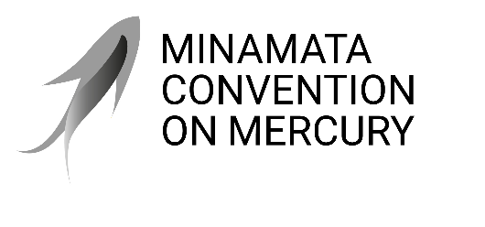 |  | Distr.: General  24 November 2025  Original: English

Conference of the Parties to the
Minamata Convention on Mercury
Sixth meeting
Geneva, 3–7 November 2025
Decisions adopted by the Conference of the Parties to the Minamata Convention on Mercury at its sixth meeting
Decision MC-6/16: Addressing health concerns of women and children
The Conference of the Parties
- Takes note with appreciation of the activities carried out by the secretariat, parties and other stakeholders during the biennium 2024–2025 as suggested in decision MC-5/15 on the gender action plan, including activities to address health concerns of women and children;
- Invites parties to continue their implementation of decision MC-5/15 on the gender action plan, including to address health concerns of women and children during the biennium
2026–2027 and to share with the secretariat their related experiences and good practices;
- Also invites parties to provide comments, as appropriate, on possible activities to be carried out by the secretariat, parties and other stakeholders during the biennium 2028–2029;
- Requests the secretariat to carry out activities during the biennium 2026–2027, subject to the availability of resources;
- Also requests the secretariat to report to the Conference of the Parties on the implementation of the present decision and propose possible activities to be carried out by the secretariat, parties and other stakeholders during the biennium 2028–2029, as appropriate, for consideration by the Conference at its seventh meeting.

Suggested activities are set out in document UNEP/MC/COP.6/29, para. 2.
Suggested activities are set out in document UNEP/MC/COP.6/29, para. 1.

