UNITED  NATIONS | 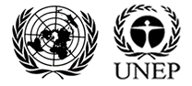

UNEP/MC/COP.6/Dec.15

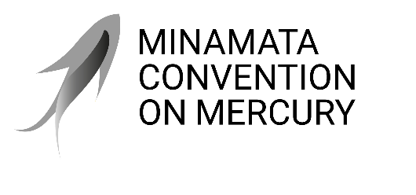 |  | Distr.: General  24 November 2025  Original: English

Conference of the Parties to the
Minamata Convention on Mercury
Sixth meeting
Geneva, 3–7 November 2025
Decisions adopted by the Conference of the Parties to the Minamata Convention on Mercury at its sixth meeting
Decision MC-6/15: Strengthening effective engagement with Indigenous Peoples, as well as local communities
The Conference of the Parties,
Recalling the rights of Indigenous Peoples as set out in the United Nations Declaration on the Rights of Indigenous Peoples, and that Indigenous Peoples, as well as local communities, are disproportionately impacted by the effects of mercury pollution,
Emphasizing that Indigenous Peoples, as well as local communities, should play an important role in the implementation of the Minamata Convention on Mercury, and underscoring that their full and effective engagement and participation in meetings and processes under the Convention are essential to achieving its objective,
Taking note of the results of the survey on the needs and priorities of Indigenous Peoples, as well as local communities, with regard to the effects of mercury on their health, livelihoods, culture and knowledge, and recognizing that effective engagement and participation in the work of the Convention are a high priority for those groups in addressing mercury pollution,
Welcoming the efforts of the secretariat to develop the Indigenous Peoples’ Platform, and encouraging parties and other relevant stakeholders to continue to promote policies that enable Indigenous Peoples, as well as local communities, to benefit from and contribute to the dissemination of information, awareness and education on emissions and releases of mercury,
Recalling decision MC-5/1 on the effects of mercury pollution on Indigenous Peoples and on local communities,
- Urges parties, and invites States not parties to the Minamata Convention on Mercury, as well as governmental, intergovernmental and non-governmental organizations and others, to provide support for the effective participation of Indigenous Peoples, as well as local communities, as appropriate, particularly those from regions disproportionately impacted by mercury pollution, in work and meetings under the Convention, including through voluntary contributions to the special trust fund of the Convention;
- Requests the secretariat to:
- Seek advice from Indigenous Peoples, as well as local communities, through Indigenous Peoples’ organizations accredited to the Convention, local communities’ organizations accredited to the Convention, and the International Indigenous Peoples’ Forum on Mercury on potential measures for strengthening their effective engagement in the work of the Convention and on proposed next steps;
- Communicate regarding opportunities for engagement and support on the Indigenous Peoples’ Platform;
- Collaborate with the Office of the United Nations High Commissioner for Human Rights, the secretariat of the Convention on Biological Diversity, and other relevant organizations and stakeholders, as appropriate, to further strengthen effective engagement regarding mercury pollution;
- Report to the Conference of the Parties at its seventh meeting on the implementation of the present decision.

