UNITED  NATIONS | 

UNEP/MC/COP.6/Dec.14

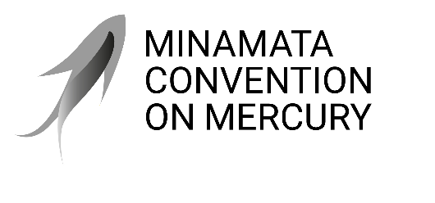 |  | Distr.: General  24 November 2025  Original: English

Conference of the Parties to the
Minamata Convention on Mercury
Sixth meeting
Geneva, 3–7 November 2025
Decisions adopted by the Conference of the Parties to the Minamata Convention on Mercury at its sixth meeting
Decision MC-6/14: Progress in the first effectiveness evaluation of the Minamata Convention on Mercury
The Conference of the Parties,
Recalling decision MC-5/14, in which it agreed to consider the outcome of the first effectiveness evaluation of the Minamata Convention on Mercury at its seventh meeting,
- Takes note of the progress made by the Effectiveness Evaluation Group and the Open-ended Scientific Group since the fifth meeting, and requests both groups to continue working to support the Conference of the Parties in the first effectiveness evaluation in accordance with their respective terms of reference;
- Acknowledges with appreciation the input from parties and other stakeholders on the effectiveness evaluation, including the submission of monitoring, emission and release data and comments on draft reports, and invites parties to continue providing such input, including comments on the draft documents developed by the Effectiveness Evaluation Group and the Open-ended Scientific Group;
- Invites parties to submit their full national reports under article 21 to the secretariat by 31 December 2025, in order to ensure that the most recent information is available for the first effectiveness evaluation.

