UNITED  NATIONS | 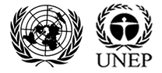

UNEP/MC/COP.6/Dec.13

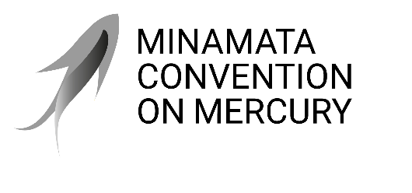 |  | Distr.: General  24 November 2025  Original: English

Conference of the Parties to the
Minamata Convention on Mercury
Sixth meeting
Geneva, 3–7 November 2025
Decisions adopted by the Conference of the Parties to the Minamata Convention on Mercury at its sixth meeting
Decision MC-6/13: National reporting (article 21): second short national reports
The Conference of the Parties,
Emphasizing the importance of reporting, and recalling the obligation of parties to submit their national reports in accordance with article 21 of the Minamata Convention on Mercury,
Considering the report on the work of the Implementation and Compliance Committee of the Convention at its sixth and seventh meetings, including its conclusions on the reporting performance of parties,
Recognizing the challenges in implementing the trade obligations under article 3 posed by informal or illegal primary mercury mining and trade in mercury that do not conform with the provisions of the Convention, including gathering data and reporting on such activities,
Welcoming the efforts of parties to report on informal or illegal primary mercury mining and trade, including as they relate to the artisanal and small-scale gold mining sector,
Recalling paragraph 2 of decision MC-5/2, in which it encouraged parties that did not receive consent for all exports of mercury from the party’s territory to provide more information, if any, in their next national reports,
- Welcomes the high rate of reporting (86 per cent) by parties for their second short national reports, and acknowledges that there is room for further improvement in the reporting rate;
- Invites parties to achieve a high rate of reporting for their second full national reports, due by 31 December 2025, and requests parties to submit their reports in a timely manner;
- Reiterates its call to parties that have received consent to export mercury to parties and/or non-parties to provide to the secretariat either copies of the consent forms used or other suitable information in their reports submitted pursuant to article 21 in order to show that the relevant requirements of article 3 have been met;
- Invites parties to submit their completed national action plans on the phase-out of dental amalgam either together with their second full national reports, due by 31 December 2025, or with their third short national reports, due by 31 December 2027;
- Takes note of the updates to the guidance for completing the national reporting format as requested in decision MC-5/13, and encourages parties to use the guidance in the current and next reporting rounds;
- Requests the secretariat:
  - To collect information on best practices for reporting on informal or illegal activities that do not conform with the provisions of the Convention, with a view to identifying information that would be helpful for assessing their scale and nature, and to explore how such information could inform tools or reporting elements to support parties facing such challenges;
  - To continue evaluating, on the basis of parties’ identification and experience in completing the second full reports, any significant issues that may arise from the reporting format, and, only to the extent necessary, to develop proposals for enhancing its ease of use and clarity for consideration by the Conference of the Parties at its future meetings;
  - To integrate relevant decisions adopted by the Conference of the Parties at the present and future meetings into the guidance for completing the reporting format, ensuring that national reporting remains consistent with the updated requirements, for review by the parties during the intersessional period;
  - To prepare draft guidance on developing national action plans to phase out dental amalgam, subject to the availability of resources, for consideration by the Conference of the Parties at its seventh meeting;
  - To report to the Conference of the Parties at its seventh meeting on the implementation of the present decision.

UNEP/MC/COP.6/14.
UNEP/MC/COP.6/INF/21.

