UNITED  NATIONS | 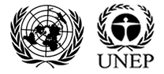

UNEP/MC/COP.6/Dec.12

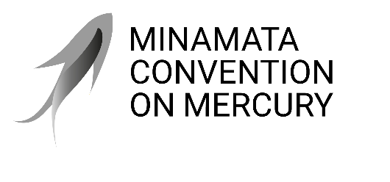 |  | Distr.: General  24 November 2025  Original: English

Conference of the Parties to the
Minamata Convention on Mercury
Sixth meeting
Geneva, 3–7 November 2025
Decisions adopted by the Conference of the Parties to the Minamata Convention on Mercury at its sixth meeting
Decision MC-6/12: Implementation of article 14 of the Minamata Convention on Mercury, on capacity-building, technical assistance and technology transfer
The Conference of the Parties,
Recalling article 14 of the Minamata Convention on Mercury, on capacity-building, technical assistance and technology transfer,
Having considered the information on initiatives and progress made in relation to alternative technologies, and appreciating the lessons learned from case studies on the successful development, transfer and diffusion of alternative technologies, as presented at its sixth meeting,
Noting the limited availability of information on the needs of parties, particularly developing-country parties, with respect to alternative technologies, while at the same time acknowledging current efforts as a step towards closing the information gap and narrowing the focus of further specific interventions to support parties,
Noting also the challenges reported by parties, particularly developing-country parties, in their national reports pursuant to article 21, with respect to alternative technologies,
Expressing its appreciation for the strong foundation for collaboration on technology transfer between the secretariat and the Global Mercury Partnership, the Basel Convention on the Control of Transboundary Movements of Hazardous Wastes and Their Disposal, the Rotterdam Convention on the Prior Informed Consent Procedure for Certain Hazardous Chemicals and Pesticides in International Trade and the Stockholm Convention on Persistent Organic Pollutants, including the regional centres of the Basel and Stockholm conventions,
- Urges developed-country parties and other parties, within their capabilities, to take into account the challenges identified with regard to the uptake of alternative technologies, specifically in promoting and facilitating the development, transfer and diffusion of up-to-date, environmentally sound alternative technologies to developing-country parties, in particular the least developed countries and small island developing States, and parties with economies in transition, to strengthen their capacity to effectively implement the Minamata Convention on Mercury;
- Encourages parties, in their national reports pursuant to article 21, including their second full national reports, to include specific information on the development, transfer and diffusion of, and access to, alternative technologies, as well as on the challenges they have experienced in accessing and transferring technology, to assist in a future review of challenges and progress;
- Requests the secretariat, subject to the availability of resources, pursuant to paragraph 4 of article 14, to further collect and analyse, in collaboration with the Global Mercury Partnership, among others, information on existing initiatives and progress made in relation to alternative technologies, as well as related needs and challenges, utilizing:
  - Information in future national reports under article 21;
  - Additional information collected through a survey of technology needs and challenges;
  - Other available information, including reports on and evaluations of projects funded by the Global Environment Facility and the Specific International Programme to Support
Capacity-Building and Technical Assistance;
- Decides to consider the matter of alternative technologies pursuant to paragraph 4 of article 14 again at its eighth meeting;
- Calls on parties, and invites non-parties to the Convention and others in a position to do so, to contribute to the special trust fund of the Minamata Convention on Mercury, to enable the implementation of the capacity-building activities described in the 2026–2027 programme of work and budget activity fact sheet for capacity-building and technical assistance (activity 4);
- Acknowledges with appreciation the work of the secretariat in developing and disseminating tools and training materials related to the implementation of parties’ obligations under the Convention;
- Requests the secretariat, subject to the availability of resources, to continue to provide capacity-building and technical assistance support to parties pursuant to paragraph 1 of article 14, including through active and sustained engagement with the Global Mercury Partnership.

See document UNEP/MC/COP.6/INF/18.

