UNITED  NATIONS | 

UNEP/MC/COP.6/Dec.7

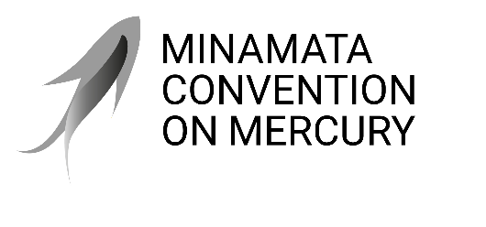 |  | Distr.: General  24 November 2025  Original: English

Conference of the Parties to the
Minamata Convention on Mercury
Sixth meeting
Geneva, 3–7 November 2025
Decisions adopted by the Conference of the Parties to the Minamata Convention on Mercury at its sixth meeting
Decision MC-6/7: Extensions of exemptions
The Conference of the Parties,
Noting that paragraph 6 of article 6 of the Minamata Convention on Mercury provides that the Conference of the Parties may, at the request of a party, decide to extend an exemption from the relevant phase-out date listed in annex A or B to the Convention,
Recognizing that the sixth meeting of the Conference of the Parties marks the first time that the Conference has been requested to consider such a request,
Welcoming the revised exemption extension requests from two of the three parties requesting extensions, in which they provide additional information related to paragraph 6 (a), (b) and (c) of article 6 for the consideration of the parties,
Highlighting the continued need to protect human health and the environment from the ongoing manufacture, import and export of the products listed in part I of annex A,
- Takes note of the requests for the extension of exemptions and related information submitted to the Conference of the Parties at its sixth meeting by Bangladesh, India and Thailand pursuant to paragraph 6 of article 6;
- Decides to extend the exemptions from the phase-out dates as requested by Bangladesh;
- Also decides to extend the exemptions from the phase-out dates as requested by India;
- Further decides to extend the exemptions from the phase-out dates as requested by Thailand;
- Notes that, with the exception of the extensions of exemptions referred to in paragraphs 2, 3 and 4 above, all registered exemptions from the 2020 phase-out dates listed in annex A will expire after 31 December 2025, in accordance with paragraph 5 of article 6, and that after that date, no State or regional economic integration organization may register for an exemption with respect to the 2020 phase-out dates, in accordance with paragraph 8 of article 6;
- Requests the secretariat to continue to maintain, update and make available on the website of the Convention the register established under paragraph 3 of article 6 and related information, as appropriate.

UNEP/MC/COP.6/28, annex I.
Ibid., annex II.
Ibid., annex III.

