UNITED  NATIONS | 

UNEP/MC/COP.6/Dec.6

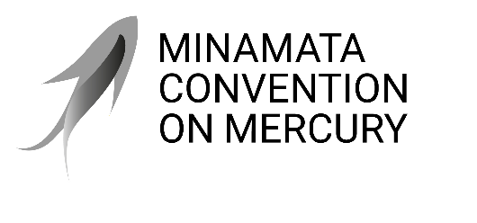 |  | Distr.: General  24 November 2025  Original: English

Conference of the Parties to the
Minamata Convention on Mercury
Sixth meeting
Geneva, 3–7 November 2025
Decisions adopted by the Conference of the Parties to the Minamata Convention on Mercury at its sixth meeting
Decision MC-6/6: Timeline for considering requests by parties for extensions of exemptions
The Conference of the Parties
Adopts, for the purpose of facilitating parties’ requests for extensions of exemptions under paragraph 6 of article 6 of the Minamata Convention on Mercury, the timeline set out in the annex to the present decision.
Annex to decision MC-6/6
- Any request for an extension of an exemption should preferably be submitted at least six months, but no less than two months, before the last meeting of the Conference of the Parties held before the expiry date of the exemption.
- The request is expected to contain the information specified in paragraph 6 (a), (b) and (c) of article 6 of the Minamata Convention on Mercury for each mercury-added product or process included in the request so that the Conference of the Parties can fully consider the request.
- The secretariat may consult as needed with the party submitting the extension request.
- The request will be considered by the Conference of the Parties at its next meeting following the submission of the request.

