UNITED  NATIONS | 

UNEP/MC/COP.6/Dec.5

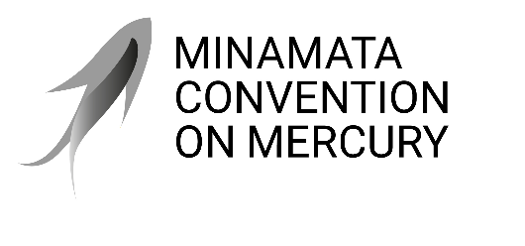 |  | Distr.: General  24 November 2025  Original: English

Conference of the Parties to the
Minamata Convention on Mercury
Sixth meeting
Geneva, 3–7 November 2025
Decisions adopted by the Conference of the Parties to the Minamata Convention on Mercury at its sixth meeting
Decision MC-6/5: Consideration of the feasibility of mercury-free alternatives for manufacturing vinyl chloride monomer
The Conference of the Parties,
Recalling the obligation, set out in paragraph 3 of article 5 of the Minamata Convention on Mercury, for each party to take measures to restrict the use of mercury or mercury compounds in the processes listed in part II of annex B to the Convention, which, in the case of vinyl chloride monomer production, includes reporting to the Conference of the Parties on the party’s efforts to develop and/or identify alternatives and phase out mercury use in accordance with article 21,
Noting that part II of annex B lists vinyl chloride monomer production and measures to be taken by the parties, including not allowing the use of mercury in vinyl chloride monomer production five years after the Conference of the Parties has established that mercury-free catalysts based on existing processes have become technically and economically feasible,
Acknowledging the work undertaken during the latest intersessional period pursuant to decision MC-5/6,
- Welcomes the report on the economic and technical feasibility of mercury-free catalysts in vinyl chloride monomer production;
- Notes with appreciation the progress reported in eliminating the use of mercury in vinyl chloride monomer production;
- Notes that it has not been possible to reach consensus in establishing the economic and technical feasibility of mercury-free catalysts in vinyl chloride monomer production at the current meeting;
- Agrees to reconsider the issue at its next meeting.

UNEP/MC/COP.6/6/Add.2.

