UNITED  NATIONS | 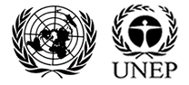

UNEP/MC/COP.6/Dec.4

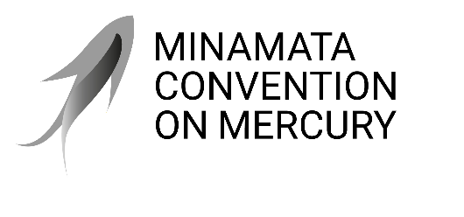 |  | Distr.: General  24 November 2025  Original: English

Conference of the Parties to the
Minamata Convention on Mercury
Sixth meeting
Geneva, 3–7 November 2025
Decisions adopted by the Conference of the Parties to the Minamata Convention on Mercury at its sixth meeting
Decision MC-6/4: Advancing work related to mercury-added cosmetics
The Conference of the Parties,
Recalling that paragraph 1 of article 4 of the Minamata Convention on Mercury provides that parties shall not allow the manufacture, import or export of mercury-added cosmetics listed in part I of annex A to the Convention after the phase-out date specified for those products, except where an exclusion is specified in annex A or the party has a registered exemption pursuant to article 6,
Noting that, despite the listing of cosmetics in annex A, some cosmetics not allowed under the Convention are finding their way into global commerce,
Acknowledging the work undertaken during the most recent intersessional period pursuant to decision MC-5/5,
- Welcomes the report on cosmetics listed in part I of annex A;
- Encourages parties without national legislation or other measures, or otherwise facing challenges in implementing their obligations regarding mercury-added cosmetics, to inform the secretariat and to consider the application of article 14 and/or 15 to their situation;
- Encourages the Global Mercury Partnership to continue its efforts, in consultation with interested parties, to compile and disseminate information related to the presence of mercury in cosmetics;
- Invites the secretariat, subject to the availability of resources, and in collaboration with the Global Mercury Partnership, to gather and provide to the Conference of the Parties at its seventh meeting available information on mechanisms for supporting enforcement and the identification of the presence of mercury in cosmetics, including field sampling and analysis equipment;
- Also invites the secretariat, subject to the availability of resources, to compile and synthesize the information provided by parties in their national reports, or submitted pursuant to paragraph 2 above, related to the challenges in preventing the manufacture, import and export of mercury-added cosmetics, including enforcement challenges, and to report on the matter to the Conference of the Parties at its seventh meeting;
- Further invites the secretariat, subject to the availability of resources, to work with the International Criminal Police Organization (INTERPOL), the World Customs Organization and other relevant international organizations with expertise related to the illegal trade of products to further investigate the major sources of manufacture, import and export of mercury-added cosmetics with greater than trace amounts or, for some parties, no more than 1 part per million of mercury that are no longer allowed under article 4, and to report on the matter to the Conference of the Parties at its seventh meeting, including in its report any specific proposals from the relevant international organizations;
- Invites the World Health Organization to:
- Consult with the United Nations Environment Programme and the Biodiversity Research Institute to provide lessons learned from the Global Environment Facility pilot project on the elimination of mercury-added cosmetics in Gabon, Jamaica and Sri Lanka;
- Prepare, with support from the Global Mercury Partnership, an illustrative national public health system-wide strategy focused on reduction measures for mercury-added cosmetics, and for skin-lightening products that may not contain mercury, that parties may utilize domestically;
- Share the lessons learned and an outline of the strategy with the secretariat by 31 December 2026.

UNEP/MC/COP.6/INF/8.

