UNITED  NATIONS | 

UNEP/MC/COP.6/Dec.2

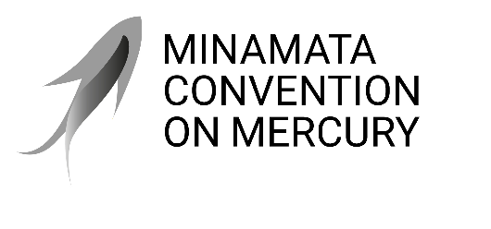 |  | Distr.: General  24 November 2025  Original: English

Conference of the Parties to the
Minamata Convention on Mercury
Sixth meeting
Geneva, 3–7 November 2025
Decisions adopted by the Conference of the Parties to the Minamata Convention on Mercury at its sixth meeting
Decision MC-6/2: Advancing work related to potential restrictions on the trade of mercury compounds
The Conference of the Parties,
Noting that paragraph 13 of article 3 of the Minamata Convention on Mercury requires the Conference of the Parties to undertake an evaluation of whether the trade in specific mercury compounds compromises the Convention’s objective of protecting human health and the environment,
Recalling that paragraph 13 of article 3 also requires the Conference of the Parties to consider whether specific mercury compounds should, by their listing in an additional annex adopted in accordance with article 27, be made subject to paragraphs 6 and 8 of article 3,
Acknowledging the work carried out during the most recent intersessional period pursuant to decision MC-5/3,
Aiming to further understand the current global supply, trade and use of specific mercury compounds in order to take informed decisions in relation to the Convention,
- Acknowledges the report on the global supply, production, trade and use of mercury compounds;
- Encourages parties and stakeholders to reflect on the information contained in the report and to consider the need for an additional annex that would make mercury compounds subject to the trade provisions of paragraphs 6 and 8 of article 3;
- Invites parties and stakeholders to submit to the secretariat, by 31 March 2026, on a voluntary basis, available information on the supply, use and trade of mercury compounds, and to share their views and input on mercury compounds which could possibly be listed in a proposed annex;
- Decides to establish an open-ended expert group whose mandate will be to consider the information in the above-mentioned report and the information submitted in accordance with paragraph 3 above, to work in English in an online setting, and to submit its recommendations to the secretariat no later than eight months before the seventh meeting of the Conference of the Parties;
- Invites parties and stakeholders to participate in the work of the expert group;
- Requests the secretariat to support the expert group in its endeavours and to submit a report on the group’s work and its findings for consideration by the Conference of the Parties at its seventh meeting.

UNEP/MC/COP.6/5/Add.1.
This work is intended to study mercury compounds that may be used in products or processes, or that can be converted to elemental mercury. It is not intended to cover mercury compounds that fall under the definition of mercury wastes in accordance with paragraph 2 of article 11.

